|  |  |  |
| --- | --- | --- |
|  |  | **To Be Completed** |
| 1 | Name of passage writer | **LIZA MUTHONI** |
| 2 | Submission date | **23/02/2024** |
| 3 | MCAT Science  (State: Bio/Biochem or Phy/Chem) | **BIO/BIO CHEM** |
| 4 | ID Code of New Passage  (Given to you in assignment) | **PASSAGE _MCAT.SB1.S3.P7** |
| 5 | Passage Number  (See column E of spreadsheet) |  |
| 6 | Reference AAMC Test, Section, Passage Number  (Set PT4.S3.P1 for Practice Test 4, Section 3, Passage 1) |  |
| 7 | Does passage align to guidelines  (Enter yes or no) |  |
| 8 | General remarks from writer about text in passage, if necessary |  |
| 9 | General remarks from writer about figures or tables in passage, if necessary |  |
| 10 | Reviewer  (Enter Accept or Reject: Provide brief reason) |  |
| 11 | Name of editor |  |
| 12 | Remarks from editor, if applicable |  |
| 13 | Returned to writer: Yes or No |

**Note: Begin passage writing on page 2.**

**File must be saved as: FILES WILL BE REJECTED IF THE FILE NAME IS INCORRECT**

* PASSAGE_MCAT.TestNumber.SectionNumber.PassageNumber_writer’s initials

**Examples**

* PASSAGE_MCAT.A1.S1.P4_ST (Use S1 for Section 1: Physics/Chem passage)
* PASSAGE_MCAT.A1.S3.P4_ST (Use S3 for Section 3: Bio/Biochem passage)
* PASSAGE_MCAT.OPC.S3.P8_ST (Use OPC, OPP, OPB for databanks (C=chem, P=Phy, B=BBC))

**Place new passage and corresponding figures/tables below line.**

Fibroblast Growth Factor (FGF) pathway activation is usually responsible for the coordinated migration of parapineal cells in the zebrafish epithalamus, guaranteeing their exact movement during embryonic development. However, parapineal cells exhibit a greater activation of the FGF pathway when Notch signaling is interfered with. This anomaly causes abnormalities in parapineal migration and affects these cells' specification, suggesting that the Notch and FGF pathways interact intricately to control migration and cellular identity.

The transgenic line *Tg(dusp6:d2GFP)*, serving as an FGF pathway reporter, was recently employed to characterize the dynamics of FGF pathway activation during parapineal migration by analyzing its temporal and spatial activation. This transgene utilizes the dual-specificity phosphatase (Dusp6) gene, which functions in negatively regulating the FGF pathway. *Tg(dusp6:d2GFP),* which has been altered to express green fluorescent protein (GFP) whenever the gene is activated, offers an invaluable tool for observation.

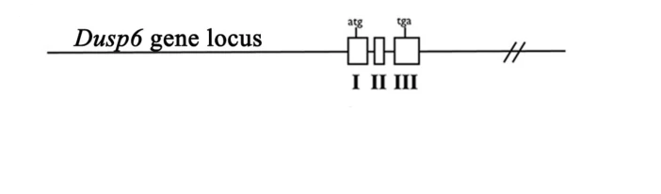

Figure 1: The Dusp6 gene locus

*mindbomb* (*mibta52b*) gene mutations, serving as a well-established loss-of-function model for the Notch pathway, were employed to investigate their impact on FGF pathway activation within parapineal cells. Utilizing the FGF pathway activity reporter transgene, *Tg(dusp6:d2EGFP*), control embryos and *mib-/-* mutants were analyzed for *Tg(dusp6:d2EGFP)* expression patterns at 32 hours post-fertilization (hpf). The dot plots involved analyzing the expression patterns of *Tg(dusp6:d2EGFP)* in embryos at 32 hours post-fertilization (hpf).

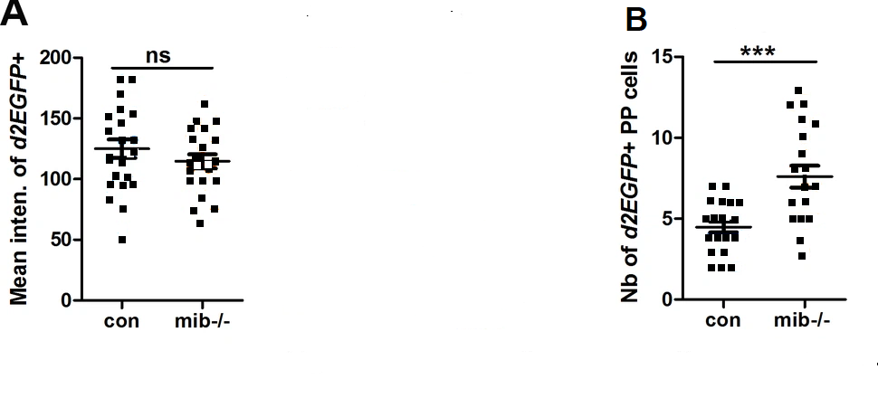

**Figure 2**: The mean intensity of *Tg(dusp6:d2EGFP)* +cells.

Adapted from L, Wei et al*., Elife, 8*. ©2019, elifesciences.org

Passage Writers Upload file to Folder 10 on Drive. And STOP.

## Item Writers: Continue to next page, but only when assignment is given to do so.

**Place new question items below. Key stem and distractors. Place * to the left of the correct answer letter. Enter Skills Assessed and answer the last two items. There are templates for 7 new items. Only set the number of items as shown in the spreadsheet for your passage.**

Question Number: 1

Stem

Distractors

A.

B.

C.

D.

## **Categorization (Information below must align to one row on the PDF)**

## **Section:**

## **Content:**

## **Subject:**

## **Topic:**

**Difficulty** <choose one and delete the other two>

* Easy

**Scientific or Reasoning Skill Assessed**<delete all but the skill assessed per AAMC>

* Knowledge of Scientific Concepts and Principles

**Do students need information from the passage (or question stem) to answer the item**? <Yes or No; if no, be sure to mention it in the explanation>

# **Explanation**

<Insert introductory sentence; do not restate the question>

<The next three headers can be arranged in a different order and/or deleted if not needed>

## **Key Passage Information**

<Key information if pertinent to question, otherwise delete this section>

## **Key Question Information**

<Key information if pertinent to question, otherwise delete this section >

## **Background Information**

<Key information if pertinent to question, otherwise delete this section >

## **Solution**

<Provide a cohesive and logical solution.>

The correct answer is **Choice X, key correct answer here.**

## **Optional Method**

<Provide an optional cohesive and logical solution, if applicable, otherwise, delete.>

The correct answer is **Choice X, key correct answer here.**

## **KPTip**

<This header can be moved to any point in the explanation. This section is not mandatory, see guidelines and samples for help, otherwise, delete.>

## **Explanation of Incorrect Answers**

Choice A is incorrect. Explain why.

Choice B is incorrect. Explain why.

Choice D is incorrect. Explain why.

## **Take Home Point**

<This section is mandatory; see guidelines and samples for help.>

## **Summary**

<This section is mandatory; see guidelines and samples for help.>

Question Number: 2

Stem

Distractors

A.

B.

C.

D.

## **Categorization (Information below must align to one row on the PDF)**

## **Section:**

## **Content:**

## **Subject:**

## **Topic:**

**Difficulty** <choose one and delete the other two>

* Medium

**Scientific or Reasoning Skill Assessed**<delete all but the skill assessed per AAMC>

* Data-Based and Statistical Reasoning

**Do students need information from the passage (or question stem) to answer the item**? <Yes or No; if no, be sure to mention it in the explanation>

# **Explanation**

<Insert introductory sentence; do not restate the question>

<The next three headers can be arranged in a different order and/or deleted if not needed>

## **Key Passage Information**

<Key information if pertinent to question, otherwise delete this section>

## **Key Question Information**

<Key information if pertinent to question, otherwise delete this section >

## **Background Information**

<Key information if pertinent to question, otherwise delete this section >

## **Solution**

<Provide a cohesive and logical solution.>

The correct answer is **Choice X, key correct answer here.**

## **Optional Method**

<Provide an optional cohesive and logical solution, if applicable, otherwise, delete.>

The correct answer is **Choice X, key correct answer here.**

## **KPTip**

<This header can be moved to any point in the explanation. This section is not mandatory, see guidelines and samples for help, otherwise, delete.>

## **Explanation of Incorrect Answers**

Choice A is incorrect. Explain why.

Choice B is incorrect. Explain why.

Choice D is incorrect. Explain why.

## **Take Home Point**

<This section is mandatory; see guidelines and samples for help.>

## **Summary**

<This section is mandatory; see guidelines and samples for help.>

Question Number: 3

Stem

Distractors

A.

B.

C.

D.

## **Categorization (Information below must align to one row on the PDF)**

## **Section:**

## **Content:**

## **Subject:**

## **Topic:**

**Difficulty** <choose one and delete the other two>

* Medium

**Scientific or Reasoning Skill Assessed**<delete all but the skill assessed per AAMC>

* Scientific Reasoning and Problem-Solving

**Do students need information from the passage (or question stem) to answer the item**? <Yes or No; if no, be sure to mention it in the explanation>

# **Explanation**

<Insert introductory sentence; do not restate the question>

<The next three headers can be arranged in a different order and/or deleted if not needed>

## **Key Passage Information**

<Key information if pertinent to question, otherwise delete this section>

## **Key Question Information**

<Key information if pertinent to question, otherwise delete this section >

## **Background Information**

<Key information if pertinent to question, otherwise delete this section >

## **Solution**

<Provide a cohesive and logical solution.>

The correct answer is **Choice X, key correct answer here.**

## **Optional Method**

<Provide an optional cohesive and logical solution, if applicable, otherwise, delete.>

The correct answer is **Choice X, key correct answer here.**

## **KPTip**

<This header can be moved to any point in the explanation. This section is not mandatory, see guidelines and samples for help, otherwise, delete.>

## **Explanation of Incorrect Answers**

Choice A is incorrect. Explain why.

Choice B is incorrect. Explain why.

Choice D is incorrect. Explain why.

## **Take Home Point**

<This section is mandatory; see guidelines and samples for help.>

## **Summary**

<This section is mandatory; see guidelines and samples for help.>

Question Number: 4

Stem

Distractors

A.

B.

C.

D.

## **Categorization (Information below must align to one row on the PDF)**

## **Section:**

## **Content:**

## **Subject:**

## **Topic:**

**Difficulty** <choose one and delete the other two>

* Hard

**Scientific or Reasoning Skill Assessed**<delete all but the skill assessed per AAMC>

* Scientific Reasoning and Problem-Solving

**Do students need information from the passage (or question stem) to answer the item**? <Yes or No; if no, be sure to mention it in the explanation>

# **Explanation**

<Insert introductory sentence; do not restate the question>

<The next three headers can be arranged in a different order and/or deleted if not needed>

## **Key Passage Information**

<Key information if pertinent to question, otherwise delete this section>

## **Key Question Information**

<Key information if pertinent to question, otherwise delete this section >

## **Background Information**

<Key information if pertinent to question, otherwise delete this section >

## **Solution**

<Provide a cohesive and logical solution.>

The correct answer is **Choice X, key correct answer here.**

## **Optional Method**

<Provide an optional cohesive and logical solution, if applicable, otherwise, delete.>

The correct answer is **Choice X, key correct answer here.**

## **KPTip**

<This header can be moved to any point in the explanation. This section is not mandatory, see guidelines and samples for help, otherwise, delete.>

## **Explanation of Incorrect Answers**

Choice A is incorrect. Explain why.

Choice B is incorrect. Explain why.

Choice D is incorrect. Explain why.

## **Take Home Point**

<This section is mandatory; see guidelines and samples for help.>

## **Summary**

<This section is mandatory; see guidelines and samples for help.>

Question Number: 5

Stem

Distractors

A.

B.

C.

D.

## **Categorization (Information below must align to one row on the PDF)**

## **Section:**

## **Content:**

## **Subject:**

## **Topic:**

**Difficulty** <choose one and delete the other two>

* Hard

**Scientific or Reasoning Skill Assessed**<delete all but the skill assessed per AAMC>

* Reasoning About the Design and Execution of Research

**Do students need information from the passage (or question stem) to answer the item**? <Yes or No; if no, be sure to mention it in the explanation>

# **Explanation**

<Insert introductory sentence; do not restate the question>

<The next three headers can be arranged in a different order and/or deleted if not needed>

## **Key Passage Information**

<Key information if pertinent to question, otherwise delete this section>

## **Key Question Information**

<Key information if pertinent to question, otherwise delete this section >

## **Background Information**

<Key information if pertinent to question, otherwise delete this section >

## **Solution**

<Provide a cohesive and logical solution.>

The correct answer is **Choice X, key correct answer here.**

## **Optional Method**

<Provide an optional cohesive and logical solution, if applicable, otherwise, delete.>

The correct answer is **Choice X, key correct answer here.**

## **KPTip**

<This header can be moved to any point in the explanation. This section is not mandatory, see guidelines and samples for help, otherwise, delete.>

## **Explanation of Incorrect Answers**

Choice A is incorrect. Explain why.

Choice B is incorrect. Explain why.

Choice D is incorrect. Explain why.

## **Take Home Point**

<This section is mandatory; see guidelines and samples for help.>

## **Summary**

<This section is mandatory; see guidelines and samples for help.>

Question Number: 6

Stem

Distractors

A.

B.

C.

D.

## **Categorization (Information below must align to one row on the PDF)**

## **Section:**

## **Content:**

## **Subject:**

## **Topic:**

**Difficulty** <choose one and delete the other two>

* Medium

**Scientific or Reasoning Skill Assessed**<delete all but the skill assessed per AAMC>

* Knowledge of Scientific Concepts and Principles

**Do students need information from the passage (or question stem) to answer the item**? <Yes or No; if no, be sure to mention it in the explanation>

# **Explanation**

<Insert introductory sentence; do not restate the question>

<The next three headers can be arranged in a different order and/or deleted if not needed>

## **Key Passage Information**

<Key information if pertinent to question, otherwise delete this section>

## **Key Question Information**

<Key information if pertinent to question, otherwise delete this section >

## **Background Information**

<Key information if pertinent to question, otherwise delete this section >

## **Solution**

<Provide a cohesive and logical solution.>

The correct answer is **Choice X, key correct answer here.**

## **Optional Method**

<Provide an optional cohesive and logical solution, if applicable, otherwise, delete.>

The correct answer is **Choice X, key correct answer here.**

## **KPTip**

<This header can be moved to any point in the explanation. This section is not mandatory, see guidelines and samples for help, otherwise, delete.>

## **Explanation of Incorrect Answers**

Choice A is incorrect. Explain why.

Choice B is incorrect. Explain why.

Choice D is incorrect. Explain why.

## **Take Home Point**

<This section is mandatory; see guidelines and samples for help.>

## **Summary**

<This section is mandatory; see guidelines and samples for help.>