|  |  |  |
| --- | --- | --- |
|  |  | **To Be Completed** |
| 1 | Name of passage writer | **LIZA MUTHONI** |
| 2 | Submission date | **27/02/2024** |
| 3 | MCAT Science  (State: Bio/Biochem or Phy/Chem) | **BIO/BIOCHEM** |
| 4 | ID Code of New Passage  (Given to you in assignment) | **PASSAGE_MCAT.SB2.S3.P7** |
| 5 | Passage Number  (See column E of spreadsheet) |  |
| 6 | Reference AAMC Test, Section, Passage Number  (Set PT4.S3.P1 for Practice Test 4, Section 3, Passage 1) |  |
| 7 | Does passage align to guidelines  (Enter yes or no) |  |
| 8 | General remarks from writer about text in passage, if necessary |  |
| 9 | General remarks from writer about figures or tables in passage, if necessary |  |
| 10 | Reviewer  (Enter Accept or Reject: Provide brief reason) |  |
| 11 | Name of editor |  |
| 12 | Remarks from editor, if applicable |  |
| 13 | Returned to writer: Yes or No |

**Note: Begin passage writing on page 2.**

**File must be saved as: FILES WILL BE REJECTED IF THE FILE NAME IS INCORRECT**

* PASSAGE_MCAT.TestNumber.SectionNumber.PassageNumber_writer’s initials

**Examples**

* PASSAGE_MCAT.A1.S1.P4_ST (Use S1 for Section 1: Physics/Chem passage)
* PASSAGE_MCAT.A1.S3.P4_ST (Use S3 for Section 3: Bio/Biochem passage)
* PASSAGE_MCAT.OPC.S3.P8_ST (Use OPC, OPP, OPB for databanks (C=chem, P=Phy, B=BBC))

**Place new passage and corresponding figures/tables below line.**

In viral pathogenesis, the angiotensin-converting enzyme 2 (ACE2) receptor stands as a crucial entry point for both SARS-CoV and SARS-CoV-2, facilitated by the binding affinity of their spike proteins. When scrutinizing the receptor-binding domains (RBDs) of these coronaviruses, the spike protein's main function, involving the engagement and binding of ACE2, contrasts with the observation that immunization with either SARS-CoV RBD or SARS-CoV-2 RBD induces the generation of potent clade-specific neutralizing antibodies. in the observed weaker cross-neutralizing activity suggests distinctive antigenic features within the RBDs within the receptor-binding domains (RBDs), such as variations in amino acid sequences or structural conformations.

Host receptor hACE2, a transmembrane protein facilitating cellular entry for both SARS-CoV and SARS-CoV-2, was investigated for distinct antigenic features. Through single amino acid substitution mutations in RBD sequences, key residues essential for hACE2 binding were deciphered. hACE2 plays a pivotal role in mediating the interaction between the viral spike protein's receptor-binding domain (RBD) and the host cell, initiating the crucial step of viral entry into target cells.

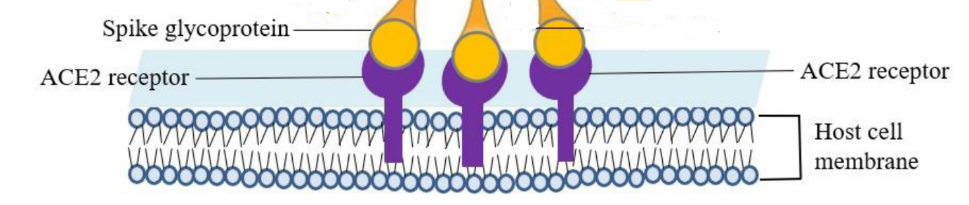

Minus the color of course, Can I use this as an image here or is there another one you would recommend?

FIGURE 1: Angiotensin-converting enzyme 2 (ACE2) receptor on the host cell’s surface.

To investigate the distinct immunogenicity of the SARS-CoV RBD and SARS-CoV-2 RBD mouse sera (blood serum collected from mice) were used to assess the cross-reactivity of antibodies induced by each RBD. Using Enzyme-linked immunosorbent assay (ELISAs), the antibody titres of mouse sera immunized with either recombinant SARS-CoV-2 RBD or SARS-CoV RBD against both RBDs were measured. Additionally, a cross-blocking assay was performed to evaluate the efficiency of the antiserum in blocking the interaction between hACE2 and S protein RBDs, and a pseudo-typed virus neutralization assay to assess cross-neutralization efficacy.

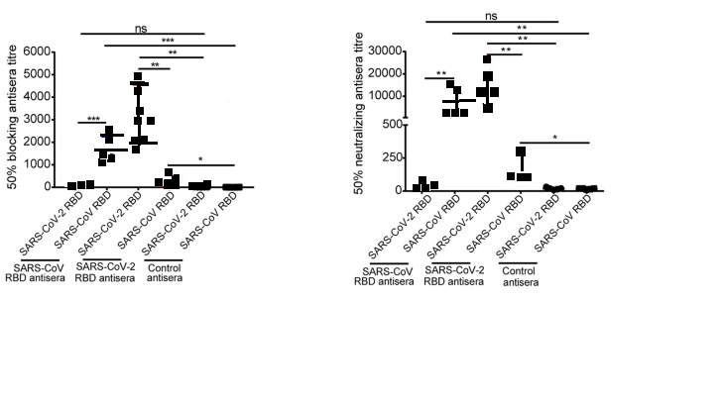

Figure 2: The antibody response induced by recombinant RBD of SARS-CoV and SARS-CoV-2 in mice

Adapted from C, Yi et al., *Cellular & molecular immunology, 17(6).* ©2020, nature.com

Passage Writers Upload file to Folder 10 on Drive. And STOP.

## Item Writers: Continue to next page, but only when assignment is given to do so.

**Place new question items below. Key stem and distractors. Place * to the left of the correct answer letter. Enter Skills Assessed and answer the last two items. There are templates for 7 new items. Only set the number of items as shown in the spreadsheet for your passage.**

Question Number: 1

Stem

Distractors

A.

B.

C.

D.

## **Categorization (Information below must align to one row on the PDF)**

## **Section:**

## **Content:**

## **Subject:**

## **Topic:**

**Difficulty** <choose one and delete the other two>

* Easy

**Scientific or Reasoning Skill Assessed**<delete all but the skill assessed per AAMC>

* Knowledge of Scientific Concepts and Principles

**Do students need information from the passage (or question stem) to answer the item**? <Yes or No; if no, be sure to mention it in the explanation>

# **Explanation**

<Insert introductory sentence; do not restate the question>

<The next three headers can be arranged in a different order and/or deleted if not needed>

## **Key Passage Information**

<Key information if pertinent to question, otherwise delete this section>

## **Key Question Information**

<Key information if pertinent to question, otherwise delete this section >

## **Background Information**

<Key information if pertinent to question, otherwise delete this section >

## **Solution**

<Provide a cohesive and logical solution.>

The correct answer is **Choice X, key correct answer here.**

## **Optional Method**

<Provide an optional cohesive and logical solution, if applicable, otherwise, delete.>

The correct answer is **Choice X, key correct answer here.**

## **KPTip**

<This header can be moved to any point in the explanation. This section is not mandatory, see guidelines and samples for help, otherwise, delete.>

## **Explanation of Incorrect Answers**

Choice A is incorrect. Explain why.

Choice B is incorrect. Explain why.

Choice D is incorrect. Explain why.

## **Take Home Point**

<This section is mandatory; see guidelines and samples for help.>

## **Summary**

<This section is mandatory; see guidelines and samples for help.>

Question Number: 2

Stem

Distractors

A.

B.

C.

D.

## **Categorization (Information below must align to one row on the PDF)**

## **Section:**

## **Content:**

## **Subject:**

## **Topic:**

**Difficulty** <choose one and delete the other two>

* Medium

**Scientific or Reasoning Skill Assessed**<delete all but the skill assessed per AAMC>

* Data-Based and Statistical Reasoning

**Do students need information from the passage (or question stem) to answer the item**? <Yes or No; if no, be sure to mention it in the explanation>

# **Explanation**

<Insert introductory sentence; do not restate the question>

<The next three headers can be arranged in a different order and/or deleted if not needed>

## **Key Passage Information**

<Key information if pertinent to question, otherwise delete this section>

## **Key Question Information**

<Key information if pertinent to question, otherwise delete this section >

## **Background Information**

<Key information if pertinent to question, otherwise delete this section >

## **Solution**

<Provide a cohesive and logical solution.>

The correct answer is **Choice X, key correct answer here.**

## **Optional Method**

<Provide an optional cohesive and logical solution, if applicable, otherwise, delete.>

The correct answer is **Choice X, key correct answer here.**

## **KPTip**

<This header can be moved to any point in the explanation. This section is not mandatory, see guidelines and samples for help, otherwise, delete.>

## **Explanation of Incorrect Answers**

Choice A is incorrect. Explain why.

Choice B is incorrect. Explain why.

Choice D is incorrect. Explain why.

## **Take Home Point**

<This section is mandatory; see guidelines and samples for help.>

## **Summary**

<This section is mandatory; see guidelines and samples for help.>

Question Number: 3

Stem

Distractors

A.

B.

C.

D.

## **Categorization (Information below must align to one row on the PDF)**

## **Section:**

## **Content:**

## **Subject:**

## **Topic:**

**Difficulty** <choose one and delete the other two>

* Medium

**Scientific or Reasoning Skill Assessed**<delete all but the skill assessed per AAMC>

* Scientific Reasoning and Problem-Solving

**Do students need information from the passage (or question stem) to answer the item**? <Yes or No; if no, be sure to mention it in the explanation>

# **Explanation**

<Insert introductory sentence; do not restate the question>

<The next three headers can be arranged in a different order and/or deleted if not needed>

## **Key Passage Information**

<Key information if pertinent to question, otherwise delete this section>

## **Key Question Information**

<Key information if pertinent to question, otherwise delete this section >

## **Background Information**

<Key information if pertinent to question, otherwise delete this section >

## **Solution**

<Provide a cohesive and logical solution.>

The correct answer is **Choice X, key correct answer here.**

## **Optional Method**

<Provide an optional cohesive and logical solution, if applicable, otherwise, delete.>

The correct answer is **Choice X, key correct answer here.**

## **KPTip**

<This header can be moved to any point in the explanation. This section is not mandatory, see guidelines and samples for help, otherwise, delete.>

## **Explanation of Incorrect Answers**

Choice A is incorrect. Explain why.

Choice B is incorrect. Explain why.

Choice D is incorrect. Explain why.

## **Take Home Point**

<This section is mandatory; see guidelines and samples for help.>

## **Summary**

<This section is mandatory; see guidelines and samples for help.>

Question Number: 4

Stem

Distractors

A.

B.

C.

D.

## **Categorization (Information below must align to one row on the PDF)**

## **Section:**

## **Content:**

## **Subject:**

## **Topic:**

**Difficulty** <choose one and delete the other two>

* Hard

**Scientific or Reasoning Skill Assessed**<delete all but the skill assessed per AAMC>

* Scientific Reasoning and Problem-Solving

**Do students need information from the passage (or question stem) to answer the item**? <Yes or No; if no, be sure to mention it in the explanation>

# **Explanation**

<Insert introductory sentence; do not restate the question>

<The next three headers can be arranged in a different order and/or deleted if not needed>

## **Key Passage Information**

<Key information if pertinent to question, otherwise delete this section>

## **Key Question Information**

<Key information if pertinent to question, otherwise delete this section >

## **Background Information**

<Key information if pertinent to question, otherwise delete this section >

## **Solution**

<Provide a cohesive and logical solution.>

The correct answer is **Choice X, key correct answer here.**

## **Optional Method**

<Provide an optional cohesive and logical solution, if applicable, otherwise, delete.>

The correct answer is **Choice X, key correct answer here.**

## **KPTip**

<This header can be moved to any point in the explanation. This section is not mandatory, see guidelines and samples for help, otherwise, delete.>

## **Explanation of Incorrect Answers**

Choice A is incorrect. Explain why.

Choice B is incorrect. Explain why.

Choice D is incorrect. Explain why.

## **Take Home Point**

<This section is mandatory; see guidelines and samples for help.>

## **Summary**

<This section is mandatory; see guidelines and samples for help.>

Question Number: 5

Stem

Distractors

A.

B.

C.

D.

## **Categorization (Information below must align to one row on the PDF)**

## **Section:**

## **Content:**

## **Subject:**

## **Topic:**

**Difficulty** <choose one and delete the other two>

* Hard

**Scientific or Reasoning Skill Assessed**<delete all but the skill assessed per AAMC>

* Reasoning About the Design and Execution of Research

**Do students need information from the passage (or question stem) to answer the item**? <Yes or No; if no, be sure to mention it in the explanation>

# **Explanation**

<Insert introductory sentence; do not restate the question>

<The next three headers can be arranged in a different order and/or deleted if not needed>

## **Key Passage Information**

<Key information if pertinent to question, otherwise delete this section>

## **Key Question Information**

<Key information if pertinent to question, otherwise delete this section >

## **Background Information**

<Key information if pertinent to question, otherwise delete this section >

## **Solution**

<Provide a cohesive and logical solution.>

The correct answer is **Choice X, key correct answer here.**

## **Optional Method**

<Provide an optional cohesive and logical solution, if applicable, otherwise, delete.>

The correct answer is **Choice X, key correct answer here.**

## **KPTip**

<This header can be moved to any point in the explanation. This section is not mandatory, see guidelines and samples for help, otherwise, delete.>

## **Explanation of Incorrect Answers**

Choice A is incorrect. Explain why.

Choice B is incorrect. Explain why.

Choice D is incorrect. Explain why.

## **Take Home Point**

<This section is mandatory; see guidelines and samples for help.>

## **Summary**

<This section is mandatory; see guidelines and samples for help.>

Question Number: 6

Stem

Distractors

A.

B.

C.

D.

## **Categorization (Information below must align to one row on the PDF)**

## **Section:**

## **Content:**

## **Subject:**

## **Topic:**

**Difficulty** <choose one and delete the other two>

* Medium

**Scientific or Reasoning Skill Assessed**<delete all but the skill assessed per AAMC>

* Knowledge of Scientific Concepts and Principles

**Do students need information from the passage (or question stem) to answer the item**? <Yes or No; if no, be sure to mention it in the explanation>

# **Explanation**

<Insert introductory sentence; do not restate the question>

<The next three headers can be arranged in a different order and/or deleted if not needed>

## **Key Passage Information**

<Key information if pertinent to question, otherwise delete this section>

## **Key Question Information**

<Key information if pertinent to question, otherwise delete this section >

## **Background Information**

<Key information if pertinent to question, otherwise delete this section >

## **Solution**

<Provide a cohesive and logical solution.>

The correct answer is **Choice X, key correct answer here.**

## **Optional Method**

<Provide an optional cohesive and logical solution, if applicable, otherwise, delete.>

The correct answer is **Choice X, key correct answer here.**

## **KPTip**

<This header can be moved to any point in the explanation. This section is not mandatory, see guidelines and samples for help, otherwise, delete.>

## **Explanation of Incorrect Answers**

Choice A is incorrect. Explain why.

Choice B is incorrect. Explain why.

Choice D is incorrect. Explain why.

## **Take Home Point**

<This section is mandatory; see guidelines and samples for help.>

## **Summary**

<This section is mandatory; see guidelines and samples for help.>