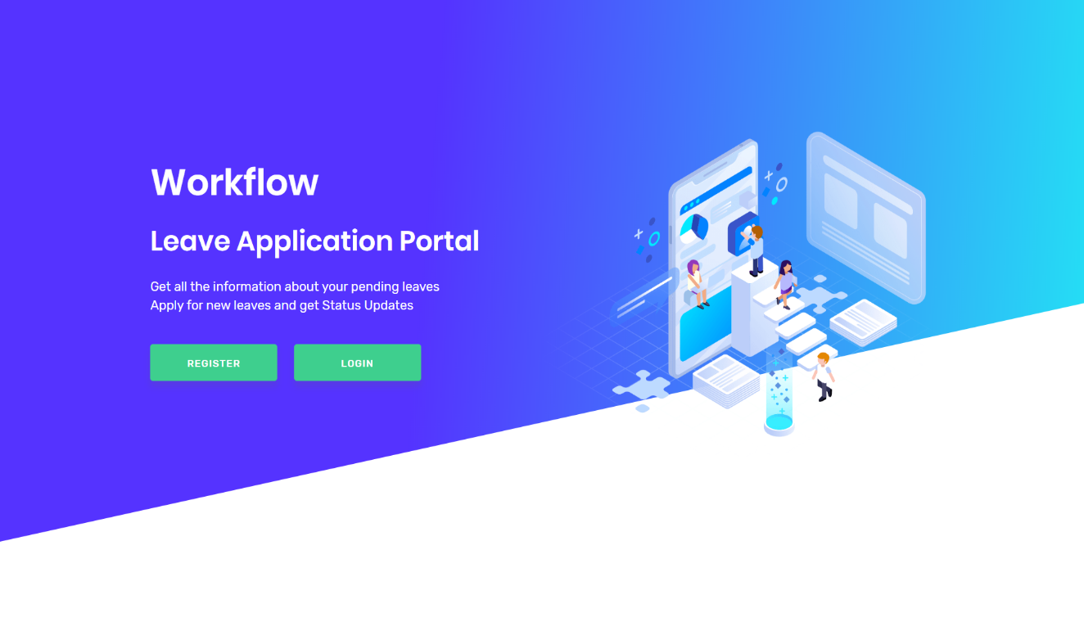

**Fig. 1.1** Home Page

This is the landing page of our project ‘Workflow’ with register and login button.

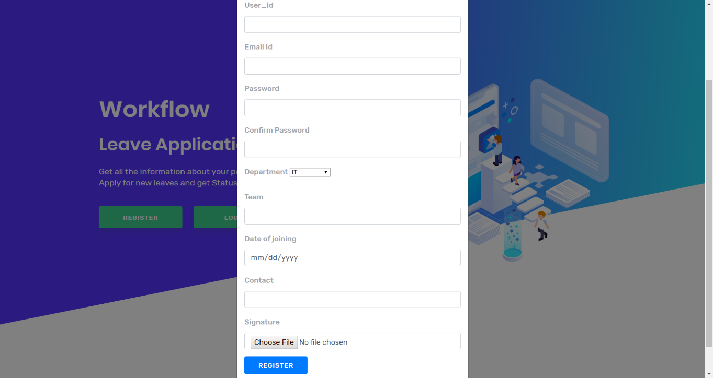

**Fig. 1.2** Registration modal

This is the modal for registration of Employees. The registering employee has to fill all the necessary details and has to upload his/her signature, which are further used in application pdf.

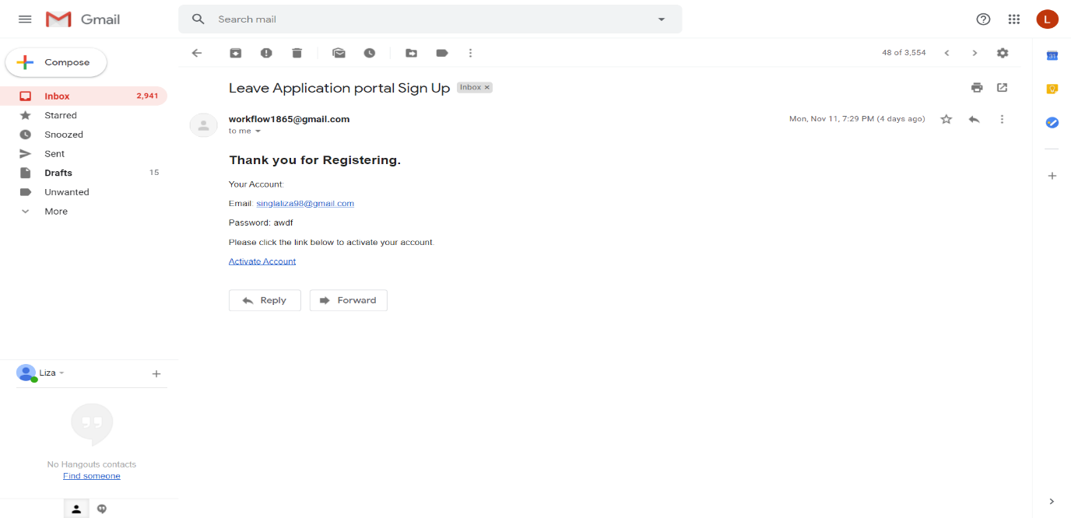

**Fig. 1.3** Email Verification

Now, this is the next page where employee has to visit, as after clicking on register button an email is send for verification to the registered gmail id of employee. An activation code is generated through which the account is verified and activated. Only after activating an employee is allowed to login.

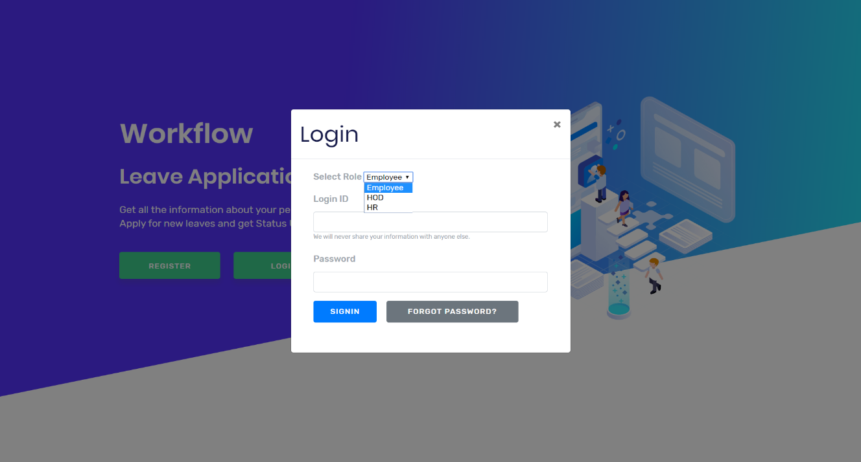

**Fig. 1.4** Login Modal

This is the login modal where a user select its role as Employee, HOD or HR. User enters the required detail to login and clicks on SIGNIN button.

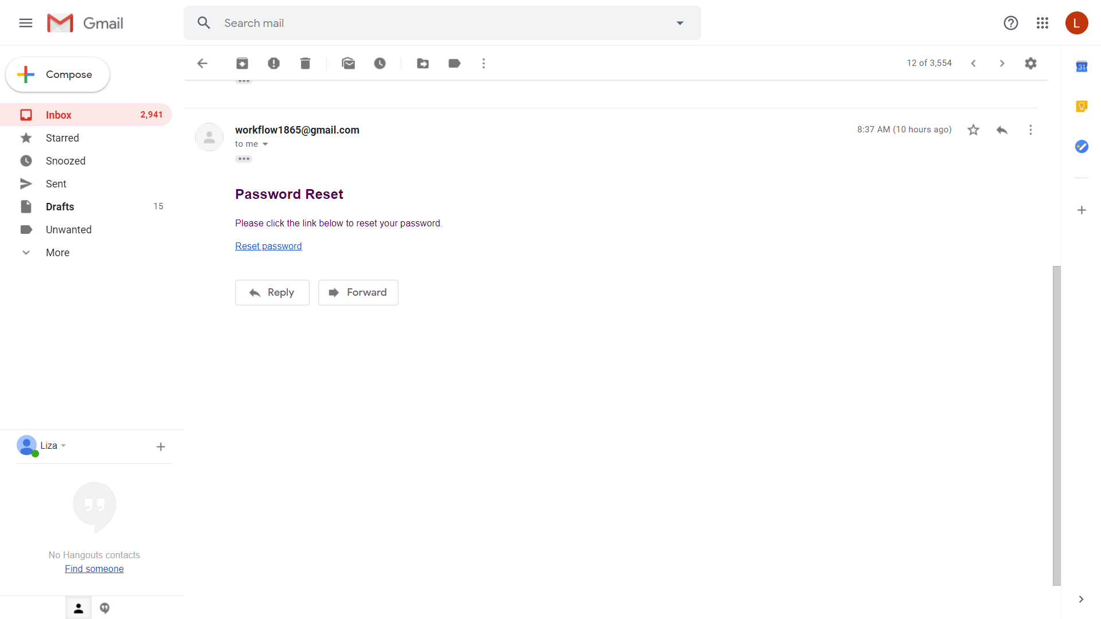

**Fig. 1.5** Reset Password

If a user forget its password, he can click on forgot password on login modal. On clicking it, a reset password link is send to the registered email id. When we click on the link in the email the page is redirected to new page which asks you to enter new password.

**ACKNOWLEDGEMENT**

We take this opportunity to express our sincere gratitude to all those who helped us in various capacities in undertaking this project and devising the report.

We are privileged to express our sense of gratitude to our coordinator **Dr. Rajitha B.** whose unparalleled knowledge, moral fiber and judgment along with her know-how, was an immense support in completing the project.

We are also grateful to **Miss. Roshini Singh,** our instructor for the brainwave and encouragement given.

**MCA II Group A7**

Somya Gupta

Simarpreet Kaur

Liza Singla

Anshu Kiran Kushawaha

Aayushi Jain