**Employee**

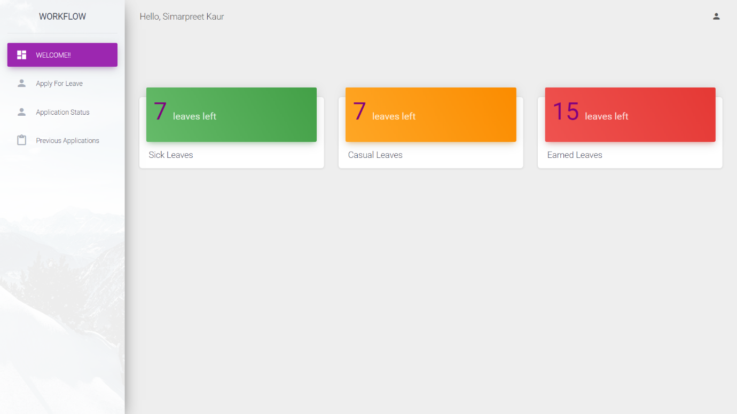

**Fig. 2.1** Leave information page

This is the first page that shows up when employee logs-in. This page shows the information about different types of leaves that the employee is left with.

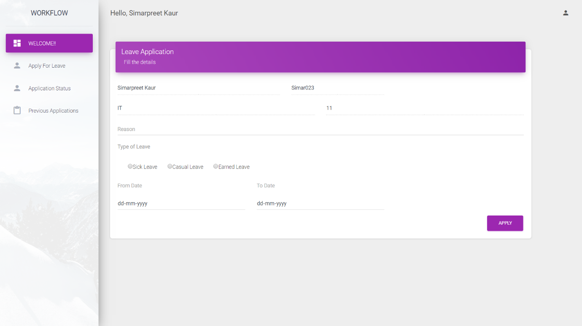

**Fig. 2.2** Apply leave page

This is the leave application form that employee has to fill to apply for a leave. Employee’s id, name, department and team number are being fetched from the database. Employee has to specify the reason, type of leave and dates to and from which he/she wants to apply leave for.

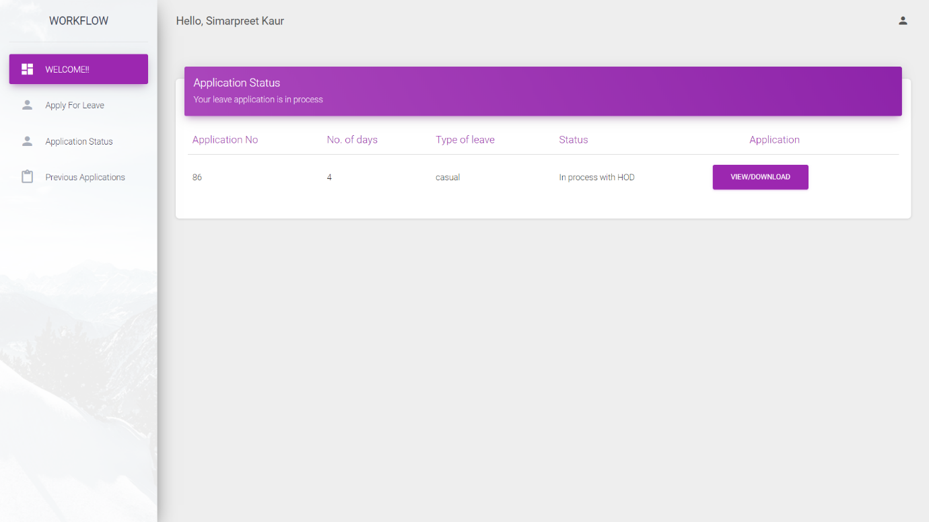

**Fig. 2.3** Status page

This is the status page of employee. Various details are being fetched from the database. Also, Employee can view/download his application on this page by clicking the button on this page.

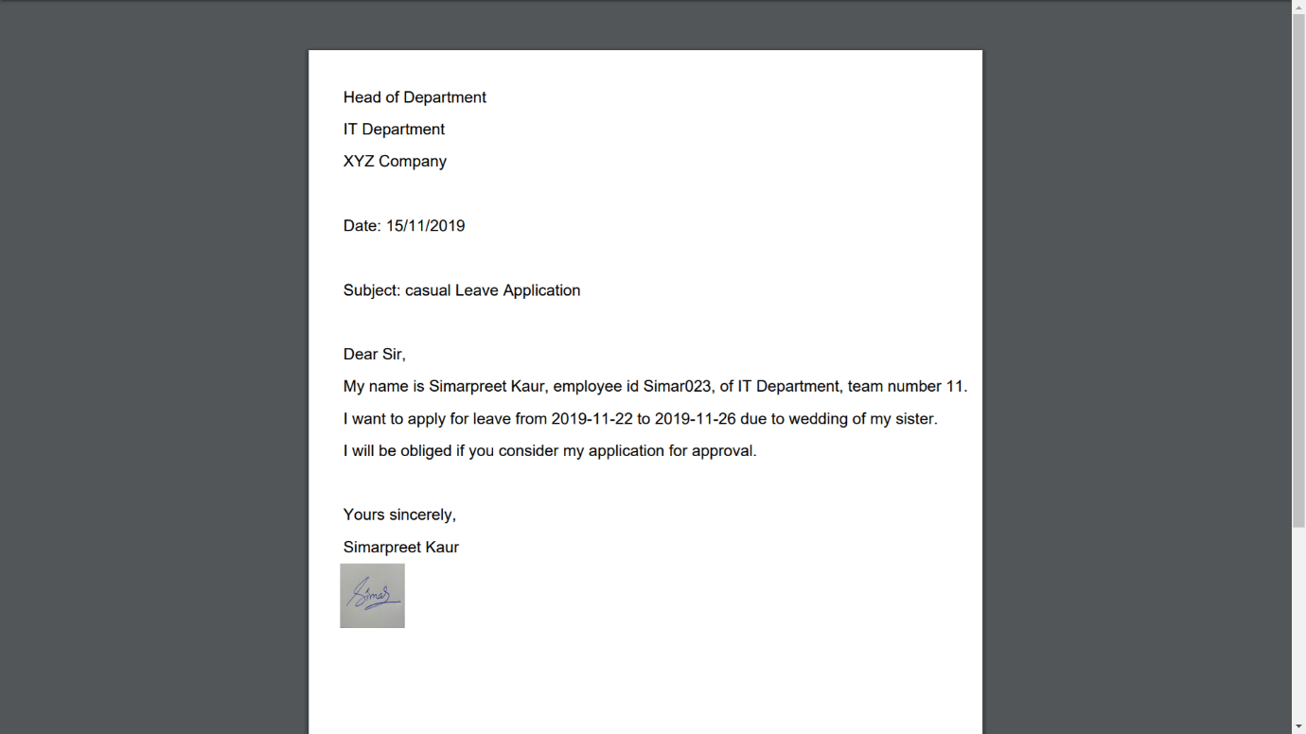

**Fig. 2.4** Application in PDF form

This is the PDF form of the application that is being generated once the employee applies for a leave.

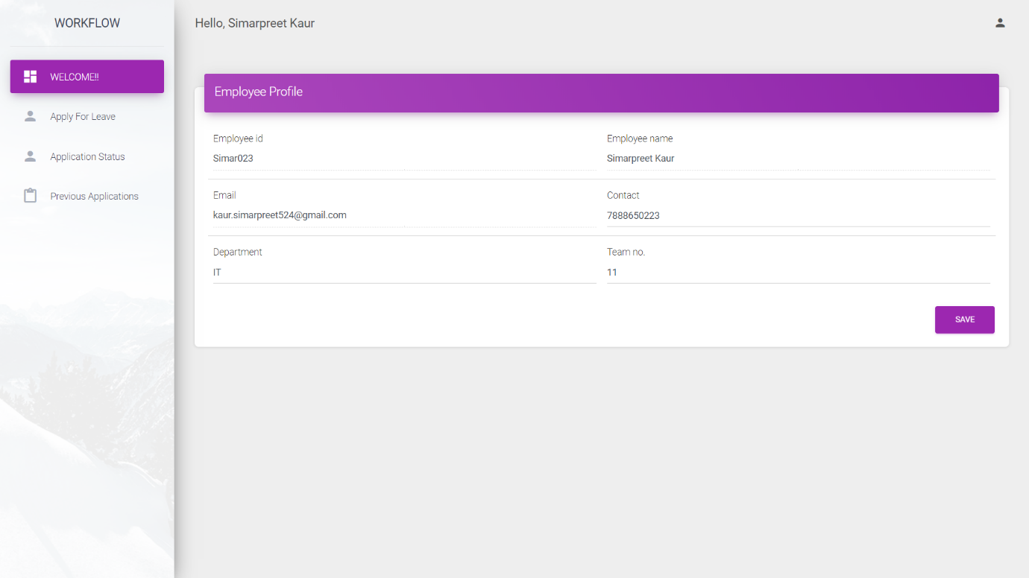

**Fig. 2.5** Profile page

This is the profile page of employee. All the values are fetched from the database, out which only contact, department and team number are editable.

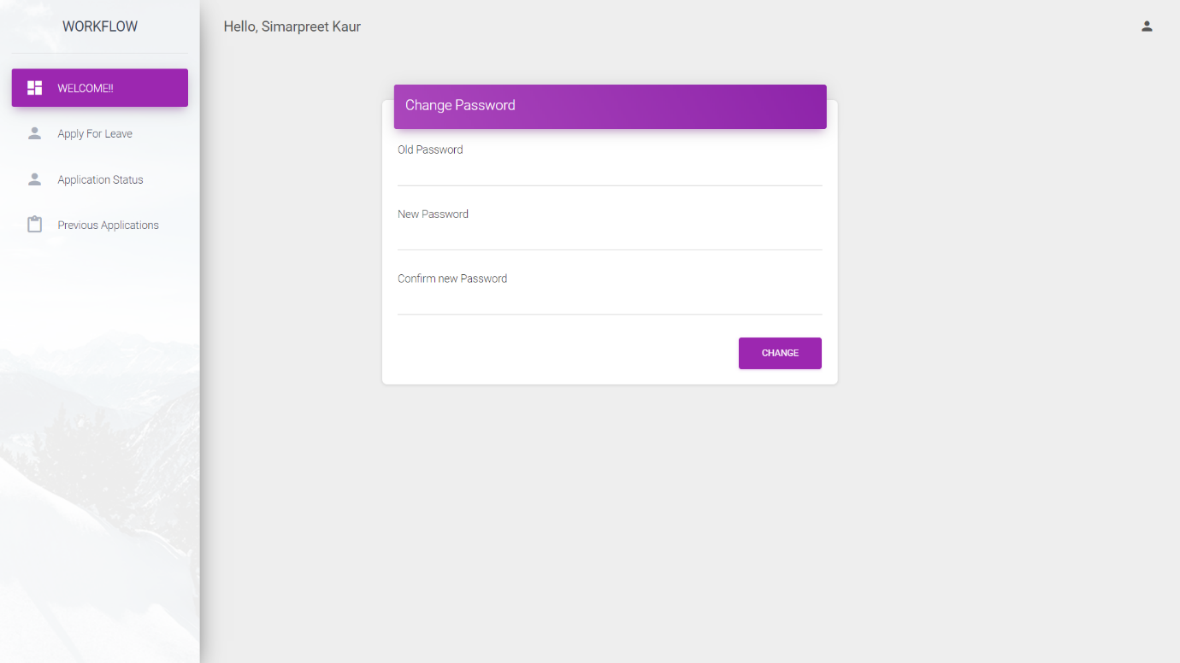

**Fig. 2.6** Change password page

This is the change password page of employee. Employee can anytime change his/her password if he/she wants to.

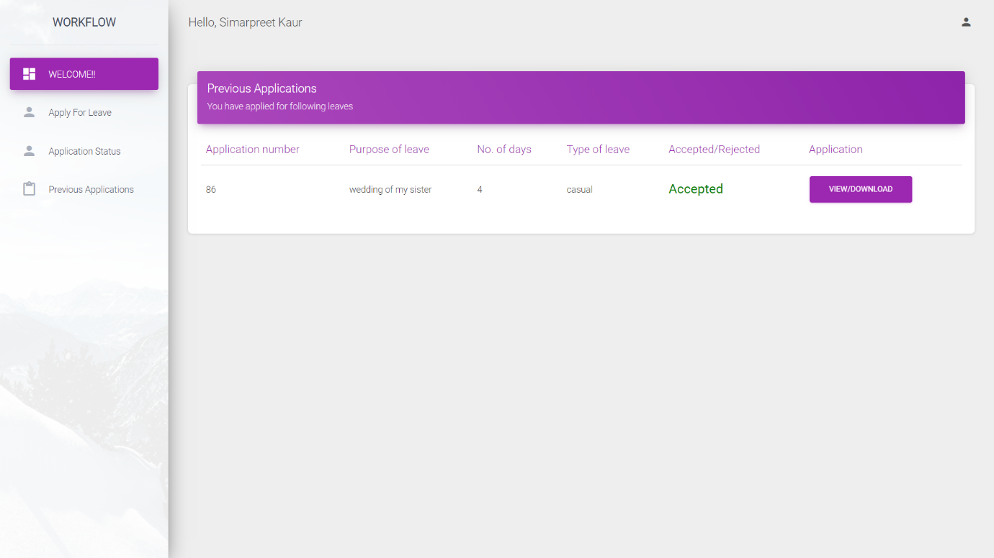

**Fig. 2.7** Previous applications page

This page shows previous applications of employee. Once an application is accepted or rejected, it reflects in this page.

**Motilal Nehru National Institute Of Technology**

**Allahabad**



**CERTIFICATE**

Certified that the work contained in the report titled ‘WORKFLOW – a leave application portal’, by Somya Gupta, Liza Singla, Simarpreet Kaur, Anshu Kiran Kushawaha and Aayushi Jain goes here, has been carried out under my supervision and that this work has not been submitted elsewhere.

NOVEMBER, 2019 Allahabad

Dr. Rajitha B.

Computer Science and Engineering Dept.

M.N.N.I.T, Allahabad

**Motilal Nehru National Institute Of Technology**

**Allahabad**

COMPUTER SCIENCE AND ENGINEERING

DEPARTMENT



**WORKFLOW**

-A Leave Application Portal

**Cordinated by:** Dr. Rajitha B.

**Instructed by:** Ms. Roshini Singh

**Future Scope**

We have a web-application that allows an employee to apply leaves easily which can be used by any company. This system is an efficient alternative to the manual paper-work one has to do while submitting applications and keeping a record of them.

In future more functionalities can be added to this to provide a solution to the problems like budget approval, salary management etc.

**Contents**

* Problem Statement
* E-R Diagram
* Tools, Platforms and Applications used
* Web pages with description
  1. Login and Register
  2. Employee
     1. Leave application page
     2. Apply leave page
     3. Status page
     4. Application in PDF form
     5. Profile page
     6. Change password page
     7. Previous applications page
  3. HOD
  4. HR
* Future Scope
* Biblography