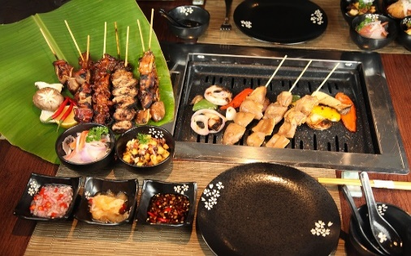R

Limited Seats

Register Now

[WWW.Literacyindia.org](http://WWW.Literacyindia.org) Session Starts From

January 2024

Contact no- 8588853380

Programs Offered

* Robotics/Tinkering
* Computer Hardware
* Mobile Repairing
* Cooking/Hospitality
* Beauty & Wellness
* Stitching & Cutting
* Electrical Troubleshooting
* Two-wheeler Repairing
* Mobile Journalism
* Computer Science
* Call Center/BPO
* Logisties
* Data Digitization
* Natural Farming Market Connect
* Banking

Literacy India Community College (LICC)

