bmi

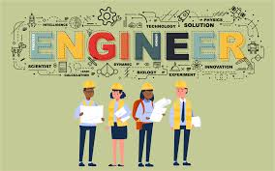

***What Is an Engineer?***

Engineers are *experts in their fields*, creating and innovating constantly. As **practitioners of engineering**, engineering professionals deal with complex systems, structures, devices, and materials to fulfill functional requirements while also considering the limitations imposed by regulation, safety, cost, and more. Because of existing limitations, engineering has sometimes been called *design under constraint.*

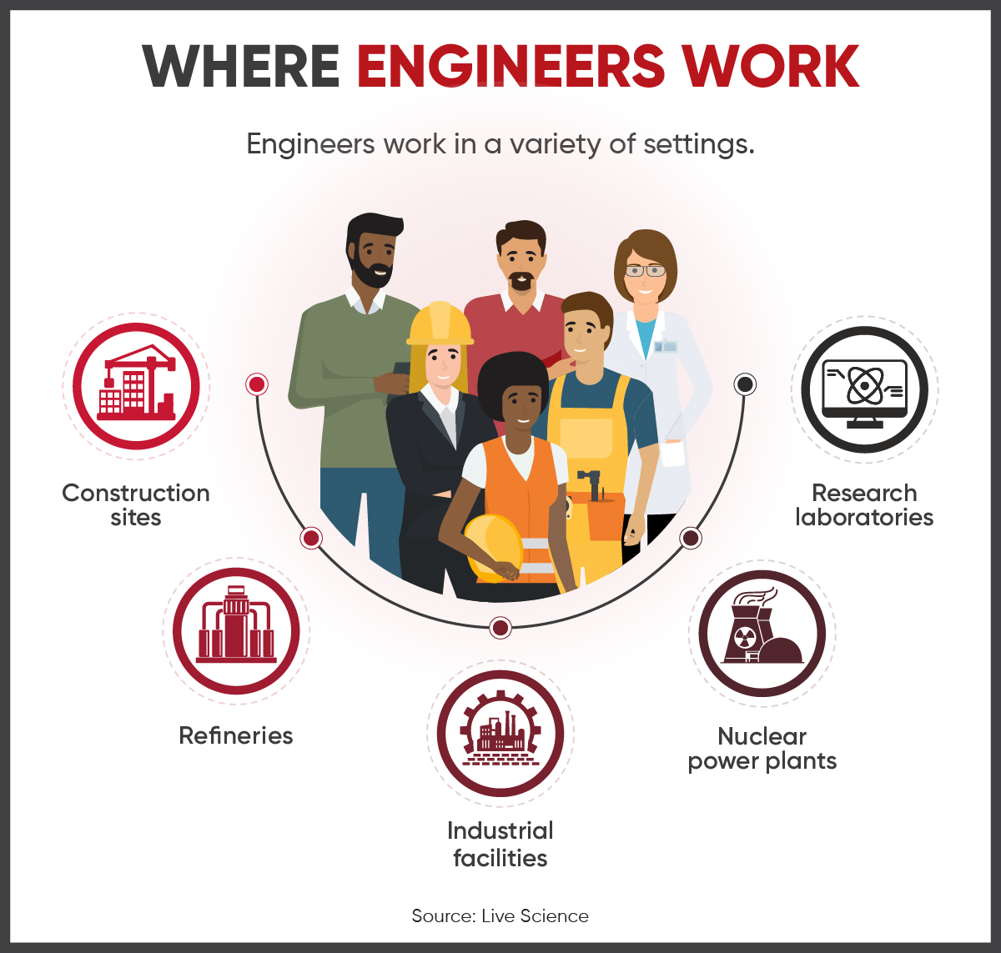

## **What Are the 5 Main Types of Engineering?**

To engineer something means to create, build, or design it. As such, engineering entails any scientific or technological branch that deals with designing and developing machines, engines, and other products or structures.

Some types of engineering are subfields of other kinds of engineering. For example, [environmental engineering](https://www.bestcolleges.com/engineering/bachelors/environmental-engineering/) is often described as a subset of civil engineering. Some branches, like industrial engineering, are considered interdisciplinary because they combine aspects from multiple disciplines.

Other types of engineering may not fit neatly into any one category. These include nuclear engineering, biological engineering, and rehabilitation engineering.

Most sources divide engineering into the following five branches.

### **1*. Civil Engineering***5 Things to Know about a Career in Civil Engineering﻿ -

Often thought to be the [oldest engineering](https://www.livescience.com/47612-civil-engineering.html) discipline, [civil engineering](https://www.bestcolleges.com/careers/science-and-engineering/civil-engineering/) focuses on constructing, designing, and maintaining physical structures used by the public, such as dams, bridges, tunnels, roads, airports, subway systems, and water supply systems. Many of today's engineers specialize in building eco-friendly architecture to [combat climate change](https://www.bestcolleges.com/blog/climate-change-jobs/).

Civil engineers work in many industries, like transportation, urban planning, and space. Famous civil engineering projects include the Great Wall of China, the Panama Canal, the Golden Gate Bridge, and the Eiffel Tower.

### ***Civil Engineering Subfields***

### ***2. Chemical Engineering***What Are The Skills Needed To Be a Chemical Engineer? - C V Raman Global UniversityIn the broadest sense of the term, [chemical engineering](https://www.bestcolleges.com/blog/talk-with-a-chemistry-student/) deals with chemicals. These engineers design and manufacture materials and products using scientific principles from chemistry, biology, math, and physics. They may also come up with innovative processes to use and transform energy.

Chemical engineers can work with microorganisms, food, pharmaceuticals, and fuels. Often performing experiments and other tasks in labs, many also use computers to design experiments.

### ***Chemical Engineering Subfields***

### B.Tech. Mechanical Engineering ...***3. Mechanical Engineering***

[Mechanical engineering](https://www.bestcolleges.com/engineering/what-can-you-do-mechanical-engineering-degree/) entails the development and production of mechanical systems and other devices in motion. These professionals use problem-solving, critical thinking, and the principles of math and physics to transform concepts into functional products, such as ships, firearms, household appliances, turbines, and vehicles.

Today's mechanical engineers rely on many of the same core components that have been used for thousands of years, including wheels, springs, screws, and axles.

### ***Mechanical Engineering Subfields***

### ***4. Electrical Engineering***Why study electrical engineering at Sydney? - The University of SydneyA [newer branch of engineering](https://www.livescience.com/47571-electrical-engineering.html) introduced in the 19th century, [electrical engineering](https://www.bestcolleges.com/careers/science-and-engineering/electrical-engineering/) focuses on electrical equipment and electronics. These engineers design, test, and maintain devices that use or produce electricity, from small objects like microchips and computers to large-scale projects like satellites and power station generators.

Most electrical engineers complete tasks in an office or lab, though on-site work is also common.

### ***Electrical Engineering Subfields***

### ***5. Industrial Engineering***Study Industrial Engineering Abroad | IDP Education

The final engineering branch is [industrial engineering](https://www.bestcolleges.com/careers/science-and-engineering/industrial-engineering/), which combines engineering with general business practices to reduce costs, improve quality, and increase efficiency. These specialists often find employment in industries related to service, entertainment, and healthcare.

As an industrial engineer, you must [work well with people](https://www.bestcolleges.com/blog/best-jobs-for-extroverts/). Industrial engineers' primary tasks may include designing facilities and information systems, managing inventories, overseeing personnel assignments, and ensuring workplace safety.