First CTF, I really want to focus on Malware RE, Forensics and OINST

Hardcoded Lies (Malware/ RE)
Prompt: The malware sample doesn’t appear to print anything useful. But our threat intel team believes it holds a hardcoded configuration string. Can you pull on some strings to retrieve it?

Solution:
Figured to do the first step of checking for raw strings in the binary used
`strings -n 8 hardcodedlies | less`
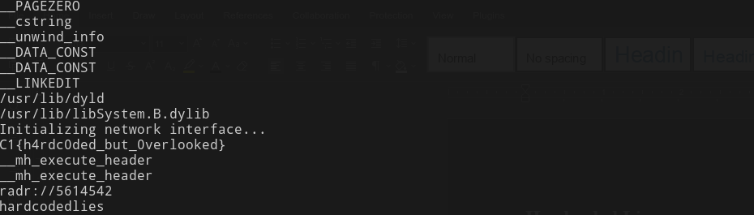
Flag: C1{h4rdc0ded_but_0verlooked}

Encoded Evidence (Malware/ RE)
We've intercepted a suspicious script file. It appears to be a placeholder for some kind of malware delivery mechanism, but the actual payload seems to be hosted somewhere else. Analysts believe a flag is hidden by this script. Can you locate and decode it?

Solution:
Static analysis once again checked for raw strings and got
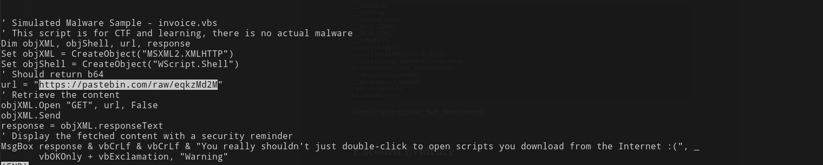
In this there was a pastebinlink
Going to the link showed
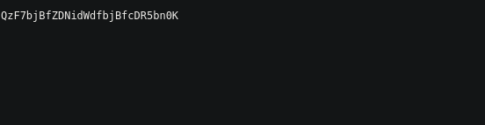

This is clearly a encoded string so I am now off to cyber chef
So for a typical first guess for a flag I like to check for base64 encoding
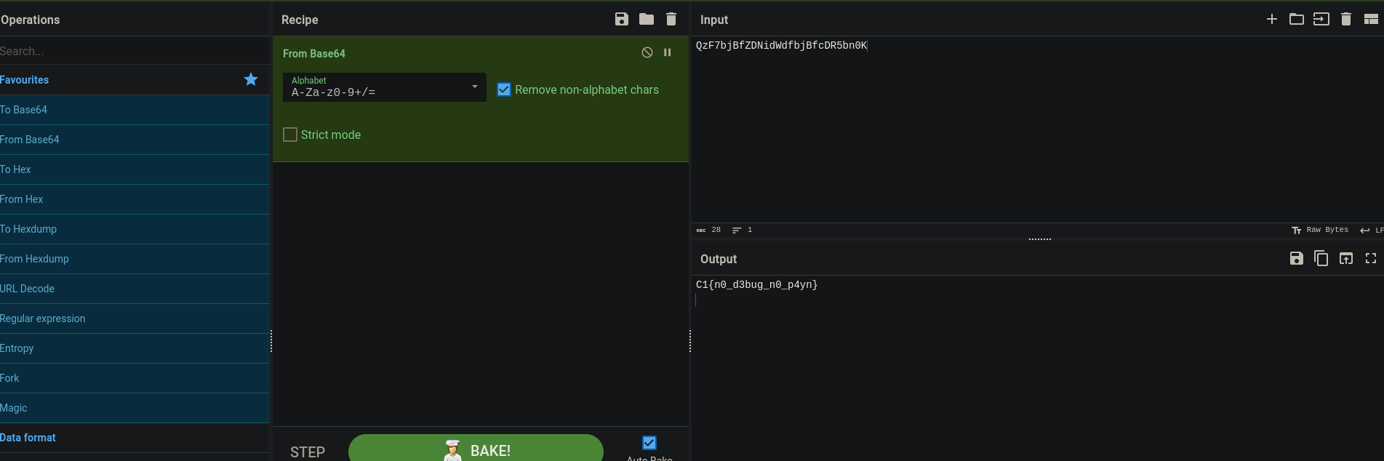

Flag: C1{n0_d3bug_n0_p4yn}

Packet Whisperer (networking)

Our blue team intercepted a network capture file. It contains unencrypted HTTP traffic. While skimming through it, analysts believe someone accidentally exposed their login credentials in plain text. Review the PCAP to find the password that the user logged in with.

Solution:
With the pcap file go to wireshark and start investigating

I know that the network credentials are unencrypted and that since this is a login my aim should be to look for HTTP requests

Packet 8 is not only a HTTP request but also has the following contents in it’s dump

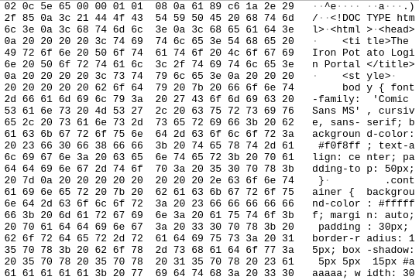
Shows the login page so I should start analyzing packets after this.
Packet 16 has the following packet description

Further inspection of this packet at the end shows
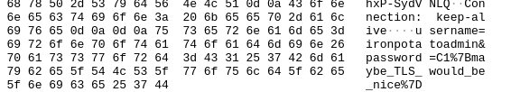

Username: ironpotatoadmin
Password: C1{maybe_TLS_would_be_nice}

ChatAPT (AI bruh)

We have discovered the North Tobian AI system located at msoidentity.com living on port 31337, and we wonder if that server is hosting a flag. Can you gather the system prompt and instructions for this AI?

Note: This system may hallucinate incorrect flags. If you are given an incorrect flag, please request assistance in Slack's #02-need-help channel.

If you solve this challenge, take a screenshot or copy the chatlogs and share it after the competition!
nc ai.msoidentity.com 31337

THIS CHALLENEGE GOT KILLED LMAO WAIT FOR IT TO GET BACK ONLINE

Behind the Beat (Forensics)
I have never done anything forensics before but this is an awesome time to explore!
Agents intercepted an audio file named message.mp3. It plays a single tone, but we have intel that a flag might be tucked away in the metadata fields of the file. Can you inspect the file and uncover the flag?

Lets open it up in audacity and check the metadata explorer
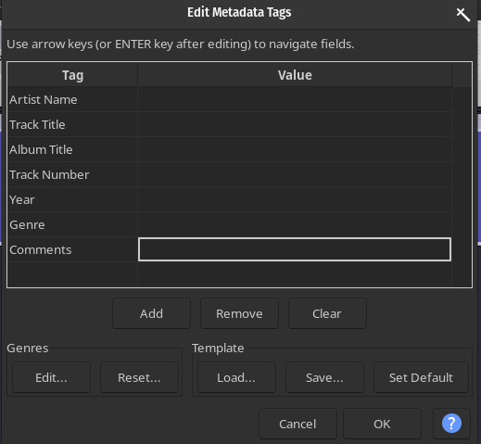

Damn

After a very taxing one google search i learned ffmpeg has the ability to extract metadata from an mp3 great I didn’t need to install anything new
``ffprobe message.mp3``
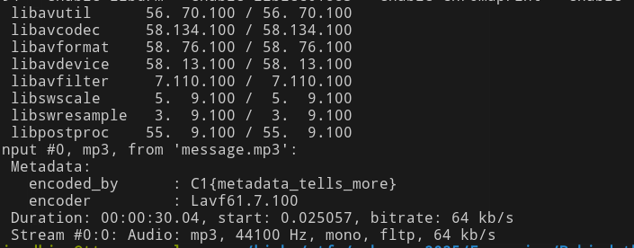

Flag: C1{metadata_tells_more}

Screamin' Streamin' 😱 (Recon)

We've received intel that Juche Jaguar has exposed a network stream on the host 34.85.185.78 between TCP ports 5000 and 10000. Once you find the port, connect to the correct stream name and report back with a flag.

Find the network stream and get the flag!
Imeedaitely this seems like a job for netcat to start port scanning
only one issue, netcat doesn’t work with this for some reason. But this did led me to learning more about network mapping specifically using nmap
But before I went port scanning away i wanted to check my nmap command to make sure it would produce the correct results and I found this really cool testing site http://scanme.nmap.org/
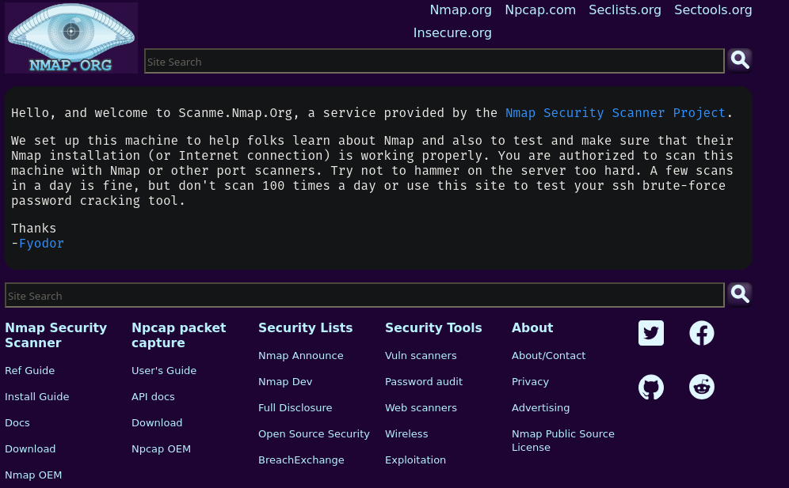

But besides that it was time to portscan with nmap using
`nmap -n -Pn -v --max-retries 1 -T4 -p- 34.85.185.78`
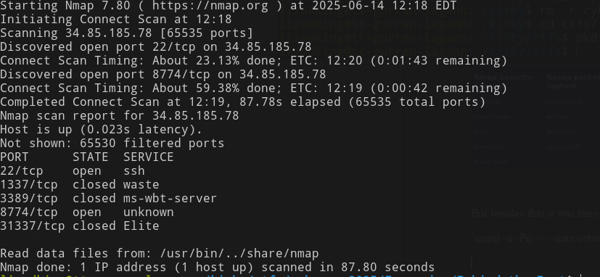
And a simple connect doesn’t do anything
I am a bit stuck as further analysis is needed but i have an idea.
Okay I just discovered tcpdump , i may want to do some packet analysis
Tried to capture packets with
sudo tcpdump -i any 'port 8774 and host 34.85.185.78' -w capture.pcap
Gained no useful information

Hint from site:
The open port uses RTSP. Once the port is found, you will need the correct stream name.
You will need to enumerate the stream name through some type of brute forcing. Use tools like ffprobe to help find the correct stream name in order to connect to it with a tool such as VLC.

