JAMES CARL E. BITUIN BSCPE_2A
Laboratory Activity No. 1
Laboratory Activity No. 1:
Topic: Introduction to Software Design, History, and Overview
Title: Setting Up the Development Environment for Django Project

Introduction: This activity will guide you through the process of setting up your development environment to start building the Library Management System (LMS) in Django. The process involves installing necessary software, setting up Python and Django, and verifying the installation.

Objectives:
- Install Python and Django on your system.
- Create a virtual environment to manage dependencies.
- Verify the installation by running a simple Django project.

Theory and Detailed Discussion: To develop the Library Management System, we will use the Django framework. Django is a high-level Python web framework that allows developers to create robust web applications quickly and efficiently. Before we can start developing, we need to set up the development environment.

Program/Code: The code here is focused on setting up the environment. The following commands should be run in the terminal:

python -m venv library_env
source library_env/bin/activate # or .\library_env\Scripts\activate on Windows
pip install django
django-admin startproject library_system
cd library_system
python manage.py runserver

Results: (print screen the result and provide the github link of your work)
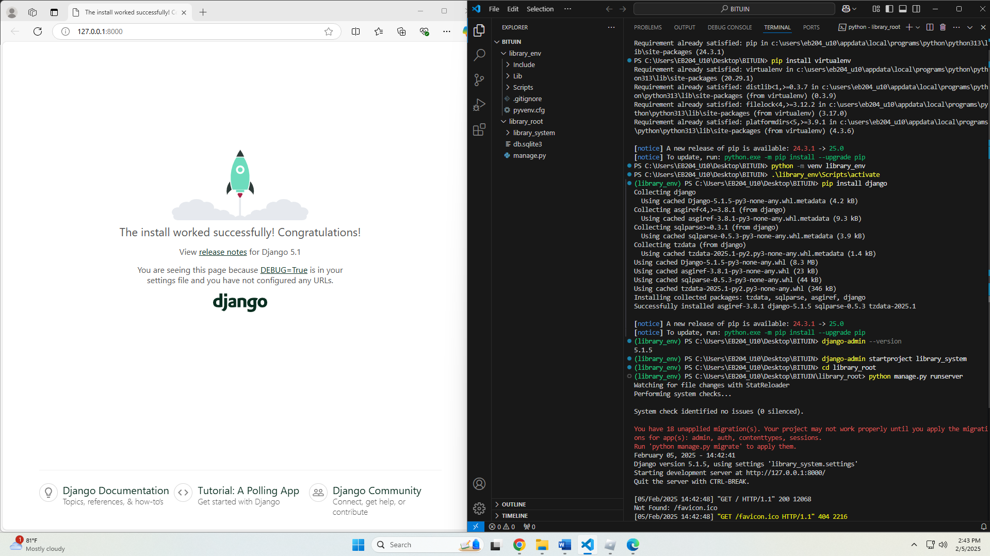

Follow-Up Questions:
- What is the purpose of using ForeignKey in Django models?
Answer:
A virtual environment isolates project dependencies, preventing conflicts between different projects. It ensures consistency across development environments and allows you to manage specific versions of libraries for each project without affecting the global Python setup.
- How does Django’s ORM simplify database interaction?
Answer:
- Batteries Included: Comes with built-in features like an ORM, admin panel, authentication, and security tools.
- Rapid Development: Allows quick setup and development of web apps.
- Scalability: Suitable for large, high-traffic applications.
- Security: Includes protections against common vulnerabilities (e.g., SQL injection, CSRF).
- Admin Interface: Provides a customizable admin dashboard out of the box.
- Strong Community: Large community and excellent documentation.
- ORM: Simplifies database interaction using Python objects.
- Maturity: Proven, reliable, and widely used in production.

Laboratory Activity No. 2:
Laboratory Activity No. 2:
Topic belongs to: Software Design and Database Systems
Title: Designing the Database Schema for the Library Management System

Introduction: In this activity, you will design the database schema for the Library Management System. The database will include tables for books, authors, users, and borrowing records. You will also learn how to use Django’s ORM (Object-Relational Mapping) to define the models.

Objectives:
- Design the database schema for the Library Management System.
- Create Django models to represent the schema.
- Use Django’s ORM to interact with the database.

Theory and Detailed Discussion: Django uses an ORM (Object-Relational Mapping) system to map Python objects to database tables. By defining models in Python code, Django automatically creates the corresponding database tables. We will start by designing the database schema with the necessary relationships between entities like books, authors, and users.

Django Program or Code: Write down the summary of the code for models that has been provided in this activity.
- python manage.py startapp books
- python manage.py startapp users
- from django.db import models

class Author(models.Model):
name = models.CharField(max_length=100)
birth_date = models.DateField()

def __str__(self):
return self.name

class Book(models.Model):
title = models.CharField(max_length=200)
author = models.ForeignKey(Author, on_delete=models.CASCADE)
isbn = models.CharField(max_length=13)
publish_date = models.DateField()

def __str__(self):
return self.title
- from django.db import models
from books.models import Book

class User(models.Model):
username = models.CharField(max_length=100)
email = models.EmailField()

def __str__(self):
return self.username

class BorrowRecord(models.Model):
user = models.ForeignKey(User, on_delete=models.CASCADE)
book = models.ForeignKey(Book, on_delete=models.CASCADE)
borrow_date = models.DateField()
return_date = models.DateField(null=True, blank=True)
- python manage.py makemigrations
- python manage.py migrate
- python manage.py createsuperuser
- from django.contrib import admin
from .models import Author, Book

admin.site.register(Author)
admin.site.register(Book)
- from django.contrib import admin
from .models import User, BorrowRecord

admin.site.register(User)
admin.site.register(BorrowRecord)

Results: By the end of this activity, you will have successfully defined the database schema using Django models, created the corresponding database tables, and registered the models in the admin panel. (print screen the result and provide the github link of your work)
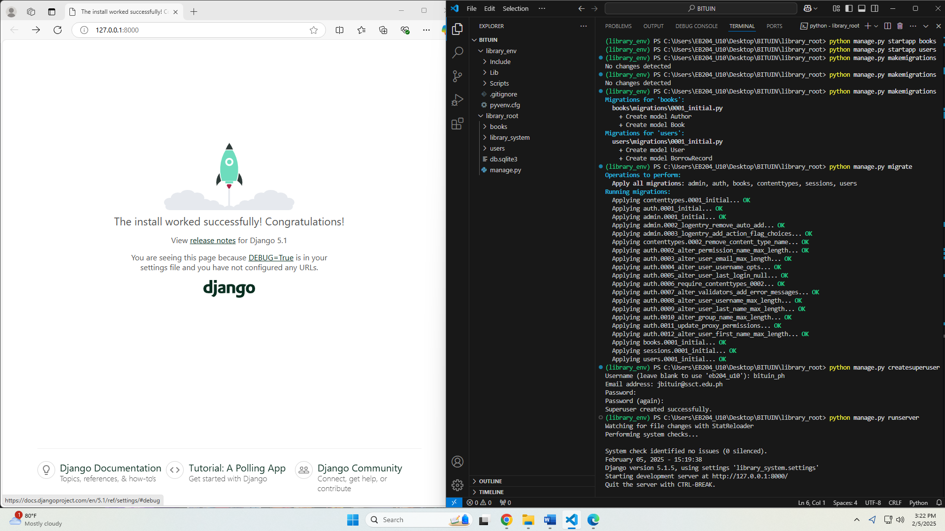

Follow-Up Questions:

Follow-Up Questions:
- What is the purpose of using ForeignKey in Django models?
Answer:
A ForeignKey in Django models is used to create a one-to-many relationship between two models. It allows one model to reference another, establishing a link between the two. For example, if you have a Book model and an Author model, each book can have one author, but an author can have many books. The ForeignKey field is placed in the Book model, linking each book to a specific author.

- How does Django’s ORM simplify database interaction?
Answer:
Django’s ORM (Object-Relational Mapping) allows developers to interact with the database using Python code instead of writing raw SQL queries. It translates Python objects into database tables and vice versa, making it easier to:
- Query: Retrieve data using Python objects (Book.objects.all() instead of SELECT * FROM books).
- Create, Update, Delete: Easily create and modify records (e.g., book.save() instead of INSERT INTO books).
- Maintain Relationships: Manage relationships between models (like ForeignKey) with simple attributes rather than complex SQL joins.

