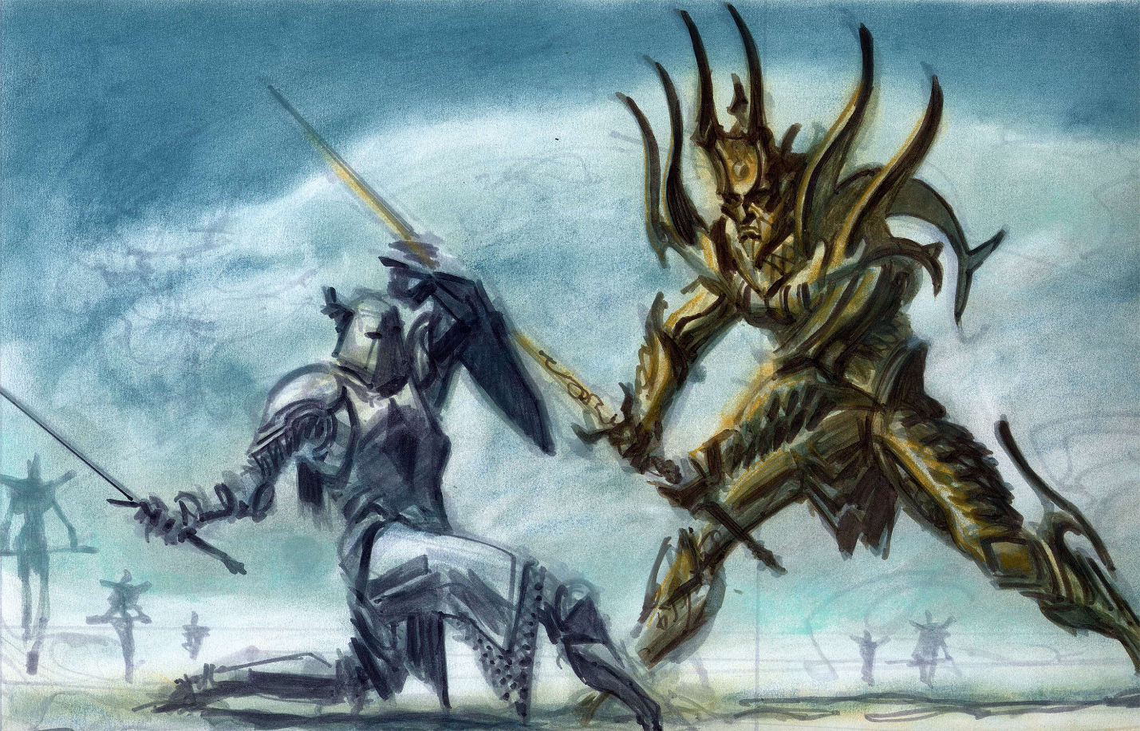

Whitestrake

Design Document

By Stephen Catledge

Ver. 1: 1/28/25

**Overview:**

“Whitestrake” is a First Person Action game based on the story of Pelinal Whitestrake from the world of Elder scrolls. The player will take the role of Pelinal during his final battle against Umaril the Unfeathered. Pelinal is a character from the 1st age of the Elder Scrolls timeline. He was a warrior with divine powers who was sent to assist Queen Alessia and her slave rebellion against the Elven Ayleid Kings.

The gameplay will be based on the boomer shooter genre originated from games such as Doom and Quake. However, instead of a focus on guns and ranged combat it will focus on melee combat. The melee combat will take inspiration from the main Elder Scrolls games and more in depth Melee combat like Chivalry 2.

The player will have access to a few different weapon options such as a Sword, Mace and Shield. They will face enemies such as Ayleids, Deadra and Umaril himself.

**Scope:**

The game will be comprised of one or two levels located in the Ayleid Imperial City. Levels will have multiple sections divided between combat and puzzles to find the way forward. Areas will be 3D environments with some level of verticality while the player, enemies, and pickups will be 2D sprites.

There will be 5 different enemies to face:

Ayleid Soldiers: Two different types of common Ayleid Soldier. One will be the basic generic sword and shield soldier and the other will be a more ranged opponent.

Ayleid Leader: A bigger type of enemy that will be a heavier version of the Ayleid soldier. They will hit harder and take more to kill. Possible access to magic.

Auroran: A daedra of the Daedric Prince Meridia who the Ayleids draw some of their power from. The most dangerous non-boss enemy the player will face. They will have both ranged and melee attacks with access to magic.

Umaril, The Unfeathered: The final boss of the game. Umaril is an Ayleid who has become the champion of Meridia. He is the biggest and most powerful enemy the player will face and has access to ranged magic attacks and hard melee hits.

The game will also include normal features such as menus. It will include either a simple cutscene or a text crawl as the intro to the game.

**Gameplay:**

**Menus:**

**Main Menu:** The main menu will have three options: New Game, Load Game, Quit Game

**Pause Menu:** The pause menu will have 3 options: Save Game, Load Game, Quit to Menu, Quit to Desktop

**Start:**

When New Game is selected, the player will be loaded into the start of the game while a cutscene(text crawl or cutscene) plays, introducing the player to the story.

The player will load in with full health, half shield, and access to sword and shield. The Mace will be accessed later when a new enemy is introduced that the mace will be better to use against.

**Gameplay Loop:**

The player will spawn into the level and move through various sections of the level. Throughout the level the player will encounter different types of enemies in various group sizes. The objective is to kill these enemies to progress to the next area. The player will also need to solve puzzles in order to progress, fighting enemies as they do. The end goal is to reach the end of the level and progress to the next level/beat the game.