**Contents**

Project Proposal 2

Goals and Objectives 2

Scope and Deliverables 2

Project Scope 2

Project Deliverables 2

Project Specification and Target Audience 2

Project Schedule and milestones 3

Resources Required 3

Functional and Non-Functional Requirement 3

Functional Requirements 3

Non-Functional Requirements 3

Project Assumptions 3

Detailed Design 4

Home Page 4

Login Page 4

Admin Companies Page 4

Admin Registration Page 5

Admin Home Page 5

Admin Stock Buyer Page 6

Buyer Signup Page 6

Companies Page Buyer View 7

Project Testing 8

Testing Scope 8

Testing Environment 8

System Usability Testing 8

Testing 8

User Manual 10

Introduction 10

User Activities 10

Admin Activities 10

# Project Proposal

## Goals and Objectives

The main aim of this project is to implement an online Asp.net application named “Stock Register”. Using this application, one can buy stock from a trusted issuer. In this application there are stock admin and buyer. Stock admin can edit, delete and view companies. Edit, delete, and check detail for stock buyers. Edit, delete, and check details for stock payment. Buyers can view companies and buy stocks. Moreover, admin can register new admins and new buyers can signup for free.

## Scope and Deliverables

### Project Scope

This is a 4-week project i.e 20 days altogether. The scope of the project is as follows:

* Implement Admin functions like edit, delete view company.
* To implement the functionalities for stock buyers i.e. Edit, delete, and check detail.
* To implement the functionalities for stock payment i.e edit, delete, and check details of the stock payment.
* To implement the functionalities of the stock buyer such as buying stock.
* Testing of all functionalities.

### Project Deliverables

To achieve the goal of our project, we have set the following deliverables:

|  |  |
| --- | --- |
| **Deliverables** | **Explanation** |
| Planning of the project | This includes the planning and specification of the project. |
| Coding and Implementation of the project | This will show the coding and implementation part of the project. |
| Testing and documentation of the project | This will demonstrate how the application will be used and also the test details of the web app. |
| Final written report of the project | This will provide a detailed report along with all details of goals, objectives, timelines, etc. |

## Project Specification and Target Audience

* Secure login and registration by admin and user.
* View, edit, and delete companies.
* Edit, delete and check details of stock buyers
* Edit, delete, and check details of stock payments.
* Buyers can view company details and can buy the stock
* New Buyers can signup
* Admin can register new admins.
* Edit, delete of readers by admin.

The target audience for this project is the people who are keen to buy stocks for a trusted issuers.

# Project Schedule and milestones

|  |  |  |
| --- | --- | --- |
| Weeks | Milestone | Deliverable(s) Completed |
| 1-2 | Project planning | * Kickoff Meeting * Project Proposal * Project Definition Document * Analysis Report |
| 2-3 | Iteration 1 | * Database Design * Front End Design |
| 3-4 | Iteration 2 | * Back End – Phase 1 * Back End – Phase 2 * Final Product |
| 3-4 | Iteration 3 | * Testing * Report and final Documentation |

# Resources Required

* Windows OS 10, 4 GB RAM, Minimum i5 processor
* ASP.Net MVC and Identity Framework.
* Microsoft Word Processor

# Functional and Non-Functional Requirement

## **Functional Requirements**

* The system should allow new buyers to signup.
* The system should allow the buyer to view all companies.
* The system should allow the buyers to buy stock.
* The system should allow the admin to edit, delete, and view company details.
* The system should allow admin to edit, delete and check details of stock buyers.
* The system should all admin to edit, delete and check details of the stock payments.

## **Non-Functional Requirements**

* Device compatibility.
* Browser Compatibility
* Fast and easy to use.
* Personal details of the users should be secured.

## **Project Assumptions**

During the plan I made the following assumption for the application:

* At least one Buyer has registered at the time of the implementation.
* Admin has already registered and can register another person as admin later.
* No registration fee.

# Detailed Design

## Home Page

This is the main page of the web application, which will be common for all admin and buyers. This page contains home, companies, signup as a buyer, log in, and register stock admin menu. Also the header image contains a view stocks button.



## Login Page

Login page allow register user and admin to login into the web app. This page is common among buyer and admin

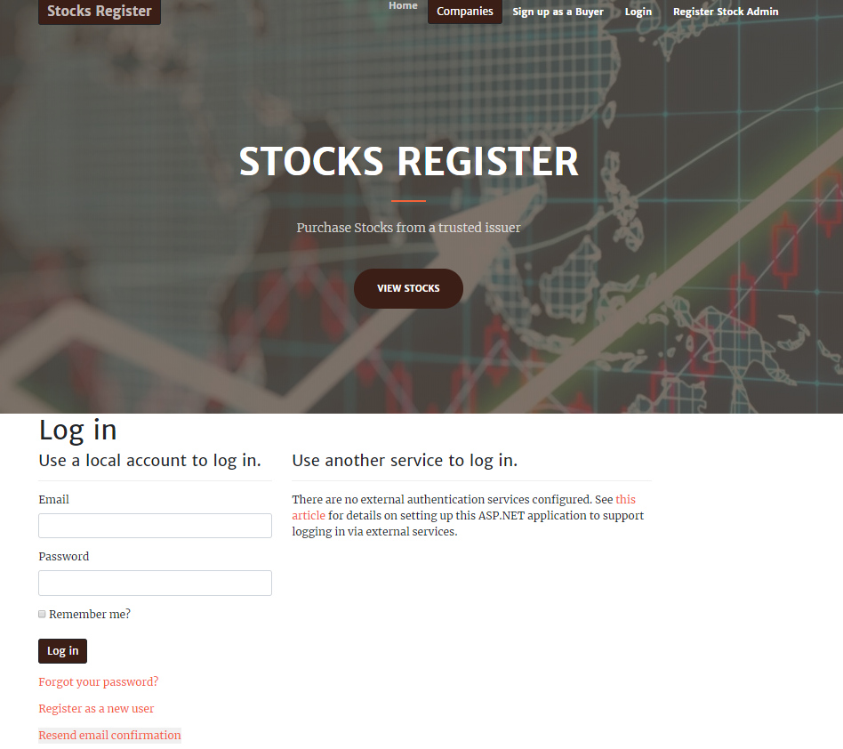

## Admin Companies Page

This page will be used to show the available companies in the online stock register app in the admin view. Admin can edit, delete, and view the details of the existing companies.

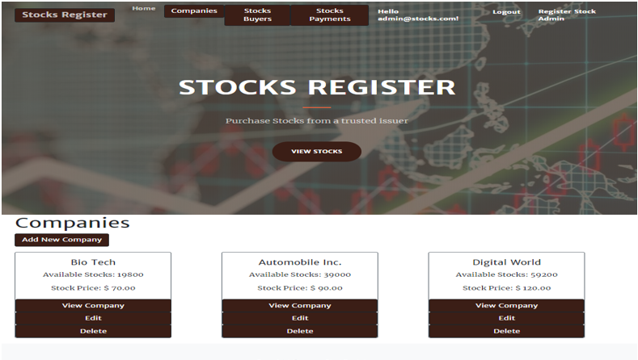

## Admin Registration Page

With the help of this page admin can register new admins.

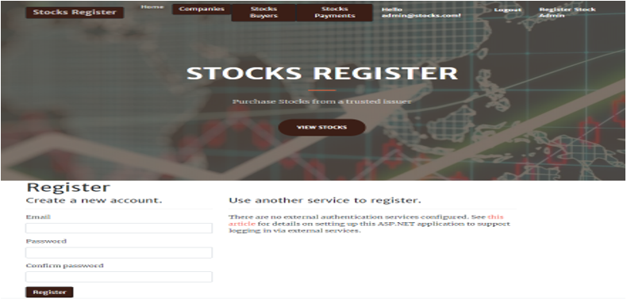

## Admin Home Page

This is the admin home page.



## Admin Stock Buyer Page

In this page admin can edit, delete, and check details of the stock buyers.

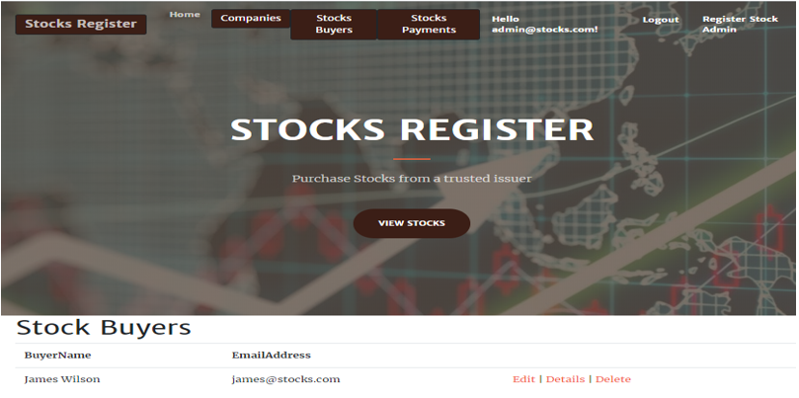

## Buyer Signup Page

With the help of this page new buyers can signup for the app for free.

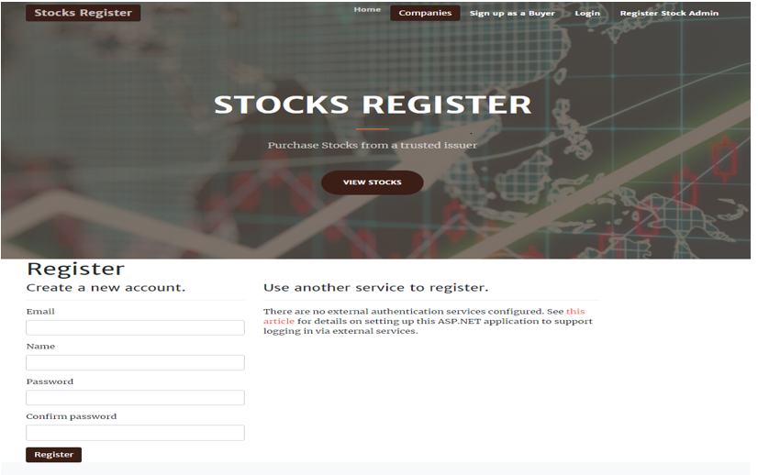

## Companies Page Buyer View

With the help of this page, the buyer can view companies and check the details. Once click on view companies, buyers can navigate to buy the stock page and can buy the stock of their choice.

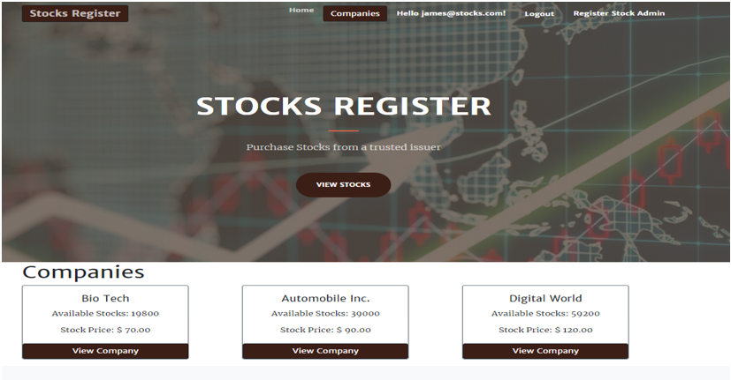

# Project Testing

## Testing Scope

As it has been mentioned before due to the limited period, we prioritized system usability testing only

The testing process will include, Accessibility, Compatibility, Functionality, Content, Navigation, Performance, and Usability.

## Testing Environment

All testing will be conducted using stand-alone Windows 10 with using Chrome desktop

browser. Installed memory (RAM) 8.00 GB. System type: 64-bit Operating System, x64-based processor. And Windows 10 and Chrome Brower.

## 

## System Usability Testing

### Testing

**Tester 1**

|  |  |  |  |  |  |  |
| --- | --- | --- | --- | --- | --- | --- |
| **Tester – 1** | | **Answer Scale** | | | | |
| **No.** | **Question** | **Strongly Disagree (1)** | **Disagree (2)** | **Normal (3)** | **Agree (4)** | **Strongly Agree (5)** |
| 1 | I think that I would like to use this system frequently |  |  |  |  |  |
| 2 | I found the system unnecessarily complex |  |  |  |  |  |
| 3 | I thought the system was easy to use |  |  |  |  |  |
| 4 | I think that I would need the support of a technical person to be able to use this system |  |  |  |  |  |
| 5 | I found the various functions in this system were well-integrated |  |  |  |  |  |
| 6 | I thought there was too much inconsistency in this system |  |  |  |  |  |
| 7 | I would imagine that most people would learn to use this system very quickly |  |  |  |  |  |
| 8 | I found the system very cumbersome to use |  |  |  |  |  |
| 9 | I felt very confident using the system |  |  |  |  |  |
| 10 | I needed to learn a lot of things before I could get going with this system |  |  |  |  |  |

**Tester 2**

|  |  |  |  |  |  |  |
| --- | --- | --- | --- | --- | --- | --- |
| **Tester –2** | | **Answer Scale** | | | | |
| **No.** | **Question** | **Strongly Disagree (1)** | **Disagree (2)** | **Normal (3)** | **Agree (4)** | **Strongly Agree (5)** |
| 1 | I think that I would like to use this system frequently |  |  |  |  |  |
| 2 | I found the system unnecessarily complex |  |  |  |  |  |
| 3 | I thought the system was easy to use |  |  |  |  |  |
| 4 | I think that I would need the support of a technical person to be able to use this system |  |  |  |  |  |
| 5 | I found the various functions in this system were well-integrated |  |  |  |  |  |
| 6 | I thought there was too much inconsistency in this system |  |  |  |  |  |
| 7 | I would imagine that most people would learn to use this system very quickly |  |  |  |  |  |
| 8 | I found the system very cumbersome to use |  |  |  |  |  |
| 9 | I felt very confident using the system |  |  |  |  |  |
| 10 | I needed to learn a lot of things before I could get going with this system |  |  |  |  |  |

# User Manual

## Introduction

“Stock Register” is an online web application. Using this application, one can buy stock from a trusted issuer. In this application there are stock admin and buyer. Stock admin can edit, delete and view companies. Edit, delete, and check detail for stock buyers. Edit, delete, and check details for stock payment. Buyers can view companies and buy stocks. Moreover, admin can register new admins and new buyers can signup for free.

## User Activities

* Registration
* Login/Logout
* View Companies
* Buy Stock

## Admin Activities

* Login/Logout
* Delete/Edit and check details of companies
* Edit, delete, and check details of the stock buyers.
* Edit, delete, and check details for stock payments.