EHSC P8321: Lab & Homework #1

Lizbeth Gomez (UNI: LG2982)

Due: April 6, 2020 by 3:59 pm

## PART I. Setting up RStudio & Reading Datasets in

### The first task we want to do after creating up our R Markdown document is to install and load any necessary packages.

### Create new dataframes in RStudio with the COVID-19 time series datasets.

confirmed = read_csv("./data/time_series_covid19_confirmed_global.csv")

## Parsed with column specification:  
## cols(  
## .default = col_double(),  
## `Province/State` = col_character(),  
## `Country/Region` = col_character()  
## )

## See spec(...) for full column specifications.

deaths = read_csv("./data/time_series_covid19_deaths_global.csv")

## Parsed with column specification:  
## cols(  
## .default = col_double(),  
## `Province/State` = col_character(),  
## `Country/Region` = col_character()  
## )  
## See spec(...) for full column specifications.

recovered = read_csv("./data/time_series_covid19_recovered_global.csv")

## Parsed with column specification:  
## cols(  
## .default = col_double(),  
## `Province/State` = col_character(),  
## `Country/Region` = col_character()  
## )  
## See spec(...) for full column specifications.

## PART II. Descriptive Statistics

### What if we wanted to know the total number of confirmed cases, deaths, and those recovered from COVID-19 of a country? Let’s generate some summary statistics for Iran.

# Let's do some data tidying. First we want to convert the dataset from wide-to-long format using the pivot_longer function. We can use the janitor::clean_names() function to change the variable names into RStudio-friendly names. Next, we want to select only the variables of interest. Last, we can filter the dataset for cases in Iran only.  
iran_confirmed = confirmed %>%  
 pivot_longer(  
 "1/22/20":"3/7/20",  
 names_to = "date",  
 values_to = "cases") %>%  
 janitor::clean_names() %>%   
 select(country_region, lat, long, date, cases) %>%   
 filter (country_region == "Iran")   
iran_totalcases = sum(iran_confirmed$cases)  
  
# We can follow the same tidying method for the deaths and recovered datasets.  
iran_deaths = deaths %>%  
 pivot_longer(  
 "1/22/20":"3/7/20",  
 names_to = "date",  
 values_to = "deaths") %>%  
 janitor::clean_names() %>%   
 select(country_region, lat, long, date, deaths) %>%   
 filter (country_region == "Iran")  
iran_totaldeaths = sum(iran_deaths$deaths)  
  
iran_recovered = recovered %>%  
 pivot_longer(  
 "1/22/20":"3/7/20",  
 names_to = "date",  
 values_to = "recovered") %>%  
 janitor::clean_names() %>%   
 select(country_region, lat, long, date, recovered) %>%   
 filter (country_region == "Iran")  
iran_totalrecovered = sum(iran_recovered$recovered)

To date, Iran has 2.343710^{4} total confirmed cases, 836 total deaths, and 4924 total recovered individuals.

### Your turn: Generate the total number of confirmed cases, deaths, and those recovered from COVID-19 in Ireland. Using inline R, include a summary sentence about Ireland’s statistics.

ireland_confirmed = confirmed %>%  
 pivot_longer(  
 "1/22/20":"3/7/20",  
 names_to = "date",  
 values_to = "cases") %>%  
 janitor::clean_names() %>%   
 select(country_region, lat, long, date, cases) %>%   
 filter (country_region == "Ireland")   
ireland_totalcases = sum(ireland_confirmed$cases)  
  
# We can follow the same tidying method for the deaths and recovered datasets.  
ireland_deaths = deaths %>%  
 pivot_longer(  
 "1/22/20":"3/7/20",  
 names_to = "date",  
 values_to = "deaths") %>%  
 janitor::clean_names() %>%   
 select(country_region, lat, long, date, deaths) %>%   
 filter (country_region == "Ireland")  
ireland_totaldeaths = sum(ireland_deaths$deaths)  
  
ireland_recovered = recovered %>%  
 pivot_longer(  
 "1/22/20":"3/7/20",  
 names_to = "date",  
 values_to = "recovered") %>%  
 janitor::clean_names() %>%   
 select(country_region, lat, long, date, recovered) %>%   
 filter (country_region == "Ireland")  
ireland_totalrecovered = sum(ireland_recovered$recovered)

To date, Ireland has 53 total confirmed cases, 0 total deaths, and 0 total recovered individuals.

## PART III. Creating Visualizations

### Let’s create a scatterplot with confirmed case counts to date of the three largest Chinese cities by population (Shanghai, Beijing, and Chongqing).

china_confirmed = confirmed %>%  
 pivot_longer(  
 "1/22/20":"3/7/20",  
 names_to = "date",  
 values_to = "cases") %>%  
 janitor::clean_names() %>%   
 select(province_state, country_region, lat, long, date, cases) %>%   
 rename ("city" = province_state) %>%   
 filter (country_region == "China", city == c("Shanghai", "Beijing", "Chongqing")) %>%   
 mutate(date = as.Date(date, format = "%m/%d/%y"))

## Warning in city == c("Shanghai", "Beijing", "Chongqing"): longer object length  
## is not a multiple of shorter object length

china_confirmed %>%   
 ggplot(aes(x = date, y = cases, color = city)) +   
 geom_point(alpha = 0.5) +  
 geom_smooth(se = FALSE) +  
 facet_grid(. ~ city) +  
 labs(title = "Confirmed COVID-19 Cases, 1/22/20-3/7/20",  
 x = "Date",  
 y = "Number of Confirmed Cases")

## `geom_smooth()` using method = 'loess' and formula 'y ~ x'

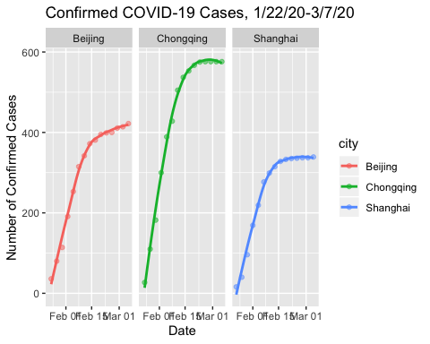

### Your turn: create a scatterplot of Italy’s confirmed case counts to date.

italy_confirmed = confirmed %>%  
 pivot_longer(  
 "1/22/20":"3/7/20",  
 names_to = "date",  
 values_to = "cases") %>%  
 janitor::clean_names() %>%   
 select(province_state, country_region, lat, long, date, cases) %>%   
 rename ("city" = province_state) %>%   
 filter (country_region == "Italy") %>%   
 mutate(date = as.Date(date, format = "%m/%d/%y"))  
  
italy_confirmed %>%   
 ggplot(aes(x = date, y = cases)) +   
 geom_point(alpha = 0.5) +  
 geom_smooth(se = FALSE) +  
 facet_grid(. ~ city) +  
 labs(title = "Confirmed COVID-19 Cases in Italy \n [1/22/20-3/7/20]",  
 x = "Date",  
 y = "Number of Confirmed Cases")

## `geom_smooth()` using method = 'loess' and formula 'y ~ x'

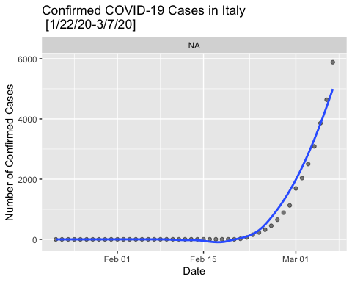

## What if we wanted to know if the distribution of the number of deaths from COVID-19 differed across the three main cities in China? Let’s create a histogram of China’s deaths from COVID-19 to date:

china_deaths = deaths %>%  
 pivot_longer(  
 "1/22/20":"3/7/20",  
 names_to = "date",  
 values_to = "deaths") %>%  
 janitor::clean_names() %>%   
 select(province_state, country_region, lat, long, date, deaths) %>%   
 rename ("city" = province_state) %>%   
 filter (country_region == "China", city == c("Shanghai", "Beijing", "Chongqing")) %>%   
 mutate(date = as.Date(date, format = "%m/%d/%y"))

## Warning in city == c("Shanghai", "Beijing", "Chongqing"): longer object length  
## is not a multiple of shorter object length

china_deaths %>%   
 ggplot(aes(x = deaths, fill = city)) +   
 geom_histogram(position = "dodge", binwidth = 2) +  
 labs(title = "Distribution of Deaths from COVID-19 Between 1/22/20-3/7/20",  
 x = "Number of Deaths",  
 y = "Count")

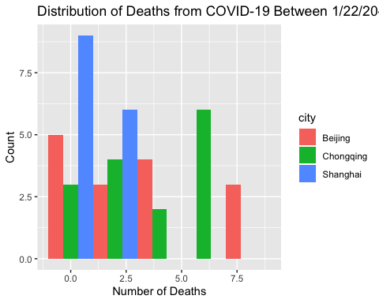

### While a histogram is a great way of showing the distribution of data, having the bars for each group side-by-side gets sort of hard to understand. We can often use density plots in place of histograms when comparing distributions across groups:

china_deaths %>%   
 ggplot(aes(x = deaths, fill = city)) +   
 geom_density(alpha = 0.4, adjust = 0.5, color = "black") +  
 labs(title = "Distribution of Deaths from COVID-19 Between 1/22/20-3/7/20",  
 x = "Number of Deaths",  
 y = "Count")

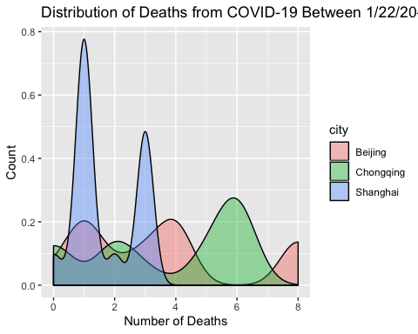

### Your turn: Create both a histogram and a density plot of Italy’s deaths from COVID-19 to date.

italy_deaths = deaths %>%  
 pivot_longer(  
 "1/22/20":"3/7/20",  
 names_to = "date",  
 values_to = "deaths") %>%  
 janitor::clean_names() %>%   
 select(province_state, country_region, lat, long, date, deaths) %>%   
 filter (country_region == "Italy") %>%   
 mutate(date = as.Date(date, format = "%m/%d/%y"))  
  
italy_deaths %>%   
 ggplot(aes(x = deaths)) +   
 geom_histogram(position = "dodge", binwidth = 2) +  
 labs(title = "Distribution of Deaths from COVID-19 in Italy \n Between 1/22/20-3/7/20",  
 x = "Number of Deaths",  
 y = "Count")

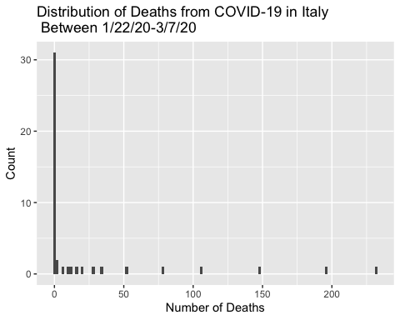

#density plot  
italy_deaths %>%   
 ggplot(aes(x = deaths)) +   
 geom_density(alpha = 0.4, adjust = 0.5, color = "black") +  
 labs(title = "Distribution of Deaths from COVID-19 Between \n 1/22/20-3/7/20",  
 x = "Number of Deaths",  
 y = "Count")

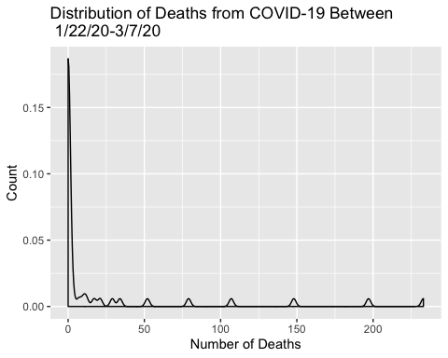

## Homework 1, Part 1: Finish generating the plots from the labs if you have not done so already. Knit this R Markdown document to a Word document and submit on Courseworks.