QRM II Graded Assignment (4)
  - Period 1, 2026
Group 4: Lize den Hertog, Tamara Bakker, Nienke Wielstra, Saliou Diallo, and Zakaria Azarioh
11-10-2026
#install.packages("tidyverse")
library(tidyverse)
## ── Attaching core tidyverse packages ──────────────────────── tidyverse 2.0.0 ──
## ✔ dplyr 1.2.1 ✔ readr 2.2.0
## ✔ forcats 1.0.1 ✔ stringr 1.6.0
## ✔ ggplot2 4.0.3 ✔ tibble 3.3.1
## ✔ lubridate 1.9.5 ✔ tidyr 1.3.2
## ✔ purrr 1.2.2
## ── Conflicts ────────────────────────────────────────── tidyverse_conflicts() ──
## ✖ dplyr::filter() masks stats::filter()
## ✖ dplyr::lag() masks stats::lag()
## ℹ Use the conflicted package (<http://conflicted.r-lib.org/>) to force all conflicts to become errors

Introduction
This assignment is to be completed in groups of 4-5. Further, all students in your group need to be assigned to the same R tutorial group (Friday’s tutorial). You can sign yourself up for a group on Canvas. Please do so You can use the Discussion Board in Canvas if you do not have a group yet or if your group is incomplete.
The assignment has 5 parts, and each part corresponds to the course material of that week (with the exclusion of week 6, for which there is no R programming material).
You are supposed to hand in these assignments on Canvas at the following dates:
- Deadline 1 Sunday September 27th, at 23:59pm: you are supposed to hand in weeks 1, 2, and 3 of this assignment. This will determine 18% of your overall course grade
- Deadline 2 Sunday October 11th, at 23:59pm: you are supposed to hand in weeks 4, and 5 of this assignment. This will determine 12% of your overall course grade
The R tutorials (each Friday) will consist of two halves. During the first half, you will discuss the tutorial exercises. These can be downloaded separately from Canvas. During the second half, you can work on this graded assignment within your own group. The purpose is that you find out how to work with R for doing statistical analyses by yourself. The tutorial exercises are meant to teach you basic commands to get you started, but to answer the problem sets in this assignment, you might need to research your own solutions, and use functions and commands not described in the tutorial exercises. Learning how to solve your own research problems is integral part of learning R. When you and your group get stuck on how to approach an exercise, the hierarchy in finding your way is as follows:
- use the concepts from the tutorial exercises;
- use the cheat sheets available on Canvas;
- use Google, YouTube, StackOverflow, or another website;
- ask the teacher.
The use of generative AI is permitted and may result in a grade of 0. See the AI protocol in the course manual for details.
To answer the assignment, you can simply fill out this R markdown document. There are designated places which you can fill with R code. There are also designated spaces for you to answer each question. Often, the structure of an answer will be as follows. First, you type the R code in the designated box. This will show how you analyzed the data to get the answer to the question. Below the box for the R code, you will then summarize your answer to the question, i.e. what are the conclusions that you draw from the data analysis?
When handing in, you are supposed to submit this .Rmd file, and a knitted version of this document. You can knit this document to pdf, word, or html. Knitting to pdf requires you to have a .tex distribution installed on your computer. Knitting to Word requires you to have Word installed.
The exercises are designed such that you should be able to finish the majority of them during the tutorial each week. If you are not able to finish them fully during that time, you are expected to work on it in your own time using the computers on campus or your own device. It is best to meet as a group in-person when working together. If you want to work remotely, github is a good platform to guarantee smooth collaboration. Alternatively, you can email this .Rmd file back and forth to one another as a group, but this is not recommended as it is more cumbersome.
We encourage you to keep your code blocks, printing statements, and final answers, as short as possible. In any case, there is a page limit of 6 pages per week, which encompasses the total length of this document which consists of the questions, your coding lines, and your answers. When your answers to questions of the respective week exceed this page limit, they will not be graded, resulting in zero points.
Each week consists of 1, 2, or 3 subquestions. The total amount of points you can earn per week is 20 points.

Week 4
- There is an argument going on in the movie studio. Bob claims that production budgets are getting out of hand, and that the studio should focus on making cheaper movies. Chantal disagrees. She tells Bob that ``The profitability ratio of the movie will remain similar, no matter how much the budget is’’.
- Set up a regression model to test Chantal’s claim, and estimate it. That is, estimate:
$${\text{PR}}_{i}=β_{0}+β_{1}{\text{Budget}}_{i}+ε_{i}.$$
- Print a summary of your estimated model.
- What is the estimated value of $β_{1}$ how do you interpet it?
- Test for the null hypothesis that $β_{1}=0$. Report the p-value and state your conclusion.
- Who do you think is correct? Bob or Chantal? What would you advise the movie studio to do?
- Make a histogram of the residuals of your model. Based on the histogram, do you have any reason to doubt the validity of your model? Explain.
- Estimate hatvalues for each observation that you used to estimate your model. Do any hatvalues exceed the critical value? Based on this analysis, do you hvae any reason to doubt the validity of your model?
- Based on your analysis in f.), estimate your model again, but remove any outliers. Print a summary of your model and again test for the null hypothesis that $β_{1}=0$. What do you conclude? Based on this new model, would your advice to the movie studio in question d. change?
step a
movies <- readRDS("cleaned_movies.rds")
model <- lm(formula = movies$PR ~ movies$budget)
summary(model)
##
## Call:
## lm(formula = movies$PR ~ movies$budget)
##
## Residuals:
## Min 1Q Median 3Q Max
## -2.953 -2.519 -1.292 0.599 70.726
##
## Coefficients:
## Estimate Std. Error t value Pr(>|t|)
## (Intercept) 2.953e+00 2.946e-01 10.025 <2e-16 ***
## movies$budget -2.235e-09 4.946e-09 -0.452 0.651
## ---
## Signif. codes: 0 '***' 0.001 '**' 0.01 '*' 0.05 '.' 0.1 ' ' 1
##
## Residual standard error: 5.431 on 607 degrees of freedom
## (199 observations deleted due to missingness)
## Multiple R-squared: 0.0003364, Adjusted R-squared: -0.001311
## F-statistic: 0.2042 on 1 and 607 DF, p-value: 0.6515
Your Answer:
A summary of a linear regression model with budget as the predictor/independent variable and PR as the response variable/dependent variable.
step b
coef(model)["movies$budget"]
## movies$budget
## -2.235093e-09
Your Answer:
The estimated value of $β_{1}$ retrieved from the summary, and it is -2.235e-09 or -0.000000002235. This means that a one unit increase of the budget is associated with a -2.235e-09 increase (so a 2.235e-09 decrease) of PR. It means that the budget and the PR have a negative relation. The reason why $β_{1}$ is so small is because budget is a way larger variable than PR.
step c
summary(model)$coefficients["movies$budget", "Pr(>|t|)"]
## [1] 0.6514832
Your Answer:
The hypotheses are $H_{0}:β_{1}=0$ and $H_{1}:β_{1}≠0$, with significance level $α=0.05$. The test statistic is the p-value, if the p-value is smaller than the significance level, we reject the null hypothesis. From the summary of the linear regression model, a p-value of 0.6515 can be retrieved. A high p-value mean that the chance that the null hypothesis is true is large, so, since $0.6515>0.05$, we fail to reject the null hypothesis that the linear model is statistically significant, because at a 95% confidence level, there is not enough prove to state that the model is statistically significant.
step d
Your Answer:
We agree with Chantal, although her statement cannot be 100% proven correct. The null hypothesis that the linear regression model with budget as the predictor and the profitability ratio as the dependent variable is statistically insignificant ($β_{1}=0$) cannot be rejected as the p-value of the coefficient of the budget is way too high (0.651). This means that there is not enough prove to state that there is a linear relationship between the profitability ratio and the budget. This agrees with Chantal’s statement, that the profitability ratio will stay similar, no matter the budget. However, this does not prove Chantal’s statement, it simply fails to reject her statement. Bob’s statement can be interpreted as the statement that there is a negative relationship between the budget and the profitability ratio. Since we fail to reject the null hypothesis of statistical insignificance, this statement is not backed by statistical evidence.
step e
residuals_PR <- residuals(model)
hist(residuals_PR, main="Histogram residuals estimated PR", xlab="Residuals estimated PR", breaks =200)
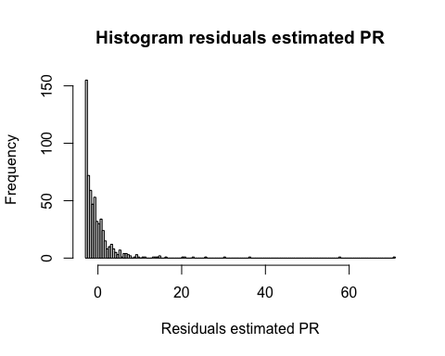
Your Answer:
Yes, there is reason to doubt the validity of the model. One of the rules of regression is that the residuals should be distributed normally, else there is something wrong/missing in the model. In the histogram, it is clearly visible that the residuals peak on the left side and slope downwards to the right side, which is nothing like the bell-shaped distribution of the normal distribution. This makes the validity of the model questionable.
step f
nobs(model)
## [1] 609
hat_values_yea <- hatvalues(model)
sum(hat_values_yea>2/609)
## [1] 75
sum(hat_values_yea<=2/609)
## [1] 534
75/609*100
## [1] 12.31527
Your Answer:
Of the 609 observations of the budget that are considered in the model, not 808 because PR contains a lot of NAs, 75 are considered “suspect” according to the general rule of the hat values, which is $h_{j}>2/n$. This is approximately 12.3% of all the observations, which is a significant number. In itself, this observation definitely requires further investigation as to why there are so many outliers and what the influence of these outliers is, but it does not necessarily have to affect the validity of the model. However, considering the outcomes of the other assignments, this result can be associated with further proof that the validity of this model is very questionable.
step g
used <- as.numeric(rownames(model.frame(model)))
hat_values <- hatvalues(model)
outliers <- which(hat_values >2/609)
outlier_rows <- used[outliers]
movies_clean <- movies[-outlier_rows, ]
clean_model <- lm(formula = PR ~ budget, data = movies_clean)
summary(clean_model)
##
## Call:
## lm(formula = PR ~ budget, data = movies_clean)
##
## Residuals:
## Min 1Q Median 3Q Max
## -3.404 -2.614 -1.390 0.637 70.344
##
## Coefficients:
## Estimate Std. Error t value Pr(>|t|)
## (Intercept) 3.404e+00 3.902e-01 8.722 <2e-16 ***
## budget -2.171e-08 1.147e-08 -1.893 0.0589 .
## ---
## Signif. codes: 0 '***' 0.001 '**' 0.01 '*' 0.05 '.' 0.1 ' ' 1
##
## Residual standard error: 5.737 on 532 degrees of freedom
## (199 observations deleted due to missingness)
## Multiple R-squared: 0.00669, Adjusted R-squared: 0.004823
## F-statistic: 3.583 on 1 and 532 DF, p-value: 0.05892
Your Answer:
Hypotheses: $H_{0}:β_{1}=0$, $H_{1}:β_{1}≠0$, with significance level $α=0.05$. The test statistic and the rules about rejection are the same as 1c: the p-value and if the p-value is smaller than the significance level, we reject the null hypothesis. the p-value is 0.0589, which is larger than 0.05, so we fail to reject the null hypothesis, however, this time the p-value is way smaller than when the outliers were still included, which was 0.651. So, the model did improve because of the outlier removal. This means that we do not change our answer in d, since the test still shows insufficient statistical evidence of a linear (negative) relationship between the profitability ratio and the budget, even though this model comes way closer than the previous one (on a 90% confidence interval, the null hypothesis could be rejected). This is also because we do not know whether these outliers are truely outliers, in the sense of distorting the actual situation or being wrong, or just outliers as in observations that lie further from the other observations.
2.
- Make a scatterplot with vote_average on the y-axis, and runtime on the x-axis. Within the same scatterplot, draw a straight line which summarizes the association between the average vote and the runtime.
- Using the insights from the scatterplot, your linear model, and your data, find an example of a movie that vastly overperformed. That means, find a movie that had much higher average vote than expected, given its runtime. For this movie, report its vote_average, its predicted vote_average, and its residual.
step a
ggplot(movies, aes(x=runtime, y=vote_average))+
geom_point()+
labs(title="Association between vote average and runtime", x="Runtime", y="Vote average")+
geom_smooth(method="lm")+
theme_minimal()
## `geom_smooth()` using formula = 'y ~ x'
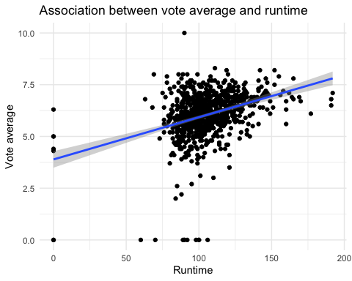
Your Answer:
Scatterplot of vote average and runtime with a linear line of “best fit” with a confidence interval.
step b
new_model <- lm(formula = movies$vote_average ~ movies$runtime)
movies$residual <- residuals(new_model)
movies$model_vote <- predict(new_model)
max(movies$residual)
## [1] 4.274564
subset(movies, residual == max(residual))$vote_average
## [1] 10
subset(movies, vote_average == 10)$model_vote
## 166
## 5.725436
subset(movies, residual == max(residual))$title
## [1] "Me You and Five Bucks"
Your Answer:
In the scatterplot, it is already visible that one observation, in which the vote average was 10, lies further away from the model than all other values, but to ensure that this is correct, it was calculated mathematically as well. One movie that overperformed compared to its runtime, is the movie “Me, You, and Five Bucks”. This movie has a vote average of 10, while its estimated vote average is 5.7254. This gives the vote average estimate a residual of 4.2746.

Week 5
- Create a plot of the mean PR by year of release. Include 95% confidence intervals around each mean Do you see any indication of a time trend in the PR?
- Estimate an OLS model which has as dependent variable the PR of a movie, and as independent variable the log of budget, a dummy for each level that genre2 can take, and the year of release. Show a summary of the resulting model and interpret each coefficient.
The movie studio that you work is releasing a new movie in May of 2026. It will be a Comedy movie with a budget of 40,000,0000. It will have a runtime of 160 minutes.
- Estimate a model that is able to predict the revenue of this movie. Give its predicted revenue and include a 95% prediction interval.
- Plot the residuals against various independent variables in the model. Do you find any evidence of heteroskedasticity?
- The movie is set in Germany. The director wants to make the movie with only german-speaking actors. The executive producer is strongly against this, as she is afraid that movies that are not english spoken will have a low profit ratio. Estimate a model that can test whether the language spoken impacts the PR of this specific movie. Use an appropriate hypothesis test to test whether the language affects the PR ratio. What would you advise the movie studio regarding the language to be spoken?
step a
pr_year <- movies %>% group_by(release_year) %>%
summarise(mean_pr = mean(PR, na.rm=TRUE), s=sd(PR, na.rm=TRUE), n = sum(!is.na(PR))) %>%
mutate(lower= mean_pr - qt(0.975, df = n-1)*s/sqrt(n),
upper= mean_pr + qt(0.975, df = n-1)*s/sqrt(n))
ggplot(pr_year, aes(release_year, mean_pr)) +
geom_point() +
geom_errorbar(aes(ymin = lower, ymax = upper), width = 0.3) +
labs(title = "Average PR per year, with 95% confidence interval", x = "Release year", y = "PR mean")
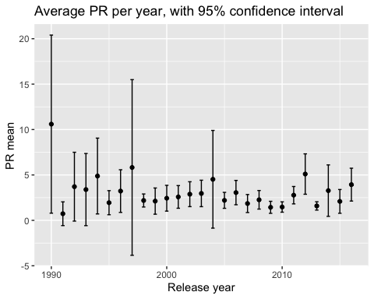
Your Answer:
In this graph, all NAs are removed from the computation, There does not seem to be a time trend concerning the average profitability ratio over the years, meaning that it does not seem to increase or decrease over the years. There seems to be a slight wavy pattern, but this pattern does not seem very significant, as the differences are small. Some years have big confidence intervals, while others have small ones, and these are often grouped, but overall there does not seem to be a general trend in the PR.
step b
model_2 <- lm(formula = PR ~ log(budget) + genre2 + release_year, data = movies)
summary(model_2)
##
## Call:
## lm(formula = PR ~ log(budget) + genre2 + release_year, data = movies)
##
## Residuals:
## Min 1Q Median 3Q Max
## -7.043 -2.341 -1.136 0.603 69.047
##
## Coefficients:
## Estimate Std. Error t value Pr(>|t|)
## (Intercept) 135.75895 67.05652 2.025 0.0434 *
## log(budget) -0.26435 0.11541 -2.291 0.0223 *
## genre2Drama -1.30554 0.55516 -2.352 0.0190 *
## genre2Other -0.24957 0.75291 -0.331 0.7404
## genre2Thriller -0.79564 0.69108 -1.151 0.2501
## release_year -0.06367 0.03335 -1.909 0.0567 .
## ---
## Signif. codes: 0 '***' 0.001 '**' 0.01 '*' 0.05 '.' 0.1 ' ' 1
##
## Residual standard error: 5.391 on 603 degrees of freedom
## (199 observations deleted due to missingness)
## Multiple R-squared: 0.02129, Adjusted R-squared: 0.01317
## F-statistic: 2.623 on 5 and 603 DF, p-value: 0.02332
Your Answer:
The intercept of 135.75895 can be interpreted as the estimated value of PR if all the independent variables were zero. The intercept does not necessarily need to be logically true, it is mathematical. The coefficient of the logarithm of the budget can be interpreted as the fact that a 1% increase of the budget is associated with a 0.0026435 decrease in PR, holding all other variables constant. The coefficients of the dummy variables representing the different genre categories are the associated change in the PR if the movie belongs to a certain genre compared to the PR associated with the genre Comedy. So, if the movie belongs to the genre drama, the change in PR associated with this genre compared to the genre comedy is a decrease of 1.30554, holding all other variables constant. Likewise, if a movies belongs to the other genres, the change in PR associated with this genre compared to the genre comedy is a decrease of 0.24957, holding all other variables constant. If a movie has the genre Thriller, the change in PR associated with this genre compared to the genre comedy is a decrease of 0.06367, holding all other variables constant. Finally, release year has a coefficient of -0.06367, meaning that if the movie is released one year later, this is associated with a 0.06367 decrease in PR holding all other variables constant. overall, these coefficients are dubious, considering the R-squared and adjusted R-squared of only 0.02129 and 0.01317 respectively. This means that the model only explains approximately 2% or even 1% of the variations of PR.
step c
movies$may <- as.numeric(movies$release_month == 5)
model_3 <- lm(formula = revenue ~ budget + genre2 + runtime + release_year + may, data = movies)
summary(model_3)
##
## Call:
## lm(formula = revenue ~ budget + genre2 + runtime + release_year +
## may, data = movies)
##
## Residuals:
## Min 1Q Median 3Q Max
## -446690420 -34934937 -93987 19146159 829642172
##
## Coefficients:
## Estimate Std. Error t value Pr(>|t|)
## (Intercept) -9.767e+08 1.214e+09 -0.804 0.4214
## budget 3.076e+00 1.070e-01 28.754 <2e-16 ***
## genre2Drama -1.766e+07 1.030e+07 -1.715 0.0868 .
## genre2Other -1.990e+05 1.370e+07 -0.015 0.9884
## genre2Thriller -2.488e+07 1.303e+07 -1.910 0.0565 .
## runtime 2.313e+05 2.151e+05 1.075 0.2825
## release_year 4.756e+05 6.044e+05 0.787 0.4315
## may 1.833e+07 1.391e+07 1.317 0.1882
## ---
## Signif. codes: 0 '***' 0.001 '**' 0.01 '*' 0.05 '.' 0.1 ' ' 1
##
## Residual standard error: 109200000 on 800 degrees of freedom
## Multiple R-squared: 0.6033, Adjusted R-squared: 0.5998
## F-statistic: 173.8 on 7 and 800 DF, p-value: < 2.2e-16
new_movie <- data.frame(budget= 40000000, genre2 = "Comedy", release_year = 2026, runtime = 160, may = 1)
predict(model_3, newdata = new_movie, interval = "prediction", level = 0.95)
## fit lwr upr
## 1 165322676 -54395901 385041253
Your Answer:
The revenue of this movie is predicted to be 165,322,676 dollars, with a prediction interval between -54,395,901 and 385,041,253 dollars. However, since revenue cannot be negative, we should consider placing the lower bound of the confidence interval at zero dollars.
step d
movies$resd <- residuals(model_3)
ggplot(movies, aes(budget, resd)) +
geom_point() +
labs(title = "Budget against Residuals", x = "Budget", y = "Residuals") +
geom_hline(yintercept = 0)
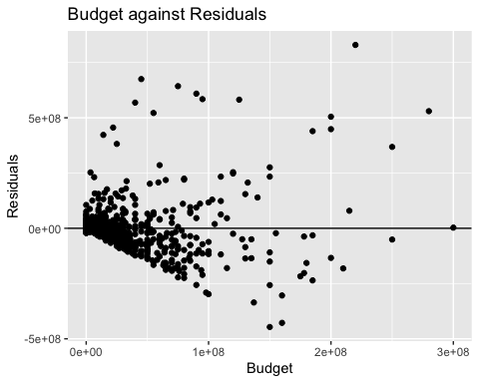
ggplot(movies, aes(runtime, resd))+
geom_point()+
labs(title = "Runtime against Residuals", x = "Runtime", y = "Residuals") +
geom_hline(yintercept = 0)
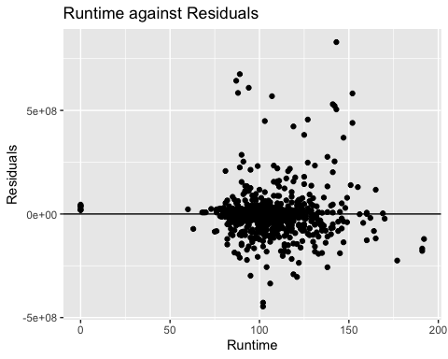
ggplot(movies, aes(release_year, resd))+
geom_point()+
labs(title = "Release Year against Residuals", x = "Release Year", y = "Residuals") +
geom_hline(yintercept = 0)
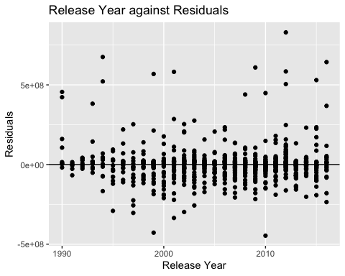
Your Answer:
Considering these three numerical variables, plotting runtime and release year against the residuals do not give any results back that indicate heteroskedasticity. However, plotting the budgets against the residuals gives a scatterplot in which the dots fan out, indicating heteroskedasticity. The fan pattern indicates that the variance of the residuals changes for different values of the budget, which violates homoskedasticity and the assumption of the OLS model.
step e
full_model <- lm(formula = PR ~ log(budget) + genre2 + release_year + original_language, data = movies)
reduced_model <- lm(formula = PR ~ log(budget) + genre2 + release_year, data = movies)
anova_result <- anova(reduced_model, full_model)
print(anova_result)
## Analysis of Variance Table
##
## Model 1: PR ~ log(budget) + genre2 + release_year
## Model 2: PR ~ log(budget) + genre2 + release_year + original_language
## Res.Df RSS Df Sum of Sq F Pr(>F)
## 1 603 17526
## 2 588 17430 15 95.522 0.2148 0.9993
Your answer:
Hypothesis: null hypothesis: $H_{0}:β_{6}=...β_{23}=0$, alternative hypothesis: $H_{1}:$at least one of the coefficients is not zero, with significance level $α=0.05$. The test statistic is the p-value of the ANOVA, analysis of variance, since we want to know whether adding the original language to the model will improve it. We reject the null hypothesis if the p-value is smaller than the significance level. The p-value of the analysis of variance is 0.9993, which is greater than 0.05, so we fail to reject the null hypothesis, as there is insufficient statistical evidence to state that the language in which the movie is spoken is associated with a chance in the profitability ratio. Given this information, we would advise the studio to choose the language they prefer, so German, since there is no statistical evidence that making the movie English will be associated with a higher profitability ratio or that the language in which the movie is spoken is relevant to the profitability ratio.

