**DAY 02**

**20.03.2023**

**Dataset Used:**

Preparation of our own datasets either binary or multi-class and the data set was a topic of our own choice. A binary class dataset was created which contained 300 images of lion and tiger (selected topic) respectively.

Separation of images into train, validation and test class.

The dataset was cleaned and then executed using sequential CNN and the accuracy was observed.

**Google Drive**

<https://drive.google.com/drive/folders/1TH10MoXK5v6Mxt8AGxQyhncWjSiHNiFe?usp=drive_link>

The images were downloaded in bulk with the help of a google extension and were cleaned after sorting.

**Google Colab**

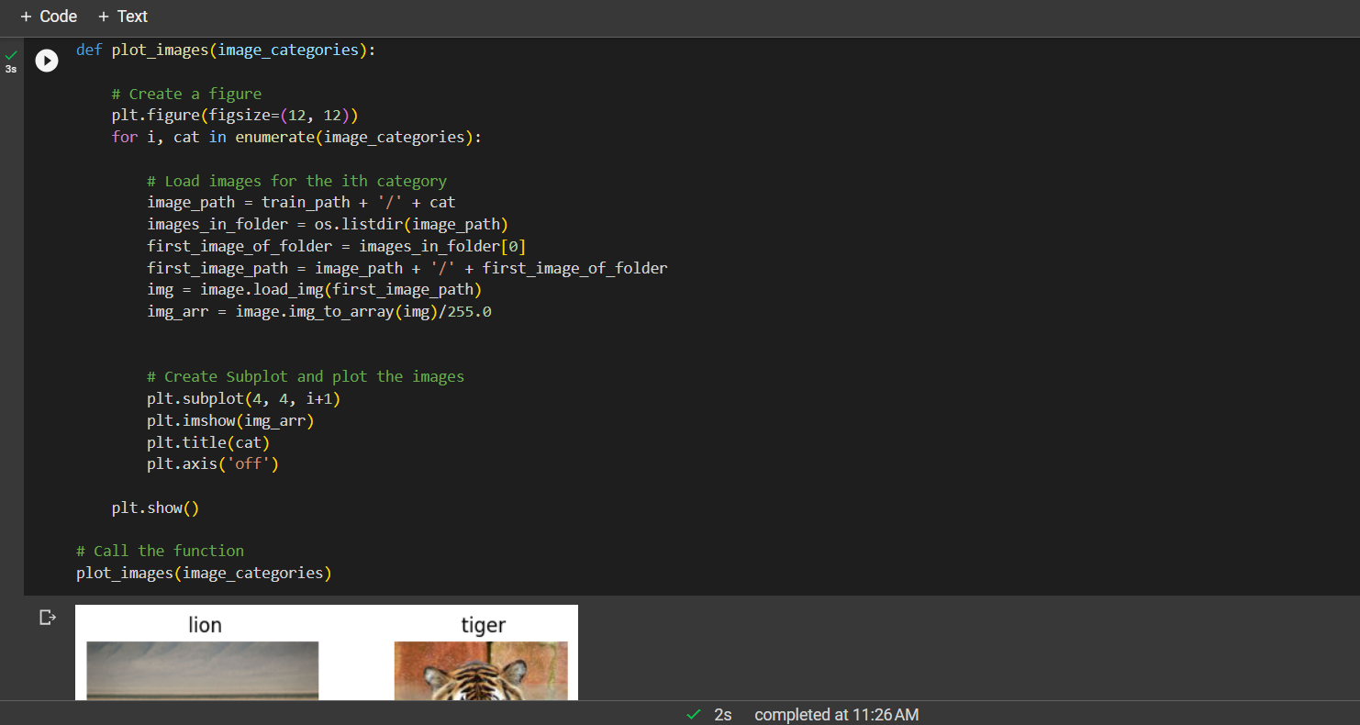

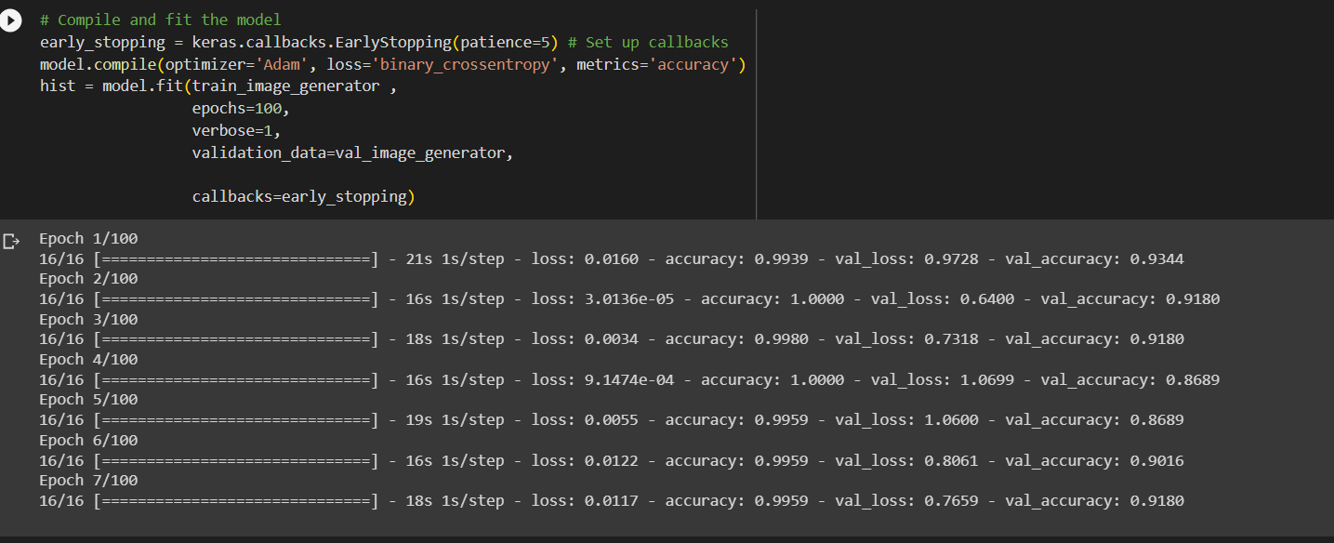

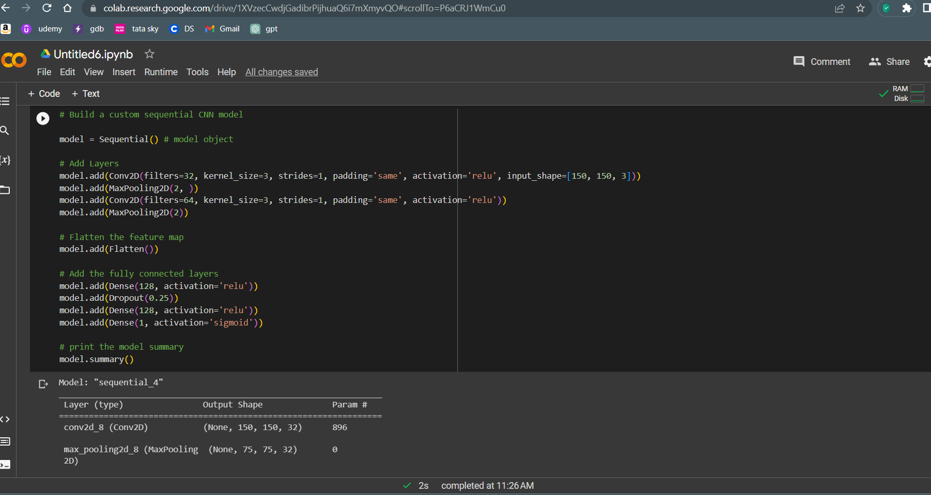

**Output:**

