**DAY 03**

**21.03.2023**

**Dataset provided:**

An examination dataset was provided to us(interns) in google drive.

It contained three folders namely train, validation and validation2.

Each folder further had 5 sub folders(multi-class) which were normal, cheat, phone, paperseeing and paperexchange.

Train set: train

Test set: validation

Validation set: validation2

**Online Class Summary:**

Introduction to Jupyter.

Downloading and Installing Jupyter.

Explanation of datasets.

**Google Drive**

https://drive.google.com/drive/folders/1v0nUtgz8wMnn7JJWqw4MHPaVJZZ1GqOa?usp=drive_link

**Google Colab**

import pandas as pd

import numpy as np

import matplotlib.pyplot as plt

import seaborn as sns

import plotly.express as px

import os

import tensorflow as tf

from tensorflow.keras.preprocessing.image import ImageDataGenerator

from sklearn.preprocessing import LabelBinarizer

from sklearn.metrics import roc_curve, auc, roc_auc_score

# from IPython.display import clear_output

import warnings

warnings.filterwarnings('ignore')

# 1. Train Set

train_gen = ImageDataGenerator(rescale = 1.0/255.0) # Normalise the data

train_image_generator = train_gen.flow_from_directory(

                                            train_path,

                                            target_size=(150, 150),

                                            batch_size=32,

                                            class_mode='categorical')

# 2. Validation Set

val_gen = ImageDataGenerator(rescale = 1.0/255.0) # Normalise the data

val_image_generator = train_gen.flow_from_directory(

                                            validation_path,

                                            target_size=(150, 150),

                                            batch_size=32,

                                            class_mode='categorical')

# 3. Test Set

test_gen = ImageDataGenerator(rescale = 1.0/255.0) # Normalise the data

test_image_generator = train_gen.flow_from_directory(

                                            test_path,

                                            target_size=(150, 150),

                                            batch_size=32,

                                            class_mode='categorical')

# Build a custom sequential CNN model

model = Sequential() # model object

# Add Layers

model.add(Conv2D(filters=32, kernel_size=3, strides=1, padding='same', activation='relu', input_shape=[150, 150, 3]))

model.add(MaxPooling2D(2, ))

model.add(Conv2D(filters=64, kernel_size=3, strides=1, padding='same', activation='relu'))

model.add(MaxPooling2D(2))

# Flatten the feature map

model.add(Flatten())

# Add the fully connected layers

model.add(Dense(128, activation='relu'))

model.add(Dropout(0.25))

model.add(Dense(128, activation='relu'))

model.add(Dense(5, activation='softmax'))

# print the model summary

model.summary()

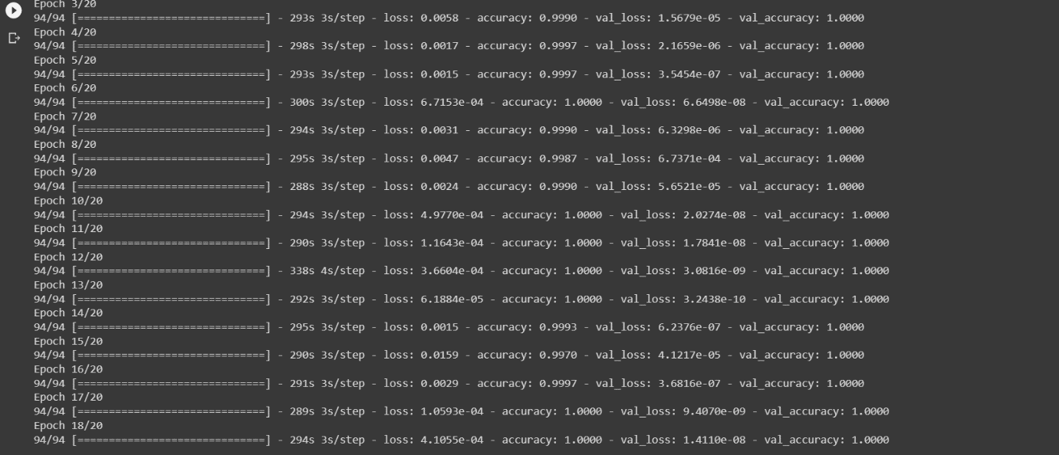

**Graphs:**

