**DAY 06**

**23.03.2023**

**Dataset Used:**

A multi-class dataset was provided to work with using various CNN algorithms. The dataset provided was well cleaned and was also classified as train and validation which was used as both test and validation dataset.

The dataset had images of various architecture such as gargoyle, dome(outer), dome(inner), flying buttress, altars, bell tower, vault, stained glass, apse and column. A total of 10 sub folders(datasets).

**Jupyter(VGG-16 CNN)**

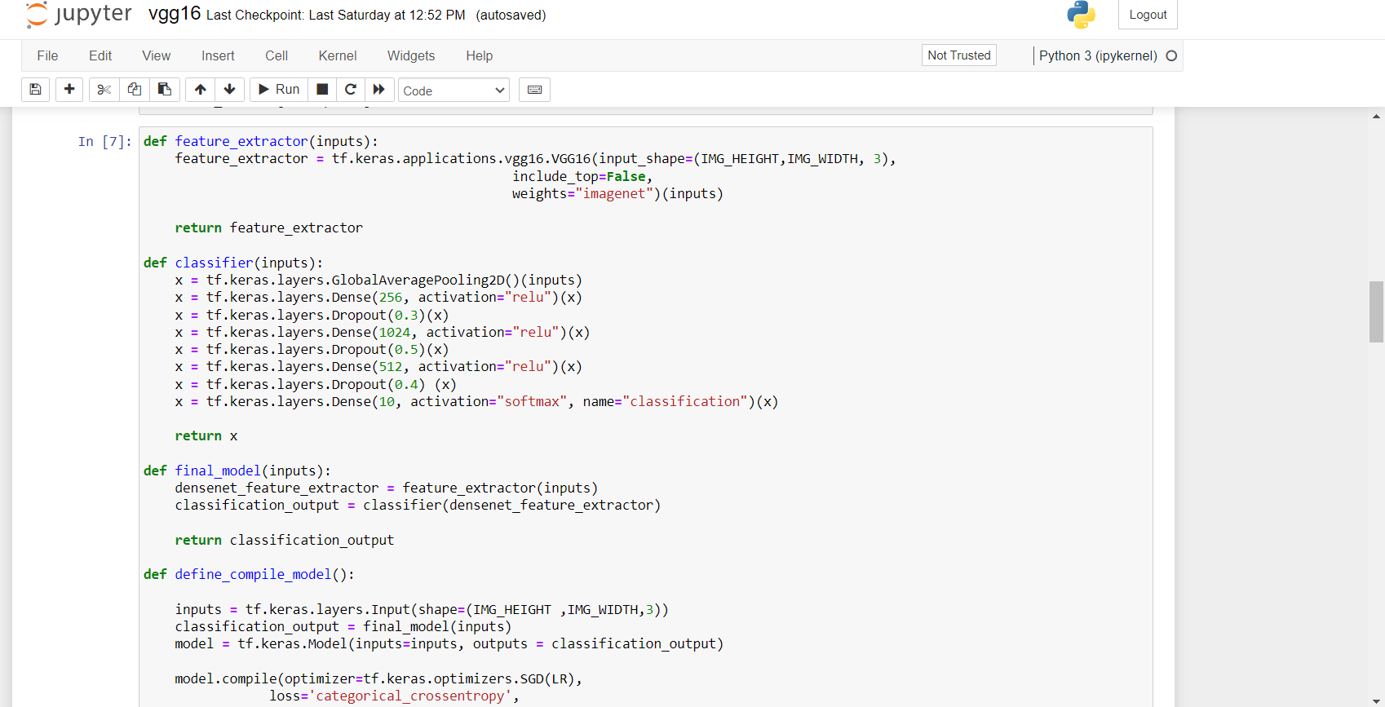

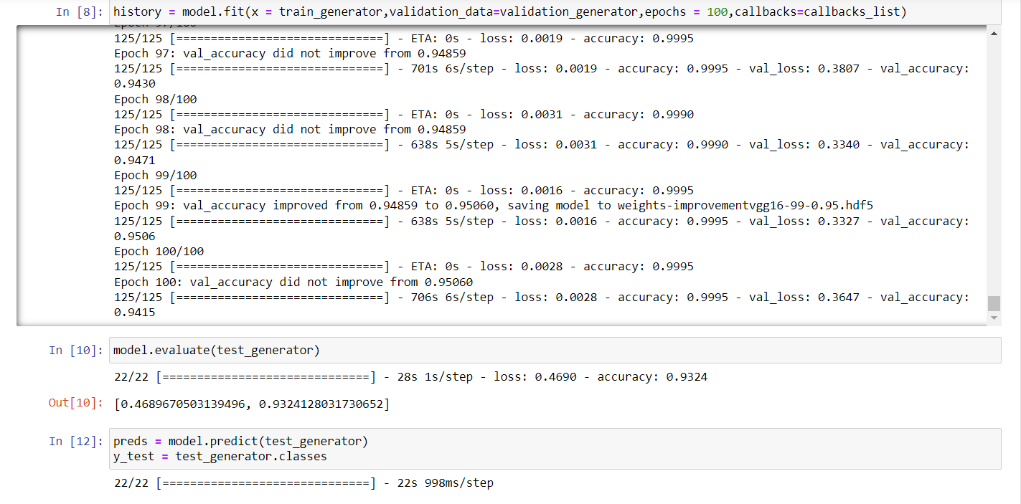

Confusion Matrix:

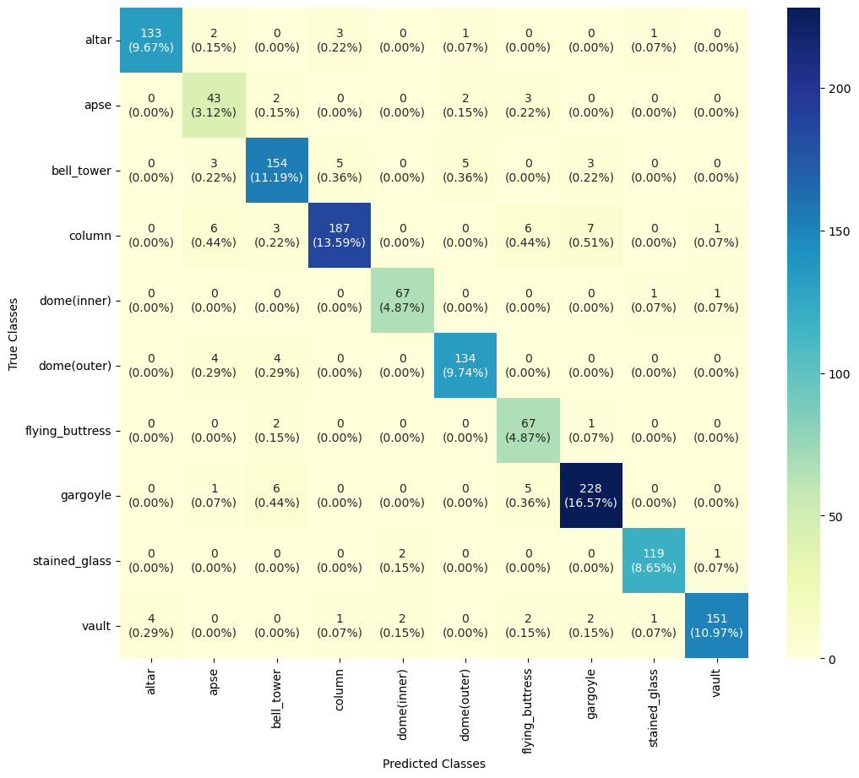

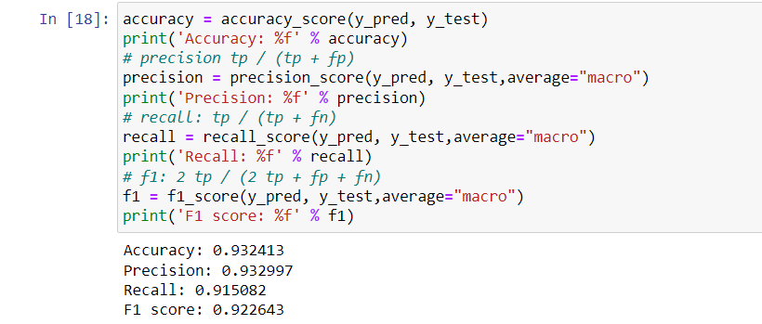

**Jupyter(Efficientnet_V2):**

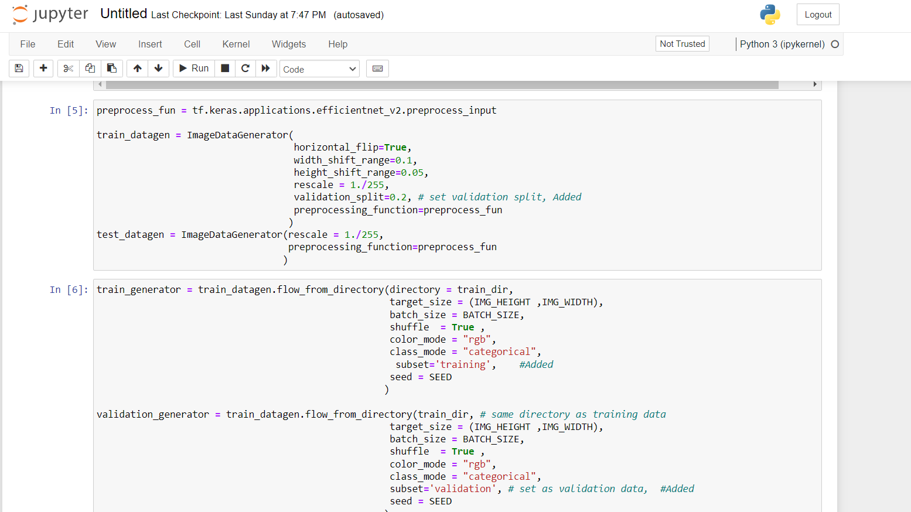

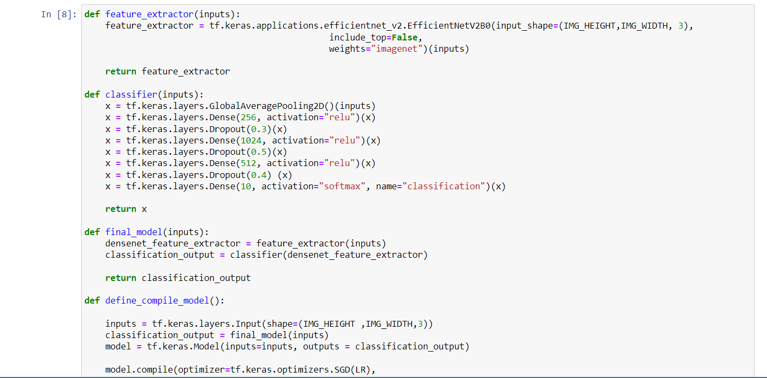

**Confusion Matrix:**

