**Lizeth Campos**

**Lab 7 report**

**Introduction**

Dynamic Programming helps us solve bigger problem into smaller ones. By doing this sectioning the bigger problem into smaller ones it helps resolve the main one. For this Lab we were asked to implement this Data Structure Dynamic programming of Edit distance.

**Proposed Solution**

To Start solving this the problem we can start with The strings, if the length is zero then you can just return the other string we were using. Comparing the Elements to each other and checking if they were the same, if they were not the same then we can use insert, replace and remove to at the end check how much it took for each to be the same at the end.

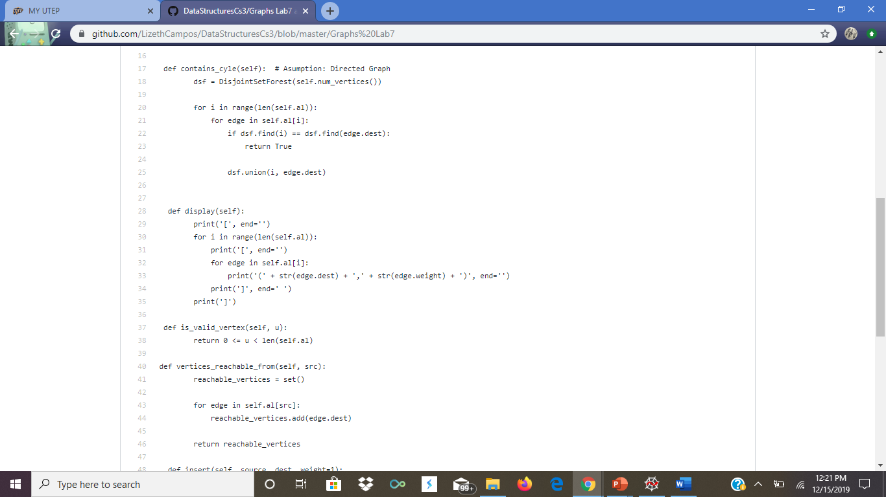

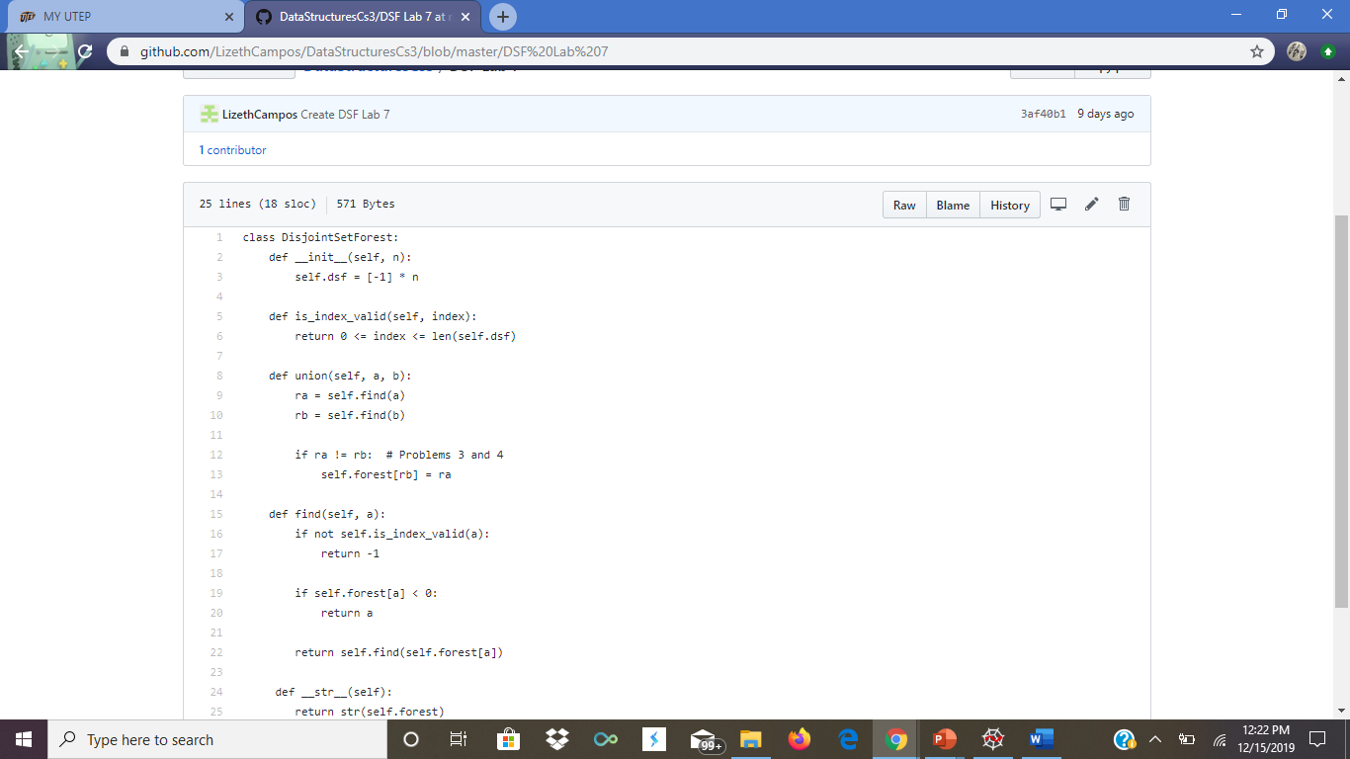

**Experimental Result**

Testing different words and comparing them to each other a pair at a time and see how much it took for it to at the end be the same and another test that i did was have two of the same words and compare them and see the ending result.

**Conclusion**

With this lab I got a better understanding of this new data structure and learn more in depth on how to better use it in different occasions and have different test that are important to see how each of the things being implemented worked with different cases.