Lizeth Campos

Lab 5 report

Introduction

In this lab we were asked to implement the following LRU which removes the least used item first then we were also asked to implement a max heap to print the most frequent elements used in the lab.

Proposed implementation

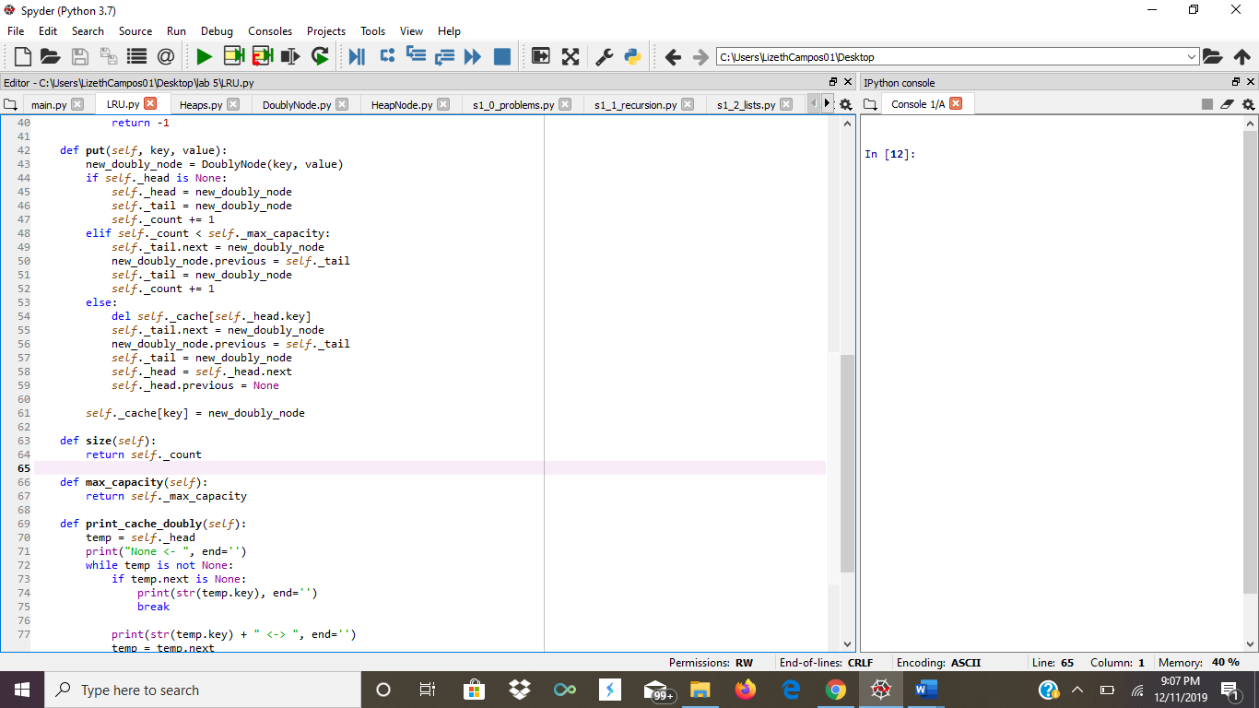In this lab our task was to implement all of the stuff I previously talked about but the catch was that they had to have a running time of O(1). Some of the methods being implemented in this lab are the following a method to get the size, a method called get which basically what its doing its that it returns the value of a key. Another method being implemented is the method called put which basically inserts a new value and finally the last method is called max Capacity which all is doing is returning the maximum capacity of it.

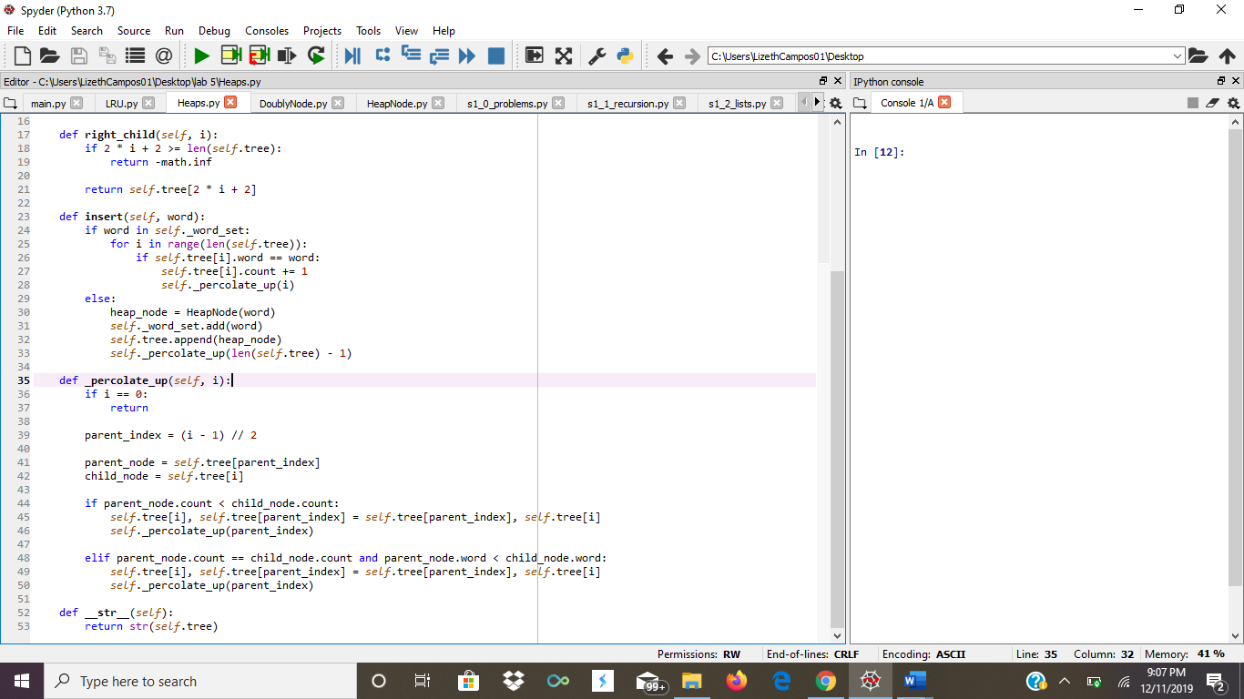

Experimental result

Having to implement a max heap and implementing the running time of O(1) was hard but some of the Methods were also hard to process but diving the implementations into different parts was making the job much easier also the constructors of the lab were a big process of getting the lab correctly. But over all getting the insertion method down was hard because I need it to make sure that it was inserting correctly to get the implementation correct.

Conclusion

Having to implement this kind of stuff was pretty hard but it helped understand and be able to compute something in the running time of O(1) using the kind of methods being implemented. The challenging part was just getting them to work at that specific running time.