1. Detailed configurations (CPU, Mem, etc...) of my experimental setup:

Memory: 16GB

CPU:Intel Core i5

Free Disk Space: 396.11GB

OS:Mac OS

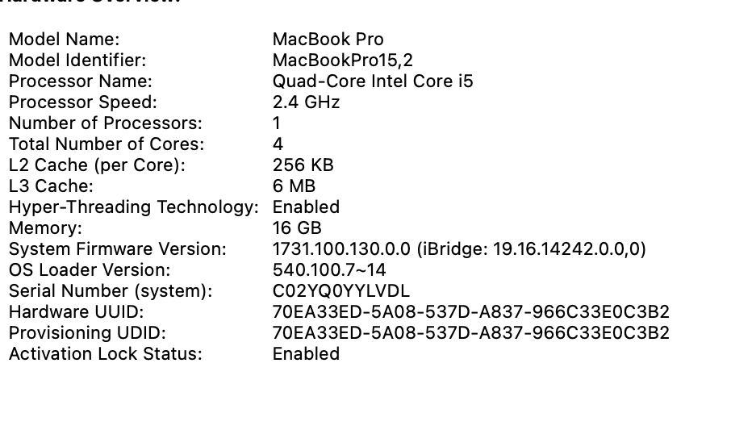

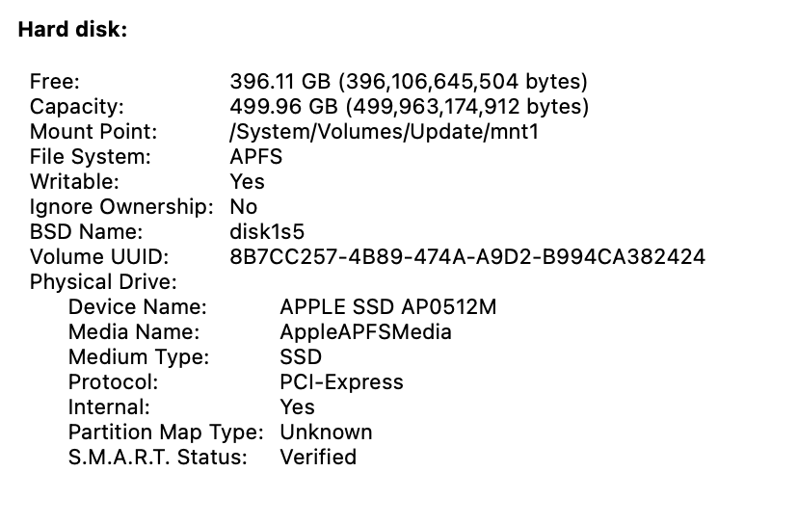

1. Main steps to enable a QEMU VM:

Prepare:

First download the ISO installation image(**ubuntu-20.04.4-live-server-amd64.iso**) from the link <https://releases.ubuntu.com/focal/ubuntu-20.04.4-live-server-amd64.iso>in HW1

1. Install QEMU:

HomeBrew is already installed in my Mac

Just execute: $ **brew install qemu** in terminal

1. Prepare the Virtual Machine qcow2 image file

**$ qemu-img create -f qcow2 ubuntu.img 20G**

1. Install and Start the virtual machine

$ qemu-system-x86_64 \

    -machine type=q35,accel=hvf \

    -smp 4 \

    -cpu host \

    -hda ubuntu.img \

    -m 16G \

    -vga virtio \

    -usb \

    -device usb-tablet \

    -display default,show-cursor=on -cdrom ./ubuntu-20.04.4-live-server-amd64.iso -nographic

1. Main steps to enable a Docker container and some important operations :
2. Install a Docker Desktop Application from the link: <https://docs.docker.com/desktop/mac/install/>
3. Get Image:

**$ docker pull zyclonite/sysbench**

1. Start the container

**$ docker run -it zyclonite/sysbench**

1. View all container commands as follows:

**docker ps -a**

1. Deletes all containers that have a status of exited:

**$ docker rm $(docker ps -a -q -f status=exited)**

1. Remove the specific container using the **docker rm** command:

**$ docker rm -f xxxxxxxxxxxx(container ID)**

1. Screen snapshots of your Docker and QEMU running environments for each experiment:

**CPU Test:**

**A.**

CPU = 1, Memory = 16G, threads = 1, max-prime = 1000, time = 30s

Docker:

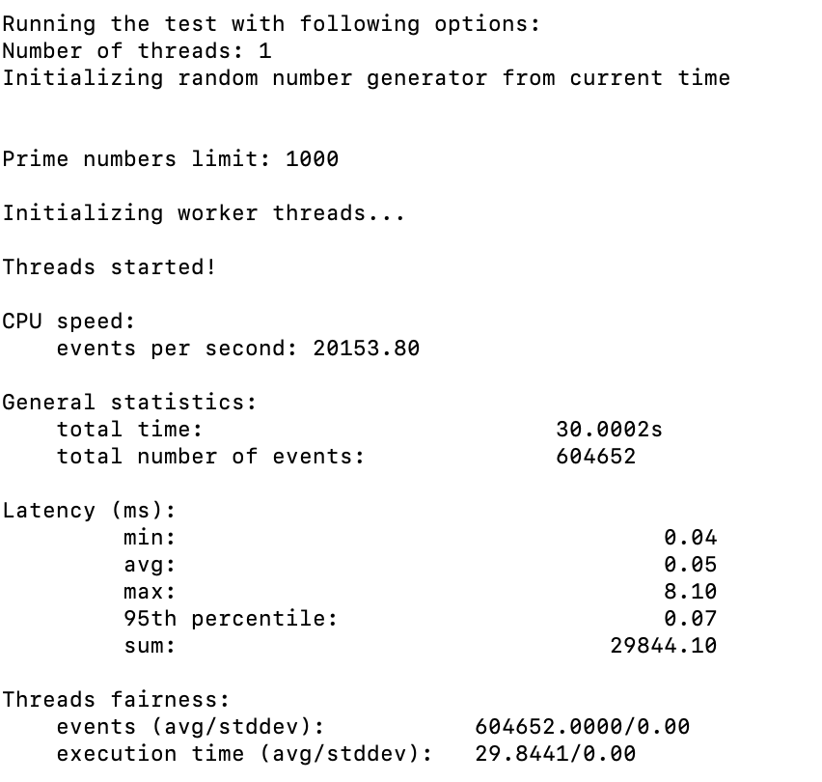

QEMU:

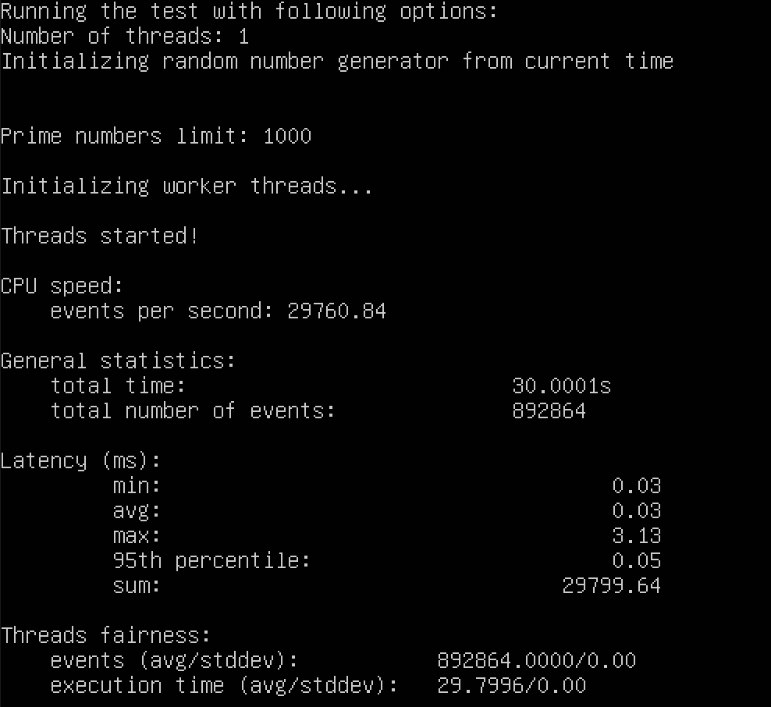



Docker:

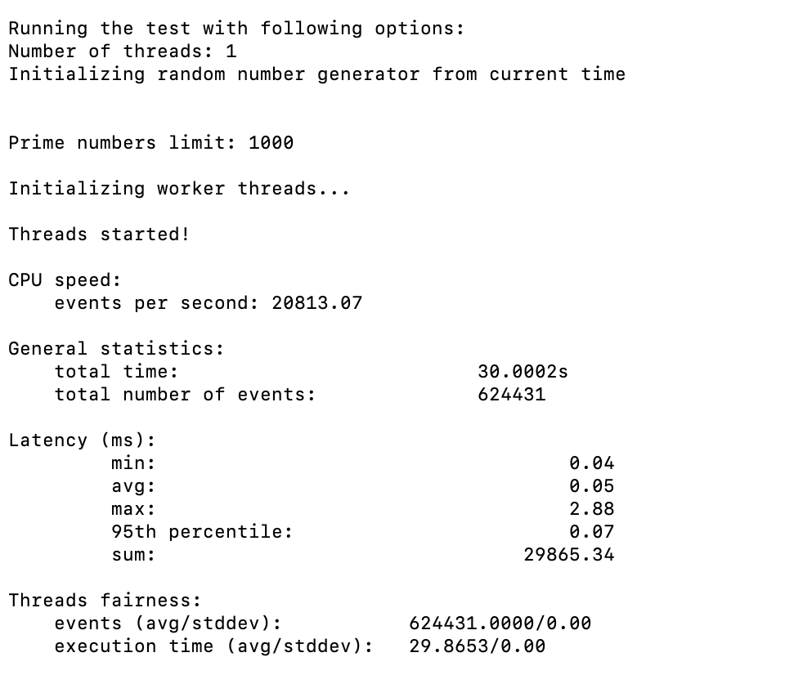

QEMU:

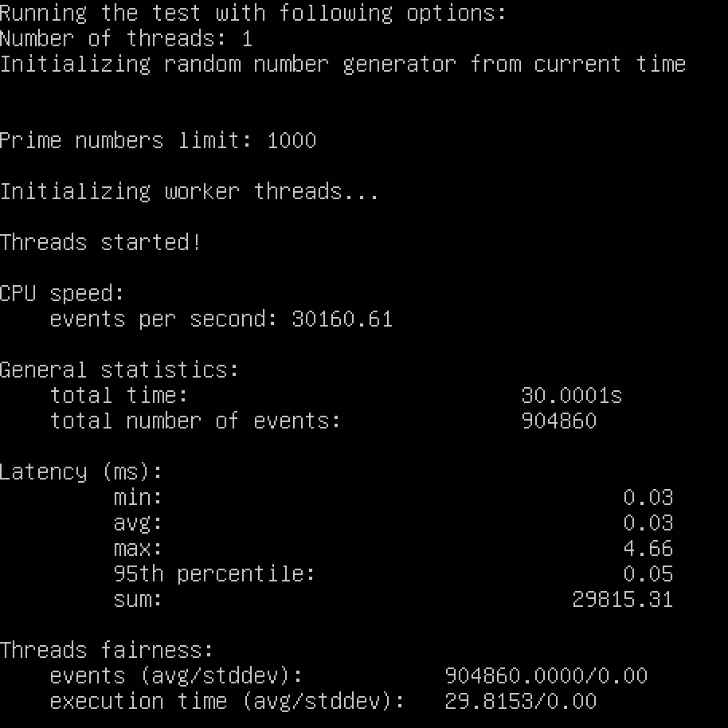

Docker:

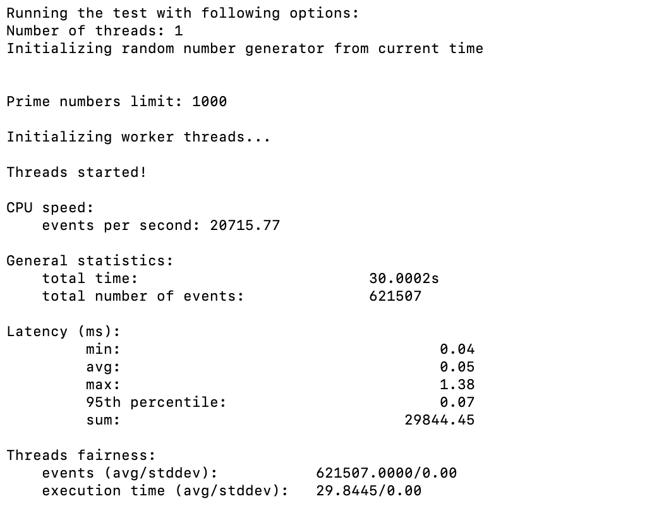

QEMU:

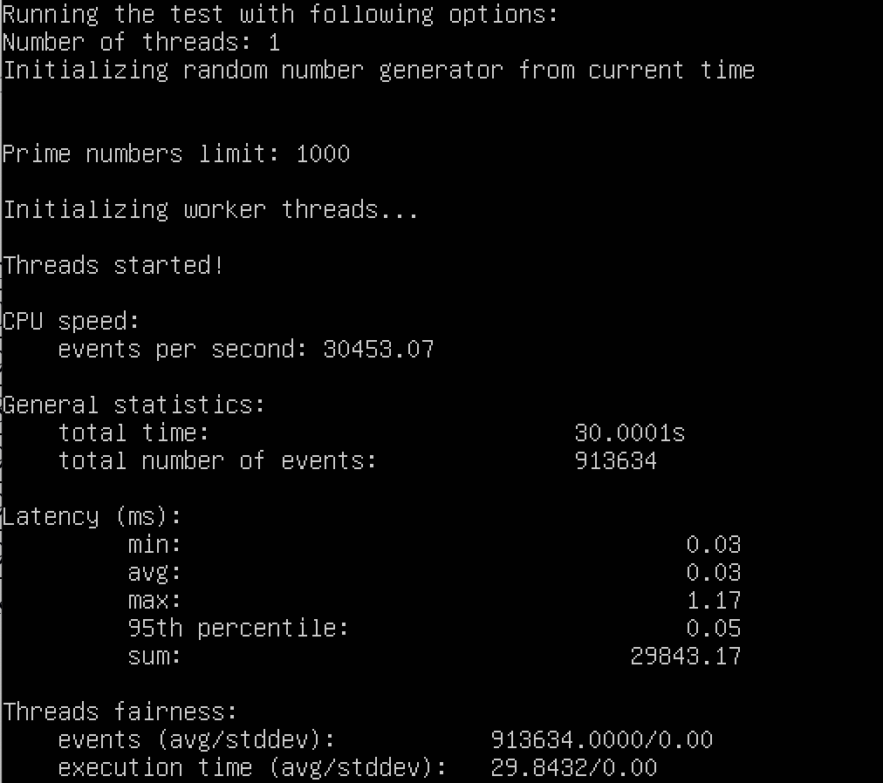



Docker:

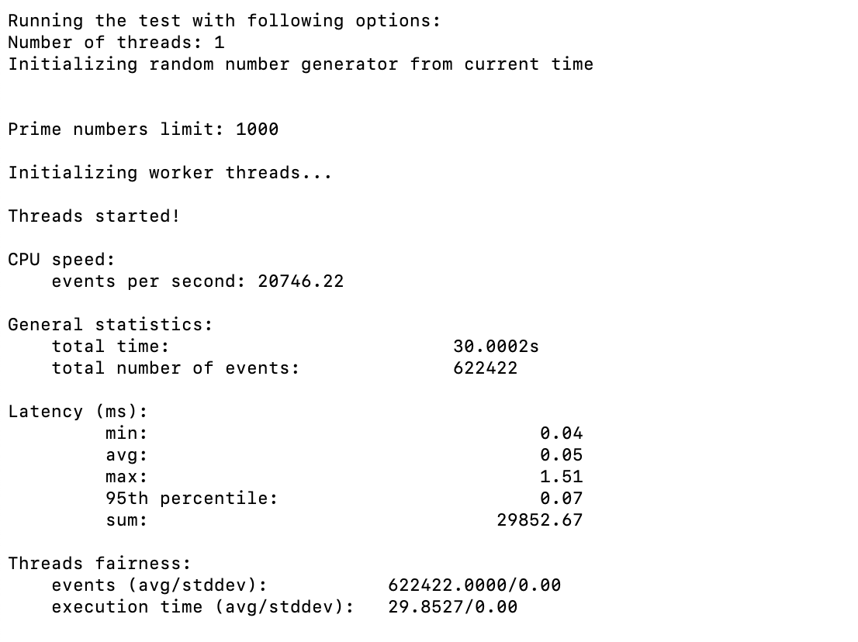

QEMU:

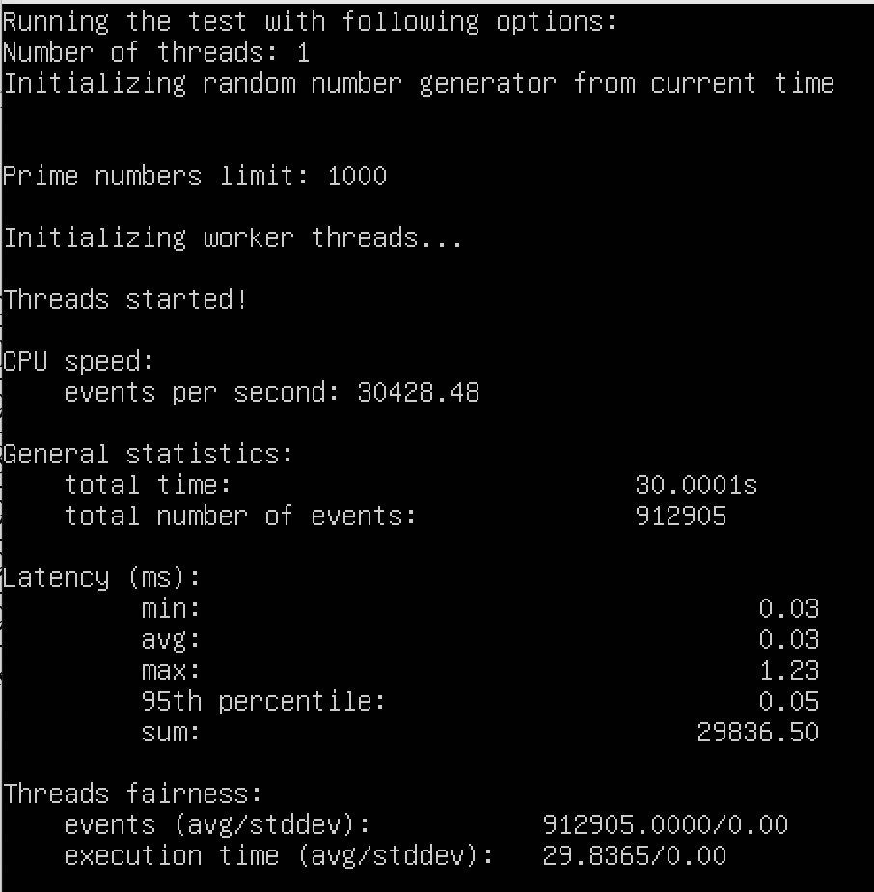



Docker:

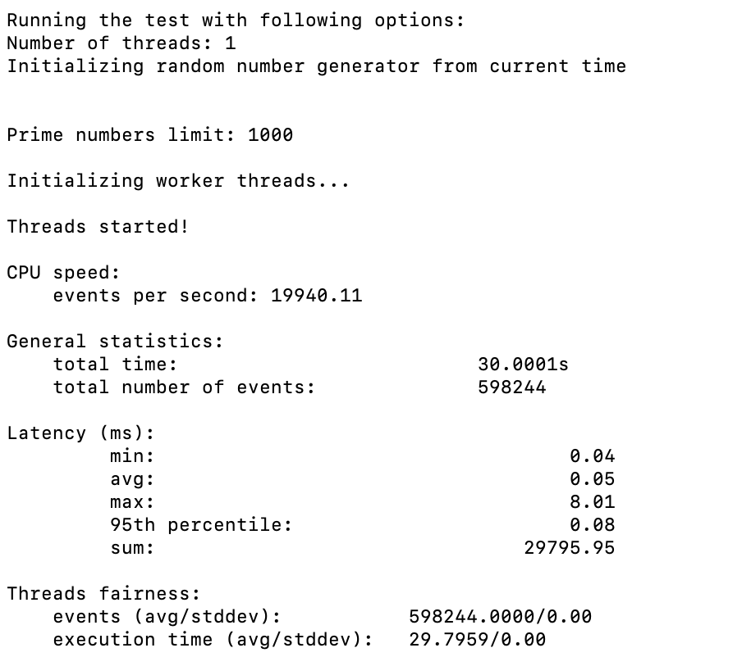

QEMU:

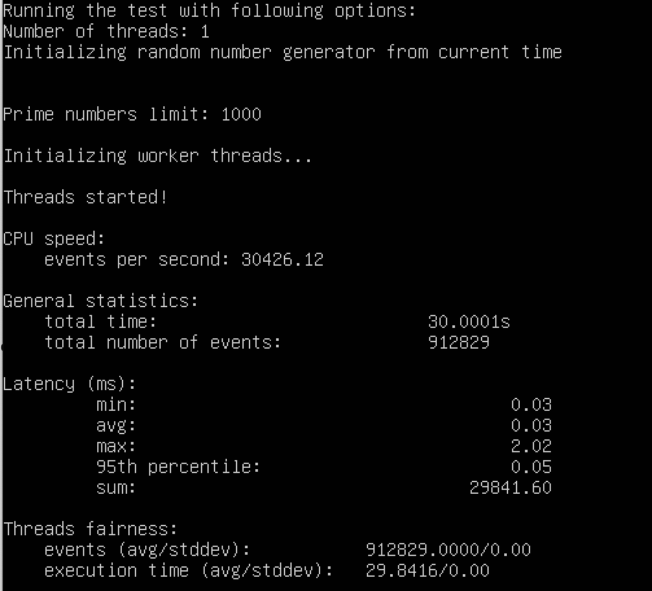

**B.**

CPU = 4, Memory = 16G, threads = 1, max-prime = 1000, time = 30s

a.

Docker:

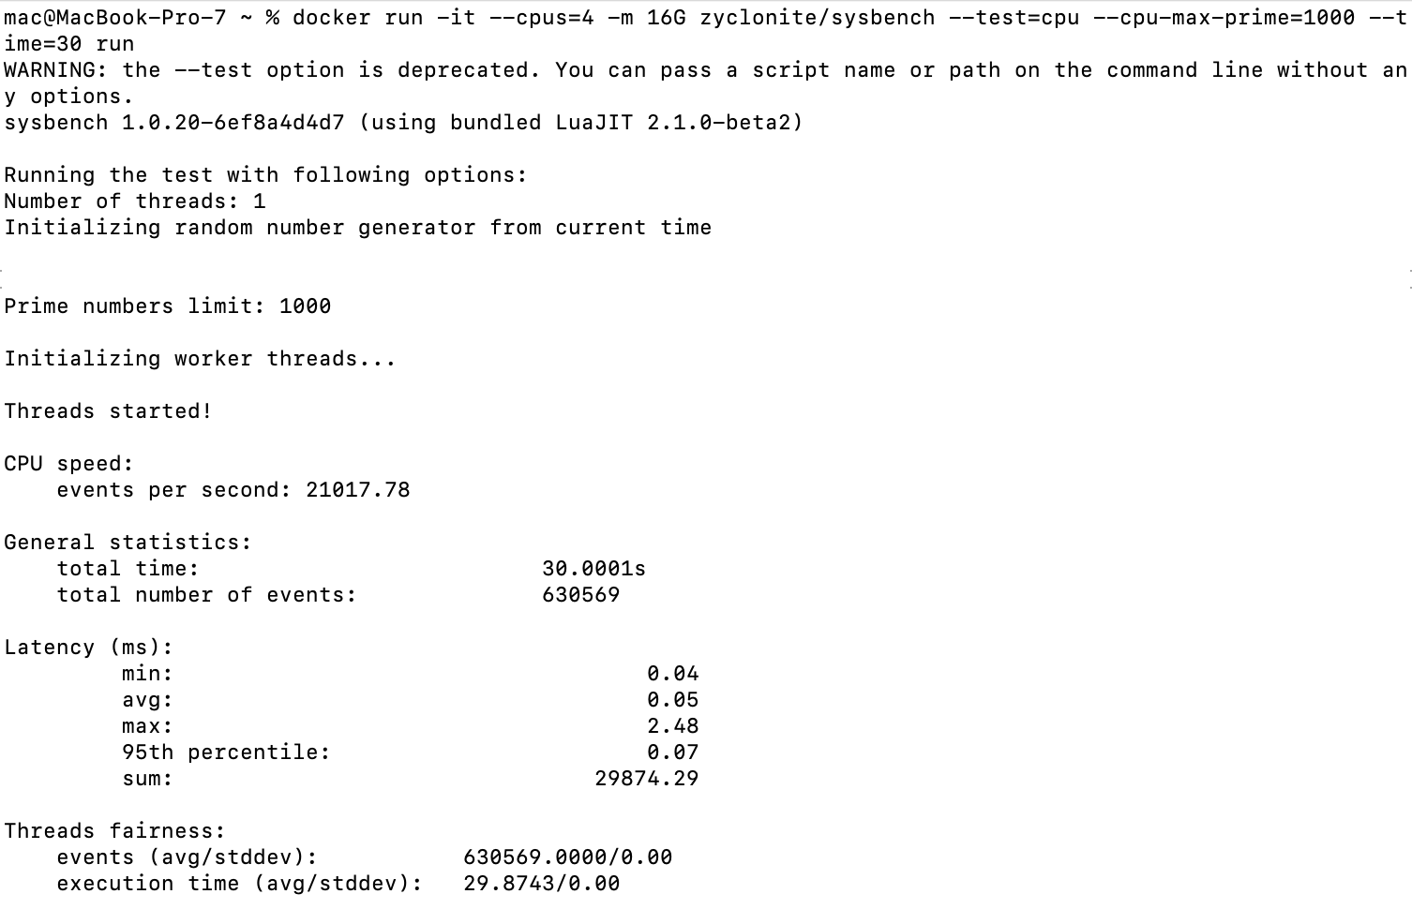

QEMU:

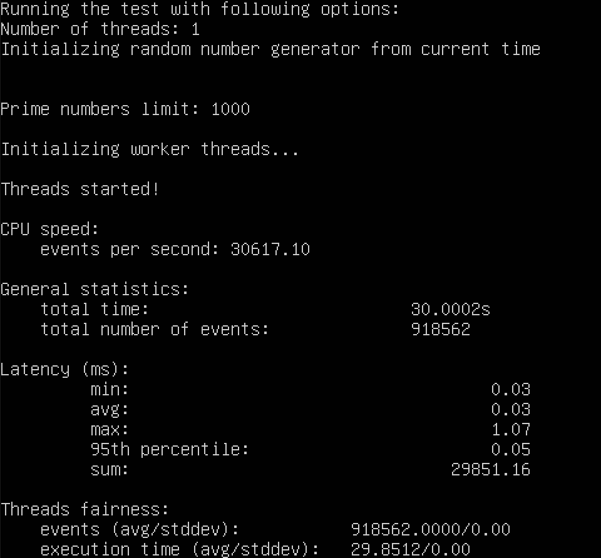

b.

Docker:

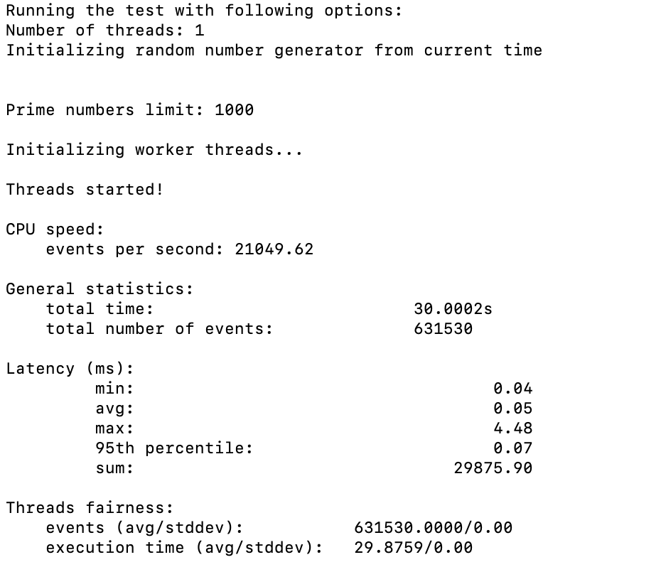

QEMU:

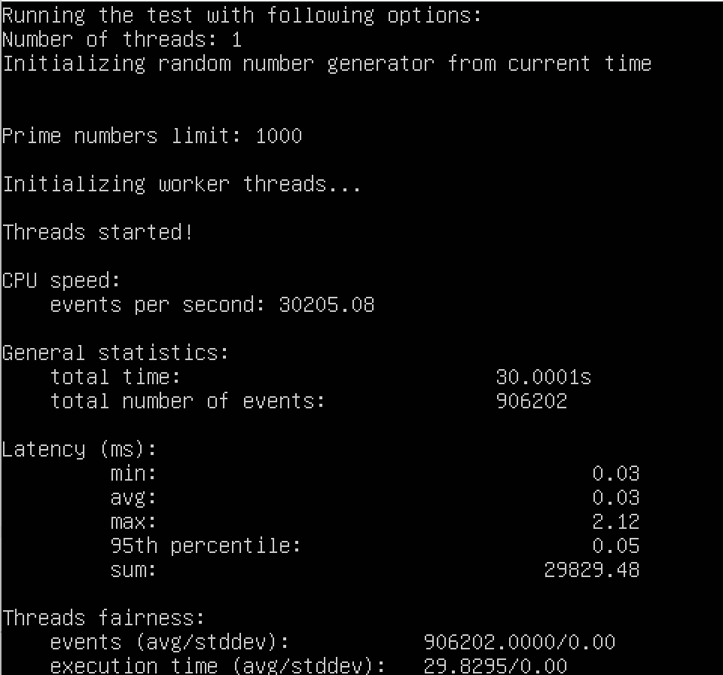

c.

Docker:

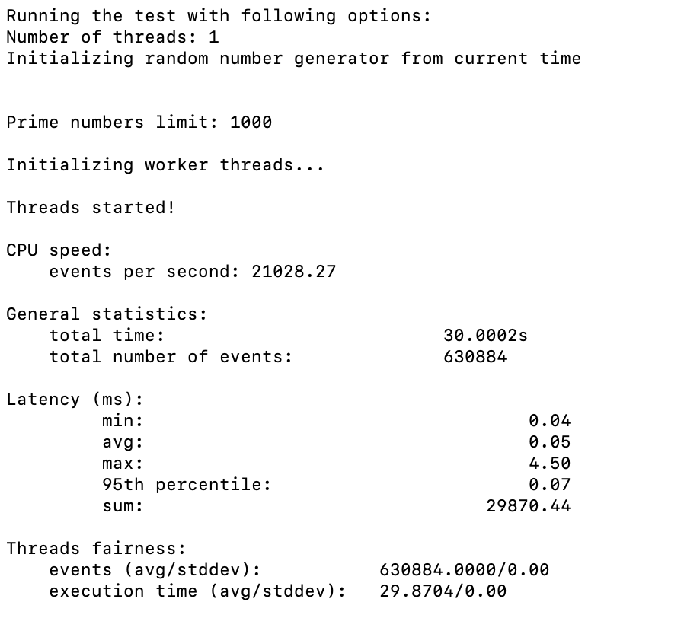

QEMU:

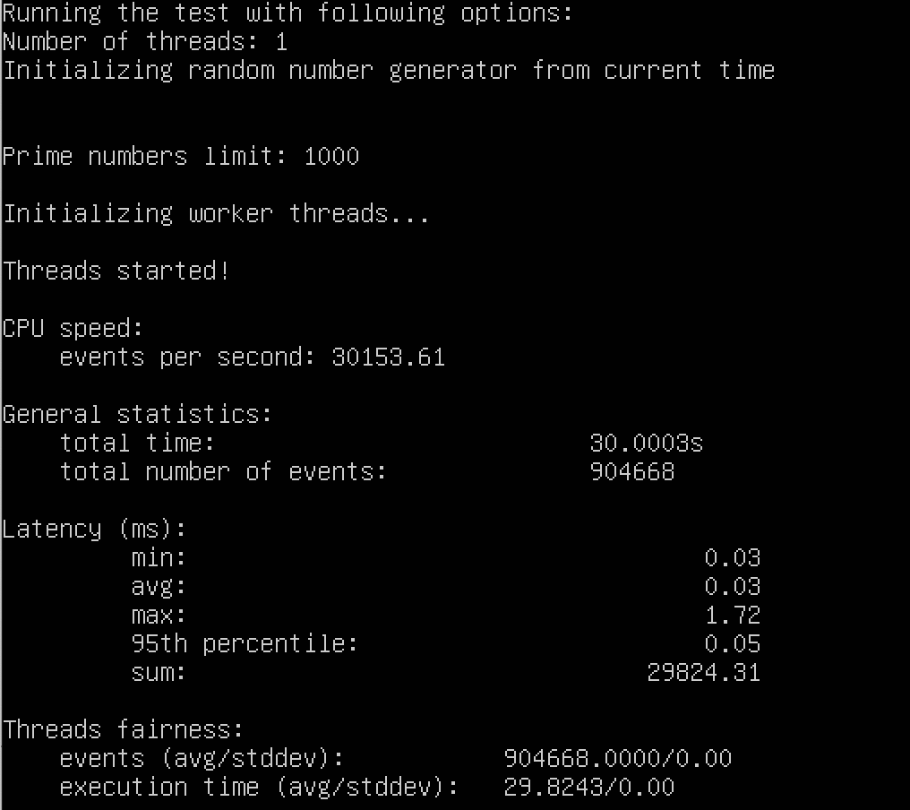

d.

Docker:

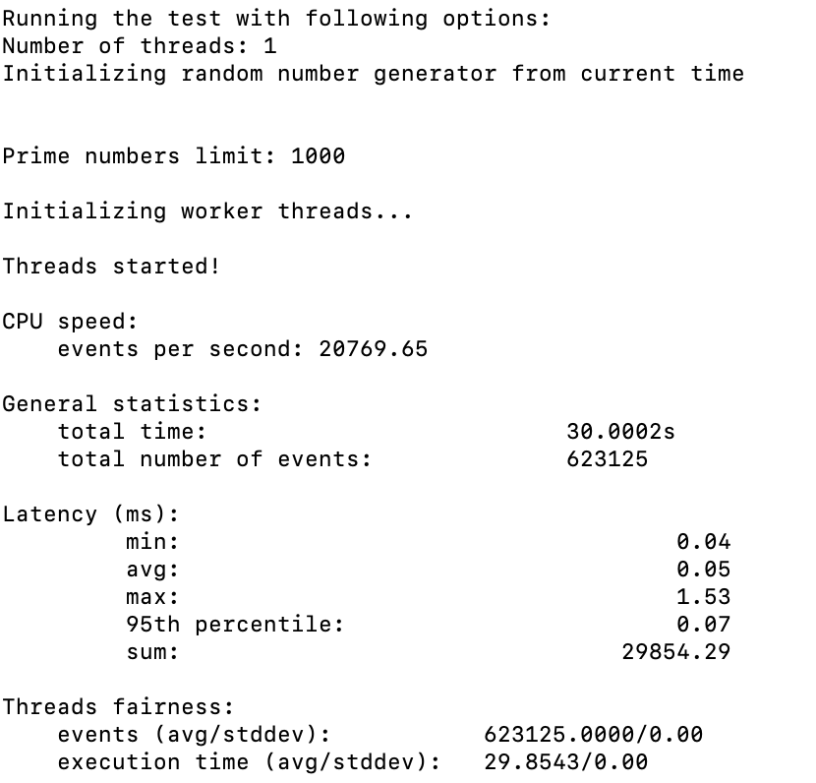

QEMU:

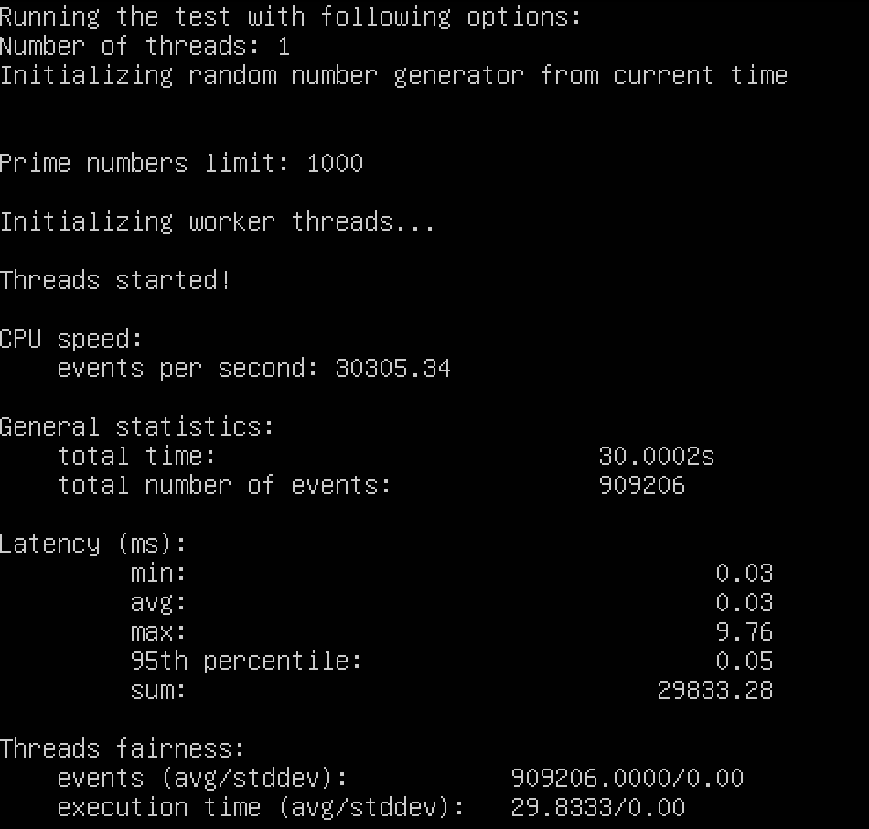

e.

Docker:

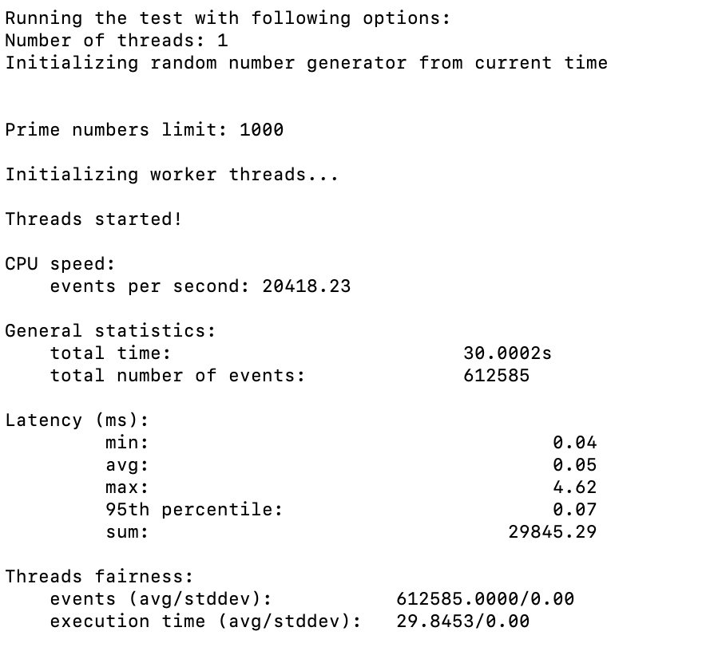

QEMU:

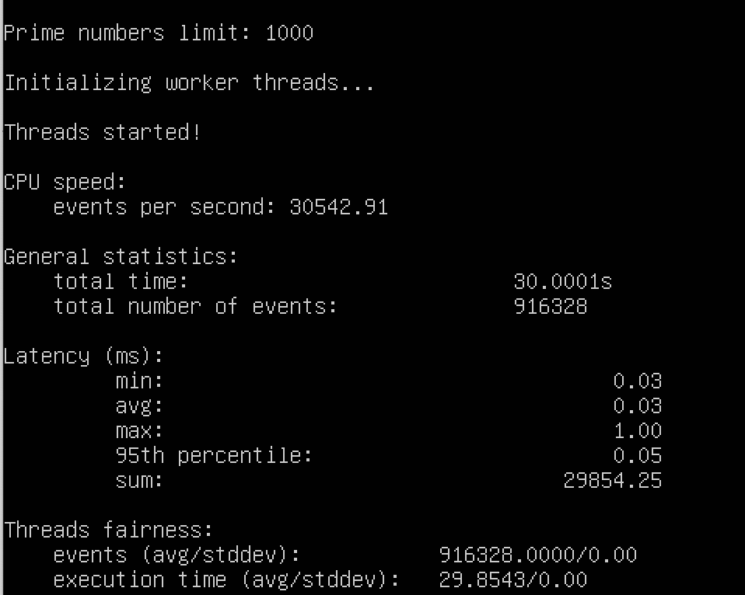

**C.**

CPU = 4, Memory = 4G, threads = 1, max-prime = 1000, time = 30s

a.

Docker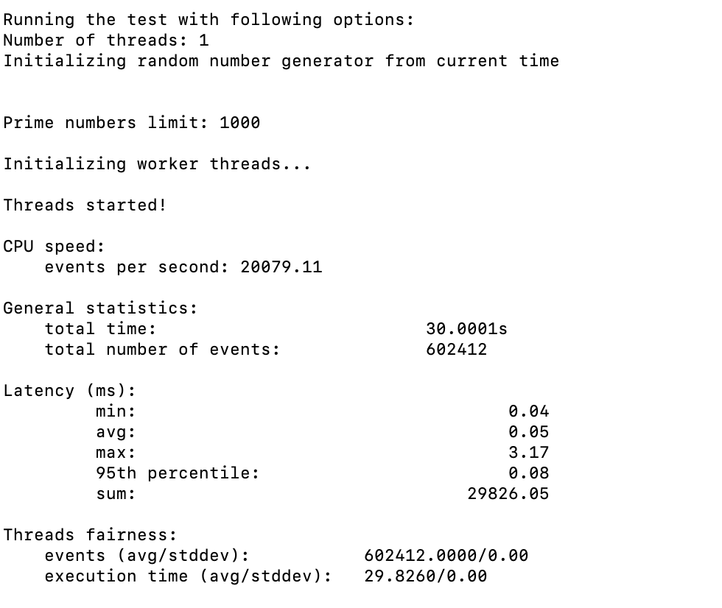

QEMU:

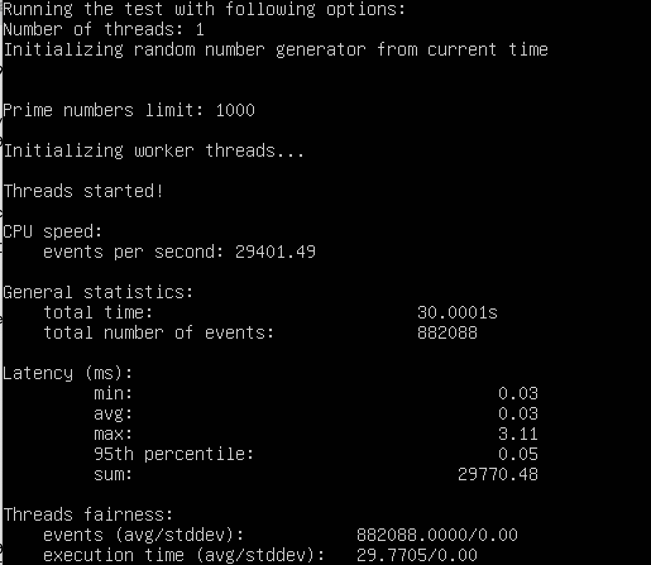

b.

Docker:

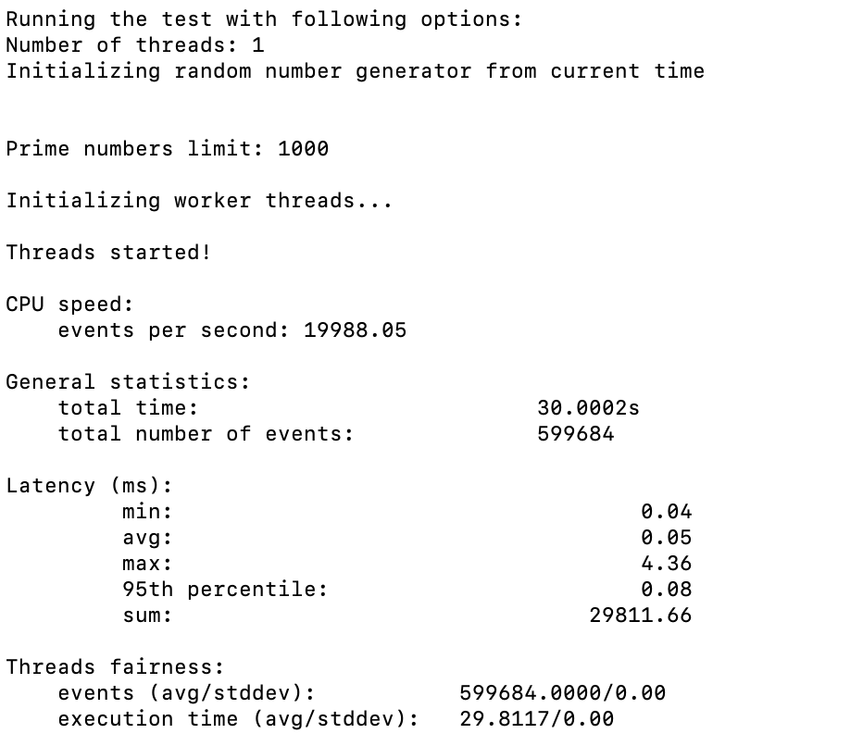

QEMU:

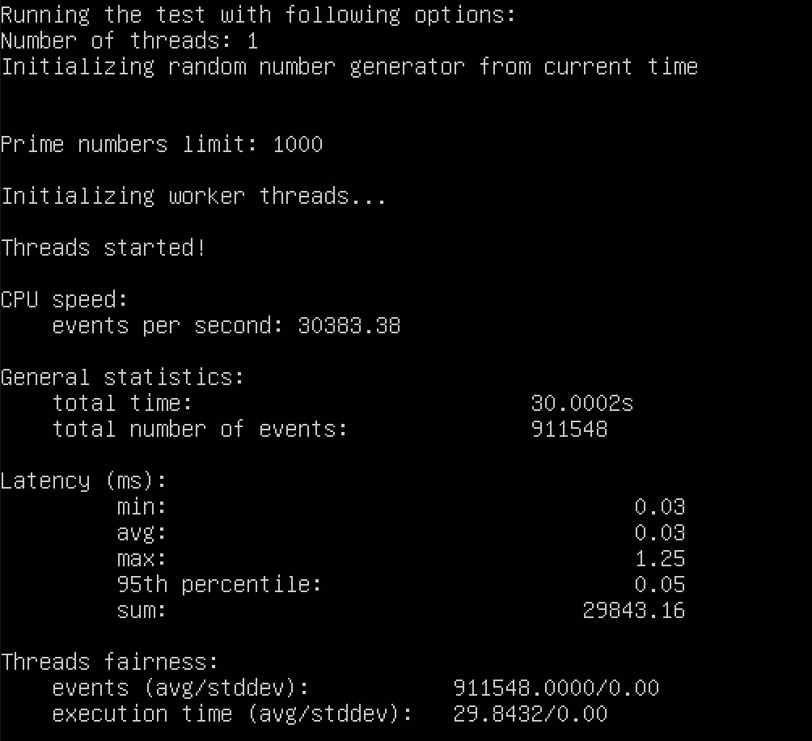

c.

Docker:

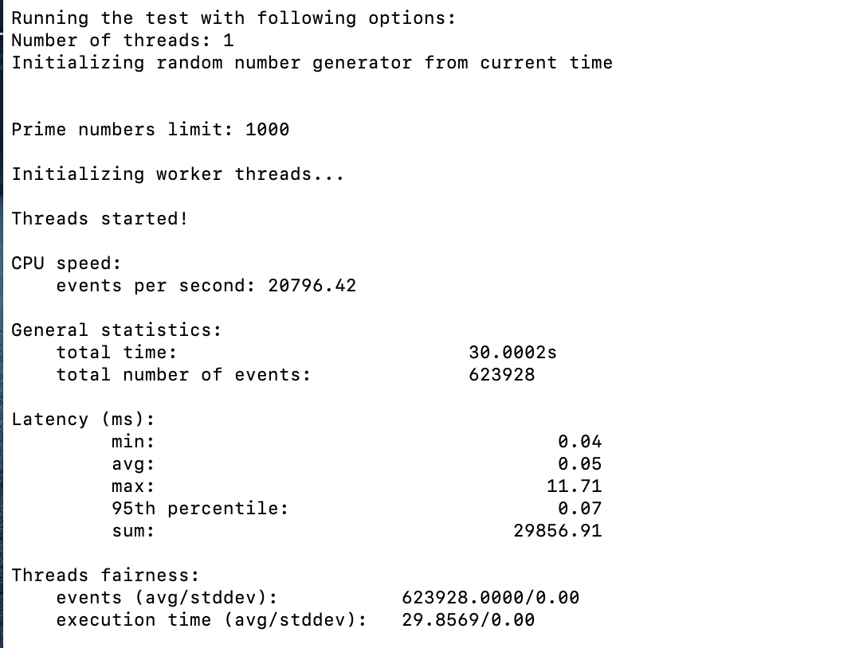

QEMU:

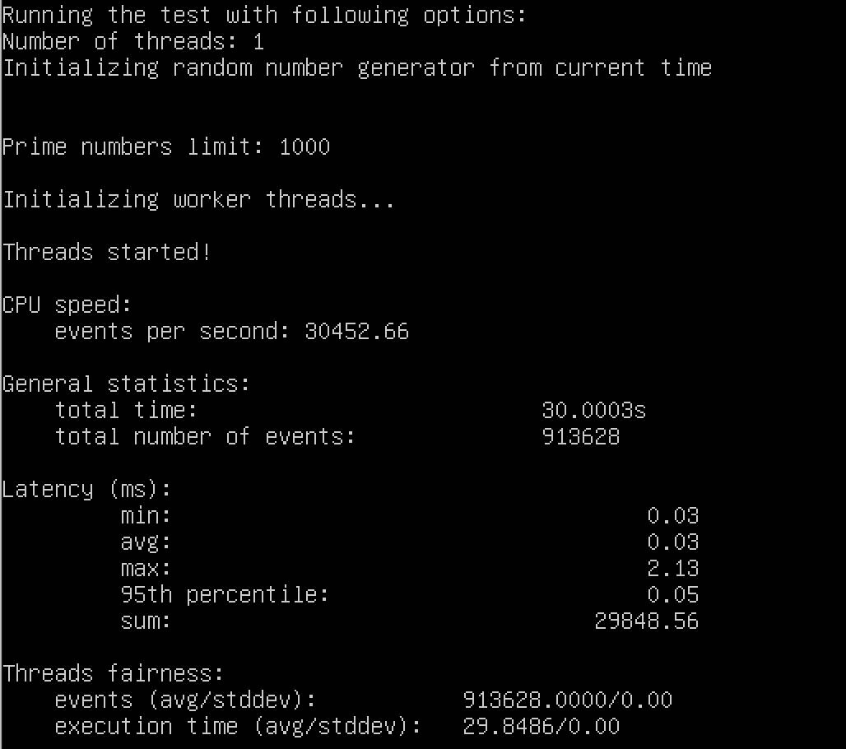

d.

Docker:

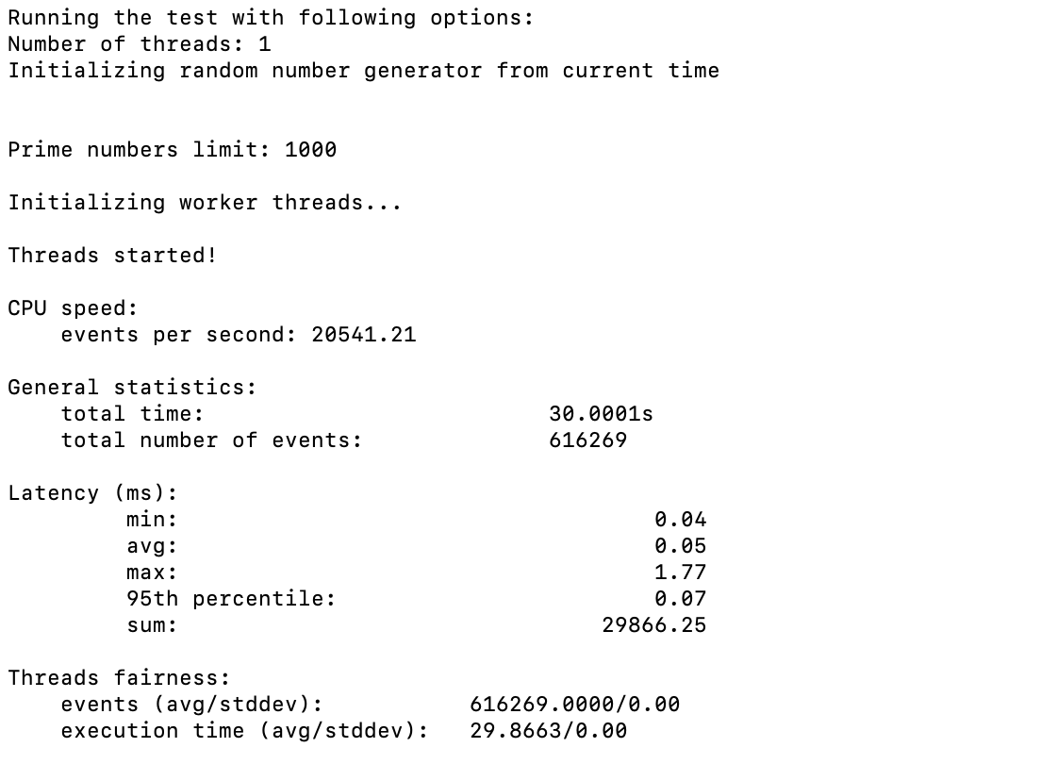

QEMU:

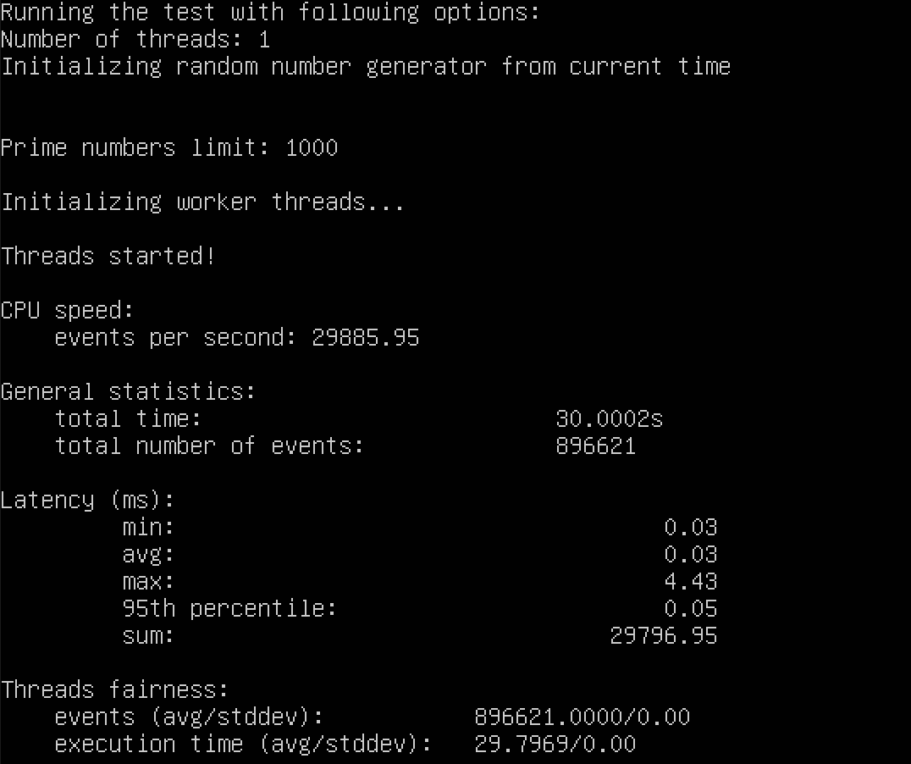

e.

Docker:

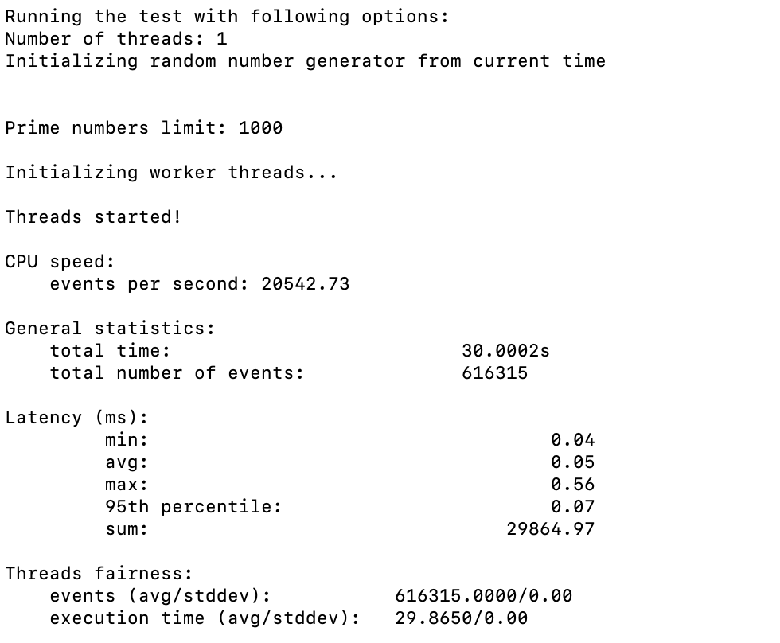

QEMU:

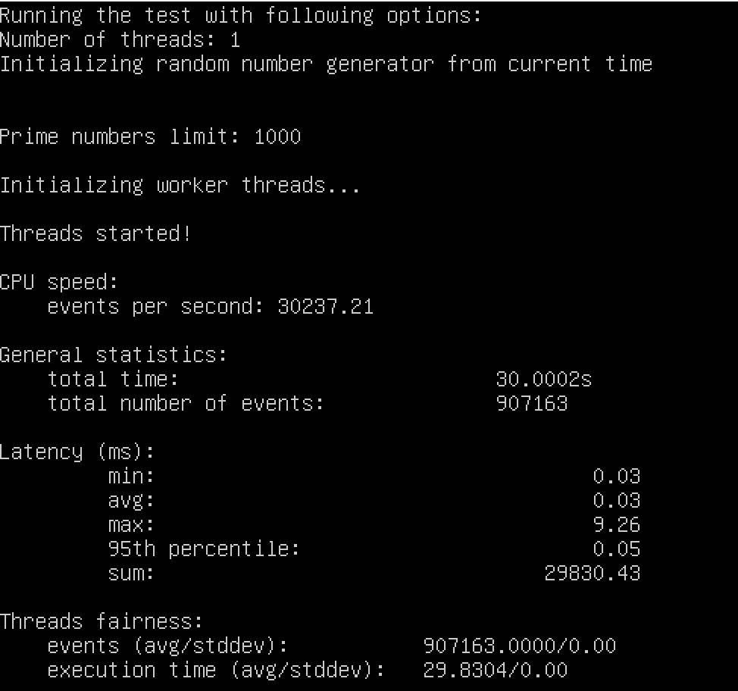

**File I/O Test:**

1. a.CPU = 4, Memory = 16G, file-total-size=1G file-test-mode=rndrw, time = 10s(default)

**Docker:**

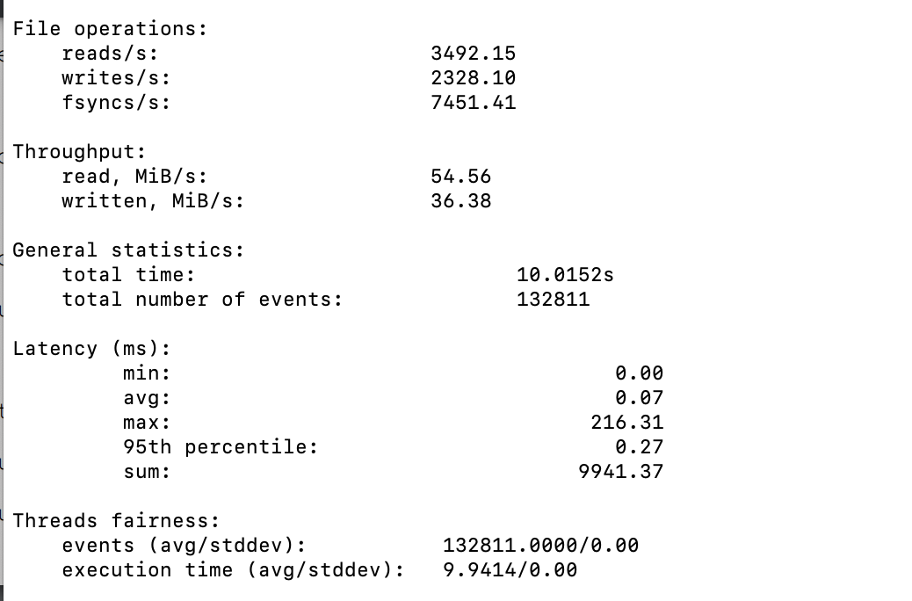

**QEMU:**

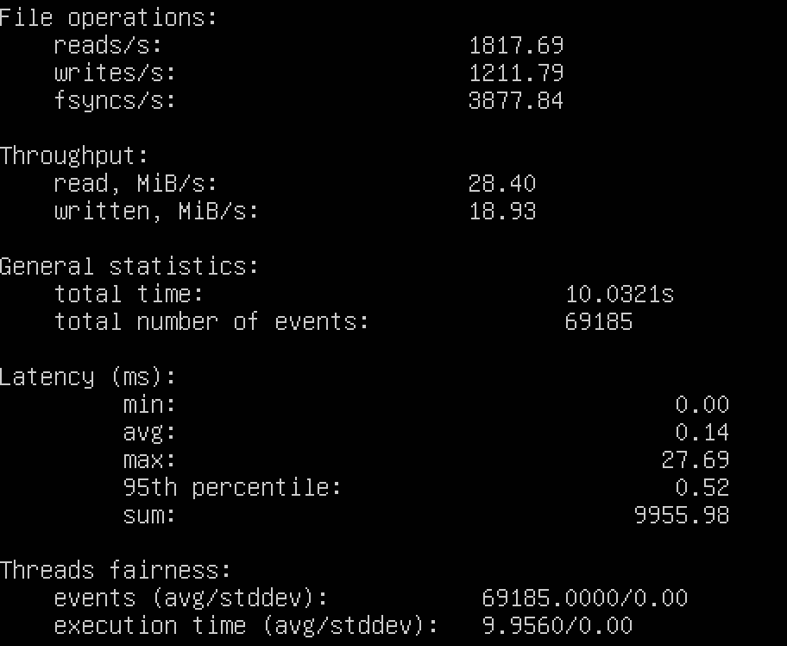

b.

Docker:

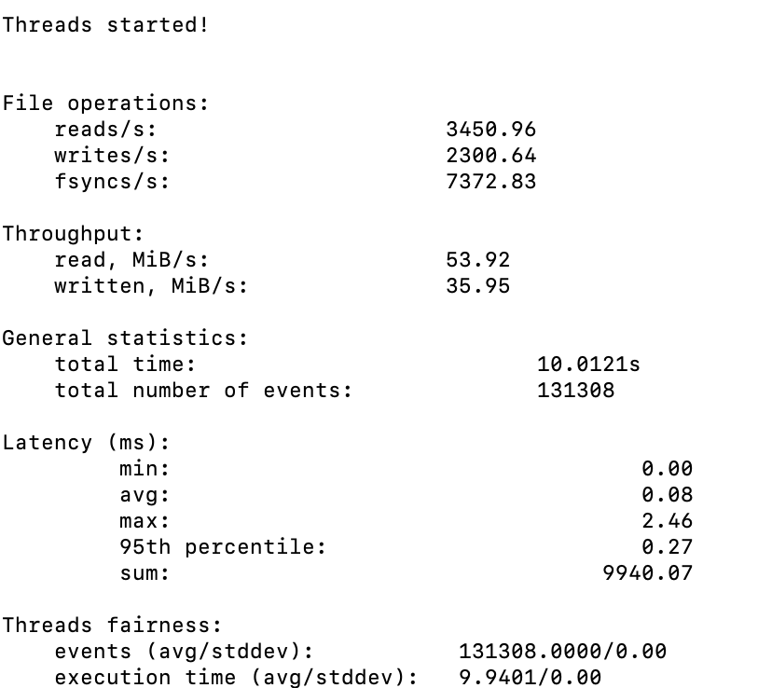

QEMU:

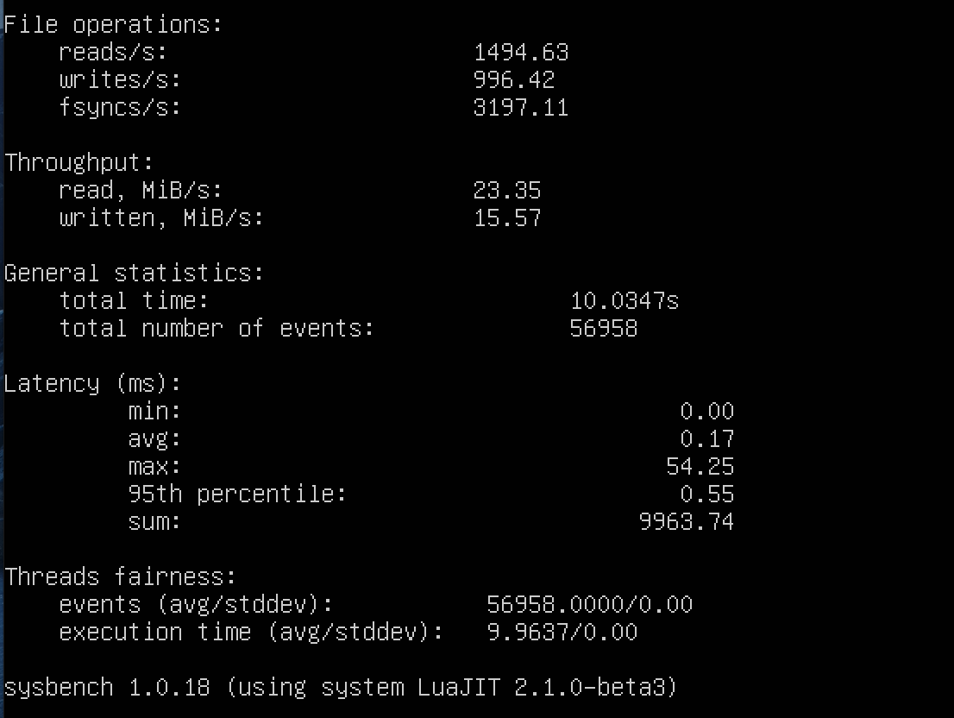

c.

Docker:

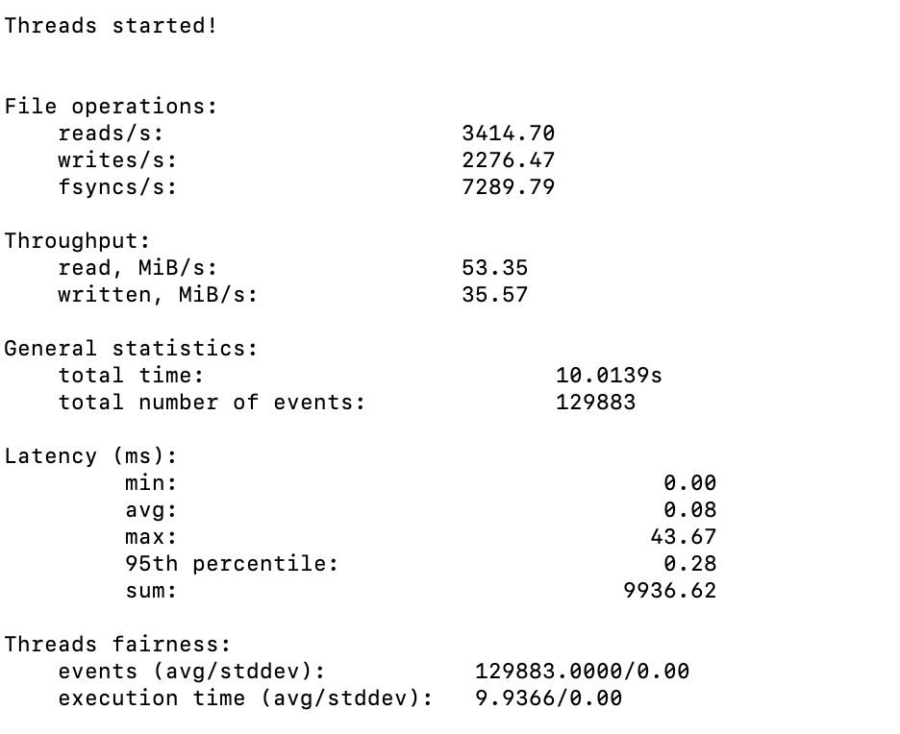

QEMU:

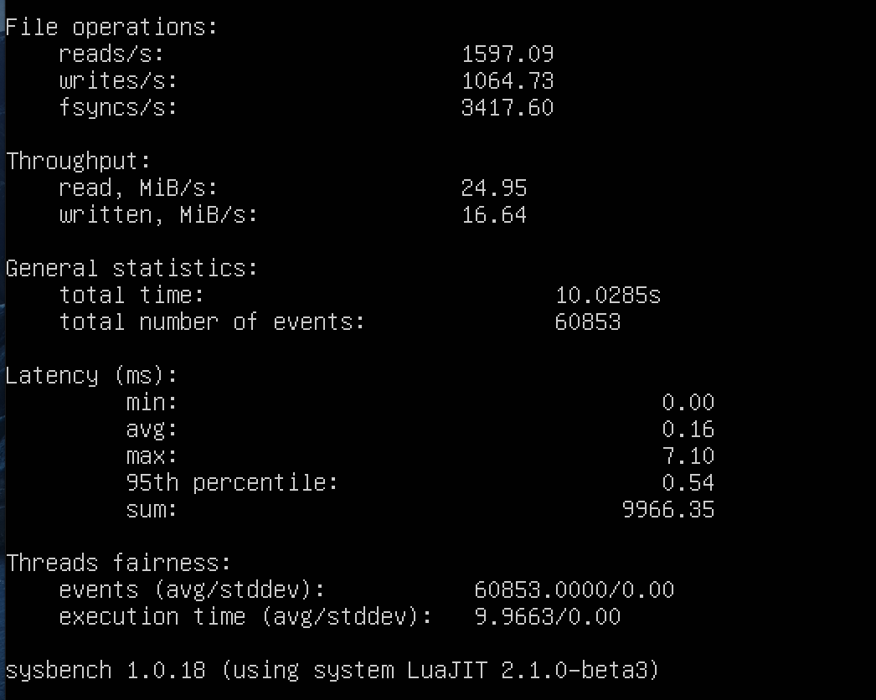

d.

Docker:

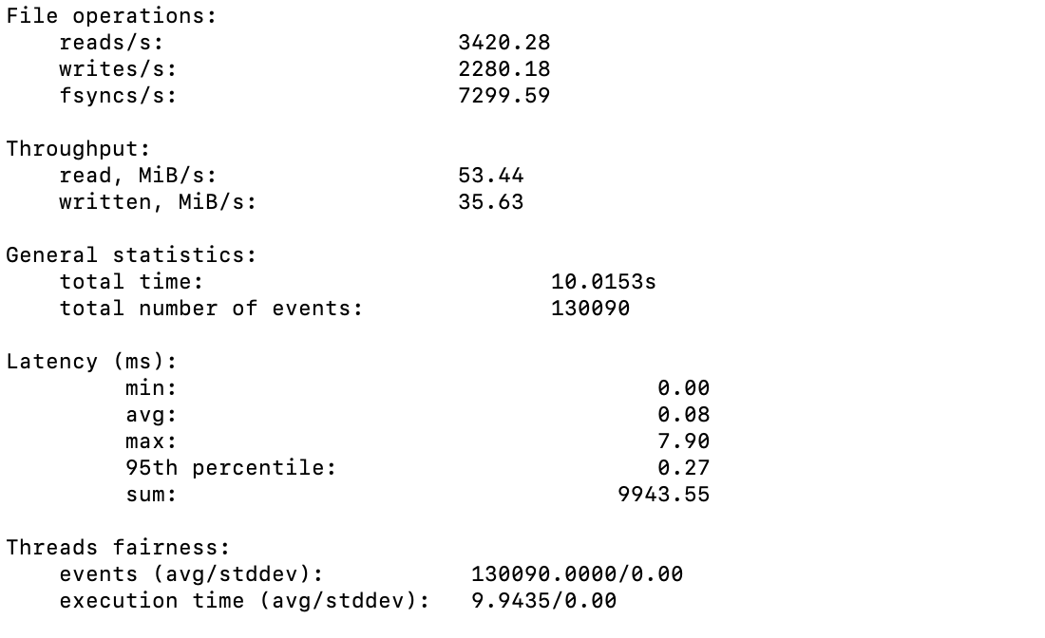

QEMU:

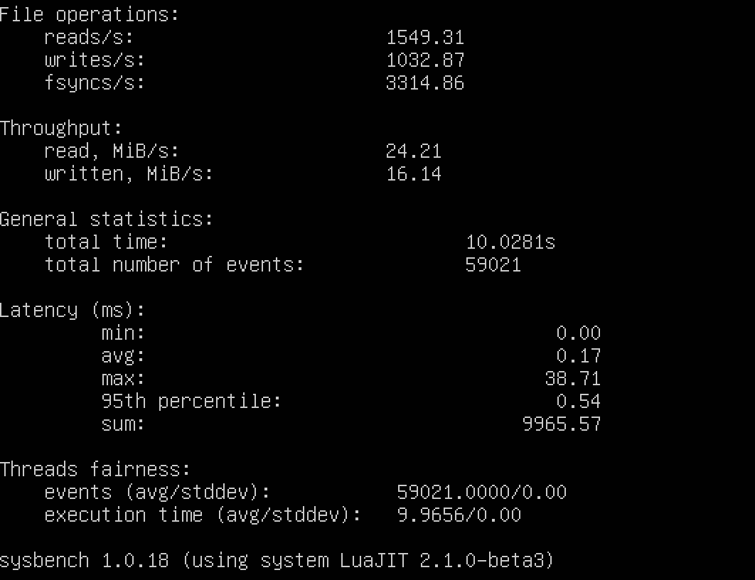

e.

Docker:

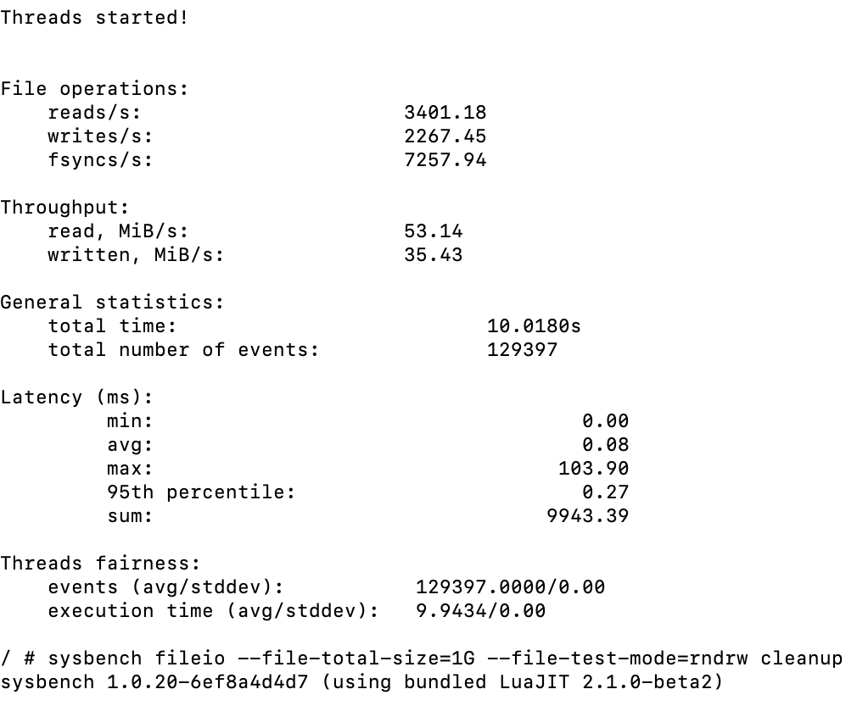

QEMU:

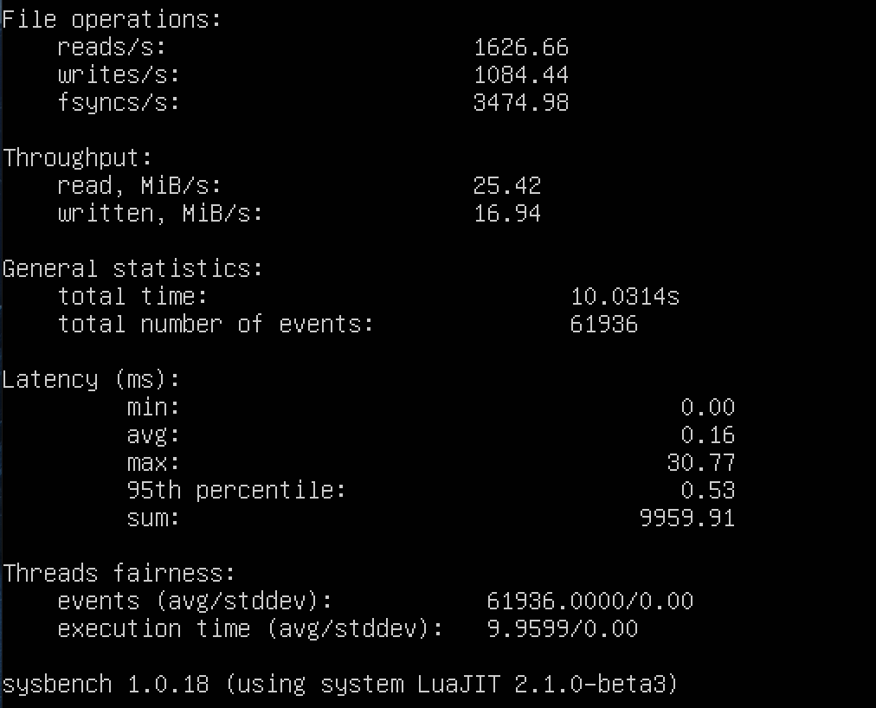

**B.**

CPU = 4, Memory = 4G, file-total-size=1G file-test-mode=rndrw, time = 10s(default)

a.

Docker:

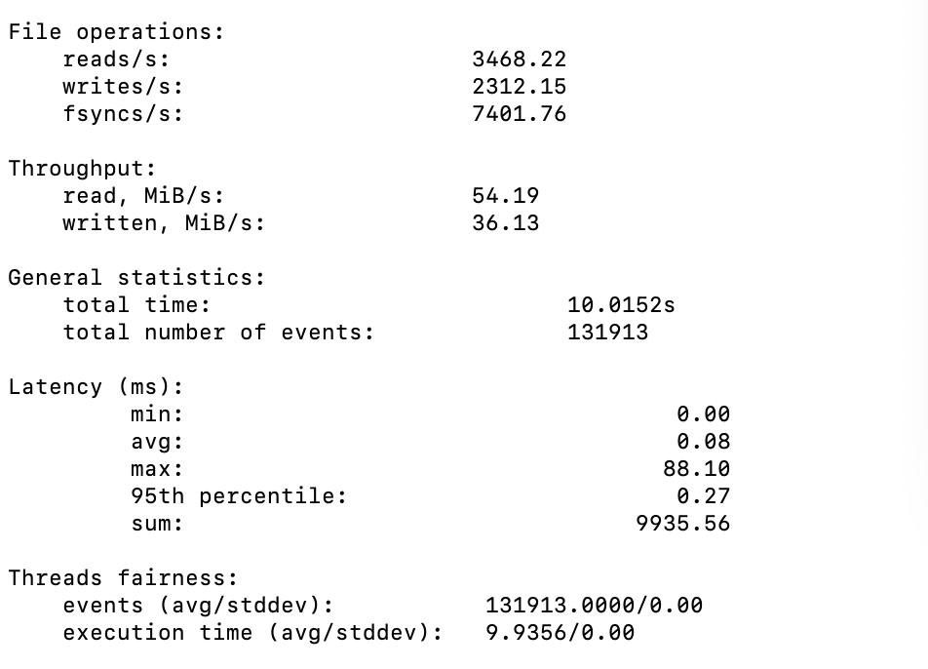

QEMU:

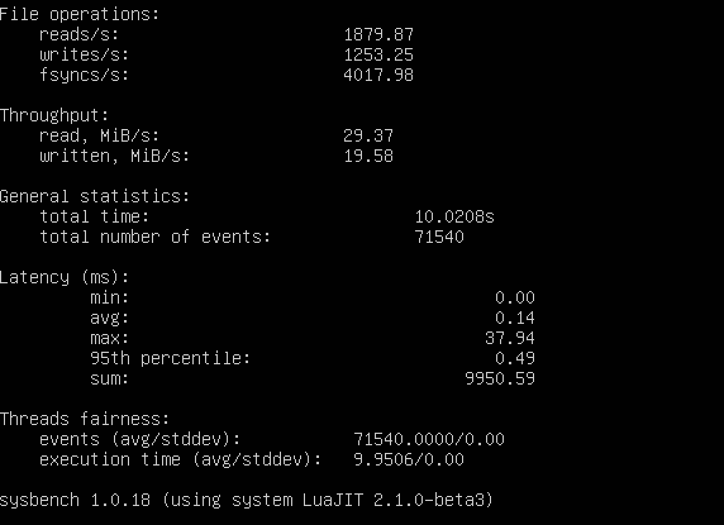

b.

Docker:

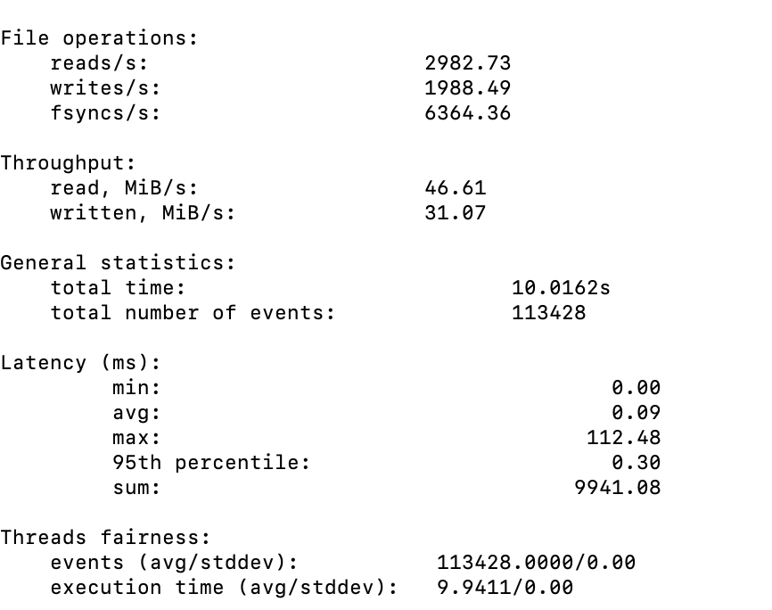

QEMU:

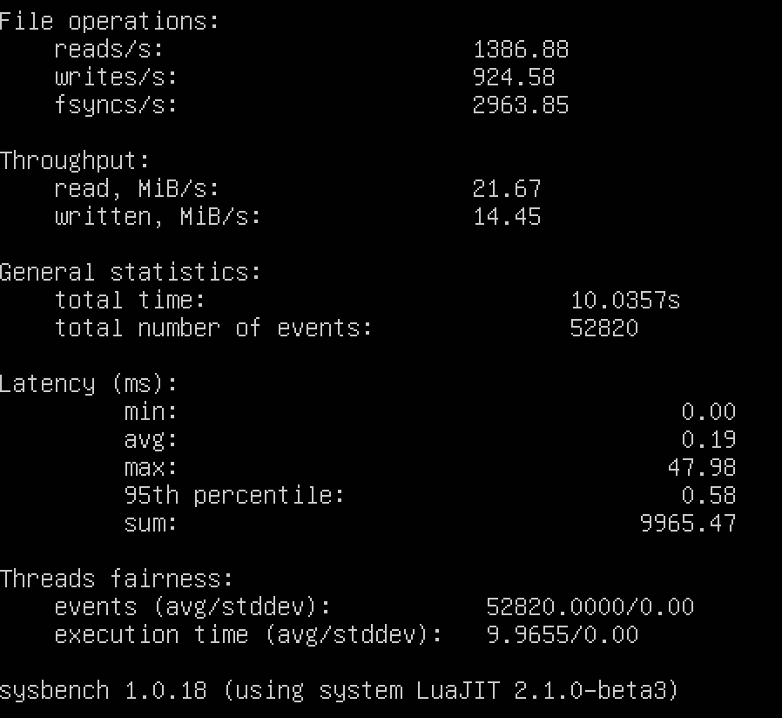

c.

Docker:

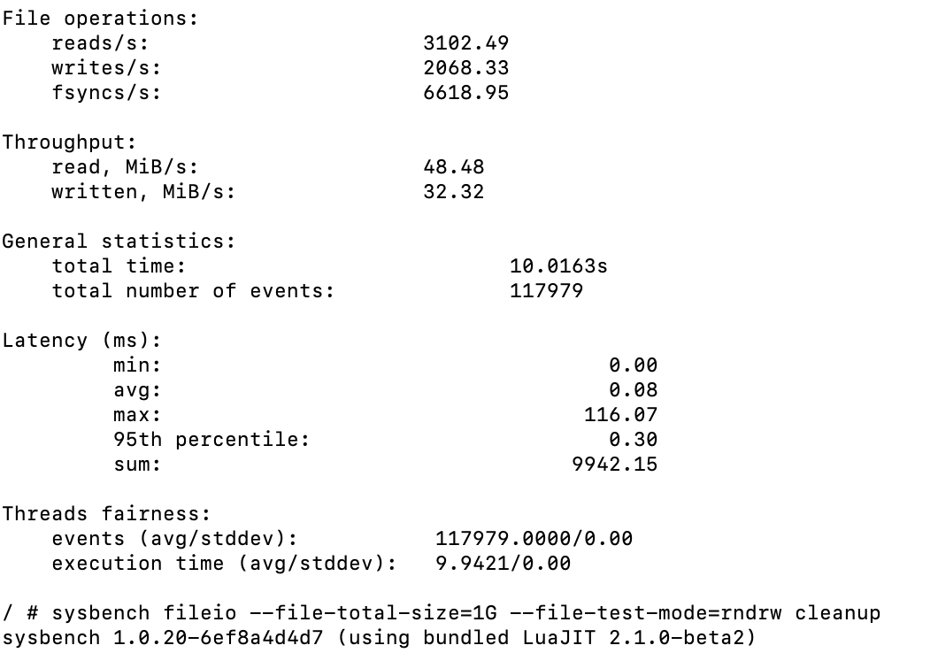

QEMU:

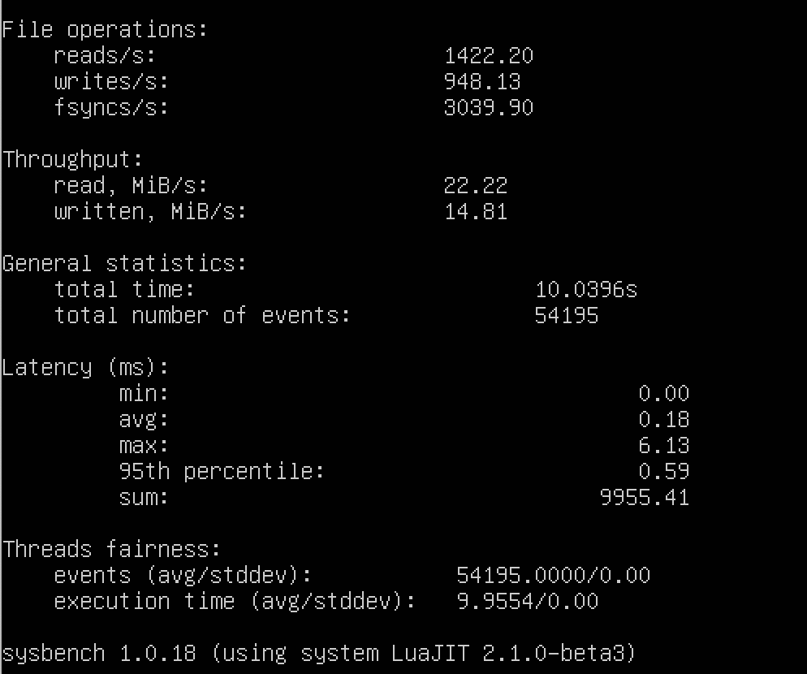

d.

Docker:

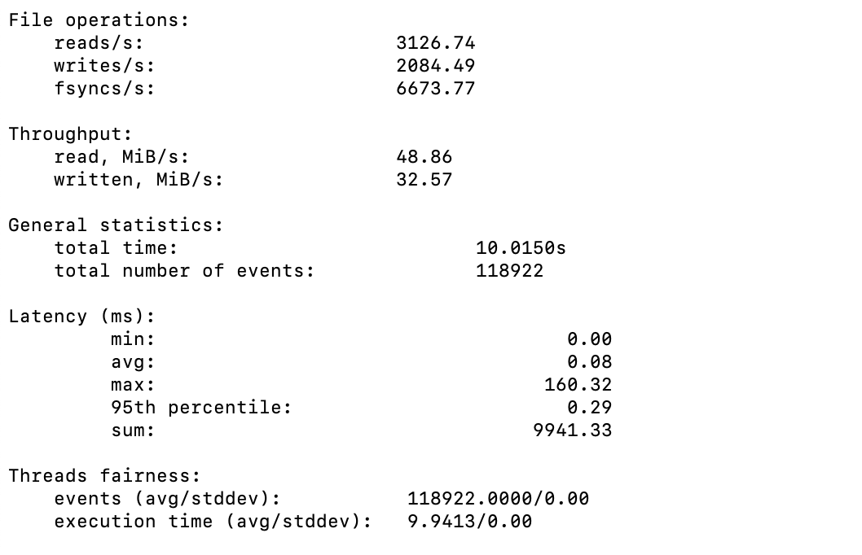

QEMU:

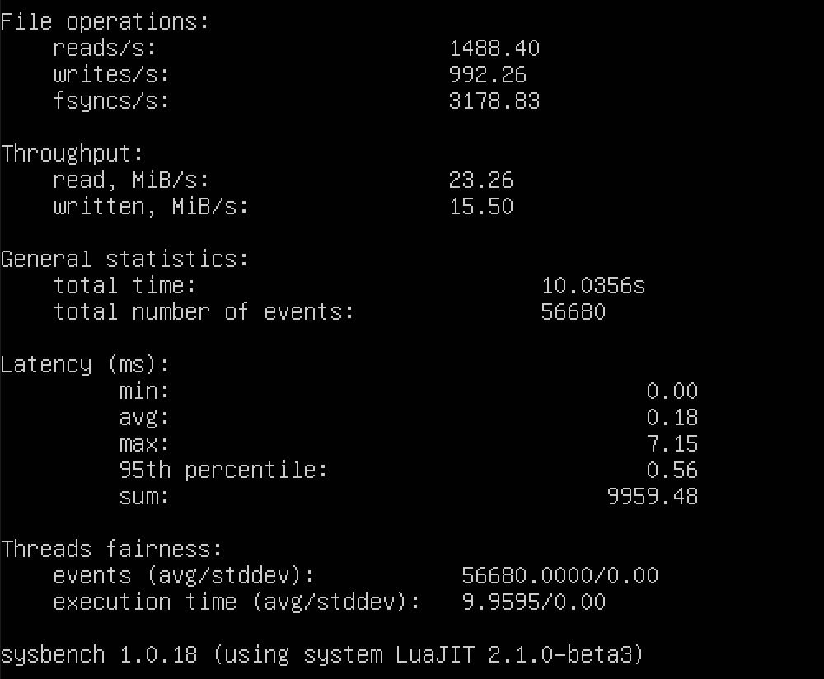

e.

Docker:

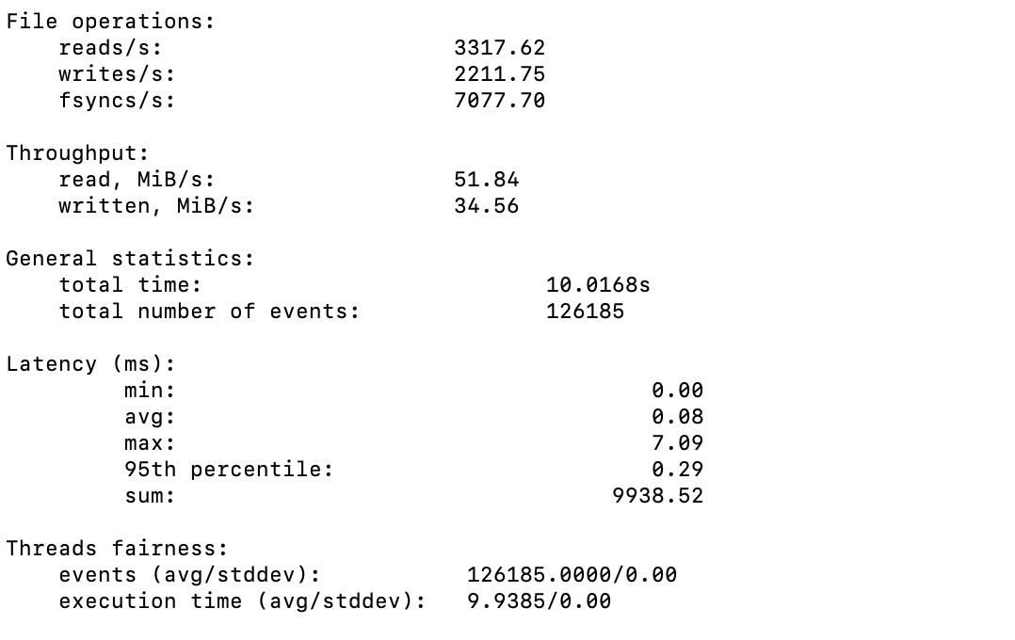

QEMU:

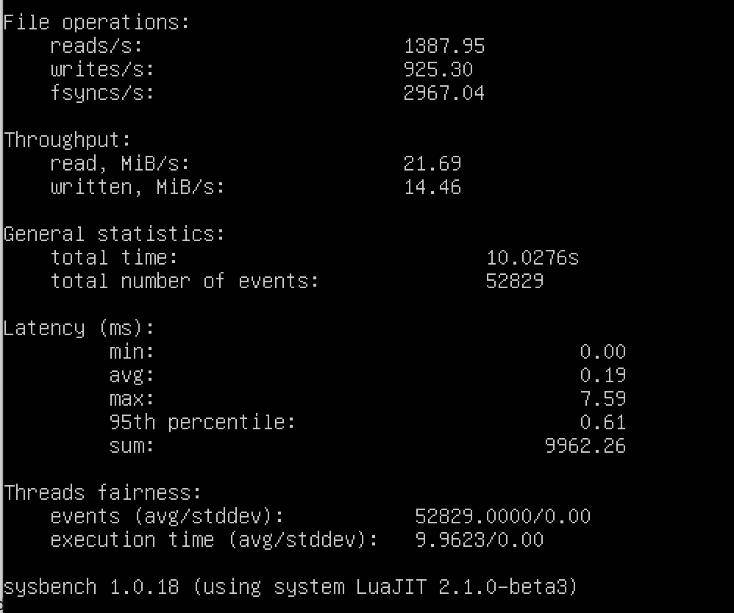

**C.**

CPU = 1, Memory = 16G, file-total-size=1G file-test-mode=rndrw, time = 10s(default)

a.

Docker:

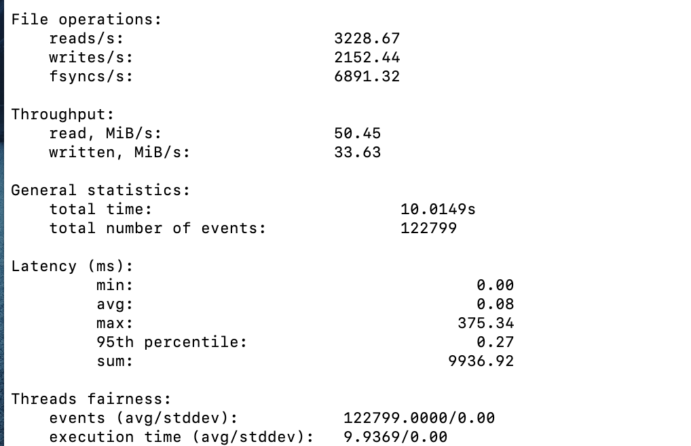

QEMU:

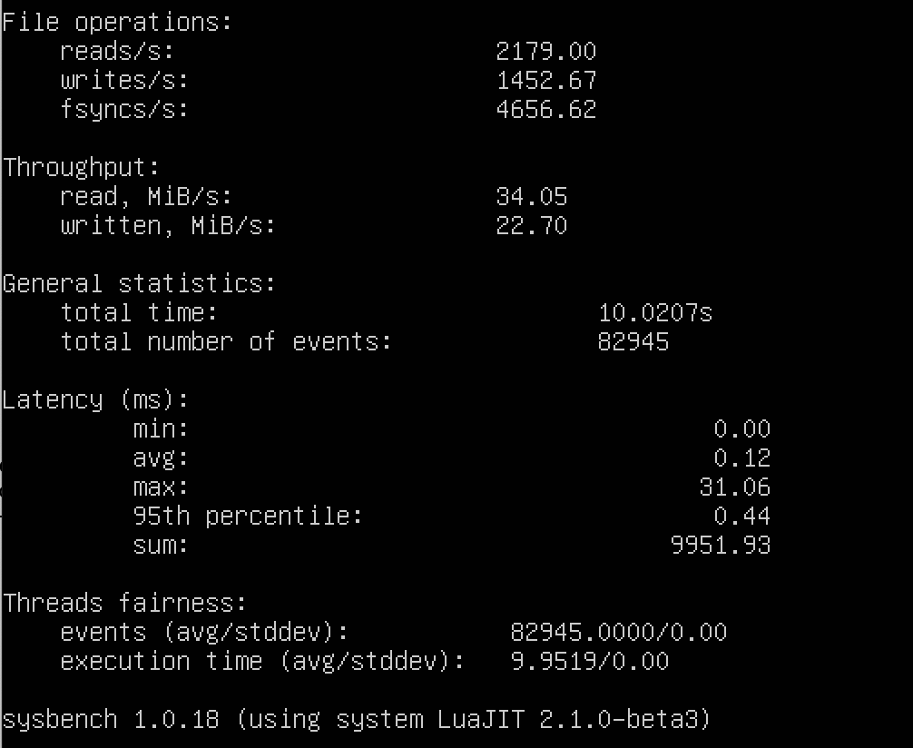

b.

Docker:

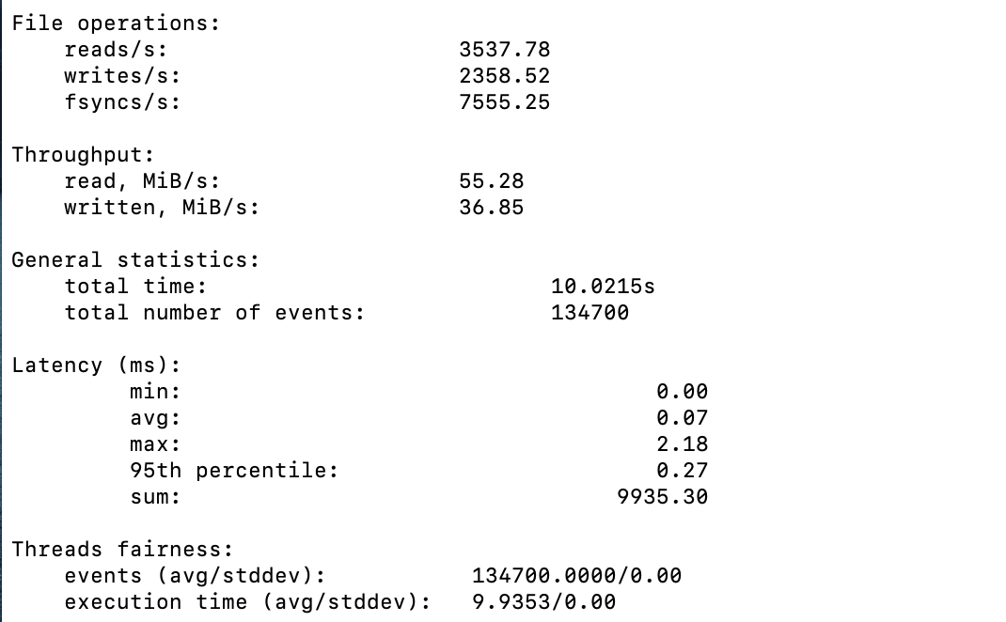

QEMU:

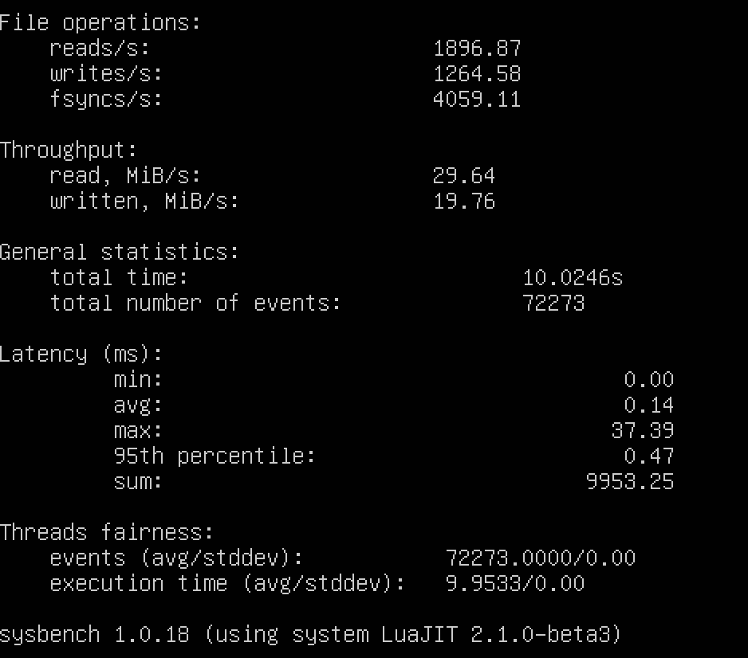

c.

Docker:

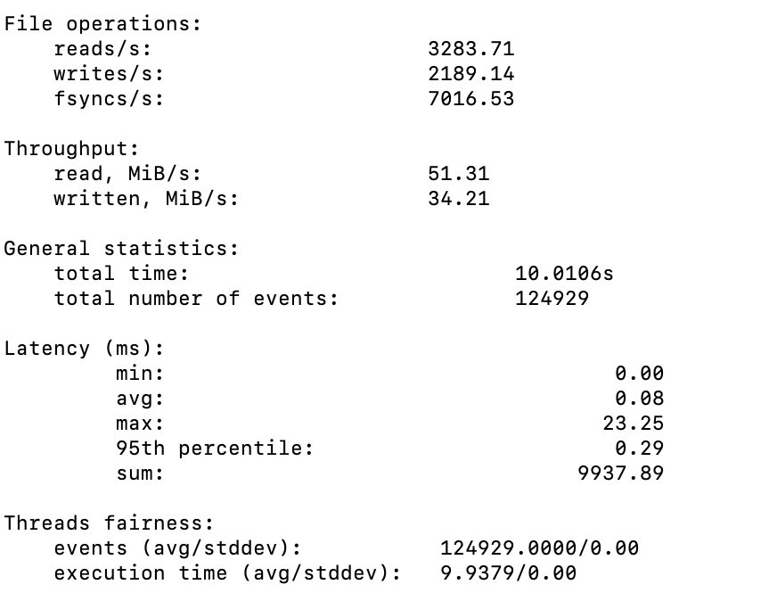

QEMU:

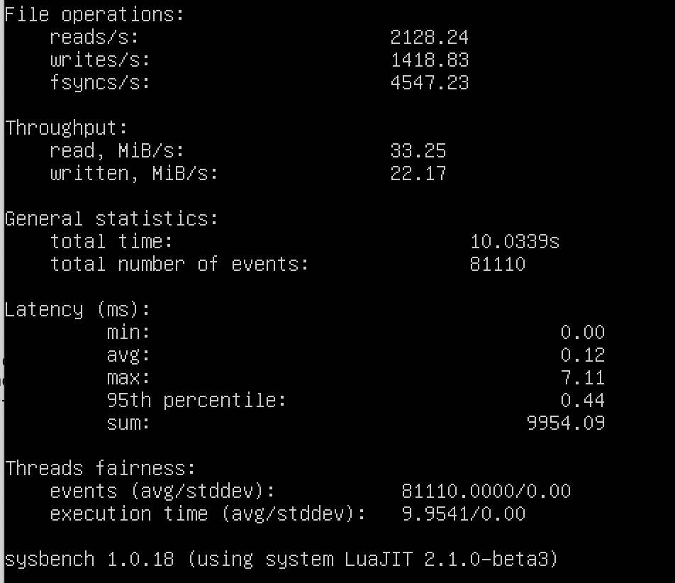

d.

Docker:

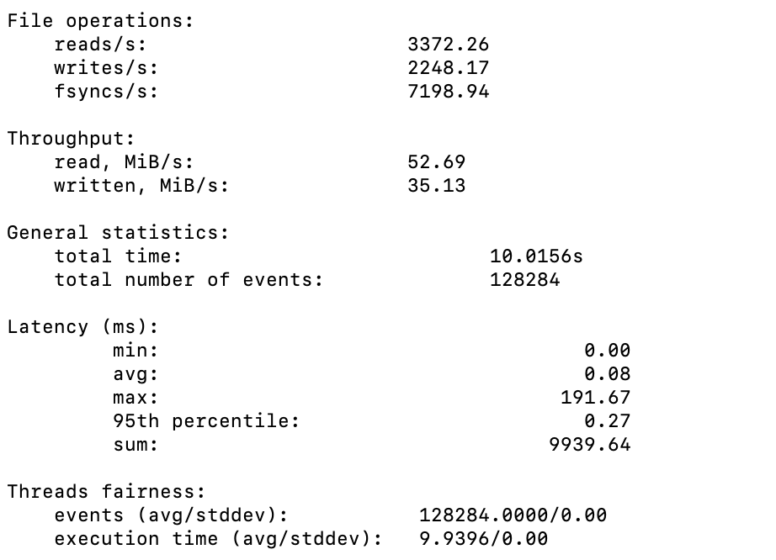

QEMU:

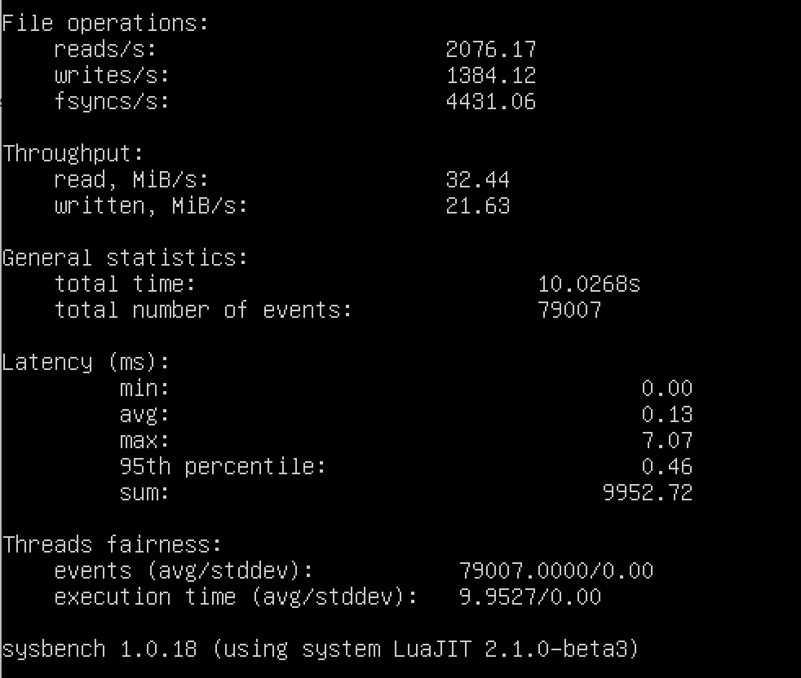

e.

Docker:

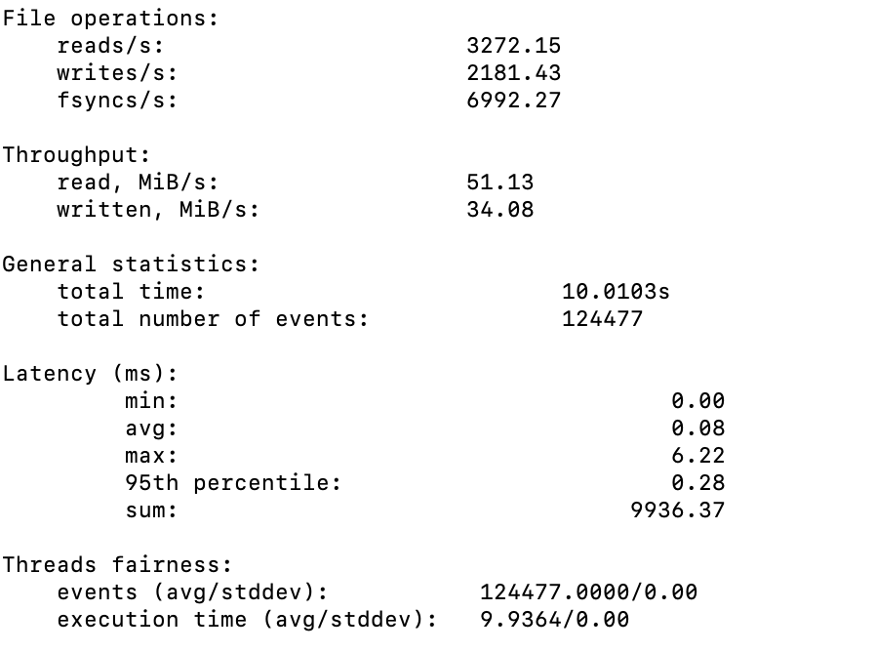

QEMU:

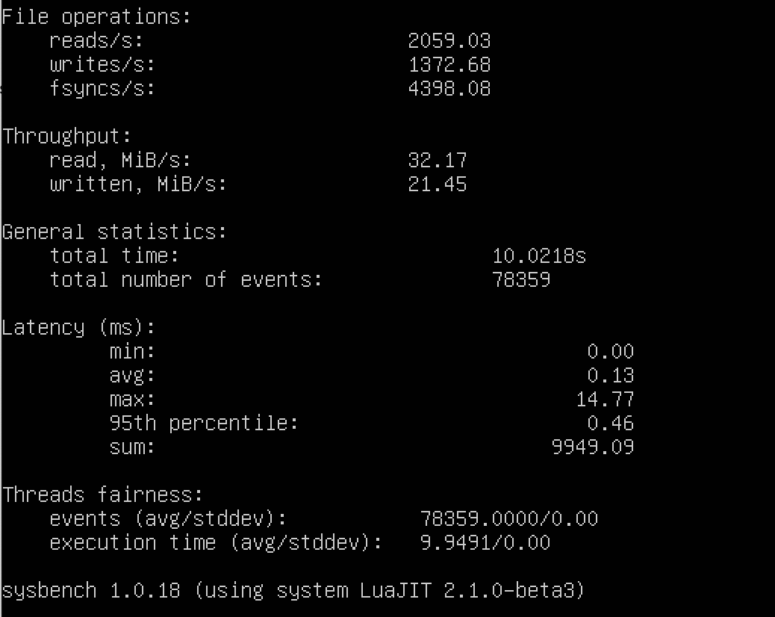

1. How I conduct my measurements in three different scenarios for each virtualization technology:
2. Shell scripts for running the experiment:
3. Presentation and analysis of the performance data：

**CPU Test:**

**A.**

CPU = 1, Memory = 16G, threads = 1, max-prime = 1000, time = 30s

|  |  |  |
| --- | --- | --- |
| CPU Speed(events/s) | Docker | VM |
| 1 | 20153.80 | 29760.84 |
| 2 | 20813.07 | 30160.61 |
| 3 | 20715.77 | 30453.07 |
| 4 | 20746.22 | 29447.38 |
| 5 | 19940.11 | 30426.12 |

|  |  |  |  |  |  |  |  |  |
| --- | --- | --- | --- | --- | --- | --- | --- | --- |
| Latency(ms) | Min | | Avg | | Max | | 95th percentile | |
| Docker | VM | Docker | VM | Docker | VM | Docker | VM |
| 1 | 0.04 | 0.03 | 0.05 | 0.03 | 8.10 | 3.13 | 0.07 | 0.05 |
| 2 | 0.04 | 0.03 | 0.05 | 0.03 | 2.88 | 4.66 | 0.07 | 0.05 |
| 3 | 0.04 | 0.03 | 0.05 | 0.03 | 1.38 | 1.17 | 0.07 | 0.05 |
| 4 | 0.04 | 0.03 | 0.05 | 0.03 | 1.51 | 1.23 | 0.07 | 0.05 |
| 5 | 0.04 | 0.03 | 0.05 | 0.03 | 8.01 | 2.02 | 0.08 | 0.05 |

**B.**

CPU = 4, Memory = 16G, threads = 1, max-prime = 1000, time = 30s

|  |  |  |
| --- | --- | --- |
| CPU Speed(Events/s) | Docker | VM |
| 1 | 21017.18 | 30617.10 |
| 2 | 21049.62 | 30205.08 |
| 3 | 21028.27 | 30153.61 |
| 4 | 20749.65 | 30305.34 |
| 5 | 20418.23 | 30542.91 |

|  |  |  |  |  |  |  |  |  |
| --- | --- | --- | --- | --- | --- | --- | --- | --- |
| Latency(ms) | Min | | Avg | | Max | | 95th percentile | |
| Docker | VM | Docker | VM | Docker | VM | Docker | VM |
| 1 | 0.04 | 0.03 | 0.05 | 0.03 | 2.48 | 1.07 | 0.07 | 0.05 |
| 2 | 0.04 | 0.03 | 0.05 | 0.03 | 4.48 | 2.12 | 0.07 | 0.05 |
| 3 | 0.04 | 0.03 | 0.05 | 0.03 | 4.50 | 1.72 | 0.07 | 0.05 |
| 4 | 0.04 | 0.03 | 0.05 | 0.03 | 1.53 | 9.76 | 0.07 | 0.05 |
| 5 | 0.04 | 0.03 | 0.05 | 0.03 | 4.62 | 1.00 | 0.07 | 0.05 |

**C.**

CPU = 4, Memory = 4G, threads = 1, max-prime = 1000, time = 30s

|  |  |  |
| --- | --- | --- |
| CPU Speed(Events/s) | Docker | VM |
| 1 | 20079.11 | 29401.49 |
| 2 | 19988.05 | 30383.38 |
| 3 | 20796.42 | 30452.66 |
| 4 | 20541.21 | 29885.95 |
| 5 | 20542.73 | 30237.21 |

|  |  |  |  |  |  |  |  |  |
| --- | --- | --- | --- | --- | --- | --- | --- | --- |
| Latency(ms) | Min | | Avg | | Max | | 95th percentile | |
| Docker | VM | Docker | VM | Docker | VM | Docker | VM |
| 1 | 0.04 | 0.03 | 0.05 | 0.03 | 3.17 | 3.11 | 0.08 | 0.05 |
| 2 | 0.04 | 0.03 | 0.05 | 0.03 | 4.36 | 1.25 | 0.08 | 0.05 |
| 3 | 0.04 | 0.03 | 0.05 | 0.03 | 11.71 | 2.13 | 0.07 | 0.05 |
| 4 | 0.04 | 0.03 | 0.05 | 0.03 | 1.77 | 4.43 | 0.07 | 0.05 |
| 5 | 0.04 | 0.03 | 0.05 | 0.03 | 0.56 | 9.26 | 0.07 | 0.05 |

**File I/O Test:**

1. CPU = 4, Memory = 16G, file-total-size=1G file-test-mode=rndrw, time = 10s(default)

|  |  |  |  |  |  |  |
| --- | --- | --- | --- | --- | --- | --- |
| File Operations | Reads/S | | Writes/S | | Fsyncs/S | |
| Docker | VM | Docker | VM | Docker | VM |
| 1 | 3492.15 | 1817.69 | 2328.10 | 1211.79 | 7451.41 | 3877.84 |
| 2 | 3450.96 | 1494.63 | 2300.64 | 996.42 | 7372.83 | 3197.11 |
| 3 | 3414.70 | 1597.09 | 2276.47 | 1064.73 | 7289.79 | 3417.60 |
| 4 | 3420.28 | 1519.31 | 2280.18 | 1032.87 | 7299.59 | 3314.86 |
| 5 | 3401.18 | 1626.66 | 2267.45 | 1084.44 | 7257.94 | 3474.98 |

|  |  |  |  |  |
| --- | --- | --- | --- | --- |
| Throughput | Read(MiB/s) | | Written(MiB/s) | |
| Docker | VM | Docker | VM |
| 1 | 54.56 | 28.40 | 36.38 | 18.93 |
| 2 | 53.92 | 23.35 | 35.95 | 15.57 |
| 3 | 53.35 | 24.95 | 35.57 | 16.64 |
| 4 | 53.44 | 24.21 | 35.63 | 16.14 |
| 5 | 53.14 | 25.42 | 35.43 | 16.94 |

|  |  |  |  |  |  |  |  |  |
| --- | --- | --- | --- | --- | --- | --- | --- | --- |
| Latency(ms) | Min | | Avg | | Max | | 95th percentile | |
| Docker | VM | Docker | VM | Docker | VM | Docker | VM |
| 1 | 0.00 | 0.00 | 0.07 | 0.14 | 216.31 | 27.69 | 0.27 | 0.52 |
| 2 | 0.00 | 0.00 | 0.08 | 0.17 | 2.46 | 54.25 | 0.27 | 0.55 |
| 3 | 0.00 | 0.00 | 0.08 | 0.16 | 43.67 | 7.10 | 0.28 | 0.54 |
| 4 | 0.00 | 0.00 | 0.08 | 0.17 | 7.90 | 38.71 | 0.27 | 0.54 |
| 5 | 0.00 | 0.00 | 0.08 | 0.16 | 103.90 | 30.77 | 0.27 | 0.53 |

**B.** CPU = 4, Memory = 4G, file-total-size=1G file-test-mode=rndrw, time = 10s(default)

|  |  |  |  |  |  |  |
| --- | --- | --- | --- | --- | --- | --- |
| File Operations | Reads/S | | Writes/S | | Fsyncs/S | |
| Docker | VM | Docker | VM | Docker | VM |
| 1 | 3468.22 | 1879.87 | 2312.15 | 1253.25 | 7401.76 | 4017.98 |
| 2 | 2982.73 | 1386.88 | 1988.49 | 924.58 | 6364.46 | 2963.85 |
| 3 | 3102.49 | 1422.20 | 2068.33 | 948.13 | 6618.95 | 3039.90 |
| 4 | 3126.74 | 1488.40 | 2084.49 | 992.26 | 6673.77 | 3178.83 |
| 5 | 3317.62 | 1387.95 | 2211.75 | 925.30 | 7077.70 | 2967.04 |

|  |  |  |  |  |
| --- | --- | --- | --- | --- |
| Throughput | Read(MiB/s) | | Written(MiB/s) | |
| Docker | VM | Docker | VM |
| 1 | 54.19 | 29.37 | 36.13 | 19.58 |
| 2 | 46.61 | 21.67 | 31.07 | 14.45 |
| 3 | 48.48 | 22.22 | 32.32 | 14.81 |
| 4 | 48.86 | 23.26 | 32.57 | 15.50 |
| 5 | 51.84 | 21.69 | 34.56 | 14.46 |

|  |  |  |  |  |  |  |  |  |
| --- | --- | --- | --- | --- | --- | --- | --- | --- |
| Latency(ms) | Min | | Avg | | Max | | 95th percentile | |
| Docker | VM | Docker | VM | Docker | VM | Docker | VM |
| 1 | 0.00 | 0.00 | 0.08 | 0.14 | 88.10 | 37.94 | 0.27 | 0.49 |
| 2 | 0.00 | 0.00 | 0.09 | 0.19 | 112.48 | 47.98 | 0.30 | 0.58 |
| 3 | 0.00 | 0.00 | 0.08 | 0.18 | 116.07 | 6.13 | 0.30 | 0.59 |
| 4 | 0.00 | 0.00 | 0.08 | 0.18 | 160.32 | 7.15 | 0.29 | 0.56 |
| 5 | 0.00 | 0.00 | 0.08 | 0.19 | 7.09 | 7.59 | 0.29 | 0.61 |

**C.** CPU = 1, Memory = 16G, file-total-size=1G file-test-mode=rndrw, time = 10s(default)

|  |  |  |  |  |  |  |
| --- | --- | --- | --- | --- | --- | --- |
| File Operations | Reads/S | | Writes/S | | Fsyncs/S | |
| Docker | VM | Docker | VM | Docker | VM |
| 1 | 3228.67 | 2179.00 | 2152.44 | 1452.67 | 6891.32 | 4656.62 |
| 2 | 3537.78 | 1896.87 | 2358.52 | 1264.58 | 7555.25 | 4059.11 |
| 3 | 3283.71 | 2128.24 | 2189.14 | 1418.83 | 7016.53 | 4547.23 |
| 4 | 3372.26 | 2076.17 | 2248.17 | 1384.12 | 7198.94 | 4431.06 |
| 5 | 3272.15 | 2059.03 | 2181.43 | 1372.68 | 6992.27 | 4398.08 |

|  |  |  |  |  |
| --- | --- | --- | --- | --- |
| Throughput | Read(MiB/s) | | Written(MiB/s) | |
| Docker | VM | Docker | VM |
| 1 | 50.45 | 34.05 | 33.63 | 22.70 |
| 2 | 55.28 | 29.64 | 36.85 | 19.76 |
| 3 | 51.31 | 33.25 | 34.21 | 22.17 |
| 4 | 52.69 | 32.44 | 35.31 | 21.63 |
| 5 | 51.13 | 32.17 | 34.08 | 21.45 |

|  |  |  |  |  |  |  |  |  |
| --- | --- | --- | --- | --- | --- | --- | --- | --- |
| Latency(ms) | Min | | Avg | | Max | | 95th percentile | |
| Docker | VM | Docker | VM | Docker | VM | Docker | VM |
| 1 | 0.00 | 0.00 | 0.08 | 0.12 | 375.34 | 31.06 | 0.27 | 0.44 |
| 2 | 0.00 | 0.00 | 0.07 | 0.14 | 2.18 | 37.39 | 0.27 | 0.47 |
| 3 | 0.00 | 0.00 | 0.08 | 0.12 | 23.25 | 7.11 | 0.29 | 0.44 |
| 4 | 0.00 | 0.00 | 0.08 | 0.13 | 191.67 | 7.07 | 0.27 | 0.46 |
| 5 | 0.00 | 0.00 | 0.08 | 0.13 | 6.22 | 14.77 | 0.28 | 0.46 |