Invoke Fliglet:

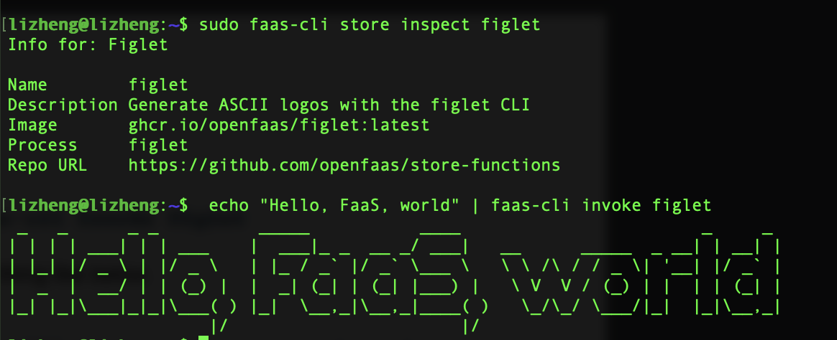

Explanation:

Just run the following command line on QEMU terminal. Then we can get the result of the above picture.

$ echo “Hello, Faas, world” | faas-cli invoke figlet

This function will convert the input string to a amazing sign

‘

Invoke Slack-interactive

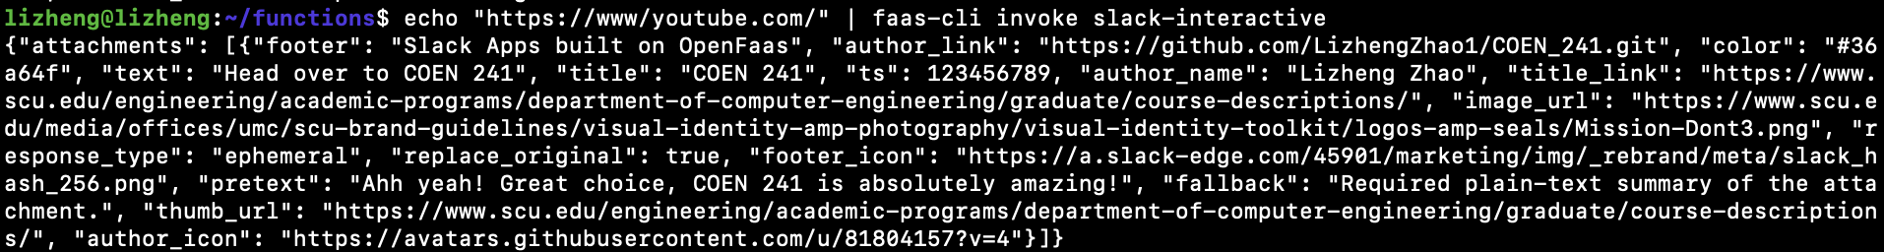

Explanation:

Just run the following command line on QEMU terminal. Then we can get the result of the above picture.

$ echo "https://www/youtube.com/" | faas-cli invoke slack-interactive

After executing the above command line, we will get a output of JSON object.

Invoke Slack-request:

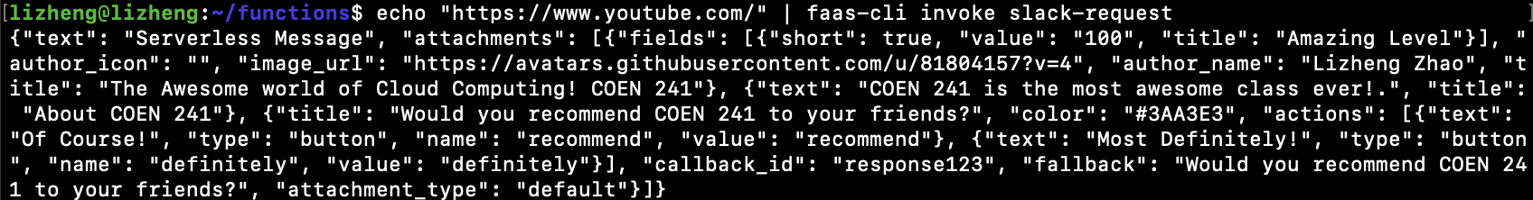

Explanation:

Just run the following command line on QEMU terminal. Then we can get the result of the above picture.

$ echo "https://www/youtube.com/" | faas-cli invoke slack-request

After executing the above command line, we will get a output of JSON object

Execute: sudo journalctl -u faasd --lines

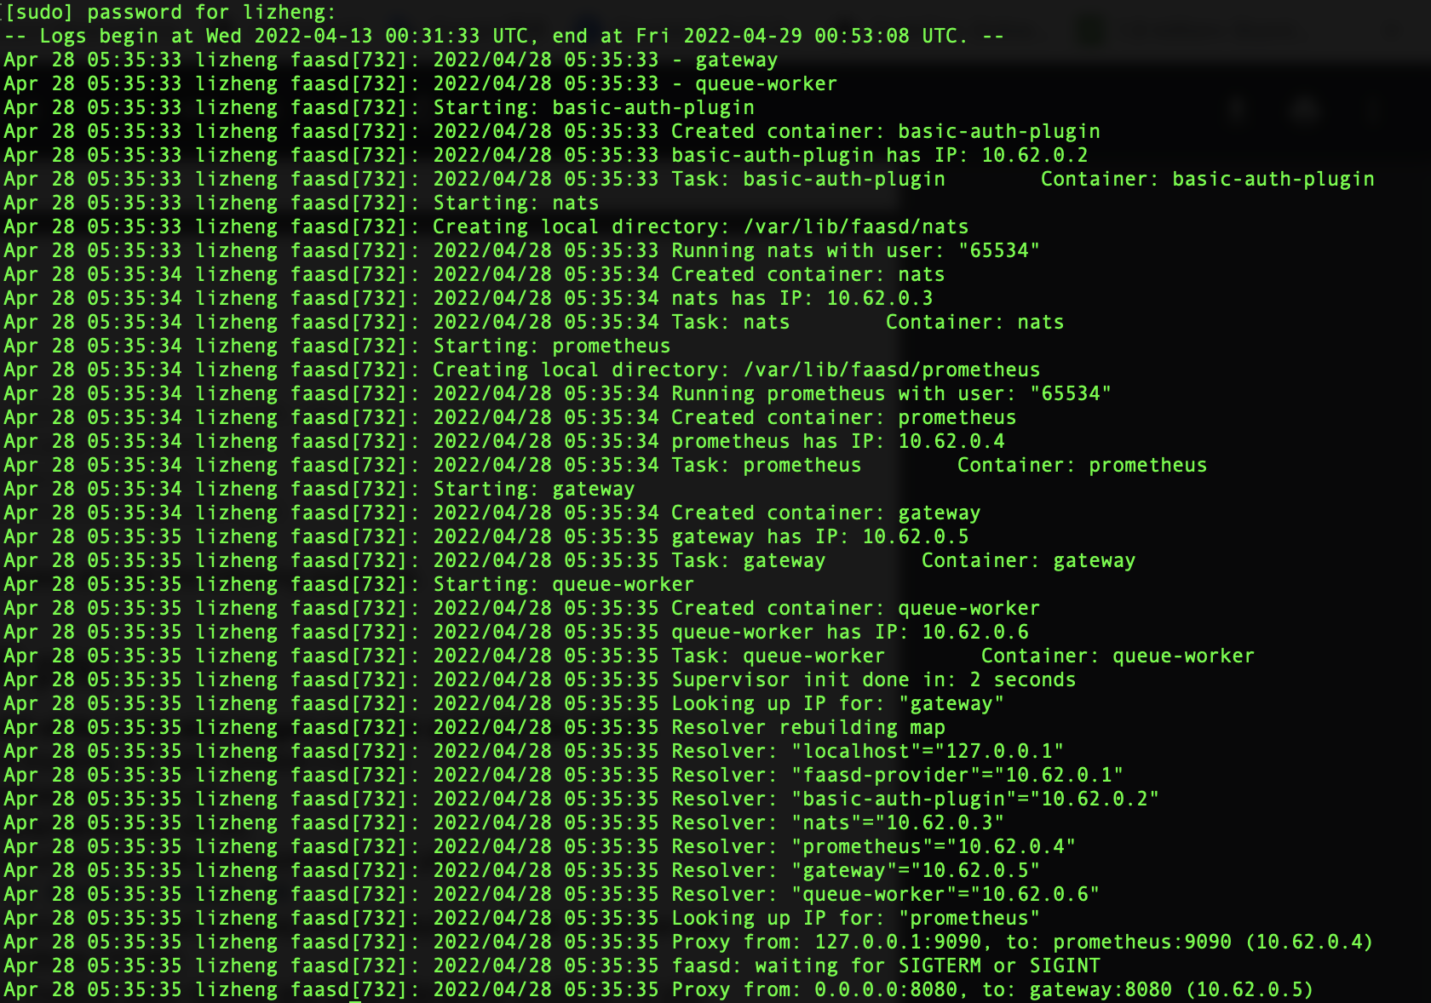

Explanation:

Just run the following command line on QEMU terminal. Then we can get the result of the above picture.

$ sudo journalctl -u faasd --lines 40

After executing the above command line, we can get some log records of fassd

My OpenFaaS gateway AFTER deploying figlet, slack-handler and slack-interactive functions:

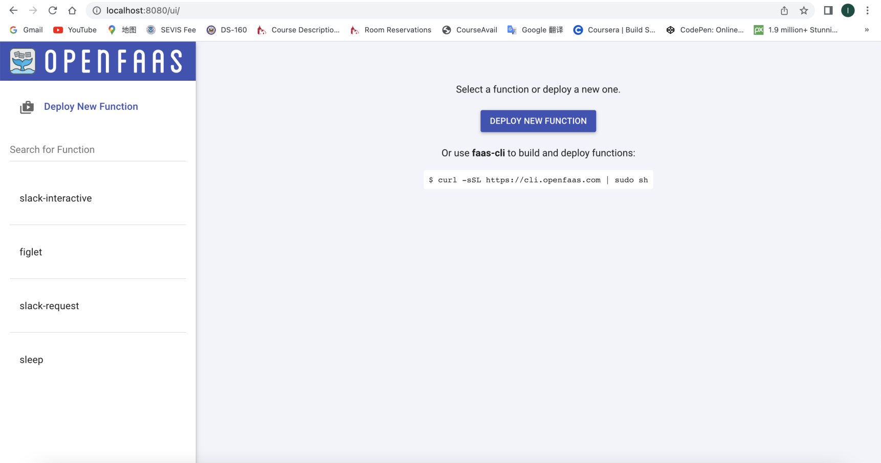

Explanation: this picture is the UI of OpenFaas gateway It shows some functions we have deployed to OpenFaas.