**Portable drone counter-shield**

**(F300)**



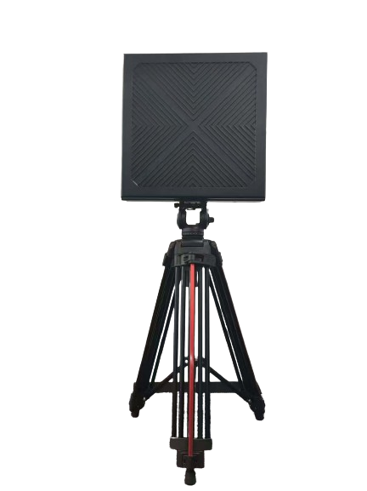

catalogs

**1.Product Overview** 1

**2.Product Features** 2

**3.Product actual shot** 3

**4.** **Product Parameter** 4

**5.Operation Instructions** 5

**1.** **Product Overview**

With the rapid development of civil drone market at home and abroad, while bringing convenience to people, it also exposes a series of public safety hidden dangers. At present, most civil drones are still in the state of “flying in the dark” and causing a series of public safety hidden dangers, therefore, drone signal jammers came into being, but the existing drone signal jammers still have the following problems. However, the existing UAV signal jammer still has the following problems: first, the jamming frequency coverage is incomplete, especially for the 5.2GHz roadway remote control mapping signals and 1.2GHz industrial-grade UAV signals can't be effectively intercepted, and the existing equipment mostly adopts a gun-shaped design, which is not easy to carry, and is limited in many application occasions.

In view of the deficiencies of the existing technology, a portable drone countermeasure shield is provided, which adopts 5-channel (1.2GHz, 1.5GHz, 2.4GHz, 5.2GHz, 5.8GHz) signal outputs to block the drone link, realizing the effective suppression of all the frequency-hopping drones on the market, and effectively avoiding the various security threats arising from the drones in the low-altitude airspace.

**2.Product Features**

⑴ Use of UHF broadband seamless interference technology.

⑵ Bipolar Module Power Output.

⑶ Effective power (channel power) is high, interference distance is far.

⑷ ffective segmentation, only interfere with drone control and video transmission frequency, will not cause interference to other frequencies.

⑸ The use of built-in battery, lasting more than 30 minutes.

⑹ Imported devices, slow start circuit design, can avoid the mechanical switch caused by the ignition phenomenon, high integration, stable work.

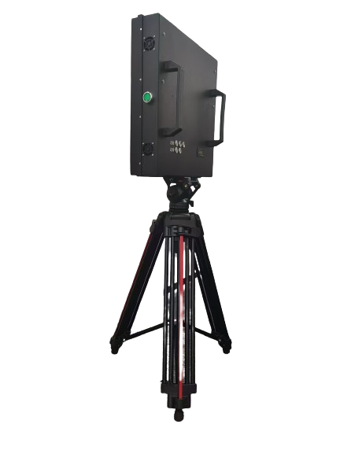**3.Product actual shot**

**4.** **Product Parameter**

（Other frequency bands can be customized）

|  |  |  |  |
| --- | --- | --- | --- |
| 输出端  Output end | 工作频率  Operating frequency | 输出功率  Average output power | 备注  remarks |
| 1.2G | 1160-1280MHz | 10W |  |
| 1.5G | 1550-1620MHz | 10W |  |
| 2.4G×2 | 2400-2500MHz | 25W | 2 |
| 5.2G×2 | 5100-5300MHz | 30W | 2 |
| 5.8G×2 | 5725-5850MHz | 30W | 2 |
| Power supply：AC220V-DC5V capacity：25A Battery | | | |
| Main Unit Weight：8kg | | | |
| Host size: 43×43×9cm | | | |
| Counter range: DJI Mavic 2 > 1500 m DJI Mavic 3 > 800 m  (drone flight height 100 meters) | | | |

**5.Operation Instructions**



⑴ Check whether the appearance of the device is intact.

⑵ Open the power display button to check whether the power is sufficient.

⑶ Press the required function key and turn on the fan switch.

⑷ Hold the handle and point it in the direction of the drone you need to counter.

⑸ The equipment will take effect after 30 seconds, and the drone will be driven away or forced to land.

⑹ After the countermeasure is completed, press the function key and turn off the fan.