PT模式

PVT 模式

系统速度设定指令 VelSet Override, Max;
Override: 机器人运行速率%。（num）
Max: 最大运行速度mm/s。 （num）
系统默认值为 VelSet 100, 5000
在执行运动速度控制指令 VelSet 后，实际运行速度为运动指令规定的运行速度乘以机器人运速率，并且不超过机器人最大运行速度，系统默认值为 VelSet 100, 5000;

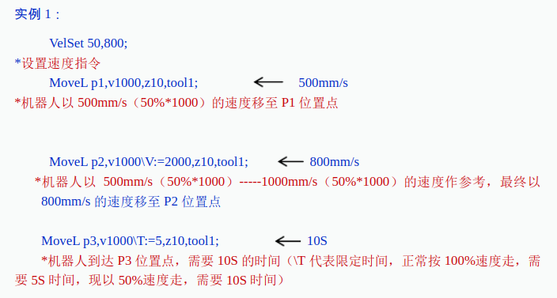

def set_speed(self, speed=[100,50,50,50]):
Speeddata四个变量含义分别为：v_tcp表示ABB机器人线性运行速度，v_rot表示机器人旋转运行速度，v_leax表示外加轴线性运行速度，v_reax表示外加轴旋转运行速度，如果没有外加轴则后两个不用修改

MoveL[\Conc ，]ToPoint，Speed[\V]│[\T] ，Zone[\Z][\Inpos] ，Tool[\WObj][\Corr] ；
1 [\Conc，]：协作运动开关。 (switch)
2 ToPoint：目标点，默认为 *。(robotarget)
3 Speed：运行速度数据。 (speeddata)
4 [\V] ：特殊运行速度 mm/s。(num)
5 [\T] ：运行时间控制 s。(num)
6 Zone：运行转角数据。 (zonedata)
7 [\Z] ：特殊运行转角 mm。(num)
8 [\Inpos] ：运行停止点数据。 (stoppointdata)
9 Tool：工具中心点 (TCP)。(tooldata)
10 [\WObj] ：工件坐标系。 (wobjdata)
11[\Corr]：修正目标点开关。 (switch)

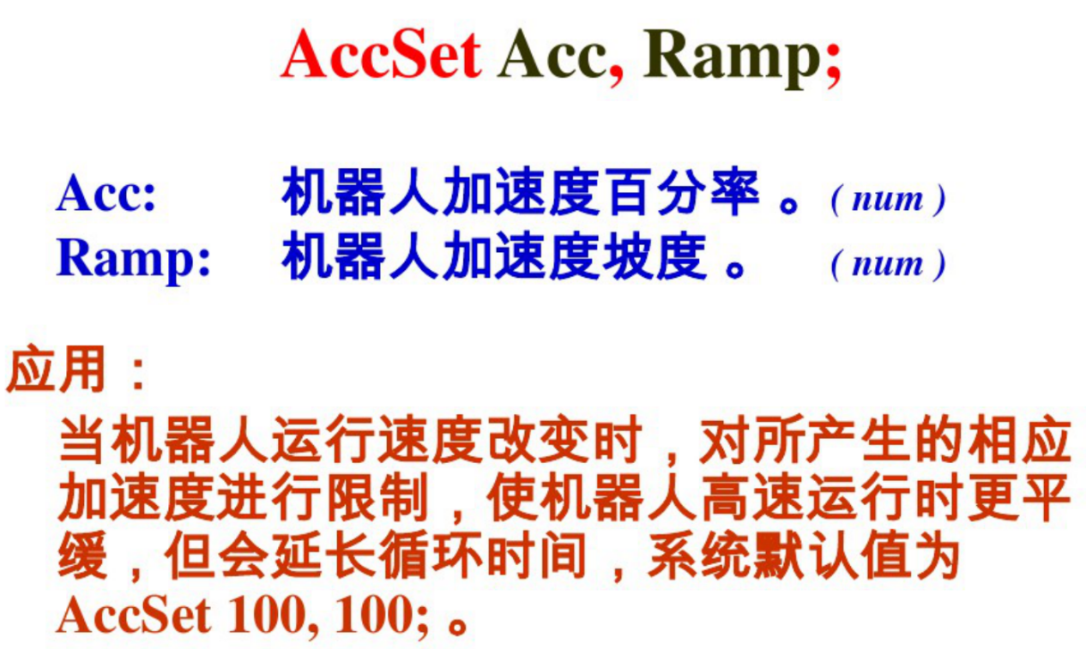

实验记录：

一、PT模式
1. 加入time.sleep()会造成计时器不准确
# coding=UTF-8
import abb
import time
# connecting to robot
R = abb.Robot('192.168.125.1')
# start point
R.set_cartesian([[350, 0, 212], [0.707,0,0.707,0]])
time.sleep(1) #加入延时会让后面的PT控制的计时有些干扰，实际机器人运动时间没有什么干扰，但是time计时器会有干扰
# firstly,start robot.
time_start = time.time() #start timing
R.set_cartesian_t([[350, 0, 250], [0.707,0,0.707,0]],0.8)
time_end = time.time() #stop timing
time_c= time_end - time_start #running time
print('time cost', time_c, 's')
$ python test.py
('time cost', 0.2818589210510254, 's')

- 去掉time.sleep()
# connecting to robot
R = abb.Robot('192.168.125.1')
# start point
R.set_cartesian([[350, 0, 212], [0.707,0,0.707,0]])
# time.sleep(1) #加入延时会让后面的PT控制的计时有些干扰，实际机器人运动时间没有什么干扰，但是time计时器会有干扰

# firstly,start robot. the first step is less than you setting
time_start = time.time() #start timing
R.set_cartesian_t([[350, 0, 250], [0.707,0,0.707,0]],0.8)
time_end = time.time() #stop timing
time_c= time_end - time_start #running time
print('time cost', time_c, 's')
$ python test.py
('time cost', 0.8505909442901611, 's')

- 测试PT模式——直接给定时间
#在上面没有其他运动命令的情况下，time计时器的计时会有一些问题，但是机器人执行是正确的
#t
time_start = time.time() #start timing
R.set_cartesian_t([[350, 0, 300], [0.707,0,0.707,0]],1) # move
time_end = time.time() #stop timing
time_c= time_end - time_start #running time
print('time cost', time_c, 's')
time_start = time.time() #start timing
R.set_cartesian_t([[350, 0, 350], [0.707,0,0.707,0]],2) # move
time_end = time.time() #stop timing
time_c= time_end - time_start #running time
print('time cost', time_c, 's')
time_start = time.time() #start timing
R.set_cartesian_t([[350, 0, 400], [0.707,0,0.707,0]],0.5) # move
time_end = time.time() #stop timing
time_c= time_end - time_start #running time
print('time cost', time_c, 's')
python test.py
('time cost', 0.9670989513397217, 's')
('time cost', 2.008294105529785, 's')
('time cost', 0.5320689678192139, 's')
#t
time_start = time.time() #start timing
R.set_joints_t([-30, -15, 60.3, 16.3, -31.5, -17.45],1) # move
time_end = time.time() #stop timing
time_c= time_end - time_start #running time
print('time cost', time_c, 's')

time_start = time.time() #start timing
R.set_joints_t([-10, -15, 60.3, 16.3, -31.5, -17.45],2) # move
time_end = time.time() #stop timing
time_c= time_end - time_start #running time
print('time cost', time_c, 's')

time_start = time.time() #start timing
R.set_joints_t([10, -15, 60.3, 16.3, -31.5, -17.45],0.5) # move
time_end = time.time() #stop timing
time_c= time_end - time_start #running time
print('time cost', time_c, 's')

python test.py
('time cost', 0.991523027420044, 's')
('time cost', 1.9841229915618896, 's')
('time cost', 0.5088579654693604, 's')

- 测试PT模式——给定运行速度（运行时间T需要自己算）
#v
time_start = time.time() #start timing
R.set_cartesian_v([[350, 0, 300], [0.707,0,0.707,0]],50) # move
time_end = time.time() #stop timing
time_c= time_end - time_start #running time
print('time cost', time_c, 's')
time_start = time.time() #start timing
R.set_cartesian_v([[350, 0, 350], [0.707,0,0.707,0]],100) # move
time_end = time.time() #stop timing
time_c= time_end - time_start #running time
print('time cost', time_c, 's')
time_start = time.time() #start timing
R.set_cartesian_v([[350, 0, 400], [0.707,0,0.707,0]],50) # move
time_end = time.time() #stop timing
time_c= time_end - time_start #running time
print('time cost ', time_c, 's')
$ python test.py
('time cost', 0.9675581455230713, 's')
('time cost', 0.508734941482544, 's')
('time cost ', 0.9913649559020996, 's')
#V
time_start = time.time() #start timing
R.set_joints_v([-30, -15, 60.3, 16.3, -31.5, -17.45],100) # move
time_end = time.time() #stop timing
time_c= time_end - time_start #running time
print('time cost', time_c, 's')
time_start = time.time() #start timing
R.set_joints_v([-10, -15, 60.3, 16.3, -31.5, -17.45],200) # move
time_end = time.time() #stop timing
time_c= time_end - time_start #running time
print('time cost', time_c, 's')
time_start = time.time() #start timing
R.set_joints_v([10, -15, 60.3, 16.3, -31.5, -17.45],50) # move
time_end = time.time() #stop timing
time_c= time_end - time_start #running time
print('time cost', time_c, 's')
轴关节运动，给定速度为线性运动的速度（圆周运动为实际运动路程），所以轴的角速度需要转化
python test.py
('time cost', 0.919274091720581, 's')
('time cost', 0.4357781410217285, 's')
('time cost', 1.7903411388397217, 's')
R=sqrt(259^2+35^2)
T=2*pi*R*(20/360)/V

二、PVT模式
暂未实现
PT 实现
R.set_cartesian([[350, 0, 250], [0.707,0,0.707,0]])

time_start = time.time() #start timing
R.wait_time(0.5)
R.set_cartesian_t([[350, 0, 300], [0.707,0,0.707,0]],0.5) # move
time_end = time.time() #stop timing
time_c= time_end - time_start #running time
print('time cost', time_c, 's')
time_start = time.time() #start timing
R.set_cartesian_t([[350, 0, 400], [0.707,0,0.707,0]],1) # move
time_end = time.time() #stop timing
time_c= time_end - time_start #running time
print('time cost', time_c, 's')
time_start = time.time() #start timing
R.set_cartesian_t([[350, 0, 300], [0.707,0,0.707,0]],1) # move
time_end = time.time() #stop timing
time_c= time_end - time_start #running time
print('time cost', time_c, 's')
time_start = time.time() #start timing
R.set_cartesian_t([[350, 0, 250], [0.707,0,0.707,0]],0.5) # move
R.wait_time(0.5)
time_end = time.time() #stop timing
time_c= time_end - time_start #running time
print('time cost', time_c, 's')

$ python test.py
('time cost', 1.083414077758789, 's')
('time cost', 0.9469950199127197, 's')
('time cost', 1.0155448913574219, 's')
('time cost', 0.9856619834899902, 's')

