Problem 1:

Error formula is –(b-a)/12*h^2*f’’(ζ)

F’(x) = 2*pi*x*cos(pi*x^2/3)/3

F’’(x) = 2*pi/3*(cos(pi*x^2/3)-2*pi*x^2*sin(pi*x^2/3)/3)

The largest value that |F’’(x)| can achieve in the [0,1] interval is 2.752

So if we wanted an error of magnitude of less than 1e-8, we want to solve for n that makes the absolute value of the error less than 1e-8, we have:

1/12*(1/n)^2*2.752<=1e-8

Solving this inequality, we get n>=4788.8, so we need at least 4789 subintervals to achieve this accuracy. Therefore, 4790 points are needed.

Problem 2:

r = 4, h = (1+1)/4 = 0.5

Isimpson = h/3*(f(1)+f(-1)+2*f(-1+2*0.5)+4*(f(-1+0.5)+f(-1+1.5)))

Therefore, we get Isimpson = 1.1667

For error, we first have f(4)(x) = 0

Since error term is multiplied by f(4)(x), if f(4)(x) is zero then the entire expression is zero. So we have zero error in this approximation.

Problem 3:

We have

A: x: b:

|  |  |  |  |  |  |
| --- | --- | --- | --- | --- | --- |
| 1 | -1 | 0 | 0 | X1 | 1.23 |
| 1 | 0 | 0 | -1 | X2 | 1.61 |
| 0 | 1 | 0 | -1 | X3 | 0.45 |
| 1 | 0 | -1 | 0 | X4 | 4.45 |
| 0 | 1 | -1 | 0 |  | 3.21 |
| 0 | 0 | 1 | -1 |  | -2.75 |
| 1 | 0 | 0 | 0 |  | 2.95 |
| 0 | 1 | 0 | 0 |  | 1.74 |
| 0 | 0 | 1 | 0 |  | −1.45 |
| 0 | 0 | 0 | 1 |  | 1.32 |

Solving A\b in matlab, we get x1=2.9600 x2=1.7460 x3=-1.4600 x4=1.3140

These values appear to be slightly different than the direct measurements. But they tend to have more nonzero digits than the original ones (like x2 and x4), which implies that they are more precise than the original ones. Also, because we solved in the least square sense to smooth out the error, we do expect it to have less errors than the direct measurements.

Problem 4:

My function: f(x) = sqrt(x)

the errors of composite and adaptive Simpson, and C1 and C2

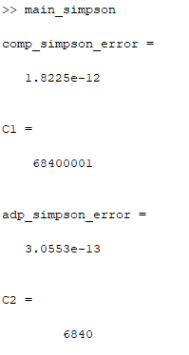

the plot

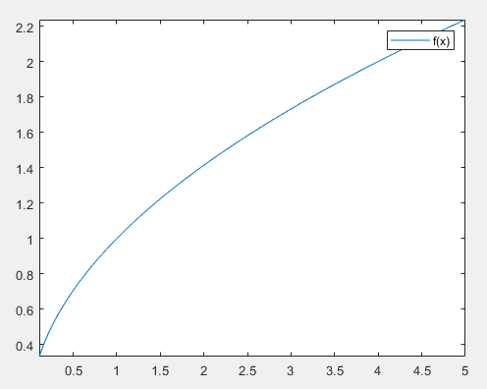

Problem 5:

The plot

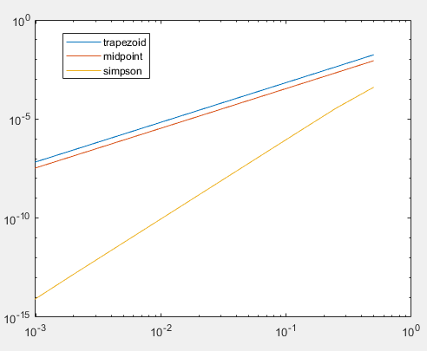

The computed constants

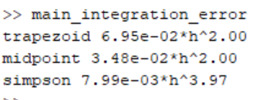

Problem 6:

