1. **ALFF Calculation**

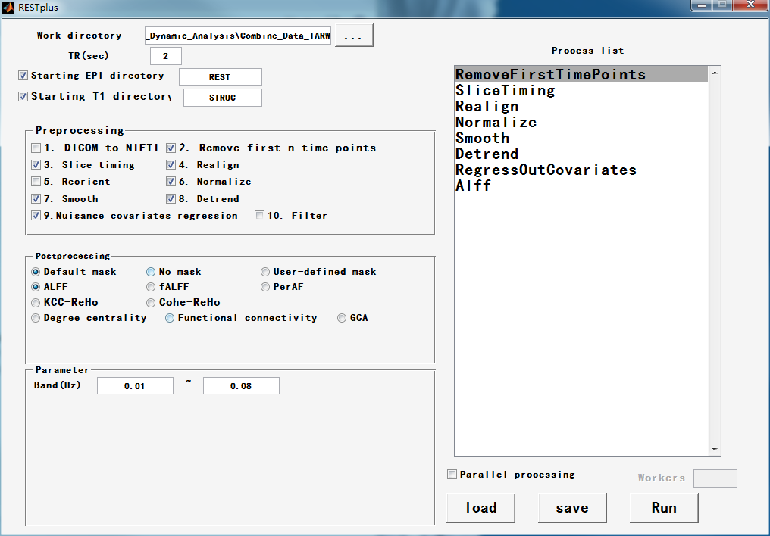

1. **fALFF Calculation**

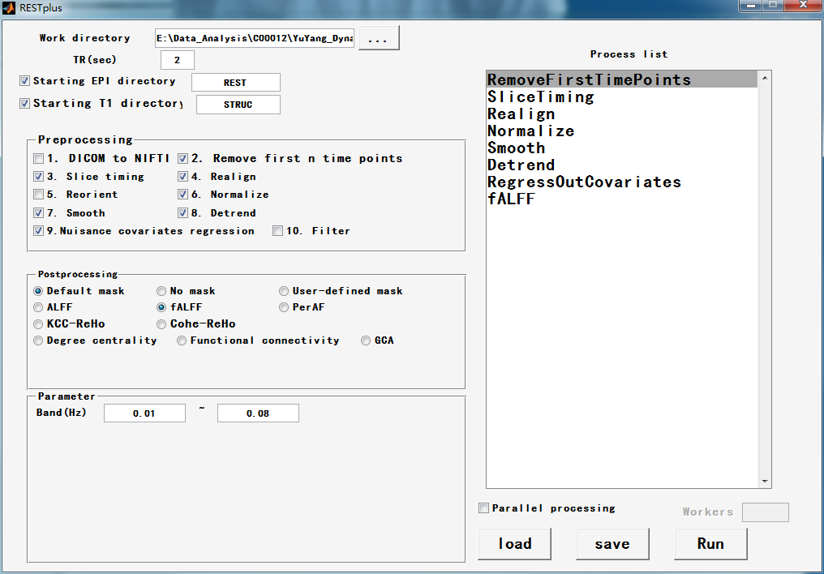

1. **PerAF Calculation**

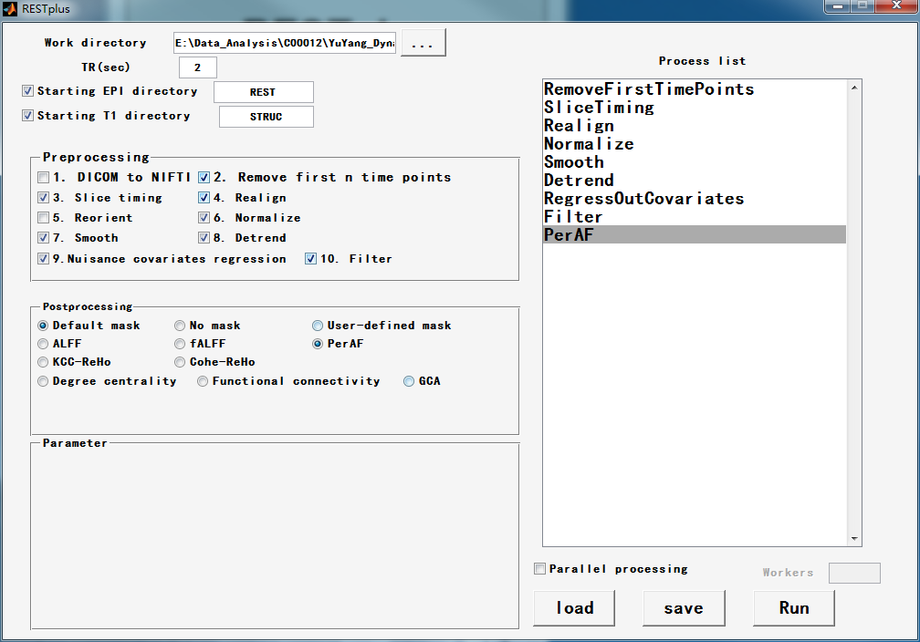

1. **ReHo Calculation**

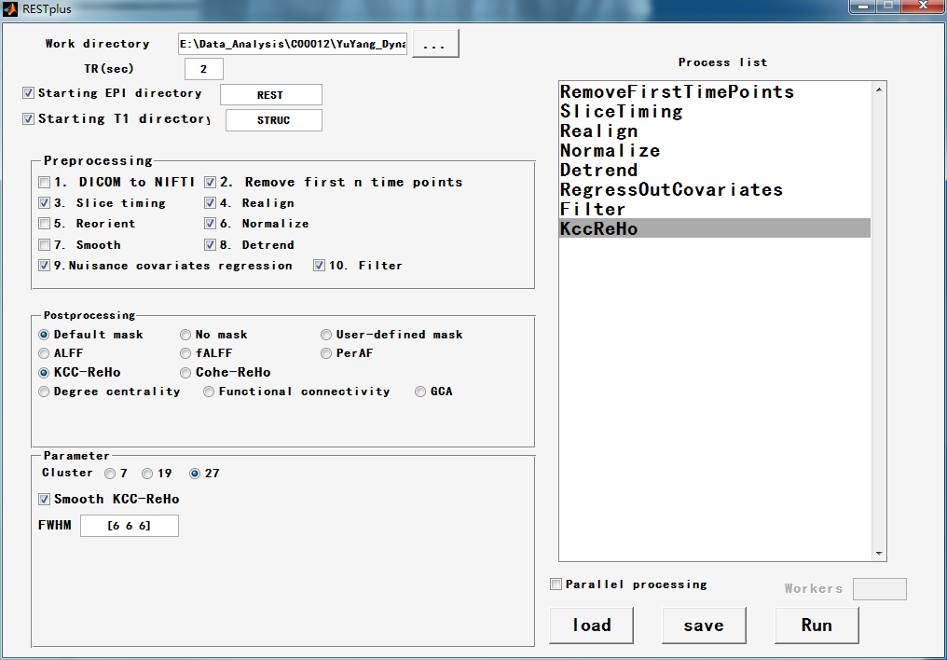

1. **dALFF、dfALFF Calculation**
2. **preprocessing:**

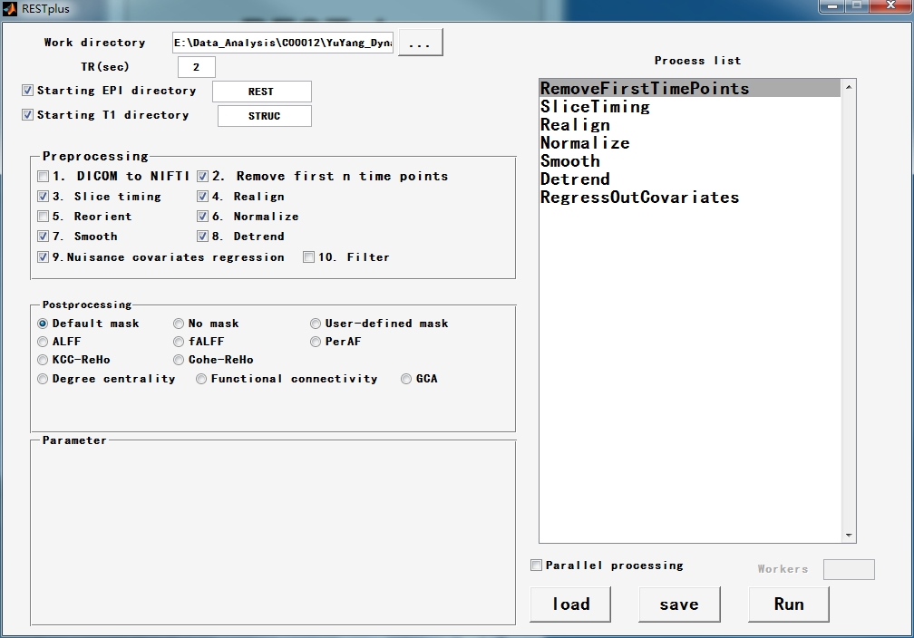

1. **postprocessing:**

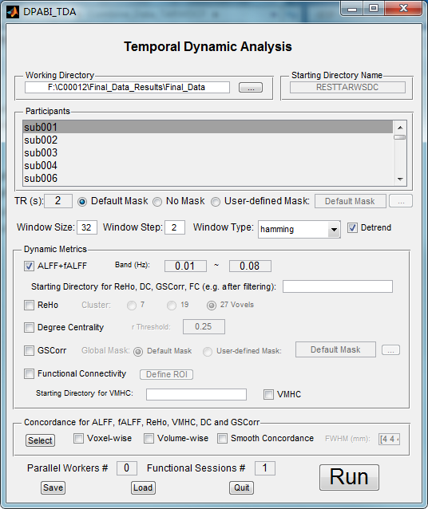

1. **dReHo Calculation**
2. **preprocessing:**

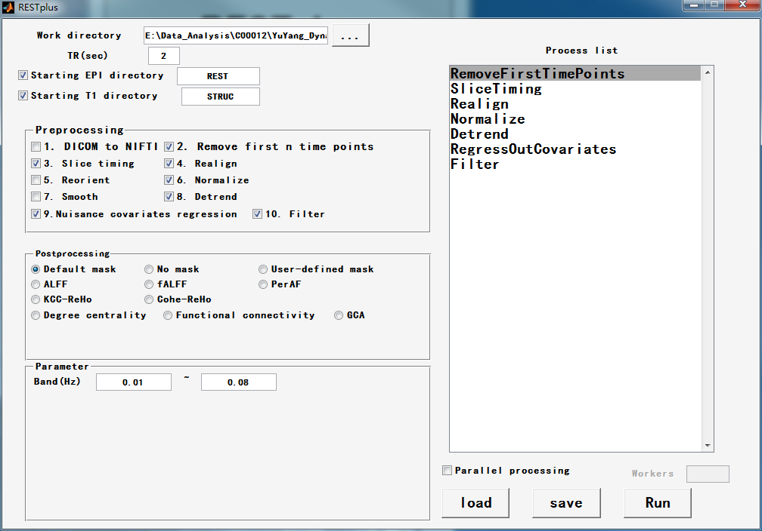

1. **postprocessing:**

