Project Plan

Temporary Workspace Management App Project

TWM Company

|  |  |
| --- | --- |
| Industry Partner | TWM Company |
| Primary Instructor | Professor Anjana Shah |
| Product Owner | Kamrun Nahar Liza |
| Scrum Master | Sudeep Manandhar |
| Front-End Developer | Rajesh Bista |
| Quality Analyst | Shishir Das |
| Back-End Developer | Suvash Sharma |

Document Revision History

|  |  |  |  |
| --- | --- | --- | --- |
| **Version** | **Date** | **Author** | **Summary of Changes** |
| 0.0.0 | 8 Oct 2020 | Rajesh Bista / Suvash Sharma | Sections 3-7 draft completed |
| 0.0.1 | 9 Oct 2020 | Shishir Das | Section 8 draft completed |
| 0.0.2 | 11 Oct 2020 | Sudeep Manandhar | Section 9-11 draft completed |
| 0.0.3 | 11 Oct 2020 | Team | Updated the document through discussion |

Table of Contents

1. Executive Summary 3

2. Project Approvers, Reviews and Distribution List 3

3. Scope 4

4. Deliverables 4

5. Assumptions 5

6. Dependencies 5

6.1. Internal Dependency: 5

6.2. External Dependency: 5

7. Risk Management 6

8. Communication 7

8.1. Reporting 7

8.2. Meetings 8

9. Task Listing (WBS- Work Breakdown Structure) & Gantt Chart 9

10. Milestones 10

11. RAM – Responsibility Assignment Matrix 11

12. Approval 12

# Executive Summary

The following describes the project to be executed.

|  |  |
| --- | --- |
| Objective | To help temporary workspace management company (TWM) to automatize their business processes and provide a platform for their clients to get connected with them conveniently. |
| Corporate Goals Addressed | Clients of TWM company will have a secured, optimized and user-friendly web application by 2021 to find the office space that suits the need of their business. |
| Planned Start Date | 14 September 2020 |
| Planned End Date | 2 April 2021 |

# Project Approvers, Reviews and Distribution List

|  |  |  |  |
| --- | --- | --- | --- |
| Project Role | Name | E-mail | Date |
| Product Owner | Kamrun Nahar Liza | [kamrunnahar.liza@georgebrown.ca](mailto:kamrunnahar.liza@georgebrown.ca) | 11 Oct 2021 |
| Scrum Master | Sudeep Manandhar | [sudeep.manandhar@georgebrown.ca](mailto:sudeep.manandhar@georgebrown.ca) | 11 Oct 2021 |
| Back-End Developer | Suvash Sharma | [suvash.sharma@georgebrown.ca](mailto:suvash.sharma@georgebrown.ca) | 11 Oct 2021 |
| Front-End Developer | Rajesh Bista | [rajesh.bista@georgebrown.ca](mailto:rajesh.bista@georgebrown.ca) | 11 Oct 2021 |
| Quality Analyst | Shishir Das | [shishir.das@georgebrown.ca](mailto:shishir.das@georgebrown.ca) | 11 Oct 2021 |
| Consultant | Anjana Shah | [ashah@georgebrown.ca](mailto:ashah@georgebrown.ca) | 12 Oct 2021 |

# Scope

Define the sum total of all of its products and their requirements or features.

|  |  |
| --- | --- |
| In Scope | Out of Scope |
| The web application will be able to process transactions between company and clients, such as booking, renting space and making payments | The web application will have no impact on daily administration and office management of TWM |
| The web application will be able to manage effective communication for support and maintenance | The web application does not impact staff and payroll management of TWM |
| The web application will be able to serve as a platform to provide feedback for further betterment of the business and company-client relationship |  |

# Deliverables

This project will deliver the following.

|  |  |
| --- | --- |
| Deliverable | Description |
| Simple intuitive user interface for registration, login and navigation | This allows new user to register and get access to the system conveniently |
| Secured online payment system | This allows registered users to make a payment for payable transactions in a secured environment |
| Dashboard to present user profile, communication, information and statistics | This manages users transactions information and displays an updated and analytical information constantly |
| Cloud based database system | This allows users 24/7 access to web application |
| List of available services/facilities and customization options | This allows users to view, customize and request the services they need |
| Platform for service ratings and feedback | This helps users to provide feedback on the services being offered and utilized |

# Assumptions

This project makes the following assumptions:

1. All necessary business processes and business/financial models are identified in time.
2. All necessary development, testing, and hosting applications and infrastructure will be made available from the patron institution.
3. Required developer skills will be acquired by time the development process begins.
4. Each project member will be able to dedicate at least 15 hours a week towards accomplishing this project.
5. Any developmental and technological issues that arise during the project will be addressed in time.

# Dependencies

The following are the internal and external dependencies that will have to be acknowledged and addressed:

## Internal Dependency:

* + Interface design phase can be initiated after completion of system requirement assessment. (FS)
  + The existing system at the company should be discarded only after the web application has been launched and functioning properly. (SF)
  + The wireframes should be completed before starting development. (FS)
  + The profile system can be initiated only after the completion of login system. (FS)
  + The checkout and payment system can be initiated only after the completeion of service system. (FS)
  + To initiate the notification system, the home page and dashboard, the service system, the checkout and payment system should be completed. (FS)
  + The documentation system cannot be completed without completion of the dashboard. (FF)

*SS = Start-to-Start, SF=Start-to-Finish*

*FS = Finish-to-Start, FF=Finish-to-Finish*

## External Dependency:

* + The infrastructure at the company should be setup before the application can be launched (FS)
  + The research on similar applications should be conducted before initializing app development (FS)

# Risk Management

|  |  |  |  |
| --- | --- | --- | --- |
| **Potential Risk** | **Severity (H/M/L)** | **Likelihood (H/M/L)** | **Management Strategy** |
| Web Security | H | L | Following standard security measures |
| Updates and Maintenance | M | L | Creating after-release-support provision plans |
| User Interface | H | L | Designing simple and intuitive interface |
| Data Privacy and Security | H | L | Creating a separate App Admin team for critical database access and backup |
| Acceptance by end users | H | L | Following standard UI/UX procedures |

# Communication

## Reporting

The following reports will be produced:

|  |  |  |
| --- | --- | --- |
| **Report** | **Audience** | **Frequency** |
| Product Vision Statement | Project stakeholders | Once |
| Product Roadmap | Project stakeholders | Once |
| Product Backlog | Project management team Project development team Quality Analyst | Initial + each time the backlog is updated |
| Release Plan | Project management team  Product owner  Quality Analyst  Developers | Initial + each time the backlog is updated |
| Sprint Backlogs | Project management team  Product owner  Quality Analyst  Developers | Initial + each time the backlog is updated |
| Increment Logs | Project management team  Product owner  Quality Analyst  Developers | Initial + each time the backlog is updated |
| Test plan / Test execution report | Project manager Quality Analyst | Daily – once the testing phase starts for each sprint |
| Change Request | Project management team  Product owner  Quality Analyst | Anytime the project requirements change |
| Burnout chart | Project management team | Updated by PM as and when possible – no less than once every fortnite |

## Meetings

The following meetings/communication will be established:

|  |  |  |  |
| --- | --- | --- | --- |
| **Meeting** | **Purpose** | **Attendees** | **Frequency** |
| Team coordination | * Record new progress * Record resolved issues * Record new issues * Record future tasks, assignments and planning | Project Development Team | At least once a week; higher frequency, if needed. |
| Kick-off | Sprint/phase kick-off/start coordination | Project Development Team | Just prior to starting each phase/sprint |
| Sprint-Planning | Selection of backlog items that will be considered in scope for the upcoming sprint | Project Development Team | At least one week before a new sprint starts |
| Stand-up | * Team coordination * Ensure interdependent issues are addresses * Task review and assignment * Progress follow-up | Project Development Team | Daily (once development starts) |
| Go/No go | Decide whether team/project is ready to move to next phase | Project Development Team | At the end of each project phase and before |

# Task Listing (WBS- Work Breakdown Structure) & Gantt Chart

The following resource proposal template summarizes the resource hours committed to this project, upon final approval of this document.

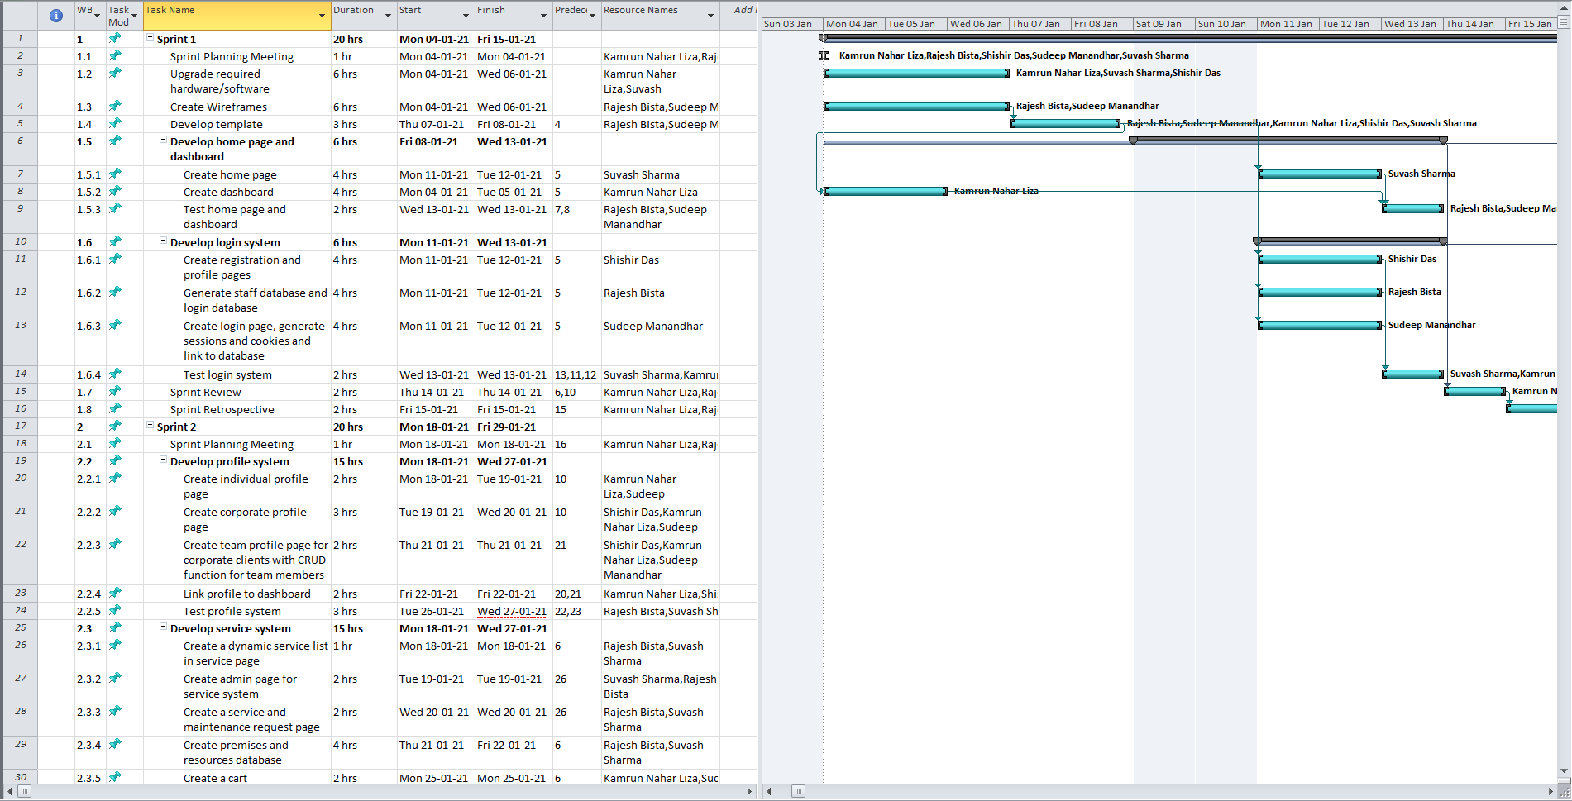

Please click [here](T15_WBS_PlanningPhase.mpp) to access the WBS and Gantt Chart for Planning Phase (Opens MS Project file).

Please click [here](T15_WBS_DevPhase.mpp) to access the WBS and Gantt Chart for Development Phase (Opens MS Project file).

# Milestones

|  |  |  |
| --- | --- | --- |
| **Major Activity or Milestone** | **Estimated Milestone Target Date** | **Owner/Reviewer Team Members** |
| Project Summary, Project Vision, High Level Requirements, Personas and User Stories | 04 Oct 2020 |  |
| Project Plan, Team Charter, Product Backlog and Spring Backlogs | 11 Oct 2020 |  |
| System Requirements, Analysis and Design | 25 Oct 2020 |  |
| Technical Requirements and Wireframes/Prototypes | 04 Nov 2020 |  |
| Application template | 08 Jan 2021 |  |
| Home Page and Dashboard | 13 Jan 2021 |  |
| Login System (Initial) | 13 Jan 2021 |  |
| User Profile System | 27 Jan 2021 |  |
| Service, Utilities and Maintenance Request System | 27 Jan 2021 |  |
| Check out and Payment System | 10 Feb 2021 |  |
| Notification / Report System | 10 Feb 2021 |  |
| Feedback and Rating System | 19 Feb 2021 |  |
| Loyalty, Referral and Reward System | 19 Feb 2021 |  |
| Documentation and Access System | 24 Feb 2021 |  |
| Login System (Final) | 05 Mar 2021 |  |
| Final Package | 26 Mar 2021 |  |

# RAM – Responsibility Assignment Matrix

Project Team Responsibilities

|  |  |  |
| --- | --- | --- |
| Project Name: |  | Temporary Workspace Management App Project |
| Project Manager: |  | Sudeep Manandhar |

|  |  |  |  |  |  |
| --- | --- | --- | --- | --- | --- |
| **Task** | **Suvash Sharma** | **Sudeep Manandhar** | **Shishir Das** | **Rajesh Bista** | **Kamrun Nahar Liza** |
| Project Summary |  | P |  | S |  |
| Project Vision | S | S | S | S | P |
| High Level Requirements | S | S | S | P | S |
| Project Plan | S | P | S | S | S |
| Team Charter | P |  |  | S |  |
| Product Backlog |  |  | P |  |  |
| Sprint Backlogs |  |  | P |  |  |
| System Requirement | S | S | S | S | P |
| System Analysis | S | S | S | S | P |
| System Design | S | S | S | P | S |
| Wireframes/Prototypes |  | P |  | S |  |
| Technical Requirements | P | S | S | S | S |
| Communication and Reporting |  | P | S |  | S |
| Application template |  | P |  | S |  |
| Home Page / Dashboard | P |  |  |  | S |
| Login System | S | S | P | S | S |
| User Profile System |  | S | P |  | S |
| Service, Utilities and Maintenance Request System | S | S |  | P | S |
| Checkout and Payment System | P |  | S | S | S |
| Notification / Report System |  | P |  | S |  |
| Rating System |  | S |  | P |  |
| Documentation and Access System | S | S | S | S | P |
| Loyalty, Referral and Reward System |  |  | S | P | S |
| Product Testing and debugging | S | S | P | S | S |
| Quality Assurance of the product | S | S | S | S | P |
| Product Finalization and Deployment | P | S | S | S | S |

P = Primary S = Secondary

# Approval

The signatures below indicate their approval of the contents of this document.

|  |  |  |  |
| --- | --- | --- | --- |
| Project Role | Name | Signature | Date |
| Primary Instructor | Professor Anjana Shah |  |  |
| Product Owner | Kamrun Nahar Liza |  | 11 Oct 2020 |
| Scrum Master | Sudeep Manandhar |  | 11 Oct 2020 |
| Front-End Developer | Rajesh Bista |  | 11 Oct 2020 |
| Quality Analyst | Shishir Das |  | 11 Oct 2020 |
| Back-End Developer | Suvash Sharma |  | 11 Oct 2020 |