Project - Measuring variation in biogenic habitat composition on subtidal reefs.
Tutor: Lizzi Oh
Field Requirements: This project will suit students with an interest in reef ecology. Students should be capable snorkelers; all data collection is done by snorkelling.
PROJECT GOALS:
Rocky reefs are colonised with a diversity of seaweeds and attached, i.e. “sessile”, invertebrates. In this project students will learn to identify the prominent species of seaweeds present at shallow depths on Maria Island and how these, and their co-occurring sessile invertebrates can be categorised by taxonomic or morphological trait groups for monitoring and reporting. We will use photographic monitoring to measure the composition of the major, morphologically distinct species and species groups on subtidal reef and compare how much they vary with changes in wave exposure, reef slope, and other factors provided from historical monitoring data.
INTRODUCTION:
The living and growing components of temperate reef habitat have two very important contributions to other reef life: they add physical structure to a reef, thereby increasing habitat complexity, and are also food for herbivores and invertivores. In particular, seaweeds are key foundational species, some growing metres tall over relatively short timescales and forming kelp forests that serve as fish nurseries and help absorb wave energy to protect coastlines from erosion (Pérez-Matus et al., 2025). Unsurprisingly, canopy-forming macroalgae are globally recognised as important indicators for reporting on reef health (Krumhansl et al., 2016).
The range of seaweed species found on Tasmanian reefs are adapted to environmental conditions such as wave exposure, depth, currents, light exposure and nutrient availability and this can be observed in their morphology. Morphological traits of seaweeds may favour resource acquisition (eg. thin enough blades to absorb nutrients readily) or conservatism (eg. corticated thick outer layers can increase resistance to wave exposure and herbivory) (Steneck & Dethier, 1994). Some examples of traits include maximum length, stipe width, number of stipes, blade width, branching complexity, surface area to volume ratio, presence of gas-filled floats (pneumatocysts), or calcification of plant tissue (Fong et al., 2023). These traits vary between species, and differences in the resulting composition of species traits on a given reef should in turn affect the provision of habitat and palatable food for mobile reef species such as fish and invertebrate epifauna (Edgar, 1983; Fraser et al., 2020; Pérez-Matus et al., 2025).
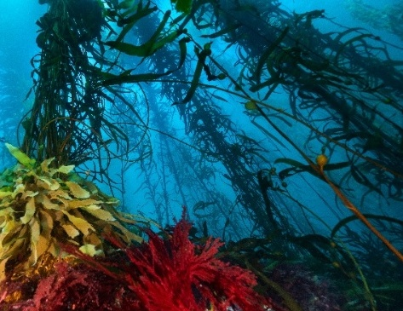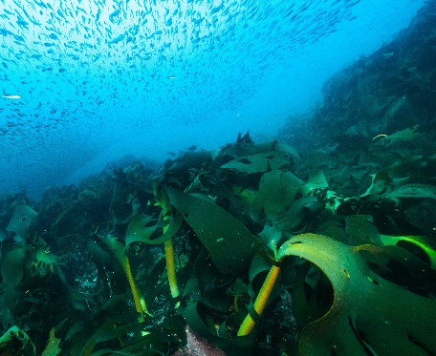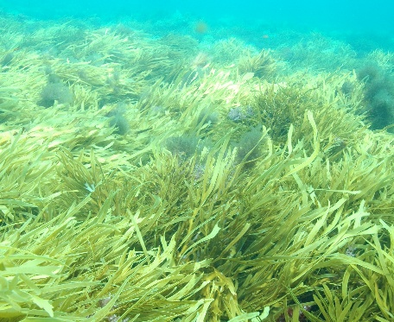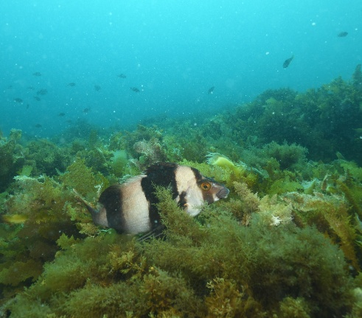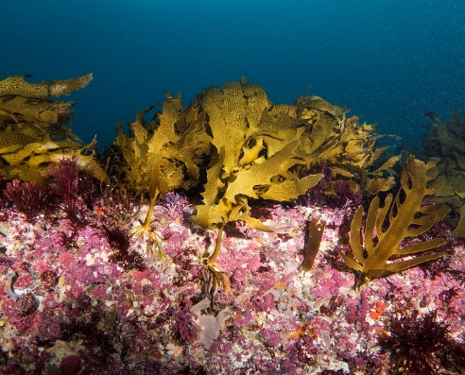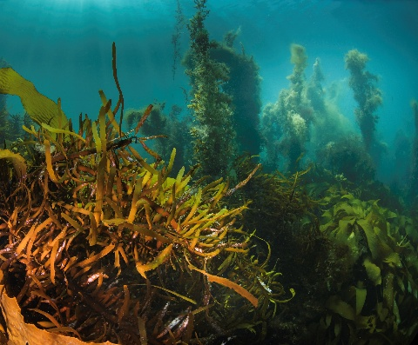
Figure 1. Variation in seaweed forms on temperate Australian subtidal reef
A rapidly developing approach of measuring biogenic habitat communities is image-based monitoring, using hand-held cameras, remotely operated vehicles, video or photogrammetry (Schoening et al., 2022). Post-processing of this imagery usually requires the use of a list or “scheme” of species or species groups to tag images with and generate counts or percentage cover data (Althaus et al., 2015). Because species are often difficult to identify through images and they vary between geographical regions, species are often grouped into morphological forms. For this project, we will use a standardised scheme that attempts to capture important morphological and taxonomic differences in habitat groups that likely represent adaptation to different environmental conditions and represent differing amenity for other reef life.
METHODS
At each site a 50m transect will be rolled out along a shallow depth contour. “Photoquadrat” style images (Figure 2) will be taken every 2.5m, and metadata (transect depth, site name, direction of the transect, and site characteristics) will be recorded. Samples of common canopy-forming brown algae, reds, and greens will be collected around the transect, taking care to include the primary stipe, holdfast all the way to branch tips.
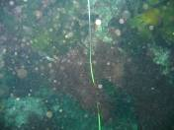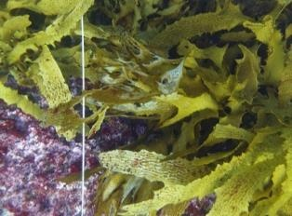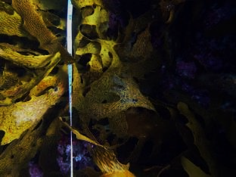
Good – In focus and sufficiently lit. Transect line vertical across shortest axis
Bad – Too much back-scatter, seaweeds not easily identifiable
Not so good – Seaweed in focus, but large dark areas.
Figure 2. Examples of photoquadrats, varying in quality
We’ll aim to sample 7-8 sites around Maria Island – conducting two photo transects at each plus collections of major algal species. The selection of sites surveyed will be weather dependent but will be between Fossil cliffs and as far south as Point Lesueur. These will be accessed by shore or boat, with shore-based ones requiring students to walk to with survey and snorkelling gear.
Afternoon sessions: Together we will identify species or genera of collected seaweed samples using taxonomic keys and resources and discuss or measure morphological traits. Photoquadrat images will be labelled and catalogued, and students can practice species group identification from imagery using the image catalogues and flashcards provided. If you have R on your computer, please download and install rls_habitat_quiz ahead of the trip:
- Install remotes if not already installed: install.packages("remotes")
- Install the RLS Habitat Quiz package from GitHub: remotes::install_github("LizziOh/rls_habitat_quiz")

WHAT YOU NEED
- Snorkelling gear. This should be discussed and arranged with Tim Harvey before the trip, so you come well prepared, but you will all need a wetsuit and snorkelling gear.
- Day pack which fits snorkelling gear, hat, water, suncream, and snacks. Wear comfortable shoes for walking and be prepared to take everything you need for the morning on a walk to reach the survey site.
- Laptop with Excel.
- If you have a waterproof camera, bring it along! We will have two Olympus TG cameras to take habitat images with, but other cameras may be useful
REFERENCES AND LITERATURE TO GET YOU STARTED
- Althaus, F., Hill, N., Ferrari, R., Edwards, L., Przeslawski, R., Schönberg, C. H. L., Stuart-Smith, R., Barrett, N., Edgar, G., Colquhoun, J., Tran, M., Jordan, A., Rees, T., & Gowlett-Holmes, K. (2015). A Standardised Vocabulary for Identifying Benthic Biota and Substrata from Underwater Imagery: The CATAMI Classification Scheme. PLOS ONE, 10(10), e0141039.
- Edgar, G. J. (1983). The ecology of south-east Tasmanian phytal animal communities. I. Spatial organization on a local scale. Journal of Experimental Marine Biology and Ecology, 70(2), 129–157.
- Edgar, G. (2008). Australian Marine Life: The Plants and Animals of Temperate Waters. Reed New Holland, Sydney.
- Fong, C. R., Ryznar, E. R., Smith, L. L., & Fong, P. (2023). Towards a trait-based framework for marine macroalgae: Using categorical data to explore the nature of emergent functional groups. Journal of Ecology, 111(9), 1848–1865.
- Fraser, K. M., Lefcheck, J. S., Ling, S. D., Mellin, C., Stuart-Smith, R. D., & Edgar, G. J. (2020). Production of mobile invertebrate communities on shallow reefs from temperate to tropical seas. Proceedings of the Royal Society B: Biological Sciences, 287(1941), 20201798.
- Krumhansl, K. A., Okamoto, D. K., Rassweiler, A., Novak, M., Bolton, J. J., Cavanaugh, K. C., Connell, S. D., Johnson, C. R., Konar, B., Ling, S. D., Micheli, F., Norderhaug, K. M., Pérez-Matus, A., Sousa-Pinto, I., Reed, D. C., Salomon, A. K., Shears, N. T., Wernberg, T., Anderson, R. J., … Byrnes, J. E. K. (2016). Global patterns of kelp forest change over the past half-century. Proceedings of the National Academy of Sciences, 113(48), 13785–13790.
- Pérez-Matus, A., Micheli, F., Konar, B., Shears, N., Low, N. H. N., Okamoto, D. K., Wernberg, T., Krumhansl, K. A., Ling, S. D., Kingsford, M., Navarrete-Fernandez, T., Ruz, C. S., & Byrnes, J. E. K. (2025). Kelp forests as nursery and foundational habitat for reef fishes. Ecology, 106(2), e70007.
- Schoening, T., Durden, J. M., Faber, C., Felden, J., Heger, K., Hoving, H.-J. T., Kiko, R., Köser, K., Krämmer, C., Kwasnitschka, T., Möller, K. O., Nakath, D., Naß, A., Nattkemper, T. W., Purser, A., & Zurowietz, M. (2022). Making marine image data FAIR. Scientific Data, 9(1), 414.
- Steneck, R. S., & Dethier, M. N. (1994). A Functional Group Approach to the Structure of Algal-Dominated Communities. Oikos, 69(3), 476–498.

