Telco Customer Churn Prediction: A Machine Learning Approach
Elizabeth-Lynda Nartey
Abstract
Customer churn remains a critical challenge for businesses in the highly competitive telecommunications industry. This project presents a machine learning-based predictive model to identify customers at risk of leaving the company. Using the Telco Customer Churn dataset from Kaggle, we explored various classification models, handled class imbalance through SMOTE, and evaluated model performance with industry-standard metrics. Key service and demographic factors influencing churn were identified, providing actionable business insights.
Introduction
In the modern telecommunications market, customer retention is as crucial as customer acquisition. Predicting customer churn enables proactive interventions, improving profitability and customer satisfaction. This project employs supervised machine learning techniques to predict churn, focusing on interpretability and actionable insights derived from customer demographics, account information, and service subscriptions.
Dataset Description
The Telco Customer Churn dataset was sourced from Kaggle. It contains demographic and service-related records of 7,043 customers, alongside a target variable indicating churn status (Yes/No).
Key Features:
- Demographic: Gender, SeniorCitizen, Partner, Dependents
- Account Information: Tenure, Contract type, Payment method
- Service Information: Phone service, Internet service, Online security, Tech support
- Target Variable: Churn Value (1 = Yes, 0 = No)

Methodological Approach
1 Data Understanding
Initial exploration using .head(), .info(), and .describe() functions revealed mixed data types and missing values in the TotalCharges column. Additionally, target class imbalance was noted, with approximately 26% of customers having churned.
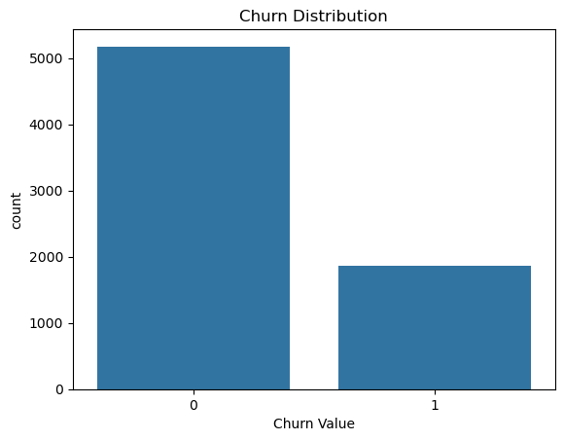
2 Data Preprocessing
Converted Total Charges to numeric, handling errors as NaN.
Imputed missing values with the median.
Label encoded categorical variables.
Target variable Churn Value encoded as binary.
Standardized numerical features using StandardScaler for models sensitive to feature scales.

3 Data Exploration
Visualizations indicated a higher churn rate among customers:
On month-to-month contracts.
Without tech support.
Using fiber optic internet.
With higher monthly charges and lower total charges.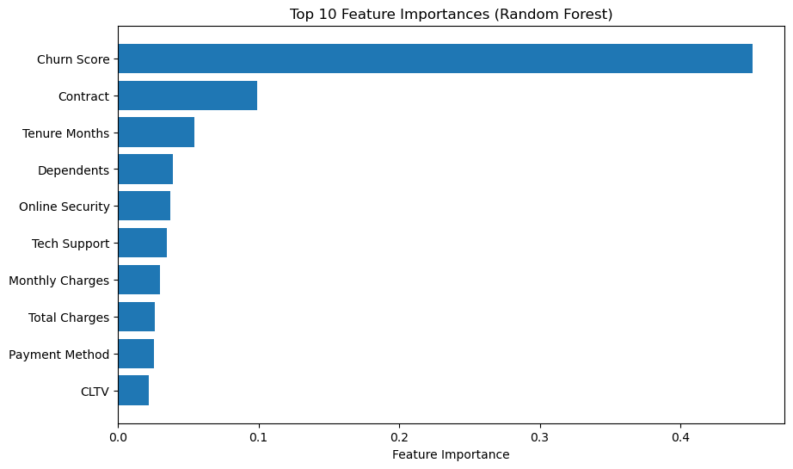
A correlation heatmap highlighted the strongest relationships:
- Contract Type (−0.396)
- Tenure Months (−0.352)
- Tech Support (−0.282)
- Online Security (−0.289)
- Total Charges (−0.199)
These factors were identified as the primary drivers of churn.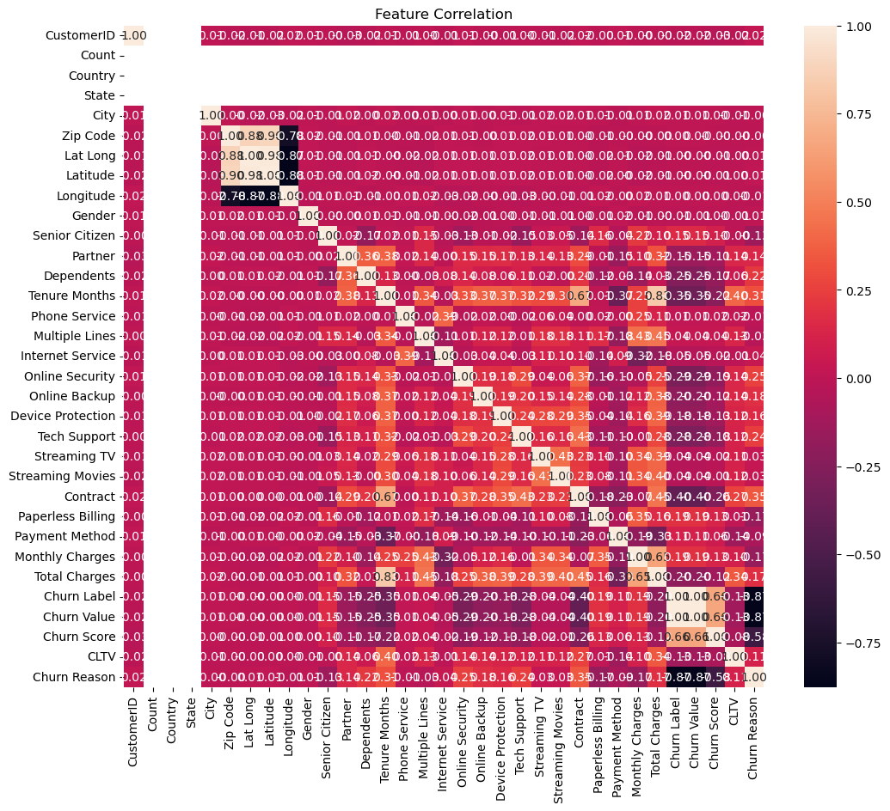
4 Handling Class Imbalance
Implemented SMOTE (Synthetic Minority Over-sampling Technique) to artificially generate minority class samples in the training set, ensuring balanced class distribution and mitigating model bias towards the majority class. Another iteration of the models was computed without SMOTE which yielded slightly same results.
5 Modeling
Three supervised classification models were tested:
- Logistic Regression (for baseline interpretability)
- Random Forest Classifier (for non-linear pattern detection)
- Multilayer Perceptron ; for additional robustness
Logistic Regression and Random Forest Classifier were trained with original data(without SMOTE) and with SMOTE. The effects of SMOTE were insignificant hence the use of the MLP without SMOTE.
6 Model Evaluation
Evaluated with:
Accuracy
Precision, Recall, F1-Score
ROC AUC
Confusion Matrix
ROC Curve visualization

Experimental Results : Model Performance with and without SMOTE
Metric | Logistic Regression (Without SMOTE) | Random Forest (Without SMOTE) | Logistic Regression (With SMOTE) | Random Forest (With SMOTE)
Accuracy | 0.92 | 0.94 | 0.92 | 0.92
Precision (Class 0) | 0.97 | 0.96 | 0.95 | 0.96
Precision (Class 1) | 0.8 | 0.88 | 0.84 | 0.88
Recall (Class 0) | 0.92 | 0.96 | 0.94 | 0.93
Recall (Class 1) | 0.92 | 0.88 | 0.85 | 0.9
F1-Score (Class 0) | 0.94 | 0.96 | 0.94 | 0.95
F1-Score (Class 1) | 0.85 | 0.88 | 0.84 | 0.86
Macro Average F1 | 0.9 | 0.92 | 0.89 | 0.92
Weighted Average F1 | 0.92 | 0.94 | 0.92 | 0.92
ROC AUC | 0.9734 | 0.9786 | 0.9742 | 0.9778

This analysis compares the performance of Logistic Regression and Random Forest in predicting customer churn, with and without the application of SMOTE (Synthetic Minority Over-sampling Technique) to handle class imbalance.
Performance Overview
Without SMOTE, Random Forest outperformed Logistic Regression with an accuracy of 94%, compared to 92% for Logistic Regression. Both models performed well, but Random Forest showed better precision and recall, especially for predicting churn (class 1).
When SMOTE was applied, Random Forest showed slight improvements in precision (88% for class 1) and recall (90% for class 1), indicating better identification of churned customers. Logistic Regression saw marginal improvements, especially in recall, but not as significantly as Random Forest.
SMOTE’s Impact
While SMOTE improved precision and recall for Random Forest, its overall impact on both models was moderate. The ROC AUC score, a key measure of model discrimination, remained similar in both cases, indicating that the model's ability to distinguish churned customers didn’t drastically change.

Comparison of all three Models without SMOTE. (MLP included)
Model | Accuracy | Precision (Class 0) | Precision (Class 1) | Recall (Class 0) | Recall (Class 1) | F1-Score (Class 0) | F1-Score (Class 1) | ROC AUC
Logistic Regression | 0.92 | 0.95 | 0.84 | 0.94 | 0.85 | 0.94 | 0.84 | 0.974
Random Forest | 0.92 | 0.96 | 0.88 | 0.96 | 0.88 | 0.96 | 0.88 | 0.979
MLP Classifier | 0.9 | 0.94 | 0.8 | 0.92 | 0.82 | 0.93 | 0.81 | 0.874

Conclusion
The results suggest that SMOTE was not necessary, as Random Forest performed well without it. However, SMOTE still offered slight improvements, especially for Random Forest. For Logistic Regression, the gains were minimal, indicating that SMOTE is more beneficial for non-linear models like Random Forest. Ultimately, SMOTE is optional but can help in certain cases where further improvements in recall and precision for churn prediction are needed. MLP Classifier had a lower accuracy of 90% and a ROC AUC of 0.874, which indicates that it struggled more than the other two models in discriminating between the classes. However, it still performed reasonably well, with an F1-score of 0.81 for class 1 (churned customers), but it underperformed compared to both Logistic Regression and Random Forest.

Tools and Environment
- Languages & Libraries: Python (pandas, numpy, scikit-learn, seaborn, matplotlib, imbalanced-learn)
- Environment: Jupyter Notebook
- Random State: 42 (for reproducibility)

Future Work
To enhance model performance and extract deeper insights:
- Hyperparameter Tuning using GridSearchCV or RandomizedSearchCV.
- Test advanced classifiers like XGBoost, LightGBM, and CatBoost.
- Apply dimensionality reduction (PCA) to improve efficiency.
- Explore deep learning with MLP Classifier for complex patterns.
- Perform time-series analysis on ‘Tenure Months’ to predict not just if but when customers might churn.
- Integrate external factors like market trends or competitor pricing.
Insights
This project successfully predicted customer churn using a machine learning pipeline, with Random Forest providing the best results. Crucial insights about service preferences and contract types were uncovered, enabling targeted customer retention strategies. This approach demonstrates the value of predictive analytics in operational decision-making.
References
Churn prediction techniques and tools were referenced from contemporary machine learning literature and open-source frameworks:
- Brownlee, J. (2020). Imbalanced Classification with Python: Better Metrics, Balance Skewed Classes, and Improve Model Performance. Machine Learning Mastery.
- Géron, A. (2019). Hands-On Machine Learning with Scikit-Learn, Keras, and TensorFlow. O'Reilly Media.
- Kaggle. (n.d.). Telco Customer Churn Dataset. Retrieved from https://www.kaggle.com/blastchar/telco-customer-churn
- Pedregosa, F., Varoquaux, G., Gramfort, A., et al. (2011). Scikit-learn: Machine Learning in Python. Journal of Machine Learning Research, 12, 2825–2830.

