METHODOLOGY - THE PROJECTION MODELS

Four projection models were used in preparing population projections for the state. The Economic-Demographic Model used both economic and demographic inputs. The Historical Migration Model is a pure demographic projection that applies the migration trend of the 2000-2014 period to the future years. The Zero Migration Model, or Cohort Survival Model, assumes no net migration at the state level. The Linear Regression Model is a linear extrapolation of the state’s total population from 1900 to 2014. The Economic-Demographic Model is designated “preferred” because of its greater scope of the input information and its consistency with the employment projections, which were developed as a part of this Department’s Projections 2024 Series. The labor force projections and all county projections are prepared based on the Economic-Demographic Model only.

THE ECONOMIC-DEMOGRAPHIC MODEL
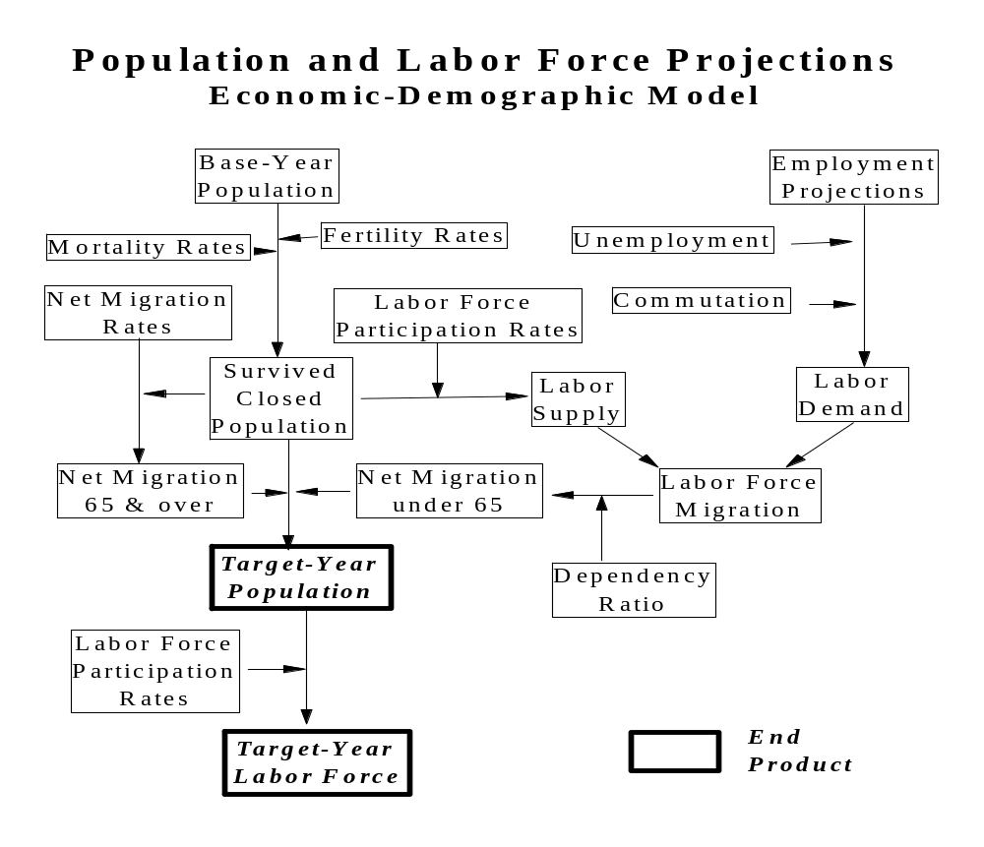

The Economic-Demographic Model is based on standard demographic projection procedures, but assumes employment growth to be the major determinant of migration in and out of the state for persons under 65 years of age. The model is, therefore, driven primarily by labor demand, which is estimated based on the employment projections prepared by this department.

The Cohort-Component Method

The basic projection procedure used in this model is known as the cohort-component method. For each five-year cycle of the projection, a base population distribution by age, race, sex and Hispanic origin is "aged" five years. Each five-year age group is reduced through a survival ratio to account for mortality during the five years. Births are computed by applying five-year age-race-sex-specific fertility rates to the female age groups from 15 to 49. After adjustment for mortality through a survival ratio, the five years of births become the projected group 0 to 4 years of age. Net migrants derived primarily from labor demand and supply are added to the resulting projected population by age, race, sex and Hispanic origin. This procedure is repeated for each five-year interval in the projection period. Specific inputs and their methods of development are discussed separately below.

Base Population

The base population used in the projection is the 2014 estimates by age, race, sex and Hispanic origin (the US Census Bureau vintage 2014 estimates). Age is defined by five-year groups from age 0 to age 84, with an open category for age 85 and over.

According to the US Bureau of the Census, 559,722 persons in New Jersey were enumerated as “some other (not specified) races” in the 2010 census. These people were not included in any racial categories listed on the census form but were included in all race-related tabulations. In order to be consistent with the race classification guidelines defined by the Office of Management and Budget’s 1997 revised standards for the collection, tabulation, and presentation of federal data on race and ethnicity, the census race statistics were modified to include only specified race categories (white alone, black alone, American Indian & Alaska Native alone, Asian alone, Native Hawaiian & other Pacific Islander alone, and persons reported more than one races). The "modified" census 2010 data also include a redistribution of certain multiracial persons, whose races include “some other races”, to a single race category.

The age-race-sex and Hispanic origin distribution of the base-year (2014) population are consistent with the 2010 Census Modified Race data. Thus, the base population of this projection reflects the demographic characteristics of the latest decennial census and postcensal estimates.

Fertility and Mortality

Age-specific fertility rates by race and Hispanic origin were used to compute births to women in each five-year interval. In the US Census Bureau’s "middle series" projections, fertility rates will remain constant among white women, fall below replacement level for black, Asian and other races, but exceed replacement level for Hispanic women between 2012 and 2060. Following the projected national trend, New Jersey’s race-specific fertility rates are projected to remain at the current level of 1.7 births per white woman, 2.0 births per black woman, 1.8 births per Asian woman, and 2.2 births per Hispanic woman throughout the projection years.

American’s mortality rate was projected to decline gradually yet very slowly by the US Census Bureau. New Jersey’s survival ratios by age, race, sex and Hispanic origin were therefore projected to increase somewhat from 2014 to 2034. (The recent annual births and deaths data for the state were provided by the New Jersey Department of Health.)

Migration of Persons Under 65 Years of Age

Projected migration for persons of working age and their children is based on the projected civilian labor market and constitutes the assumption that distinguishes this model from pure demographic models. In simple terms, an over-supply of labor relative to demand for workers results in a net out-flow of persons from the state while higher demand relative to supply results in a net in-flow of migrants from other states and abroad. Net migration is, therefore, based on the size of the civilian labor force needed to balance the state’s labor market.

Labor supply is estimated by applying projected labor force participation rates to civilian non-institutionalized persons 16 years of age and over in the population projected without migration (i.e., the "survived closed population"). These rates are based primarily on the employment and unemployment statistics for New Jersey from recent American Community Survey (ACS) and Current Population Survey (CPS). The increase/decrease pattern of participation rate for each age-race-sex group projected between 2014 and 2024 is assumed to follow the national trend projected by the US Bureau of Labor Statistics. The changing pattern is further carry over through 2034, but at a slower pace.

Labor demand is determined by employment projections adjusted to a residence basis and the projections of unemployment rates. Employment projections reflect the historical growth of industries in the state and the projected growth by industry at the national level (published by the US Bureau of Labor Statistics). Population from the Zero-Migration projections was, in turn, input to the 2024 employment projections for selected industries. Following the nation’s recent economic recovery, the state’s employment is projected to grow at 0.60 percent per year, on average, during the 2014-2024 period. Between 2024 and 2034, the state's employment is assumed to continue to grow but at a somewhat lower rate. Adjustment of employment to a residence basis is necessary due to commutation across state boundaries, self-employment and multiple-job holdings.

Finally, net migration of the labor force is determined by the balance of demand and supply, allowing a level of unemployment projected for the state. The resulting labor force net migrants are inflated to include children and adults under 65 years old who are not in the labor force and are distributed by age, race, sex and Hispanic origin according to the projected labor force participation rates and migration patterns observed in the 2000-2014 period.

Migration of Persons 65 Years of Age and Older

Migration patterns of persons 65 years of age and over are assumed to follow their migration patterns estimate based on the 2000-2014 data. Rates by age, race, sex and Hispanic origin were inferred from the five-year change in birth cohorts, and by an adjustment to the 2000-2014 annual estimates of the population 65 and over by race, sex and Hispanic origin. Differences in net migration rates among races are further assumed to converge gradually in the future.

ALTERNATIVE PROJECTION MODELS

Three additional projection models were attempted for the purpose of presenting population growth scenarios that could occur under different input assumptions. The Historical Migration Model is also based on established demographic techniques (i.e., the cohort-component method). The only difference between the Historical Migration Model and the Economic-Demographic Model is the migration assumptions. The projected population from these two models may be used as a range for possible population change in the future. The Zero Migration Model and the Linear Regression Model projections were prepared primarily for illustrative purposes and are intended only for comparison to other models.

The Historical Migration Model

The assumptions of the Historical Migration Model projection regarding base population, fertility and mortality are the same as those of the Economic-Demographic model discussed above. Net migrants by age, race and sex are inferred from 2000 to 2014 based on the census data, population estimates and annual vital statistics; and are then converted to net migration rates.

Rather than inferring migration under age 65 by economic factors, the Historical Migration Model applies the past net migration rates directly to the population distributed at each projection interval. Migration rates are assumed to gradually converge by race and sex, which implies that the rate differences among races and sexes will diminish while the effect of age on net migration will rise. Thus, the model is purely demographic which assumes that future components of population change are an outgrowth of past components of population change.

The age-race-sex details of the population projections based on Historical Migration Model are not published, but are available upon request.

The Zero Migration Model

The Zero Migration Model is presented as an illustrative projection of the population change that would occur in New Jersey in the total absence of net migration. As migration tends to be the major distinguishing factor in sub-national projection models, a model that eliminates it altogether can provide a useful analytical tool. Comparing the Zero Migration Model with either the Economic-Demographic or Historical Migration Models reveals the impact of migration on population growth according to each of the two models.

Like the two models previously discussed, the Zero Migration Model is also a cohort-component projection. The base population, as well as projected fertility and mortality are the same as that assumed in the previous two models. Age-race-sex-specific migration rates are all set to zero for the state.

The age-race-sex details of the population projections based on Zero Migration Model are not published, but are available upon request.

Linear Regression Model

The Linear Regression Model is presented primarily for comparison to the Economic-Demographic and Historical Migration Models. It hypothesizes that the population growth observed in New Jersey from 1900 to 2014 will continue until 2034. Unlike the three other models, it is not a cohort component projection but a simple extrapolation of past total population trends. The main feature of the model is the extensive history of population change on which it is based. The method employs ordinary least squares regression on a time series for the state. Total population measured by decennial censuses from 1900 to 2010 and estimates as of 2014 were regressed on time, the predicted coefficients are then applied to years 2019, 2024, 2029 and 2034.

CIVILIAN LABOR FORCE PROJECTIONS

Labor force is part of the population who are employed or unemployed but looking for jobs. Projected civilian labor force is obtained by applying the projected age-race-sex-Hispanic origin specific labor force participation rates to the civilian non-institutionalized population aged 16 and over derived from the Economic-Demographic Model. The military personnel and institutionalized population in New Jersey are assumed to be constant at its 2014 level through the projection period. The projections of total population and labor force participation rates were discussed in the previous sections of this document. Definitions of labor force and participation rates in this projection follow that of the decennial census and American Community Survey (ACS), which differ slightly from those used in the US Bureau of Labor Statistics' (BLS) publications. Numbers published by BLS are based mainly on annual averages computed from monthly sample surveys (i.e., Current Population Survey), which were taken by trained interviewers while Census and ACS data were reported by individual householders on the census/survey date.

The national labor force projections, 2014 to 2024 prepared by the US Bureau of Labor Statistics were published on the December 2015 issue of the Monthly Labor Review.
Beginning in January 1996, the state labor force estimates are generated from BLS-developed statistical models due to a sample reduction in the Current Population Survey (CPS). However, the CPS survey result still is a major input to the statistical model.

