BaseCharacter指的是角色，并不包括道具、建筑等单位。但是为了能更好的设计Actor交互，以后设计游戏时让BaseCharacter继承自一个更基础的类。

AS
构造角色属性
创建AttributeSet的C++类，命名为CPP_BaseAttributeSet。
添加头文件与宏定义
#include "AbilitySystemComponent.h"
#define ATTRIBUTE_ACCESSORS(ClassName,PropertyName) \
GAMEPLAYATTRIBUTE_PROPERTY_GETTER(ClassName,PropertyName) \
GAMEPLAYATTRIBUTE_VALUE_GETTER(PropertyName) \
GAMEPLAYATTRIBUTE_VALUE_SETTER(PropertyName) \
GAMEPLAYATTRIBUTE_VALUE_INITTER(PropertyName)
//生命值
UPROPERTY(EditAnywhere, BlueprintReadWrite, Category = "角色基础属性集")
FGameplayAttributeData HP;
ATTRIBUTE_ACCESSORS(UCPP_BaseAttributeSet, HP);
创建AttributeMetaData类型的数据表格，在数据表格中提供数值（注意行命名）
进入BP_BaseCharacter，在ASC的细节中，给“属性测试--默认起始数据”进行赋值，把表格赋值进去。
测试
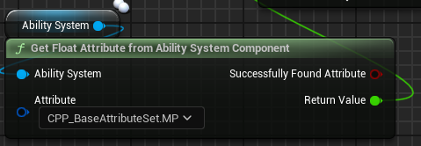
完美
接下来加上其他属性
我们的角色会用到的属性有：
等级、当前经验值、该等级最大经验值
HP/MaxHP/MP/MaxMP/SP/MaxSP/
生命恢复HR、法力恢复MR

ATK/MAG/
生命偷取ATKsuck、全能吸血MAGsuck
攻击速度ATKspeed、冷却缩减MAGspeed

护甲DEF、魔抗MDEF
护甲衰减DEFdecay、护甲穿透DEFpenetrate
魔抗衰减MDEFdecay、魔抗穿透MDEFpenetrate

暴击率CRT、暴击伤害CRTdam
移动速度Speed、韧性（体型）Tough
生命恢复强度HRintense、攻击距离extent

上述内容较多，为减少重复无用操作，将代码复制到文档尾部

其他属性
姓名
角色身份号
代号
元素属性
这些其他属性，我们稍后通过数据表结构的形式存储在角色类中。

下面在数据表格中初始化这些属性
因为这些数据太多了，所以我们通过windows表格工具来处理
在内容管理器中，右键DT，导出为CSV，命名为DT_BaseCharacterAttributeSet.csv，放在windows文件夹中
在windows里弄好之后，直接拖入到内容管理器中，
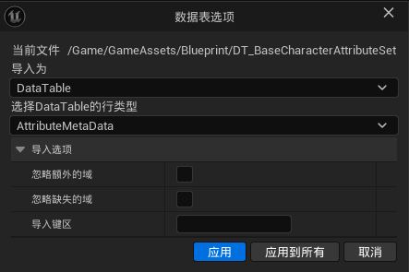
然后进入BP_BaseCharacter，将新表赋值给ASC。
测试，完美。然后就可以删除旧表了

现在我们可以根据一个角色本身，来创建一个这样的表格，给这个角色的属性进行初始化。比如给S0角色进行初始化，创建表格，命名为S0_AS.csv

UI
想在别的WBP下自定义该WBP的大小，尺寸框下加一个覆层。这样可以在尺寸框下面加很多组件。
不能在别的WBP下自定义大小的话，给图像的填充设置一下即可。
首先获取到UI的纹理，获取属性的UI和技能血条的UI
添加到对应各自的WBP中。

广播与委托
下面我们来实现角色属性的UI
通过广播的方式（不发生数值改变就不会有行为）
在CPP_BaseCharacter.h中，申请一个代理
DECLARE_DYNAMIC_MULTICAST_DELEGATE_OneParam(FOnHPChangeEvent,float,NewHP);
只有多波动态委托才能被蓝图调用。其实就是蓝图里的事件分发器。
这里的FOnHPChangeEvent这个名字是自己取得，而且必须以F开头。
然后我们需要创建对应的变量，public
UPROPERTY(BlueprintAssignable,Category="AttributeChange")
FOnHPChangeEvent HPChangeEvent;
在这个变量下面创建一个事件（其实就是函数），来给后续使用
void OnHPAttributeChanged(const FOnAttributeChangeData& Data);
实现该函数
我们调用这个函数就是希望他能进行广播。所以定义的委托（事件分发器）就是这个时候用的。
void ACPP_BaseCharacter::OnHPAttributeChanged(const FOnAttributeChangeData& Data)
{
HPChangeEvent.Broadcast(Data.NewValue);
}
然后进入CPP文件，实现BeginPlay函数
void ACPP_BaseCharacter::BeginPlay()
{
Super::BeginPlay();
TObjectPtr<UAbilitySystemComponent> OwnedAbilitySystemComponent=this->FindComponentByClass<UAbilitySystemComponent>();
if(OwnedAbilitySystemComponent)
{
OwnedAbilitySystemComponent->GetGameplayAttributeValueChangeDelegate(UCPP_BaseAttributeSet::GetHPAttribute()).AddUObject(this,&ACPP_BaseCharacter::OnHPAttributeChanged);
}
}
回到引擎，使用委托
在BP_BaseCharacter中，搜索Assign系列节点
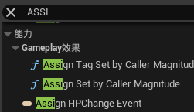
这里只实现了HP的改变事件。
在EventBeginPlay中，
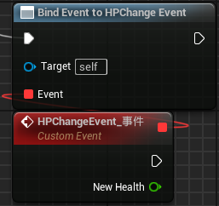
此时修改了生命值，就会Print一次。
修改生命值的合法方式是通过GE来修改。我们给我们的普通攻击加一个自己损失生命值的能力。节点是Apply Gameplay Effect To Owner。
成功实现。
接下来实现其他更多属性的广播。因为代码内容过多，具体代码见附录2。
现在我们将这个函数作为内联函数，在头文件中就进行定义。代码见附录3。
并且将这些委托更改为双参数的格式。具体代码见附录4.下面给出示例代码。
DECLARE_DYNAMIC_MULTICAST_DELEGATE_TwoParams(FOnHPChangeEvent,float,OldValue,float,NewValue);

UPROPERTY(BlueprintAssignable,Category="AttributeChange")
FOnHPChangeEvent HPChangeEvent;
void OnHPAttributeChanged(const FOnAttributeChangeData& Data)
{
HPChangeEvent.Broadcast(Data.OldValue,Data.NewValue);
}

角色属性夹值
对于HP、MP、SP，应当夹值在Max值和0之间
在CPP_BaseAttribteSet中：
在基类中有一个后处理函数，函数原型是
virtual void PostGameplayEffectExecute(const struct FGameplayEffectModCallbackData &Data) { }
这是个额外的计算，所有的伤害计算完后，会执行这个函数。
我们在BaseAttributeSet.cpp中重写该函数，在.h中声明该函数。
void PostGameplayEffectExecute(const struct FGameplayEffectModCallbackData& Data) override;
（不需要标记UFUNCTION，因为不在蓝图中进行处理）
在cpp中实现时，需要加上头文件（如果不加，Data不能 . 出东西）
#include "GameplayEffectExtension.h"
#include "CPP_BaseAttributeSet.h"
#include "GameplayEffectExtension.h"
void UCPP_BaseAttributeSet::PostGameplayEffectExecute(const struct FGameplayEffectModCallbackData& Data)
{
Super::PostGameplayEffectExecute(Data);
if(Data.EvaluatedData.Attribute==GetHPAttribute())
{
SetHP(FMath::Clamp(GetHP(),0.0f,GetMaxHP()));
}
if(Data.EvaluatedData.Attribute==GetMPAttribute())
{
SetMP(FMath::Clamp(GetMP(),0.0f,GetMaxMP()));
}
if(Data.EvaluatedData.Attribute==GetSPAttribute())
{
SetSP(FMath::Clamp(GetSP(),0.0f,GetMaxSP()));
}
}
成功。

大血条UI
圆形血条UI为WBP_BaseState，创建三个子类放在WBP_MainUI中调用。
我们将WBP_MainUI放到PlayerController中调用，同时将这个Widget在PlayerController中提升为变量，命名为WidgetMainUI。
当HPChangeEvent发生的时候，对MainUI中的BaseState（子类）进行SetPercent。这个东西似乎只能在角色类中实现，而不是在PlayerController中实现。
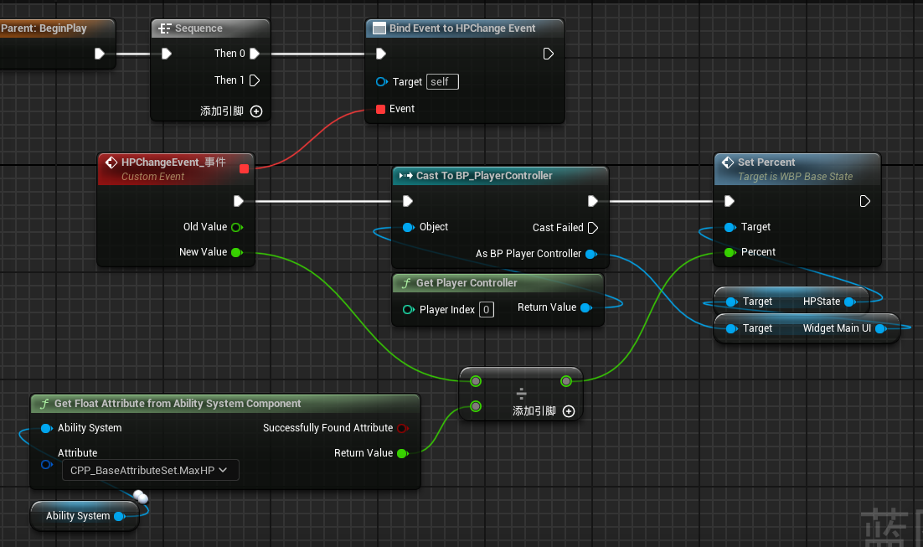
其他的同理。MP、SP自行实现。
优化节点，在BP_BaseChar中创建函数GetAttributeValue
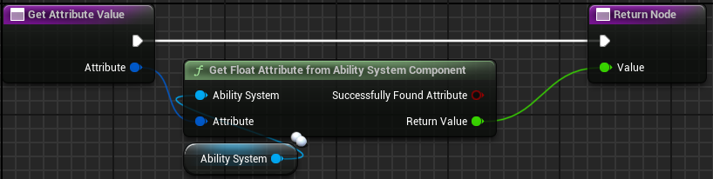
因为一般情况下一个角色只能被一个PlayerController控制，将CastTo的BP_PlayerController提升为变量。
优化结果：
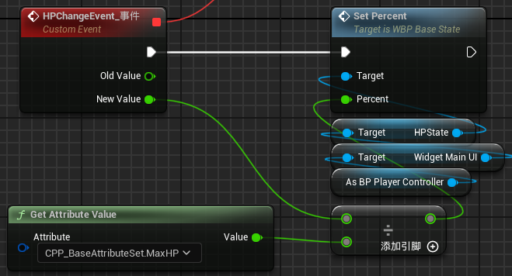
折叠节点
下面实现WBP_Attribute的数值变动。
也很简单
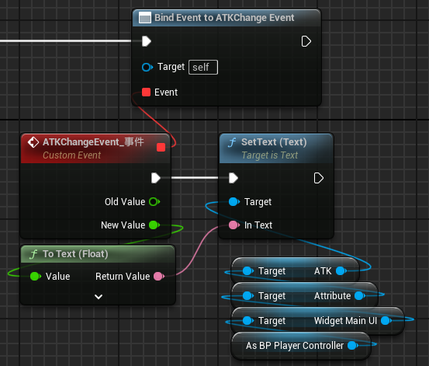
几乎所有其他数值都可以靠这个节点族实现，除了移动速度，在改变时需要设置一下最大行走速度。
提一下韧性，韧性与体型和质量成正相关。质量先不管，先弄体型。
需要提一嘴。韧性的单位是百分比，数值表示为非小数表示，基础值是0。
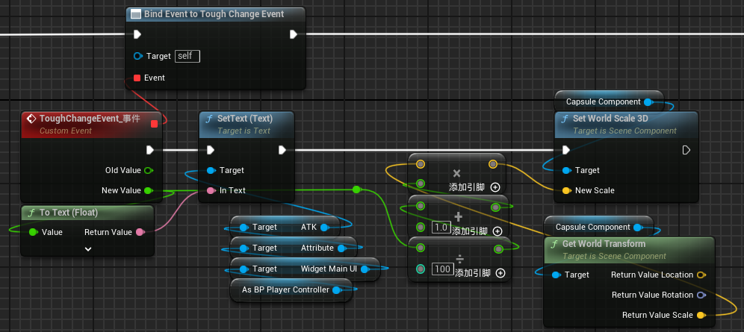

死亡
设置死亡逻辑
我们需要在角色当前生命值小于等于0的时候设置死亡逻辑。
为了实现通用效果，在BaseCharacter中创建函数KillCharacter
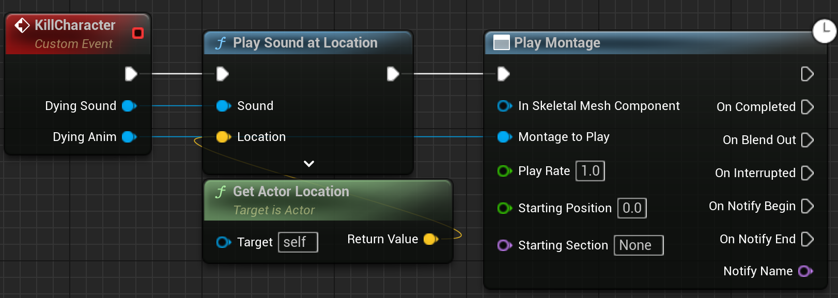
然后在改值广播时检测新值是不是小于等于0，即可完成功能
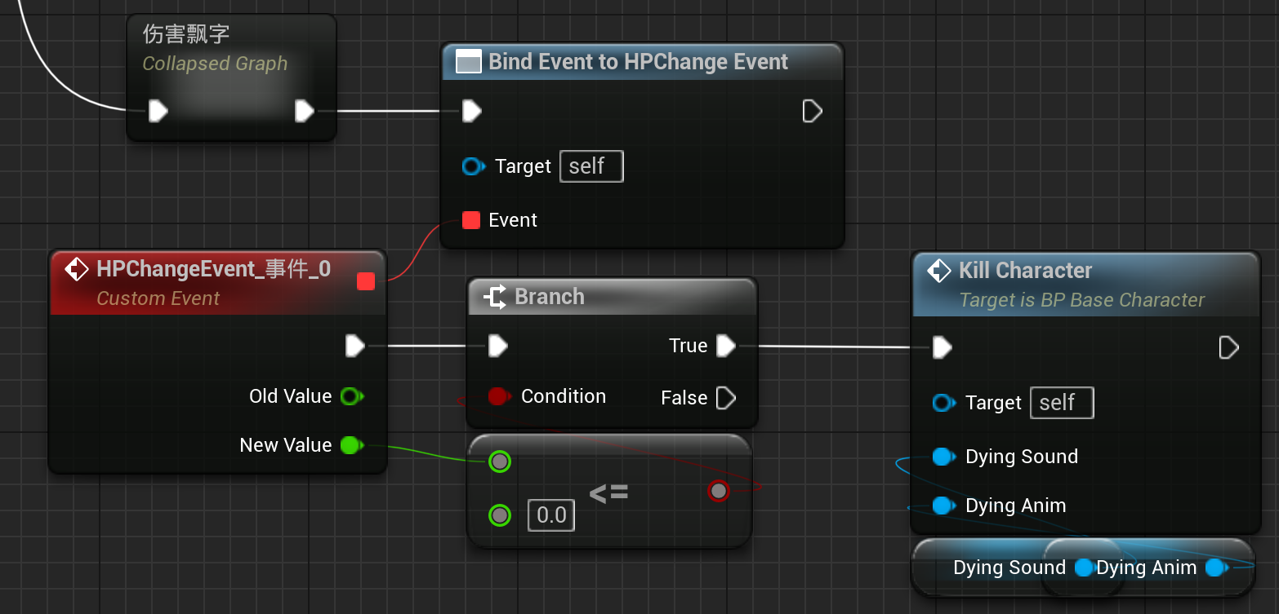
此时我们在每创建一个BaseCharacter的时候，都需要给Kill Character的两个参数变量赋值。

附录1
基础属性集代码
//生命值
UPROPERTY(EditAnywhere, BlueprintReadWrite, Category = "角色基础属性集")
FGameplayAttributeData HP;
ATTRIBUTE_ACCESSORS(UCPP_BaseAttributeSet, HP);
UPROPERTY(EditAnywhere, BlueprintReadWrite, Category = "角色基础属性集")
FGameplayAttributeData MaxHP;
ATTRIBUTE_ACCESSORS(UCPP_BaseAttributeSet, MaxHP);
//法力
UPROPERTY(EditAnywhere, BlueprintReadWrite, Category = "角色基础属性集")
FGameplayAttributeData MP;
ATTRIBUTE_ACCESSORS(UCPP_BaseAttributeSet, MP);
UPROPERTY(EditAnywhere, BlueprintReadWrite, Category = "角色基础属性集")
FGameplayAttributeData MaxMP;
ATTRIBUTE_ACCESSORS(UCPP_BaseAttributeSet, MaxMP);
//能量
UPROPERTY(EditAnywhere, BlueprintReadWrite, Category = "角色基础属性集")
FGameplayAttributeData SP;
ATTRIBUTE_ACCESSORS(UCPP_BaseAttributeSet, SP);
UPROPERTY(EditAnywhere, BlueprintReadWrite, Category = "角色基础属性集")
FGameplayAttributeData MaxSP;
ATTRIBUTE_ACCESSORS(UCPP_BaseAttributeSet, MaxSP);
//生命恢复
UPROPERTY(EditAnywhere, BlueprintReadWrite, Category = "角色基础属性集")
FGameplayAttributeData HR;
ATTRIBUTE_ACCESSORS(UCPP_BaseAttributeSet, HR);
//法力恢复
UPROPERTY(EditAnywhere, BlueprintReadWrite, Category = "角色基础属性集")
FGameplayAttributeData MR;
ATTRIBUTE_ACCESSORS(UCPP_BaseAttributeSet, MR);
//攻击力
UPROPERTY(EditAnywhere, BlueprintReadWrite, Category = "角色基础属性集")
FGameplayAttributeData ATK;
ATTRIBUTE_ACCESSORS(UCPP_BaseAttributeSet, ATK);
//法强
UPROPERTY(EditAnywhere, BlueprintReadWrite, Category = "角色基础属性集")
FGameplayAttributeData MAG;
ATTRIBUTE_ACCESSORS(UCPP_BaseAttributeSet, MAG);
//攻击速度
UPROPERTY(EditAnywhere, BlueprintReadWrite, Category = "角色基础属性集")
FGameplayAttributeData ATKspeed;
ATTRIBUTE_ACCESSORS(UCPP_BaseAttributeSet, ATKspeed);
//冷却缩减
UPROPERTY(EditAnywhere, BlueprintReadWrite, Category = "角色基础属性集")
FGameplayAttributeData MAGspeed;
ATTRIBUTE_ACCESSORS(UCPP_BaseAttributeSet, MAGspeed);
//生命偷取
UPROPERTY(EditAnywhere, BlueprintReadWrite, Category = "角色基础属性集")
FGameplayAttributeData ATKsuck;
ATTRIBUTE_ACCESSORS(UCPP_BaseAttributeSet, ATKsuck);
//全能吸血
UPROPERTY(EditAnywhere, BlueprintReadWrite, Category = "角色基础属性集")
FGameplayAttributeData MAGsuck;
ATTRIBUTE_ACCESSORS(UCPP_BaseAttributeSet, MAGsuck);
//护甲
UPROPERTY(EditAnywhere, BlueprintReadWrite, Category = "角色基础属性集")
FGameplayAttributeData DEF;
ATTRIBUTE_ACCESSORS(UCPP_BaseAttributeSet, DEF);
//魔抗
UPROPERTY(EditAnywhere, BlueprintReadWrite, Category = "角色基础属性集")
FGameplayAttributeData MDEF;
ATTRIBUTE_ACCESSORS(UCPP_BaseAttributeSet, MDEF);
//护甲衰减
UPROPERTY(EditAnywhere, BlueprintReadWrite, Category = "角色基础属性集")
FGameplayAttributeData DEFdecay;
ATTRIBUTE_ACCESSORS(UCPP_BaseAttributeSet, DEFdecay);
//魔抗衰减
UPROPERTY(EditAnywhere, BlueprintReadWrite, Category = "角色基础属性集")
FGameplayAttributeData MDEFdecay;
ATTRIBUTE_ACCESSORS(UCPP_BaseAttributeSet, MDEFdecay);
//护甲穿透
UPROPERTY(EditAnywhere, BlueprintReadWrite, Category = "角色基础属性集")
FGameplayAttributeData DEFpenetrate;
ATTRIBUTE_ACCESSORS(UCPP_BaseAttributeSet, DEFpenetrate);
//魔抗穿透
UPROPERTY(EditAnywhere, BlueprintReadWrite, Category = "角色基础属性集")
FGameplayAttributeData MDEFpenetrate;
ATTRIBUTE_ACCESSORS(UCPP_BaseAttributeSet, MDEFpenetrate);
//暴击率
UPROPERTY(EditAnywhere, BlueprintReadWrite, Category = "角色基础属性集")
FGameplayAttributeData CRT;
ATTRIBUTE_ACCESSORS(UCPP_BaseAttributeSet, CRT);
//暴击伤害
UPROPERTY(EditAnywhere, BlueprintReadWrite, Category = "角色基础属性集")
FGameplayAttributeData CRTdam;
ATTRIBUTE_ACCESSORS(UCPP_BaseAttributeSet, CRTdam);
//移动速度
UPROPERTY(EditAnywhere, BlueprintReadWrite, Category = "角色基础属性集")
FGameplayAttributeData Run;
ATTRIBUTE_ACCESSORS(UCPP_BaseAttributeSet, Run);
//韧性
UPROPERTY(EditAnywhere, BlueprintReadWrite, Category = "角色基础属性集")
FGameplayAttributeData Tough;
ATTRIBUTE_ACCESSORS(UCPP_BaseAttributeSet, Tough);
//生命恢复强度
UPROPERTY(EditAnywhere, BlueprintReadWrite, Category = "角色基础属性集")
FGameplayAttributeData HRintense;
ATTRIBUTE_ACCESSORS(UCPP_BaseAttributeSet, HRintense);
//攻击距离
UPROPERTY(EditAnywhere, BlueprintReadWrite, Category = "角色基础属性集")
FGameplayAttributeData Extent;
ATTRIBUTE_ACCESSORS(UCPP_BaseAttributeSet, Extent);

附录2
BaseCharacter代码
类外
DECLARE_DYNAMIC_MULTICAST_DELEGATE_OneParam(FOnHPChangeEvent,float,NewValue);
DECLARE_DYNAMIC_MULTICAST_DELEGATE_OneParam(FOnMaxHPChangeEvent,float,NewValue);
DECLARE_DYNAMIC_MULTICAST_DELEGATE_OneParam(FOnMPChangeEvent,float,NewValue);
DECLARE_DYNAMIC_MULTICAST_DELEGATE_OneParam(FOnMaxMPChangeEvent,float,NewValue);
DECLARE_DYNAMIC_MULTICAST_DELEGATE_OneParam(FOnSPChangeEvent,float,NewValue);
DECLARE_DYNAMIC_MULTICAST_DELEGATE_OneParam(FOnMaxSPChangeEvent,float,NewValue);
DECLARE_DYNAMIC_MULTICAST_DELEGATE_OneParam(FOnHRChangeEvent,float,NewValue);
DECLARE_DYNAMIC_MULTICAST_DELEGATE_OneParam(FOnMRChangeEvent,float,NewValue);
DECLARE_DYNAMIC_MULTICAST_DELEGATE_OneParam(FOnATKChangeEvent,float,NewValue);
DECLARE_DYNAMIC_MULTICAST_DELEGATE_OneParam(FOnMAGChangeEvent,float,NewValue);
DECLARE_DYNAMIC_MULTICAST_DELEGATE_OneParam(FOnATKSpeedChangeEvent,float,NewValue);
DECLARE_DYNAMIC_MULTICAST_DELEGATE_OneParam(FOnMAGspeedChangeEvent,float,NewValue);
DECLARE_DYNAMIC_MULTICAST_DELEGATE_OneParam(FOnATKsuckChangeEvent,float,NewValue);
DECLARE_DYNAMIC_MULTICAST_DELEGATE_OneParam(FOnMAGsuckChangeEvent,float,NewValue);
DECLARE_DYNAMIC_MULTICAST_DELEGATE_OneParam(FOnDEFChangeEvent,float,NewValue);
DECLARE_DYNAMIC_MULTICAST_DELEGATE_OneParam(FOnMDEFChangeEvent,float,NewValue);
DECLARE_DYNAMIC_MULTICAST_DELEGATE_OneParam(FOnDEFdecayChangeEvent,float,NewValue);
DECLARE_DYNAMIC_MULTICAST_DELEGATE_OneParam(FOnMDEFdecayChangeEvent,float,NewValue);
DECLARE_DYNAMIC_MULTICAST_DELEGATE_OneParam(FOnDEFpenetrateChangeEvent,float,NewValue);
DECLARE_DYNAMIC_MULTICAST_DELEGATE_OneParam(FOnMDEFpenetrateChangeEvent,float,NewValue);
DECLARE_DYNAMIC_MULTICAST_DELEGATE_OneParam(FOnCRTChangeEvent,float,NewValue);
DECLARE_DYNAMIC_MULTICAST_DELEGATE_OneParam(FOnCRTdamChangeEvent,float,NewValue);
DECLARE_DYNAMIC_MULTICAST_DELEGATE_OneParam(FOnRunChangeEvent,float,NewValue);
DECLARE_DYNAMIC_MULTICAST_DELEGATE_OneParam(FOnToughChangeEvent,float,NewValue);
DECLARE_DYNAMIC_MULTICAST_DELEGATE_OneParam(FOnHRintenseChangeEvent,float,NewValue);
DECLARE_DYNAMIC_MULTICAST_DELEGATE_OneParam(FOnExtentChangeEvent,float,NewValue);
类中
UPROPERTY(BlueprintAssignable,Category="AttributeChange")
FOnHPChangeEvent HPChangeEvent;
void OnHPAttributeChanged(const FOnAttributeChangeData& Data);
UPROPERTY(BlueprintAssignable,Category="AttributeChange")
FOnMaxHPChangeEvent MaxHPChangeEvent;
void OnMaxHPAttributeChanged(const FOnAttributeChangeData& Data);
UPROPERTY(BlueprintAssignable,Category="AttributeChange")
FOnMPChangeEvent MPChangeEvent;
void OnMPAttributeChanged(const FOnAttributeChangeData& Data);
UPROPERTY(BlueprintAssignable,Category="AttributeChange")
FOnMaxMPChangeEvent MaxMPChangeEvent;
void OnMaxMPAttributeChanged(const FOnAttributeChangeData& Data);
UPROPERTY(BlueprintAssignable,Category="AttributeChange")
FOnSPChangeEvent SPChangeEvent;
void OnSPAttributeChanged(const FOnAttributeChangeData& Data);
UPROPERTY(BlueprintAssignable,Category="AttributeChange")
FOnMaxMPChangeEvent MaxSPChangeEvent;
void OnMaxSPAttributeChanged(const FOnAttributeChangeData& Data);
UPROPERTY(BlueprintAssignable,Category="AttributeChange")
FOnHRChangeEvent HRChangeEvent;
void OnHRAttributeChanged(const FOnAttributeChangeData& Data);
UPROPERTY(BlueprintAssignable,Category="AttributeChange")
FOnMRChangeEvent MRChangeEvent;
void OnMRAttributeChanged(const FOnAttributeChangeData& Data);
UPROPERTY(BlueprintAssignable,Category="AttributeChange")
FOnATKChangeEvent ATKChangeEvent;
void OnATKAttributeChanged(const FOnAttributeChangeData& Data);
UPROPERTY(BlueprintAssignable,Category="AttributeChange")
FOnMAGChangeEvent MAGChangeEvent;
void OnMAGAttributeChanged(const FOnAttributeChangeData& Data);
UPROPERTY(BlueprintAssignable,Category="AttributeChange")
FOnATKspeedChangeEvent ATKspeedChangeEvent;
void OnATKspeedAttributeChanged(const FOnAttributeChangeData& Data);
UPROPERTY(BlueprintAssignable,Category="AttributeChange")
FOnMAGspeedChangeEvent MAGspeedChangeEvent;
void OnMAGspeedAttributeChanged(const FOnAttributeChangeData& Data);
UPROPERTY(BlueprintAssignable,Category="AttributeChange")
FOnATKsuckChangeEvent ATKsuckChangeEvent;
void OnATKsuckAttributeChanged(const FOnAttributeChangeData& Data);
UPROPERTY(BlueprintAssignable,Category="AttributeChange")
FOnMAGsuckChangeEvent MAGsuckChangeEvent;
void OnMAGsuckAttributeChanged(const FOnAttributeChangeData& Data);
UPROPERTY(BlueprintAssignable,Category="AttributeChange")
FOnDEFChangeEvent DEFChangeEvent;
void OnDEFAttributeChanged(const FOnAttributeChangeData& Data);
UPROPERTY(BlueprintAssignable,Category="AttributeChange")
FOnMDEFChangeEvent MDEFChangeEvent;
void OnMDEFAttributeChanged(const FOnAttributeChangeData& Data);
UPROPERTY(BlueprintAssignable,Category="AttributeChange")
FOnDEFdecayChangeEvent DEFdecayChangeEvent;
void OnDEFdecayAttributeChanged(const FOnAttributeChangeData& Data);
UPROPERTY(BlueprintAssignable,Category="AttributeChange")
FOnMDEFdecayChangeEvent MDEFdecayChangeEvent;
void OnMDEFdecayAttributeChanged(const FOnAttributeChangeData& Data);
UPROPERTY(BlueprintAssignable,Category="AttributeChange")
FOnDEFpenetrateChangeEvent DEFpenetrateChangeEvent;
void OnDEFpenetrateAttributeChanged(const FOnAttributeChangeData& Data);
UPROPERTY(BlueprintAssignable,Category="AttributeChange")
FOnMDEFpenetrateChangeEvent MDEFpenetrateChangeEvent;
void OnMDEFpenetrateAttributeChanged(const FOnAttributeChangeData& Data);
UPROPERTY(BlueprintAssignable,Category="AttributeChange")
FOnCRTChangeEvent CRTChangeEvent;
void OnCRTAttributeChanged(const FOnAttributeChangeData& Data);
UPROPERTY(BlueprintAssignable,Category="AttributeChange")
FOnCRTdamChangeEvent CRTdamChangeEvent;
void OnCRTdamAttributeChanged(const FOnAttributeChangeData& Data);
UPROPERTY(BlueprintAssignable,Category="AttributeChange")
FOnRunChangeEvent RunChangeEvent;
void OnRunAttributeChanged(const FOnAttributeChangeData& Data);
UPROPERTY(BlueprintAssignable,Category="AttributeChange")
FOnToughChangeEvent ToughChangeEvent;
void OnToughAttributeChanged(const FOnAttributeChangeData& Data);
UPROPERTY(BlueprintAssignable,Category="AttributeChange")
FOnHRintenseChangeEvent HRintenseChangeEvent;
void OnHRintenseAttributeChanged(const FOnAttributeChangeData& Data);
UPROPERTY(BlueprintAssignable,Category="AttributeChange")
FOnExtentChangeEvent ExtentChangeEvent;
void OnExtentAttributeChanged(const FOnAttributeChangeData& Data);
函数实现
void ACPP_BaseCharacter::OnHPAttributeChanged(const FOnAttributeChangeData& Data)
{
HPChangeEvent.Broadcast(Data.NewValue);
}
void ACPP_BaseCharacter::OnMaxHPAttributeChanged(const FOnAttributeChangeData& Data)
{
MaxHPChangeEvent.Broadcast(Data.NewValue);
}
void ACPP_BaseCharacter::OnMPAttributeChanged(const FOnAttributeChangeData& Data)
{
MPChangeEvent.Broadcast(Data.NewValue);
}
void ACPP_BaseCharacter::OnMaxMPAttributeChanged(const FOnAttributeChangeData& Data)
{
MaxMPChangeEvent.Broadcast(Data.NewValue);
}
void ACPP_BaseCharacter::OnSPAttributeChanged(const FOnAttributeChangeData& Data)
{
SPChangeEvent.Broadcast(Data.NewValue);
}
void ACPP_BaseCharacter::OnMaxSPAttributeChanged(const FOnAttributeChangeData& Data)
{
MaxSPChangeEvent.Broadcast(Data.NewValue);
}
void ACPP_BaseCharacter::OnHRAttributeChanged(const FOnAttributeChangeData& Data)
{
HRChangeEvent.Broadcast(Data.NewValue);
}
void ACPP_BaseCharacter::OnMRAttributeChanged(const FOnAttributeChangeData& Data)
{
MRChangeEvent.Broadcast(Data.NewValue);
}
void ACPP_BaseCharacter::OnATKAttributeChanged(const FOnAttributeChangeData& Data)
{
ATKChangeEvent.Broadcast(Data.NewValue);
}
void ACPP_BaseCharacter::OnMAGAttributeChanged(const FOnAttributeChangeData& Data)
{
MAGChangeEvent.Broadcast(Data.NewValue);
}
void ACPP_BaseCharacter::OnATKspeedAttributeChanged(const FOnAttributeChangeData& Data)
{
ATKspeedChangeEvent.Broadcast(Data.NewValue);
}
void ACPP_BaseCharacter::OnMAGspeedAttributeChanged(const FOnAttributeChangeData& Data)
{
MAGspeedChangeEvent.Broadcast(Data.NewValue);
}
void ACPP_BaseCharacter::OnATKsuckAttributeChanged(const FOnAttributeChangeData& Data)
{
ATKsuckChangeEvent.Broadcast(Data.NewValue);
}
void ACPP_BaseCharacter::OnMAGsuckAttributeChanged(const FOnAttributeChangeData& Data)
{
MAGsuckChangeEvent.Broadcast(Data.NewValue);
}
void ACPP_BaseCharacter::OnDEFAttributeChanged(const FOnAttributeChangeData& Data)
{
DEFChangeEvent.Broadcast(Data.NewValue);
}
void ACPP_BaseCharacter::OnMDEFAttributeChanged(const FOnAttributeChangeData& Data)
{
MDEFChangeEvent.Broadcast(Data.NewValue);
}
void ACPP_BaseCharacter::OnDEFdecayAttributeChanged(const FOnAttributeChangeData& Data)
{
DEFdecayChangeEvent.Broadcast(Data.NewValue);
}
void ACPP_BaseCharacter::OnMDEFdecayAttributeChanged(const FOnAttributeChangeData& Data)
{
MDEFdecayChangeEvent.Broadcast(Data.NewValue);
}
void ACPP_BaseCharacter::OnDEFpenetrateAttributeChanged(const FOnAttributeChangeData& Data)
{
DEFpenetrateChangeEvent.Broadcast(Data.NewValue);
}
void ACPP_BaseCharacter::OnMDEFpenetrateAttributeChanged(const FOnAttributeChangeData& Data)
{
MDEFpenetrateChangeEvent.Broadcast(Data.NewValue);
}
void ACPP_BaseCharacter::OnCRTAttributeChanged(const FOnAttributeChangeData& Data)
{
CRTChangeEvent.Broadcast(Data.NewValue);
}
void ACPP_BaseCharacter::OnCRTdamAttributeChanged(const FOnAttributeChangeData& Data)
{
CRTdamChangeEvent.Broadcast(Data.NewValue);
}
void ACPP_BaseCharacter::OnRunAttributeChanged(const FOnAttributeChangeData& Data)
{
RunChangeEvent.Broadcast(Data.NewValue);
}
void ACPP_BaseCharacter::OnToughAttributeChanged(const FOnAttributeChangeData& Data)
{
ToughChangeEvent.Broadcast(Data.NewValue);
}
void ACPP_BaseCharacter::OnHRintenseAttributeChanged(const FOnAttributeChangeData& Data)
{
HRintenseChangeEvent.Broadcast(Data.NewValue);
}
void ACPP_BaseCharacter::OnextentAttributeChanged(const FOnAttributeChangeData& Data)
{
ExtentChangeEvent.Broadcast(Data.NewValue);
}
BeginPlay函数
void ACPP_BaseCharacter::BeginPlay()
{
Super::BeginPlay();
TObjectPtr<UAbilitySystemComponent> OwnedAbilitySystemComponent=this->FindComponentByClass<UAbilitySystemComponent>();
if(OwnedAbilitySystemComponent)
{
OwnedAbilitySystemComponent->GetGameplayAttributeValueChangeDelegate(UCPP_BaseAttributeSet::GetHPAttribute()).AddUObject(this,&ACPP_BaseCharacter::OnHPAttributeChanged);
OwnedAbilitySystemComponent->GetGameplayAttributeValueChangeDelegate(UCPP_BaseAttributeSet::GetMaxHPAttribute()).AddUObject(this,&ACPP_BaseCharacter::OnMaxHPAttributeChanged);
OwnedAbilitySystemComponent->GetGameplayAttributeValueChangeDelegate(UCPP_BaseAttributeSet::GetMPAttribute()).AddUObject(this,&ACPP_BaseCharacter::OnMPAttributeChanged);
OwnedAbilitySystemComponent->GetGameplayAttributeValueChangeDelegate(UCPP_BaseAttributeSet::GetMaxMPAttribute()).AddUObject(this,&ACPP_BaseCharacter::OnMaxMPAttributeChanged);
OwnedAbilitySystemComponent->GetGameplayAttributeValueChangeDelegate(UCPP_BaseAttributeSet::GetSPAttribute()).AddUObject(this,&ACPP_BaseCharacter::OnSPAttributeChanged);
OwnedAbilitySystemComponent->GetGameplayAttributeValueChangeDelegate(UCPP_BaseAttributeSet::GetMaxSPAttribute()).AddUObject(this,&ACPP_BaseCharacter::OnMaxSPAttributeChanged);
OwnedAbilitySystemComponent->GetGameplayAttributeValueChangeDelegate(UCPP_BaseAttributeSet::GetHRAttribute()).AddUObject(this,&ACPP_BaseCharacter::OnHRAttributeChanged);
OwnedAbilitySystemComponent->GetGameplayAttributeValueChangeDelegate(UCPP_BaseAttributeSet::GetMRAttribute()).AddUObject(this,&ACPP_BaseCharacter::OnMRAttributeChanged);
OwnedAbilitySystemComponent->GetGameplayAttributeValueChangeDelegate(UCPP_BaseAttributeSet::GetATKAttribute()).AddUObject(this,&ACPP_BaseCharacter::OnATKAttributeChanged);
OwnedAbilitySystemComponent->GetGameplayAttributeValueChangeDelegate(UCPP_BaseAttributeSet::GetMAGAttribute()).AddUObject(this,&ACPP_BaseCharacter::OnMAGAttributeChanged);
OwnedAbilitySystemComponent->GetGameplayAttributeValueChangeDelegate(UCPP_BaseAttributeSet::GetATKspeedAttribute()).AddUObject(this,&ACPP_BaseCharacter::OnATKspeedAttributeChanged);
OwnedAbilitySystemComponent->GetGameplayAttributeValueChangeDelegate(UCPP_BaseAttributeSet::GetMAGspeedAttribute()).AddUObject(this,&ACPP_BaseCharacter::OnMAGspeedAttributeChanged);
OwnedAbilitySystemComponent->GetGameplayAttributeValueChangeDelegate(UCPP_BaseAttributeSet::GetATKsuckAttribute()).AddUObject(this,&ACPP_BaseCharacter::OnATKsuckAttributeChanged);
OwnedAbilitySystemComponent->GetGameplayAttributeValueChangeDelegate(UCPP_BaseAttributeSet::GetMAGsuckAttribute()).AddUObject(this,&ACPP_BaseCharacter::OnMAGsuckAttributeChanged);
OwnedAbilitySystemComponent->GetGameplayAttributeValueChangeDelegate(UCPP_BaseAttributeSet::GetDEFAttribute()).AddUObject(this,&ACPP_BaseCharacter::OnDEFAttributeChanged);
OwnedAbilitySystemComponent->GetGameplayAttributeValueChangeDelegate(UCPP_BaseAttributeSet::GetMDEFAttribute()).AddUObject(this,&ACPP_BaseCharacter::OnMDEFAttributeChanged);
OwnedAbilitySystemComponent->GetGameplayAttributeValueChangeDelegate(UCPP_BaseAttributeSet::GetDEFdecayAttribute()).AddUObject(this,&ACPP_BaseCharacter::OnDEFdecayAttributeChanged);
OwnedAbilitySystemComponent->GetGameplayAttributeValueChangeDelegate(UCPP_BaseAttributeSet::GetMDEFdecayAttribute()).AddUObject(this,&ACPP_BaseCharacter::OnMDEFdecayAttributeChanged);
OwnedAbilitySystemComponent->GetGameplayAttributeValueChangeDelegate(UCPP_BaseAttributeSet::GetDEFpenetrateAttribute()).AddUObject(this,&ACPP_BaseCharacter::OnDEFpenetrateAttributeChanged);
OwnedAbilitySystemComponent->GetGameplayAttributeValueChangeDelegate(UCPP_BaseAttributeSet::GetMDEFpenetrateAttribute()).AddUObject(this,&ACPP_BaseCharacter::OnMDEFpenetrateAttributeChanged);
OwnedAbilitySystemComponent->GetGameplayAttributeValueChangeDelegate(UCPP_BaseAttributeSet::GetCRTAttribute()).AddUObject(this,&ACPP_BaseCharacter::OnCRTAttributeChanged);
OwnedAbilitySystemComponent->GetGameplayAttributeValueChangeDelegate(UCPP_BaseAttributeSet::GetCRTdamAttribute()).AddUObject(this,&ACPP_BaseCharacter::OnCRTdamAttributeChanged);
OwnedAbilitySystemComponent->GetGameplayAttributeValueChangeDelegate(UCPP_BaseAttributeSet::GetRunAttribute()).AddUObject(this,&ACPP_BaseCharacter::OnRunAttributeChanged);
OwnedAbilitySystemComponent->GetGameplayAttributeValueChangeDelegate(UCPP_BaseAttributeSet::GetToughAttribute()).AddUObject(this,&ACPP_BaseCharacter::OnToughAttributeChanged);
OwnedAbilitySystemComponent->GetGameplayAttributeValueChangeDelegate(UCPP_BaseAttributeSet::GetHRintenseAttribute()).AddUObject(this,&ACPP_BaseCharacter::OnHRintenseAttributeChanged);
OwnedAbilitySystemComponent->GetGameplayAttributeValueChangeDelegate(UCPP_BaseAttributeSet::GetExtentAttribute()).AddUObject(this,&ACPP_BaseCharacter::OnExtentAttributeChanged);
}
}

附录3
问题：
xdm，问一下，我现在在搞GAS的属性值改变时广播，大家看一下这段代码 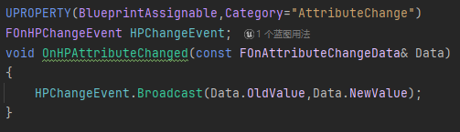
按照我现在看到的教程，都是，把前三行在头文件里实现，把第三行的函数在cpp文件里实现。但是我转念一想，这种广播，应该是调用非常频繁的一类函数，为什么不用内联函数实现呢
所以图示的是我觉得更加合理的代码，区别于教程的“函数在cpp文件中实现”，我这里把函数在头文件里就实现它，作为内联函数存在。我认为这种小的、高频调用的函数应该作为内联函数
那么为什么教程都是把函数在cpp文件中实现呢
内联函数格式
UPROPERTY(BlueprintAssignable,Category="AttributeChange")
FOnHPChangeEvent HPChangeEvent;
void OnHPAttributeChanged(const FOnAttributeChangeData& Data)
{
HPChangeEvent.Broadcast(Data.NewValue);
}
UPROPERTY(BlueprintAssignable,Category="AttributeChange")
FOnMaxHPChangeEvent MaxHPChangeEvent;
void OnMaxHPAttributeChanged(const FOnAttributeChangeData& Data)
{
MaxHPChangeEvent.Broadcast(Data.NewValue);
}
UPROPERTY(BlueprintAssignable,Category="AttributeChange")
FOnMPChangeEvent MPChangeEvent;
void OnMPAttributeChanged(const FOnAttributeChangeData& Data)
{
MPChangeEvent.Broadcast(Data.NewValue);
}
UPROPERTY(BlueprintAssignable,Category="AttributeChange")
FOnMaxMPChangeEvent MaxMPChangeEvent;
void OnMaxMPAttributeChanged(const FOnAttributeChangeData& Data)
{
MaxMPChangeEvent.Broadcast(Data.NewValue);
}
UPROPERTY(BlueprintAssignable,Category="AttributeChange")
FOnSPChangeEvent SPChangeEvent;
void OnSPAttributeChanged(const FOnAttributeChangeData& Data)
{
SPChangeEvent.Broadcast(Data.NewValue);
}
UPROPERTY(BlueprintAssignable,Category="AttributeChange")
FOnMaxMPChangeEvent MaxSPChangeEvent;
void OnMaxSPAttributeChanged(const FOnAttributeChangeData& Data)
{
MaxSPChangeEvent.Broadcast(Data.NewValue);
}
UPROPERTY(BlueprintAssignable,Category="AttributeChange")
FOnHRChangeEvent HRChangeEvent;
void OnHRAttributeChanged(const FOnAttributeChangeData& Data)
{
HRChangeEvent.Broadcast(Data.NewValue);
}
UPROPERTY(BlueprintAssignable,Category="AttributeChange")
FOnMRChangeEvent MRChangeEvent;
void OnMRAttributeChanged(const FOnAttributeChangeData& Data)
{
MRChangeEvent.Broadcast(Data.NewValue);
}
UPROPERTY(BlueprintAssignable,Category="AttributeChange")
FOnATKChangeEvent ATKChangeEvent;
void OnATKAttributeChanged(const FOnAttributeChangeData& Data)
{
ATKChangeEvent.Broadcast(Data.NewValue);
}
UPROPERTY(BlueprintAssignable,Category="AttributeChange")
FOnMAGChangeEvent MAGChangeEvent;
void OnMAGAttributeChanged(const FOnAttributeChangeData& Data)
{
MAGChangeEvent.Broadcast(Data.NewValue);
}
UPROPERTY(BlueprintAssignable,Category="AttributeChange")
FOnATKspeedChangeEvent ATKspeedChangeEvent;
void OnATKspeedAttributeChanged(const FOnAttributeChangeData& Data)
{
ATKspeedChangeEvent.Broadcast(Data.NewValue);
}
UPROPERTY(BlueprintAssignable,Category="AttributeChange")
FOnMAGspeedChangeEvent MAGspeedChangeEvent;
void OnMAGspeedAttributeChanged(const FOnAttributeChangeData& Data)
{
MAGspeedChangeEvent.Broadcast(Data.NewValue);
}
UPROPERTY(BlueprintAssignable,Category="AttributeChange")
FOnATKsuckChangeEvent ATKsuckChangeEvent;
void OnATKsuckAttributeChanged(const FOnAttributeChangeData& Data)
{
ATKsuckChangeEvent.Broadcast(Data.NewValue);
}
UPROPERTY(BlueprintAssignable,Category="AttributeChange")
FOnMAGsuckChangeEvent MAGsuckChangeEvent;
void OnMAGsuckAttributeChanged(const FOnAttributeChangeData& Data)
{
MAGsuckChangeEvent.Broadcast(Data.NewValue);
}
UPROPERTY(BlueprintAssignable,Category="AttributeChange")
FOnDEFChangeEvent DEFChangeEvent;
void OnDEFAttributeChanged(const FOnAttributeChangeData& Data)
{
DEFChangeEvent.Broadcast(Data.NewValue);
}
UPROPERTY(BlueprintAssignable,Category="AttributeChange")
FOnMDEFChangeEvent MDEFChangeEvent;
void OnMDEFAttributeChanged(const FOnAttributeChangeData& Data)
{
MDEFChangeEvent.Broadcast(Data.NewValue);
}
UPROPERTY(BlueprintAssignable,Category="AttributeChange")
FOnDEFdecayChangeEvent DEFdecayChangeEvent;
void OnDEFdecayAttributeChanged(const FOnAttributeChangeData& Data)
{
DEFdecayChangeEvent.Broadcast(Data.NewValue);
}
UPROPERTY(BlueprintAssignable,Category="AttributeChange")
FOnMDEFdecayChangeEvent MDEFdecayChangeEvent;
void OnMDEFdecayAttributeChanged(const FOnAttributeChangeData& Data)
{
MDEFdecayChangeEvent.Broadcast(Data.NewValue);
}
UPROPERTY(BlueprintAssignable,Category="AttributeChange")
FOnDEFpenetrateChangeEvent DEFpenetrateChangeEvent;
void OnDEFpenetrateAttributeChanged(const FOnAttributeChangeData& Data)
{
DEFpenetrateChangeEvent.Broadcast(Data.NewValue);
}
UPROPERTY(BlueprintAssignable,Category="AttributeChange")
FOnMDEFpenetrateChangeEvent MDEFpenetrateChangeEvent;
void OnMDEFpenetrateAttributeChanged(const FOnAttributeChangeData& Data)
{
MDEFpenetrateChangeEvent.Broadcast(Data.NewValue);
}
UPROPERTY(BlueprintAssignable,Category="AttributeChange")
FOnCRTChangeEvent CRTChangeEvent;
void OnCRTAttributeChanged(const FOnAttributeChangeData& Data)
{
CRTChangeEvent.Broadcast(Data.NewValue);
}
UPROPERTY(BlueprintAssignable,Category="AttributeChange")
FOnCRTdamChangeEvent CRTdamChangeEvent;
void OnCRTdamAttributeChanged(const FOnAttributeChangeData& Data)
{
CRTdamChangeEvent.Broadcast(Data.NewValue);
}
UPROPERTY(BlueprintAssignable,Category="AttributeChange")
FOnRunChangeEvent RunChangeEvent;
void OnRunAttributeChanged(const FOnAttributeChangeData& Data)
{
RunChangeEvent.Broadcast(Data.NewValue);
}
UPROPERTY(BlueprintAssignable,Category="AttributeChange")
FOnToughChangeEvent ToughChangeEvent;
void OnToughAttributeChanged(const FOnAttributeChangeData& Data)
{
ToughChangeEvent.Broadcast(Data.NewValue);
}
UPROPERTY(BlueprintAssignable,Category="AttributeChange")
FOnHRintenseChangeEvent HRintenseChangeEvent;
void OnHRintenseAttributeChanged(const FOnAttributeChangeData& Data)
{
HRintenseChangeEvent.Broadcast(Data.NewValue);
}
UPROPERTY(BlueprintAssignable,Category="AttributeChange")
FOnExtentChangeEvent ExtentChangeEvent;
void OnExtentAttributeChanged(const FOnAttributeChangeData& Data)
{
ExtentChangeEvent.Broadcast(Data.NewValue);
}

附录4
类外
DECLARE_DYNAMIC_MULTICAST_DELEGATE_TwoParams(FOnHPChangeEvent,float,OldValue,float,NewValue);
DECLARE_DYNAMIC_MULTICAST_DELEGATE_TwoParams(FOnMaxHPChangeEvent,float,OldValue,float,NewValue);
DECLARE_DYNAMIC_MULTICAST_DELEGATE_TwoParams(FOnMPChangeEvent,float,OldValue,float,NewValue);
DECLARE_DYNAMIC_MULTICAST_DELEGATE_TwoParams(FOnMaxMPChangeEvent,float,OldValue,float,NewValue);
DECLARE_DYNAMIC_MULTICAST_DELEGATE_TwoParams(FOnSPChangeEvent,float,OldValue,float,NewValue);
DECLARE_DYNAMIC_MULTICAST_DELEGATE_TwoParams(FOnMaxSPChangeEvent,float,OldValue,float,NewValue);
DECLARE_DYNAMIC_MULTICAST_DELEGATE_TwoParams(FOnHRChangeEvent,float,OldValue,float,NewValue);
DECLARE_DYNAMIC_MULTICAST_DELEGATE_TwoParams(FOnMRChangeEvent,float,OldValue,float,NewValue);
DECLARE_DYNAMIC_MULTICAST_DELEGATE_TwoParams(FOnATKChangeEvent,float,OldValue,float,NewValue);
DECLARE_DYNAMIC_MULTICAST_DELEGATE_TwoParams(FOnMAGChangeEvent,float,OldValue,float,NewValue);
DECLARE_DYNAMIC_MULTICAST_DELEGATE_TwoParams(FOnATKspeedChangeEvent,float,OldValue,float,NewValue);
DECLARE_DYNAMIC_MULTICAST_DELEGATE_TwoParams(FOnMAGspeedChangeEvent,float,OldValue,float,NewValue);
DECLARE_DYNAMIC_MULTICAST_DELEGATE_TwoParams(FOnATKsuckChangeEvent,float,OldValue,float,NewValue);
DECLARE_DYNAMIC_MULTICAST_DELEGATE_TwoParams(FOnMAGsuckChangeEvent,float,OldValue,float,NewValue);
DECLARE_DYNAMIC_MULTICAST_DELEGATE_TwoParams(FOnDEFChangeEvent,float,OldValue,float,NewValue);
DECLARE_DYNAMIC_MULTICAST_DELEGATE_TwoParams(FOnMDEFChangeEvent,float,OldValue,float,NewValue);
DECLARE_DYNAMIC_MULTICAST_DELEGATE_TwoParams(FOnDEFdecayChangeEvent,float,OldValue,float,NewValue);
DECLARE_DYNAMIC_MULTICAST_DELEGATE_TwoParams(FOnMDEFdecayChangeEvent,float,OldValue,float,NewValue);
DECLARE_DYNAMIC_MULTICAST_DELEGATE_TwoParams(FOnDEFpenetrateChangeEvent,float,OldValue,float,NewValue);
DECLARE_DYNAMIC_MULTICAST_DELEGATE_TwoParams(FOnMDEFpenetrateChangeEvent,float,OldValue,float,NewValue);
DECLARE_DYNAMIC_MULTICAST_DELEGATE_TwoParams(FOnCRTChangeEvent,float,OldValue,float,NewValue);
DECLARE_DYNAMIC_MULTICAST_DELEGATE_TwoParams(FOnCRTdamChangeEvent,float,OldValue,float,NewValue);
DECLARE_DYNAMIC_MULTICAST_DELEGATE_TwoParams(FOnRunChangeEvent,float,OldValue,float,NewValue);
DECLARE_DYNAMIC_MULTICAST_DELEGATE_TwoParams(FOnToughChangeEvent,float,OldValue,float,NewValue);
DECLARE_DYNAMIC_MULTICAST_DELEGATE_TwoParams(FOnHRintenseChangeEvent,float,OldValue,float,NewValue);
DECLARE_DYNAMIC_MULTICAST_DELEGATE_TwoParams(FOnExtentChangeEvent,float,OldValue,float,NewValue);
类内
UPROPERTY(BlueprintAssignable,Category="AttributeChange")
FOnTestChangeEvent TestChangeEvent;
void OnTestAttributeChanged(const FOnAttributeChangeData& Data)
{
TestChangeEvent.Broadcast(Data.OldValue,Data.NewValue);
}
UPROPERTY(BlueprintAssignable,Category="AttributeChange")
FOnHPChangeEvent HPChangeEvent;
void OnHPAttributeChanged(const FOnAttributeChangeData& Data)
{
HPChangeEvent.Broadcast(Data.OldValue,Data.NewValue);
}
UPROPERTY(BlueprintAssignable,Category="AttributeChange")
FOnMaxHPChangeEvent MaxHPChangeEvent;
void OnMaxHPAttributeChanged(const FOnAttributeChangeData& Data)
{
MaxHPChangeEvent.Broadcast(Data.OldValue,Data.NewValue);
}
UPROPERTY(BlueprintAssignable,Category="AttributeChange")
FOnMPChangeEvent MPChangeEvent;
void OnMPAttributeChanged(const FOnAttributeChangeData& Data)
{
MPChangeEvent.Broadcast(Data.OldValue,Data.NewValue);
}
UPROPERTY(BlueprintAssignable,Category="AttributeChange")
FOnMaxMPChangeEvent MaxMPChangeEvent;
void OnMaxMPAttributeChanged(const FOnAttributeChangeData& Data)
{
MaxMPChangeEvent.Broadcast(Data.OldValue,Data.NewValue);
}
UPROPERTY(BlueprintAssignable,Category="AttributeChange")
FOnSPChangeEvent SPChangeEvent;
void OnSPAttributeChanged(const FOnAttributeChangeData& Data)
{
SPChangeEvent.Broadcast(Data.OldValue,Data.NewValue);
}
UPROPERTY(BlueprintAssignable,Category="AttributeChange")
FOnMaxMPChangeEvent MaxSPChangeEvent;
void OnMaxSPAttributeChanged(const FOnAttributeChangeData& Data)
{
MaxSPChangeEvent.Broadcast(Data.OldValue,Data.NewValue);
}
UPROPERTY(BlueprintAssignable,Category="AttributeChange")
FOnHRChangeEvent HRChangeEvent;
void OnHRAttributeChanged(const FOnAttributeChangeData& Data)
{
HRChangeEvent.Broadcast(Data.OldValue,Data.NewValue);
}
UPROPERTY(BlueprintAssignable,Category="AttributeChange")
FOnMRChangeEvent MRChangeEvent;
void OnMRAttributeChanged(const FOnAttributeChangeData& Data)
{
MRChangeEvent.Broadcast(Data.OldValue,Data.NewValue);
}
UPROPERTY(BlueprintAssignable,Category="AttributeChange")
FOnATKChangeEvent ATKChangeEvent;
void OnATKAttributeChanged(const FOnAttributeChangeData& Data)
{
ATKChangeEvent.Broadcast(Data.OldValue,Data.NewValue);
}
UPROPERTY(BlueprintAssignable,Category="AttributeChange")
FOnMAGChangeEvent MAGChangeEvent;
void OnMAGAttributeChanged(const FOnAttributeChangeData& Data)
{
MAGChangeEvent.Broadcast(Data.OldValue,Data.NewValue);
}
UPROPERTY(BlueprintAssignable,Category="AttributeChange")
FOnATKspeedChangeEvent ATKspeedChangeEvent;
void OnATKspeedAttributeChanged(const FOnAttributeChangeData& Data)
{
ATKspeedChangeEvent.Broadcast(Data.OldValue,Data.NewValue);
}
UPROPERTY(BlueprintAssignable,Category="AttributeChange")
FOnMAGspeedChangeEvent MAGspeedChangeEvent;
void OnMAGspeedAttributeChanged(const FOnAttributeChangeData& Data)
{
MAGspeedChangeEvent.Broadcast(Data.OldValue,Data.NewValue);
}
UPROPERTY(BlueprintAssignable,Category="AttributeChange")
FOnATKsuckChangeEvent ATKsuckChangeEvent;
void OnATKsuckAttributeChanged(const FOnAttributeChangeData& Data)
{
ATKsuckChangeEvent.Broadcast(Data.OldValue,Data.NewValue);
}
UPROPERTY(BlueprintAssignable,Category="AttributeChange")
FOnMAGsuckChangeEvent MAGsuckChangeEvent;
void OnMAGsuckAttributeChanged(const FOnAttributeChangeData& Data)
{
MAGsuckChangeEvent.Broadcast(Data.OldValue,Data.NewValue);
}
UPROPERTY(BlueprintAssignable,Category="AttributeChange")
FOnDEFChangeEvent DEFChangeEvent;
void OnDEFAttributeChanged(const FOnAttributeChangeData& Data)
{
DEFChangeEvent.Broadcast(Data.OldValue,Data.NewValue);
}
UPROPERTY(BlueprintAssignable,Category="AttributeChange")
FOnMDEFChangeEvent MDEFChangeEvent;
void OnMDEFAttributeChanged(const FOnAttributeChangeData& Data)
{
MDEFChangeEvent.Broadcast(Data.OldValue,Data.NewValue);
}
UPROPERTY(BlueprintAssignable,Category="AttributeChange")
FOnDEFdecayChangeEvent DEFdecayChangeEvent;
void OnDEFdecayAttributeChanged(const FOnAttributeChangeData& Data)
{
DEFdecayChangeEvent.Broadcast(Data.OldValue,Data.NewValue);
}
UPROPERTY(BlueprintAssignable,Category="AttributeChange")
FOnMDEFdecayChangeEvent MDEFdecayChangeEvent;
void OnMDEFdecayAttributeChanged(const FOnAttributeChangeData& Data)
{
MDEFdecayChangeEvent.Broadcast(Data.OldValue,Data.NewValue);
}
UPROPERTY(BlueprintAssignable,Category="AttributeChange")
FOnDEFpenetrateChangeEvent DEFpenetrateChangeEvent;
void OnDEFpenetrateAttributeChanged(const FOnAttributeChangeData& Data)
{
DEFpenetrateChangeEvent.Broadcast(Data.OldValue,Data.NewValue);
}
UPROPERTY(BlueprintAssignable,Category="AttributeChange")
FOnMDEFpenetrateChangeEvent MDEFpenetrateChangeEvent;
void OnMDEFpenetrateAttributeChanged(const FOnAttributeChangeData& Data)
{
MDEFpenetrateChangeEvent.Broadcast(Data.OldValue,Data.NewValue);
}
UPROPERTY(BlueprintAssignable,Category="AttributeChange")
FOnCRTChangeEvent CRTChangeEvent;
void OnCRTAttributeChanged(const FOnAttributeChangeData& Data)
{
CRTChangeEvent.Broadcast(Data.OldValue,Data.NewValue);
}
UPROPERTY(BlueprintAssignable,Category="AttributeChange")
FOnCRTdamChangeEvent CRTdamChangeEvent;
void OnCRTdamAttributeChanged(const FOnAttributeChangeData& Data)
{
CRTdamChangeEvent.Broadcast(Data.OldValue,Data.NewValue);
}
UPROPERTY(BlueprintAssignable,Category="AttributeChange")
FOnRunChangeEvent RunChangeEvent;
void OnRunAttributeChanged(const FOnAttributeChangeData& Data)
{
RunChangeEvent.Broadcast(Data.OldValue,Data.NewValue);
}
UPROPERTY(BlueprintAssignable,Category="AttributeChange")
FOnToughChangeEvent ToughChangeEvent;
void OnToughAttributeChanged(const FOnAttributeChangeData& Data)
{
ToughChangeEvent.Broadcast(Data.OldValue,Data.NewValue);
}
UPROPERTY(BlueprintAssignable,Category="AttributeChange")
FOnHRintenseChangeEvent HRintenseChangeEvent;
void OnHRintenseAttributeChanged(const FOnAttributeChangeData& Data)
{
HRintenseChangeEvent.Broadcast(Data.OldValue,Data.NewValue);
}
UPROPERTY(BlueprintAssignable,Category="AttributeChange")
FOnExtentChangeEvent ExtentChangeEvent;
void OnExtentAttributeChanged(const FOnAttributeChangeData& Data)
{
ExtentChangeEvent.Broadcast(Data.OldValue,Data.NewValue);
}

