Homework 1

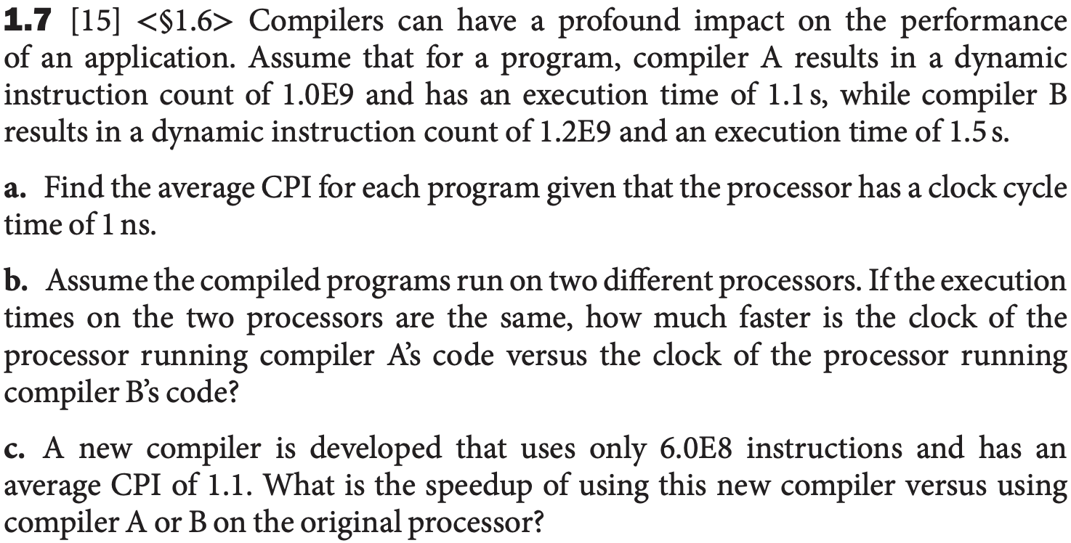

3 points

3 points

3 points

a.

CPI_A = 周期数/指令数 = ( 1.1s/1.0ns) / 1.0E9 = 1.1

CPI_B = 周期数/指令数 = ( 1.5s/1.0ns) / 1.2E9 = 1.25

CPI 就是(时间/时钟周期)/指令数

b.

CPU timeA = 周期数A / 时钟频率A

CPU timeB = 周期数B / 时钟频率B

We have CPU timeA = CPU timeB

Frequency A / Frequency B = (1.1s/1.0ns) /(1.5s/1.0ns) = 1.1/1.5 = 0.73

So the clock frequency of the processor running A is 0.73 times that of B

C.

Cycle = CPI * 指令数= 6.6*10^8

A: (1.1s/1.0ns) = 1.1 *10 ^9

B: (1.5s/1.0ns) = 1.5 *10 ^9

11/ 6.6 = 1.666

15/ 6.6 = 2.2727

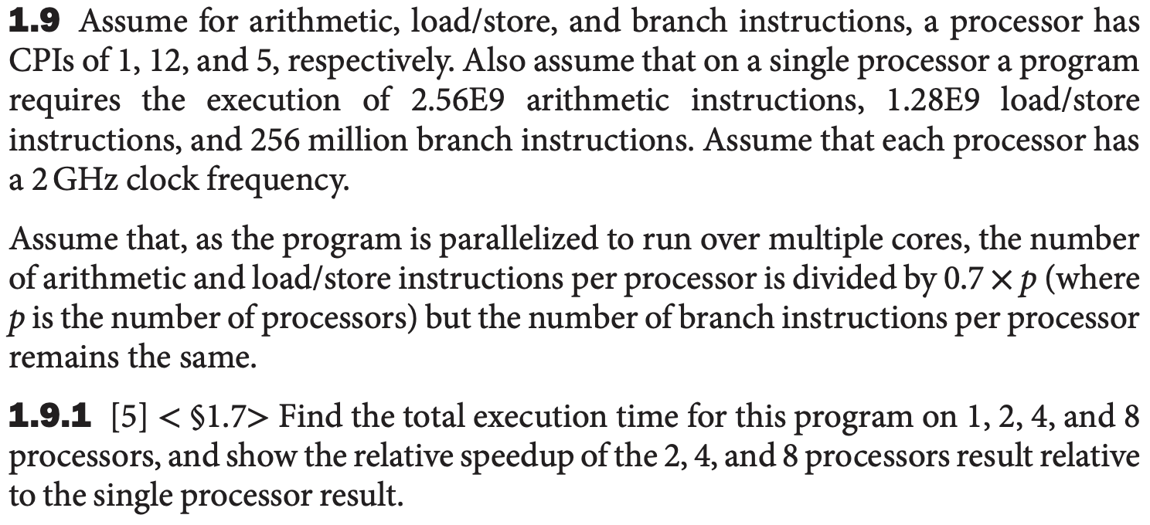

3 points

1 processor: 2.56E9 arithmetic, 1.28E9 load/store, 2.56E8 br.

Cycles: 2.56E9 *1 + 1.28E9*12 + 2.56E8 *5 = 1.884E 10

Execution time: 1.884E 10 / 2E9 = 9.42s

**2 processors:** 2.56E9 arithmetic, 1.28E9 load/store, 2.56E8 br.

Cycles: 2.56E9 *1/1.4 + 1.28E9*12/1.4 + 2.56E8 *5 = 1.408E 10

Execution time: 1.408E 10 / 2E9 = 7.04s

7.04s/9.42s = 74.7%

2 cores are 1.34 times faster than one core

**4 processors:** 2.56E9 arithmetic, 1.28E9 load/store, 2.56E8 br.

Cycles: 2.56E9 *1/2.8 + 1.28E9*12/2.8 + 2.56E8 *5 = 7.68E 9

Execution time: 7.68E 9 / 2E9 = 3.84s

3.84s /9.42s = 40.76%

4 cores are 2.45 times faster than one core

8 processors: 2.56E9 arithmetic, 1.28E9 load/store, 2.56E8 br.

Cycles: 2.56E9 *1/5.6 + 1.28E9*12/5.6+ 2.56E8 *5 = 4.48E 9

Execution time: 4.48E 9 / 2E9 = 2.24s, 2.24s /9.42s = 23.7%

Eight cores are 4.2 times faster than one core.

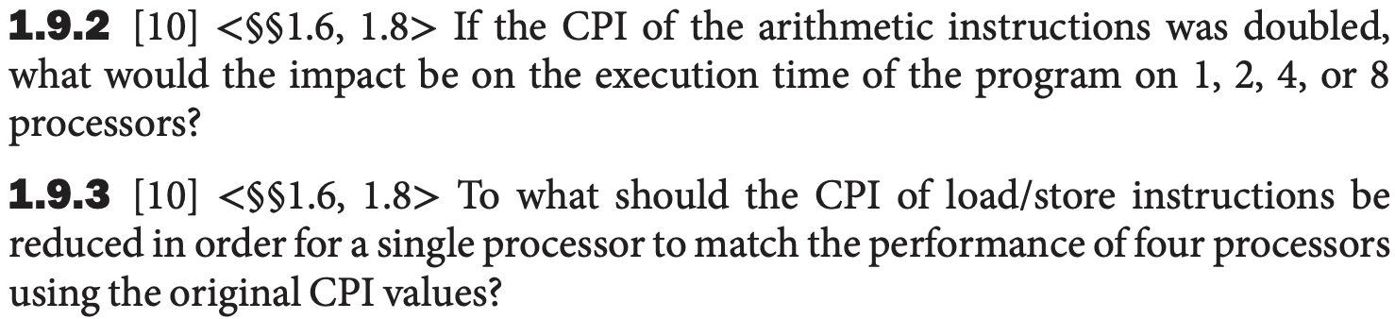

1 processor: 2.56E9 arithmetic, 1.28E9 load/store, 2.56E8 br.

Cycles: 2.56E9 *2 + 1.28E9*12 + 2.56E8 *5 = 2.176E 10

2.176E 10 / 1.884E 10 = 1.155

So the execution time of the program on 1 processor increase 15.5%

2 processors: 2.56E9 arithmetic, 1.28E9 load/store, 2.56E8 br.

Cycles: 2.56E9 *2/1.4 + 1.28E9*12/1.4 + 2.56E8 *5 = 1.59E 10

1.59E 10 / 1.408E 10 = 1.13

So the execution time of the program on 2 processor increase 13%

4 processors: 2.56E9 arithmetic, 1.28E9 load/store, 2.56E8 br.

Cycles: 2.56E9 *2/2.8 + 1.28E9*12/2.8 + 2.56E8 *5 = 8.594E 9

8.594E 9 / 7.68E 9= 1.12

So the execution time of the program on 4 processor increase 12%

8 processors: 2.56E9 arithmetic, 1.28E9 load/store, 2.56E8 br.

Cycles: 2.56E9 *2/5.6 + 1.28E9*12/5.6+ 2.56E8 *5 = 4.937 E 9

4.937 E 9 / 4.48E 9 = 1.102

So the execution time of the program on 8 processor increase 10.2%

In conclusion, the more processors we have, the less impact the CPI increment has on the execution time.

**1.9.3**

4 processors: 2.56E9 arithmetic, 1.28E9 load/store, 2.56E8 br.

Cycles: 2.56E9 *1/2.8 + 1.28E9*12/2.8 + 2.56E8 *5 = 7.68E 9

4 cores are as fast as one core. Since they have the same clock frequency, they should have the same clock cycles.

1 processor: 2.56E9 arithmetic, 1.28E9 load/store, 2.56E8 br.

Cycles: 2.56E9 *1 + 1.28E9*x + 2.56E8 *5 = 7.68E 9

1.28E9*x = 3.84, X = 3 =CPI = 3, 3/12 = 25%

Thus, we need to change the cpi of L/S to 25% of the original.

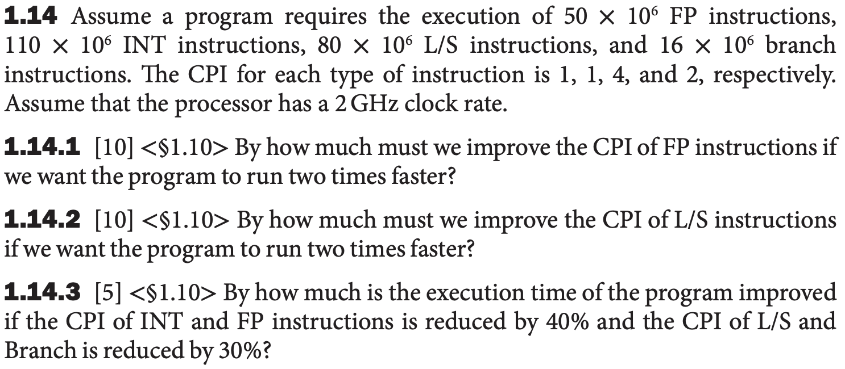

Float point 50 *10 ^6 ,Int 110 *10 ^6 ,L/S 80 *10 ^6, Branch 16 *10 ^6

**1.14.1**

Cycle: 50 *10 ^6 + 110 *10 ^6 + 4* 80 *10 ^6 + 2* 16 *10 ^6 = 5.12 *10^8

Now Cycle = 2.56 *10^8, we need to reduce 2.56 *10^8 cycles.

However, FP cycle = 50 *10 ^6 < 2.56 *10^8 cycles. So we cannot let the program run two times faster by improving the CPI of FP instruction only.

**1.14.2**

Cycle: 50 *10 ^6 + 110 *10 ^6 + 4* 80 *10 ^6 + 2* 16 *10 ^6 = 5.12 *10^8

Now Cycle = 2.56 *10^8

L/S: 320 – 256 = 64

The CPI of L/S = 0.8, 0.8 /4 = 0.2

Thus, we need to change the cpi of L/S to 20% of the original.

**1.14.3**

Now Cycle: 0.6* 50 *10 ^6 + 0.6* 110 *10 ^6 + 0.7*4* 80 *10 ^6 + 0.7*2* 16 *10 ^6 = 3.424 *10^8

Thus, we have changed the execution time to 66.875% of the original

1. How many bits do we need to represent a variable that can only take on the values 0, π or e? (3 points)

2 bits

1. If we need to address 3 TiB of memory and we want to address every byte of memory, how long does an address need to be? (3 points)

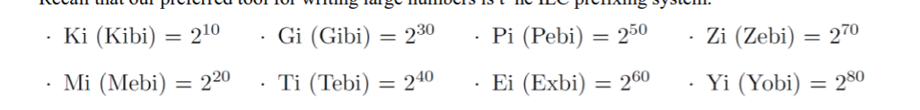

3* 2^40 bytes, 40 +2 = 42 bits

1. If the only value a variable can take on is e, how many bits are needed to represent it. (3 points)

1 bit

1. Assume an 8-bit integer and answer each one for the case of an unsigned number, biased number with a bias of -127, and two’s complement number, indicating if it cannot be answered with a specific representation.

(1) What is the largest integer? The largest integer’s representation + 1?

(a) [Unsigned] (3 points)

255 = 0b1111 1111, 0 = 0b0000 0000

(b) [Biased] (3 points)

128= 0b1111 1111, -127 = 0b0000 0000

(c) [Two’s Complement] (3 points)

0111 1111 = 127, -128 = 0b1000 0000

(2) How do you represent the numbers 0, 1, and -1?

(a) [Unsigned] (3 points)

0 = 0b0000 0000, 1 = 0b0000 0001. -1 cannot be answered with a specific representation.

(b) [Biased] (3 points)

1 = 1000 0000, 0= 0111 1111, -1 = 0111 1110

(c) [Two’s Complement] (3 points)

0b0000 0000 = +0, - 0 = 1000 0000,1= 0b0000 0001, -1 = 0b1111 1111

(3) How do you represent 17, -17?

(a) [Unsigned] (3 points)

17 = 0b0001 0001, -17 = cannot be answered with a specific representation.

(b) [Biased] (3 points)

17 = 1001 0000, -17 = 0110 1110

(c) [Two’s Complement] (3 points)

17 = 0b0001 0001, -17 = 0b1110 1111

(4) What is the largest integer that can be represented by any encoding scheme that only uses 8 bits? (3 points)

Because bias can be added, there is no maximum. 因为有bias , 没有上限.

(5) Prove that the two’s complement inversion trick is valid (i.e. that x and x + 1 sum to 0). (3 points)

We have gain a num y which every bit is 1 by adding x with (x’s inversion) Then y plus one equals 0.

1. If we only have shift registers and adders, how to implement a system
2. that can multiply any integer by 3? (7 points)
3. if we change the multiplicand to 7? (Can you design more than one structure? Which is better?) (7 points)
4. if the integer will be divided by 3? (7 points)

**Hint**: 2’s complement can be used to solve the above questions.

1. x<< 1 +x

2. x <<3 + (–x) use the 2’s complement to gain the -x

3. $\sum_{i=1}^{15}{\left(x≪\left(2i\right)\right) because \lim_{ }{\sum_{i=1}^{\backslash infity }{\frac{1}{4^{i}} =\frac{1}{3} }}}$

X /3 = x/4 + x/16 + x/64 + …. = x<<2 + x<< 4 + x<<6 + ….

Because integer have 32bits

X/3 = x<<2 + x<< 4 + … + x<<30

1. A system below is designed for the 16-b fixed-point MAC operation. It has an n*n array of the multipliers. The operands A (a15…a4a3a2a1a0) and B (b15…b5b4b3b2b1b0) are the two inputs of the multiplier. Output Y has 32 bits. Assuming operand B is a constant and stored in the multiplier. The multiplication is based on the shift and add operation (… a2*B*22+ a1*B*21+ a0*B*20, where *2n is achieved by the shift operation). We have the following two assumptions:

1) data B follow the Gaussian distribution and their mean value is 0;

2) when a bit in B is 0, there is no power consumption.

这个系统 设计一个16bit mac操作, 有n*n 乘法器,

To minimize the power consumption, what kind of binary representation should be used? Please draw a block diagram of the multiplier and explain why it helps to reduce the power consumption. (10 points)

应该用哪种二进制表示? 我们应该让1的概率小.

*Hint: Minimizing the power consumption is to minimize the ratio of “1” s in data B.



无符号数不能表示负数，因此我们从偏差或二进制补码中选择表示。

当bi等于0时，xj *bi不会消耗功率，数据B很可能接近0，因为数据B服从高斯分布，它们的均值为0；

当 B > 0 时，B 的每一位更有可能为零而不是一。 B 的补码等于 B。 如果我们使用偏差，我们可能需要加一些 1。

当 B < 0 时，B 的每一位更有可能是 1 而不是 0，但 B 的补码更有可能是零而不是一。 因此，二进制补码优于偏置。 这就是我们选择二进制补码表示的原因。

An unsigned number cannot represent a negative number, so we select representation from bias or two’s complement.

When bi equals 0, xj *bi would not consume power, data B is likely near 0 because data B follow the Gaussian distribution and their mean value is 0;

When B > 0, each bit of B is more likely to be zero instead of one. B’s inversion equals B. If we use bias, we may need to add some 1.

When B < 0, each bit of B is more likely to be 1 instead of 0, but B’s complement is more likely to be zero instead of one. Thus, two’s complement is better than bias. That is why we choose two’s complement representation.

下图可以节省需要的硬件, 减少了传播延时,在乘法位数较多时比进位保留结构快得多.

