STORA: Smart Inventory & Micro-Commerce Platform
Comprehensive Visual User Manual & Screen-by-Screen Process Guide
Target Sector: MSME Digitalization & FinTech | Year: 2026
This document provides a fully verified, step-by-step visual guide containing all 55 mobile application screens across the Stora ecosystem. It details the bidirectional Online Customer Process (17 screens) and the complete Stora Merchant Features & Customer Discovery suite (38 screens across 15 operational modules).

PART 1: Online Customer Process (End-to-End Ordering & Fulfillment)
A verified 17-step bilateral walkthrough showing how a neighborhood customer discovers items, places an order via Cash or GCash, and how the merchant inspects customer geolocation, accepts, prepares, fulfills, and receipts the order with instant live synchronization.

Step 1: Multi-Store Catalog & Store Discovery
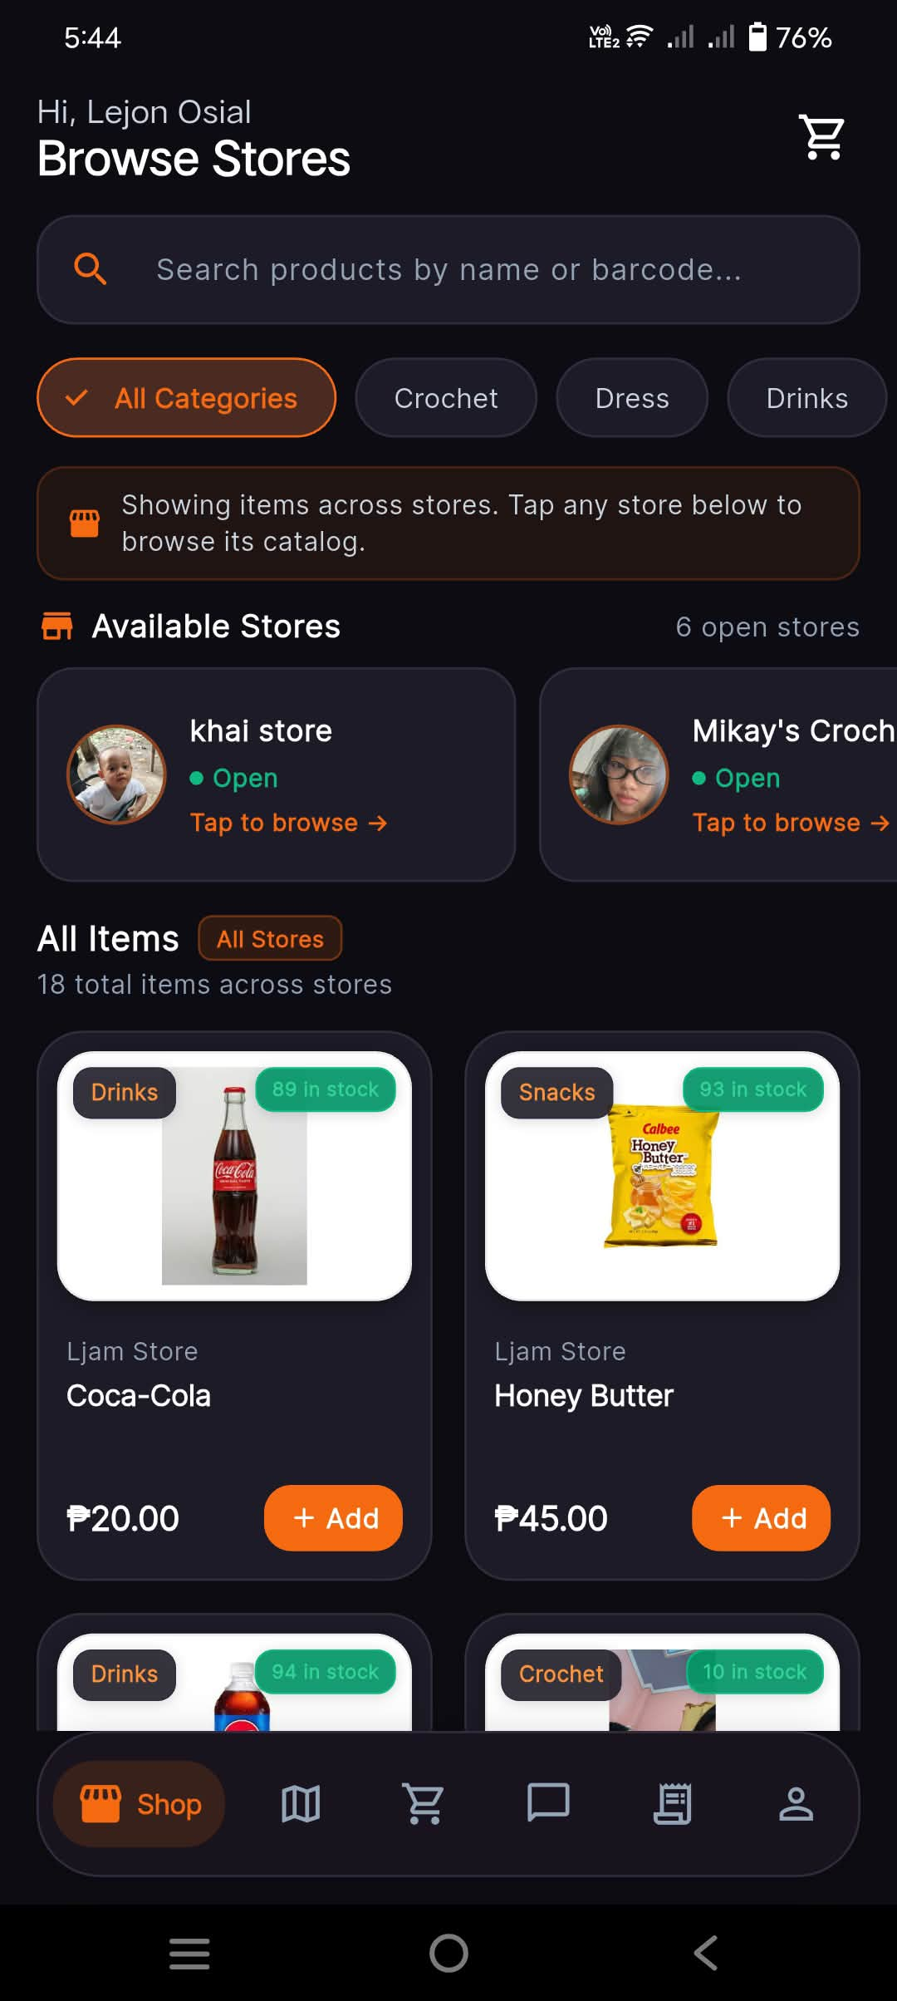
Application: Stora Customer | Screen: Browse Stores (Home Screen)

Functional Description: The customer opens the Stora Customer app to discover neighborhood stores and browse items across multiple merchants in one unified feed. Tapping an item opens the product detail bottom sheet; tapping a store card opens that specific merchant's dedicated storefront.
Key Interface Elements & Visual Indicators:
- Header greeting ('Hi, Lejon Osial') and cart shortcut with badge counter
- Universal search bar supporting product name and barcode search
- Horizontal category filters (All Categories, Crochet, Dress, Drinks, Snacks)
- 'Available Stores' carousel displaying currently open local stores (khai store, Mikay's Crochet) with live status dots
- 'All Items' multi-store catalog grid with stock indicators (89 in stock), prices (₱20.00, ₱45.00), and '+ Add' buttons
💡 Practical Micro-Retail Note: Multi-merchant aggregation allows customers to view inventory across several local vendors without switching accounts.

Step 2: Product Detail & Add-to-Cart Modal
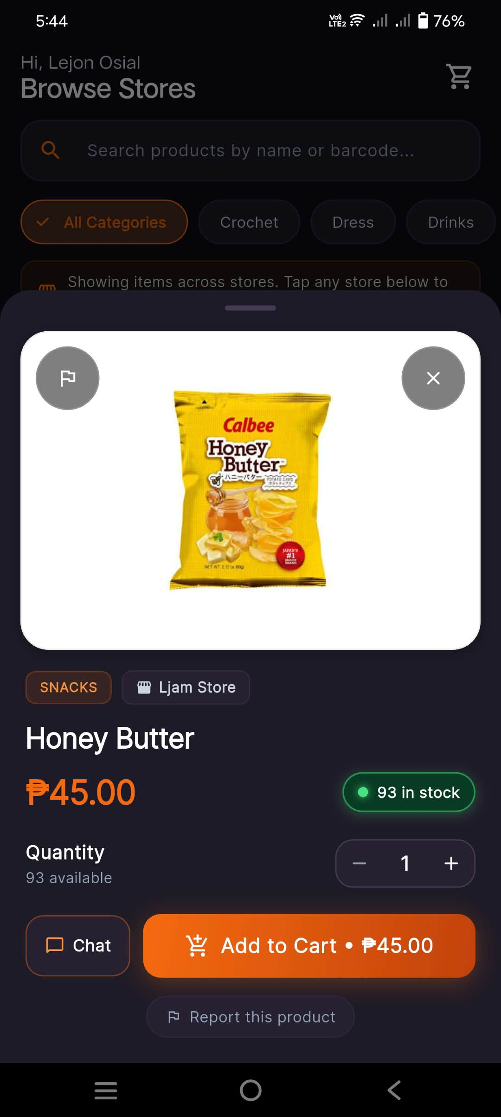
Application: Stora Customer | Screen: Product Detail Bottom Sheet (Honey Butter)

Functional Description: The customer views granular product information, confirms real-time stock availability, adjusts purchase quantities, and commits the item directly to their active shopping cart.
Key Interface Elements & Visual Indicators:
- High-resolution product image presentation
- Category badge ('SNACKS') and originating store tag ('Ljam Store')
- Unit pricing ('₱45.00') and high-contrast stock indicator ('93 in stock' with green live dot)
- Interactive quantity stepper ('-' / '+') with stock threshold limits
- Action buttons: Direct 'Chat' button (inquire with seller) and orange 'Add to Cart • ₱45.00' CTA
- Community safety link: 'Report this product'
💡 Practical Micro-Retail Note: Prevents over-ordering by strictly enforcing the maximum available inventory threshold in the quantity stepper.

Step 3: Shopping Cart Review & Delivery Landmark
Application: Stora Customer | Screen: My Shopping Cart
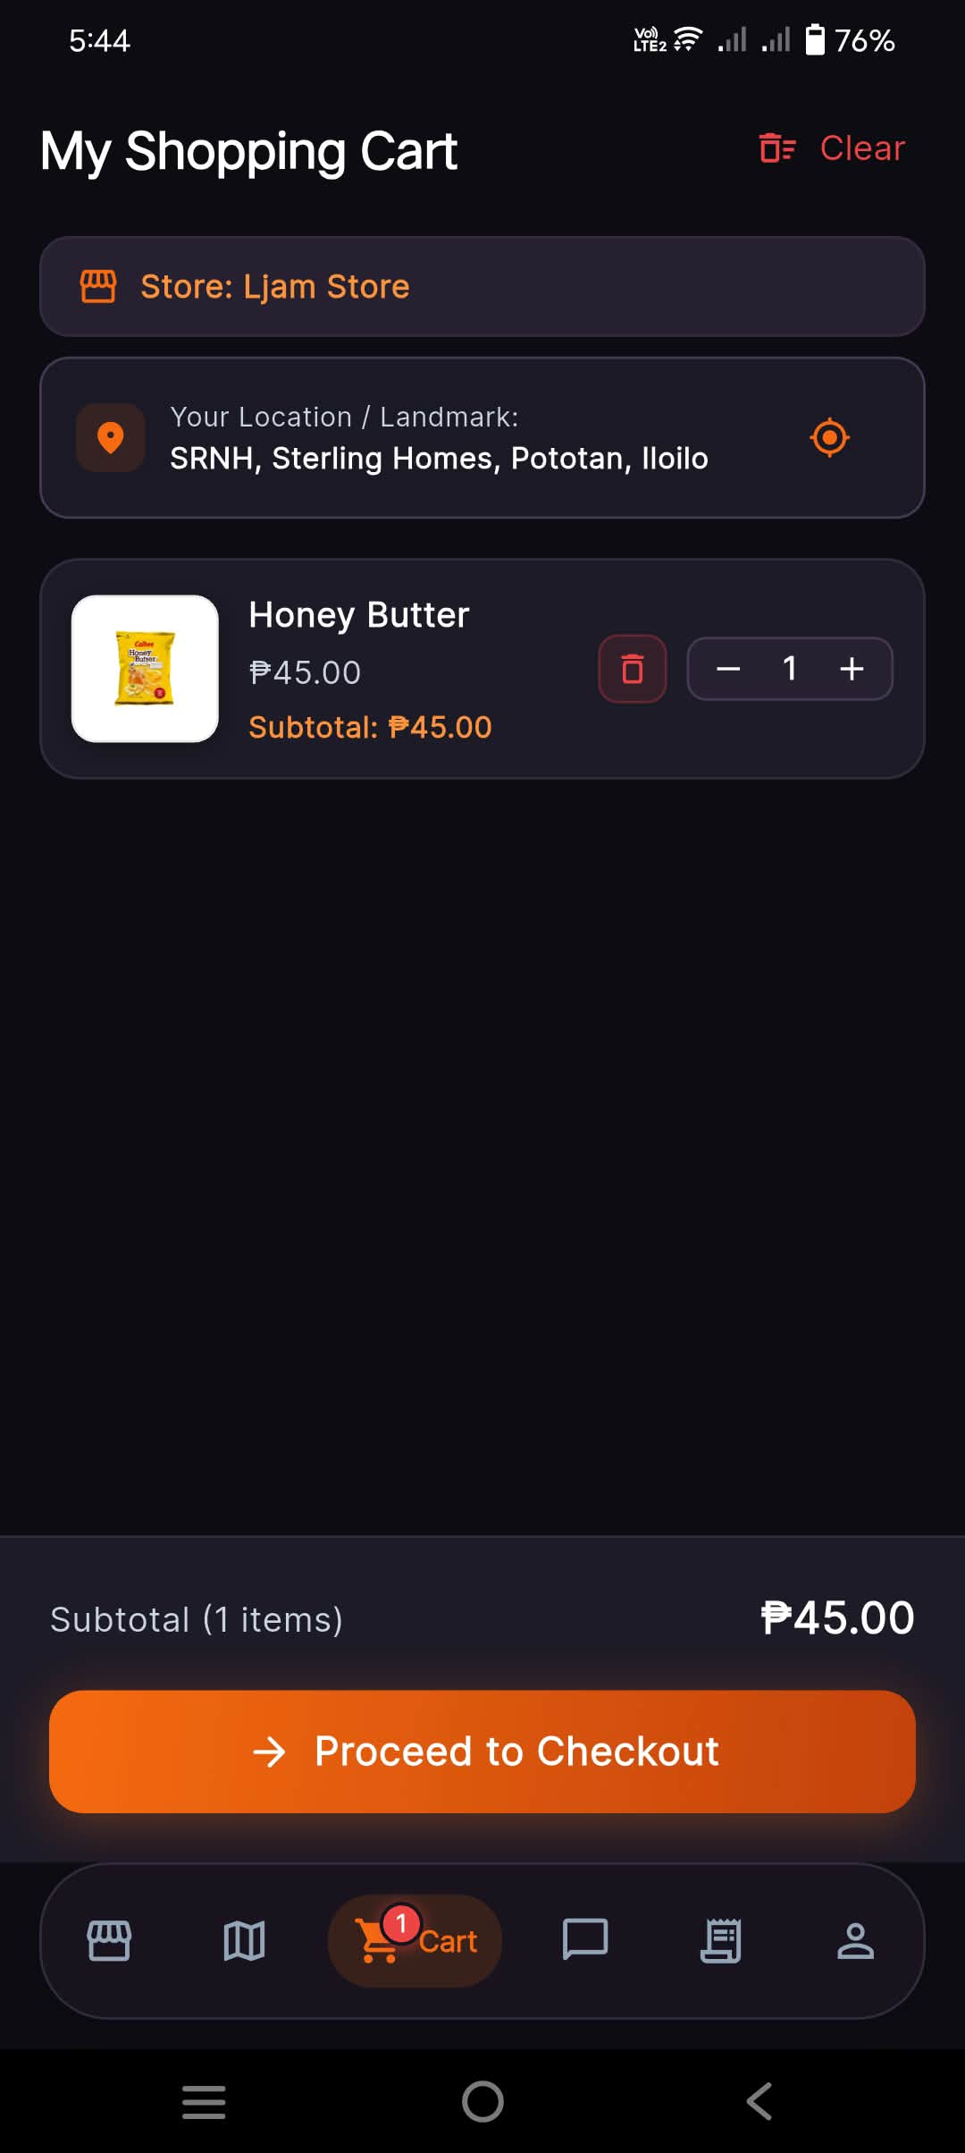
Functional Description: The customer reviews their cart contents, verifies that their delivery address/landmark is accurate, adjusts quantities if necessary, and proceeds to the checkout flow.
Key Interface Elements & Visual Indicators:
- Store grouping header ('Store: Ljam Store') ensuring single-merchant fulfillment integrity
- Customer pickup/delivery landmark display ('SRNH, Sterling Homes, Pototan, Iloilo') with GPS locator icon
- Cart line item with thumbnail, unit price, quantity modifier, subtotal ('₱45.00'), and delete icon
- Running subtotal footer ('₱45.00') and prominent 'Proceed to Checkout' CTA
💡 Practical Micro-Retail Note: Orders are strictly grouped per merchant so that pickup logistics and payments remain separated per sari-sari store.

Step 4: Checkout Order — Payment Selection (Cash on Pickup)
Application: Stora Customer | Screen: Checkout Order Configuration Screen
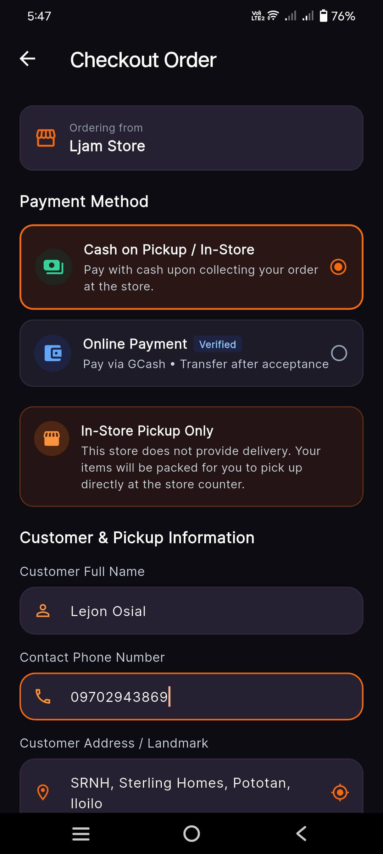
Functional Description: Allows the customer to select cash payment at the counter upon collection. Contact details are pre-filled from their profile to eliminate typing friction.
Key Interface Elements & Visual Indicators:
- Store identification banner ('Ordering from Ljam Store')
- Payment Method Radio Selector: 'Cash on Pickup / In-Store' (Selected) vs 'Online Payment (Verified)'
- Fulfillment Mode Notice: 'In-Store Pickup Only' badge explaining counter pickup terms
- Autofilled customer contact information: Customer Full Name ('Lejon Osial'), Contact Phone ('09702943869'), and Landmark
💡 Practical Micro-Retail Note: Addresses the reality that cash remains the primary transaction medium for neighborhood community stores in the Philippines.

Step 5: Checkout Order — Online Payment (GCash & Store QR)
Application: Stora Customer | Screen: Checkout Order Screen (Online Payment Active)
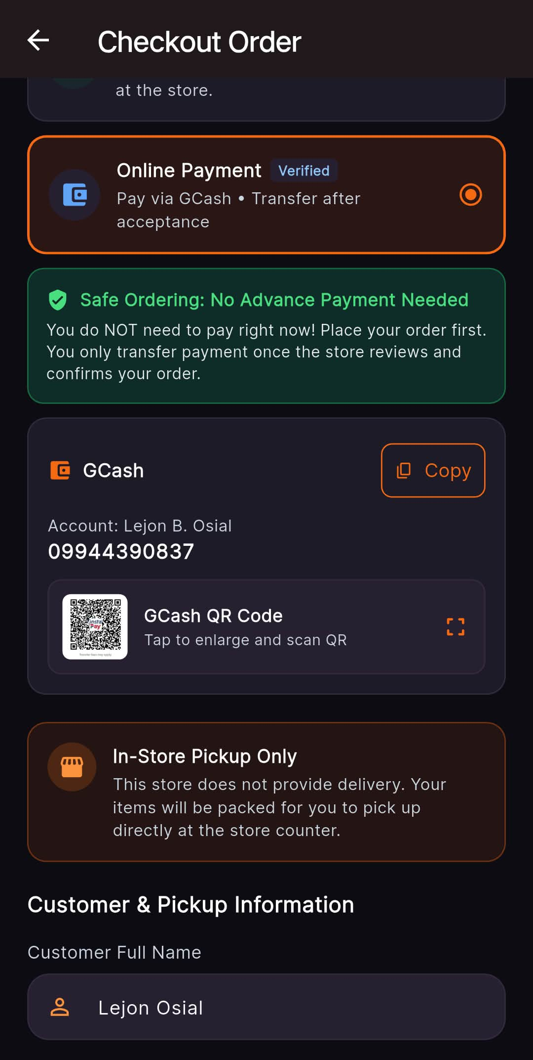
Functional Description: Provides transparent cashless payment details. Protects customers from sending money before the merchant verifies real stock availability.
Key Interface Elements & Visual Indicators:
- 'Online Payment (Verified)' method selected ('Pay via GCash • Transfer after acceptance')
- Trust Banner: 'Safe Ordering: No Advance Payment Needed' ('Do NOT pay right now! Place order first. You only transfer payment once store reviews and confirms your order.')
- Verified GCash merchant account details: Name ('Lejon B. Osial'), Account Number ('09944390837') with 1-tap 'Copy' button
- Tap-to-enlarge payment QR code thumbnail preview
💡 Practical Micro-Retail Note: Safe Ordering builds trust by preventing accidental advance transfers for out-of-stock items.

Step 6: Checkout Order — Pickup Notes & Order Submission
Application: Stora Customer | Screen: Checkout Order Final Review & Submission
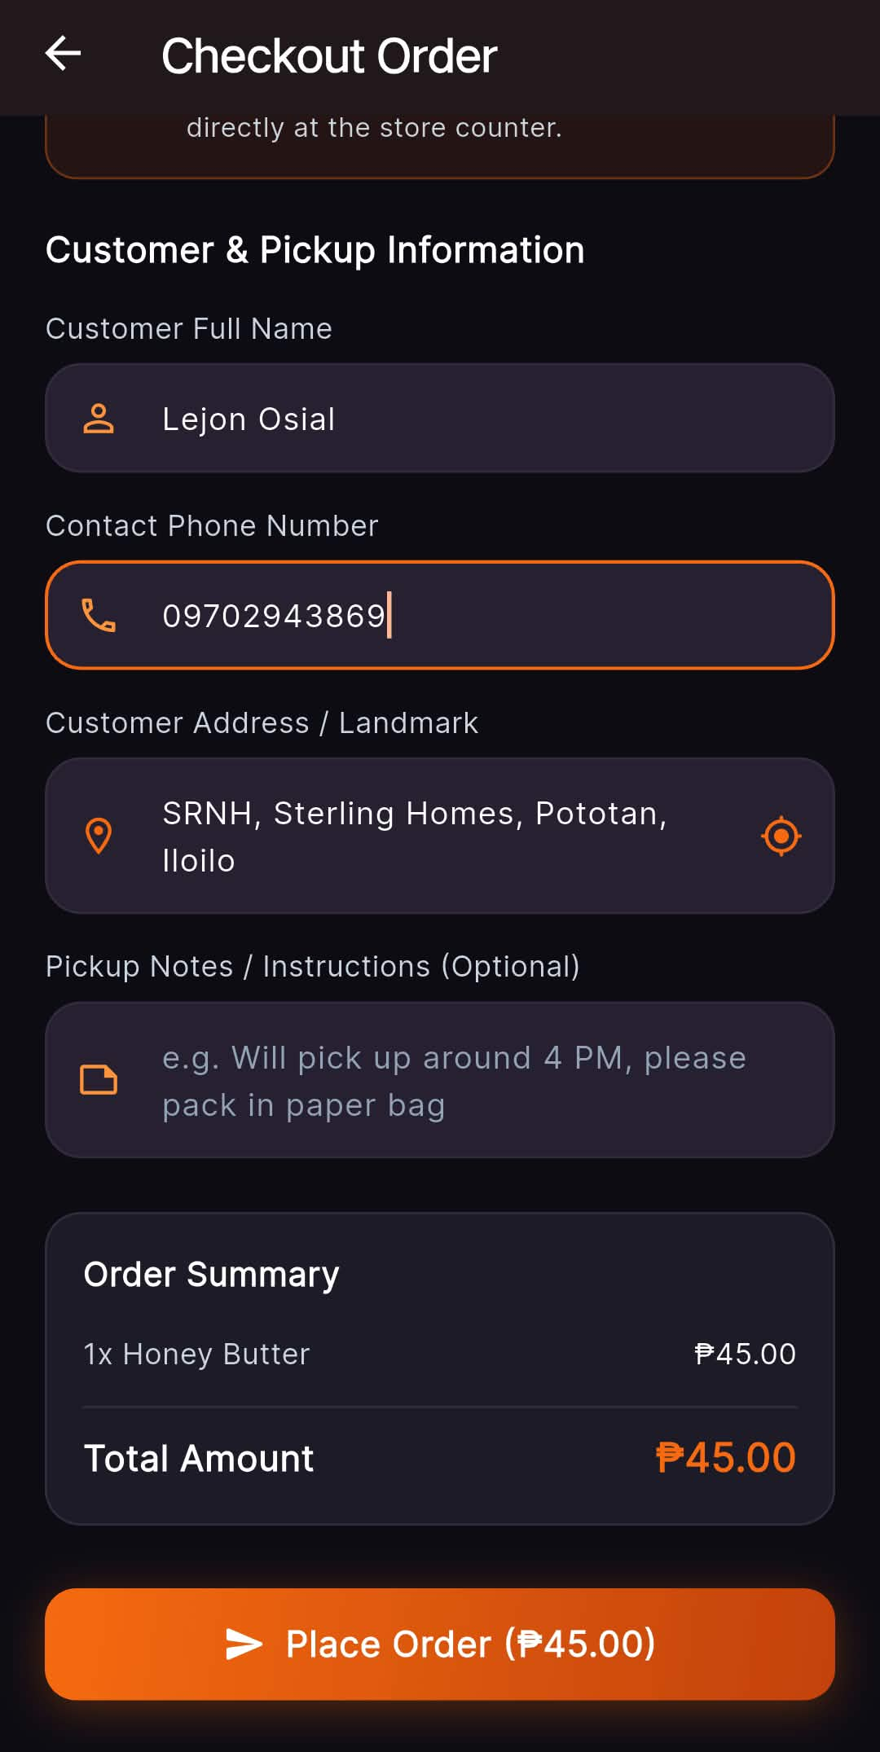
Functional Description: The customer inputs special instructions for packaging or pickup timing, verifies the order summary, and submits the order into the real-time processing queue.
Key Interface Elements & Visual Indicators:
- Optional 'Pickup Notes / Instructions' text field (e.g., 'Will pick up around 4 PM, please pack in paper bag')
- Itemized 'Order Summary' ('1x Honey Butter ₱45.00')
- Cumulative total display ('Total Amount ₱45.00')
- Full-width submission button: 'Place Order (₱45.00)'
💡 Practical Micro-Retail Note: Pickup notes give neighborhood buyers flexibility to schedule pick up around their errands or work schedules.

Step 7: Order Tracking — Placed & Awaiting Store Response
Application: Stora Customer | Screen: My Orders (Pending Tab)
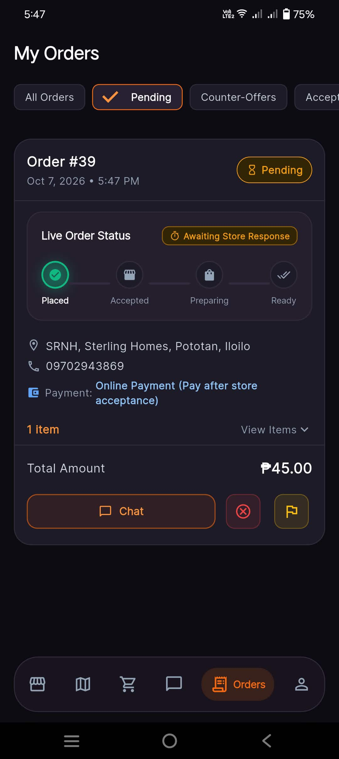
Functional Description: Provides the customer with real-time visual feedback that their order has reached the merchant's device and is waiting for merchant confirmation.
Key Interface Elements & Visual Indicators:
- Order card header: 'Order #39', timestamp ('Oct 7, 2026 • 5:47 PM'), status pill 'Pending'
- Visual 4-Stage Pipeline: Placed (✓ Active) -> Accepted -> Preparing -> Ready
- Status note: 'Awaiting Store Response'
- Recorded pickup details, chosen payment method, total cost ('₱45.00'), 'Chat', 'Cancel', and 'Report' buttons
💡 Practical Micro-Retail Note: The 4-stage pipeline gives immediate peace of mind and full transparency on order progress.

Step 8: Merchant Dashboard — Incoming Order Notification Alert
Application: Stora Owner | Screen: Home Dashboard (Hi, Ljam Store)
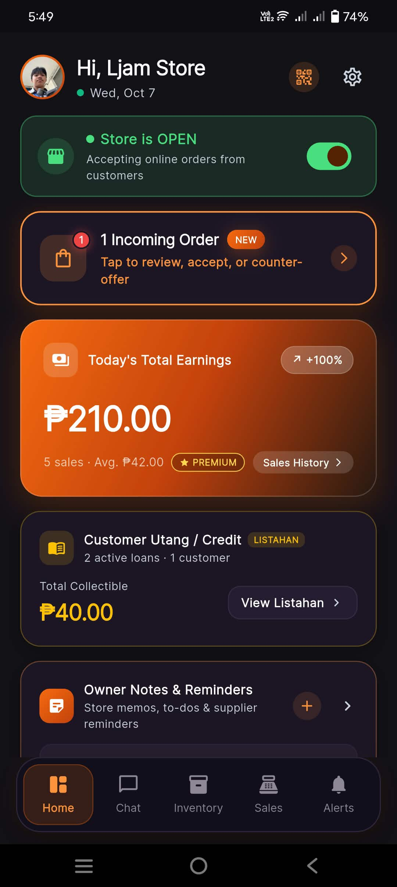
Functional Description: When an order is placed, the store owner's dashboard instantly flags the incoming transaction via real-time sync, alerting the merchant to review and act immediately.
Key Interface Elements & Visual Indicators:
- Dynamic status banner: '1 Incoming Order - NEW' ('Tap to review, accept, or counter-offer >')
- 'Store is OPEN' operational toggle showing online orders active
- Today's Total Earnings metric ('₱210.00', 5 sales, '+100%') and collectible credit tracker ('₱40.00')
💡 Practical Micro-Retail Note: High-contrast alert ensures busy store owners do not miss incoming customer requests.

Step 9: Merchant Order Review & Decision
Application: Stora Owner | Screen: Customer Orders (Active / Pending Tab)
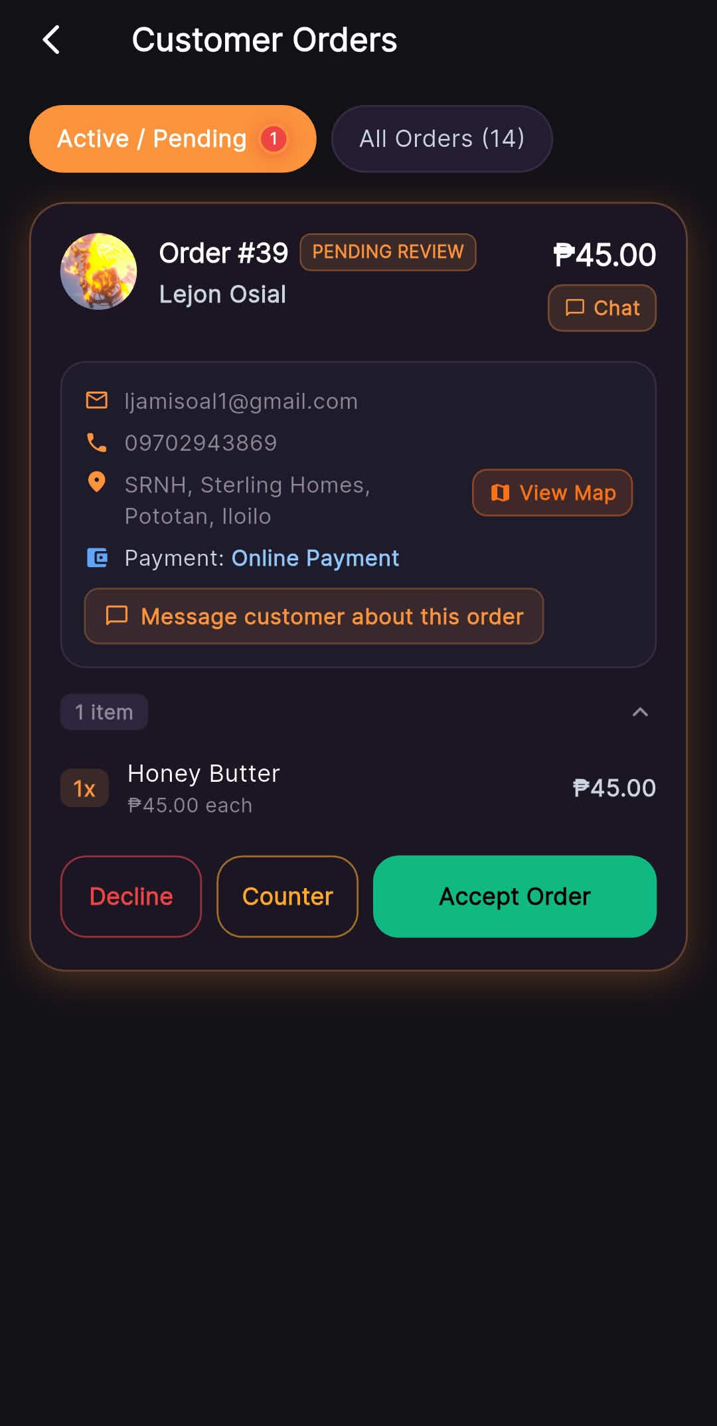
Functional Description: The merchant inspects who is ordering, where they are located, and what items are requested. The merchant can accept the order, propose substitutions (*Counter*), or decline if stock is depleted.
Key Interface Elements & Visual Indicators:
- Order card header: 'Order #39', badge 'PENDING REVIEW', total amount ('₱45.00')
- Customer information panel: Full Name ('Lejon Osial'), Email, Phone ('09702943869'), Landmark address with 'View Map' shortcut
- Item list breakdown: '1x Honey Butter' ('₱45.00 each')
- Decision trio: 'Decline', 'Counter' (propose substitute item or price adjustment), and 'Accept Order' (green primary CTA)
💡 Practical Micro-Retail Note: The Counter-offer capability is unique to local micro-retail, handling out-of-stock scenarios gracefully without outright cancellation.

Step 10: Merchant Spatial Navigation & Customer Location Map
Application: Stora Owner | Screen: Delivery Location Map Modal (Order #39)
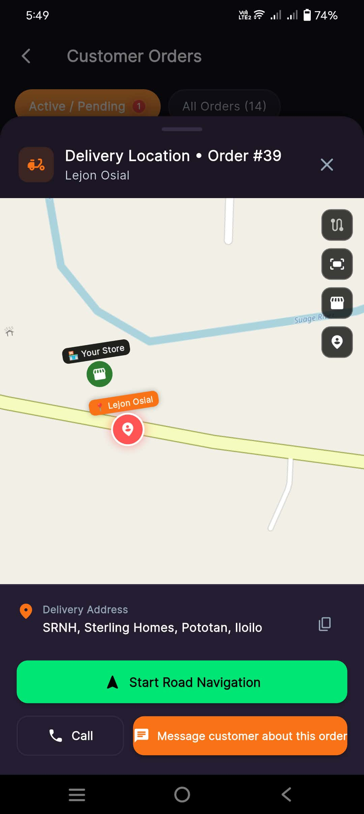
Functional Description: Tapping 'View Map' gives the store owner immediate spatial awareness of the customer's proximity, enabling delivery coordination or estimation of customer arrival time for pickup.
Key Interface Elements & Visual Indicators:
- Vector map overlay showing both the store location ('Your Store') and customer pickup landmark ('Lejon Osial')
- Road routing path connecting store to buyer coordinates in Pototan, Iloilo
- Quick action buttons: 'Start Road Navigation' (launches turn-by-turn routing), direct 'Call' shortcut, and in-app messaging
💡 Practical Micro-Retail Note: Enables neighborhood delivery or pickup timing coordination without external mapping apps.

Step 11: Merchant Preparation & 'Mark as Ready'
Application: Stora Owner | Screen: Customer Orders (Accepted State)
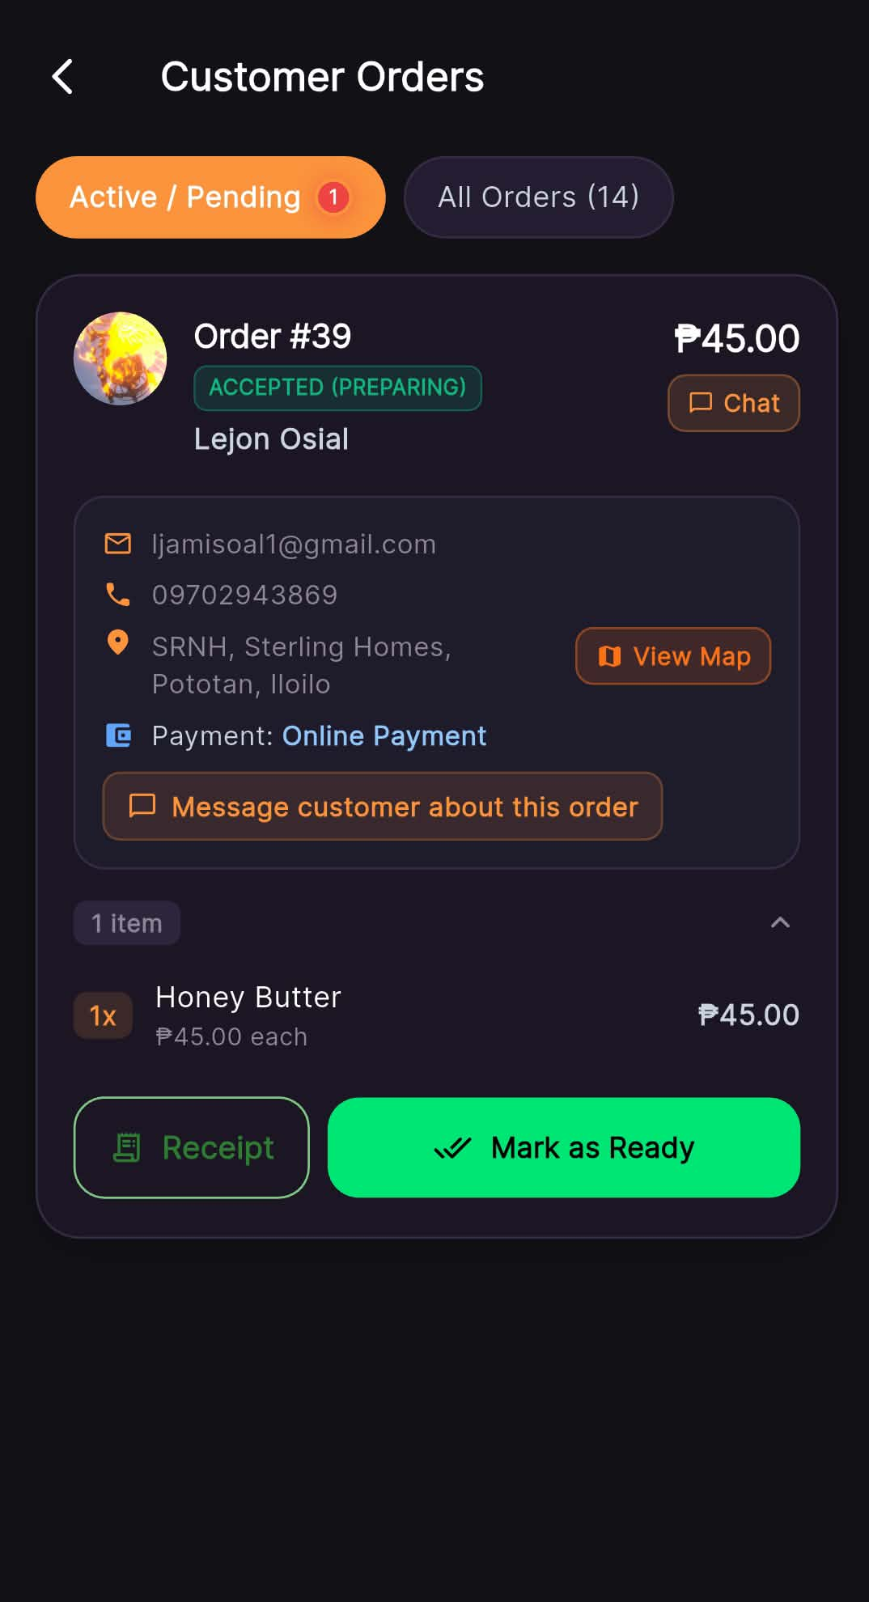
Functional Description: Having accepted the order, the merchant packages the ordered items at the store counter. Once bagged and ready, tapping 'Mark as Ready' sends an instant notification to the customer.
Key Interface Elements & Visual Indicators:
- Order card status updated to 'ACCEPTED (PREPARING)'
- Action buttons refreshed to: 'Receipt' (green icon button to view digital slip) and 'Mark as Ready' (green primary CTA)
💡 Practical Micro-Retail Note: Keeps physical packing organized and prevents customer waiting at the counter.

Step 12: Merchant Ready for Pickup & 'Complete Order'
Application: Stora Owner | Screen: Customer Orders (Ready State)
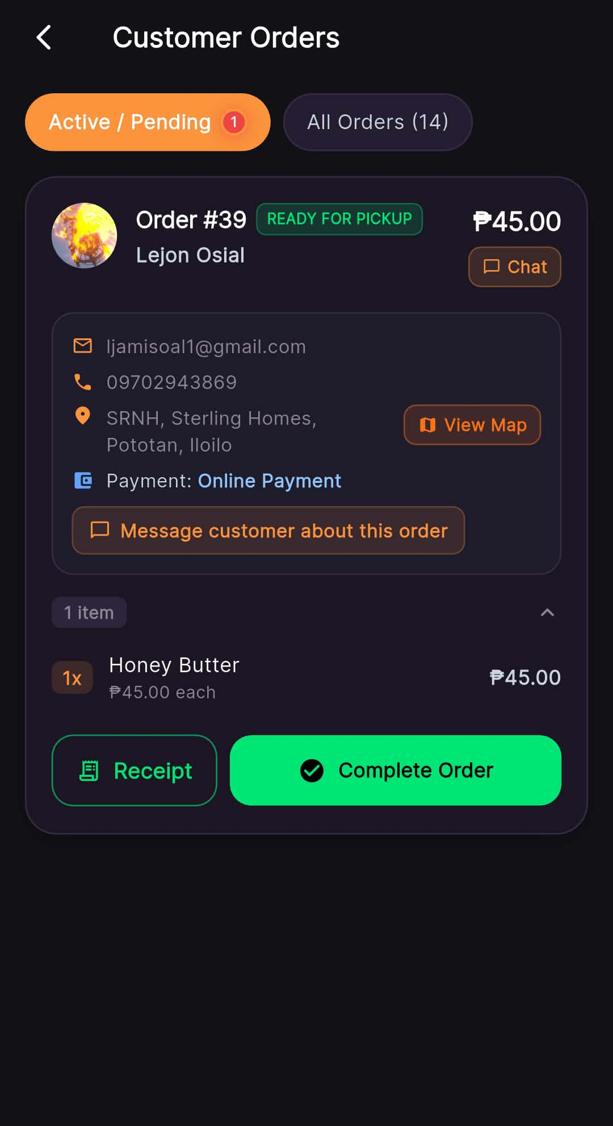
Functional Description: The order sits at the pickup counter. When the customer arrives, verifies their identity, and receives their package, the merchant taps 'Complete Order' to close the transaction.
Key Interface Elements & Visual Indicators:
- Status pill updated to 'READY FOR PICKUP'
- Action buttons refreshed to: 'Receipt' and 'Complete Order' (green checkmark CTA)
💡 Practical Micro-Retail Note: Completing the order automatically logs revenue into sales history and marks inventory deducted.

Step 13: Customer Notification — Order Ready for Pickup
Application: Stora Customer | Screen: My Orders (Ready for Pickup State)
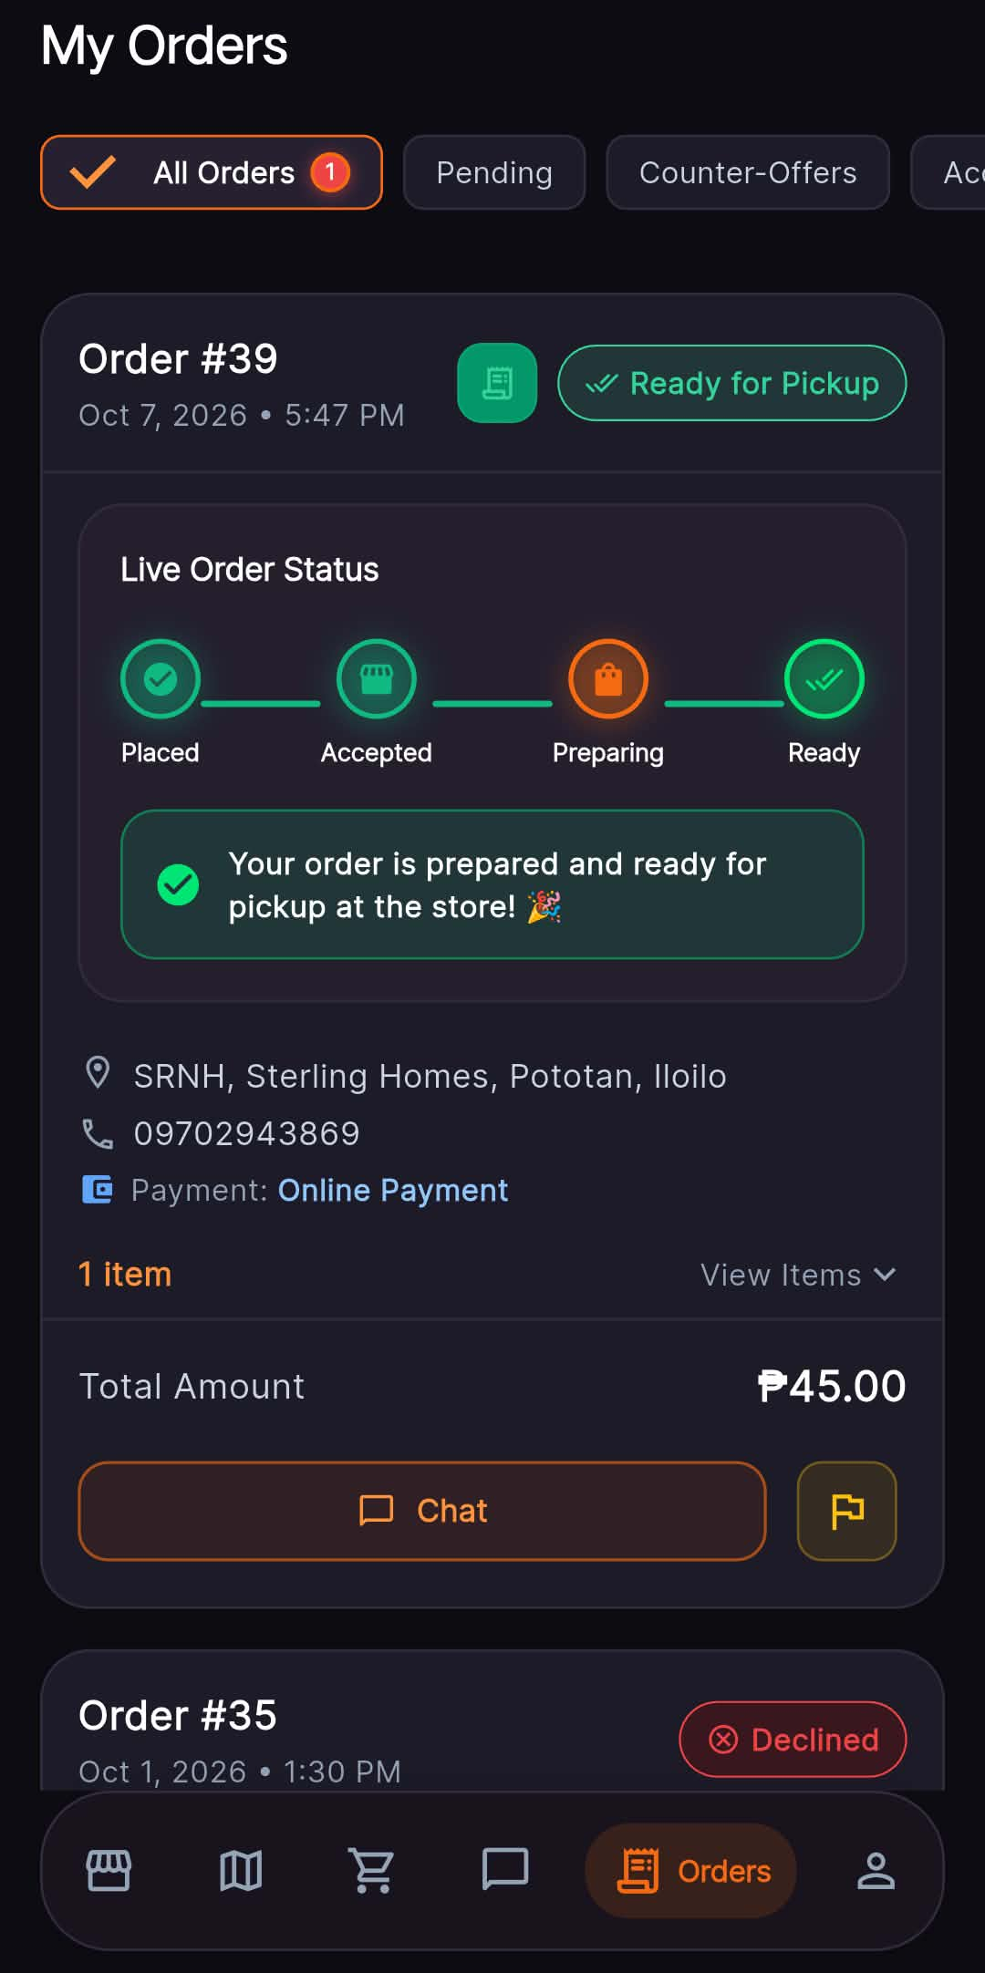
Functional Description: The customer receives live UI feedback that their goods are packaged and waiting at the counter, prompting them to walk over and collect their purchase.
Key Interface Elements & Visual Indicators:
- Status pipeline advanced: Placed (✓) -> Accepted (✓) -> Preparing (✓) -> Ready (✓)
- Success notification banner: 'Your order is prepared and ready for pickup at the store! 🎉'
- Quick access buttons: View digital receipt, chat with seller, or report order
💡 Practical Micro-Retail Note: Eliminates standing in line or wondering whether an order has been prepared.

Step 14: Customer Order Completed Confirmation
Application: Stora Customer | Screen: My Orders (Completed State)
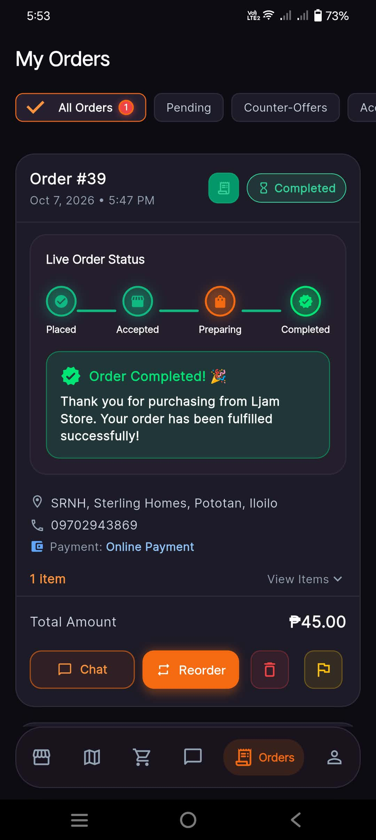
Functional Description: Confirms successful fulfillment. Historical order records remain saved in the customer's account with one-tap re-ordering for repeat purchases.
Key Interface Elements & Visual Indicators:
- Status pill updated to 'Completed'
- Pipeline completely fulfilled: Placed (✓) -> Accepted (✓) -> Preparing (✓) -> Completed (✓)
- Celebration banner: 'Order Completed! 🎉 Thank you for purchasing from Ljam Store. Your order has been fulfilled successfully!'
- Post-order action buttons: 'Chat', 'Reorder' (orange one-tap re-cart button), and 'Receipt'
💡 Practical Micro-Retail Note: The 'Reorder' button boosts customer retention by making frequent daily purchases effortless.

Step 15: Customer Digital Paper Receipt
Application: Stora Customer | Screen: Official Digital Receipt Modal (Customer View)
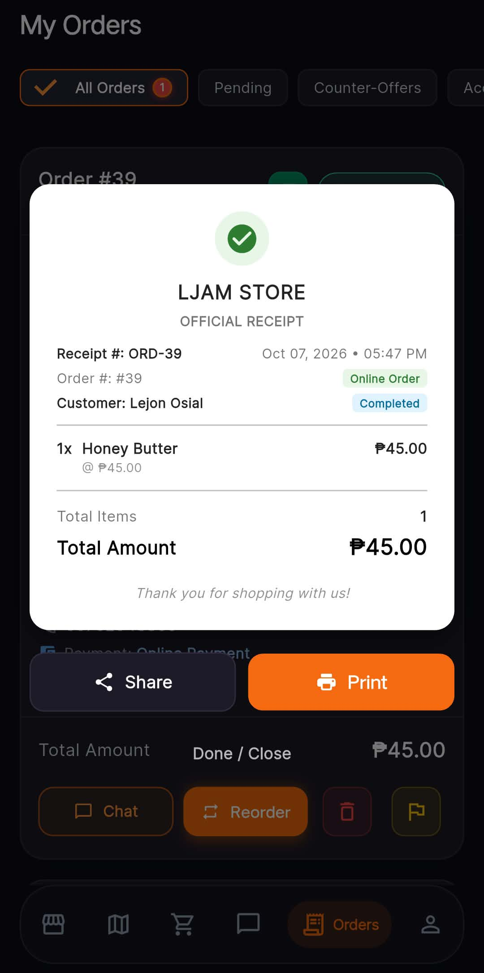
Functional Description: Provides the customer with a legally transparent digital proof of purchase without wasting paper, which can be printed or exported as an image/PDF.
Key Interface Elements & Visual Indicators:
- Authentic paper receipt aesthetic with store branding ('LJAM STORE - OFFICIAL RECEIPT')
- Audit metadata: Receipt Number ('ORD-39'), Date/Time ('Oct 07, 2026 • 05:47 PM'), Order Number, Order Type ('Online Order'), Customer Name ('Lejon Osial'), and Status ('Completed')
- Line items breakdown: '1x Honey Butter @ ₱45.00'
- Summary: Total Items (1), Total Amount ('₱45.00')
- Utility actions: 'Share' (sends receipt via messaging apps) and 'Print' (connects to Bluetooth thermal printers or system printer)
💡 Practical Micro-Retail Note: Zero paper waste with Bluetooth thermal printer compatibility.

Step 16: Direct In-App Bilateral Chat
Application: Both (Stora Customer & Stora Owner) | Screen: Active Order Chat
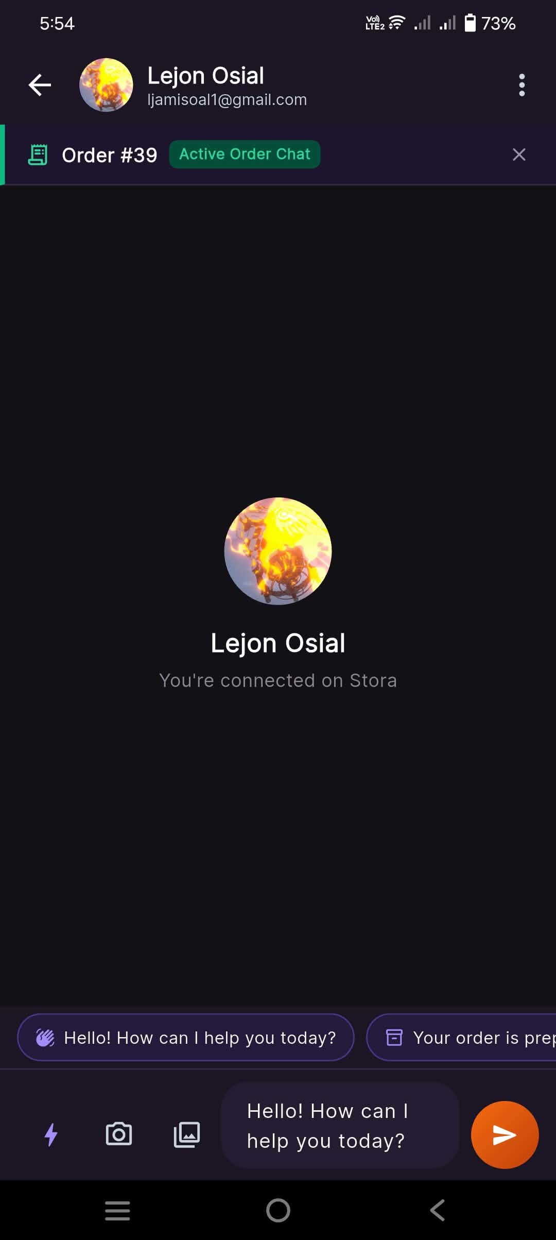
Functional Description: Enables secure, direct, in-app messaging between store owner and shopper for pickup coordination, product queries, or payment confirmations without needing third-party chat apps.
Key Interface Elements & Visual Indicators:
- Header identifying customer name ('Lejon Osial') and linked order identifier ('Order #39 - Active Order Chat')
- Pre-built quick reply chips ('Hello! How can I help you today?', 'Your order is prepared')
- Multimodal messaging input bar: text input, camera snapshot, photo gallery upload, and quick send action
💡 Practical Micro-Retail Note: Keeps communications contained within the order context for easy dispute resolution.

Step 17: Merchant Official Fulfillment Receipt
Application: Stora Owner | Screen: Official Digital Receipt Modal (Merchant View)
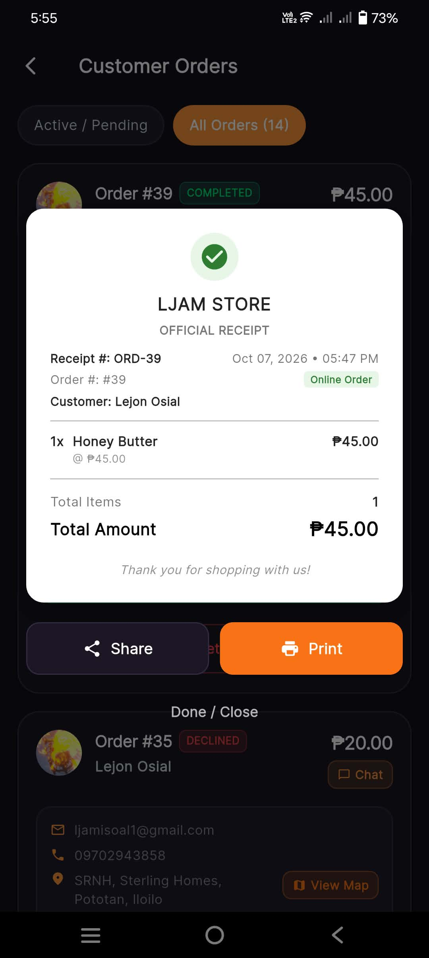
Functional Description: Enables the merchant to print a physical thermal receipt for the customer or keep digital accounting records for tax and bookkeeping purposes.
Key Interface Elements & Visual Indicators:
- Identical official digital store receipt for 'Order #39'
- Itemized total ('₱45.00'), customer name, and 'Completed' badge
- Action buttons: 'Share' and 'Print'
💡 Practical Micro-Retail Note: Ensures store accounting matches physical goods dispensed.

PART 2: Stora Features & Stora Customer Ecosystem
A comprehensive 38-screen visual breakdown spanning 15 functional modules: Merchant POS terminal, automated Sukli (change) calculator, Digital Utang Ledger (Listahan) with penalty/patong options, store memos, in-store digital QR standee, AI business insights, GPS store pinning, sales analytics, inventory catalog, and customer map routing.

Screen 1: Merchant Dashboard (Top View & Store Open Toggle)
Application: Stora Owner | Screen: Home Dashboard (Top)
Module: Module 1: Owner Dashboard & Business Pulse
Functional Description: Central dashboard providing store owners an at-a-glance overview of online store status, live daily revenue, pending incoming orders, and uncollected Utang credit balances.
Key Interface Elements & Visual Indicators:
- Personalized header greeting ('Hi, Ljam Store - Wed, Oct 7') with QR standee and Settings shortcuts
- 'Store is OPEN' operational toggle with instant online customer order intake control
- Real-time incoming orders banner widget
- Today's Total Earnings summary card ('₱210.00', 5 sales, '+100%', 'Sales History >')
- Customer Utang / Credit summary card ('Total Collectible ₱40.00', 2 active loans, 1 customer)
💡 Practical Micro-Retail Note: Store owners can turn their online store on/off with 1 tap during lunch breaks or after closing hours.

Screen 2: Merchant Dashboard (Bottom View & Quick Actions)
Application: Stora Owner | Screen: Home Dashboard (Bottom)
Module: Module 1: Owner Dashboard & Business Pulse
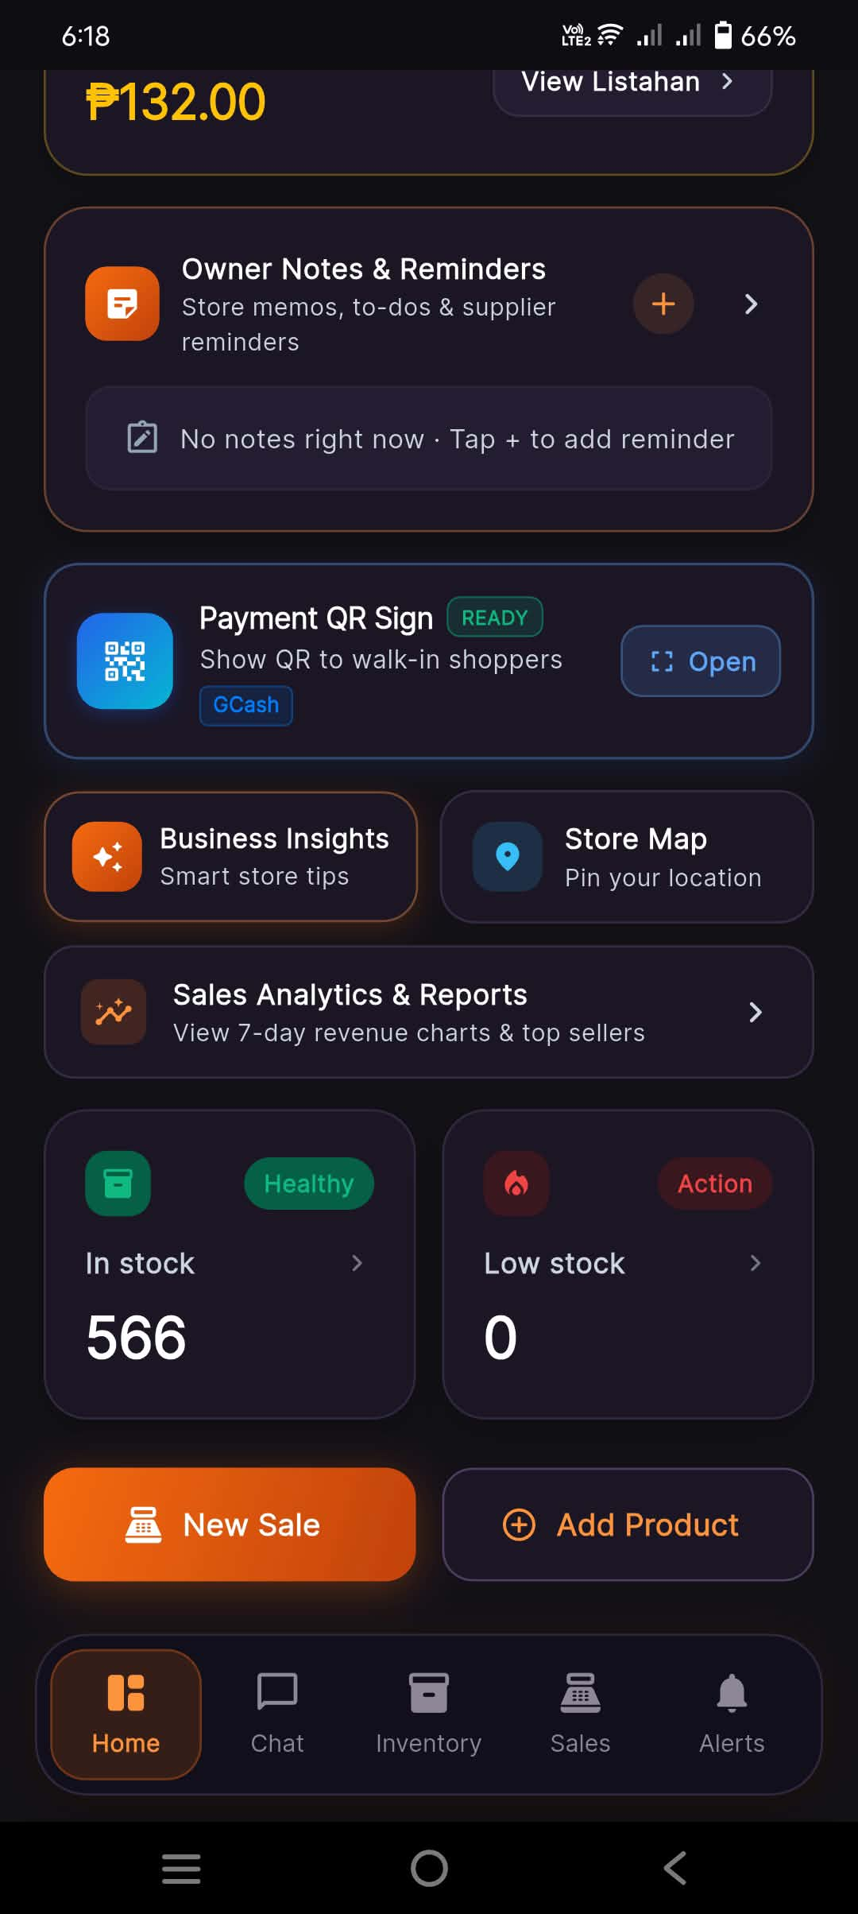
Functional Description: Lower dashboard view providing one-tap access to all critical day-to-day store operations: showing payment QR codes, checking stock health, reviewing analytics, and launching POS transactions.
Key Interface Elements & Visual Indicators:
- Owner Notes & Reminders preview card
- 'Payment QR Sign - READY' quick launcher ('Show QR to walk-in shoppers')
- Strategic feature grid: 'Business Insights' and 'Store Map'
- 'Sales Analytics & Reports' navigation card
- Inventory health summary: 'In stock - 566 (Healthy)' and 'Low stock - 0 (Action)'
- Prominent primary actions: 'New Sale' (POS terminal) and '+ Add Product'
💡 Practical Micro-Retail Note: Ergonomic thumb-zone placement for the two most frequent tasks: 'New Sale' and 'Add Product'.

Screen 3: Sales History & Transaction Log
Application: Stora Owner | Screen: Sales History Screen
Module: Module 2: Transaction History & Financial Audit
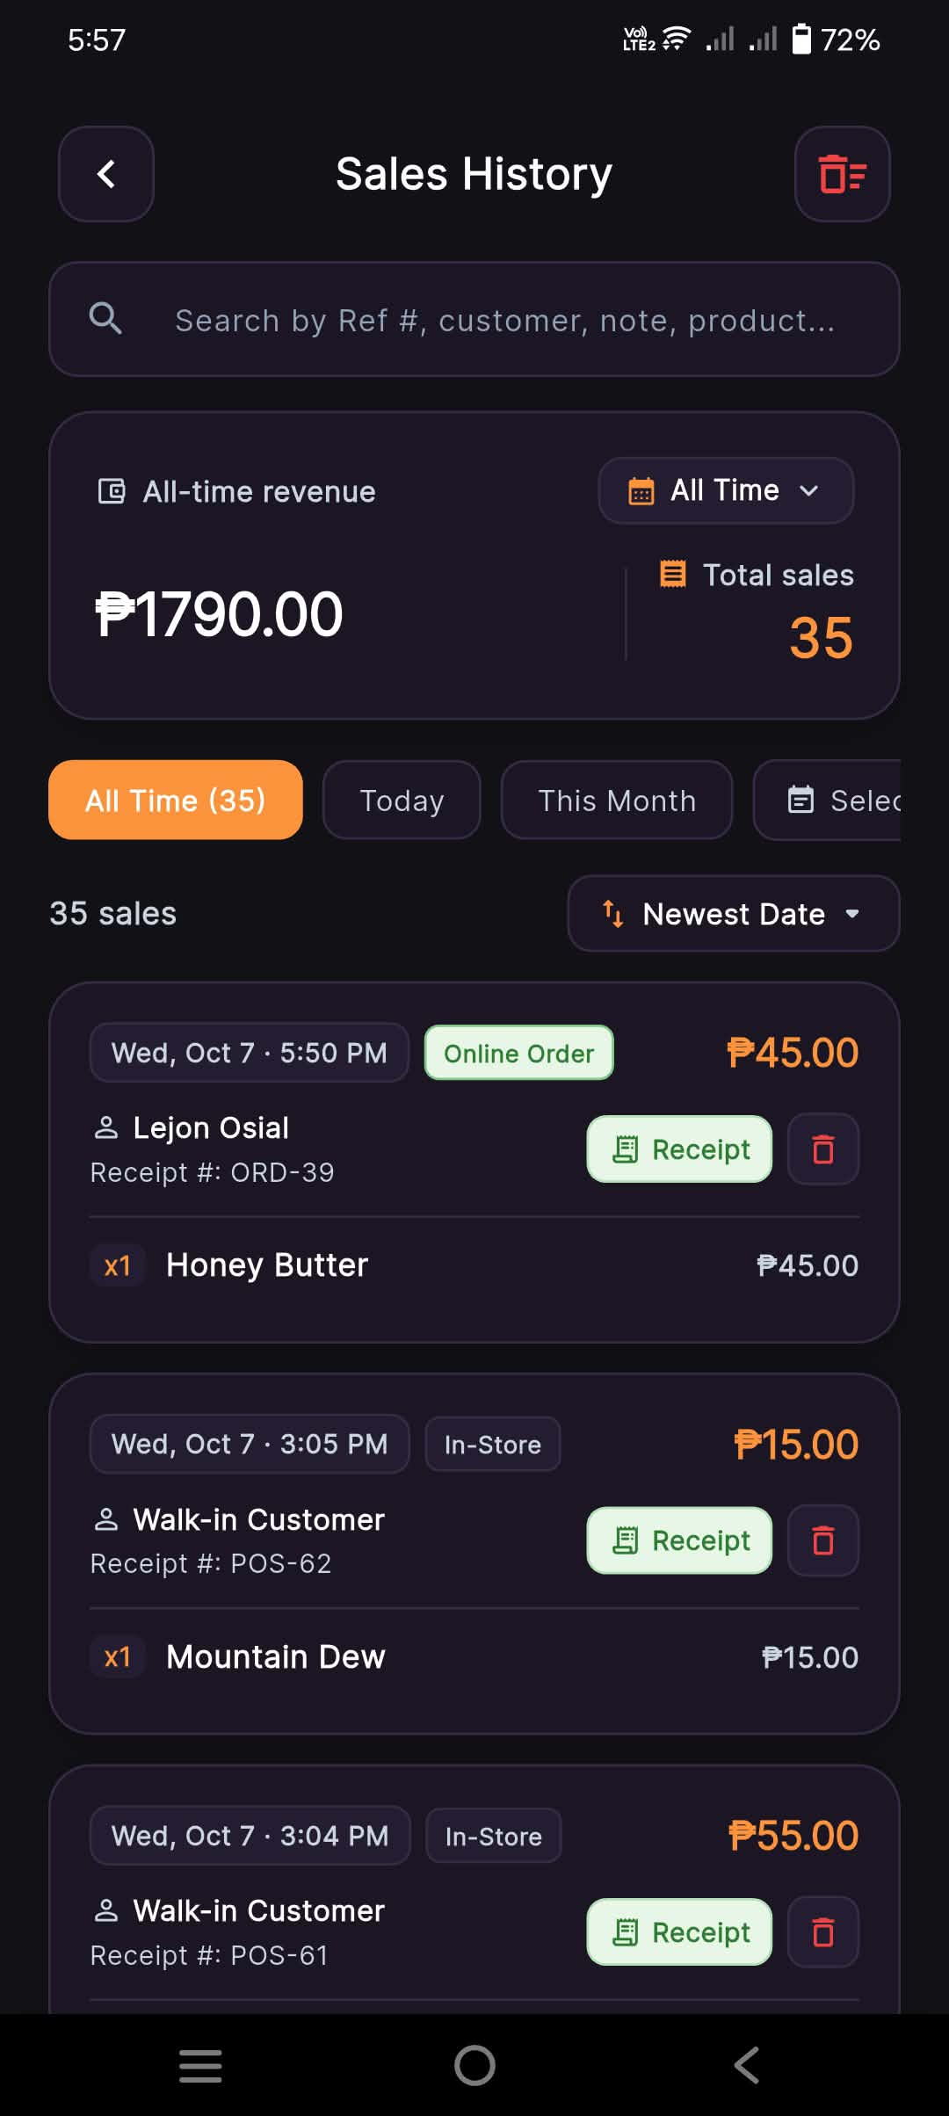
Functional Description: Comprehensive audit log of all completed transactions (both walk-in POS and online customer orders) with date filtering, total revenue metrics, item breakdown, and instant digital receipt retrieval.
Key Interface Elements & Visual Indicators:
- Universal search bar (search by Ref #, customer, note, product)
- Date filter pills (All Time, Today, This Month, Select Date)
- Metrics banner: All-time revenue ('₱1790.00') and Total sales count ('35')
- Sorted transaction cards with payment tags ('Online Order' vs 'In-Store')
- Direct 'Receipt' viewing button and delete action per transaction
💡 Practical Micro-Retail Note: Provides complete financial accountability for every centavo flowing through the store.

Screen 4: Utang Ledger / Digital Listahan (Overview & Empty State)
Application: Stora Owner | Screen: Utang Ledger (Listahan) Screen
Module: Module 3: Digital Utang Ledger & Credit Management
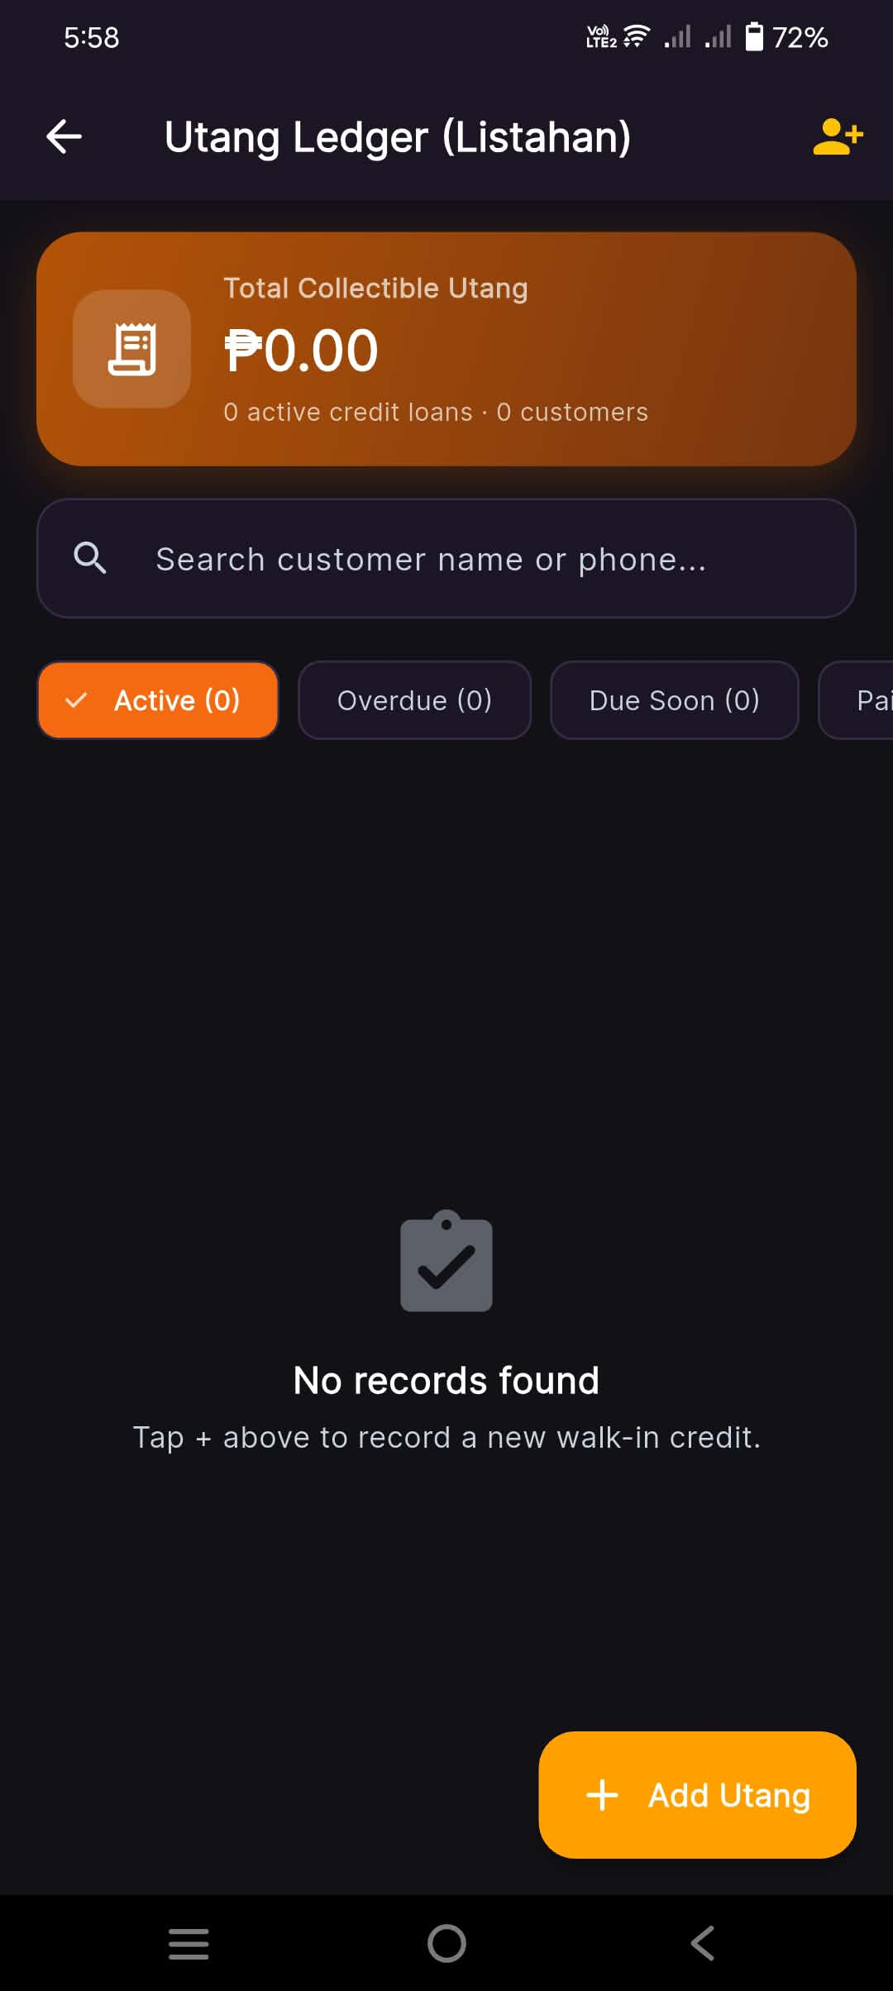
Functional Description: Digital credit ledger replacing traditional paper notebook listahan. Organizes store credit receivables with status tabs and real-time total collectible balance.
Key Interface Elements & Visual Indicators:
- Header with '+ Add Customer' shortcut icon
- Metric summary banner: 'Total Collectible Utang: ₱0.00' (0 active credit loans, 0 customers)
- Status filter tabs: 'Active', 'Overdue', 'Due Soon', 'Paid'
- Search bar by customer name or phone number
- Empty state message and floating '+ Add Utang' action button
💡 Practical Micro-Retail Note: Replaces vulnerable paper notebooks that can be misplaced, wet, or torn.

Screen 5: New Utang Entry (Customer Information & Due Date)
Application: Stora Owner | Screen: New Utang Entry Modal (Part 1)
Module: Module 3: Digital Utang Ledger & Credit Management
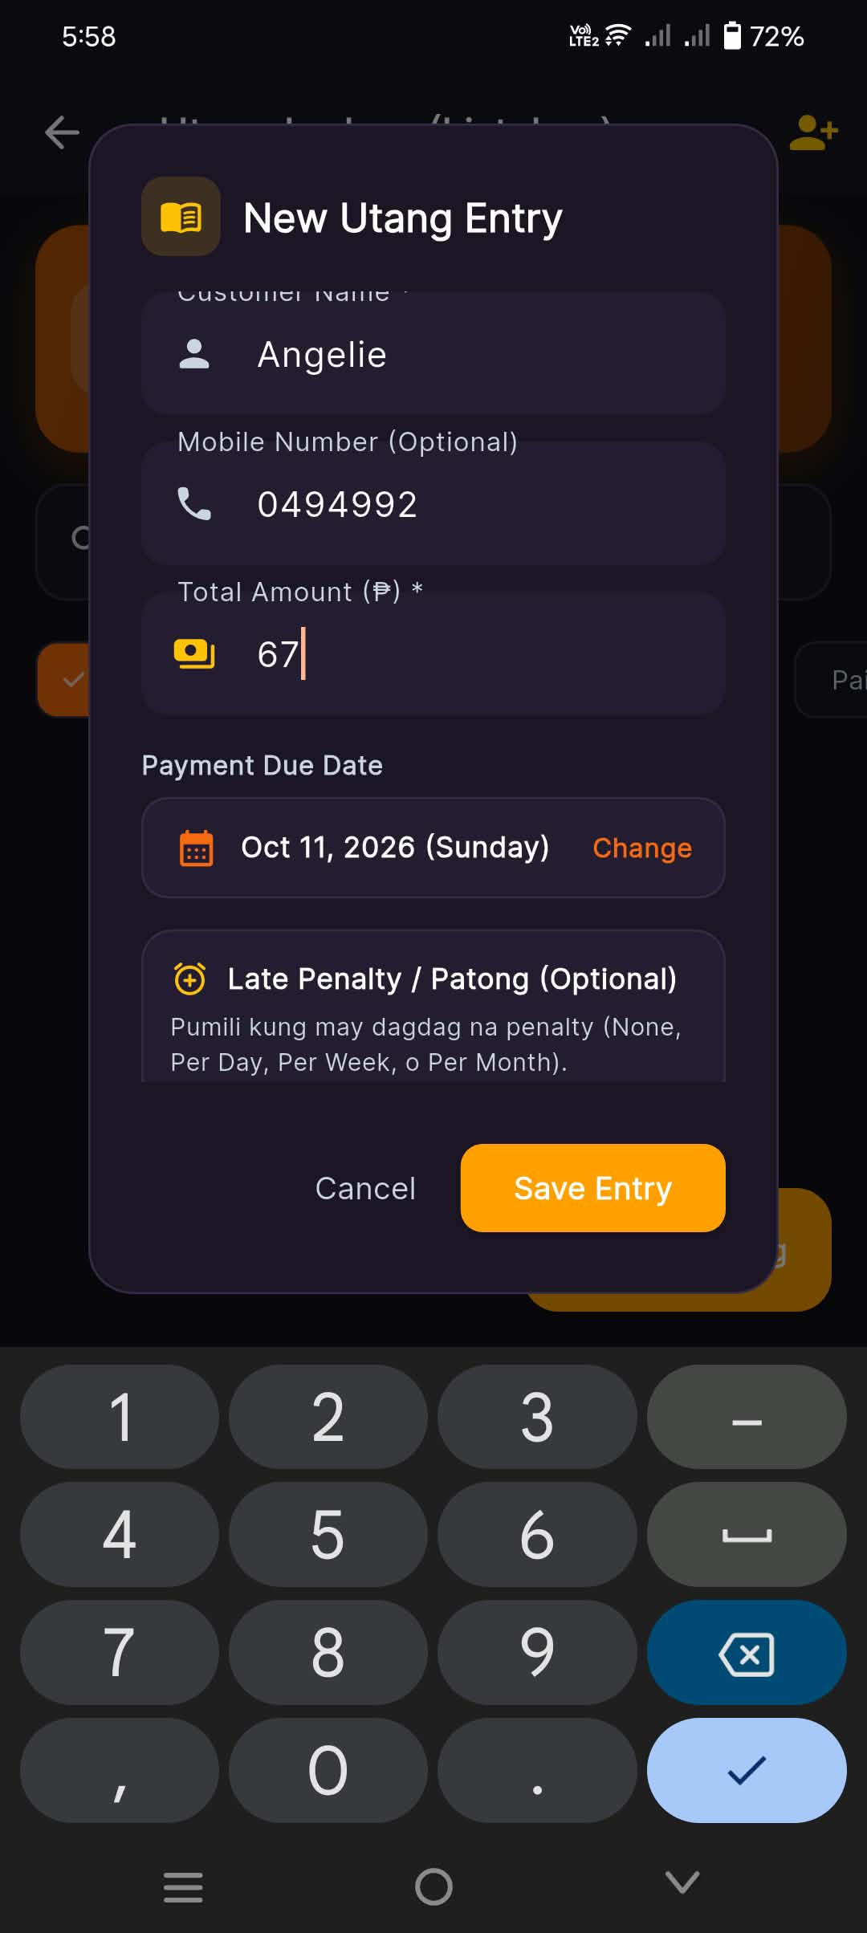
Functional Description: The store owner inputs borrower identification, contact details, total borrowed amount, and an agreed-upon repayment due date.
Key Interface Elements & Visual Indicators:
- Customer Name input field ('Angelie')
- Mobile Number input field (Optional: '0494992') for automated SMS reminders
- Total Borrowed Amount input ('₱67.00')
- Payment Due Date picker ('Oct 11, 2026 (Sunday)') with 'Change' button
- 'Late Penalty / Patong (Optional)' configuration trigger
💡 Practical Micro-Retail Note: Capturing mobile numbers enables automated payment reminders.

Screen 6: Late Penalty / Patong Rules Configuration
Application: Stora Owner | Screen: New Utang Entry Modal (Part 2 - Patong)
Module: Module 3: Digital Utang Ledger & Credit Management
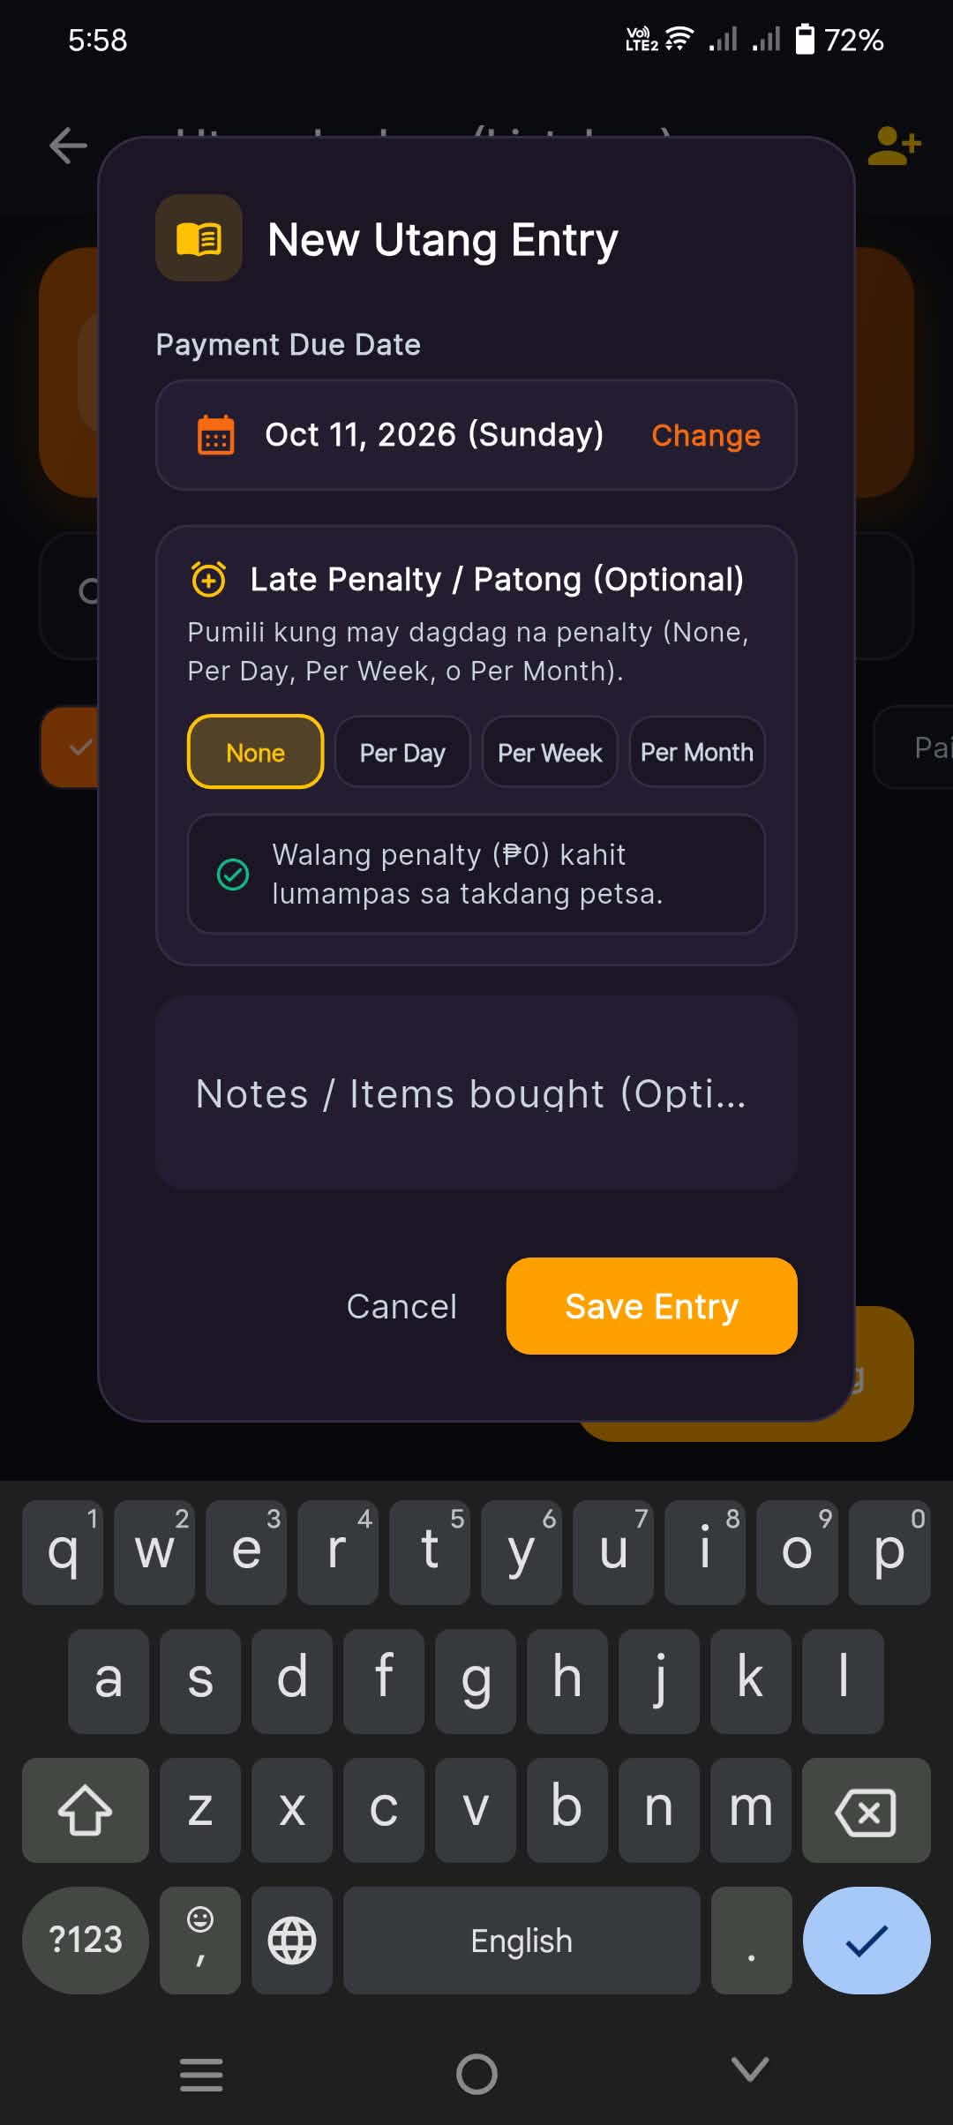
Functional Description: Configures store credit terms with optional daily, weekly, or monthly late penalties (patong), accompanied by itemized notes of borrowed goods.
Key Interface Elements & Visual Indicators:
- Late Penalty segmented options: 'None', 'Per Day', 'Per Week', 'Per Month'
- Local guidance note: 'Walang penalty (₱0) kahit lumampas sa takdang petsa.' (No penalty even past due date)
- Optional 'Notes / Items bought' text field
- Action buttons: 'Cancel' and 'Save Entry'
💡 Practical Micro-Retail Note: Adapts to local Filipino credit practices, from zero-interest neighborhood favors to formal micro-credit terms.

Screen 7: Active Credit Loan Record & Collection Actions
Application: Stora Owner | Screen: Utang Ledger (Active Loans List)
Module: Module 3: Digital Utang Ledger & Credit Management
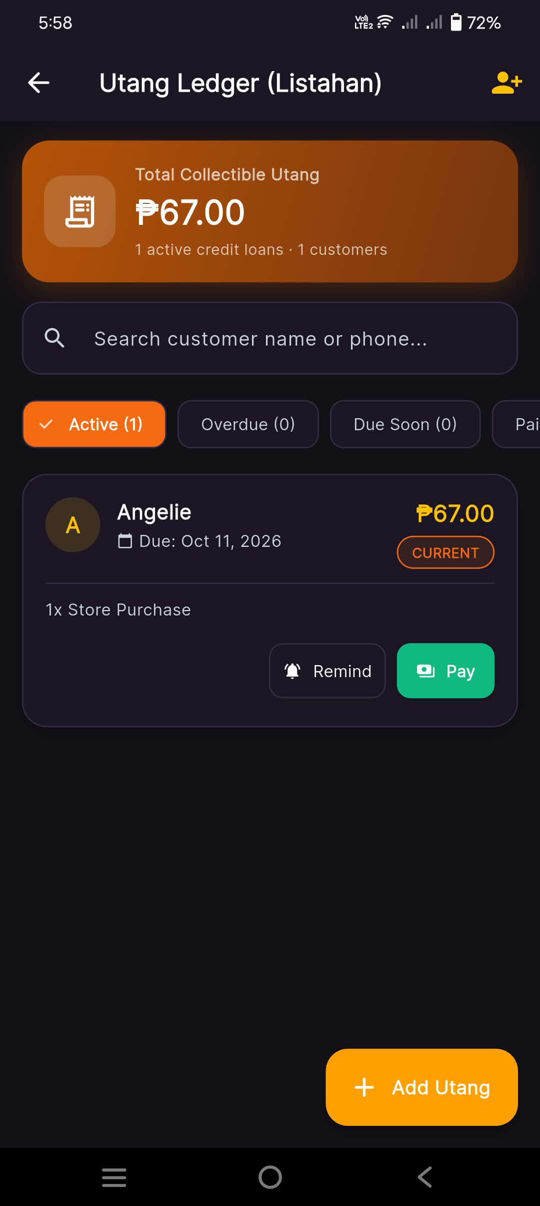
Functional Description: Displays the active customer credit record with due date tracking, color-coded health badges (Current/Overdue), and one-tap collection action shortcuts.
Key Interface Elements & Visual Indicators:
- Updated Total Collectible Utang: '₱67.00' (1 active loan, 1 customer)
- Customer Card: 'Angelie', 'Due: Oct 11, 2026', health status pill 'CURRENT'
- Loan amount ('₱67.00') and item note ('1x Store Purchase')
- Collection action buttons: 'Remind' (triggers automated SMS/notification) and 'Pay' (records partial or full settlement)
💡 Practical Micro-Retail Note: One-tap 'Remind' removes the awkwardness of verbally asking neighbors for payment.

Screen 8: Owner Notes & Reminders (Empty State)
Application: Stora Owner | Screen: Owner Notes & Reminders Screen
Module: Module 4: Owner Notes, Reminders & Task Pinning
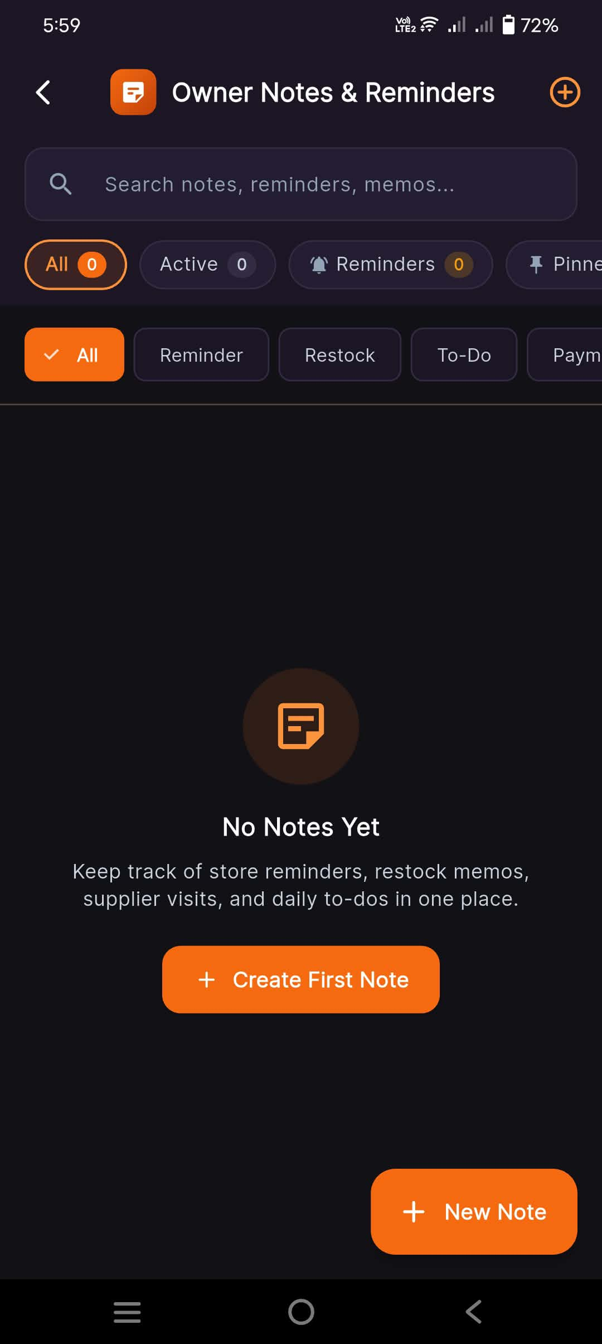
Functional Description: Dedicated organizer for store memos, restocking checklists, supplier delivery reminders, and daily task management.
Key Interface Elements & Visual Indicators:
- Search bar for notes, reminders, and memos
- Status pills (All 0, Active 0, Reminders 0, Pinned 0)
- Category filters: 'All', 'Reminder', 'Restock', 'To-Do', 'Payment'
- Empty state guidance and '+ Create First Note' / '+ New Note' buttons
💡 Practical Micro-Retail Note: Categorized system keeps daily store chores separated from inventory supplier runs.

Screen 9: New Note Creation & Dashboard Pinning
Application: Stora Owner | Screen: New Note / Reminder Modal
Module: Module 4: Owner Notes, Reminders & Task Pinning
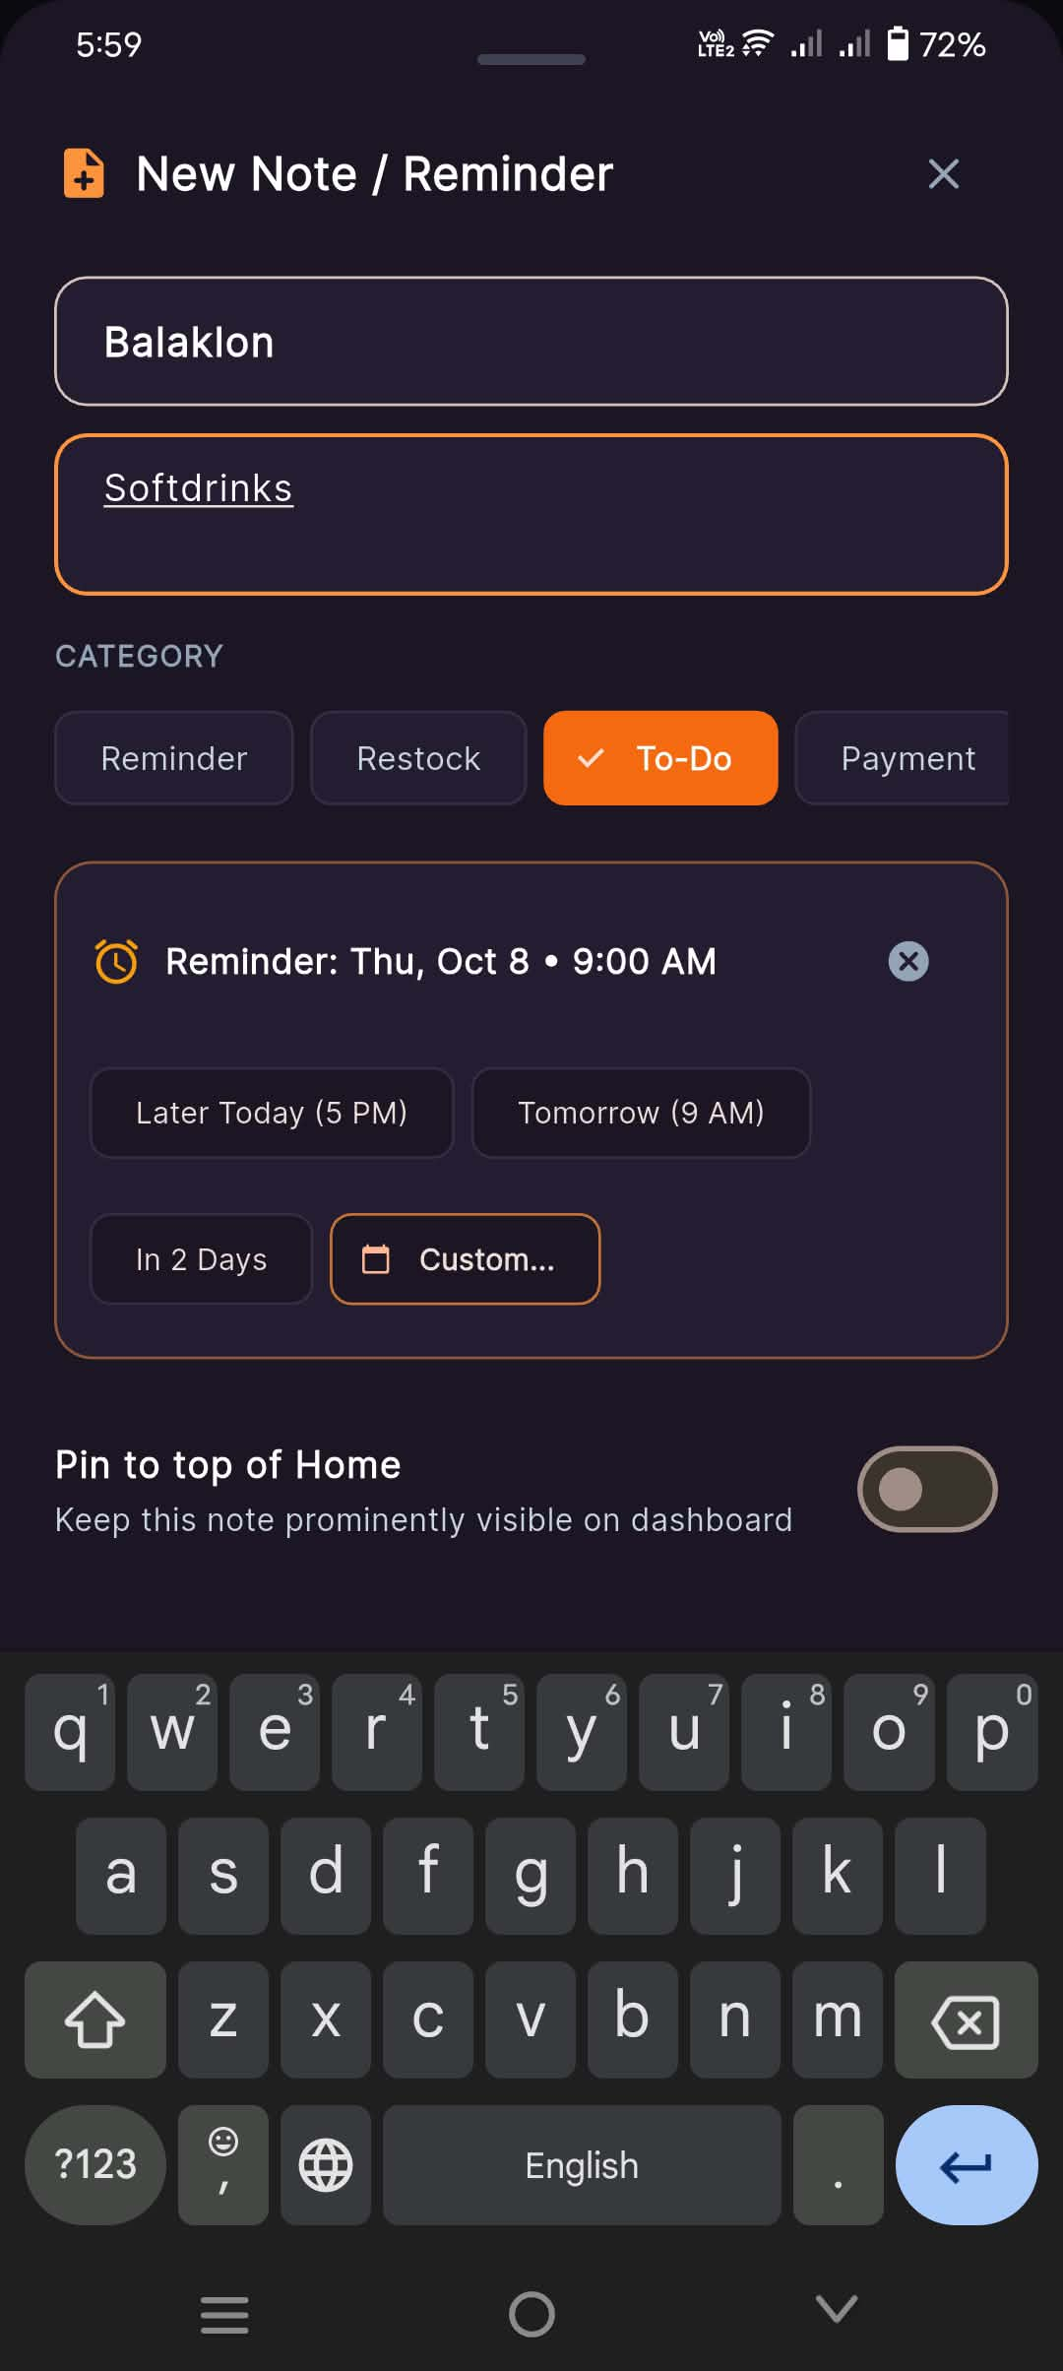
Functional Description: The merchant crafts a note with custom category tags, sets an automated notification reminder with quick date presets, and toggles 'Pin to top of Home' for dashboard prominence.
Key Interface Elements & Visual Indicators:
- Title input with local dialect support ('Balaklon' — Hiligaynon for 'Items to buy')
- Content description input ('Softdrinks')
- Category selector: 'To-Do' active
- Reminder scheduler ('Reminder: Thu, Oct 8 • 9:00 AM') with quick presets ('Later Today', 'Tomorrow', 'In 2 Days', 'Custom')
- 'Pin to top of Home' toggle switch
💡 Practical Micro-Retail Note: Pinning to dashboard guarantees that critical restocking tasks are seen every time the app opens.

Screen 10: Active Notes & Scheduled Reminders List
Application: Stora Owner | Screen: Owner Notes & Reminders (Active List)
Module: Module 4: Owner Notes, Reminders & Task Pinning
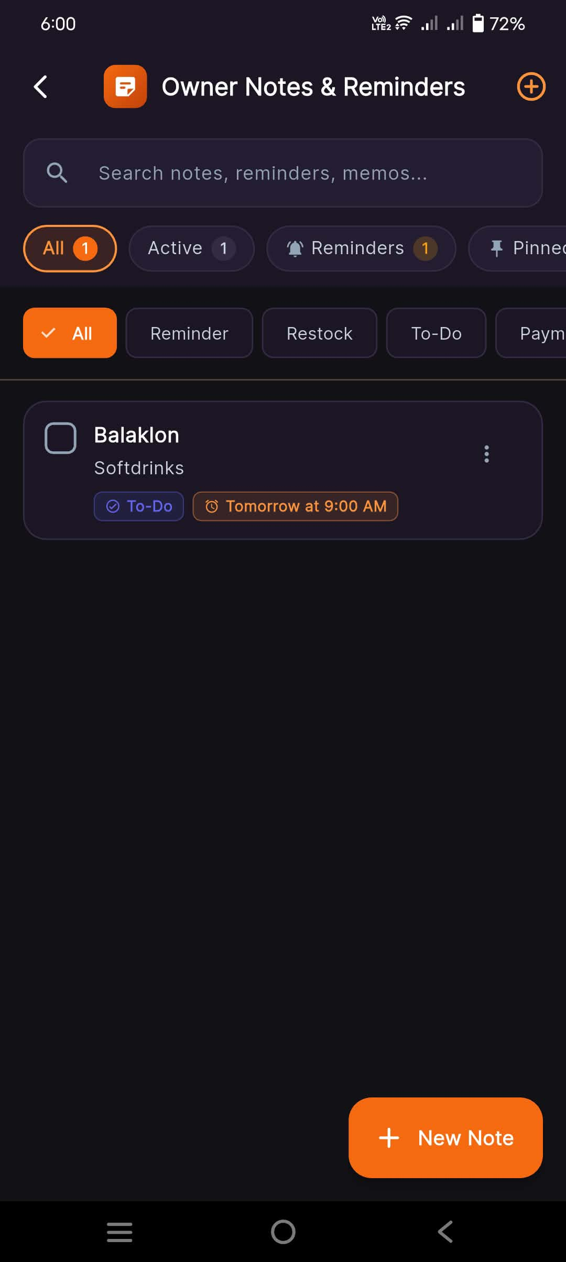
Functional Description: Lists organized tasks and reminders with completion checkboxes, category tags, and alert timings.
Key Interface Elements & Visual Indicators:
- Status filter: All 1, Active 1, Reminders 1
- Note card: Checkbox, 'Balaklon - Softdrinks', tag 'To-Do', scheduled badge 'Tomorrow at 9:00 AM', options menu
- '+ New Note' action button
💡 Practical Micro-Retail Note: Tapping the checkbox marks the task done without deleting the history.

Screen 11: Dashboard with Pinned Task & Updated Revenue
Application: Stora Owner | Screen: Home Dashboard (With Pinned Task)
Module: Module 4: Owner Notes, Reminders & Task Pinning
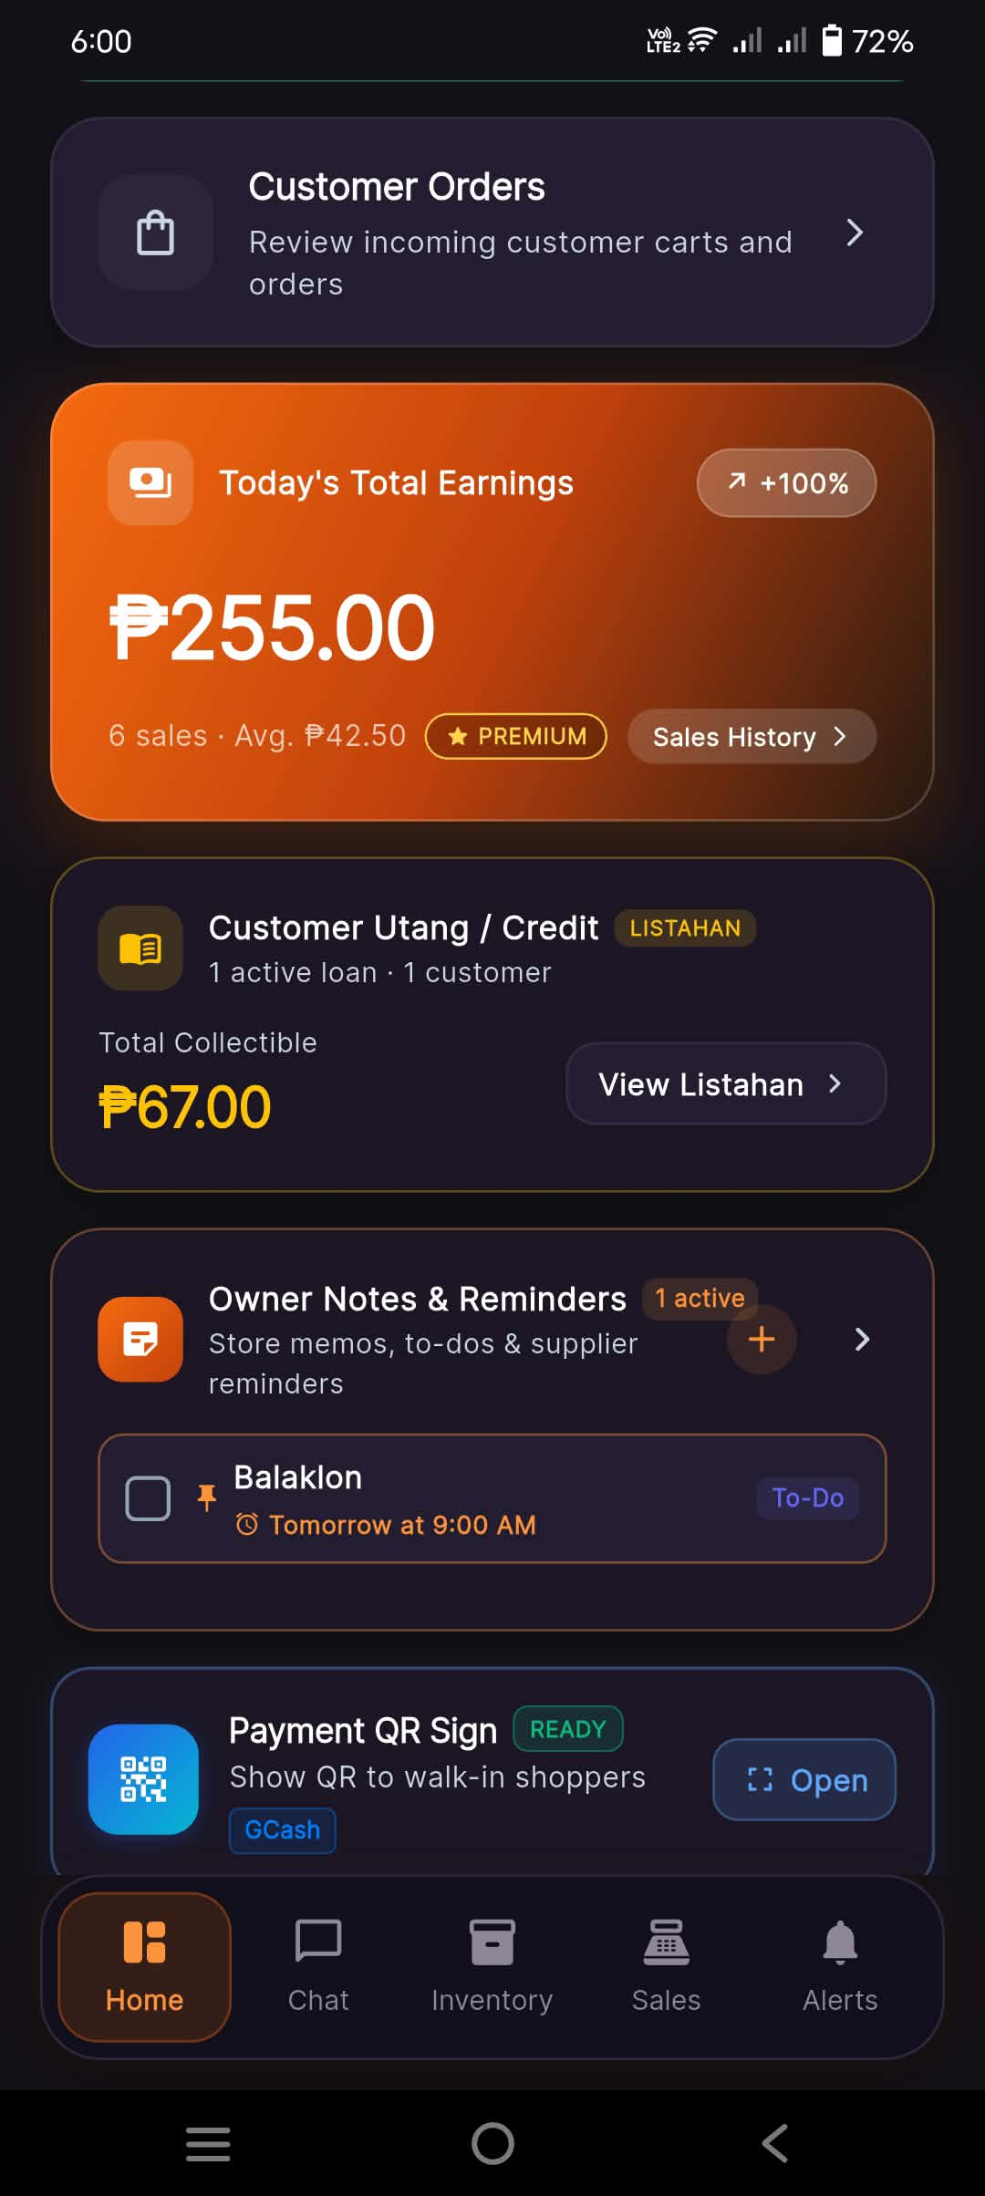
Functional Description: Shows how pinned tasks appear directly on the main dashboard alongside live earnings and credit balances for seamless daily workflow.
Key Interface Elements & Visual Indicators:
- Customer Orders navigation shortcut
- Today's Total Earnings updated to '₱255.00' (6 sales, '+100%')
- Customer Utang metric reflecting '₱67.00'
- Owner Notes card displaying pinned task '[ ] Balaklon - To-Do - Tomorrow at 9:00 AM' directly on Home
💡 Practical Micro-Retail Note: Brings essential store reminders into the merchant's immediate field of vision.

Screen 12: Digital Payment QR Standee for Walk-in Shoppers
Application: Stora Owner | Screen: Scan to Pay (Walk-in) Modal
Module: Module 5: In-Store Digital Payment QR Standee
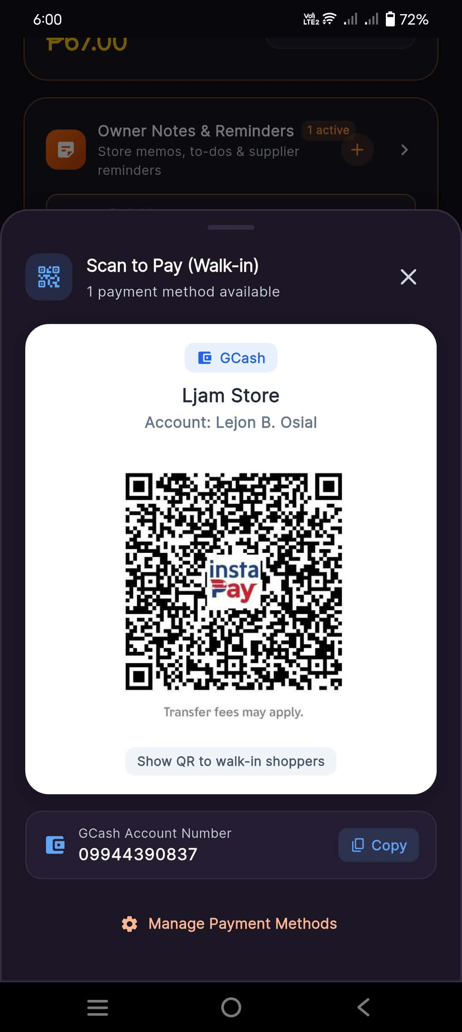
Functional Description: Full-screen digital QR display for in-store walk-in customers to scan and pay via GCash or InstaPay without requiring physical plastic printouts.
Key Interface Elements & Visual Indicators:
- Header: '1 payment method available'
- GCash card with Store Name ('Ljam Store') and Account Name ('Lejon B. Osial')
- High-resolution InstaPay / QR Ph QR code ('Show QR to walk-in shoppers')
- GCash Account Number ('09944390837') with 1-tap 'Copy' button
- 'Manage Payment Methods' shortcut
💡 Practical Micro-Retail Note: Saves micro-retailers from printing and laminating paper QR codes that degrade over time.

Screen 13: AI Business Insights (Smart Store Assistant)
Application: Stora Owner | Screen: Business Insights Screen
Module: Module 6: AI-Driven Business Insights
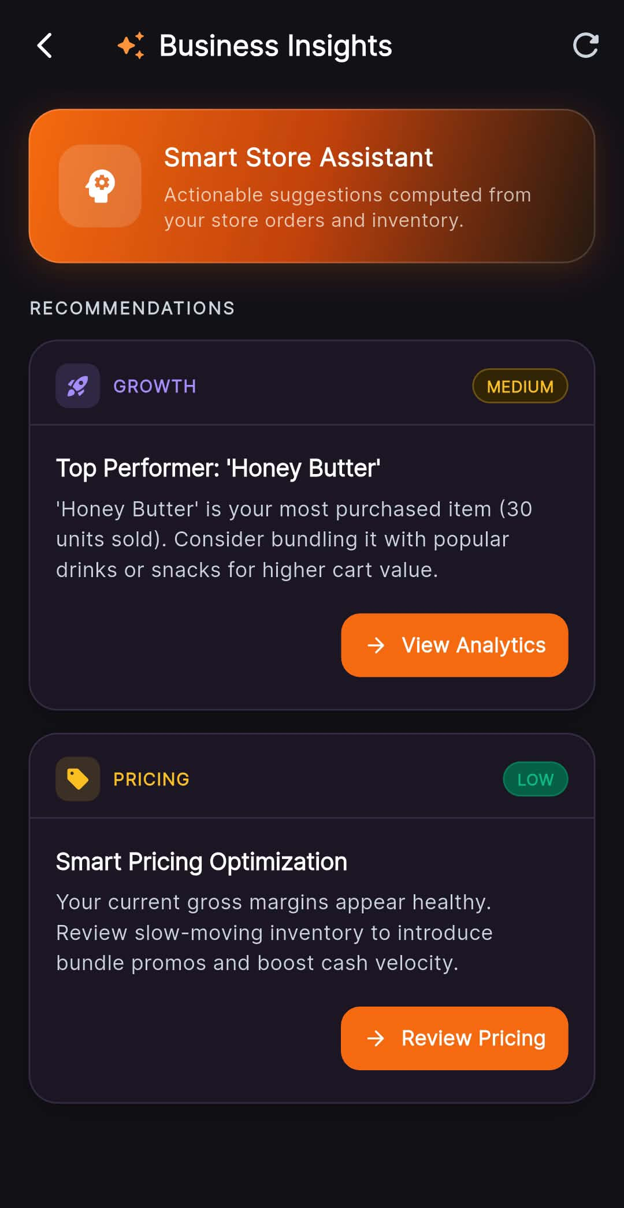
Functional Description: Intelligent store analytics offering actionable data-driven advice on top performers, cross-selling bundle recommendations, and pricing margin optimizations.
Key Interface Elements & Visual Indicators:
- Header: 'Smart Store Assistant - Actionable suggestions computed from your store orders and inventory.'
- Growth Recommendation (Medium): 'Top Performer: Honey Butter - 30 units sold. Consider bundling it with popular drinks or snacks for higher cart value' with 'View Analytics' button
- Pricing Recommendation (Low): 'Smart Pricing Optimization - Your current gross margins appear healthy. Review slow-moving inventory to introduce bundle promos' with 'Review Pricing' button
💡 Practical Micro-Retail Note: Empowers small sari-sari store owners with enterprise-grade business intelligence translated into plain terms.

Screen 14: Set Store Location & GPS Geofencing
Application: Stora Owner | Screen: Set Store Location Screen
Module: Module 7: Store Geolocation & Map Pinning
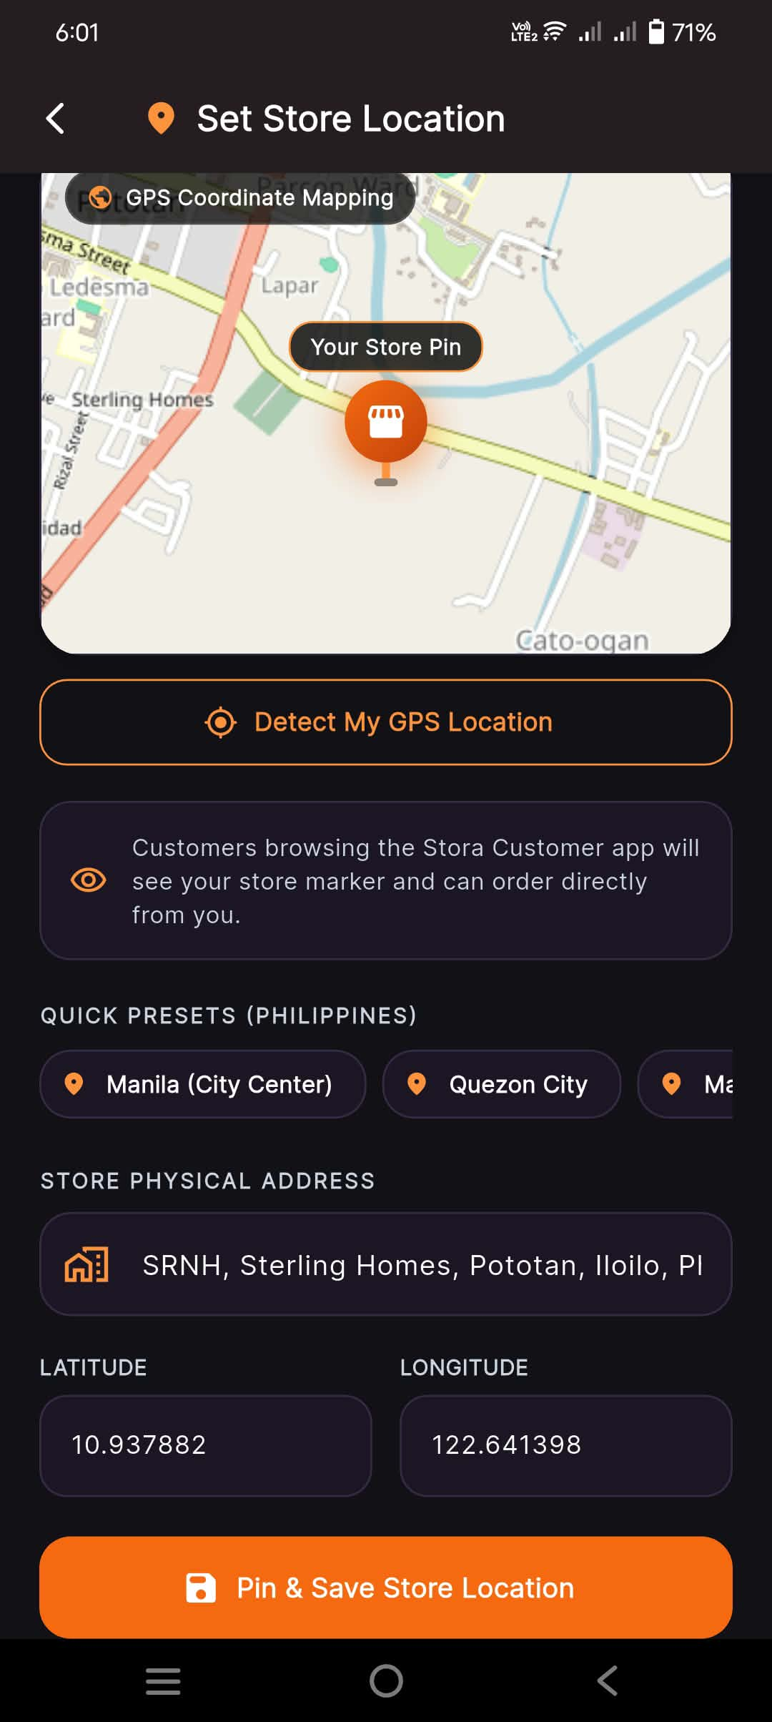
Functional Description: Store owners pin their physical store coordinates using device GPS or map drag-and-drop, making their store discoverable on the Stora Customer discovery map.
Key Interface Elements & Visual Indicators:
- Top interactive map view: 'GPS Coordinate Mapping' showing 'Your Store Pin' at Pototan, Iloilo
- 'Detect My GPS Location' hardware trigger button
- Guidance note: 'Customers browsing the Stora Customer app will see your store marker and can order directly from you.'
- Quick presets (Manila, Quezon City, etc.)
- Store Physical Address ('SRNH, Sterling Homes, Pototan, Iloilo, Ph')
- Precise coordinate inputs: Latitude ('10.937882'), Longitude ('122.641398')
- 'Pin & Save Store Location' submission button
💡 Practical Micro-Retail Note: Precision GPS mapping connects hyper-local neighborhood customers to the exact sari-sari store stall.

Screen 15: Sales Analytics & Revenue Charts
Application: Stora Owner | Screen: Sales Analytics (Overview)
Module: Module 8: Sales Analytics & Performance Reporting
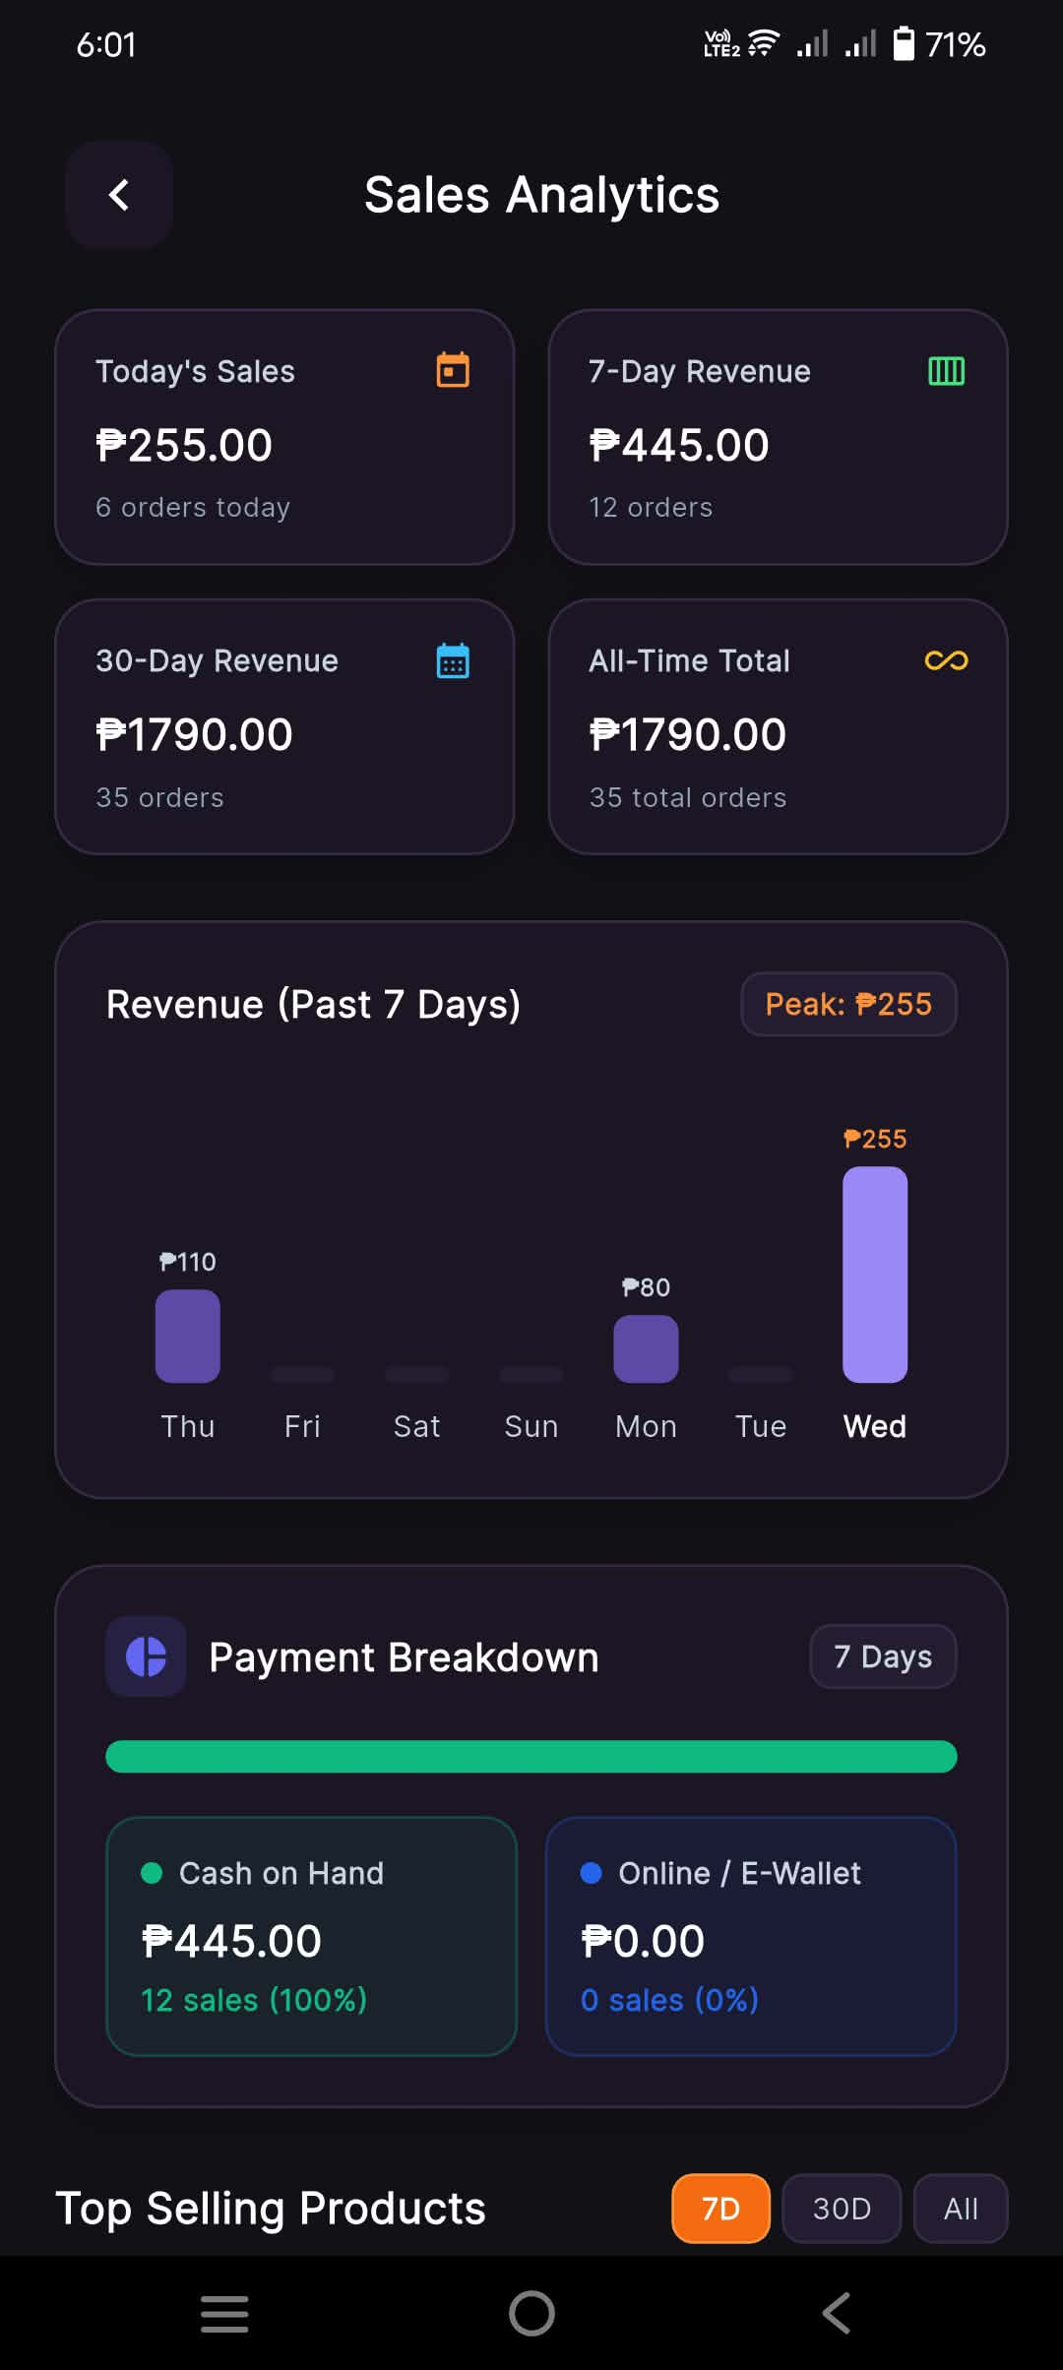
Functional Description: In-depth sales visualization showing multi-period sales figures, daily revenue bar graphs, peak revenue tracking, and payment method share breakdown.
Key Interface Elements & Visual Indicators:
- Multi-tier metric cards: Today's Sales ('₱255.00', 6 orders), 7-Day Revenue ('₱445.00', 12 orders), 30-Day Revenue ('₱1790.00', 35 orders), All-Time Total ('₱1790.00', 35 orders)
- Interactive Revenue Bar Chart: 'Revenue (Past 7 Days)' with peak indicator ('Peak: ₱255')
- Payment Breakdown widget: 'Cash on Hand ₱445.00 (100%)' vs 'Online / E-Wallet ₱0.00 (0%)'
💡 Practical Micro-Retail Note: Visual bar charts make it easy to spot the busiest days of the week for stock planning.

Screen 16: Top Selling Products Leaderboard
Application: Stora Owner | Screen: Sales Analytics (Top Sellers)
Module: Module 8: Sales Analytics & Performance Reporting
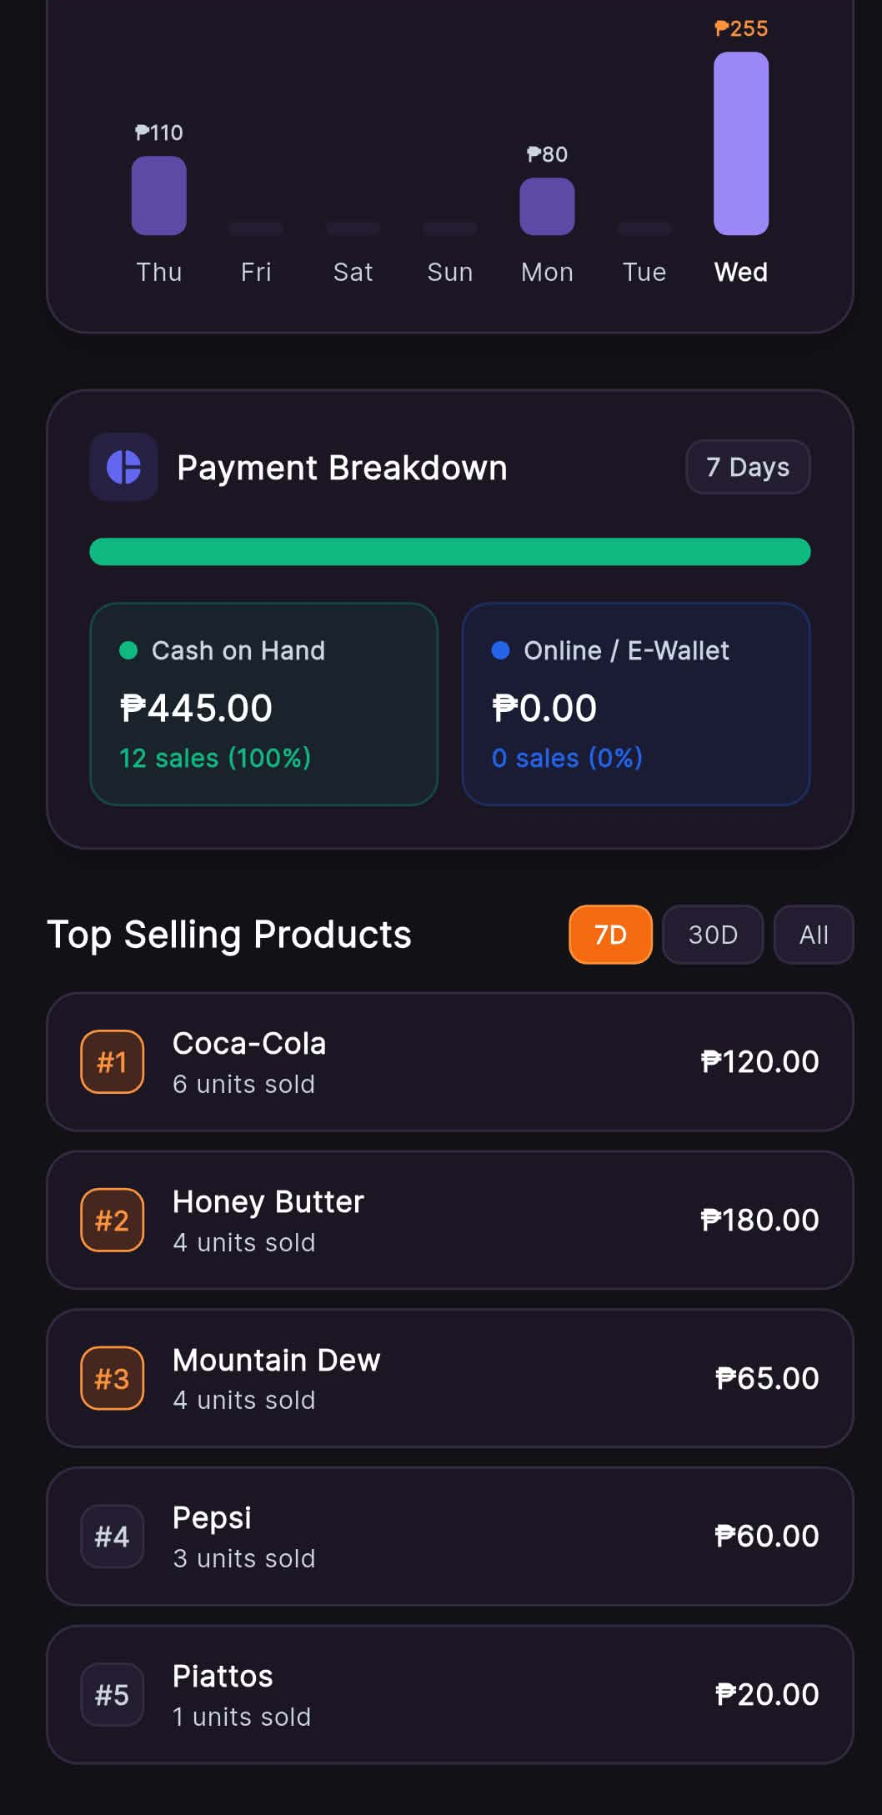
Functional Description: Leaderboard tracking bestselling items by volume and revenue generated across weekly, monthly, and all-time periods to guide inventory replenishment.
Key Interface Elements & Visual Indicators:
- Time filter tabs: 7D, 30D, All
- Ranked product leaderboard:
- #1 Coca-Cola: 6 units sold, ₱120.00
- #2 Honey Butter: 4 units sold, ₱180.00
- #3 Mountain Dew: 4 units sold, ₱65.00
- #4 Pepsi: 3 units sold, ₱60.00
- #5 Piattos: 1 units sold, ₱20.00
💡 Practical Micro-Retail Note: Prevents overstocking slow-movers by highlighting exactly what items produce 80% of store profits.

Screen 17: Stock Alerts & Inventory Health Monitoring
Application: Stora Owner | Screen: Stock Alerts Screen
Module: Module 9: Stock Alerts & Threshold Monitoring
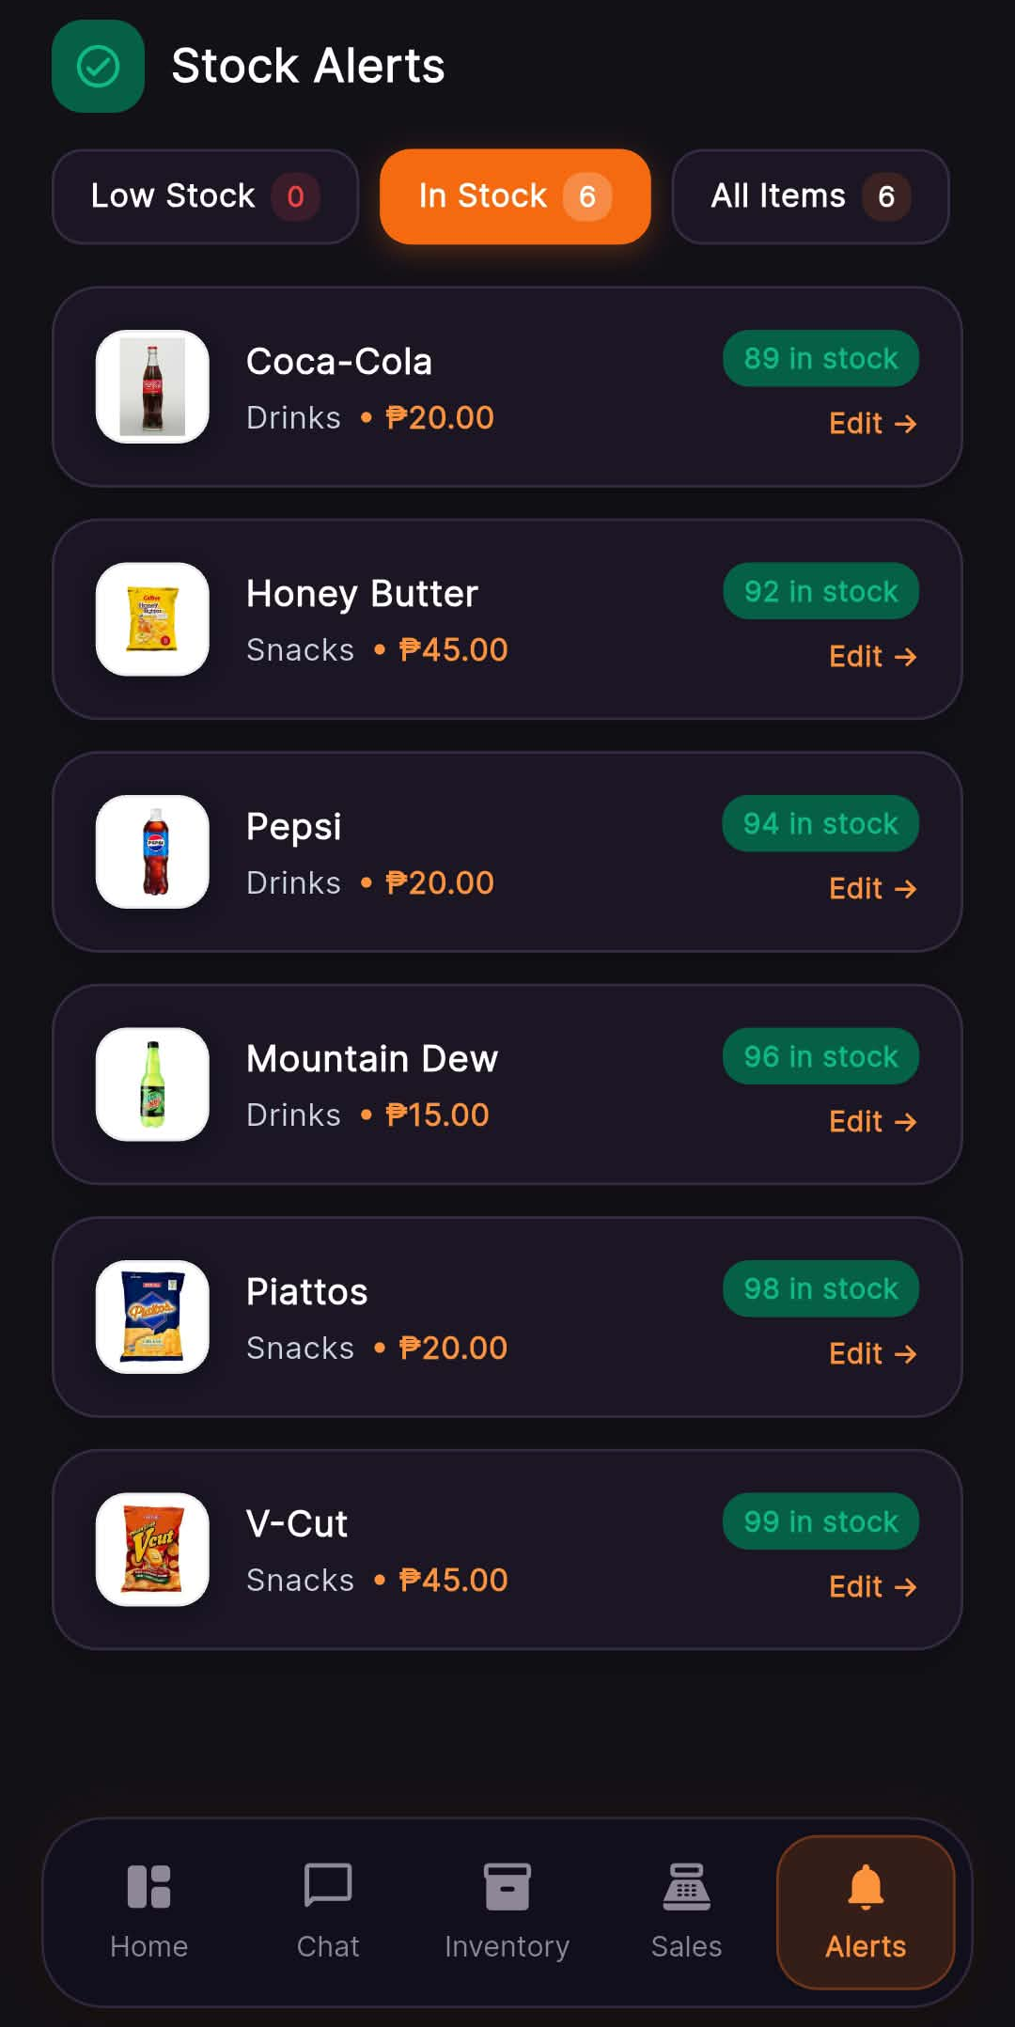
Functional Description: Centralized inventory health monitor categorizing products by Low Stock (<5 threshold), In Stock, or All Items, providing quick one-tap edit access for restocking.
Key Interface Elements & Visual Indicators:
- Filter tabs: 'Low Stock (0)', 'In Stock (6 - active)', 'All Items (6)'
- Product list with stock count pills and 'Edit ->' buttons: Coca-Cola (89 in stock), Honey Butter (92 in stock), Pepsi (94 in stock), Mountain Dew (96 in stock), Piattos (98 in stock), V-Cut (99 in stock)
💡 Practical Micro-Retail Note: Unified Alerts tab lets owners manage and edit healthy inventory and stock emergencies side by side.

Screen 18: Inventory Management & Stock Levels
Application: Stora Owner | Screen: Inventory Screen
Module: Module 10: Inventory Catalog & Product Addition
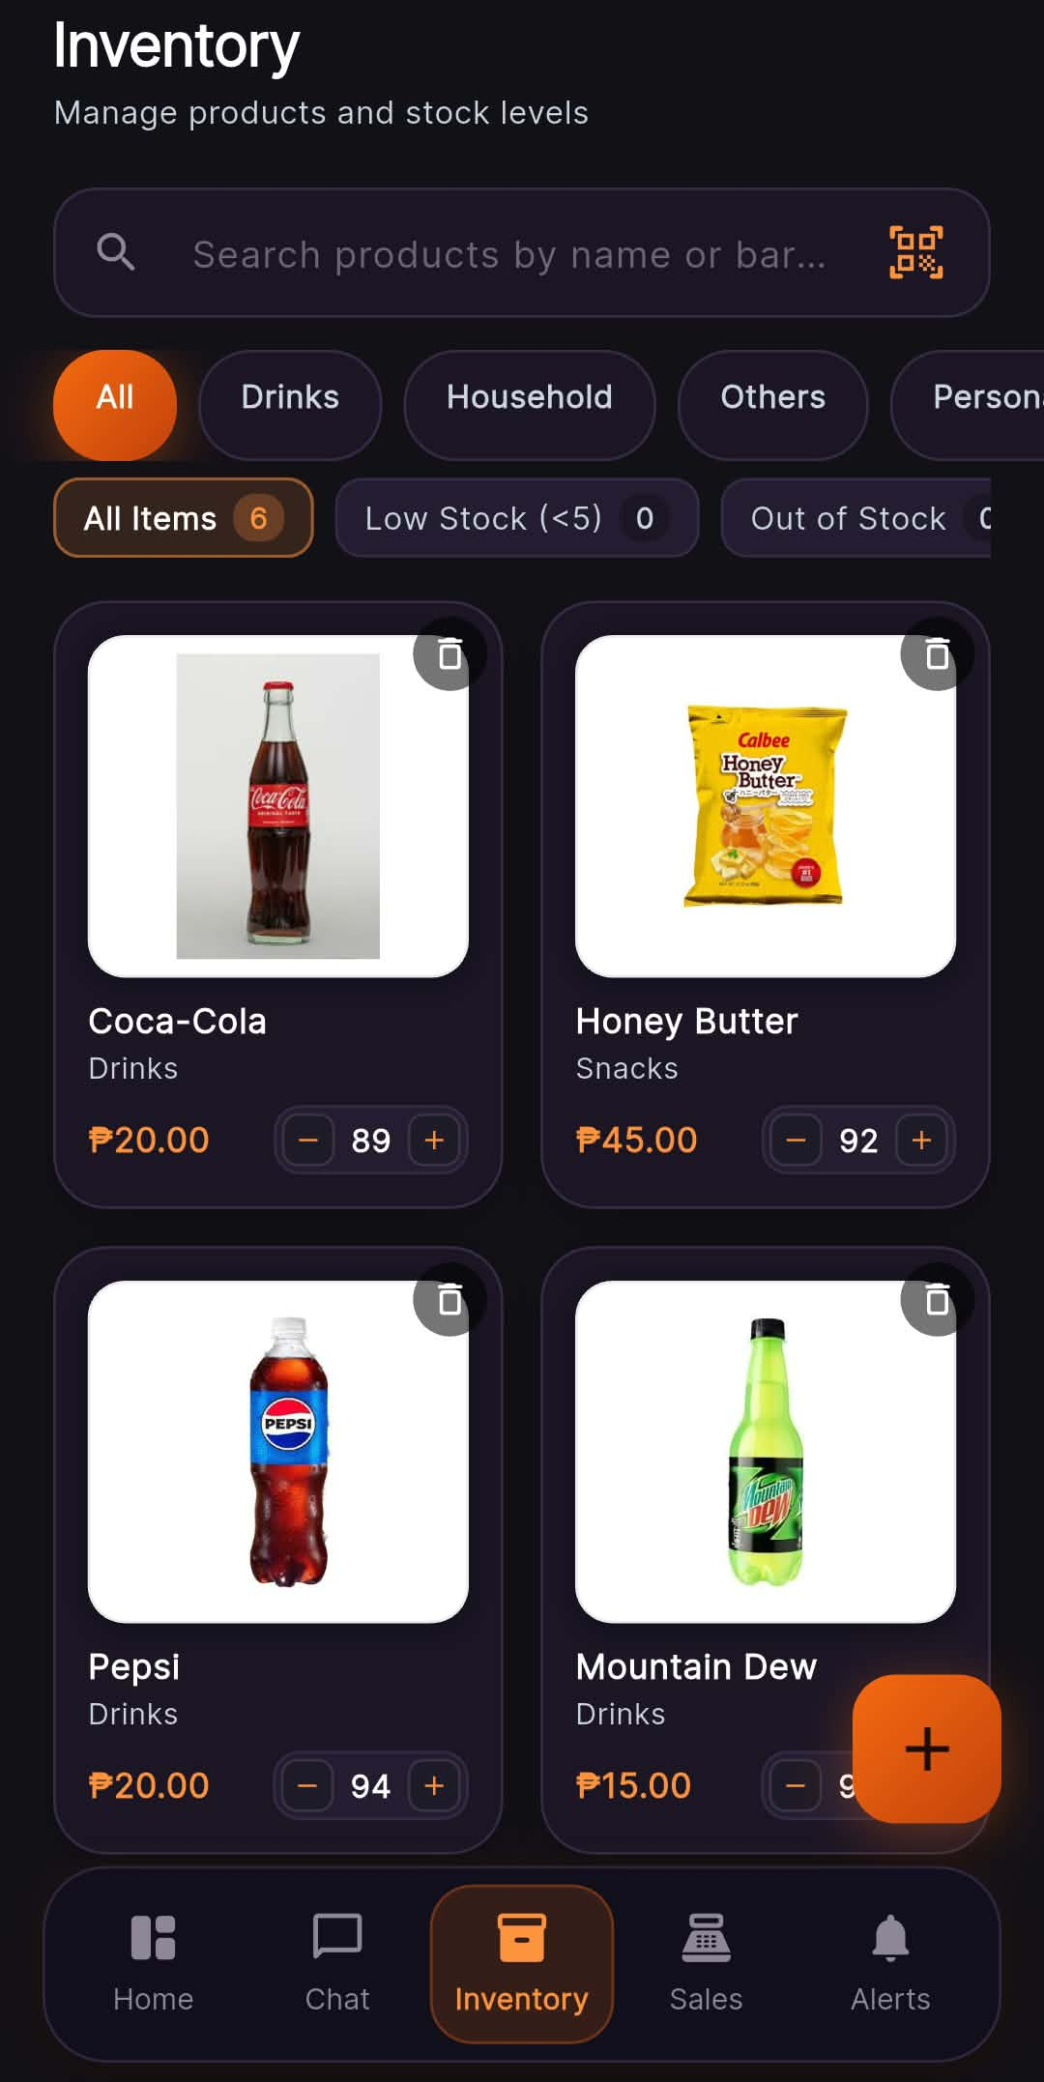
Functional Description: Comprehensive stock catalog supporting product search, barcode scanning, category filtering, and interactive stepper controls for rapid manual stock adjustments.
Key Interface Elements & Visual Indicators:
- Header: 'Inventory - Manage products and stock levels'
- Search bar and barcode scanner trigger icon
- Category filters (All, Drinks, Household, Others, Personal...)
- Stock health summary chips (All Items 6, Low Stock 0, Out of Stock 0)
- Product cards with images, prices, and fast stock modifier steppers ('-' / '+')
- Floating '+ Add Product' action button
💡 Practical Micro-Retail Note: In-card steppers allow store owners to log freshly received crates in seconds.

Screen 19: Add Product Form (Product Information & Barcode)
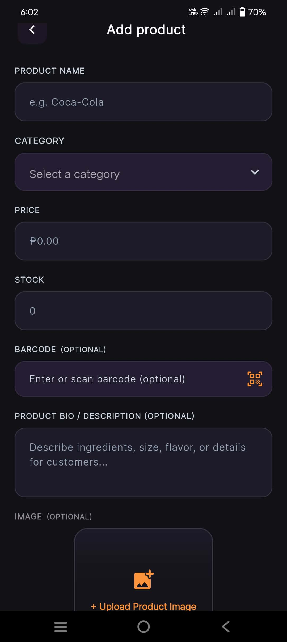
Application: Stora Owner | Screen: Add Product Screen (Top Half)
Module: Module 10: Inventory Catalog & Product Addition

Functional Description: First half of the product addition form allowing store owners to input product identity, pricing, initial quantity, and scan EAN/UPC barcodes using the smartphone camera.
Key Interface Elements & Visual Indicators:
- Product Name input ('e.g. Coca-Cola')
- Category selection dropdown
- Selling Price numeric input ('₱0.00')
- Initial Stock counter ('0')
- Barcode input field with built-in camera barcode scanner trigger icon
- Product Bio / Description field ('Describe ingredients, size, flavor, or details...')
💡 Practical Micro-Retail Note: Integrated camera barcode scanner eliminates the need for expensive physical handheld barcode guns.

Screen 20: Add Product Form (Image Upload & Submission)
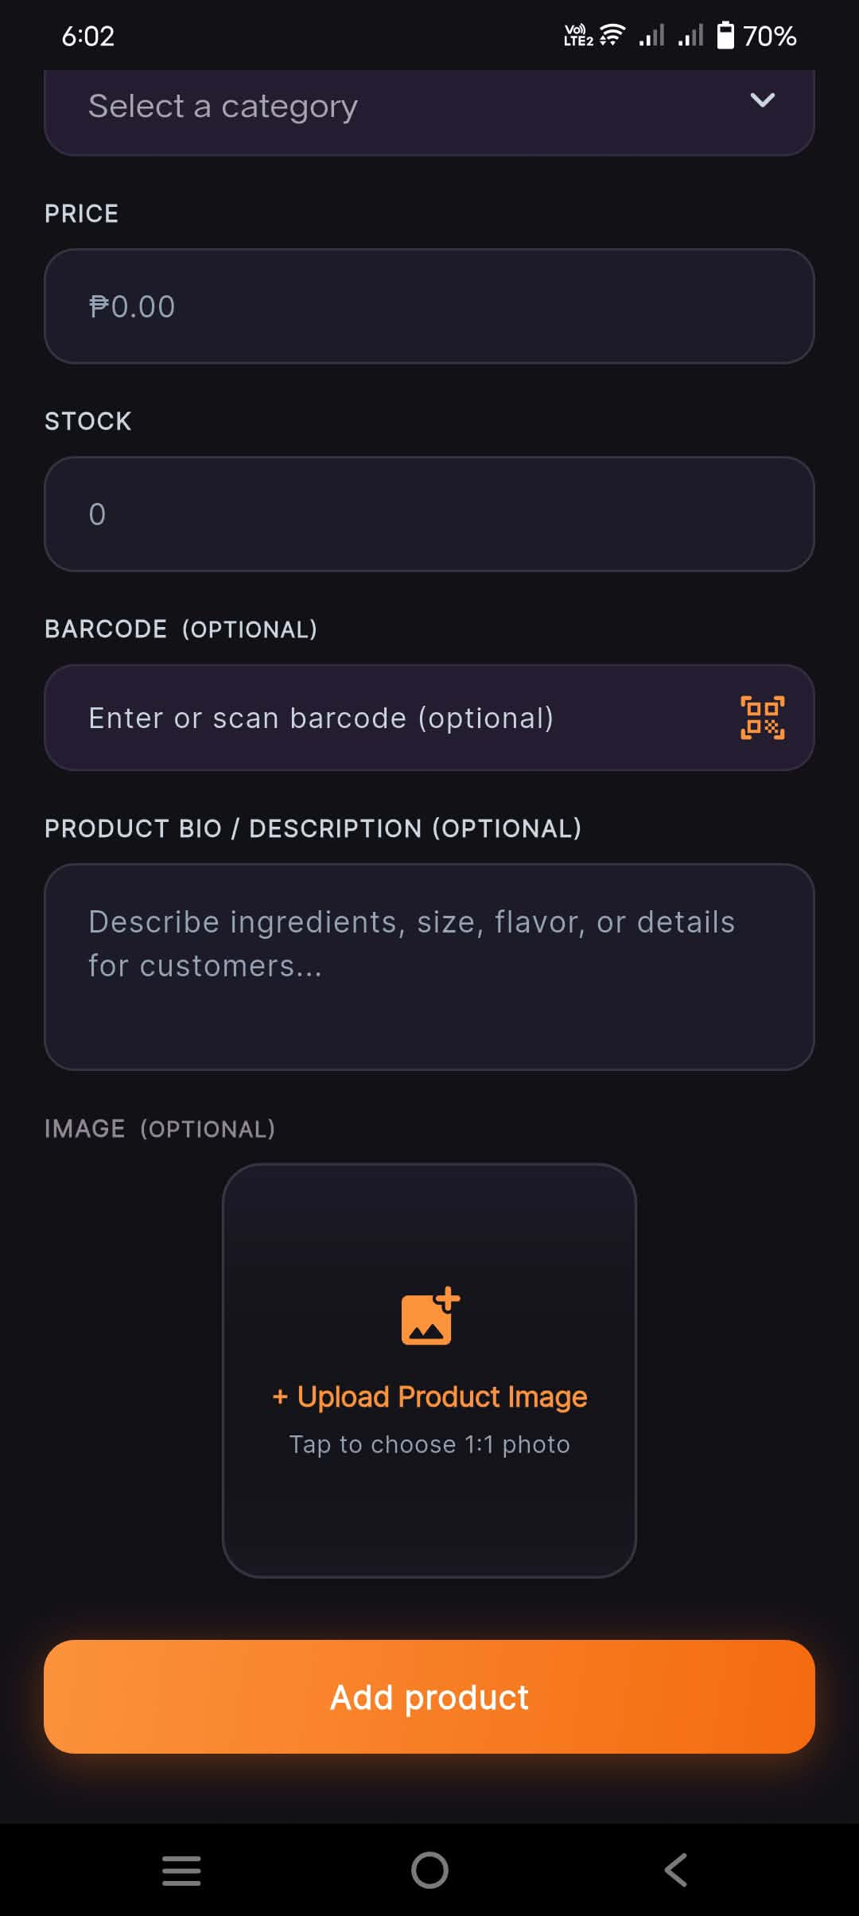
Application: Stora Owner | Screen: Add Product Screen (Bottom Half)
Module: Module 10: Inventory Catalog & Product Addition

Functional Description: Allows taking a photo or selecting an image from the gallery, followed by instant optimistic product creation that dismisses with 0ms lag while syncing to the server in the background.
Key Interface Elements & Visual Indicators:
- 1:1 Aspect ratio Product Image upload zone ('+ Upload Product Image - Tap to choose 1:1 photo')
- High-contrast orange submission button: 'Add product'
💡 Practical Micro-Retail Note: Optimistic UI update ensures store owners aren't stuck waiting for server responses.

Screen 21: POS Terminal (Virtual Cart & Item Selection)
Application: Stora Owner | Screen: Sales POS Tab
Module: Module 11: POS Terminal & Integrated Utang Sale
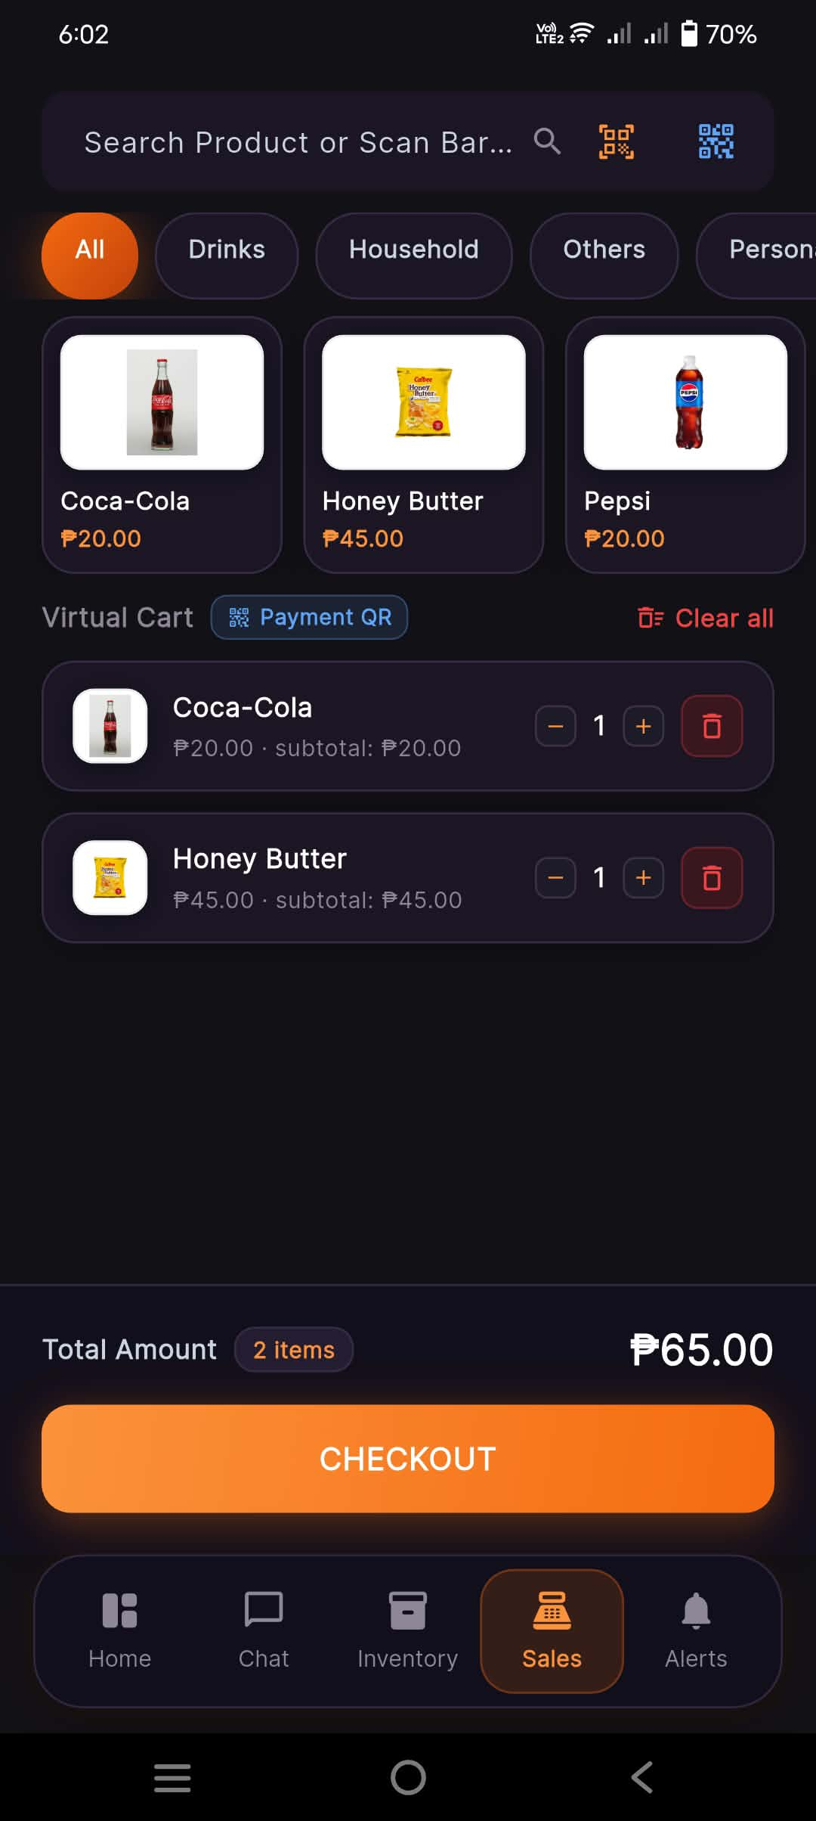
Functional Description: In-store Point-of-Sale interface allowing the store owner to tap products into a virtual cart, adjust quantities, review order total, and proceed to checkout.
Key Interface Elements & Visual Indicators:
- Product grid and search/barcode header
- Virtual Cart section with itemized items: Coca-Cola (1x, ₱20.00) and Honey Butter (1x, ₱45.00)
- Quantity steppers and remove icons per cart item
- Total Amount footer ('2 items - ₱65.00')
- Primary orange 'CHECKOUT' CTA button
💡 Practical Micro-Retail Note: Replaces mechanical cash registers with an intuitive smartphone counter terminal.

Screen 22: POS Checkout — Online / E-Wallet Payment
Application: Stora Owner | Screen: POS Checkout (Online / E-Wallet Tab)
Module: Module 11: POS Terminal & Integrated Utang Sale
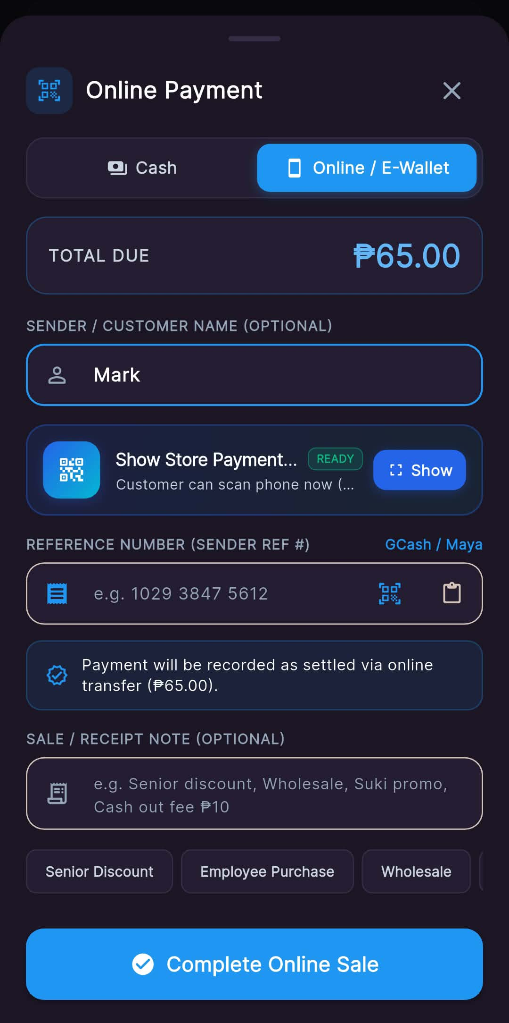
Functional Description: Records cashless in-store sales by inputting customer name, presenting the store's payment QR code for scanning, and logging transaction reference numbers.
Key Interface Elements & Visual Indicators:
- Tab switcher: 'Cash' vs 'Online / E-Wallet' (active)
- Total Due indicator: '₱65.00'
- Sender / Customer Name input ('Mark')
- 'Show Store Payment QR' trigger ('Customer can scan phone now')
- Reference Number input with barcode/paste shortcuts
- Sale note pills (Senior Discount, Wholesale, Suki promo)
- 'Complete Online Sale' CTA
💡 Practical Micro-Retail Note: Capturing reference numbers ensures easy auditing against GCash transaction logs.

Screen 23: POS Checkout — Cash Payment & Sukli Calculator
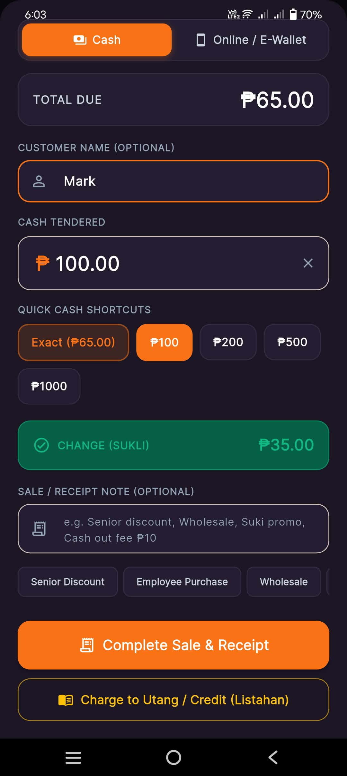
Application: Stora Owner | Screen: POS Checkout (Cash Tab)
Module: Module 11: POS Terminal & Integrated Utang Sale

Functional Description: Cash payment tab with quick denomination shortcuts, automated change calculation, and direct option to charge the transaction as store credit (*Utang*).
Key Interface Elements & Visual Indicators:
- Total Due: '₱65.00'
- Customer Name: 'Mark'
- Cash Tendered input ('₱100.00') with quick shortcut buttons ('Exact ₱65.00', '₱100', '₱200', '₱500', '₱1000')
- Automatic Sukli (Change) computation card ('CHANGE (SUKLI): ₱35.00' in green)
- 'Complete Sale & Receipt' primary button
- Prominent 'Charge to Utang / Credit (Listahan)' action button
💡 Practical Micro-Retail Note: Automated sukli calculation prevents costly mathematical mistakes during busy store hours.

Screen 24: Charge to Utang / Credit Modal from POS
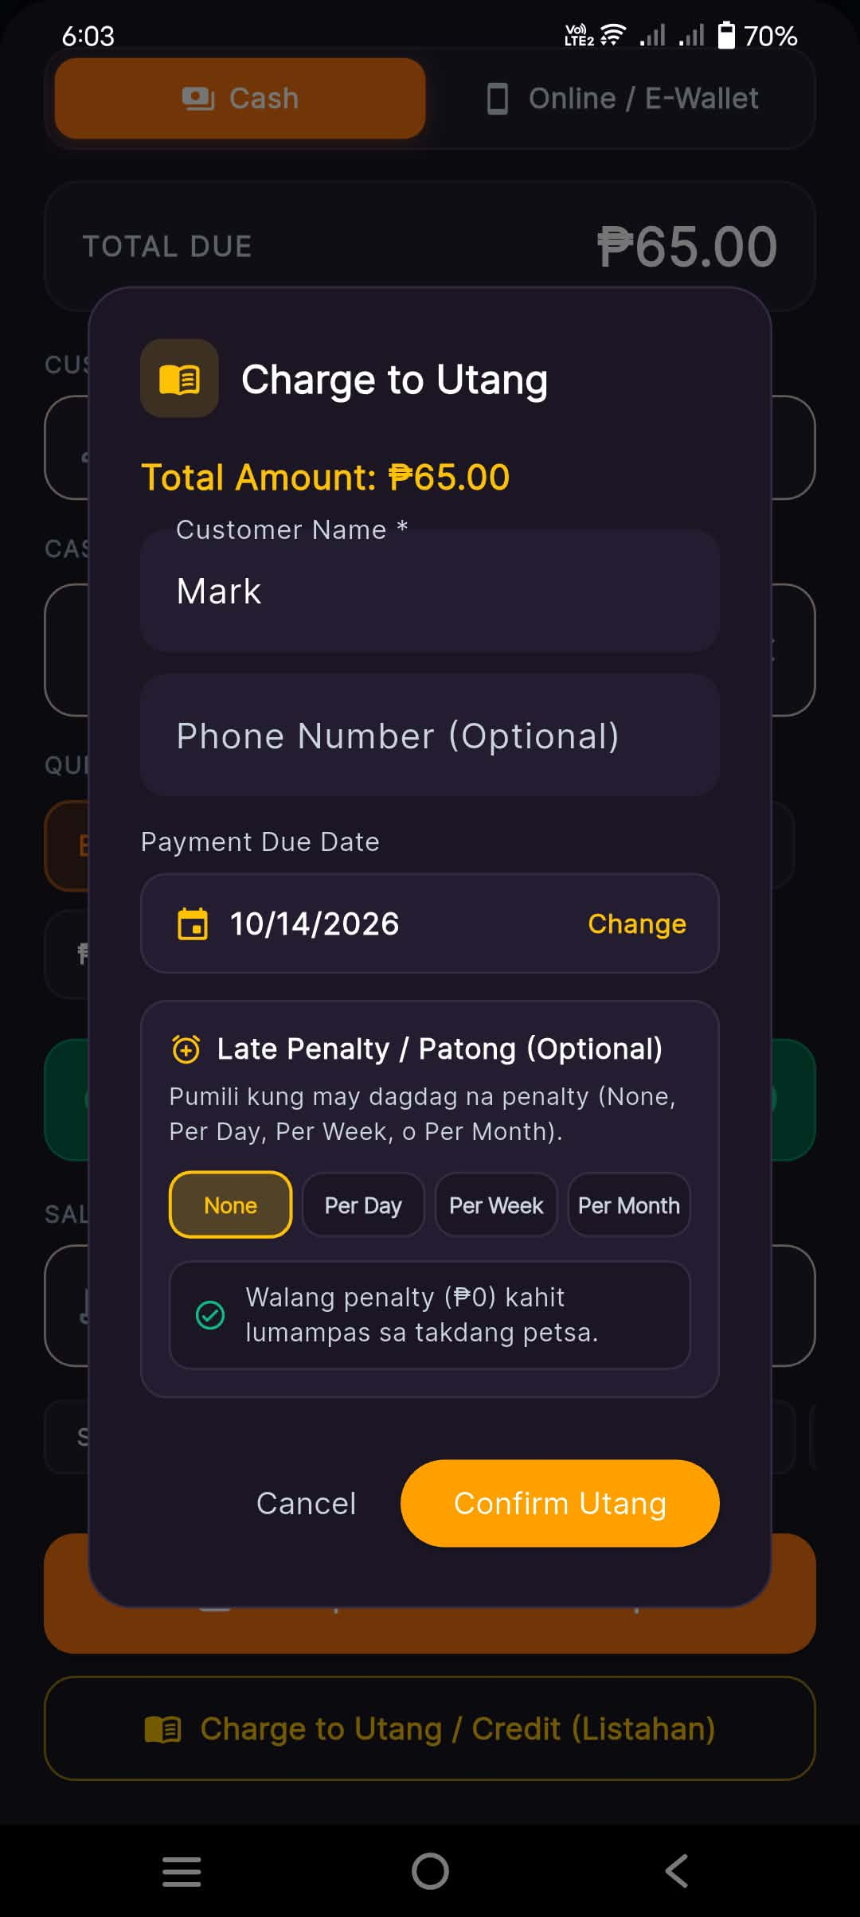
Application: Stora Owner | Screen: Charge to Utang Modal
Module: Module 11: POS Terminal & Integrated Utang Sale

Functional Description: Converts unpaid POS purchases directly into an official Utang loan, carrying forward the customer name, total amount, due date, and patong rules.
Key Interface Elements & Visual Indicators:
- Total Amount: '₱65.00'
- Customer Name: 'Mark'
- Phone Number (Optional)
- Payment Due Date: '10/14/2026' with 'Change' picker
- Late Penalty / Patong selector (None active)
- Action buttons: 'Cancel' and 'Confirm Utang'
💡 Practical Micro-Retail Note: Seamless integration bridges physical walk-in shopping with digital credit bookkeeping.

Screen 25: POS Official Digital Receipt (Charged to Utang)
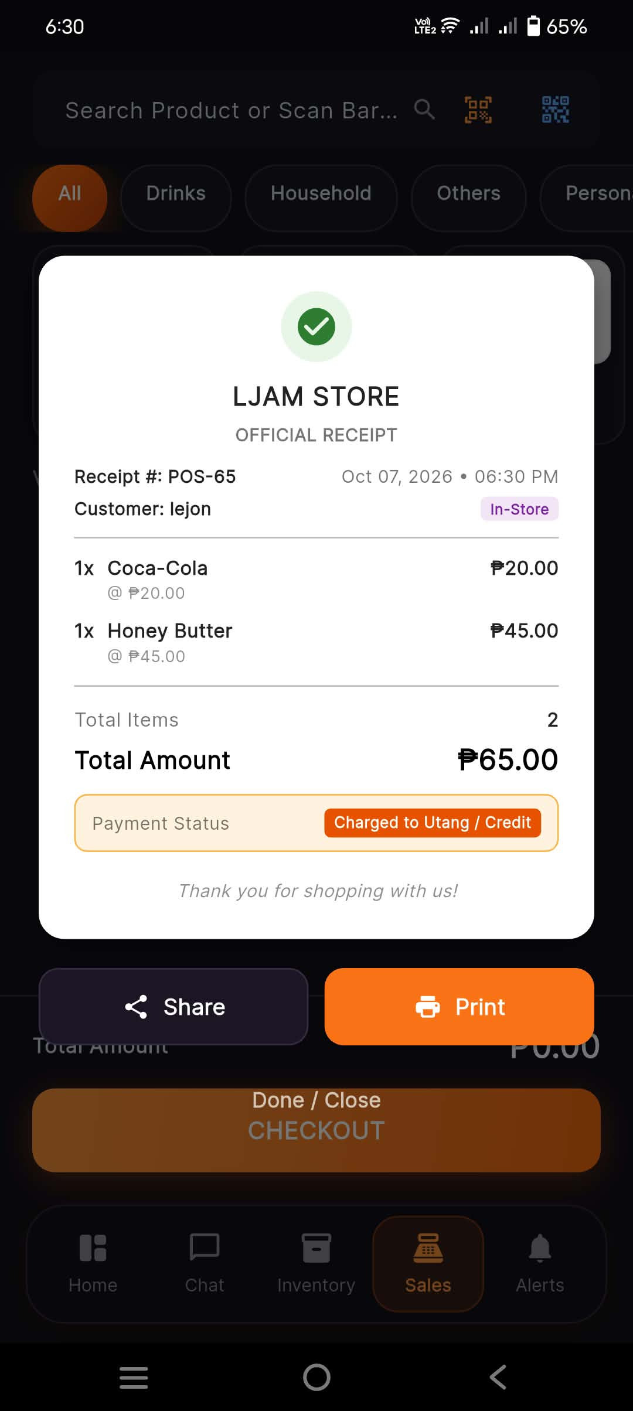
Application: Stora Owner | Screen: Official Receipt Modal (POS-65)
Module: Module 11: POS Terminal & Integrated Utang Sale

Functional Description: Official receipt for POS-65 itemizing purchased goods and clearly displaying payment status as Charged to Utang / Credit.
Key Interface Elements & Visual Indicators:
- Receipt Number: 'POS-65', Date: 'Oct 07, 2026 • 06:30 PM', Customer: 'lejon', Type: 'In-Store'
- Itemized goods: 1x Coca-Cola @ ₱20.00, 1x Honey Butter @ ₱45.00
- Total Amount: '₱65.00'
- Distinct Payment Status badge: 'Charged to Utang / Credit'
- 'Share' and 'Print' action buttons
💡 Practical Micro-Retail Note: Gives the customer a digital acknowledgment of the credit transaction for transparency.

Screen 26: Sales History Audit (POS Utang Transaction Logged)
Application: Stora Owner | Screen: Sales History (Updated)
Module: Module 12: Financial Synchrony & Utang Reconciliation

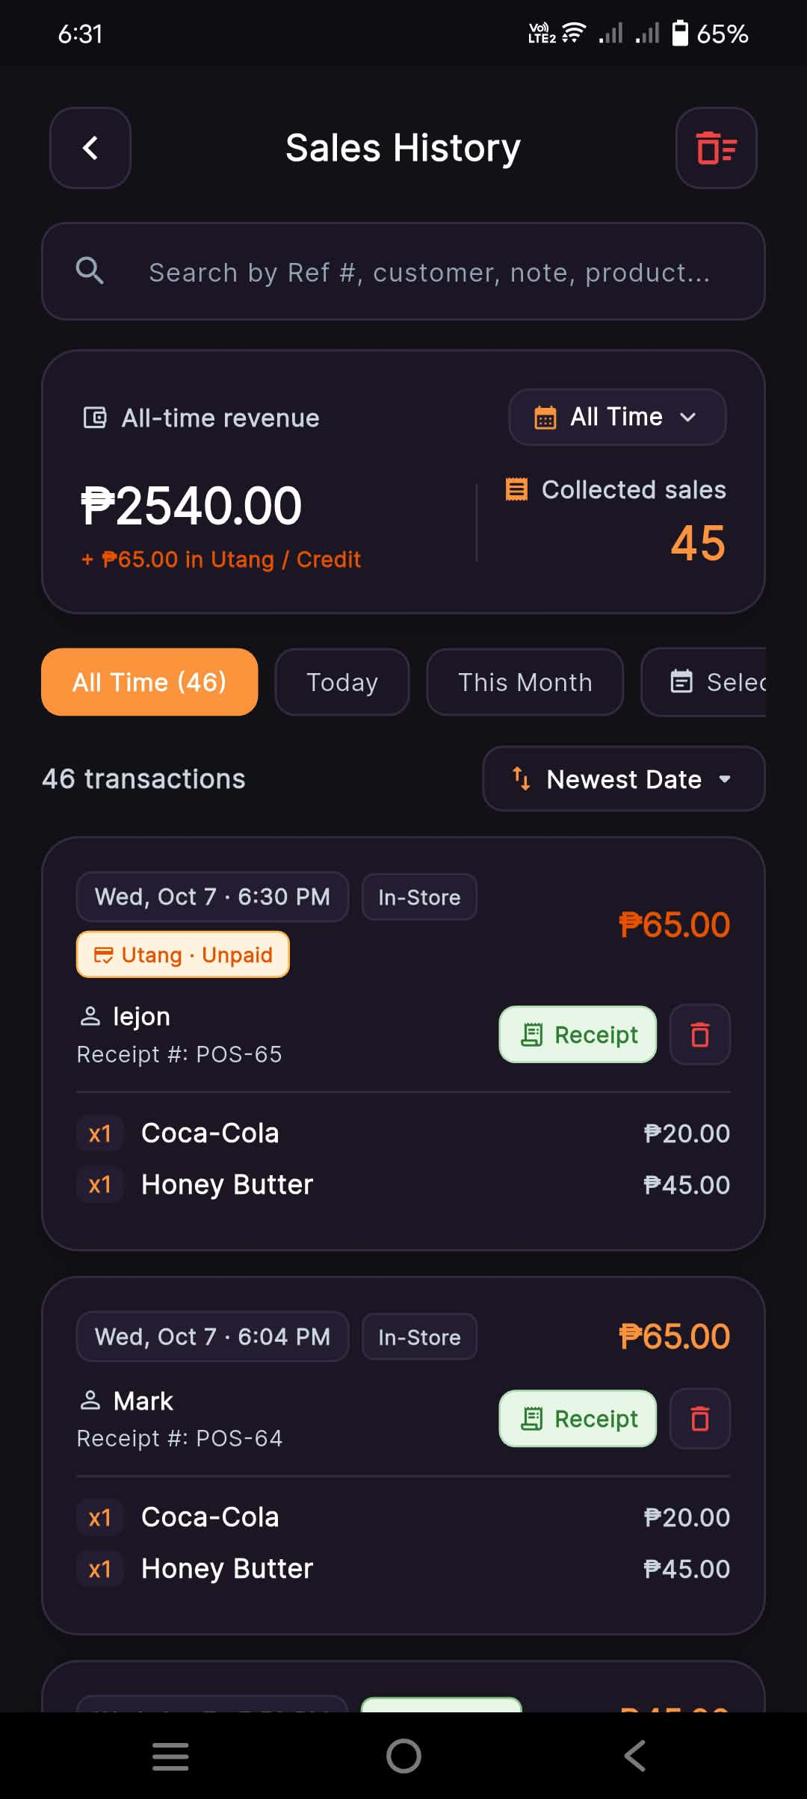
Functional Description: Shows POS-65 immediately logged in Sales History as Utang • Unpaid, with cumulative revenue metrics updating to ₱2,540.00 + ₱65.00 in Utang across 46 transactions.
Key Interface Elements & Visual Indicators:
- Updated metrics: All-time revenue '₱2540.00' (+ ₱65.00 in Utang / Credit), 46 transactions
- Transaction card: 'POS-65', Customer: 'lejon', amount '₱65.00', status tag 'Utang • Unpaid'
- Itemized breakdown (1x Coca-Cola, 1x Honey Butter) and direct 'Receipt' button
💡 Practical Micro-Retail Note: Distinguishes realized cash revenue from outstanding credit receivables in financial statements.

Screen 27: Utang Ledger Synchronization (Multiple Active Loans)
Application: Stora Owner | Screen: Utang Ledger (Updated List)
Module: Module 12: Financial Synchrony & Utang Reconciliation
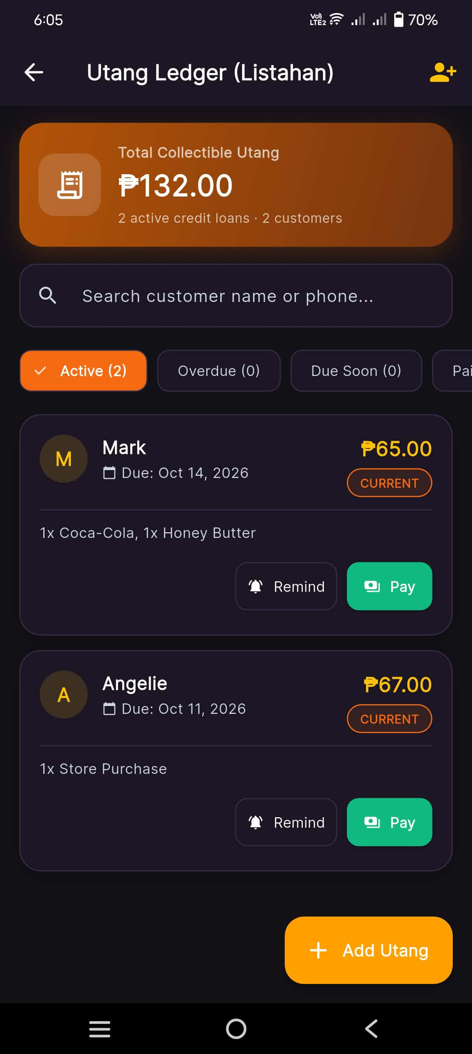
Functional Description: The Utang Ledger automatically reconciles the POS loan, updating total collectible receivables to ₱132.00 with active accounts for both Mark (₱65.00) and Angelie (₱67.00).
Key Interface Elements & Visual Indicators:
- Updated Total Collectible Utang: '₱132.00' (2 active loans, 2 customers)
- Active Loan 1: 'Mark', '₱65.00', Due: Oct 14, 2026, status 'CURRENT' (Items: 1x Coca-Cola, 1x Honey Butter)
- Active Loan 2: 'Angelie', '₱67.00', Due: Oct 11, 2026, status 'CURRENT'
- 'Remind' and 'Pay' action buttons for each loan
💡 Practical Micro-Retail Note: Guarantees zero discrepancy between POS checkout and credit ledger balances.

Screen 28: Store Owner Profile (Account & Store Operations)
Application: Stora Owner | Screen: Profile Screen (Top Half)
Module: Module 13: Store Owner Profile & Settings
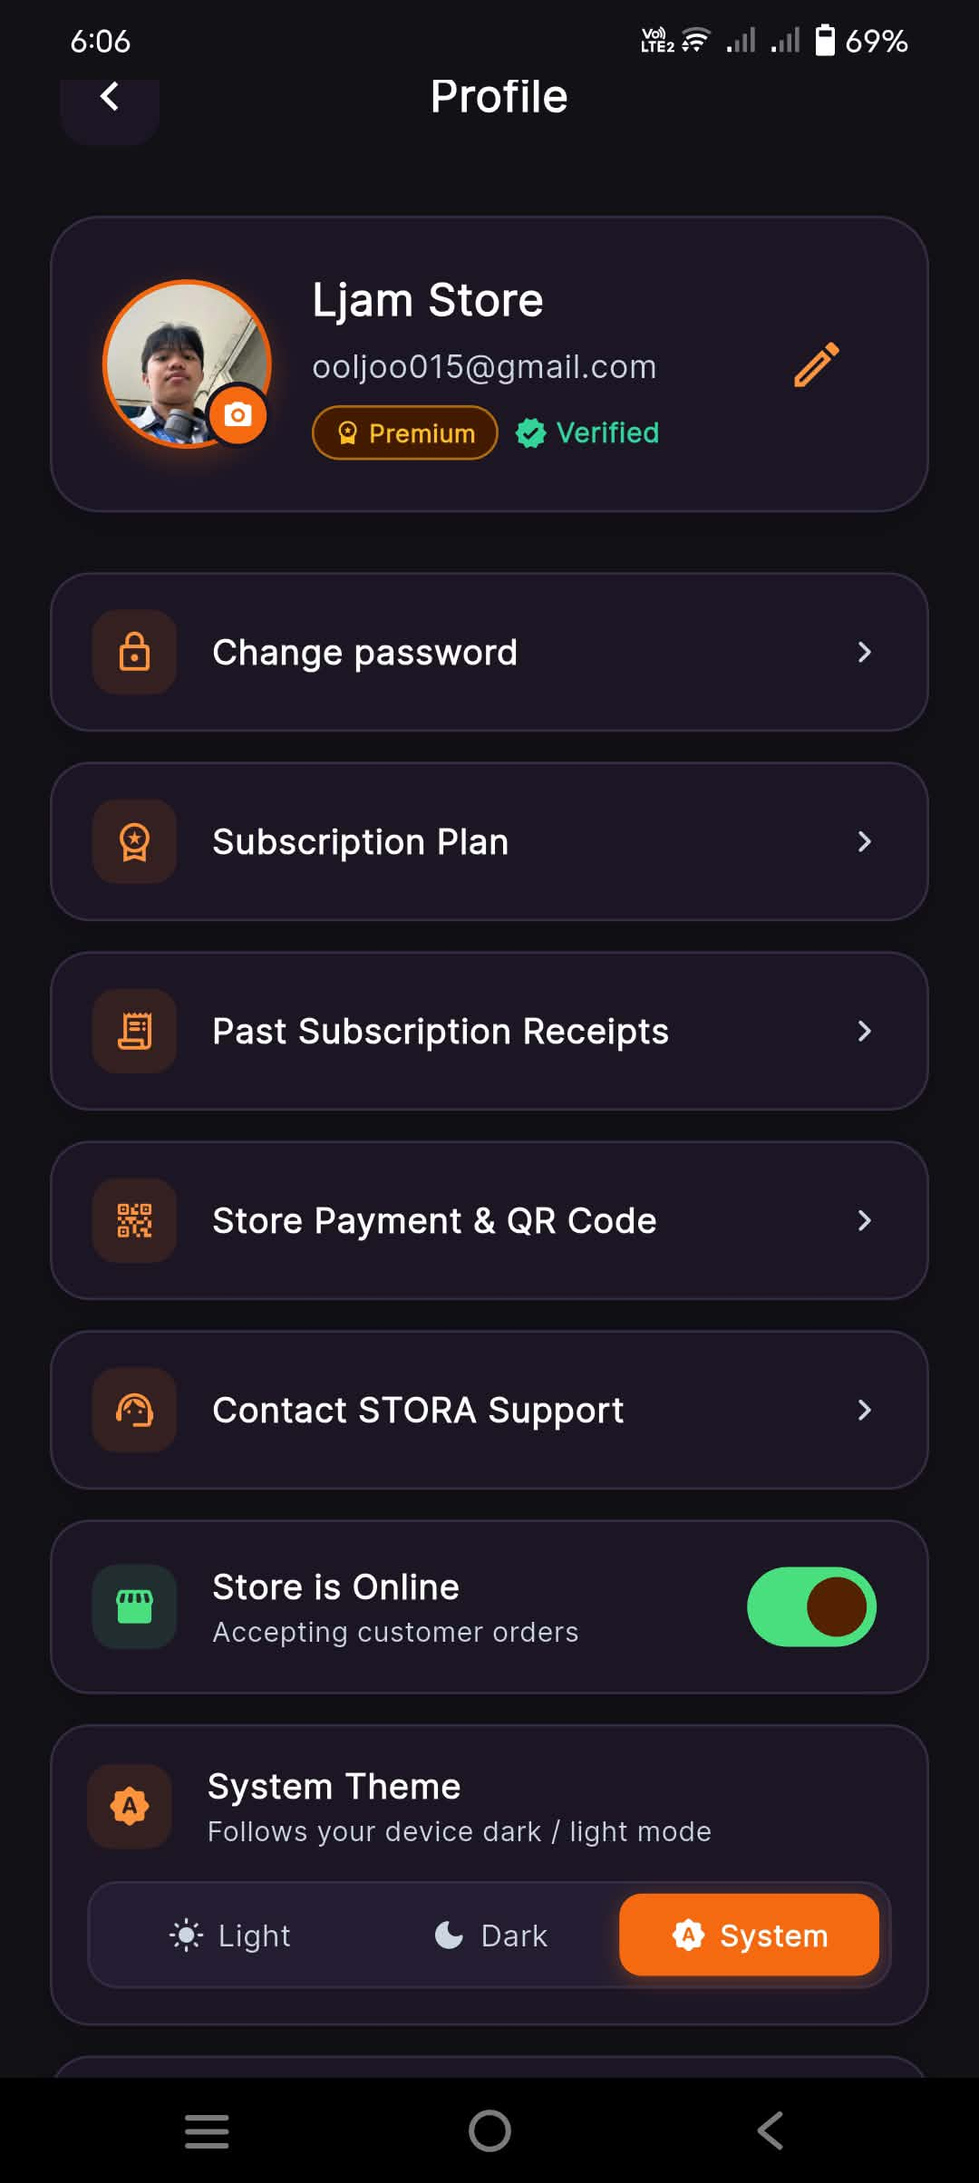
Functional Description: Store details, subscription tier, store availability toggle, and system theme switcher.
Key Interface Elements & Visual Indicators:
- Store photo, Store Name ('Ljam Store'), email address, and badges: 'Premium' and 'Verified'
- Navigation links: 'Change password', 'Subscription Plan', 'Past Subscription Receipts', 'Store Payment & QR Code', 'Contact STORA Support'
- 'Store is Online' toggle ('Accepting customer orders')
- System Theme switcher: 'Light', 'Dark', 'System'
💡 Practical Micro-Retail Note: Comprehensive store administrative options organized in a clean card layout.

Screen 29: Store Owner Profile (Security & Account Lifecycle)
Application: Stora Owner | Screen: Profile Screen (Bottom Half)
Module: Module 13: Store Owner Profile & Settings
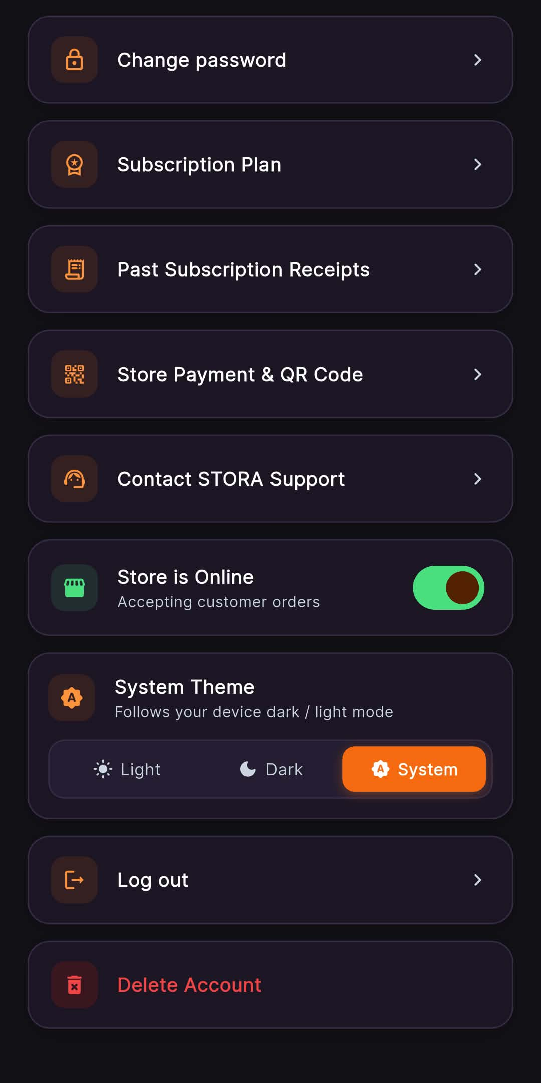
Functional Description: Lower profile options including logout and hardened account deletion with cascading protections.
Key Interface Elements & Visual Indicators:
- Session control: 'Log out' navigation card
- High-risk action: 'Delete Account' in red
💡 Practical Micro-Retail Note: Account deletion cleans up products atomically while safely preserving historical sales records.

Screen 30: Online Payment & QR Codes Configuration
Application: Stora Owner | Screen: Online Payment & QR Codes Screen
Module: Module 13: Store Owner Profile & Settings
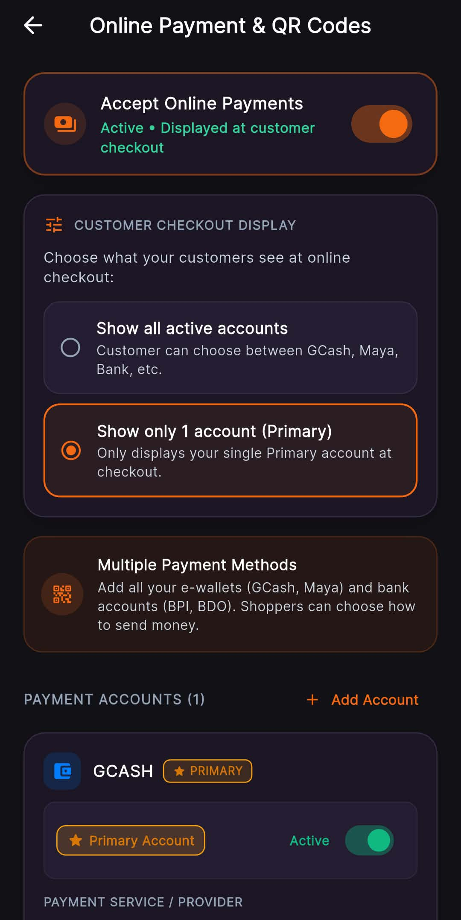
Functional Description: Settings panel for toggling online payment acceptance, choosing customer checkout display mode, and managing GCash/Maya accounts.
Key Interface Elements & Visual Indicators:
- Master switch: 'Accept Online Payments' (Active)
- Customer Checkout Display options: 'Show all active accounts' vs 'Show only 1 account (Primary)' (Selected)
- Multiple Payment Methods explainer
- Payment Accounts list: 'GCASH ★ PRIMARY' (Active toggle enabled)
- '+ Add Account' action button
💡 Practical Micro-Retail Note: Allows owners to configure whether customers see one primary GCash or multiple wallet options.

Screen 31: Welcome Back Login Screen
Application: Stora Owner / Stora Customer | Screen: Login Screen
Module: Module 14: Authentication & Fast Store Onboarding
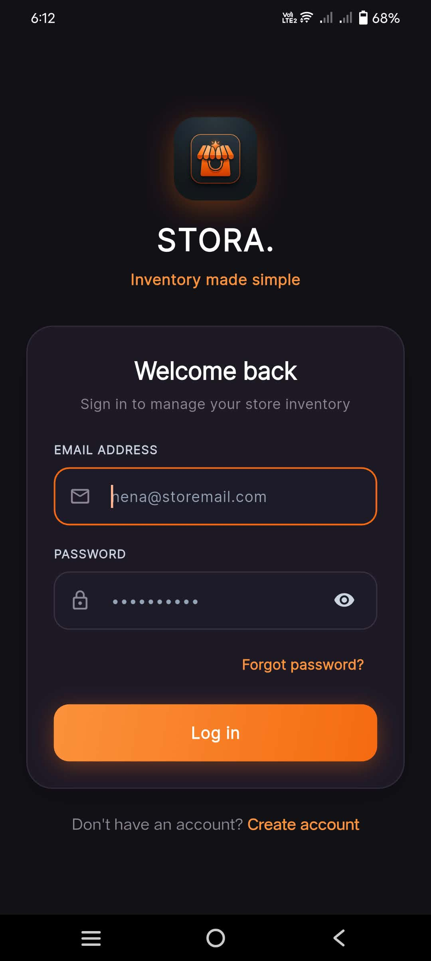
Functional Description: Clean dark-mode login screen with email, password visibility toggle, and password recovery.
Key Interface Elements & Visual Indicators:
- Stora logo badge and branding: 'STORA. Inventory made simple'
- Heading: 'Welcome back - Sign in to manage your store inventory'
- Email Address input field ('nena@storemail.com')
- Password input field with interactive visibility toggle ('eye' icon)
- 'Forgot password?' recovery link
- Orange 'Log in' CTA button and 'Create account' redirect
💡 Practical Micro-Retail Note: Interactive password toggle eliminates frustrating login typos on mobile keypads.

Screen 32: Get Started Free Registration Screen
Application: Stora Owner / Stora Customer | Screen: Sign Up Screen
Module: Module 14: Authentication & Fast Store Onboarding
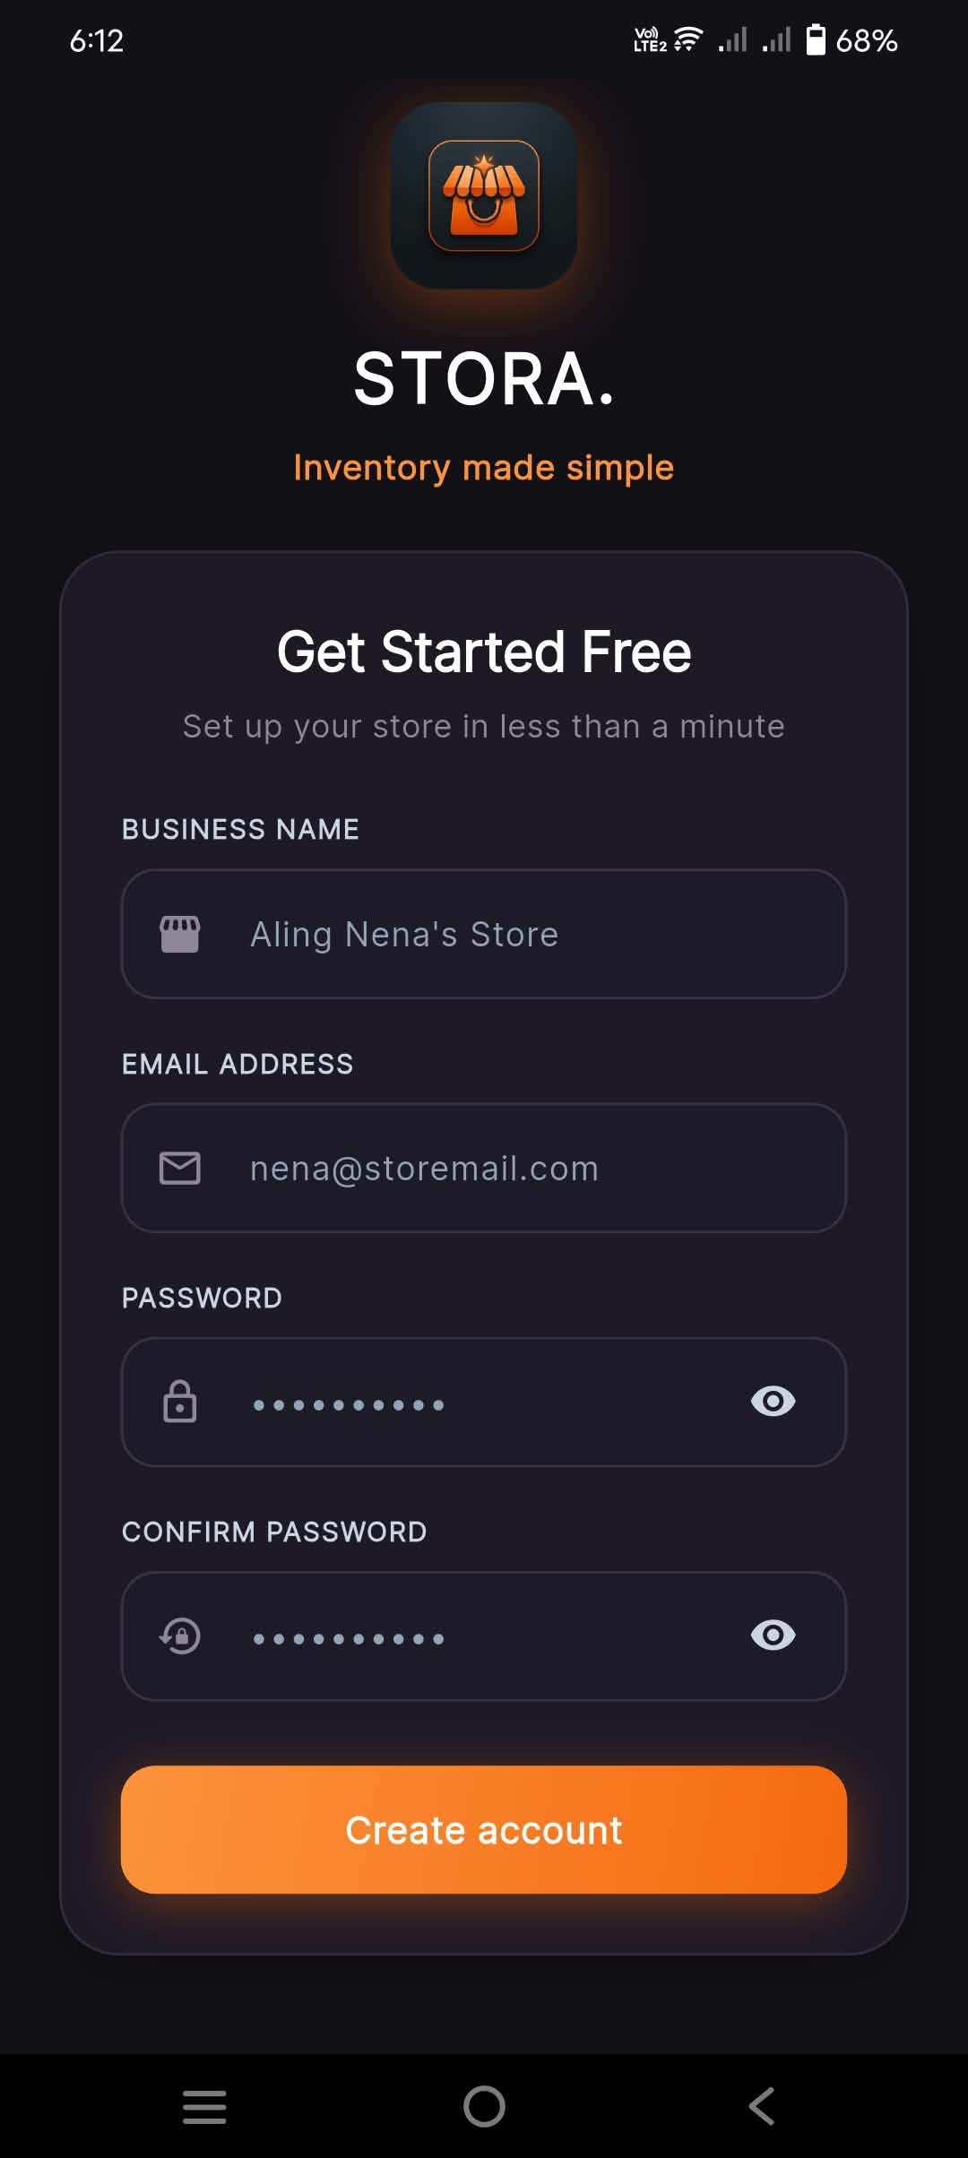
Functional Description: Rapid onboarding form requiring only Business Name, Email, and Password confirmation, enabling micro-retailers to set up a digital store in under 60 seconds.
Key Interface Elements & Visual Indicators:
- Header: 'Get Started Free - Set up your store in less than a minute'
- Business Name input ('Aling Nena's Store')
- Email Address input ('nena@storemail.com')
- Password input with show/hide toggle
- Confirm Password input with show/hide toggle
- Prominent 'Create account' submission button
💡 Practical Micro-Retail Note: Zero-barrier onboarding designed specifically for non-technical community store owners.

Screen 33: Stora Customer Discovery Catalog (Home Feed)
Application: Stora Customer | Screen: Browse Stores (Home Screen)
Module: Module 15: Stora Customer Experience Ecosystem
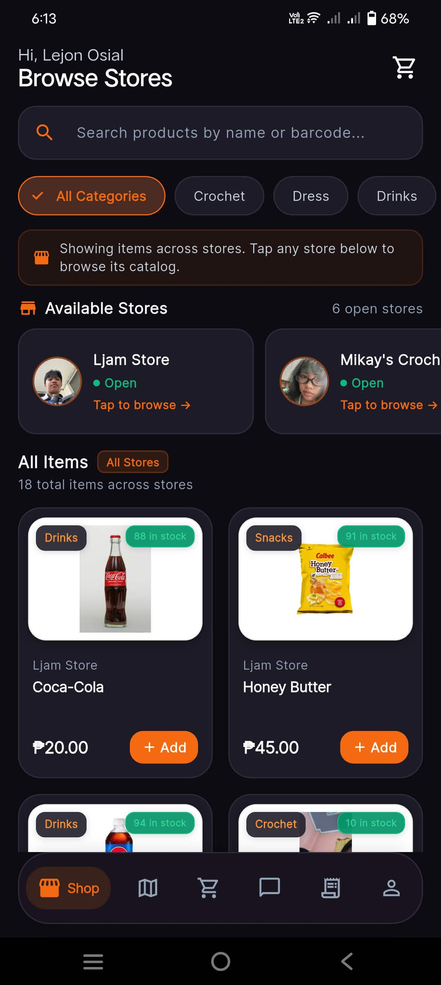
Functional Description: Main shopping feed showing available neighborhood stores, category chips, and live item stock counts.
Key Interface Elements & Visual Indicators:
- Customer header greeting ('Hi, Lejon Osial') with cart badge
- Search bar and category pills
- Available Stores carousel showing 'Ljam Store' (Open) and 'Mikay's Crochet' (Open)
- All Items feed with updated stock levels (Coca-Cola 88 in stock, Honey Butter 91 in stock)
💡 Practical Micro-Retail Note: Real-time stock decrement is immediately visible to all shoppers across the community.

Screen 34: Customer Interactive Geolocation Discovery Map
Application: Stora Customer | Screen: Store Discovery Map
Module: Module 15: Stora Customer Experience Ecosystem
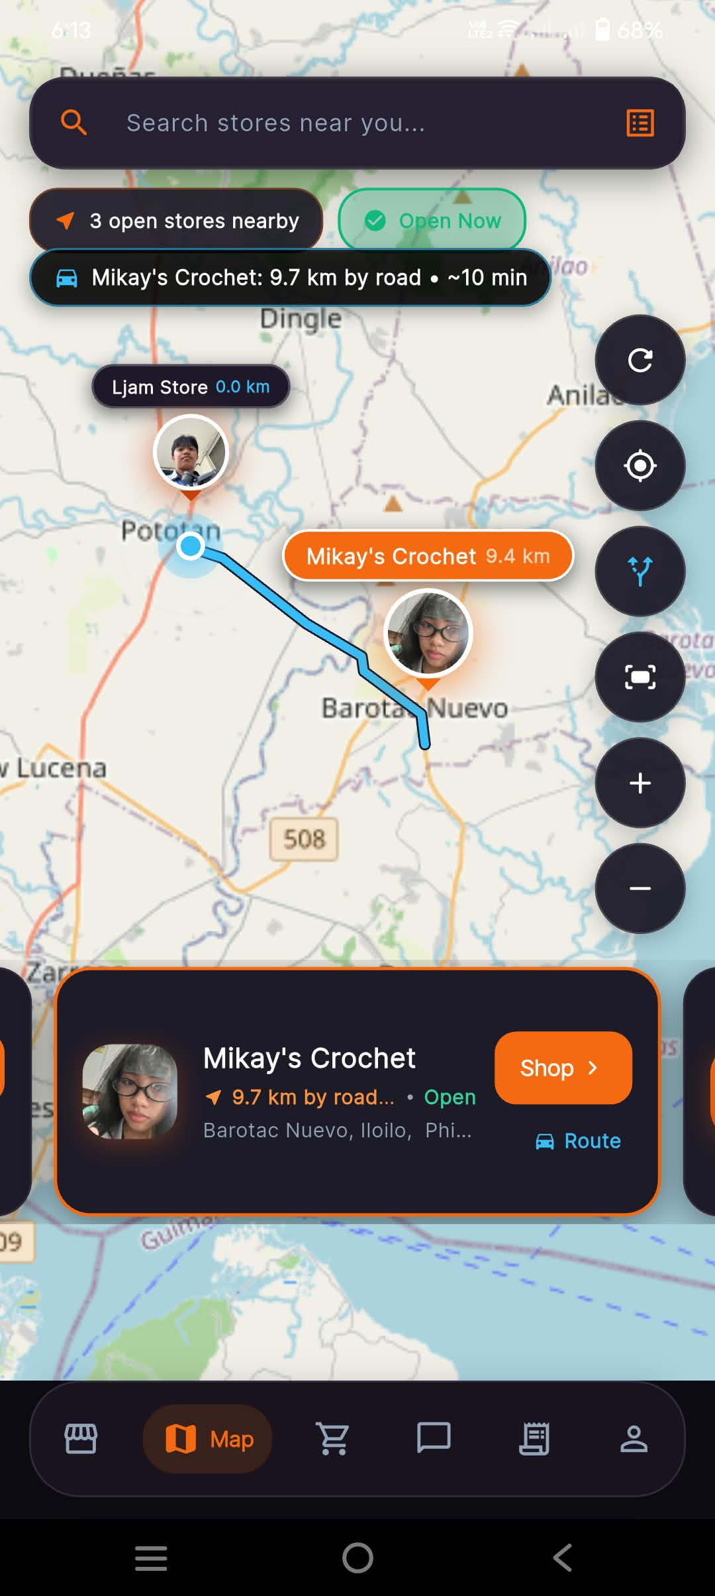
Functional Description: Interactive map radar detecting open stores in the area, showing road distance, travel time, route polyline, and direct shopping navigation.
Key Interface Elements & Visual Indicators:
- Search bar: 'Search stores near you...'
- Filter pills: '3 open stores nearby', 'Open Now'
- Interactive radar banner: 'Mikay's Crochet: 9.7 km by road • ~10 min'
- Map canvas plotting 'Ljam Store 0.0 km' and 'Mikay's Crochet 9.4 km' with road route polyline in Pototan / Barotac Nuevo, Iloilo
- Floating map controls: Recenter, Layers, Compass, Zoom (+ / -)
- Selected Store Card: 'Mikay's Crochet', '9.7 km by road', 'Open', with 'Shop >' and 'Route' buttons
💡 Practical Micro-Retail Note: Spatial intelligence helps shoppers find exactly which neighboring store has open doors and available stock.

Screen 35: Customer Profile Management
Application: Stora Customer | Screen: My Profile
Module: Module 15: Stora Customer Experience Ecosystem
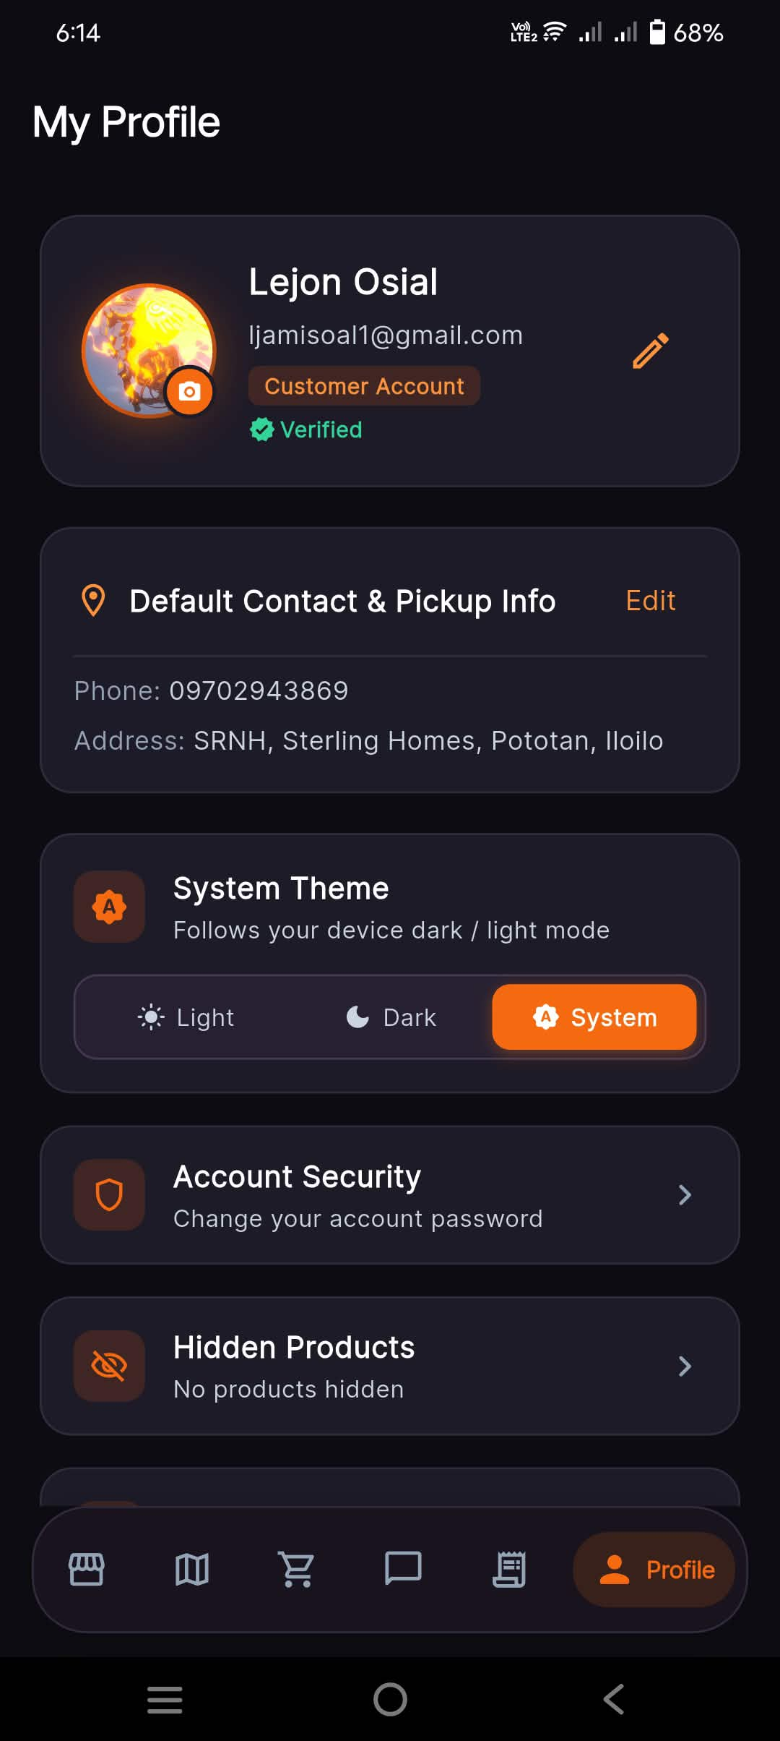
Functional Description: Customer profile management, default contact phone and pickup landmark editor, theme preferences, and security settings.
Key Interface Elements & Visual Indicators:
- Profile photo, Customer Name ('Lejon Osial'), email, and 'Customer Account • Verified' badge
- 'Default Contact & Pickup Info' card with Phone ('09702943869'), Address Landmark ('SRNH, Sterling Homes, Pototan, Iloilo'), and 'Edit' button
- System Theme switcher: 'Light', 'Dark', 'System'
- Account Security and Hidden Products management cards
💡 Practical Micro-Retail Note: Saved landmarks automatically populate future checkout screens for effortless ordering.

Screen 36: Community Product Moderation (Report Product)
Application: Stora Customer | Screen: Report Product Bottom Sheet
Module: Module 15: Stora Customer Experience Ecosystem
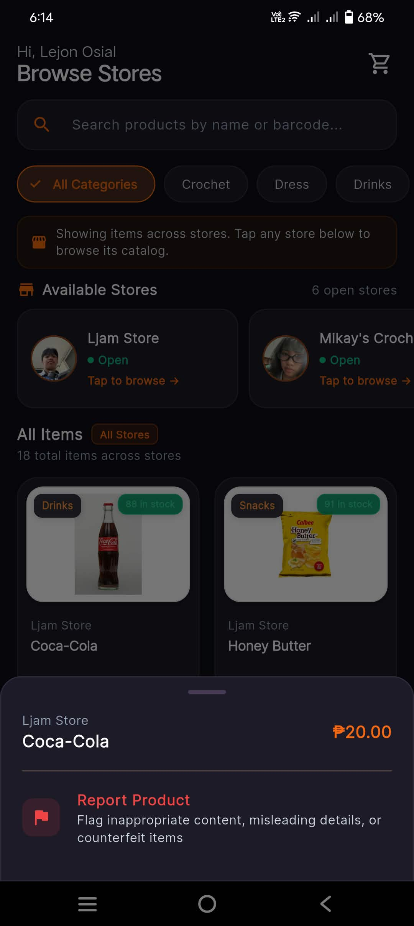
Functional Description: Safety sheet allowing customers to flag inappropriate content, misleading product details, or counterfeit items.
Key Interface Elements & Visual Indicators:
- Item reference ('Coca-Cola • ₱20.00')
- 'Report Product' action item ('Flag inappropriate content, misleading details, or counterfeit items')
💡 Practical Micro-Retail Note: Community moderation safeguards platform integrity across decentralized neighborhood sellers.

Screen 37: Customer Product Detail Bottom Sheet (Coca-Cola)
Application: Stora Customer | Screen: Product Detail Sheet (Coca-Cola)
Module: Module 15: Stora Customer Experience Ecosystem
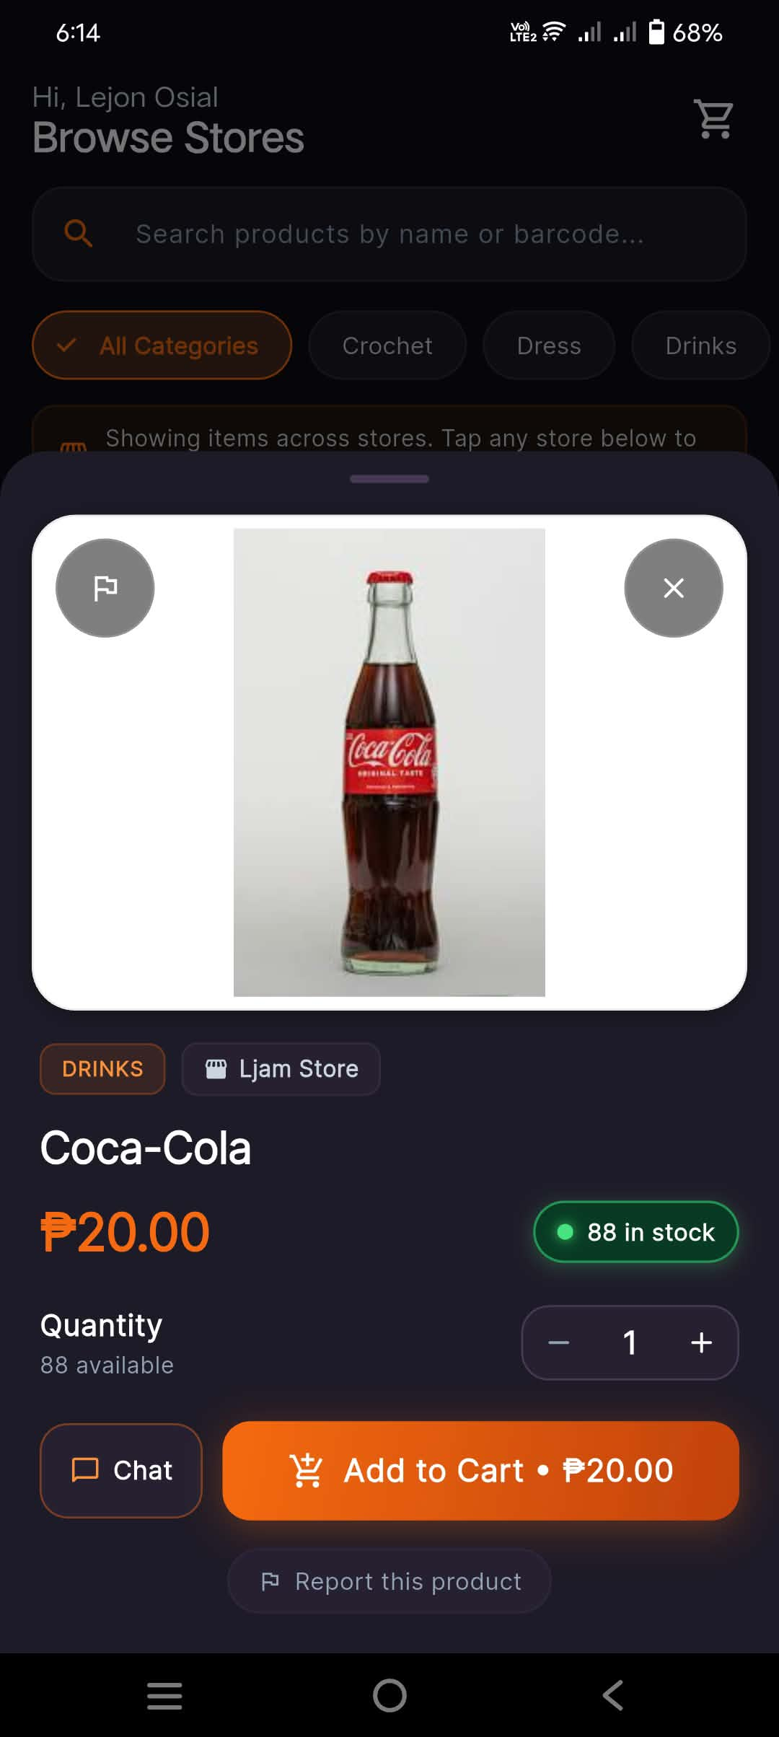
Functional Description: Product sheet showing item image, price, stock level, quantity stepper, and Add to Cart CTA.
Key Interface Elements & Visual Indicators:
- Full bottle product photo presentation
- Category ('DRINKS'), Store ('Ljam Store'), Price ('₱20.00')
- High-contrast stock badge ('88 in stock' with green dot)
- Quantity selector ('-' / '+') and 'Add to Cart • ₱20.00' button
- 'Chat' and 'Report this product' options
💡 Practical Micro-Retail Note: Dynamic stock indicator reflects deductions from both online orders and walk-in POS sales.

Screen 38: Single Store Branded Catalog (Ljam Store)
Application: Stora Customer | Screen: Single Store Catalog View
Module: Module 15: Stora Customer Experience Ecosystem
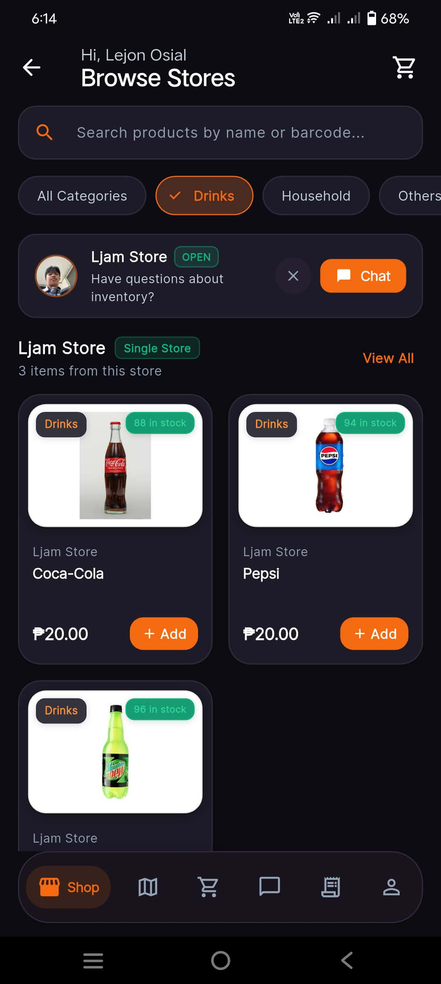
Functional Description: Dedicated storefront for a single merchant displaying only their inventory, category filters, and a direct store chat button.
Key Interface Elements & Visual Indicators:
- Merchant banner: 'Ljam Store (OPEN)' with profile avatar and orange 'Chat' button ('Have questions about inventory?')
- Header: 'Ljam Store - Single Store - 3 items from this store' with 'View All' link
- Drinks category filter active
- Dedicated product grid: Coca-Cola (₱20.00, 88 in stock), Pepsi (₱20.00, 94 in stock), Mountain Dew (₱15.00, 96 in stock)
💡 Practical Micro-Retail Note: Gives neighborhood sari-sari stores their own digital branded storefront link.

