Points for Addition and Modification

- Personal Information page: A Next button is needed at the bottom of the page, which should only become active after all required fields are completed. Currently, this button is missing.
- Clinical History page: Similarly, a Next button should be added at the end of this page and activated only once all fields are filled in. Also, I was unable to upload the histology report in either Word or PDF format?
- Family Pedigree Page:
  - There should be two options: one to upload a pedigree and another to construct one manually. Currently, I do not see the upload option?
  - A Next button is needed at the bottom of the page, which should only become active after all required fields are completed. Currently, this button is missing.
  - A note should be added on this page stating: Please watch the tutorial videos section on the bottom left-hand before starting the pedigree construction. You may also upload the pedigree image instead (which format you accepted?)
  - Additionally, I have some questions about the script.
This is the new script you shared with me via email; I only changed the user path to (C:\ProgramData\miniconda3) and ran the script.
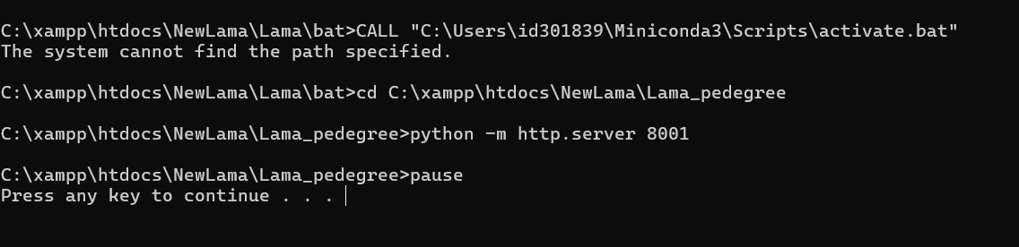
The version I ended up with is as shown below can you please confirm if it’s, correct?
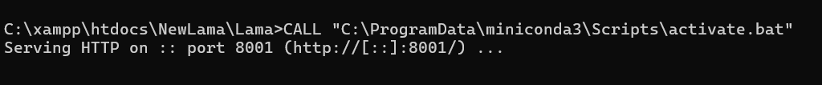

- Patient Eligibility for NCCN Testing Criteria Page:
  - Regarding the new script you provided me by email (first one); I only updated the user path to (C:\ProgramData\miniconda3) and ran it. The resulting script (second one) appears as shown below, can you confirm if it’s, correct?
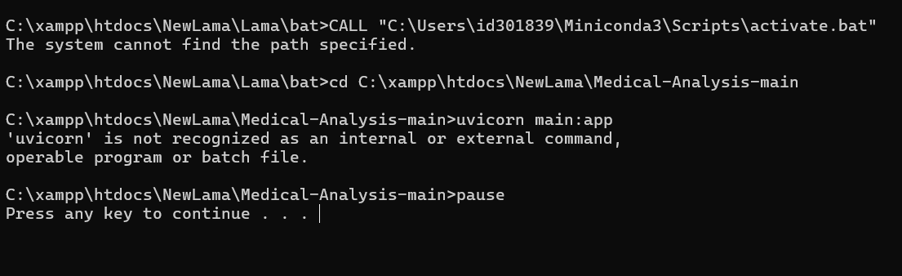
After running the script 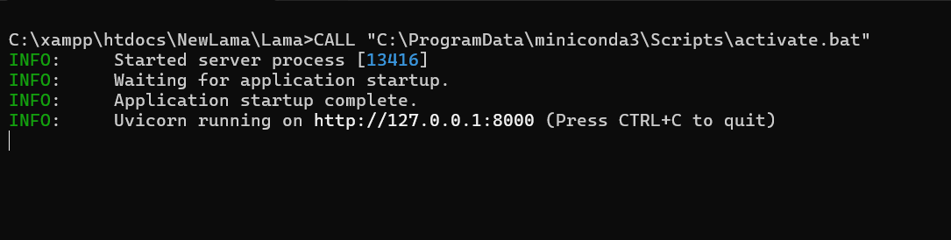
  - As discussed in our last meeting, the AI-generated report should be integrated into the application and visible to the user on this page.
  - When I click Start, it immediately moves to the next page, which should not happen. Instead, the AI report should appear here. This page should also process the uploaded histology report and the pedigree (uploaded or constructed) after clicking Start.
  - A Next button is needed at the bottom of the page, which should only become active after AI-generated report completed.
  - This site http://localhost:8000/medical/ can be used as an external service but need to add the same concept within the application.
  - The logo needs to be updated as previously agreed.
  - The script you provided activate this service http://localhost:8000/medical/, I need to activate within the application also as explained above

- Educational Session page:
Before beginning the educational session, we agreed that a green or red light should appear in the AI-generated report to indicate eligibility. If the light is green, the user proceeds; if not (so it is red), they should not be able to move forward. Currently, I can access all educational sections without any restriction, which needs to be fixed.

- Patient Consent Form page:
I am unable to upload the consent form file, and a Next button should be added at the bottom, which becomes active only after completing the required fields.

- Patient Assessment page:
I cannot see the score after submission, and we also need a Next button at the end of the page that activates only once all fields are completed.
- Chatbot page:
- The new script you provided via email is not working for me at all (below one).
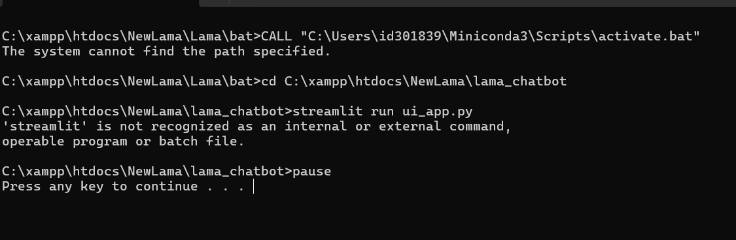

  - I attempted to use the previous method from our last meeting by following these steps:
    - Added the OpenAI key to the env file located in the lama_chatbot folder.
    - Opened Anaconda Prompt (which one should I use: Administrator: Anaconda Prompt or Anaconda Prompt?) and executed the following commands:

b.1 cd C:\xampp\htdocs\NewLama\lama_chatbot → Enter
b.2 pip install streamlit → Enter (Do I need to do this every time?)
b.3 python -m streamlit run ui_app.py → Enter
b.4 On my first attempt, I encountered an error when trying to use the chatbot site (see details below).

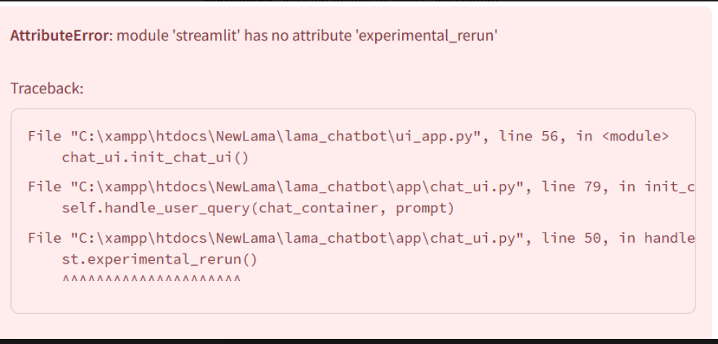
b.5 To fix the issue, I navigated to lama_chatbot > app > chat_ui.py, opened chat_ui.py at line 50, and replaced st.experimental_rerun() with st.rerun(). After making this change, I re-ran the script, and the error disappeared. Is that correct?
Request please: Could you please modify the new script so I can use it directly? I am unsure how to make these adjustments myself.
  - As agreed, when accessing the Chatbot page, this page should be displayed to the user, but I do not see it appearing.
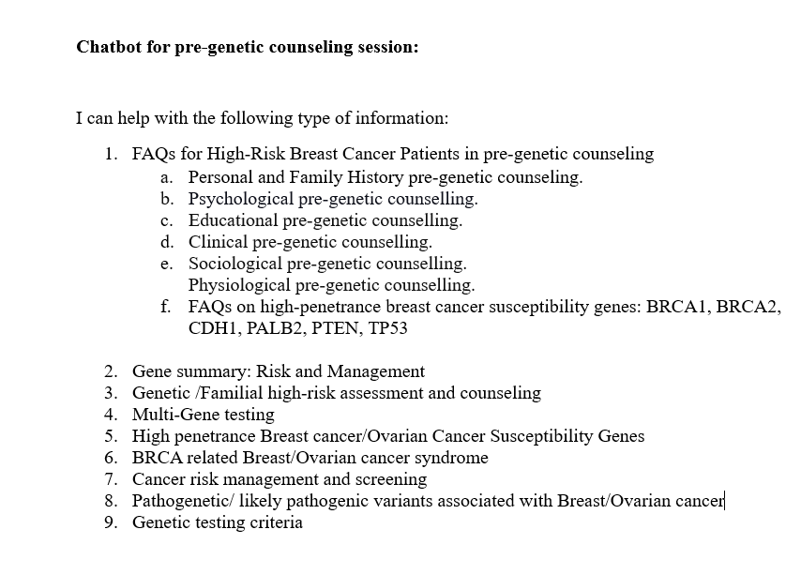
  - The name should be "Chatbot" only, without "NCCN Guidelines", as it includes additional information from other sources.
  - A Return button is needed at the bottom of the page to allow users to navigate back to the application.

- Tutorial page:
As agreed, this section should contain two instructional videos, but the Tutorial button is not functioning, and I am unable to access any content.

- For OpenAI Key:
  - During our last meeting, you advised me to purchase $5 in credits. How long will this amount last?
  - If I need to add more credits, what is the process for doing so?

- I would be grateful if I could run the application in your presence.

Thank You

