Table of Content

1 Introduction 2

2 Problem 2

3 Method 3

3.1 Scoping 3

3.1.1 Context 3

3.1.2 Function 4

3.1.3 Life's Principles 4

3.2 Discovering 4

3.2.1 Function Lense 4

3.2.2 Operating Conditions 6

3.2.3 Naturalist Lens 7

3.3 Creating 8

3.4 Evaluating 9

3.4.1 Evolve to Survive 9

3.4.2 Be Resource (Material and Energy) Efficient 9

3.4.3 Adapt to changing conditions 10

3.4.4 Use Life-friendly Chemistry 10

3.5 Translating 10

3.5.1 Concept 10

3.5.2 Extension Possibilities 11

4 Cradle to Cradle 12

5 Discussion 12

6 Conclusion 13

7 References 13

# Introduction

Micro air vehicles are booming in the past decades. MAVs gained use in a wide range of purposes and are available for industrial, public, and private use. Branches that profit of MAVs are surveillance, photographing, and delivery of goods. Fast developing markets are good indicators for potential. Therefore, is developing an innovation for this specific market connected with minor risk. In Collaboration with the Swiss army, the goal is to develop a Prototype MAV that can be deployed for both air as well as water missions. The conceptual phase of the prototyping follows biomimicry methods. Biomimicry methods are created for technical solutions which implement the advantages of nature's evolution and adaptability.

# Problem

Bionic engineering principles are difficult to integrate in the construction of a MAV. To enhance the performance of technological systems, bionic engineering incorporates biological principles and materials. This can be a complex and subtle procedure, requiring an in-depth knowledge of both the biological systems being replicated and the technological requirements of the MAV.

MAVs would be able to function in a greater variety of situations if they could transition from water to air. MAVs with the ability to transition from water to air, for instance, might be utilized for search and rescue operations in places containing bodies of water, such as flood zones or coastal regions. Additionally, MAVs with this capability could be utilized for aquatic research and monitoring, including the study of marine life and water quality monitoring. Overall, the capacity to move from water to air would significantly increase the potential uses and applications of MAVs, making them even more important tools for a variety of sectors and organizations.

Multiple variables contribute to the difficulties of incorporating bionic engineering principles into the design of an MAV. The necessity to balance the opposing demands of performance, functionality, and durability is one of the key obstacles. Due of the fragility and environmental sensitivity of bionic materials and systems, it might be challenging to fit them into an MAV's tough and high-performance design. In addition, the integration of bionic systems into an MAV necessitates a high level of technical skill and complex production procedures, which can be time-consuming and costly.

Implementing bionic engineering principles in the design of an MAV necessitates a cautious and nuanced approach, and it is a substantial task that calls for a combination of technical expertise, ingenuity, and resourcefulness.

# Method

## Scoping

Scoping is used to clarify the Requirements. Main parts of scoping are defining the boundaries, challenge, context, and constraints of the Project. The Scoping Process is applied to the project according to the biomimicry modelling wheel (Fig. 1). The model divides the scoping efforts into three main categories:

* Context definition
* Function identification
* Life's principle integration

### Context

Project boundaries define the space for development. Each work step has to full fill the projects requirements in the assigned boundaries. The Boundaries for the development of the MAV-prototype has been set around the product itself. All functions are focused on the MAV and the interaction with its surroundings. Communication with the pilot must be implemented. The control unit for the pilot is not part of the project.

Developing a MAV-prototype according to the challenge requires the prototype to perform in air and water. These requirements lead to the context of the project. Separating the context into air, transition and water helps to focus on relevant influences. Movement in air exposes the MAV to weather, topology, and hazards. Weather includes the influences of sunlight, Temperature, humidity, rain, wind, ice, and snow. Hazardous objects can be animals, insects, moving objects, obstacles, abrasives, and people. The topology of Switzerland is a combination of mountains, forests, glaciers, buildings, or whole cities. Transitioning between the two main context fields challenges the MAV with change of fluid density, water surface tension and floating objects on water. During the movement in water, resist and adapt to water condition, topology and hazards is vital for the MAV to persist. Water condition is containing the properties of sweet water, current and waves. Topology includes the differentiation of lakes and rivers, depth, stones and water plants.

### Function

Combining the three context modules helps to define the necessary functions for an MAV to fit the requirements of the challenge (Fig.2). Ein Bild, das Text enthält.

### Life's Principles

When looking at how to integrate/use natural engineering solution, following Life's Principles have been identified in order to integrate them into the project:

* Adapt to changing conditions
* Change between air and water
* Temperature change
* Altitude change
* Be resource efficient
* Navigation for over and underwater

## Discovering

Understanding the technical answers that the natural world must give after millions of years of natural evolution is the focus of the discovering phase.

The goal was to identify relevant biological models or solutions for the challenges and functions that the MAV would have to overcome/perform. Therefore, using the terms of our scoping section, we began to seek inspiration in nature. We conducted a keyword search on Asknature.org for some of the tasks identified during scoping. Other elements were derived from experience. In the section that follows, only the few mechanisms that made it into the final prototype are listed.

### Function Lense

In this method, we searched multiple sources for the functionalities our challenge must satisfy. Consequently, the questions/functions were required to be Biologized.

#### How would nature transition from air to water?

The transition between air/flight and water/diving is one of the most vital and crucial capabilities that the MAV must master to perfection.

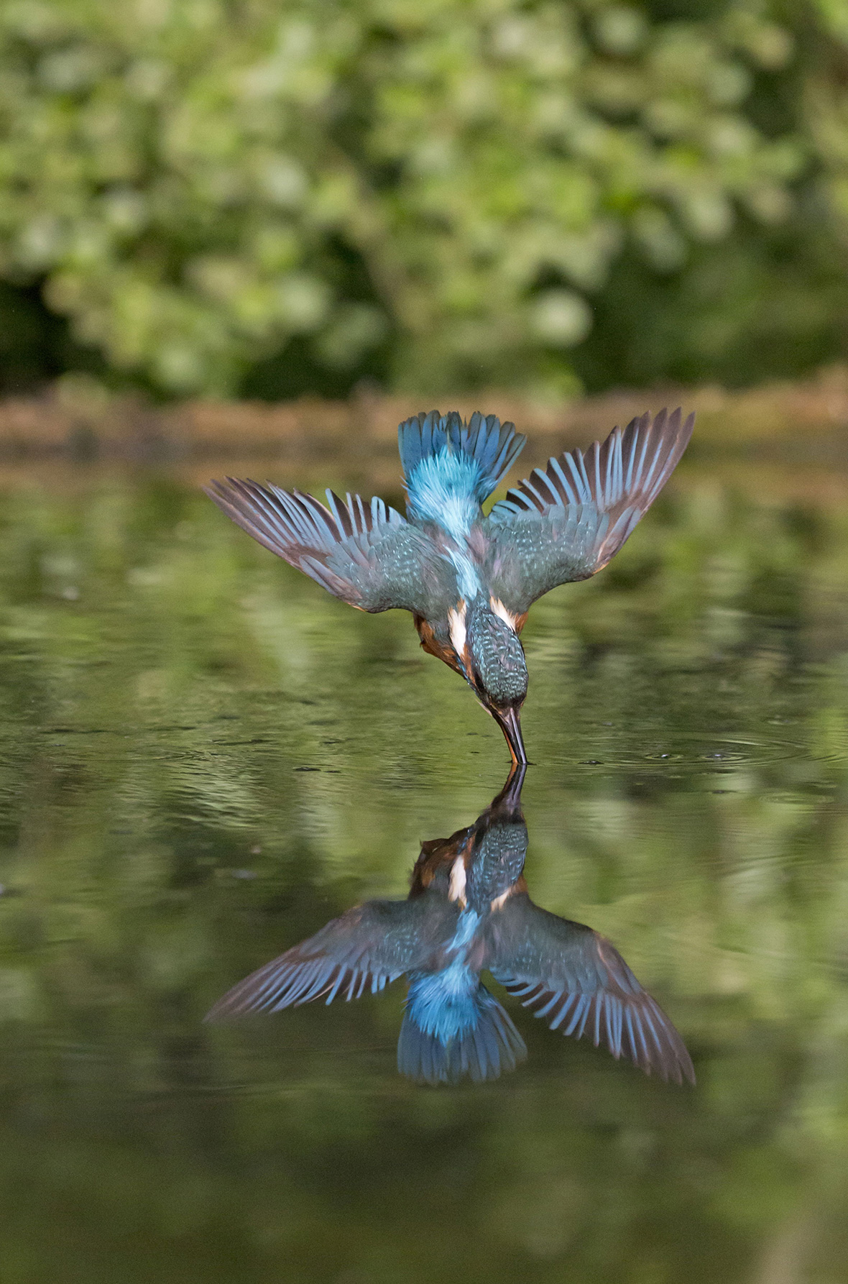The issue is surface tension, which increases with speed and causes the water to become solid like concrete. Various bird species have already developed this trait over many years. One of these species is the Kingfisher. They fly approximately 30 meters above the ocean and dive into it at a speed of 97 kilometers per hour. Not only can they dive to depths of up to 25 meters, but they can also hunt fish as deep as 90 meters. To break the water tension optimally, they fold their wings right before impact, and the anatomy of their beak's aids in this process.

#### How would nature navigate underwater?

Without navigation, the MAV is ineffective. The issue lies in finding an underwater navigation system and having a backup plan.

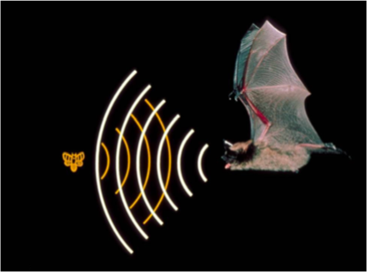Various creatures, such as the tenrec, bats, and whales, utilize a well-known variant of this called the echosounder. This method involves releasing extremely high-pitched noises that reflect off things and return to the animal. You may determine the distance, direction, speed, density, and size of an object based on the duration of bounce and the incoming waves.

#### How would nature tackle underwater and airborn communication?

Fortunately, or thanks to intelligent evolution, animals also use ultrasound to communicate. The same approach applies here as mentioned previously.

#### How does nature solve airborn and underwater motility?

MAVs use traditional designs for flight that may not be as agile and versatile as required for our machine's functions and missions. Therefore, we looked for inspiration from the natural world and the ways it solves airborn motility for a more effective and appropriate solution.

For example, certain spider species can be found flying several kilometers in the air and traveling over a thousand kilometers out to sea. They can even detect electrically charged atmospheres and use their senses and environment to their advantage. To accomplish these feats, they crawl along a negatively charged edge and then shoot out strands of silk, which pick up the negative charges of the surface and repel away from it, allowing them to fly.

Due to the rapid entry of our MAV into the water, the underwater movement strategy emphasized direction changes and short distances. As such, we looked for underwater motility strategies in nature, and Flagella from certain bacteria and microorganisms came to our mind.

Numerous microorganisms utilize flagella, which are long, whip-like appendages, to travel through water. They are made of proteins known as flagellins, which are spirally organized around a central core. At the base of the flagellum lies a molecular motor called the basal body that powers the flagellum. The rotation of the basal body causes the flagellum to oscillate, propelling the bacterium through the water. The microbe can control the movement's direction and velocity by regulating the rotation of its basal body. Flagella are an integral aspect of the biology and behavior of numerous aquatic bacteria, as they are particularly effective at propelling microbes through water.

### Operating Conditions

The MAV must always consider the operating conditions. It is necessary to consider a wide variety of application domains, which is especially important when thinking about the varied topography of Switzerland.

#### Resilience to big temperature variation

Variations in temperature can pose a serious threat to electronics. Large temperature swings can pose several issues for electronic components, including thermal expansion, which can put physical stress on the components, and changes in the electrical properties of materials, which can compromise the performance and dependability of the electronics. In addition, elevated temperatures can hasten the deterioration of materials and the aging of components, leading to their early failure. Extremely low temperatures, on the other hand, can lead to issues such as brittle failure, higher resistance, and decreased performance. In order to maintain the dependability and performance of electronic devices, it is necessary to safeguard them against significant temperature fluctuations.

Therefore, proper thermal insulation is necessary for the normal operation of the MAV. To address this issue, we can assess the tactics utilized by various animals and plants to withstand extreme temperatures.

A nice model is a furry animal, such as a beaver.

Animal fur always consists of two unique types of hair strand. The longer ones are called guard hairs and act as a protective covering for the underhairs, which are denser (one guard hair protects on average 3 underhairs).

Beavers and other aquatic mammals have scales on the outermost layer of their underhair. This causes the hairs to intertwine, preventing cold water from penetrating and trapping air bubbles. Air bubbles effectively insulate a surface.

Extremophile multicellular creatures, such as the Pompeii worm (Alvinella Pompejana), are similarly well adapted to great temperature changes. The measurements revealed that they can survive despite a 60°C differential between two bodily sections. It accomplishes this by constructing protective tubes that generate a mosaic of microenvironments from which the researcher may determine the thermal and chemical gradients.

#### Structural Integrity

Structural design is crucial for ensuring the structural integrity of a system or structure.

As such, it is essential to consider durability as a distinct criterion, as the MAV must be able to tolerate water pressure, water impact, and the possibility of collision. Nature is once more a fantastic source of inspiration for structural integrity, with a wide variety of techniques available to meet the criteria.

As an example of shock absorption, a woodpecker must absorb force while pecking at a tree to prevent brain harm. This is made possible by the anatomy of its cranium. The layered, plate-like structure of the skull bone resembles a sponge. They serve as shock absorbers by deflecting impact forces in various directions.

Diatoms are another example of extraordinary biological engineering. These organisms have developed a distinctive strategy for preserving structural stability and rigidity while limiting the amount of energy and construction materials required to construct their outer silicona shell.

They acquire a very high level of structural stability through a specific shape, such as circular or star-shaped, and a pore pattern. Besides diatoms The Venus' flower basket marine sponge features a distinctive structure in addition to diatoms. Sea sponges, like diatoms, are comprised of silica (glass).

A coating of silica spheres between 50 and 200 nanometers in diameter and organic compounds can limit the spread of fractures. The relatively rigid inorganic spheres and the energy-absorbing organic compounds are arranged in a square lattice formed of tubes. This is the most prevalent sort of glass sponge, and it is so tough that the shrimp residing in its glass basket cannot escape.

### Naturalist Lens

Turning the tables and drawing ideas from nature are the next logical step after conducting a functional analysis and determining the operational circumstances. Websites such as asknature can be leveraged for this purpose to look for new and original ideas.

#### Buoyancy

To create neutral or positive buoyancy, fish use a simple but very solid strategy. They have a swim bladder, which is in the body cavity. This bubble is filled with gas, which can provide buoyancy due to its lower density.

#### Swarm behavior

Swarm behaviors can be useful for MAV systems because they allow multiple drones to coordinate and work together to achieve a common goal.

Swarm behavior includes collision detection and avoidance of the separate "units" that comprise it. For example, locusts travel in a massive swarm without clashing. Their motions, like those of humans, are translated into electrical signals by the eye and then read by the brain. The fascinating part is that locusts only notice movements that disrupt their flight path. This occurs because when an object moves directly towards them, the electrical signal rises. This signal is then filtered based on its strength so that only objects on a direct flight path are recognized.

Collaboration among the many members of the swarm would be another useful aspect. Honeybees can communicate their expertise in two ways. On the one hand, they communicate through movement by performing a "waggle dance," which conveys to other bees, for example, the location of a food source. They can, however, communicate using pheromones. When a worker bee stings, pheromones are released, alerting other bees to the danger.

#### Hydrophobic coating

Hydrophobic coatings are advantageous because they prevent water from clinging to a surface, hence reducing drag, enhancing the performance of aquatic vehicles, and providing corrosion protection. These coatings can be placed intentionally to a surface, or they can arise naturally, as with lily pads. Lily pads feature a hydrophobic layer that repels water, allowing them to float on the surface of ponds and other bodies of water. This coating is created by the cells on the surface of the lily pad, which exude a layer of hydrophobic wax. The wax provides a barrier that keeps water from adhering to the pad, allowing it to float and travel through the water without difficulty. The natural occurrence of hydrophobic coatings in lily pads and other plants provides inspiration for the creation of artificial hydrophobic coatings for a variety of practical uses.

## Creating

After the phase of discovery, it was possible to proceed to the next step, which included numerous fascinating natural strategies. This chapter describes which concepts are merged to create a prototype, how they interact, and which biomimicry techniques cannot be applied.

1. To make transitioning from air to water as easy as possible, two different traits inspired by plunging birds will be adopted. On the one hand, attention will be paid to a slender hydrodynamic design, which helps to break into the water at high speed, and on the other hand, the wings and propellers will be collapsible to further optimize the hydrodynamics.
2. For vision, we are integrating the bee's functions by incorporating compound vision cameras that can perceive as many aspects of the environment as possible. Not only the vision but also the swarm behavior should work as well as the bees. This will be made possible by artificial intelligence with emergent behavior, which replicates the behavior of bees so that multiple MAVs can work together.
3. As a defense mechanism, the prototype will be covered with a non-lethal toxin to keep enemies in the environment and human opponents at bay.
4. To navigate underwater and in poor conditions, echolocation technology is used for maximum performance in all conditions.
5. Inspired by whales and bats, ultrasound is also used to communicate and transfer research data underwater.
6. To create a hydrophobic effect, the surface of the fabric is coated with a water-repellent coating, which also increases bacterial resistance.
7. The drone's frame is modeled like marine organisms such as Sponges and Diatomea. Topological optimization, a novel technique, guarantees a lightweight but sturdy construction with insulation capabilities that shield delicate gear from impacts.
8. Like the Anacondas in the Amazonian Basin or certain microorganisms with their flagellum, while underwater the drone should be propelled by its tail. Thus, it can push itself and travel in 3D underwater space when agitated.
9. To control the buoyancy, a bladder similar to the fish should be used. This bladder should be filled with gas and be controllable to stabilize the drone in the water.

Of course, many exciting technologies did not qualify for the final prototype such as:

* "Surfing on electric fields" was not feasible as a means of transport because the weight of the MAV is too great.
* Although the Pompeii worm is insanely resistant to temperature differences, its protective tube building strategy did not translate well into a micro air vehicle.
* Fur as insulation has long been discussed as it can also be water repellent and hydrophobic. However, it was decided against, as a coating and a smooth surface is more practical and easier to produce.

In the discussion, the possibility of moving forward under water for short distances was also often discussed, as the use case was only intended for a fast, deep dive. It was decided to incorporate a biomimicry aspect for a controlled forward movement under water. Therefore, the discovery process had to be gone through again and the flagella was found.

## Evaluating

The Evaluation chapter aims to objectively assess and compare the performance of selected functions based on the principles of Life. This thorough analysis will provide valuable insights into the efficiency and effectiveness of each function and help inform future decision-making and design choices. The results of this evaluation will be used to determine the best course of action for optimizing and improving the overall system.

### Evolve to Survive

Continually incorporate and embody information to ensure enduring performance.

#### Replicated Strategies that work

Functioning micro air vehicles have already implemented many strategies. therefore, some components such as the propeller structure and RF communication will be adopted in the new design. In addition, various strategies from nature mentioned in the Idea Creation chapter are reused and adapted to the MAV context.

### Be Resource (Material and Energy) Efficient

Skillfully and conservatively take advantage of resources and opportunities.

#### Use Multi-functional Design

Several designs with several functions have been merged. One of these is the flagella, which functions both a mode of transportation in water and an antenna for RF waves in the air. The echo sounder is a similar device that can be used not only for navigation but also for communication. The topologically optimized surface is the final and most fascinating multifunctional design element, since it combines optimal lightness, insulation, and resistance.

#### Recycle all Materials

The use of recyclable materials, such as BiomeHTX, for 3D printing our MAV structure is highly advantageous as it allows for the creation of a modular design. This not only simplifies the manufacturing process, but also aligns with our cradle-to-cradle design philosophy, which seeks to minimize waste and maximize resource efficiency. Using recyclable materials in the 3D printing process not only reduces our environmental impact, but also allows us to create a more sustainable and resilient product.

#### Fit form to function

The adaptation of form to function while utilizing biomimicry designs enables the development of a lean solution design that successfully satisfies the needs of the product or system. By researching and replicating natural designs efficient and effective solutions with low environmental impact can be identified. This minimalist approach reduces not only the quantity of resources needed to make the product, but also waste and environmental impact. By harmonizing form and function in this way, sustainable and resilient designs can be built.

### Adapt to changing conditions

Appropriately respond to dynamic contexts.

#### Redundancy through diversity

We placed a significant emphasis on variety in the creation of our system, especially for crucial components like navigation and communication. To account for probable failures, fluctuations in visibility, and the unexpected nature of settings, we used both cameras and echolocation for navigation. Furthermore, we used two separate communication technologies, RF and echolocation, because how it works in water differs greatly from how it works on land. We hoped to ensure the dependability and durability of these critical components by using this varied approach.

### Use Life-friendly Chemistry

Use chemistry that supports life processes.

The adoption of life-friendly chemistry presented a challenge, since the hydrophobic and non-toxic coating we intended to utilize is a chemical product that necessitates in-depth analysis. While several viable solutions exist, additional research is required to ensure their safety in all authorized application regions. To limit harmful effects on living organisms, it is crucial to ensure the use of non-lethal and environmentally friendly chemicals. Therefore, we must evaluate and confirm the suitability of these options.

## Translating

### Concept

The MA3V (Micro Aero-Amphibious Autonomous Vehicle) is intended to be a flexible and efficient instrument for mapping, surveillance, reconnaissance, and rescue operations in a range of conditions. It is perfect for use in the field because of its simple design and low maintenance requirements, and it is extremely effective for a variety of tasks due to its extensive capabilities.

MA3V units are meant to operate in swarms, with at least three units collaborating to execute their missions. These machines employ enhanced compound vision and active sonar for obstacle avoidance and underwater navigation and communicate over secure channels.

As an underwater drone, the MA3V makes use of ingenious natural adaptations for effective movement in aquatic conditions. By contracting its wings and propellers and adopting a vertical position, it can descend to depths five times its size due to its hydrodynamic design. It then uses flagella-like propellers and sonar technology to move and map its surroundings, while its compound camera eyesight enables it to successfully orient and navigate. To improve its hydrodynamic qualities, the MA3V's surface is nano-etched with a hydrophobic pattern that mimics the structure of lotus leaves.

The MA3V is coated with a mild neurotoxic comparable to that secreted by hooded pitohui birds to prevent unauthorized handling. This poison numbs an attacker's senses and induces a burning sensation that can persist for hours, rendering any unauthorized use of the device dangerous.

The MA3V is constructed utilizing 3D printing techniques, with the topology optimized to maximize its strength and resiliency while decreasing material prices, production time, and weight. The MA3V is a unique and efficient solution for a variety of underwater and airborne operations.

### Extension Possibilities

# Cradle to Cradle

Innovation through biomimicry, applied life's principles, and all other methods is insufficient without achieving zero waste production and building a cradle-to-cradle product. To accomplish this, various ways were worked out so that the changes on zero waste can become as high as possible.

1. The hull, propeller, and topologically optimized structure will be made from a 3D-printable biodegradable material, BiomeHTX. This is not only useful because lost parts are ecologically degradable but also efficient in the prototyping phase because 3D printing is simple and allows for easier iterations and testing.
2. A modular design is intended to extend the service life of an MAV. This is achieved by simply replacing or upgrading old or damaged components.
3. The electronics, which are not biodegradable, are encapsulated centrally. This results in no harmful chemicals leaking into the environment and makes it easier to extract the rare earths and electronics so that they can be given a new life cycle.

# Discussion

The problem was tackled in an entirely different way and viewed from a completely different aspect thanks to a cradle to cradle and biomimicry approach. This resulted in the functionality being rethought from the ground up, and not only the question of what? but also the question of why? was continuously in focus. Starting with scoping, it was unclear how the ultimate product might look, and everything that might be significant was simply questioned and documented. During the scoping and context process, for example, it became clear that the transition from the surface into the water is crucial. During the discovery phase many fascinating and novel techniques were found, which could (not always) be used, but even if they were not used, they remained in the back of the mind for the next project (e.g. sending data like water strides). After the more creative part, it was verified whether the collected biomimicry approaches harmonize and fulfill all requirements regarding life's principles and cradle to cradle. This was not always easy to grasp, since a lot of experience is necessary for such an assessment, but with intensive internet research much could be confirmed. When it came to the prototype, a lot of preliminary work had been completed, and all that remained was to confirm compatibility and technological requirements. This was not always easy, but with proper planning, a lot of time could be saved.

# Conclusion

In this report, an ecological and nature-inspired approach was chosen with the resulting goal of obtaining a MAV capable of operating in both air and water. Thanks to intensive research, the concept is in a stadium that does not need many more additions before a first prototype could be created. therefore, it is proposed to further elaborate the following questions:

* Which source of energy does it need?
* What are the data storage options?
* How might a transport function be realized?
* Where could an MAV's enlarged applicability areas be?

After a 3D model has been created and the most important questions have been answered, the prototype will be realized and tested for functionality, resilience, and efficiency in cooperation with the Swiss Armed Forces. Improvements and lessons learned can then be incorporated into the next iteration of prototyping.

# References