wondering if can run up a quick test of the rest of the synth by using a digital emulation of an analogue synth as a source of 'analogue' wavefor to be sample and generate a wavetble from which to draw the materal for the pulsar synth pulsarets.
the ideal was to dom this is probably using BLIT synthesis.
the main idea behind BLIT is that basic analog synth waveforms ucch a saw/square/tri that we are trying to generate digitally can be thought of as the integral (over t) of impulse trains:
a sawtooth can be thought of as the integral of the sum of a little bit of DC and an impulse train.
a square wave is the integral of impulses of alternating signs.
the triangle wave is the integral of the square wave.
so, to create bandlimited waveforms of the above, the impulse trains are bandlimited which means that each impulse δ(t−tn) is replaced by a sinc(t−tn)function, which is that impulse bandlimited through a Nyquist brick-wall LPF. that sequence of bandlimited impulses is a BLIT.
The sinc function is inherently ideally band limited. It is the time domain function corresponding to an ideal (brick wall) low pass function in the frequency domain.
then, since integration is a filter with s-plane transfer function of H(s)=1s and is LTI (Linear, Time-Invariant), integrating the BLITs will introduce no new frequency components. if your BLITs are bandlimited, so are the other waveforms that are derived from filtering the BLITs.
prob is, the BLI is (no T, yet). likely a windowed sinc(). but the impulse happens at times that do not generally land on a sampling instance. so then, knowing when the impulse happens, and making the bandlimited impulse happen at the same time, that involves using values of the sinc((t−tn)/T) when (t−tn)/T is not an integer. then you have to be able to overlap at least a couple of BLI and sum them to get the BLIT.

Analytic pluck synthesis 2021-03-21 Geraint Luff

No feedback, no wavetables, no aliasing: synthesising a plucked-string sound using a family of directly-computable band-limited impulses.

Background
This article assumes you're familiar with Fourier analysis, complex phase and aliasing.
Here's something cool I found: a family of band-limited impulses where each frequency decays exponentially as we increase the shape parameter:
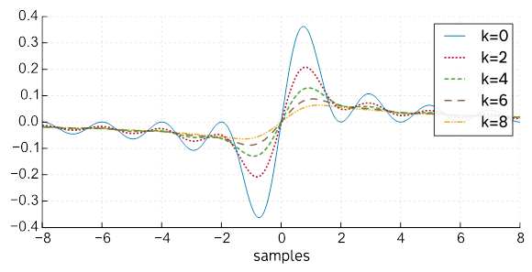I've called this family of curves BLEX due to their exponentially-decaying spectra. Their equation and frequency-response are below.
When used as an impulse train, this means we can synthesise a plucked-string sound with no aliasing, no detuning/phase issues, and no delay-buffers. Let's look at how that works:

Plucked strings
The key property which makes an instrument sound "plucked" is exponential decay. To sound natural, each harmonic decays at a different rate (usually faster for higher harmonics):
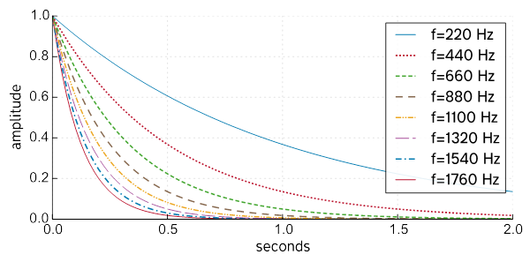
Amplitudes of harmonics in a synthesised pluck over time. You can see the higher-pitched harmonics die away much earlier than the 220Hz fundamental, making the sound increasingly mellow.
A common method for synthesising decaying harmonics like this is Karplus-Strong, which tunes a feedback-delay loop to the period of our virtual resonator/string, and sends an impulse through it to make it go "ding":
A big challenge with Karplus-Strong is choosing the delay to put inside the loop, because the ideal delay has some conflicting requirements:
- support fractional delays (because most notes won't have whole-sample wavelengths)
- have a very flat amplitude response (otherwise long notes will decay faster than intended)
- be linear phase (otherwise some frequencies are delayed longer than others, so harmonics can end up out of tune)
- support small delay times (for high notes)
Balancing these goals is tricky - on the other hand the overall structure is simple and intuitive, and you can get quite creative with the decay filter.
But we're not here for Karplus-Strong, let's try something different!

The exponential-frequency click
Here's a neat family of pulse signals:
f_k(x) = \frac{k}{k^2 + (2 \pi x)^2}
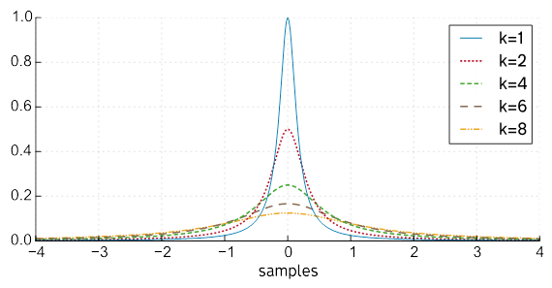

They're interesting because their Fourier transforms decay exponentially, with both increasing frequency \omega and the parameter k:
F_k(\omega) = e^{-k |\omega|}|

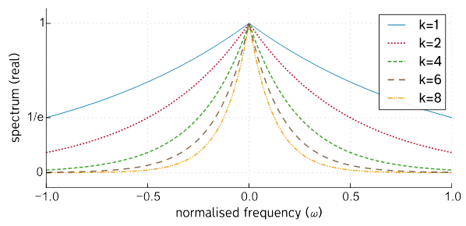
Each curve decreases exponentially as ||\omega|| increases, but each frequency also decays exponentially as we increase k.

Impulse train
If you repeat an impulse at regular intervals, you get a periodic signal (i.e. a note) with a timbre/spectrum derived from the impulse:

So, what happens if we repeat our pulses, but increasing klinearly with time? We get a note where each harmonic fades away exponentially at a different rate:
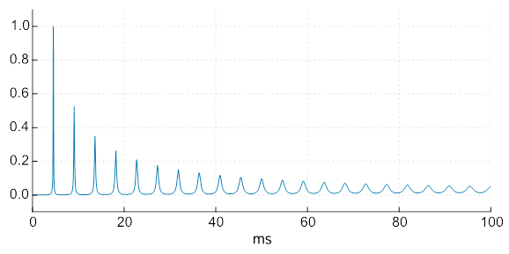
You can see the impulses changing shape as the note progresses
Awesome - except we clearly have some DC offset, because our pulses all have DC offset. What can we do about that?

90° phase shift
Even-symmetric impulses often have problems with DC offset - but if you shift the phase of each frequency by 90 degrees, you get an odd-symmetric impulse. There's a neat equation for this variant as well:
g_k(x) = \frac{2 \pi x}{k^2 + (2 \pi x)^2}
2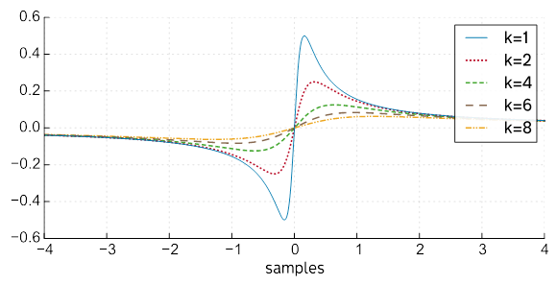

No DC offset — plus, it just looks prettier. ?
The spectrum still decays exponentially in k and \omega, but it's entirely imaginary, and the positive/negative halves are flipped:

\DeclareMathOperator{\sgn}{sgn}
G_k(\omega) = -e^{-k |\omega|} \sgn(\omega)

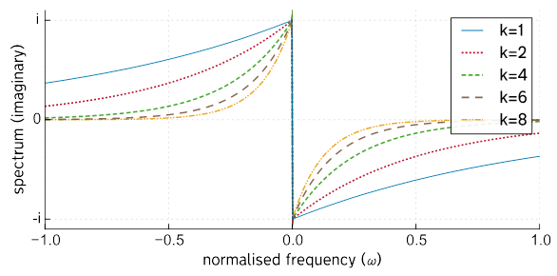

The amplitude of every frequency is preserved (aside from the DC offset). Let's see what that looks like:
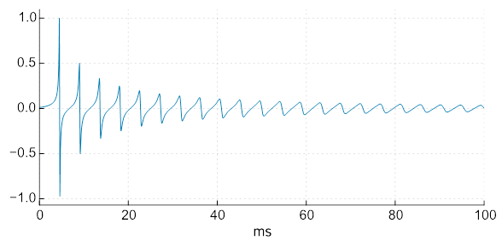
In practice, we have to apply a window to each impulse, because they are otherwise infinitely long. This can still be done analytically though, and won't produce DC offset if the window is even-symmetrical.

Aliasing
These impulses are cool, but they contain frequencies way above Nyquist. That means we get aliasing, particularly for smaller k. Here's the spectrum of a note (made from k=5 impulses) where the aliasing is, uh... visible:

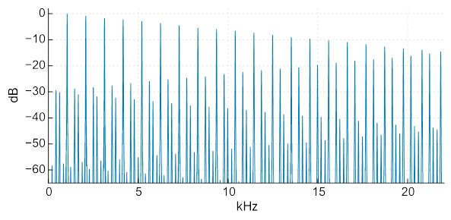
good lord what is that
We can see the harmonics we want slowly decaying at the top - but with higher harmonics aliased down in between them.

Band-limited variant
What would be great is a band-limited version of the these impulses. We want them to have the same exponential shape as before up to Nyquist, and then suddenly disappear, like this:
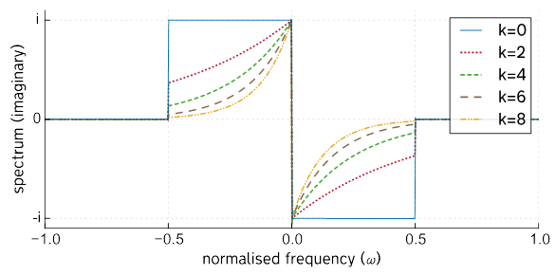

It turns out there's a computable time-domain solution for this:
\frac{2 \pi x - e^{-k/2}\left( k \cdot \sin(\pi x) + 2 \pi x \cdot \cos(\pi x) \right)}{k^2 + (2 \pi x)^2}
Don't ask how I found this - if I confess to it they'll revoke my maths degree.

Higher values of k wobble around less, corresponding to a smaller jump when the spectrum cuts off at Nyquist
The equation's a bit messier than our previous version, and not quite as simple to evaluate. Unlike the non-bandlimited version, this is defined and bounded for all real k, athough we still need a special case for x = k = 0
Let's see what happens when we create a note from these, with linearly-increasing k as before:
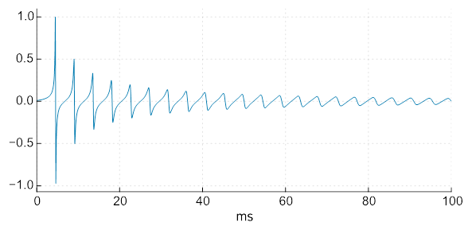
This might look the same as the previous one, but it has the warm glow of nitpicky correctness.
If we use our new band-limited impulses to plot the spectrum where we previously saw the aliasing, improvements are pretty clear:

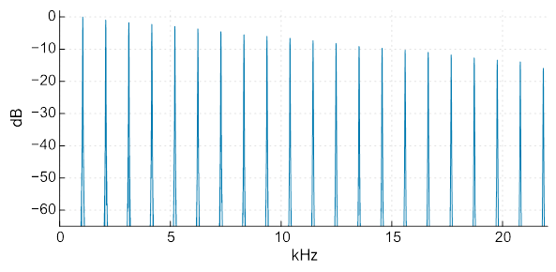

Conclusion
So there you have it! Perfectly-pitched alias-free string-plucks.
I couldn't find this mentioned anywhere else, so (following the naming convention of BLIT, BLEP and BLAMP) I've been calling this family of impulses BLEX (Band-Limited EXponential).
Because it's analytically generating the impulses, k can be trivially modulated or even reversed:
Computing the band-limited impulse seems tricky. You have exp⁡(), sin⁡() and cos⁡() as well as the division - and the wider your window, the more your impulses overlap.
It's not actually that bad, because xwill increment in steps of 1 sample, so sin(\pi x) can be calculated/cached once for each impulse. If we keep a constant k for each impulse, we can cache exp(-k/2) as well, so the whole thing can be pretty efficient.
But I think it's fun! I haven't put this in a synth yet, but maybe someone will find it useful. ?
Geraint

