
Department of Computer Science
College of Computer and Cyber Sciences
and Software Engineering

FC 421/332 – Applied Cryptography
Man-In-The-Middle Attack on Diffie-Hellman

Fall
2025

Instructor Name:
Dr. Abdulhakim Sabur

Student Names:
Lama Alshel – 4110108
Omnia Alharbi – 4210393


GitHub Repository: https://github.com/Lk-Git24/Man-In-The-Middle-Attack-on-Diffie-Hellman-Project.git

TABLE OF CONTENT
1.0 INTRODUCTION 3
1.1 Background Statement 3
1.2 Problem Statement 3
1.3 Project Motivation 3
1.4 Scope and Limitation 3
1.5 Report Organization 3
2.0 THEORETICAL BACKGROUND 4
2.1 Diffie-Hellman Key Exchange Overview 4
2.2 Man-In-The-Middle Attack Concept 4
2.3 Digital Signature and Authentication 4
2.4 Related Works and Case Studies 4
3.0 SYSTEM DESIGN AND METHODOLOGY 5
3.1 Design Approach 5
3.2 System Architecture Diagram 5
3.3 Workflow Model (Eddie, Venom, Mallory) 5
3.4 Tools and Software Requirements 6
3.5 Cryptography Algorithms Implemented (DH, AES, RSA) 6
4.0 IMPLEMENTATION AND DEVELOPMENT 7
4.1 Environmental Setup 7
4.2 Secure DH + AES Chat Application 7
4.3 MITM Attack Simulation (Mallory Proxy) 7
4.4 Digital Signature Integration (RSA Authentication) 7
4.5 Sample Code Snippets and Workflow 7
5.0 RESULTS AND ANALYSIS 10
5.1 Testing Process 10
5.2 MITM Attack Outcome 10
5.3 Secure Communication Results 11
5.4 Wireshark Traffic Visualization 12
5.5 Findings Discussions 13
6.0 CONCLUSION 14
6.1 Achievements Summary 14
6.2 Lessons Learned 14
6.3 Abstract 14
7.0 REFERENCES 15
8.0 APPENDICES 16
8.1 System Screenshots and Diagram 16
Fig 1: Code of the DH protocol, generation of the common key and the exchange of the secret keys. 16
Fig 2: Code of Signature and verification 17
Fig 3: The attacker failed to eavesdrop the messages after verifying the signature 18
Fig 4: Success of digital signature and failure of MITM from eavesdropping massages. 19
Fig 5: Eavesdropping from MITM in massage. 20
Fig 6: The simulate the success of the attack 21
Fig 7: The success of a secure connection using the digital signature 22
8.2 Team Contribution Table 23

INTRODUCTION

1.1 Background Statement

Diffie-Hellman is a way for two people to make a shared key even if the network isn't safe. But the problem is that DH doesn't check who the other person really is. Because of this, an attacker can jump in the middle and change things without anyone knowing. This is many systems add digital signatures to make it more secure.

1.2 Problem Statement
The problem in our project is that normal Diffie-Hellman can be attacked with MITM. Since DH doesn't confirm the identity of the sender, an attacker can pretend to be both sides. This lets the attacker read or change the message. In our project, we want to show this problem and then fix it by using a digital signature.

1.3 Project Motivation
We chose this project because we wanted to understand how these attacks work in real life. MITM is a common attack, and it is important to know how to stop it. By doing the attack and then adding the fix, we learned how secure communication really works.

1.4 Scope and Limitation
The project only focuses on testing Diffie-Hellman with authentication and without it . We implement DH, AES encryption, a simulated MITM attacker, and RSA signatures. We don't implement full certificate system, CA server, or large-scale real-world protocols like TLS. Our focus is only on demonstrating the concept clearly.

1.5 Report Organization
This report starts with the introduction and background, followed by a theoretical section explaining DH, MITM, and digital signatures. After that, we present the system design and methodology, then the implementation details and experiment. Finally, we show the result and conclude the work.

2.0 THEORETICAL BACKGROUND

2.1 Diffie-Hellman Key Exchange Overview
Diffie-Hellman allows two parties to create a shared secret key even if someone is listening to their communication. The idea is that each side makes a private value, sends a public one, and then both of them end up with the same shared key. The problem is that DH doesn't authenticate who sent the public value.

2.2 Man-In-The-Middle Attack Concept
A Man-in-the-Middle attack happens when an attacker places themselves between two communicating parties without them noticing. The attacker receives message from both sides, changed them, and forward them. In DH, an attacker can make two different shared keys and secretly read all the message.

2.3 Digital Signature and Authentication
A digital signature makes sure the message is from the right person and nothing was changed. The sender signs it with their key, and the receiver checks it with yhe public key.

2.4 Related Works and Case Studies
Many previous works show that DH alone isn't safe. a modern protocols like TLS use signed DH or ECDH to make it safe.

3.0 SYSTEM DESIGN AND METHODOLOGY

3.1 Design Approach
We designed the system in two version. The first uses basic Diffie-Hellman with AES encryption to show how MITM can succeed. The second adds RSA-based digital signatures to authenticate the DH values and block the attack. The design makes comparing the two versions easy and clear.

3.2 System Architecture Diagram
System Architecture Diagram 3.2
The system has three main roles:
. Eddie client
. Venom server
. Mallory attacker/MITM
Message flow between Eddie and Venom, while Mallory intercepts them to attempt manipulation.

3.3 Workflow Model (Eddie, Venom, Mallory)
Venom does the same (show in Fig 6). This gives Mallory two shared keys and full access. In the second version, whin Mallory tries to replace a signed value, the verification fails and the attack stops.

3.4 Tools and Software Requirements
We used Python as the main programming language because it allows fast cryptographic prototyping. The project uses built-in libraries and simple sockets for communication. No heavy frameworks were needed.

3.5 Cryptography Algorithms Implemented (DH, AES, RSA)
The system uses Diffie-Hellman to make the shared secret, AES to encrypt messages. and RSA signatures to check that public values are correct in the secure version.

4.0 IMPLEMENTATION AND DEVELOPMENT

4.1 Environmental Setup
We used Python 3 for the project. we ran the server, the client, and the attacker in separate terminals so we could test everything easily.

4.2 Secure DH + AES Chat Application

The client and server share DH values, make a shared key, and then use AES to encrypt their message. This creates a simple encrypted chat between them.

4.3 MITM Attack Simulation (Mallory Proxy)
Mallory sits between both parties. In the first version, Mallory successfully intercepts the DH exchange, creates two shared keys, and reads or edits all message.

4.4 Digital Signature Integration (RSA Authentication)
In the second version, we add RSA signatures to the DH public values. If Mallory tries to modify anything, the signature check fails and the message is rejected. The prevents the MITM attack.

4.5 Sample Code Snippets and Workflow

We included short code example to show how the shared key is computed, how AES encrypts message, and how signatures are verified.

In fig 1, it shows the basic code that we created to apply the protocol Diffie-Hellman (DH). The task of the code is to generate and exchange general values such as (g, h ,ect…) to calculate a shared secret key. The verification process (assert) appears in the code to make sure that the secret key obtained by the first party is equal to the secret key in the second party.

from random import randint
from Crypto.PublicKey import RSA
def generate_prime(bitsize=1024):
key = RSA.generate(bitsize * 2)
return key.p
class DiffieHellman:
def __init__(self, p=None, g=None):
if p is None:
self.p = generate_prime()
self.g = randint(self.p // 2, self.p - 1)
else:
self.p = p
self.g = g
self.private_exponent = randint(self.p // 2, self.p - 1)
def generate_public_broadcast(self):
return self.p, self.g, pow(self.g, self.private_exponent, self.p)
def get_shared_secret(self, public_share):
return pow(public_share, self.private_exponent, self.p)

After that the simple idea that represents securing communication by adding a digital signature is explained. The build_signed_packet function uses the private key of the sender (Eidde / Venom),to put a signature on the key exchange data before sending it. The verify_signed_packet function uses the other party’s public key to verify that the signature is correct. If the verification fails, the connection is rejected, which stops the MITM attack.

In this shot of the code fig 2:

def build_signed_packet(info, priv_key):
json_bytes = json.dumps(info, sort_keys=True, separators=(',', ':')).encode()
sig = sign_bytes(priv_key, json_bytes)
info['signature'] = b64encode(sig)
return json.dumps(info)

def verify_signed_packet(txt, peer_pub):
data = json.loads(txt)
sig = b64decode(data.get('signature', ''))
tmp = dict(data)
if 'signature' in tmp:
tmp.pop('signature')
msg = json.dumps(tmp, sort_keys=True, separators=(',', ':')).encode()
ok = verify_bytes(peer_pub, msg, sig)
return tmp, ok

5.0 RESULTS AND ANALYSIS

5.1 Testing Process
We tested the system in two main part to check both functionality and security. The first secure communication, was designed to validate the end-to-end functionality of the implemented cryptographic suite, we verify that DH, and AES encryption all operated correctly to make the message secure. The second mode, Man-in-the-Middle (MITM) simulation, was conducted to specifically test the how well the security change work. Against active network interception and block the attacker (Mallory) from establishing a false shared secret.

5.2 MITM Attack Outcome
The testing confirmed that the integrated security measures were successful in defending against the MITM attack. When the attacker (Mallory) trying to intercept and proxy the Diffie-Hellman public parameters (A and B) between Eddie and Venom, the following outcome was noted. The system ready to verify the attached RSA Digital Signature using the public key of the expected peer. Since the signature was not created by the valid sender's private key but by Mallory's key, the signature validation process direct failed. This failure resulted in the end of the connection, block the creation of an insecure shared secret. The controller output confirmed the defense automatic was active shown in fig3.
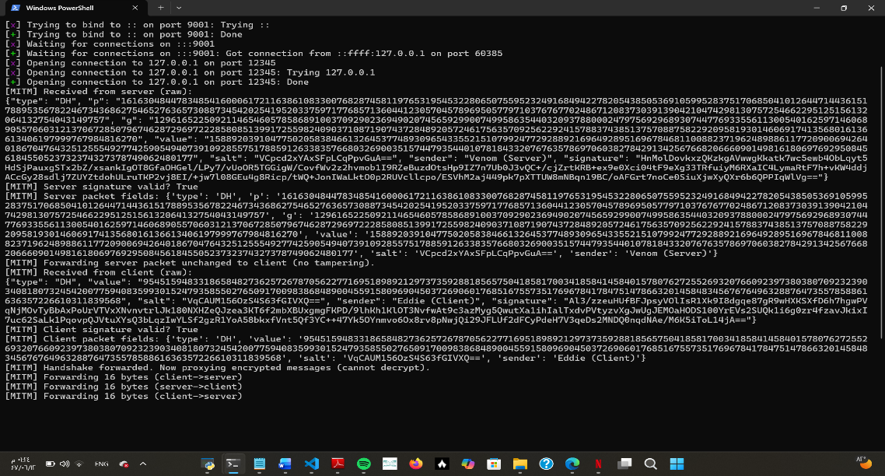
Fig 3: The attacker failed to eavesdrop the messages after verifying the signature

Signature verification failed for incoming B possible MITM. The result showed that Digital Signatures blocked the MITM attack effectively.

5.3 Secure Communication Results
In the absence of the MITM proxy, the secure chat application operated successfully. The communication flow validated the protocol work normal without issue of the cryptographic protocol. Key Exchange and Authentication (Initial Handshake): The process began with the successful exchange of Diffie-Hellman public parameters as in fig 4. Critically, each parameter (p, g, and the public key A or B) fig 6 was accompanied by a Digital Signatures generated using the sender's private RSA key. Eddie and Venom step ensured share verification of the RSA signatures by both Eddie and Venom Signatures. This build trust and verifying the identity of the peer before any key derivation. Key Derivation: Following the successful authentication as shown in fig 4, the shared secret (from DH) was used by a unique Salt value in Key Derivation Function (KDF) to generate a strong and unique AES Symmetric Key. Message Confidentiality: Utilizing this shared AES key, messages transmitted between the two GUI windows named, as client (Eddie) and the server (Venom) were correctly encrypted on receipt. This shows the application s enforces data confidentiality meet the core requirement of the system. DH parameters and signed public keys were exchanged. Mutual verification of the RSA signatures established trust and authentication. A shared AES symmetric key was derived. Messages transmitted between Eddi and Venom were correctly encrypted with AES and decrypted on receipt, confirming data confidentiality.

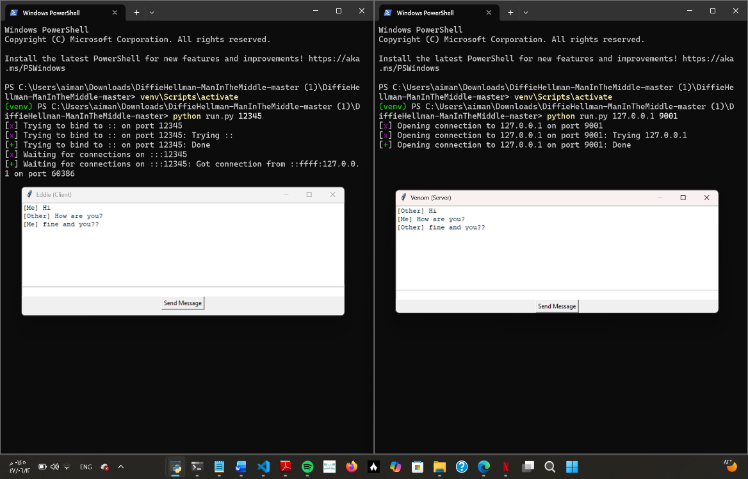

Fig 4: Success of digital signature and failure of MITM from eavesdropping massages.

5.4 Wireshark Traffic Visualization
Traffic analysis using Wireshark confirmed, what actually happened in practice of encryption. while the initial DH key exchange packets showed the public parameters and the digital signatures (which must be public), all subsequent chat messages were observed to be transmitted entirely as unreadable ciphertext. This shows that AES encryption is being used appropriately on the data load, which protects the communication channel from passive eavesdropping. But in another scenario, we see (in fig5) that all the massage from client (Eddie) and the server (Venom) not decrypt and encrypt they don’t have save way to communicate with each other, the security of this massage very bad because no authentication here, as in fig6. So, we must work to apply the goal of this project of cryptography.

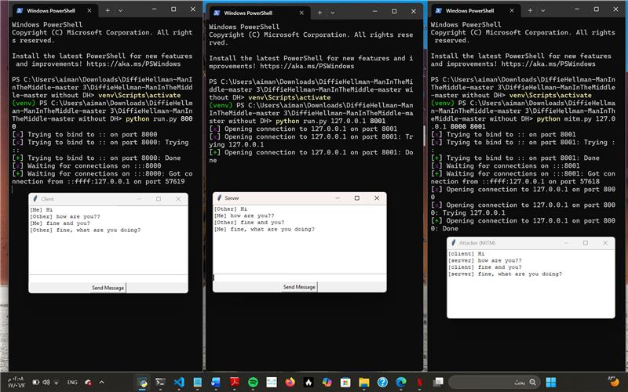
Fig 5: Eavesdropping from MITM in massage.

5.5 Findings Discussions
This part explains how RSA Digital Signatures added to the Diffie-Hellman key exchange. The idea is to make the system more secure, especially against. The failure of the MITM simulation (as resolute in section 5.2) validate that the implemented cryptographic protocol, relying on the combined strength of DH, AES, and RSA, is sound. This show that following standard practices like digital authentication is important for secure key exchange. Using DH, AES, and RSA together improve security and achieve the project goals.

6.0 CONCLUSION

6.1 Achievements Summary
This project successfully achieved its primary objective by implementing a secure chat application protected from the Man-in-the-Middle attack. The key achieve was the successful integration of layered cryptography. This included Diffie-Hellman for secure key agreement, AES for massage encryption, and RSA Digital Signatures for crucial mutual authentication.
Consequently, establishing a result secure communication channel.

6.2 Lessons Learned
In this part of the project, we notice a lot of issues, specific when we reached the last steps of adding the cryptography part. A lot of the problems were related to how the messages were structured inside the protocol. For example, we had issue during run the implementation with DH, private and public key, then we know that we have mastic when in the encryption. There was something that happened before the right thing, the problem was searched and solved completely, even small mistakes in the JSON structure caused the verification to fail. Fixing these issues took time because we had to test everything more than once. This experience showed us that most of the difficulty is not in the algorithms themselves, but in the small details, this knows with practice. Overall, even though it was challenging because we are two students differ major, it helped us understand how real secure communication systems work and differ major work together.

6.3 Abstract
The standard Diffie-Hellman (DH) key exchange protocol is fundamental weak to Man-in-the-Middle (MITM) attacks due to its lack of authentication. This project addressed this critical flaw by adopting using more than one encryption method. The methodology combined DH for secure key agreement, AES for message confidentiality, and critically, RSA Digital Signatures for check strong identity verification during the handshake. Tests showed the system don’t allow verification for MITM attacker. signature verification ensured that digital authentication is necessary for secure key exchange.
Keywords: Diffie-Hellman (DH), Man-in-the-Middle (MITM), AES, RSA Digital Signatures, Authentication.

7.0 REFERENCES
[1]“GeeksforGeeks,” GeeksforGeeks, 2025. https://www.google.com/url?q=https://www.geeksforgeeks.org/&sa=U&sqi=2&ved=2ahUKEwjLjqqVgaSRAxUd_rsIHWuaHCAQFnoECCQQAQ&usg=AOvVaw3L-dQySvfQ6DeMIJSnFAkl (accessed Dec. 04, 2025).
‌ [2]W. Shen, Y. Cheng, B. Yin, K. Liu, and X. Cao, “Diffie-Hellman in the Air: A Link Layer Approach for In-Band Wireless Pairing,” arXiv.org, 2019. https://www.google.com/url?q=https://arxiv.org/abs/1901.09520&sa=U&sqi=2&ved=2ahUKEwjI7u_MgaSRAxVLOPsDHVhoOJYQFnoECCcQAQ&usg=AOvVaw2uPQYZ9RCWoRUB0FqwXHTa (accessed Dec. 04, 2025).
‌
[3]S. Devi and R. Makani, “Generation of N-party Man-In-Middle Attack for Diffie-Hellman Key Exchange Protocol: A Review.” Accessed: Dec. 04, 2025. [Online]. Available: https://www.ijcsit.com/~ijcsitco/docs/Volume%206/vol6issue05/ijcsit2015060526.pdf
‌
[4]“Securing Text Files: A Comprehensive Study on AES and Diffie-Hellman Encryption,” Ijraset.com, 2024. https://www.ijraset.com/research-paper/comprehensive-study-on-aes-and-diffie-hellman-encryption
‌
[5]Davidmenamm, “GitHub - Davidmenamm/Cyber_Security_Diffie_Hellman_Man_in_the_Middle_Attack: Diffie Hellman Algorithm implementation with man in the middle attack simulation.,” GitHub, 2025. https://github.com/Davidmenamm/Cyber_Security_Diffie_Hellman_Man_in_the_Middle_Attack (accessed Dec. 04, 2025).
‌[6]jaybosamiya, “GitHub - jaybosamiya/DiffieHellman-ManInTheMiddle: Demonstrating a practical attack on the Diffie Hellman Key Exchange protocol, through breaking a secure chat system,” GitHub, 2025. https://github.com/jaybosamiya/DiffieHellman-ManInTheMiddle (accessed Dec. 04, 2025).
‌
[7]“Home,” Openssl.org, 2024. https://openssl.org/
‌
[8]Cryptography, “Welcome to pyca/cryptography — Cryptography 3.0.dev1 documentation,” cryptography.io. https://cryptography.io/en/latest/
[9]H. Eijs, “pycryptodome: Cryptographic library for Python,” PyPI. https://pypi.org/project/pycryptodome/

8.0 APPENDICES

8.1 System Screenshots and Diagram
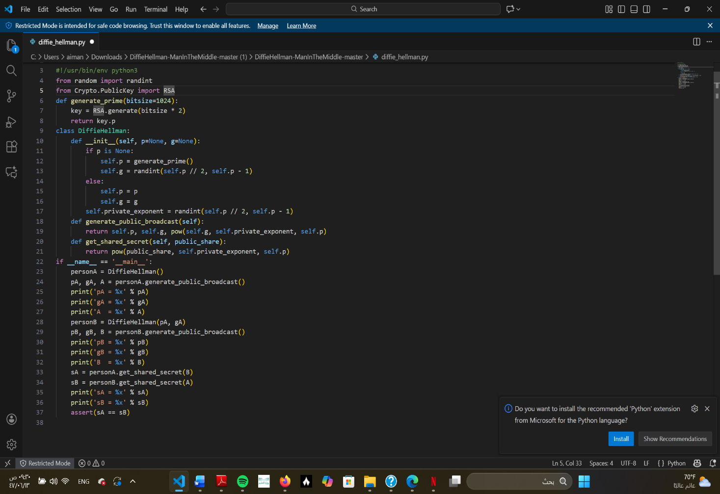

Fig 1: Code of the DH protocol, generation of the common key and the exchange of the secret keys.

The part marked in red shows the execution of the function, the generation of special basics, the calculation of public keys and the shared secret key.

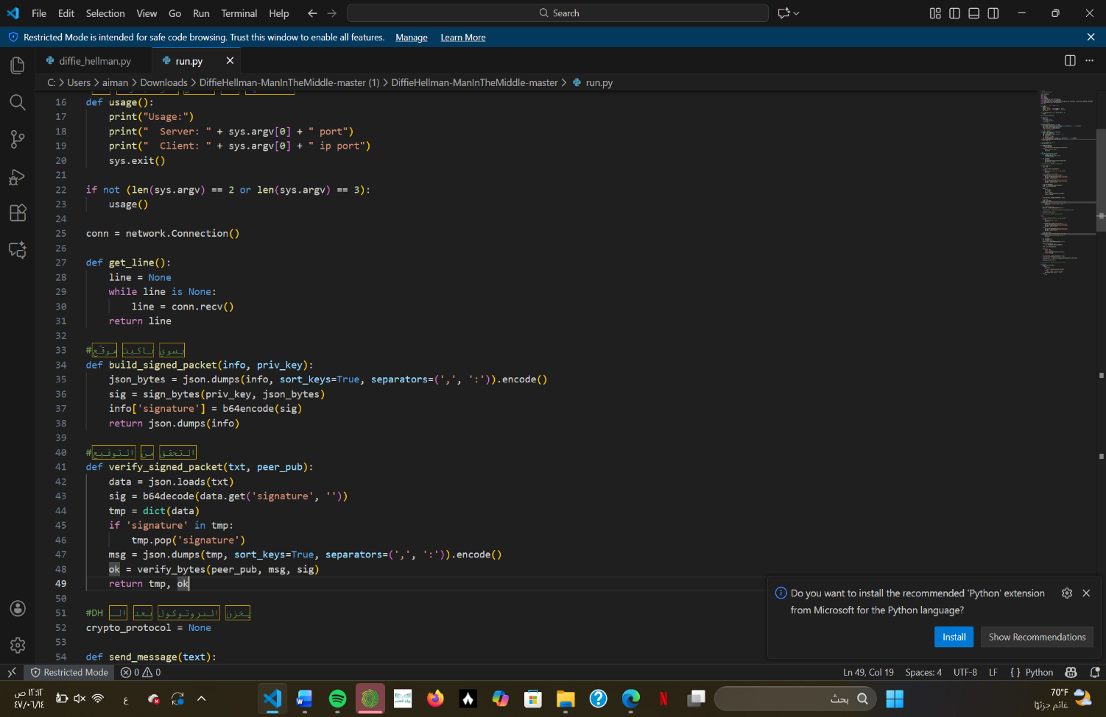

Fig 2: Code of Signature and verification

This part of the code marked in red is the solution to the MITM problem. Show the build function that the sender's private key to generate a unique digital signature for the DH, so must be ensure the integrity and authentication.

Fig 3: The attacker failed to eavesdrop the messages after verifying the signature

The outputs show that the attacker is trying to eavesdrop using the authentication process during the exchange of public keys. The main point is the success of the digital signature of the messages from the server and the client. This confirms that public keys have not been manipulated, which prevents the attacker from creating private secret keys in it, which leads to the success of secure communication between Eddie and Venom.

Fig 4: Success of digital signature and failure of MITM from eavesdropping massages.

In this picture, it shows the success of a secure connection between the customer and the server after mutual verification of the RSA digital signature, and a shared secret key was derived from the exchanged messages and appeared only to the customer and server that we send over the network in encrypted end-to-End Encryption, which achieves confidentiality requirements for data.

Fig 5: Eavesdropping from MITM in massage.

In this picture, shows the interfaces of the client, the server and the attacker and the success of the attacker in eavesdropping messages and reading them clearly in the right destination, which confirms the weakness of the Diffie-Hellman effective attack

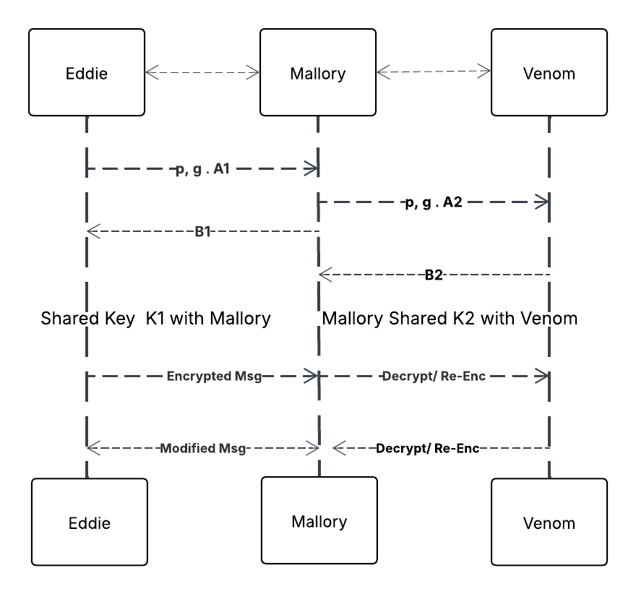

Fig 6: The simulate the success of the attack

The diagram shows the success of the attack in an uncertified version of the protocol, so that the attacker in the middle shows his success in decrypting and reading all DH messages exchanged between the client and the server, which is weak.

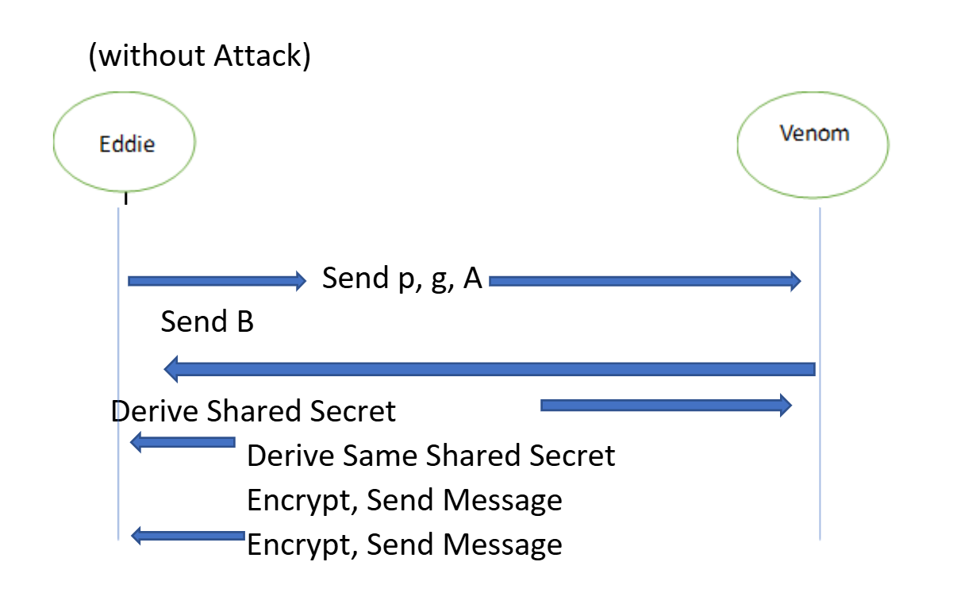

Fig 7: The success of a secure connection using the digital signature

This diagram shows the secure and successful connection between the client and the server with the presence of authentication. Keys are exchanged and a secure connection is built by signing an RSA. Any attempt by the attacker to intercept or modify messages is rejected, ensuring the confidentiality of the data.

8.2 Team Contribution Table

Team member | Description | Task
Omnyah | Wrote the opening part of the report including:  1.1 Background Statement  1.2 Problem Statement  1.3 Project Motivation  1.4 Scope and Limitation  1.5 Report Organization | Report writing- introduction section
Omnyah | Wrote section2.0 which includes:  2.1 Diffie-Hellman Key Exchange Overview  2.2 Man-In-The-Middle Attack Concept  2.3 Digital Signature and Authentication  2.4 Related Works and Case Studies | Report writing-Theoretical Background
Omnyah | Prepared section 3.0 including:  3.1 Design Approach  3.2 System Architecture Diagram  3.3 Workflow Model (Eddie, Venom, Mallory)  3.4 Tools and Software Requirements  3.5 Cryptography Algorithms Implemented (DH, AES, RSA) | Report writing-System Design & Methodology
Omnyah | Wrote section 4.0:  4.1 Environmental Setup  4.2 Secure DH + AES Chat Application  4.3 MITM Attack Simulation (Mallory Proxy)  4.4 Digital Signature Integration (RSA Authentication)  4.5 Sample Code Snippets and Workflow | Report writing-Implementation section
Lama | Wrote section 5.0 including:  5.1 Testing Process  5.2 MITM Attack Outcome  5.3 Secure Communication Results  5.4 Wireshark Traffic Visualization  5.5 Findings Discussions | Report writing-Results & Analysis
Lama | Wrote section 6.0 ,7.0 ,8.0 including:  6.1 Achievements Summary  6.2 Lessons Learned  6.3 Abstract  7.0 REFERENCES  8.0 APPENDICES  8.1 System Screenshots and Diagram  8.2 Team Contribution Table | Report writing-conclusion & Final Section
Omnyah | Upgraded the code from version2 to version3 of the python environment, updated packages. | Updating the version of the code from python2 to python3
Lama | Wrote Diffie-Hellman key exchange function from scratch ,improved the GUI fixed interaction, massage handling | Coding Diffie-Hellman, updating GUI
Both | Worked on debugging errors,performed final testing for secuer communication + MITM behavior validation | System Execution & Testing
Omnyah | Fig 7: The success of a secure connection using the digital signature | Drawing Diagram
Lama | Fig 6: The simulate the success of the attack | Drawing Diagram

