Supplementary Figures
This appendix contains the full set of supplementary figures generated across the analytical pipeline (quality control, differential expression, lncRNA prioritisation, WGCNA network construction, functional enrichment, and machine learning classification), provided in full to demonstrate the complete scope of analyses performed. A subset of these findings is synthesised into the composite figures presented in the main Results section (see Main_Results_Figures.docx).

S1. Quality Control
Sample-level quality control metrics assessed prior to differential expression and network analyses, confirming the integrity of the 98-sample GSE164416 pancreatic islet RNA-seq dataset (ND n=18, IGT n=41, T2D n=39).
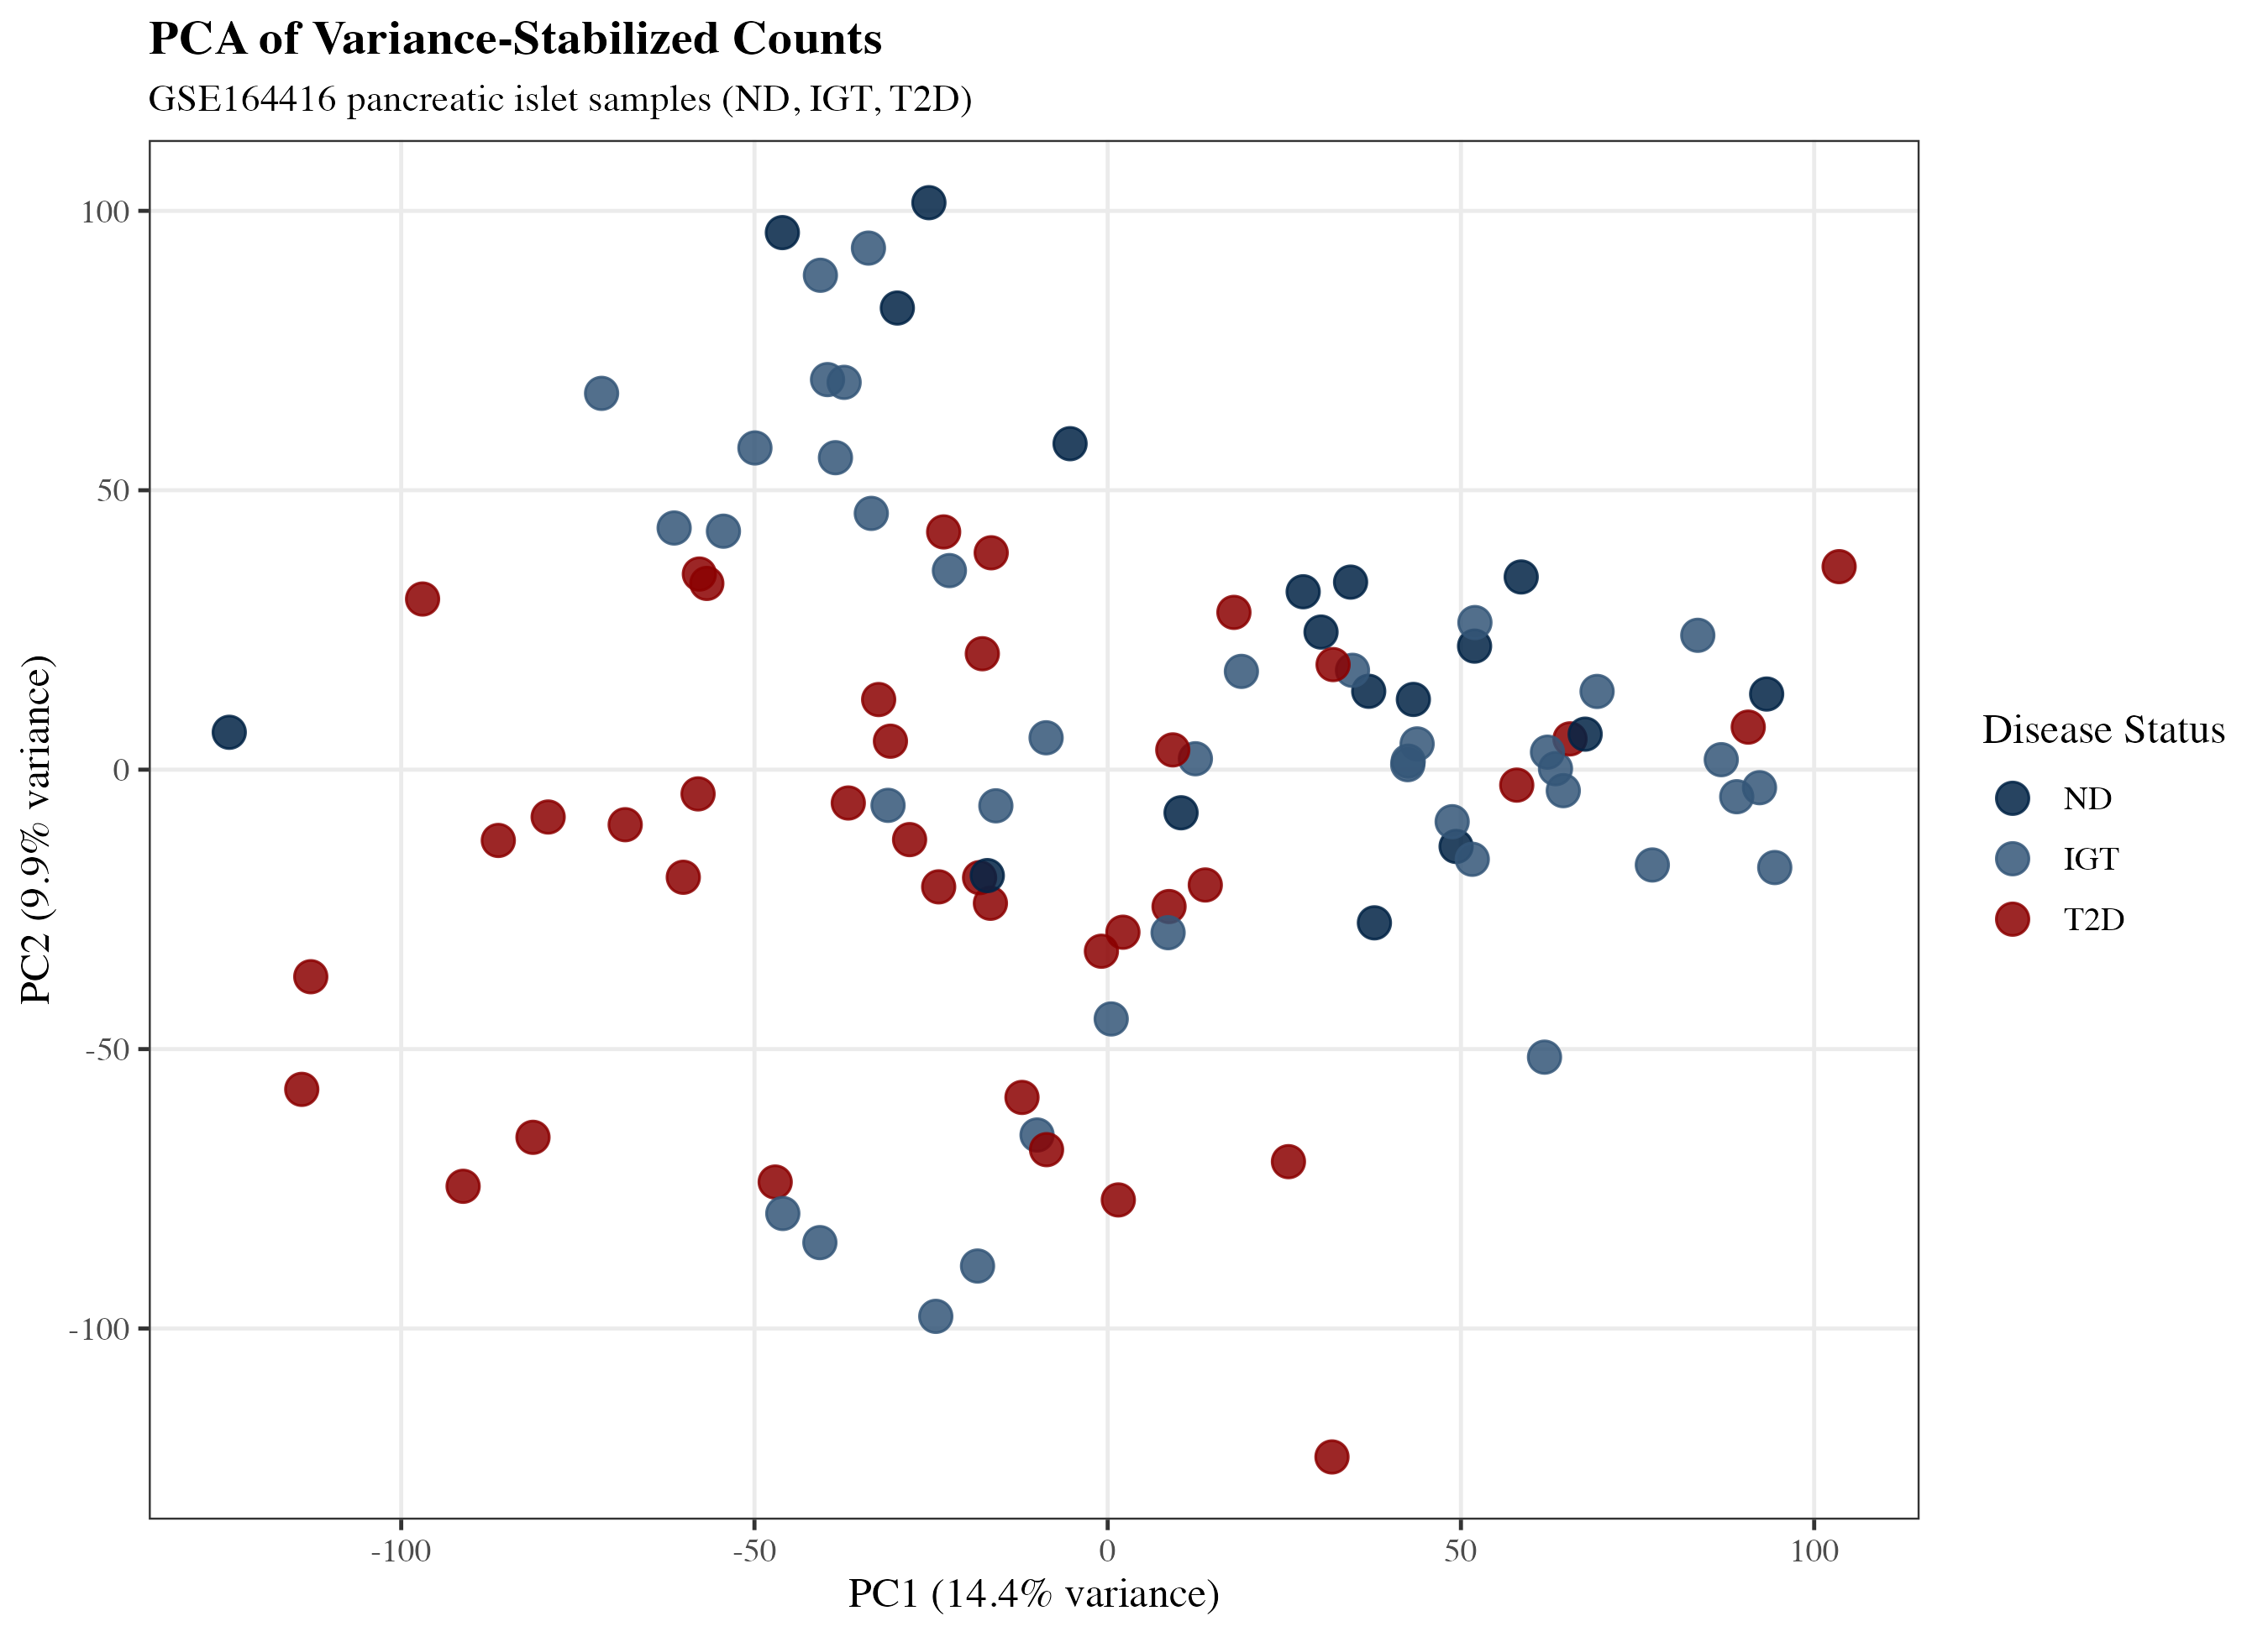
Figure S1. Principal component analysis of VST-normalised islet transcriptomes.
PCA of variance-stabilising-transformed (VST, blind=TRUE) read counts across all 98 samples, coloured by disease status (ND, IGT, T2D). Percentage variance explained by PC1 and PC2 is indicated on each axis. Used to assess global sample clustering and detect batch effects or outliers prior to downstream analysis.
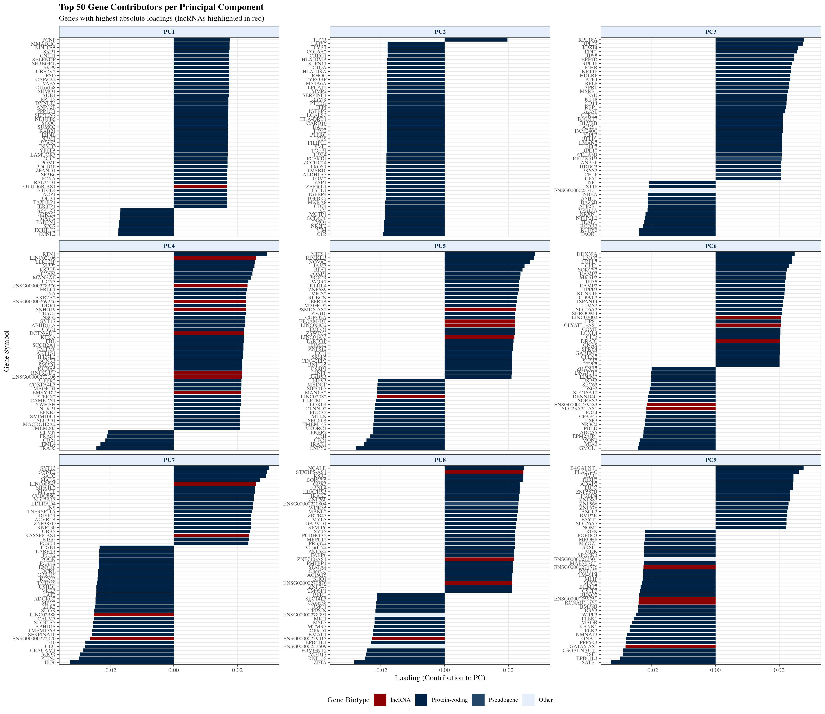
Figure S2. Top 50 genes contributing to principal component loadings.
Loading scores of the 50 genes contributing most strongly to PC1 and PC2 of the sample-level PCA, identifying the dominant transcriptional drivers of sample separation.
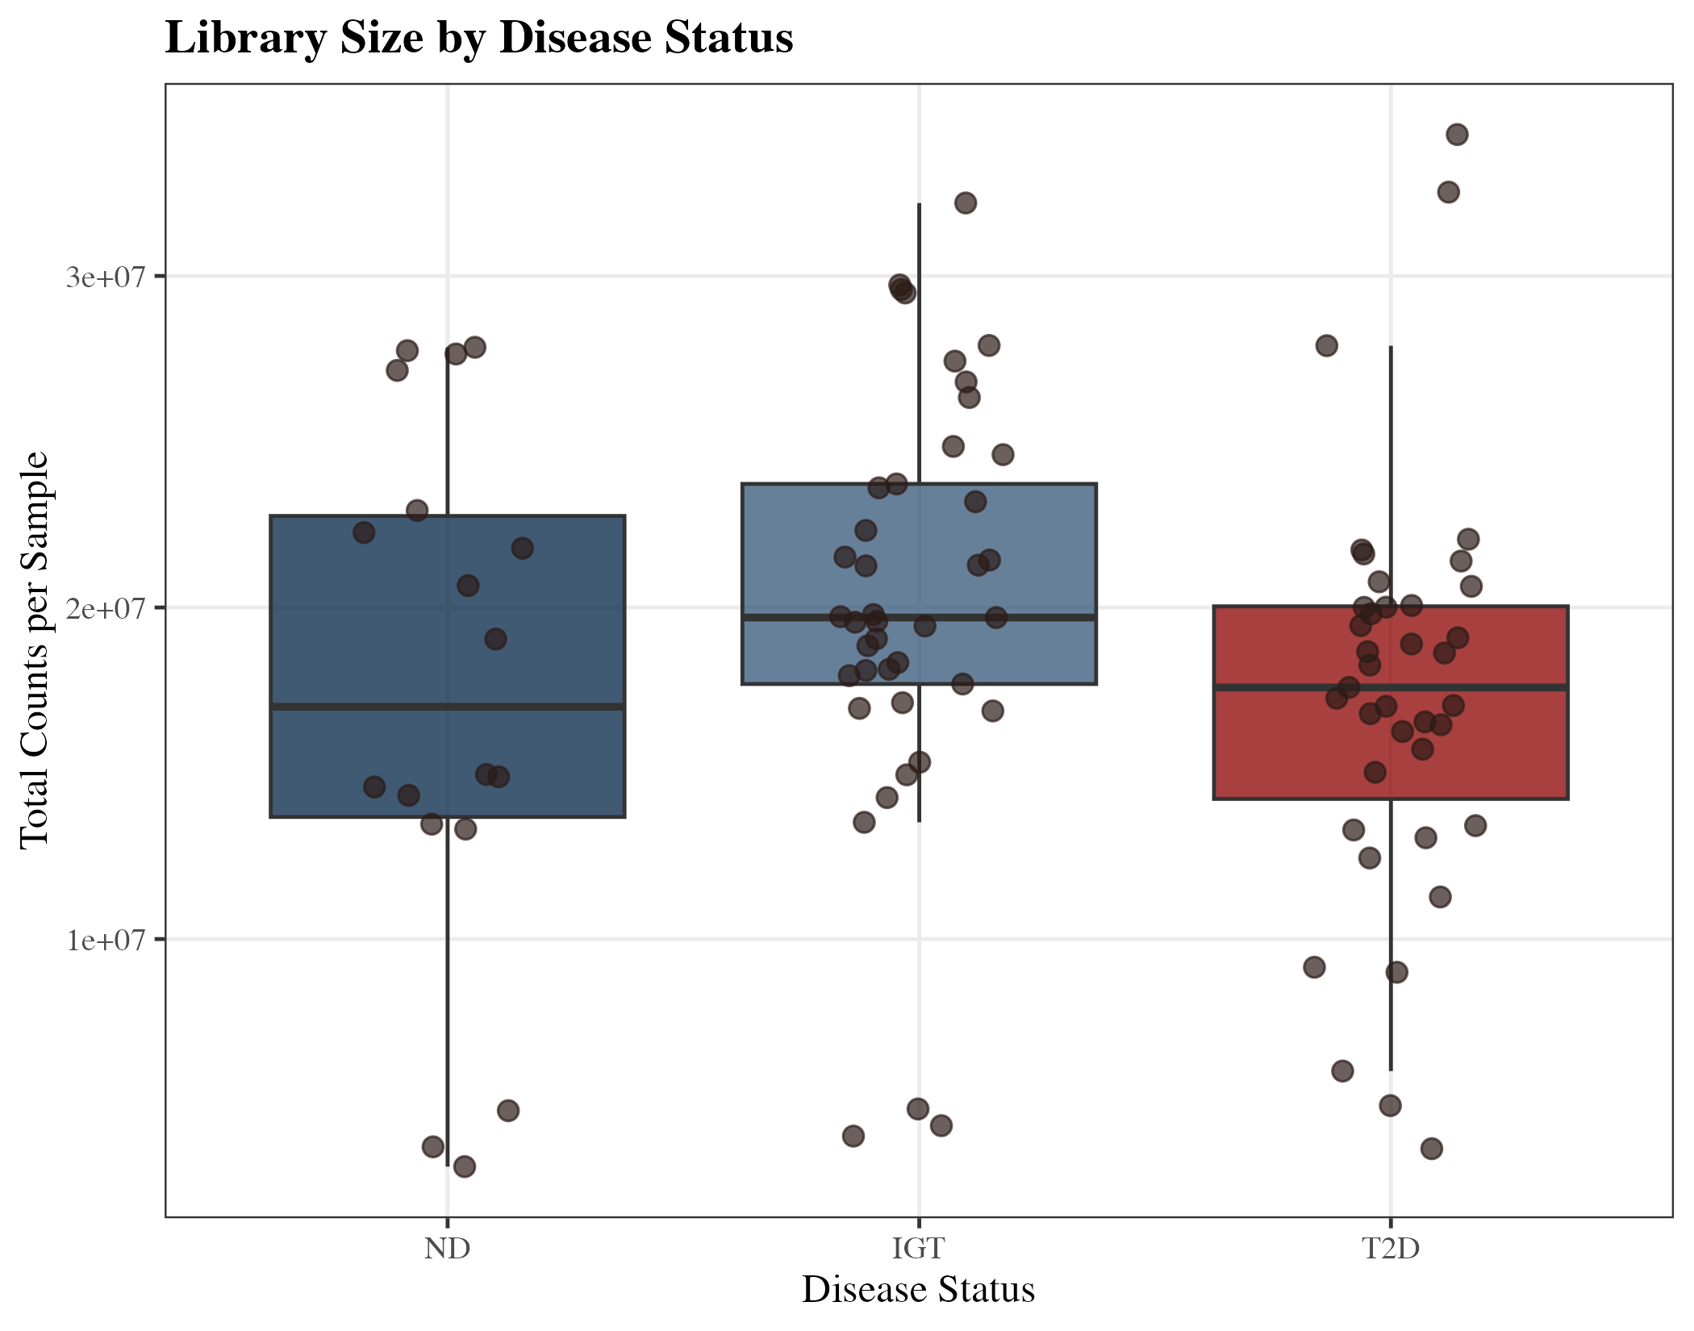
Figure S3. Sequencing library size distribution by disease group.
Total mapped read counts (library size) per sample, stratified by disease status. Boxplots show median, interquartile range, and outliers; used to confirm comparable sequencing depth across groups prior to normalisation.
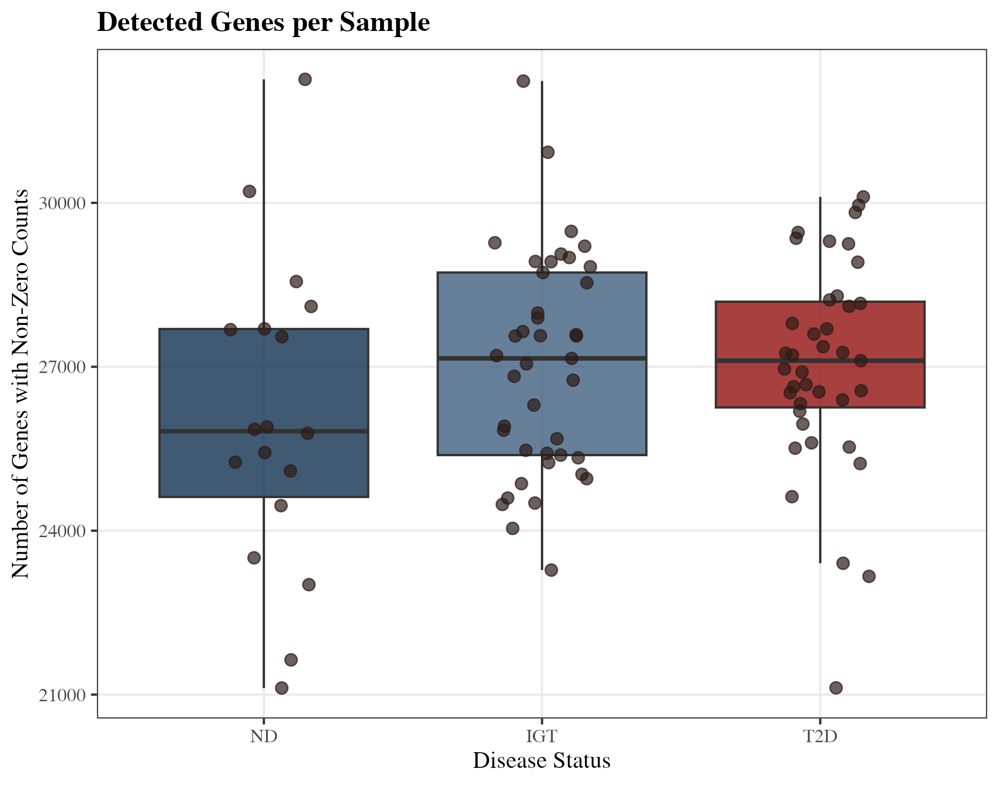
Figure S4. Number of detected genes per sample by disease group.
Count of genes with non-zero read counts per sample, stratified by disease status, confirming consistent transcriptome complexity across ND, IGT, and T2D groups.
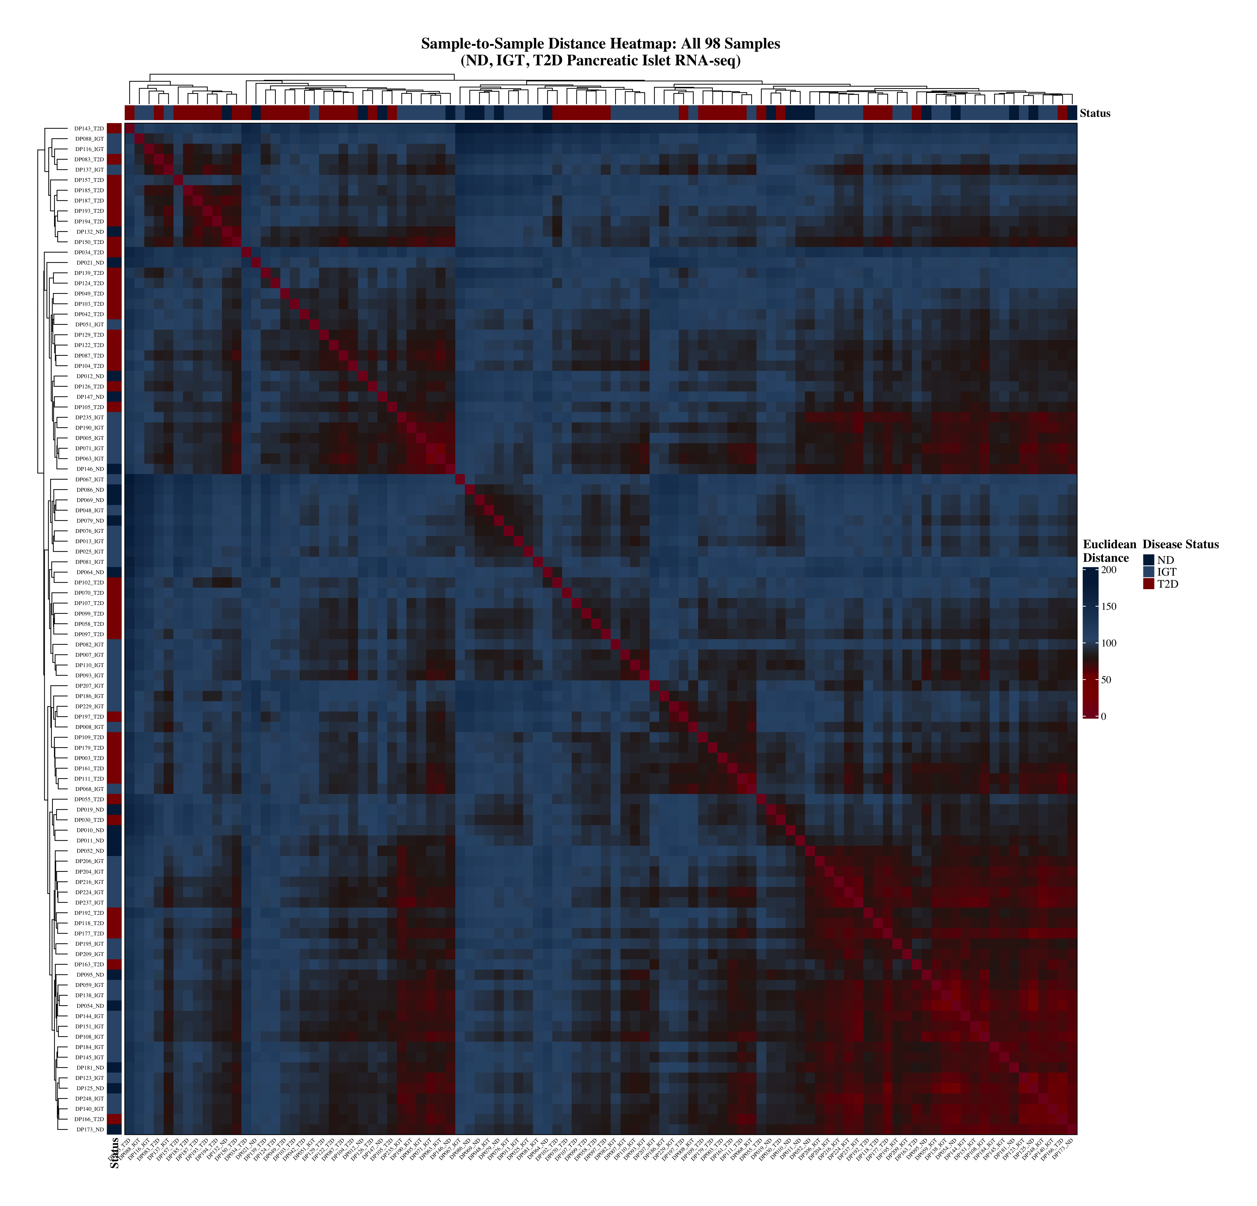
Figure S5. Sample-to-sample Euclidean distance heatmap (full cohort, n=98).
Pairwise Euclidean distance matrix computed from VST-normalised expression across all 98 samples, hierarchically clustered. Darker cells indicate greater transcriptional similarity. Used to identify potential outlier samples prior to network construction.
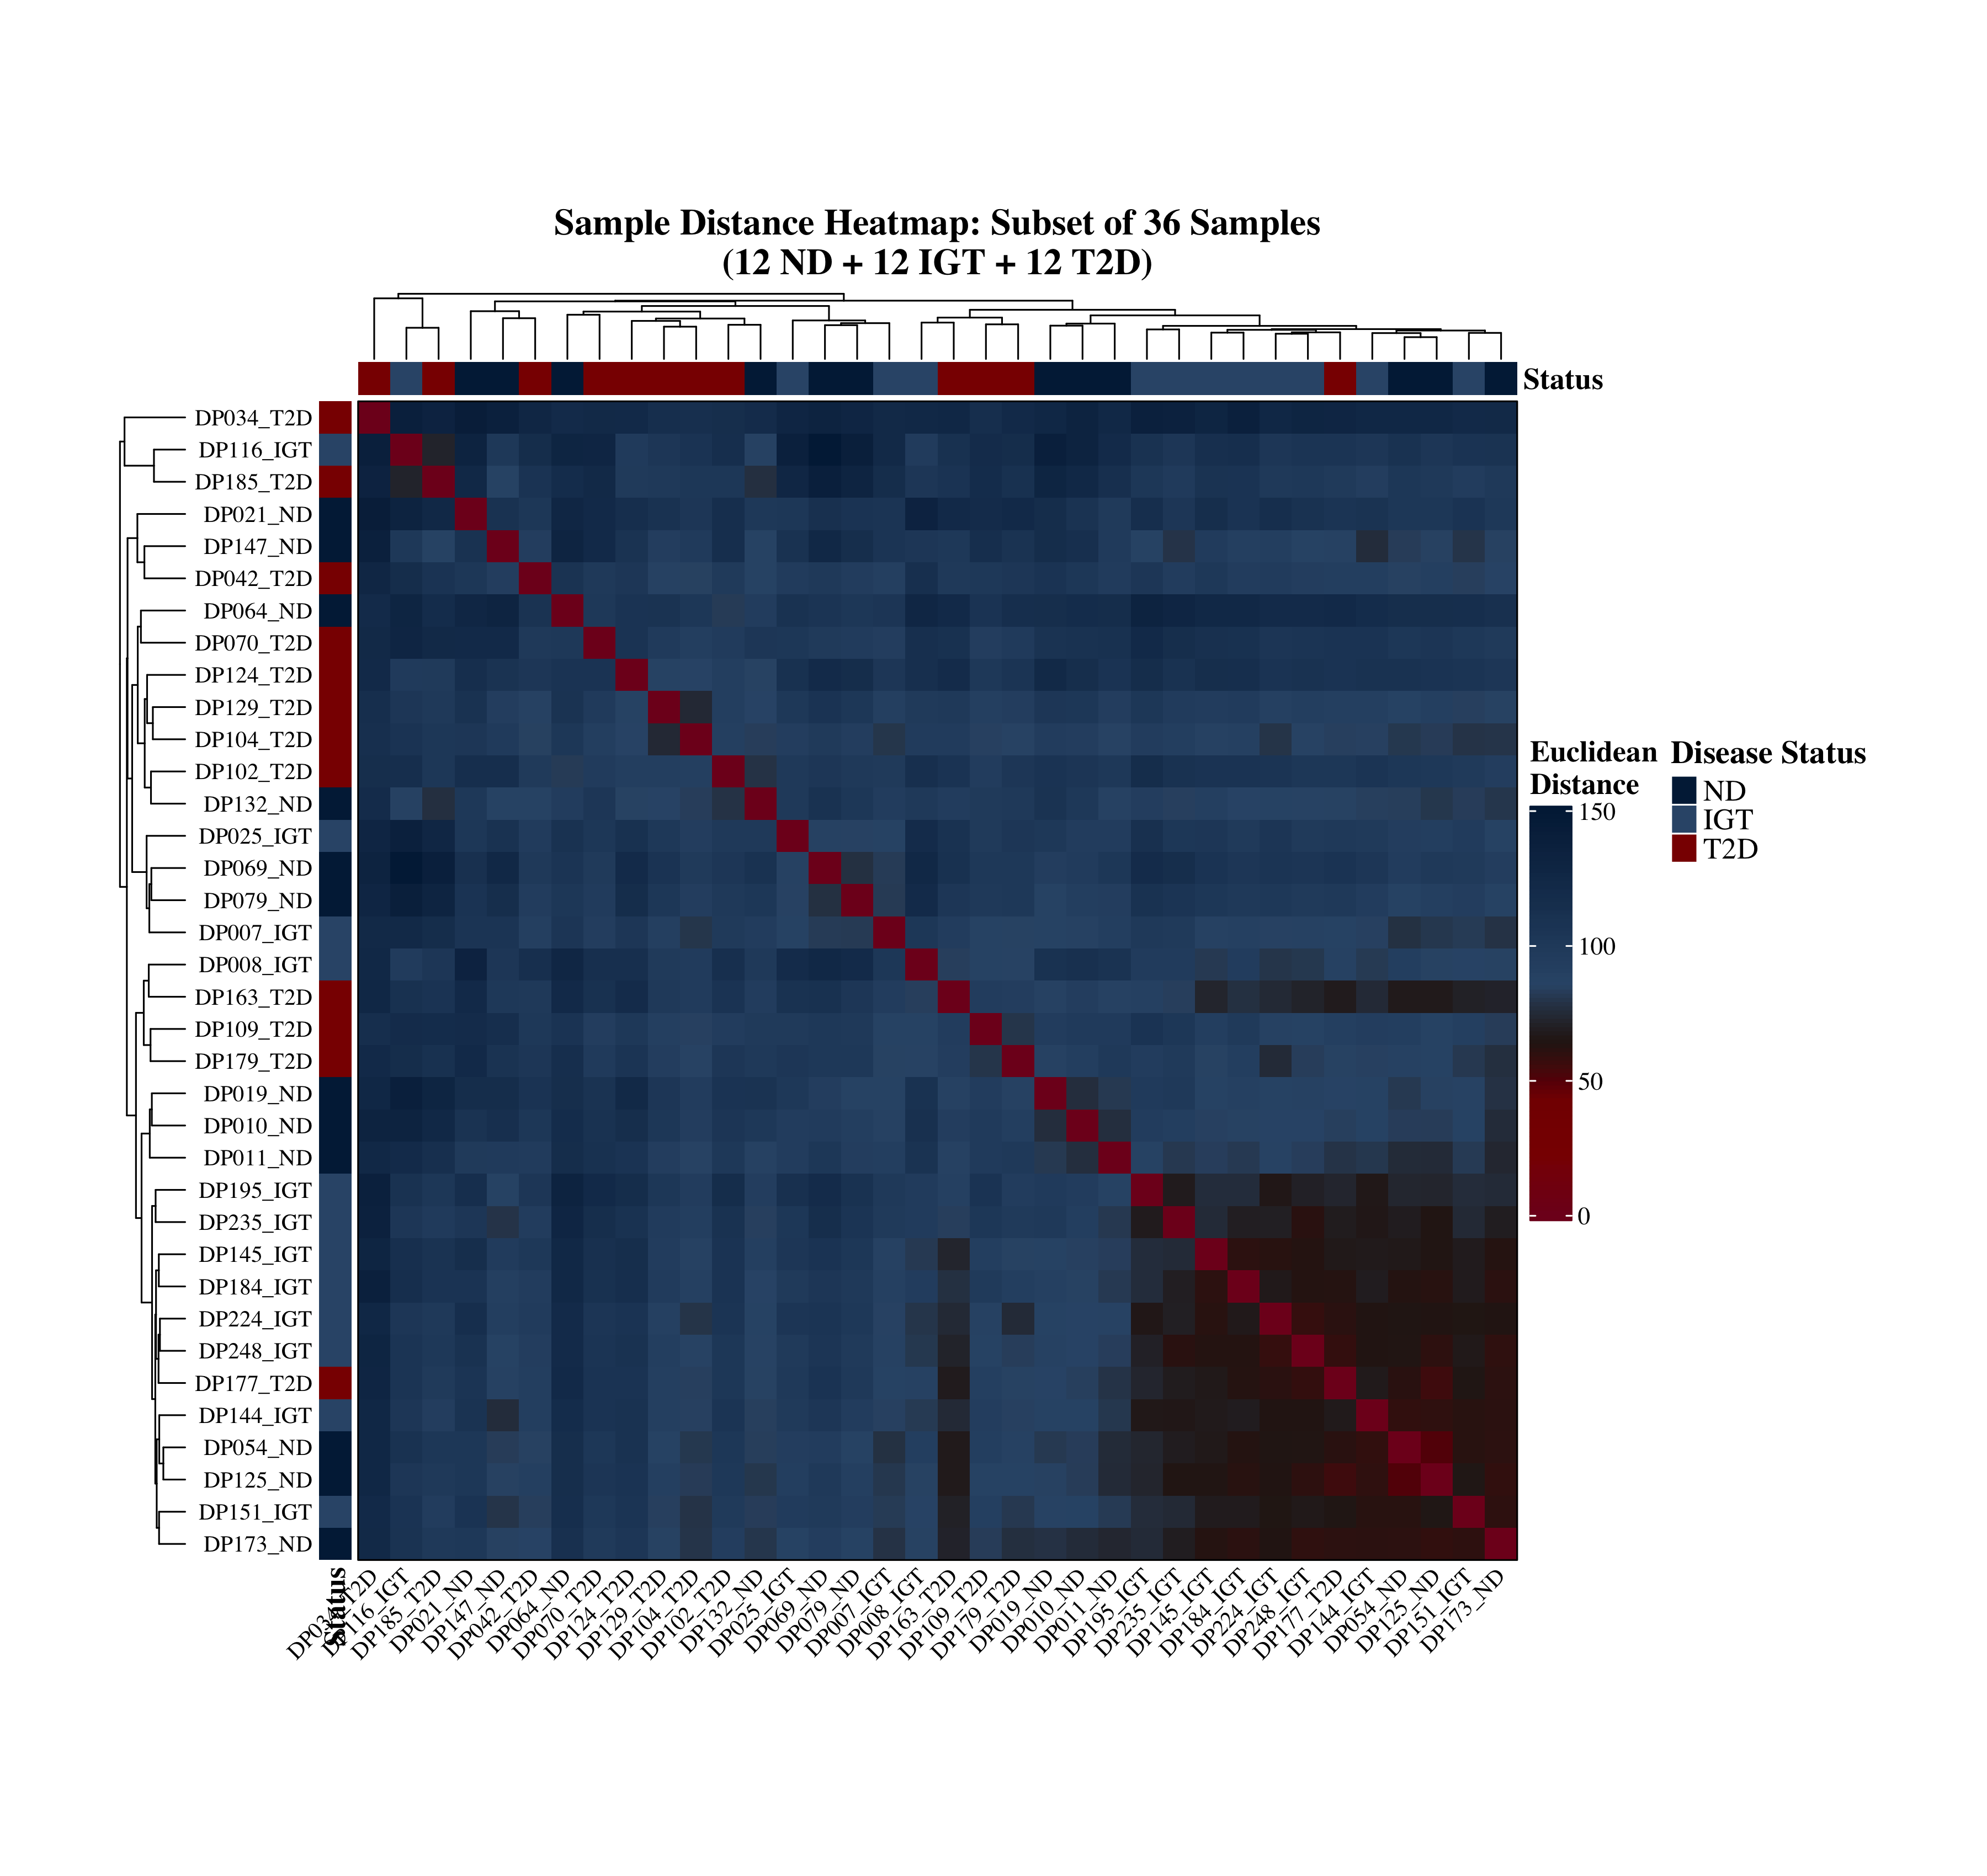
Figure S6. Sample-to-sample distance heatmap (representative subset, n=36).
Euclidean sample-distance heatmap for a representative 36-sample subset, used as a higher-resolution visual check of clustering structure within a balanced subset of the cohort.

S2. Differential Expression
Gene-level differential expression testing was performed independently for three pairwise disease-stage comparisons using DESeq2 (negative binomial GLM, Wald test, Benjamini–Hochberg FDR correction).
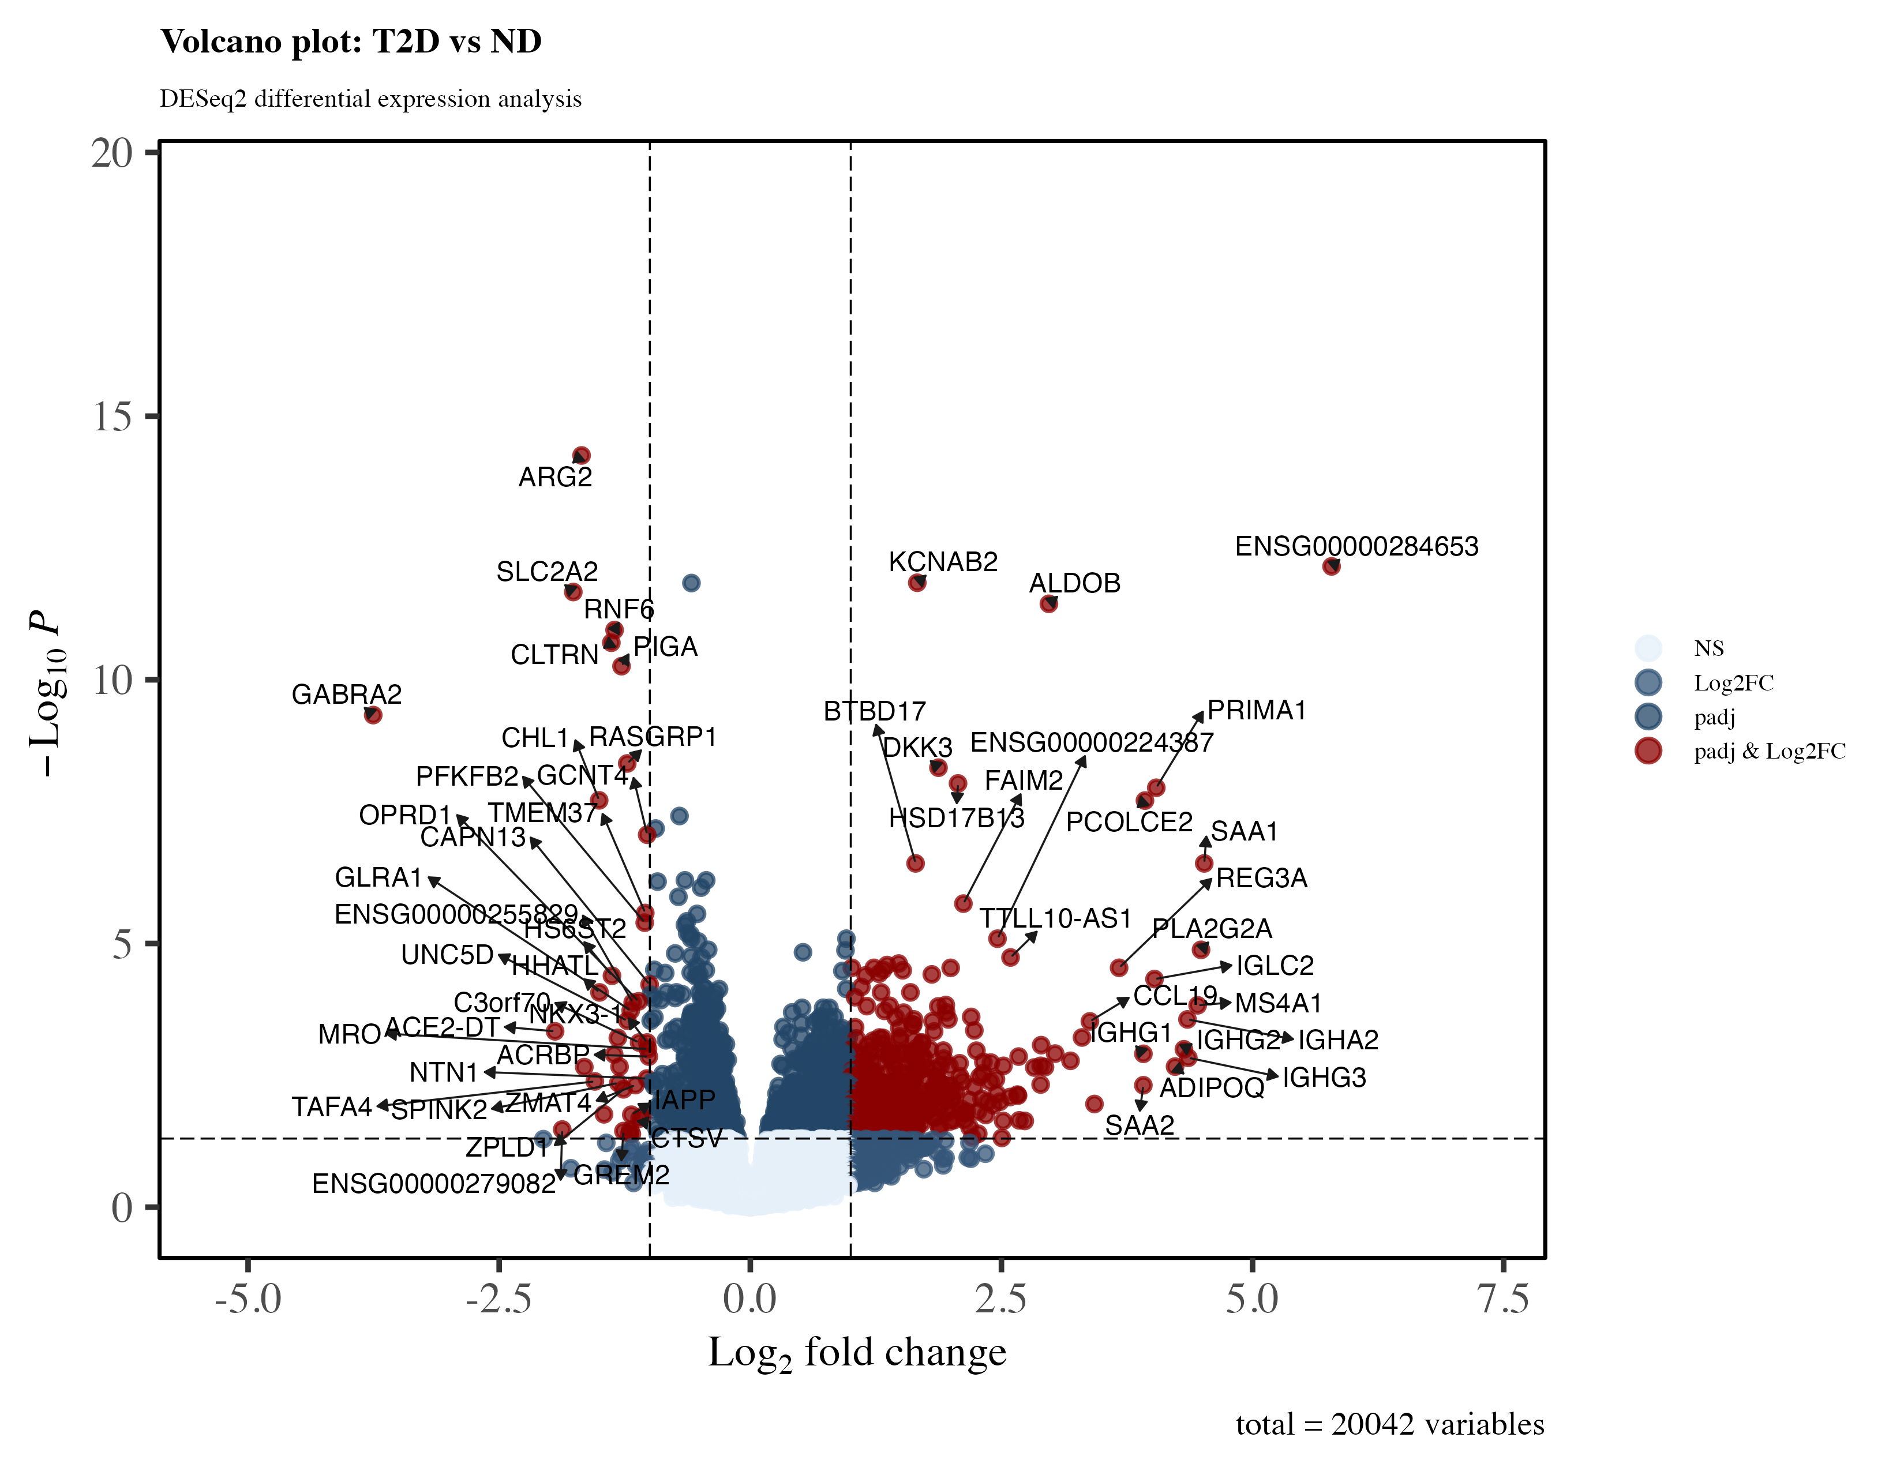
Figure S7. Volcano plot: T2D vs ND.
Differential expression results for type 2 diabetes (T2D, n=39) vs non-diabetic (ND, n=18) islets. –log10(adjusted p-value) plotted against log2 fold-change. Red = significantly upregulated, blue = significantly downregulated (FDR < 0.05, |log2FC| > 1); grey = non-significant. 563 genes upregulated, 41 downregulated.
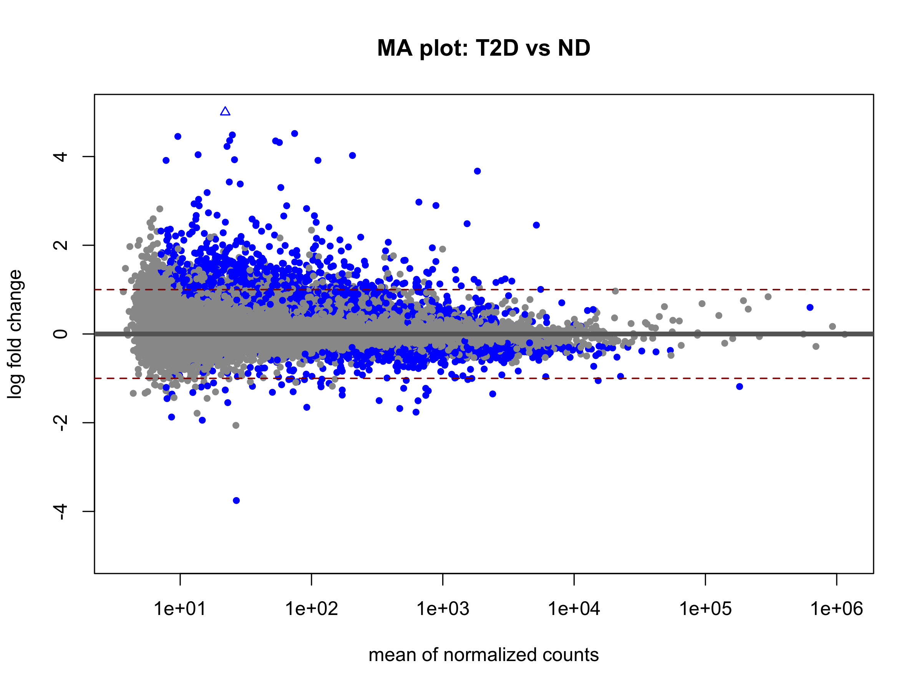
Figure S8. MA plot: T2D vs ND.
Log2 fold-change plotted against mean normalised expression (log10 scale) for the T2D vs ND comparison, used to assess expression-level-dependent bias in fold-change estimates following DESeq2 shrinkage.
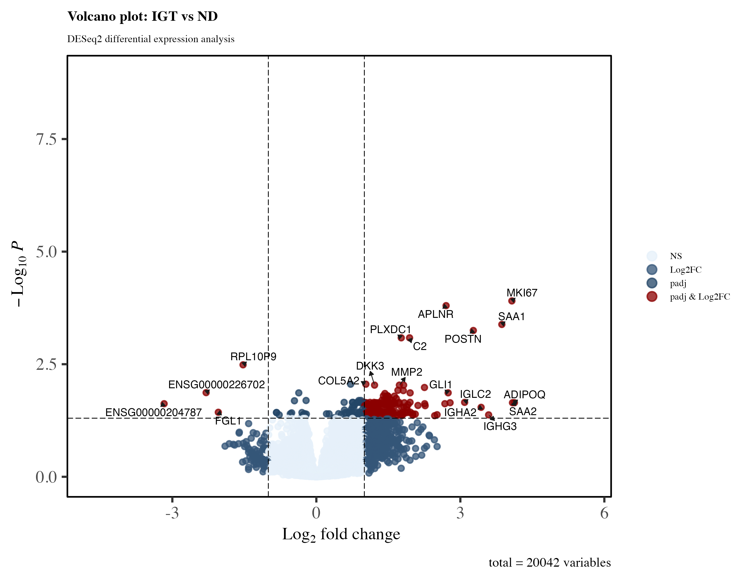
Figure S9. Volcano plot: IGT vs ND.
Differential expression results for impaired glucose tolerance (IGT, n=41) vs non-diabetic (ND, n=18) islets, representing the pre-diabetic transcriptional signature. 189 genes upregulated, 4 downregulated (FDR < 0.05, |log2FC| > 1).
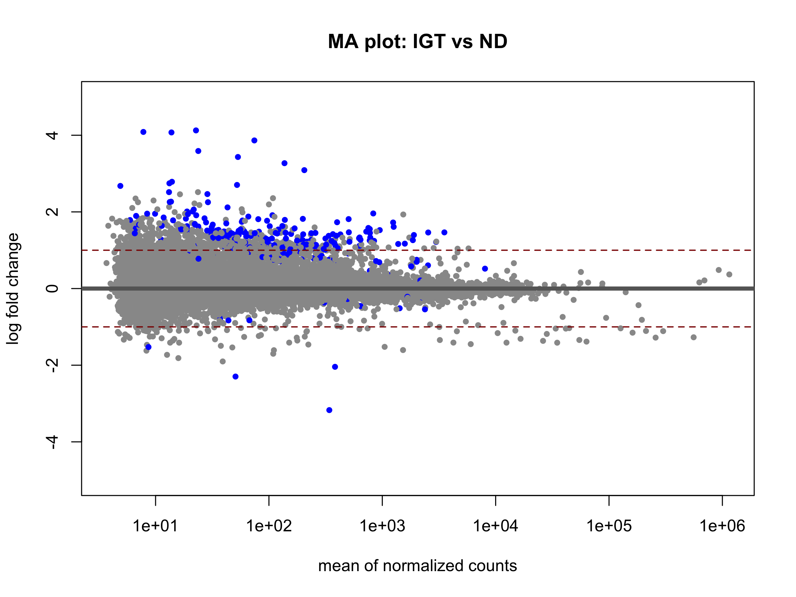
Figure S10. MA plot: IGT vs ND.
Log2 fold-change vs mean normalised expression for the IGT vs ND comparison.
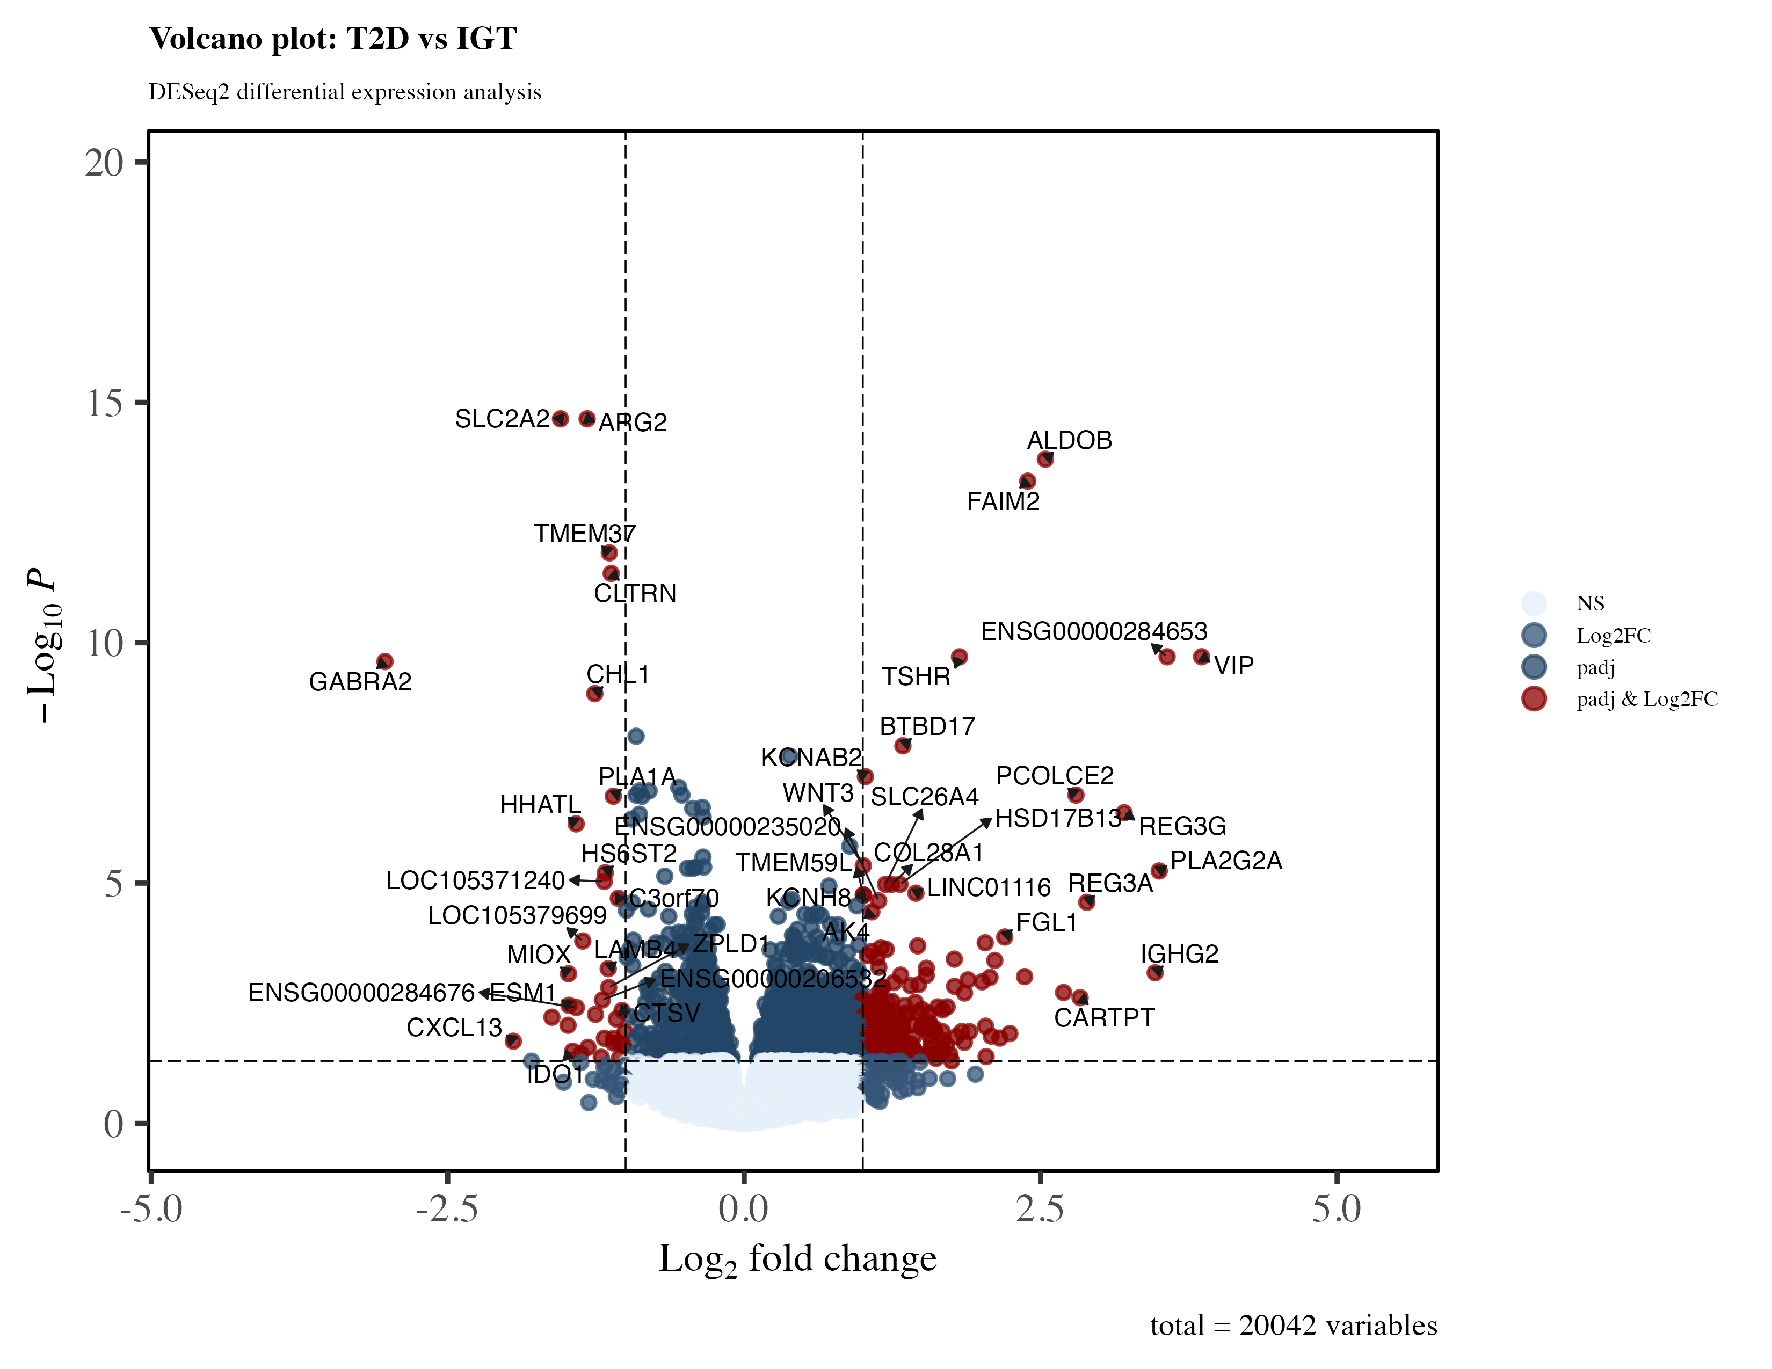
Figure S11. Volcano plot: T2D vs IGT.
Differential expression results for T2D vs IGT islets, capturing transcriptional changes associated with progression from impaired glucose tolerance to overt diabetes. 210 genes upregulated, 35 downregulated (FDR < 0.05, |log2FC| > 1).
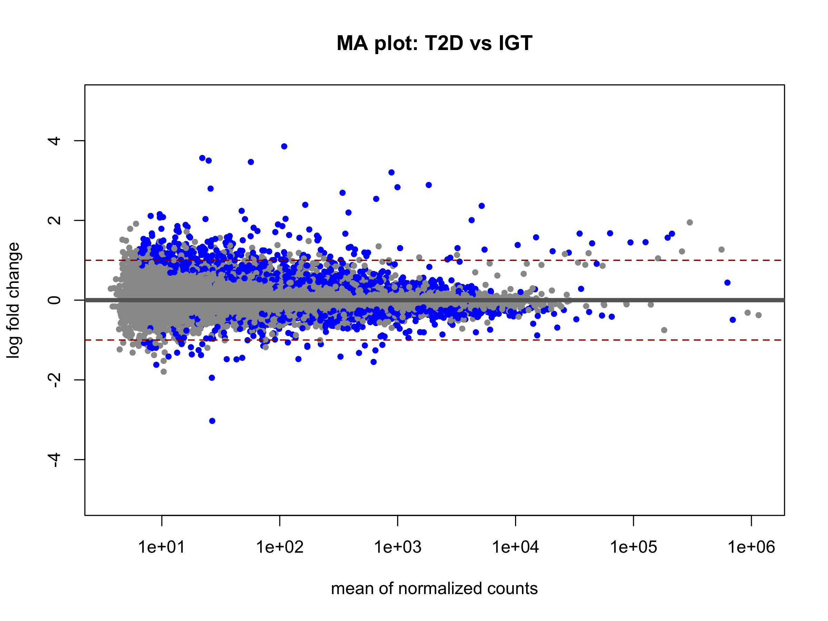
Figure S12. MA plot: T2D vs IGT.
Log2 fold-change vs mean normalised expression for the T2D vs IGT comparison.

S3. lncRNA Prioritisation
Long non-coding RNAs (GENCODE-annotated biotype) among the differentially expressed gene sets were ranked using a composite priority score combining effect size, statistical significance, and cross-comparison recurrence.
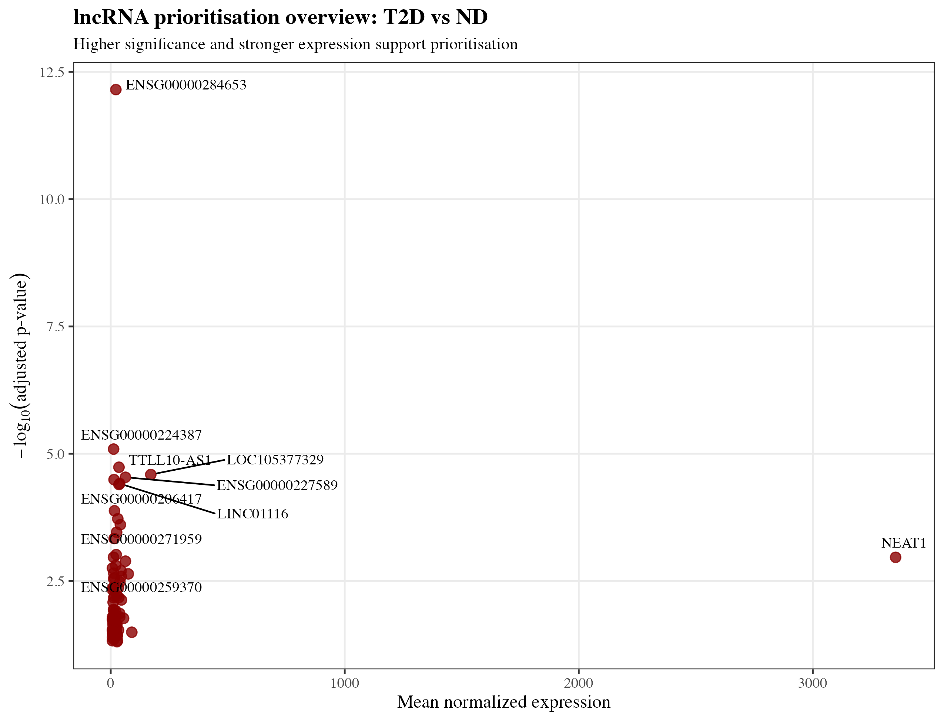
Figure S13. lncRNA effect size vs significance, T2D vs ND.
Scatter plot of absolute log2 fold-change against –log10(adjusted p-value) for all differentially expressed lncRNAs in the T2D vs ND comparison, coloured by composite priority score = rescale01(|log2FC|) + rescale01(–log10(padj)) + rescale01(recurrence).
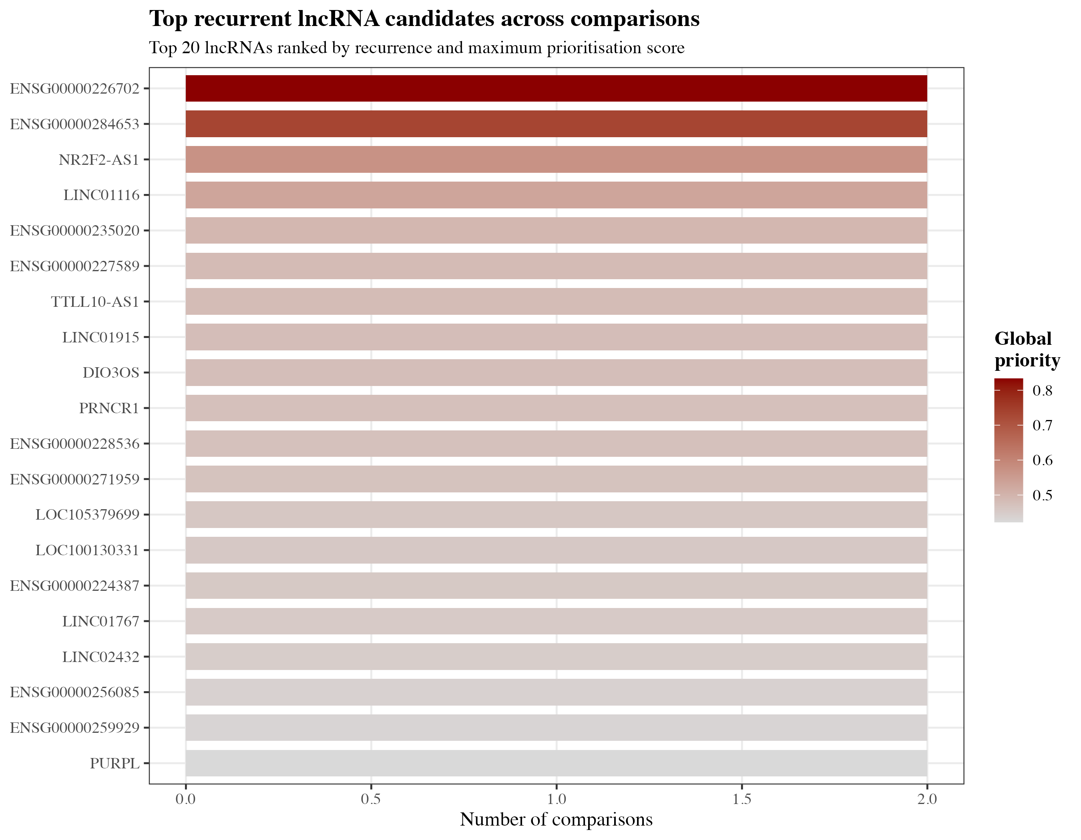
Figure S14. lncRNA recurrence across the three disease-stage comparisons.
Bar chart quantifying how many of the three pairwise comparisons (T2D vs ND, IGT vs ND, T2D vs IGT) each lncRNA was significantly differentially expressed in, identifying candidates with consistent dysregulation across disease progression.
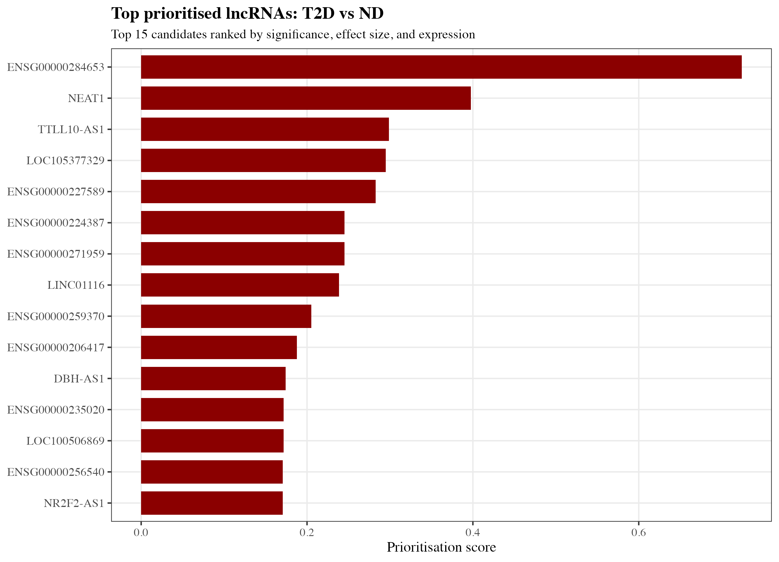
Figure S15. Top prioritised lncRNA candidates, T2D vs ND.
Top 15 lncRNA candidates ranked by composite priority score for the T2D vs ND comparison, with gene identifiers and priority scores labelled.
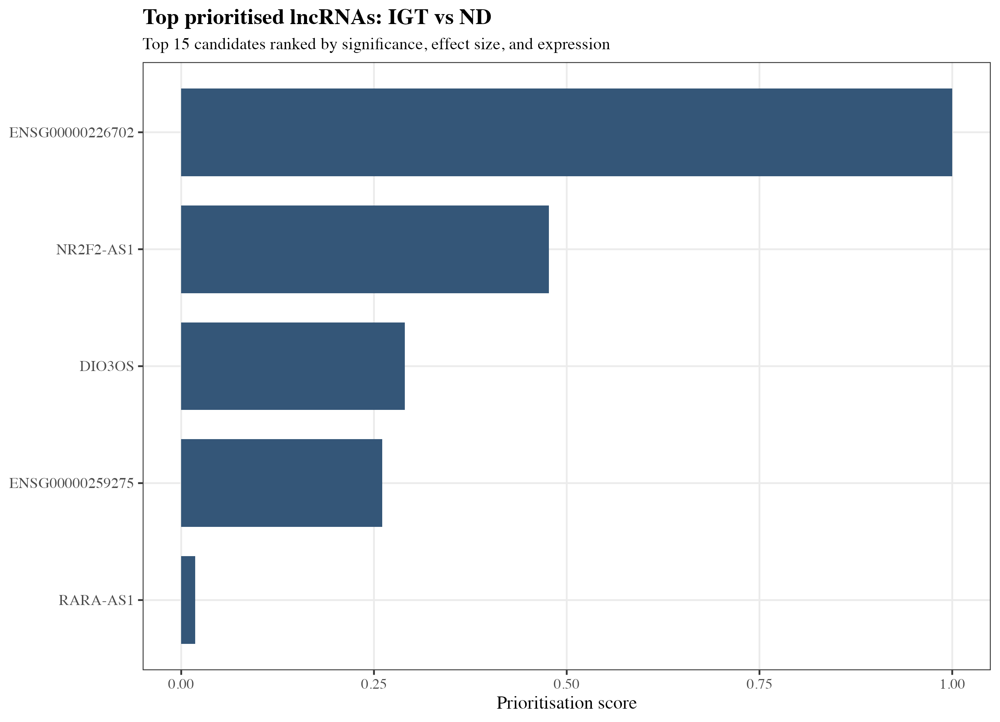
Figure S16. Top prioritised lncRNA candidates, IGT vs ND.
Top 15 lncRNA candidates ranked by composite priority score for the IGT vs ND comparison.
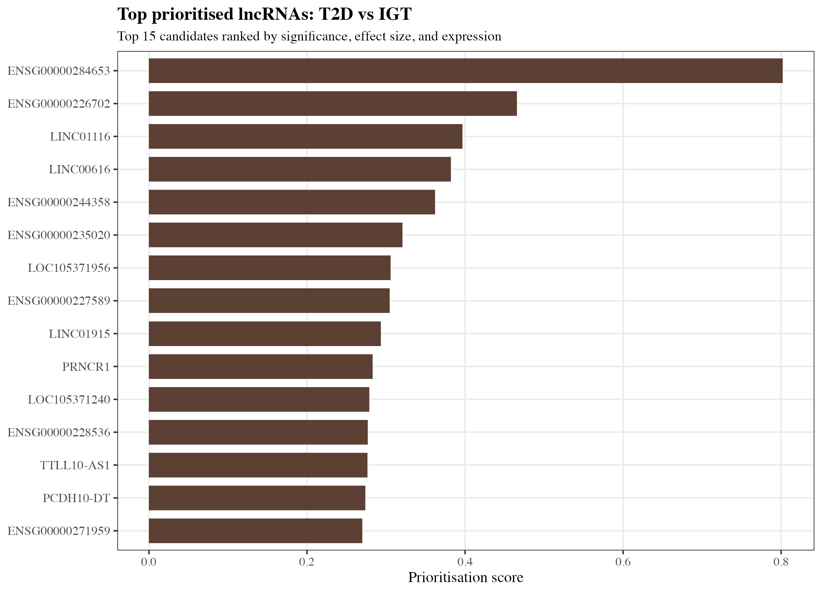
Figure S17. Top prioritised lncRNA candidates, T2D vs IGT.
Top 15 lncRNA candidates ranked by composite priority score for the T2D vs IGT comparison.

S4. WGCNA Network Construction
Weighted gene co-expression network analysis (WGCNA, signed network, bicor correlation) was performed on 20,042 VST-normalised genes across all 98 samples to identify modules of co-expressed genes and relate them to clinical trait variables.
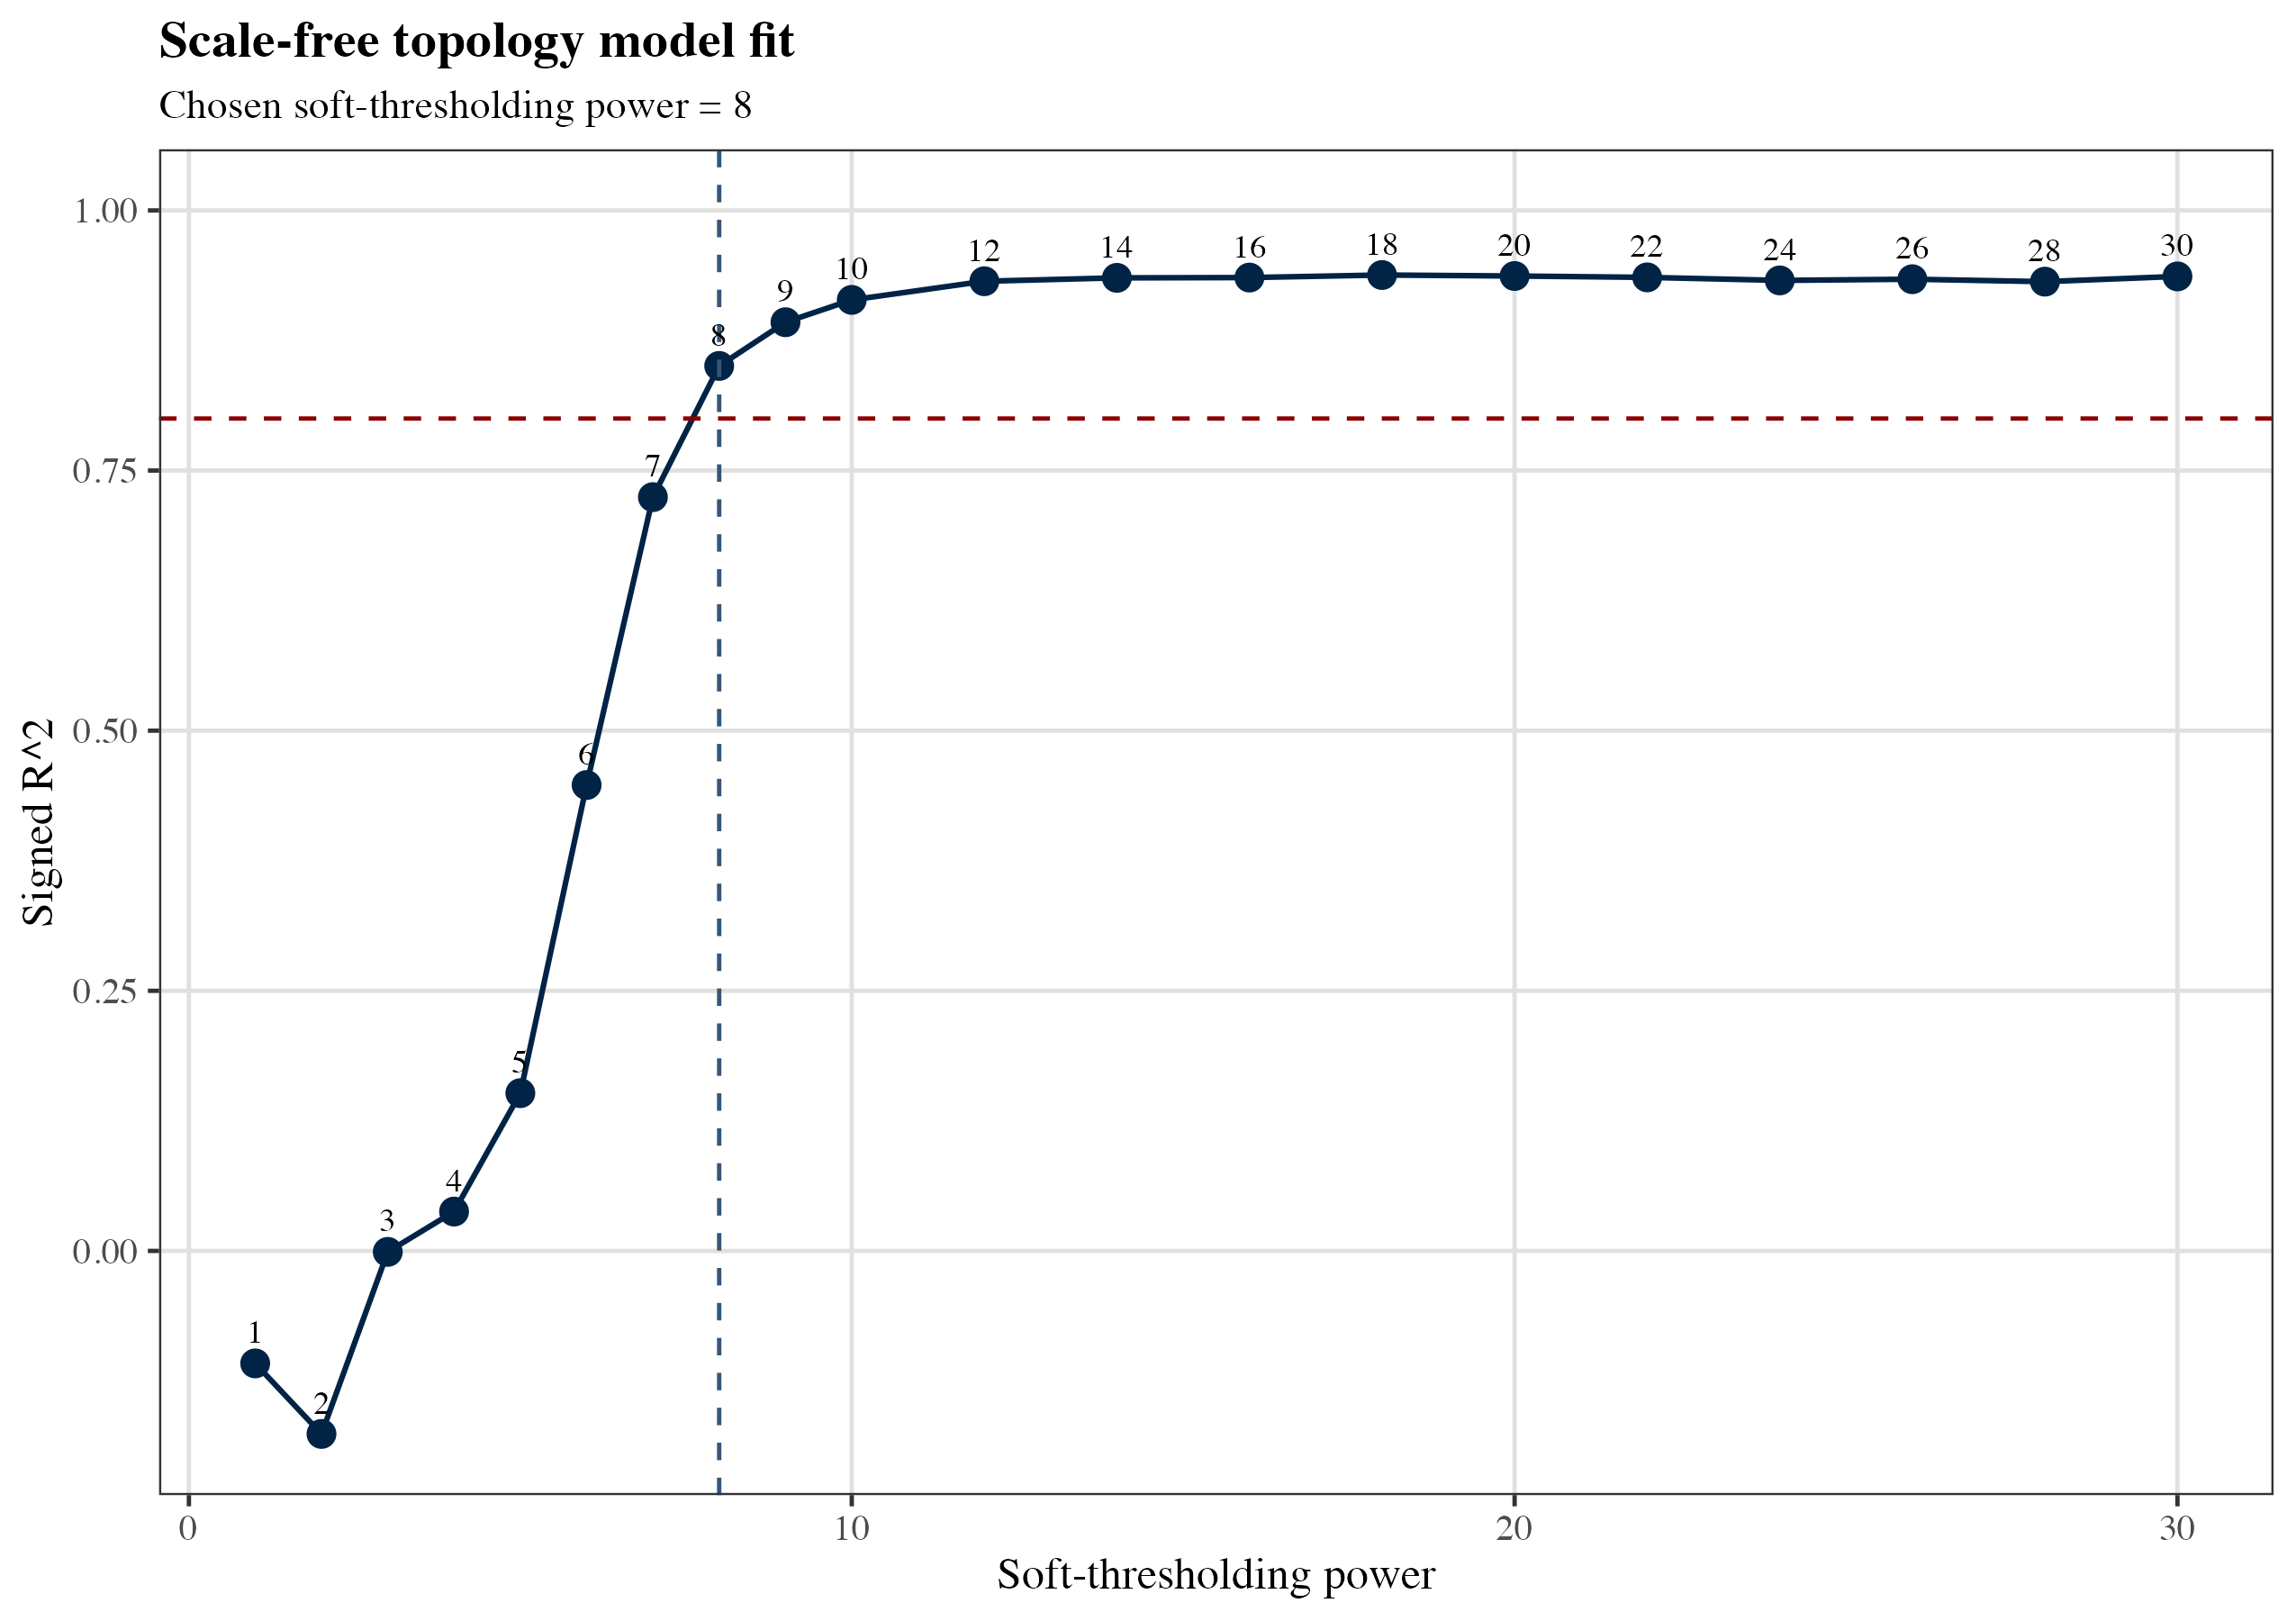
Figure S18. Scale-free topology model fit across soft-thresholding powers.
Scale-free topology fit index (signed R²) as a function of soft-thresholding power β (1–20). β=8 was selected as the lowest power achieving R² > 0.80 (R²=0.851), balancing scale-free topology approximation against retained connectivity.
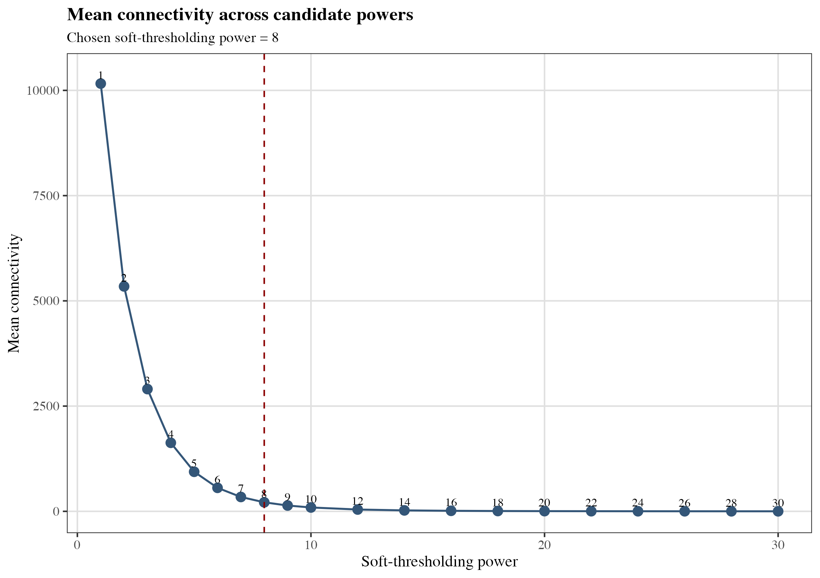
Figure S19. Mean network connectivity across soft-thresholding powers.
Mean connectivity (k) as a function of soft-thresholding power β, showing the expected decline in connectivity as β increases. Selected power (β=8) indicated.
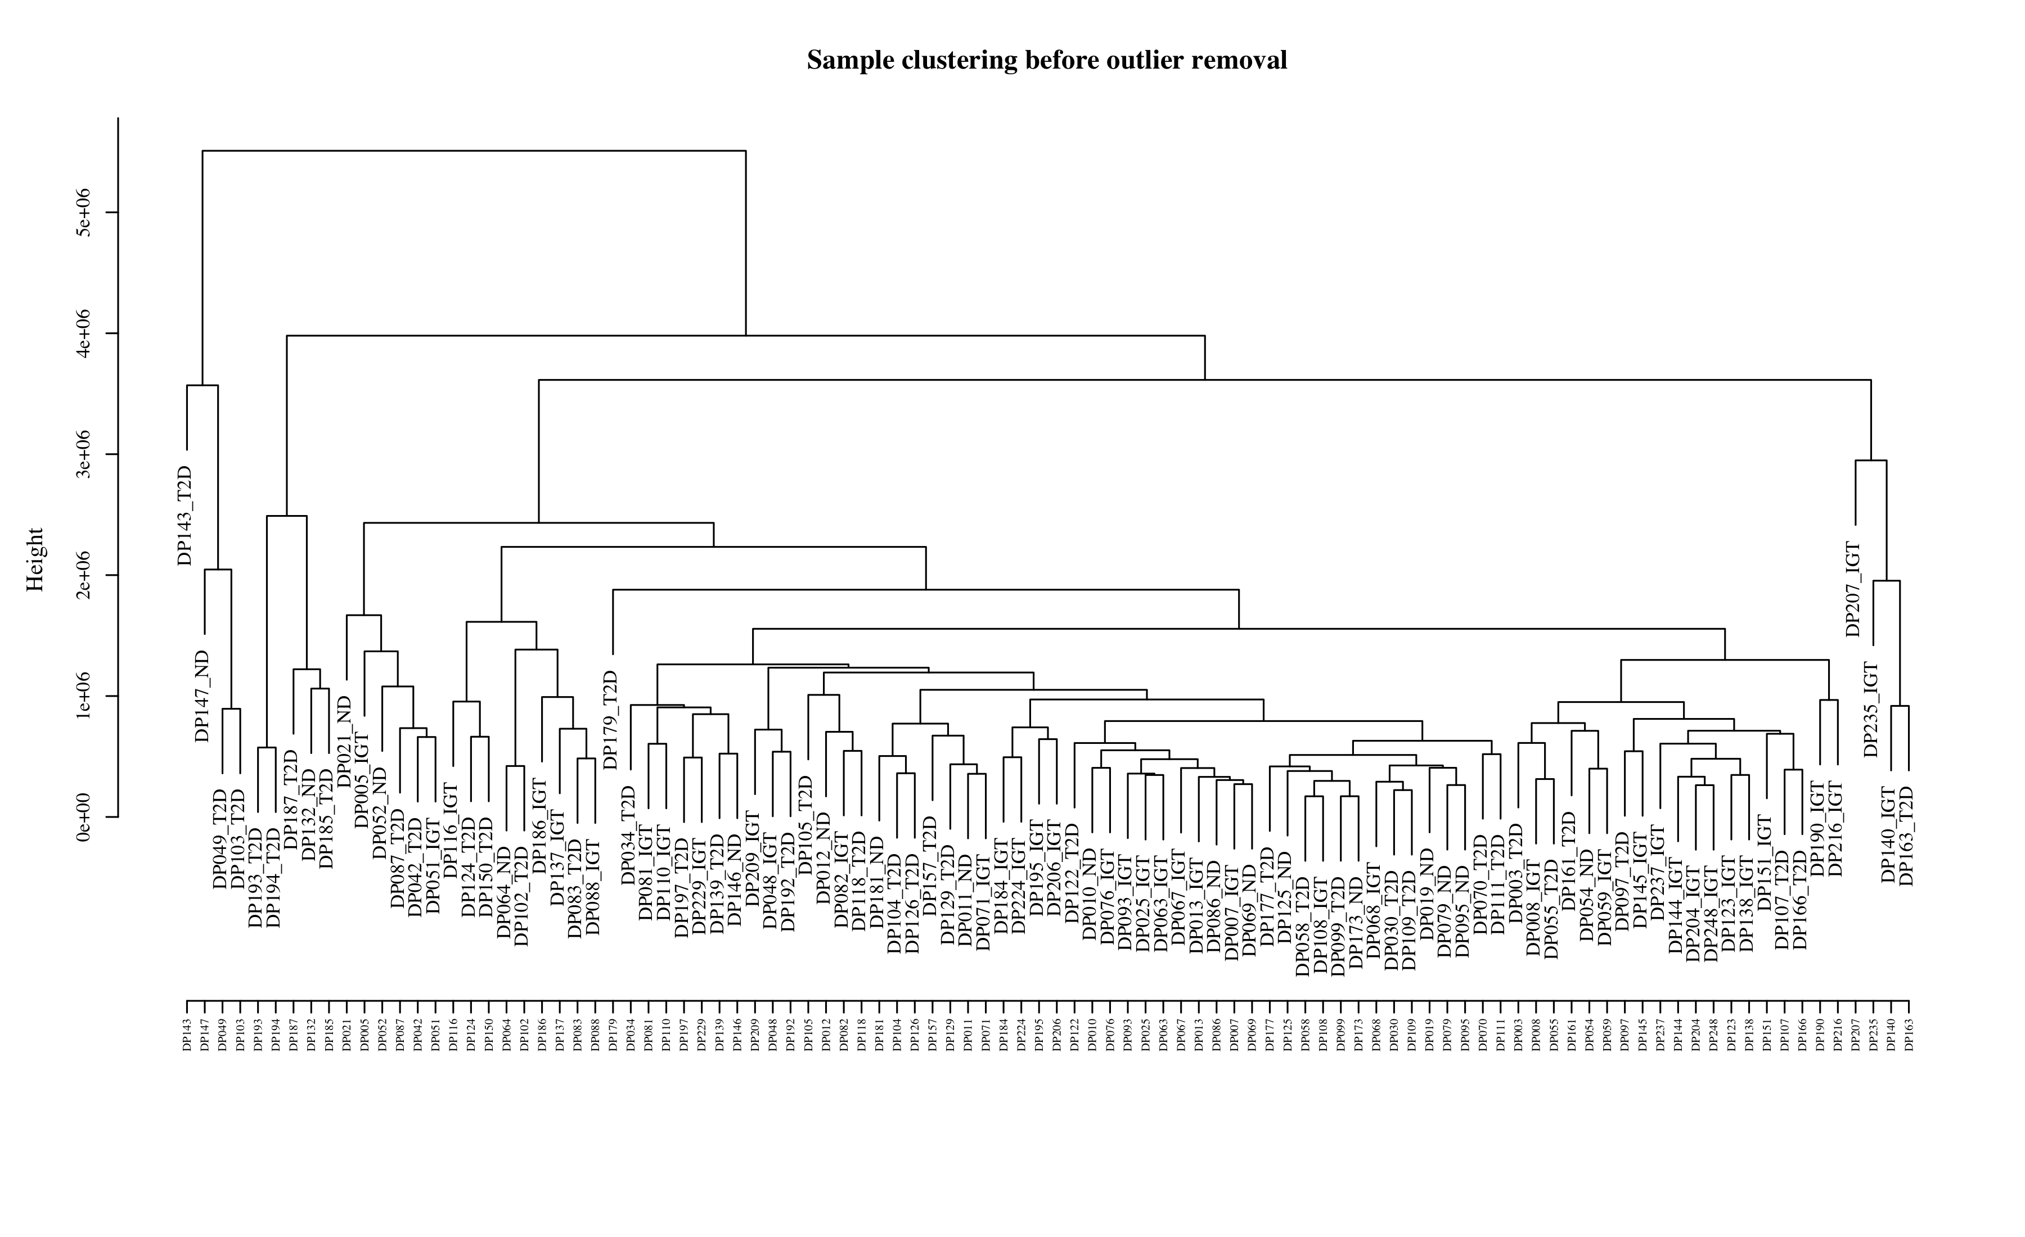
Figure S20. Sample clustering dendrogram prior to outlier assessment.
Hierarchical clustering of all samples based on pairwise expression distance, performed prior to network construction to identify potential outlier samples requiring exclusion.
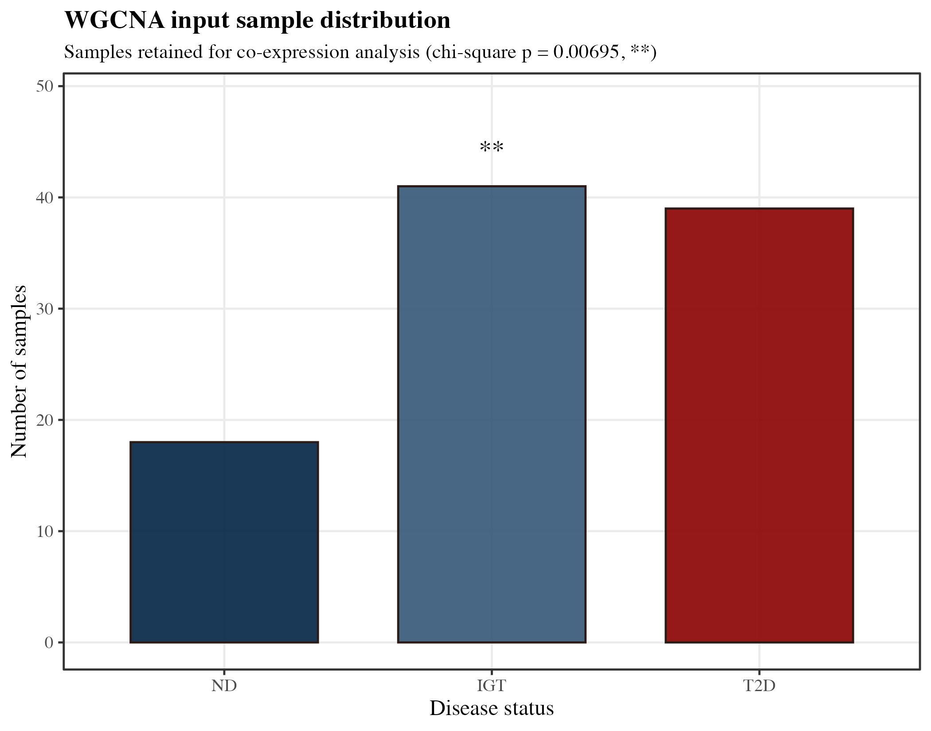
Figure S21. Sample distribution by disease status used in network construction.
Number of samples per disease status group (ND, IGT, T2D) included in the WGCNA network construction, confirming the full 98-sample cohort was retained.
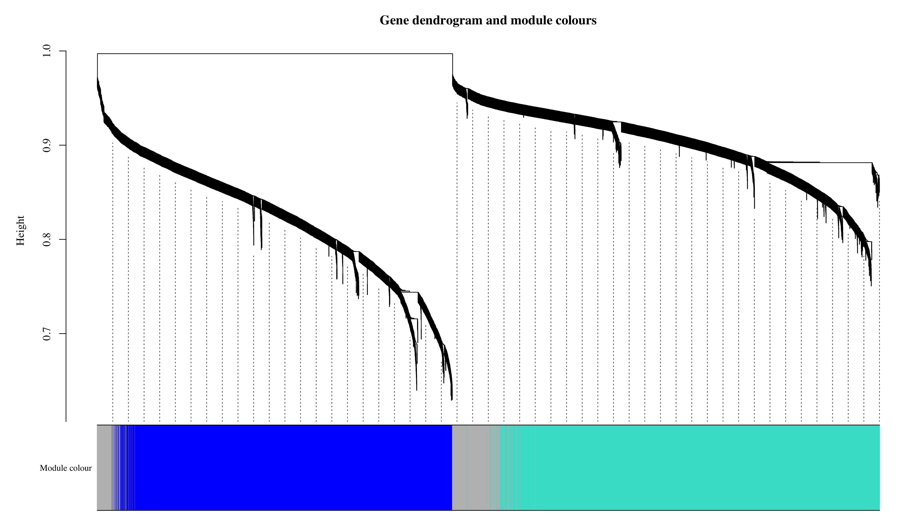
Figure S22. Gene dendrogram with module colour assignments.
Hierarchical clustering dendrogram of 20,042 genes based on topological overlap dissimilarity (1 – signed bicor TOM), with module membership indicated by the colour band beneath the dendrogram (blockwiseModules, mergeCutHeight=0.25; 30 modules identified, grey = unassigned).
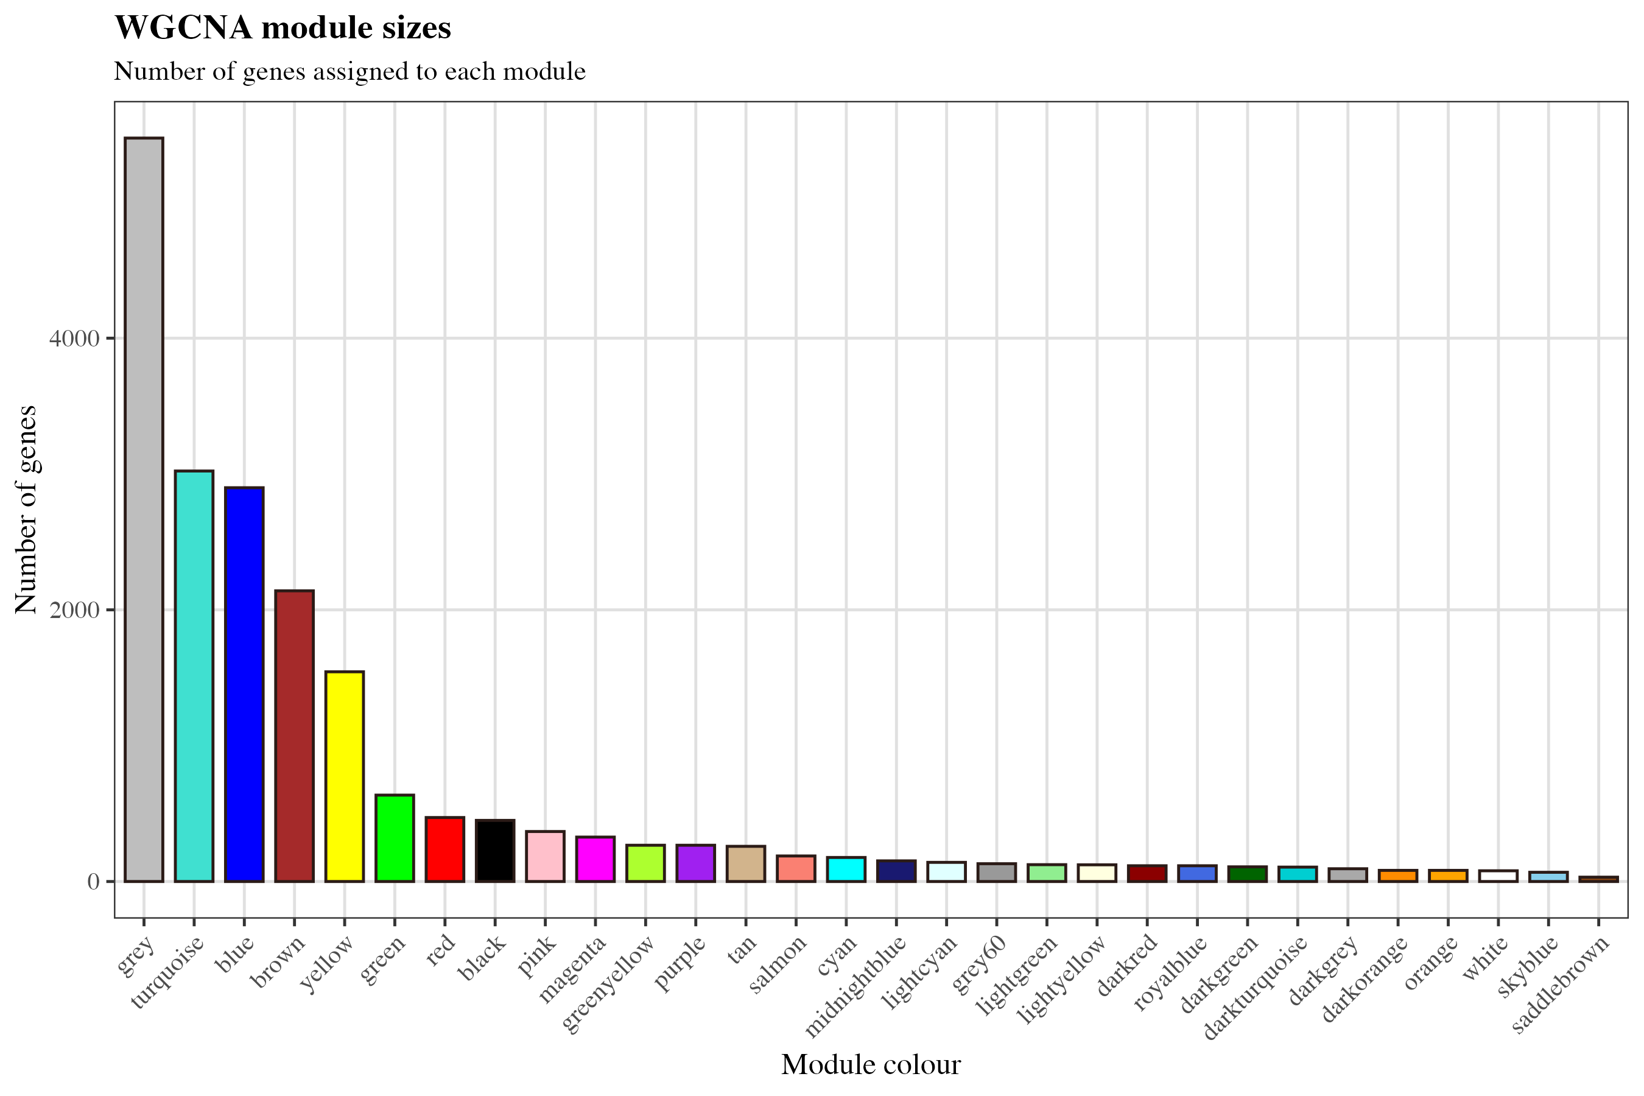
Figure S23. Module size distribution across all 30 co-expression modules.
Number of genes assigned to each of the 30 co-expression modules identified by WGCNA, ordered by descending module size.
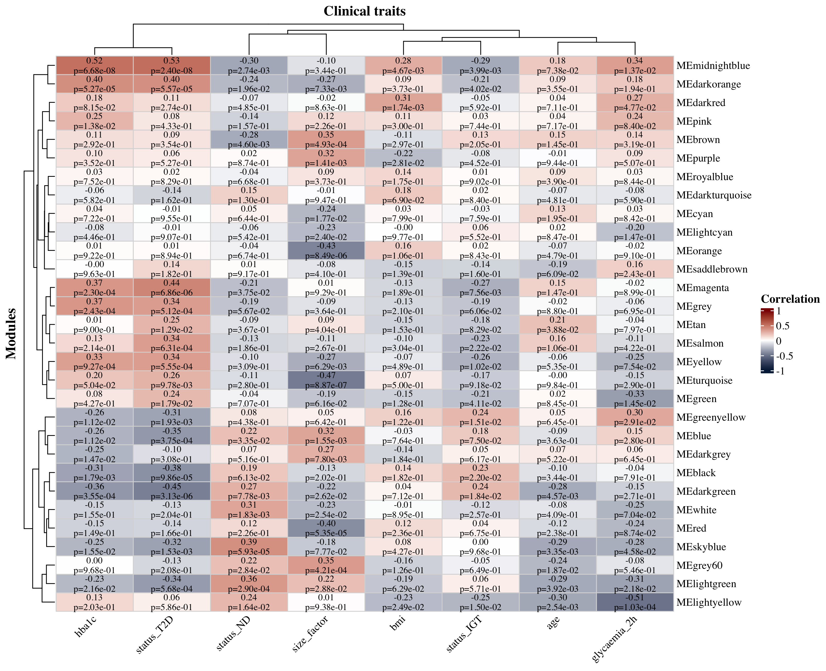
Figure S24. Module-trait correlation heatmap.
Pearson correlation between module eigengene expression and clinical trait variables (HbA1c, fasting glucose, BMI, age, and binary disease status). Cell values indicate r (p-value); colour scale from blue (negative) to red (positive) correlation. Used to identify disease-associated modules for downstream focus-module selection.
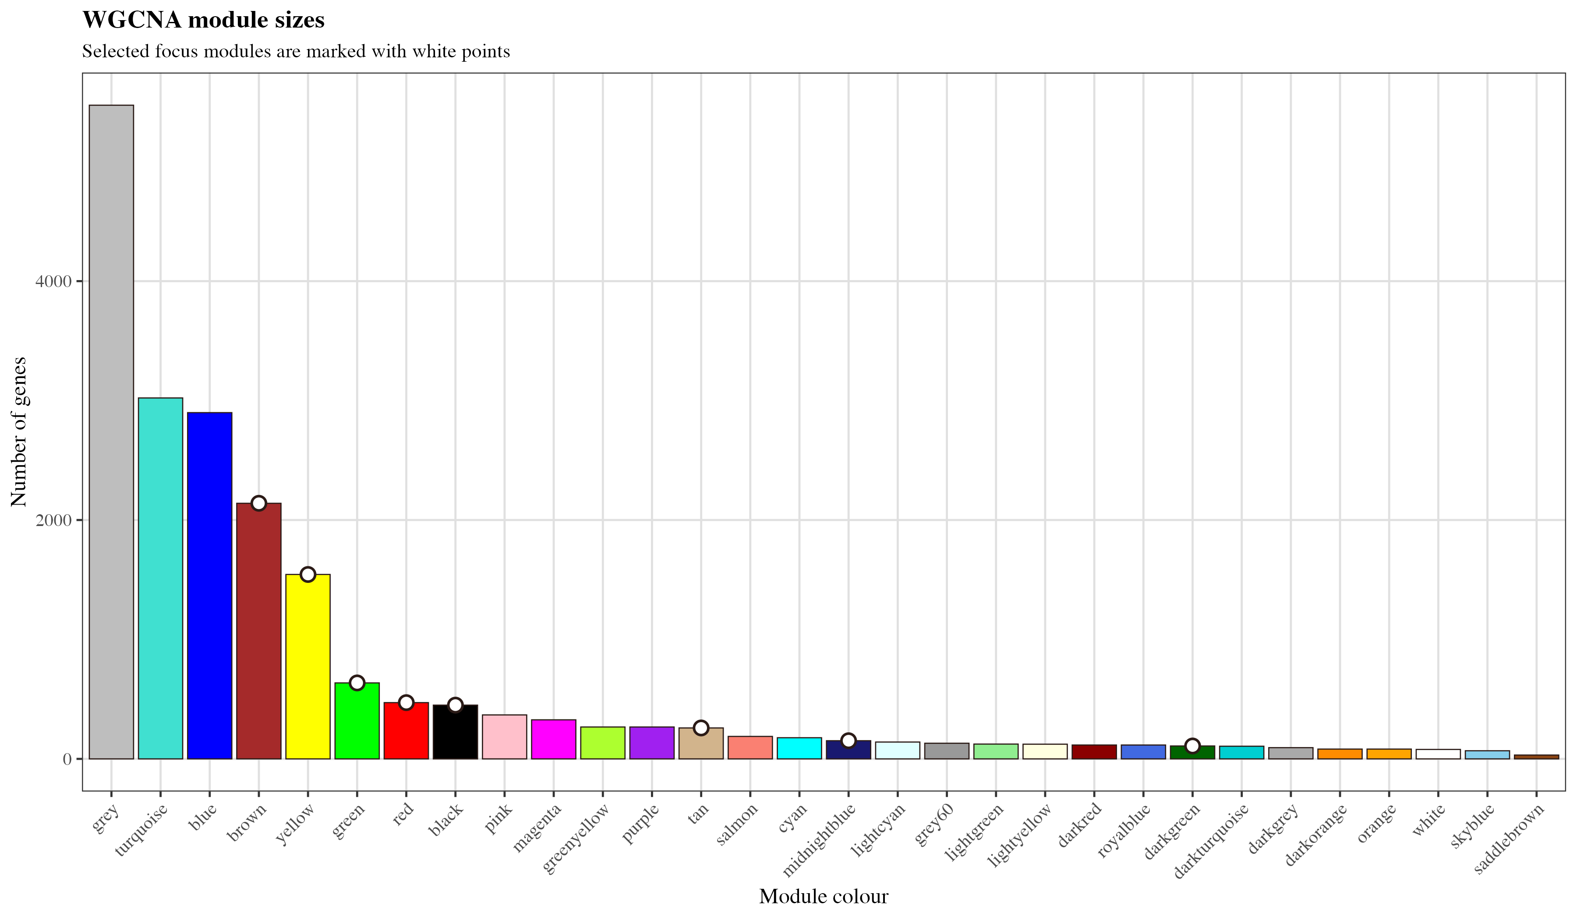
Figure S25. Size of the 8 focus modules selected for downstream analysis.
Gene counts for the 8 focus modules (brown, yellow, green, red, black, midnightblue, darkgreen, tan; 5,760 genes total), selected on the basis of significant trait correlation (FDR < 0.05) and/or containing top-prioritised lncRNA candidates.
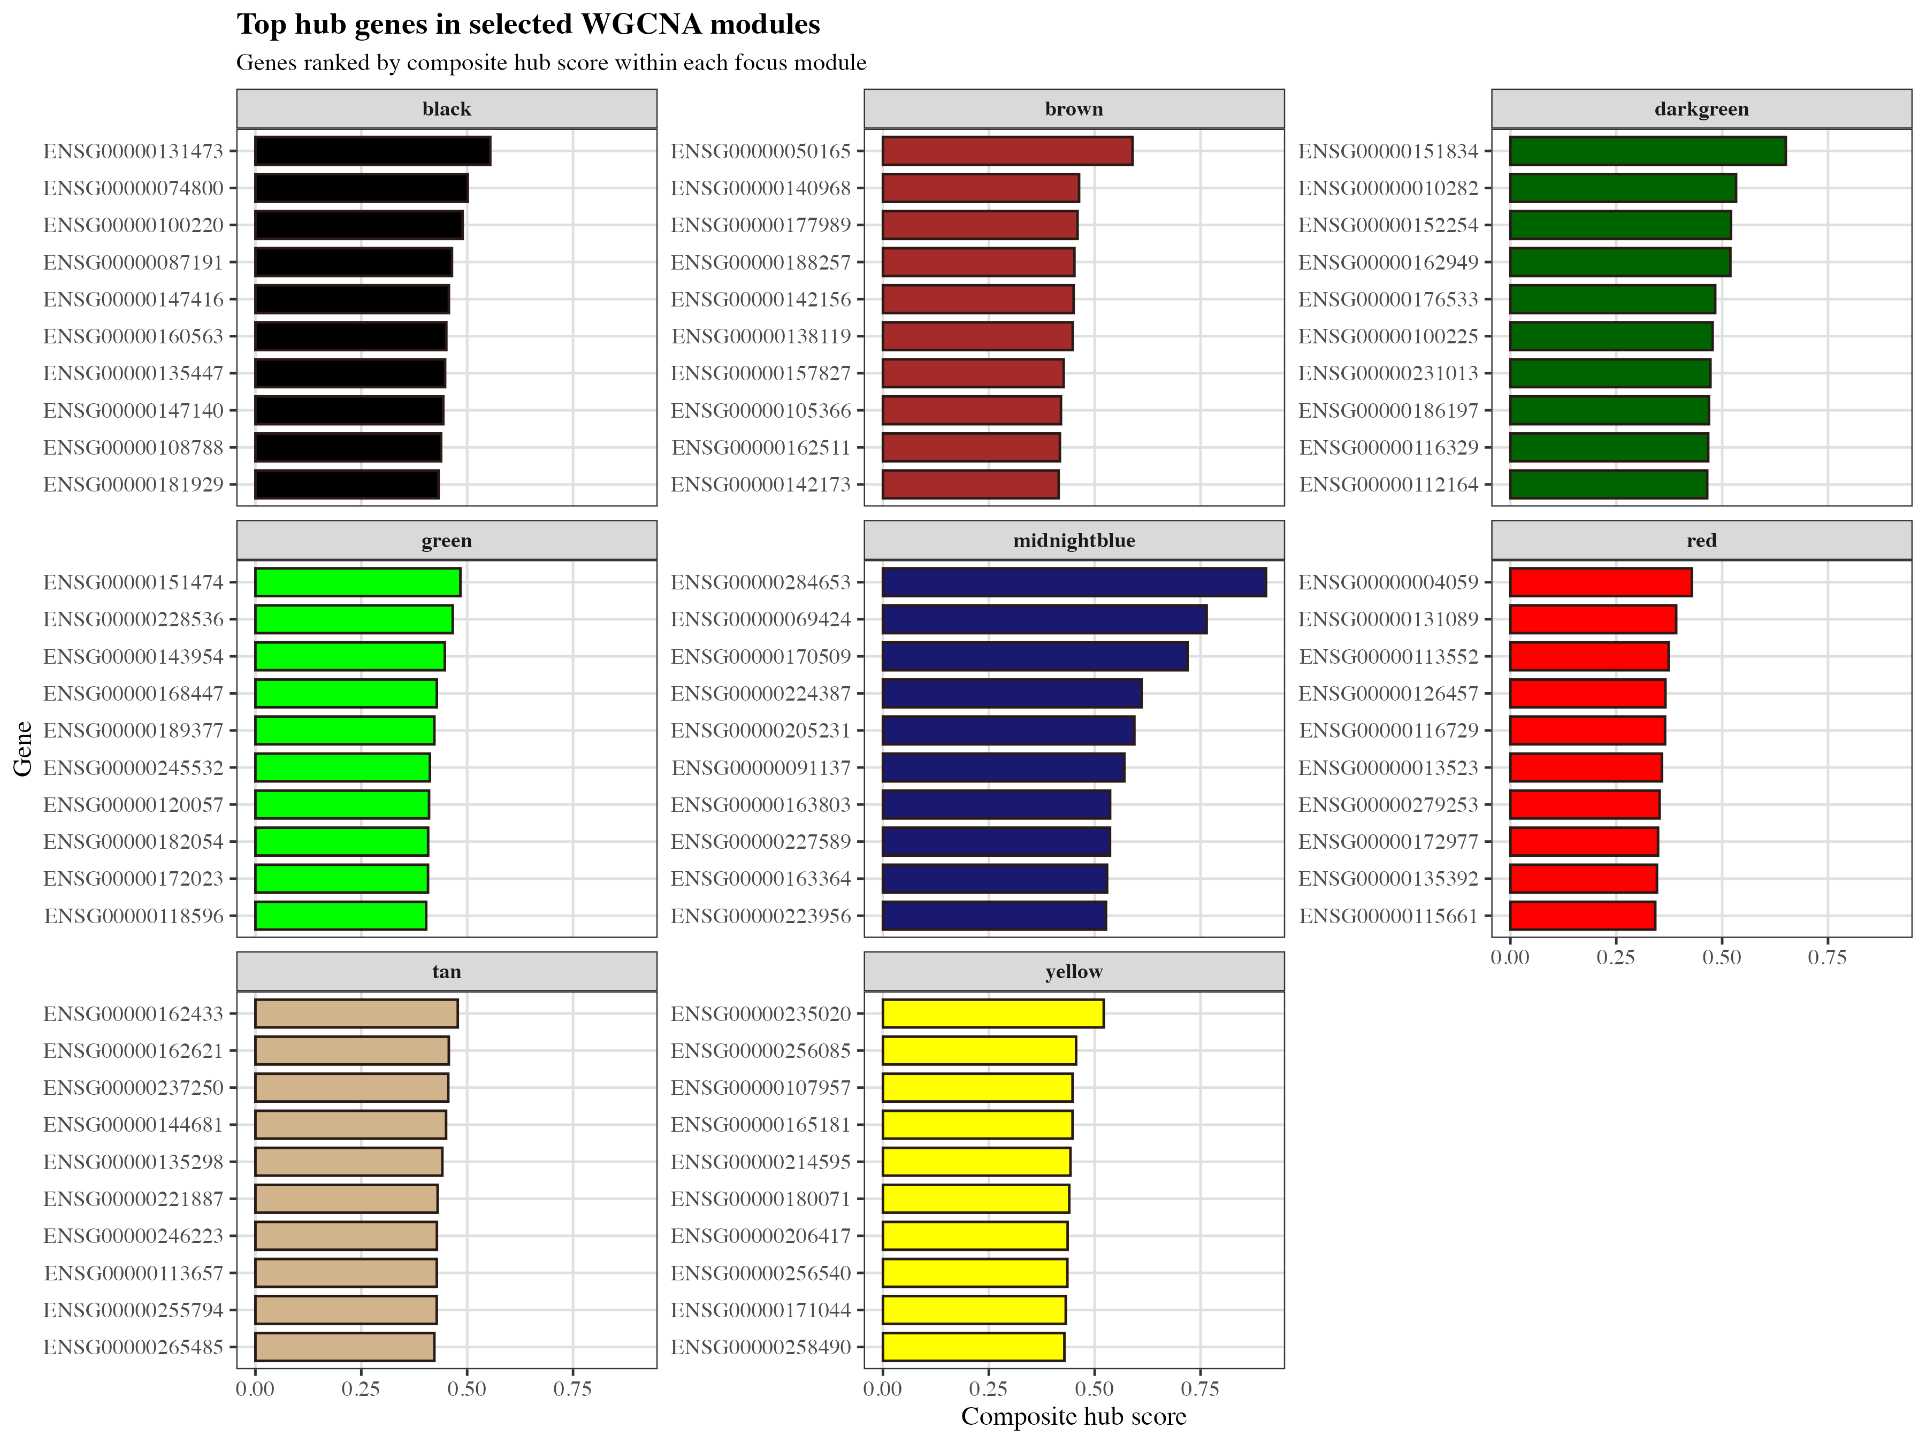
Figure S26. Top hub genes across the 8 focus modules.
Top-ranked hub genes per focus module, ranked by composite hub score combining module membership (kME), gene significance (GS) for T2D status, and intramodular connectivity.
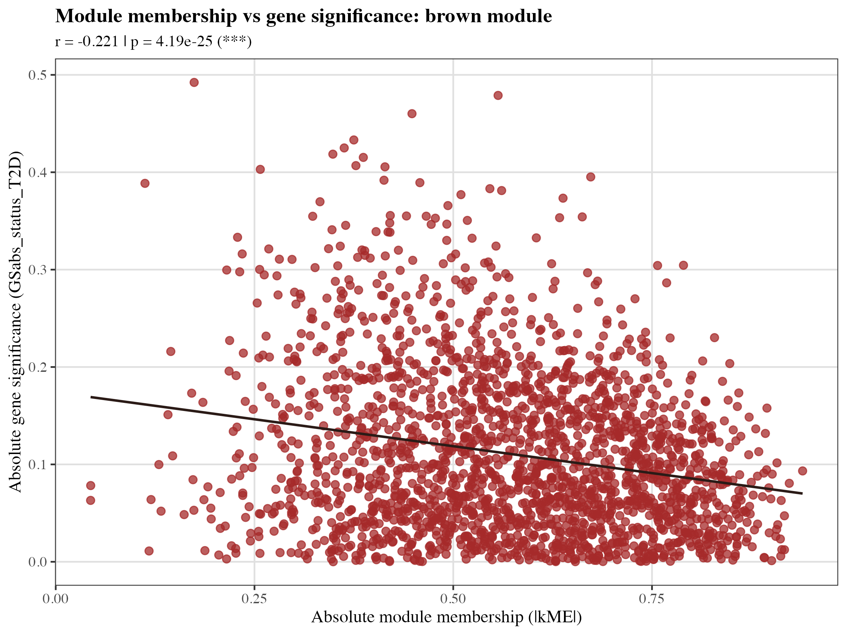
Figure S27. Module membership vs gene significance, brown module.
Scatter plot of module membership (kME, correlation to module eigengene) against gene significance (GS, correlation to T2D trait) for all genes in the brown module. High kME + high GS genes (upper right) represent putative disease-relevant hub genes, including DKK3, IRF8, PLA2G2A, COL6A1, and MYOF.

S5. Functional Enrichment Analysis
Gene Ontology (Biological Process, Molecular Function) and KEGG pathway over-representation analysis was performed using clusterProfiler with Benjamini–Hochberg FDR correction (q < 0.05), against a background of all 20,042 genes tested in the differential expression analysis, for both DE gene sets and WGCNA focus modules.
Figure S28. GO Biological Process enrichment summary across DE comparisons.
Dot plot summarising significantly enriched GO Biological Process terms (q < 0.05) for the differentially expressed gene sets across all three comparisons (T2D vs ND, IGT vs ND, T2D vs IGT). Dot size = gene ratio; colour = –log10(q-value).
Figure S29. GO Biological Process enrichment, T2D vs ND DE genes.
Top enriched GO Biological Process terms for genes differentially expressed between T2D and ND islets.
Figure S30. GO Biological Process enrichment, IGT vs ND DE genes.
Top enriched GO Biological Process terms for genes differentially expressed between IGT and ND islets.
Figure S31. GO Biological Process enrichment, T2D vs IGT DE genes.
Top enriched GO Biological Process terms for genes differentially expressed between T2D and IGT islets.
Figure S32. GO Molecular Function enrichment, T2D vs ND DE genes.
Top enriched GO Molecular Function terms for genes differentially expressed between T2D and ND islets.
Figure S33. GO Molecular Function enrichment, IGT vs ND DE genes.
Top enriched GO Molecular Function terms for genes differentially expressed between IGT and ND islets.
Figure S34. GO Molecular Function enrichment, T2D vs IGT DE genes.
Top enriched GO Molecular Function terms for genes differentially expressed between T2D and IGT islets.
Figure S35. KEGG pathway enrichment, T2D vs ND DE genes.
Top enriched KEGG pathways for genes differentially expressed between T2D and ND islets.
Figure S36. KEGG pathway enrichment, IGT vs ND DE genes.
Top enriched KEGG pathways for genes differentially expressed between IGT and ND islets.
Figure S37. KEGG pathway enrichment, T2D vs IGT DE genes.
Top enriched KEGG pathways for genes differentially expressed between T2D and IGT islets.
Figure S38. GO Biological Process enrichment summary across all 8 focus modules.
Cross-module dot plot summarising the top significantly enriched GO Biological Process terms (q < 0.05) across all 8 WGCNA focus modules, enabling comparison of dominant biological functions between modules.
Figure S39. GO Biological Process enrichment, brown module.
Top enriched GO Biological Process terms for genes in the brown co-expression module.
Figure S40. GO Molecular Function enrichment, brown module.
Top enriched GO Molecular Function terms for genes in the brown co-expression module.
Figure S41. KEGG pathway enrichment, brown module.
Top enriched KEGG pathways for genes in the brown co-expression module.
Figure S42. GO Biological Process enrichment, black module.
Top enriched GO Biological Process terms for genes in the black co-expression module, dominated by RNA modification processes (17/373 genes).
Figure S43. GO Molecular Function enrichment, black module.
Top enriched GO Molecular Function terms for genes in the black co-expression module.
Figure S44. KEGG pathway enrichment, black module.
Top enriched KEGG pathways for genes in the black co-expression module.
Figure S45. GO Biological Process enrichment, green module.
Top enriched GO Biological Process terms for genes in the green co-expression module.
Figure S46. GO Molecular Function enrichment, green module.
Top enriched GO Molecular Function terms for genes in the green co-expression module.
Figure S47. KEGG pathway enrichment, green module.
Top enriched KEGG pathways for genes in the green co-expression module.
Figure S48. GO Molecular Function enrichment, midnightblue module.
Top enriched GO Molecular Function terms for the midnightblue co-expression module, added to the focus module set on the basis of containing prioritised lncRNA candidates.
Figure S49. GO Biological Process enrichment, midnightblue module.
Top enriched GO Biological Process terms for the midnightblue co-expression module.
Figure S50. GO Biological Process enrichment, darkgreen module.
Top enriched GO Biological Process terms for the darkgreen co-expression module, added to the focus module set on the basis of containing prioritised lncRNA candidates.
Figure S51. KEGG pathway enrichment, darkgreen module.
Top enriched KEGG pathways for the darkgreen co-expression module.
Figure S52. GO Molecular Function enrichment, tan module.
Top enriched GO Molecular Function terms for the tan co-expression module, dominated by G protein-coupled receptor activity (14/184 genes); added to the focus module set on the basis of containing prioritised lncRNA candidates.
Figure S53. KEGG pathway enrichment, tan module.
Top enriched KEGG pathways for the tan co-expression module.

S6. Machine Learning Classification
Supervised classification models were trained on hub-gene expression features from the 8 focus modules to evaluate the diagnostic discriminative capacity of the co-expression-derived gene signature, using 5-fold stratified cross-validation and permutation testing (n=200 permutations).
Figure S54. ROC curves for binary T2D vs ND classification.
Receiver operating characteristic curves for three classifiers (Random Forest, Logistic Regression, SVM-RBF) trained on hub-gene expression features to distinguish T2D from ND samples. RF AUC=0.992±0.017, LR AUC=0.992, SVM-RBF AUC=0.992 (5-fold stratified cross-validation).
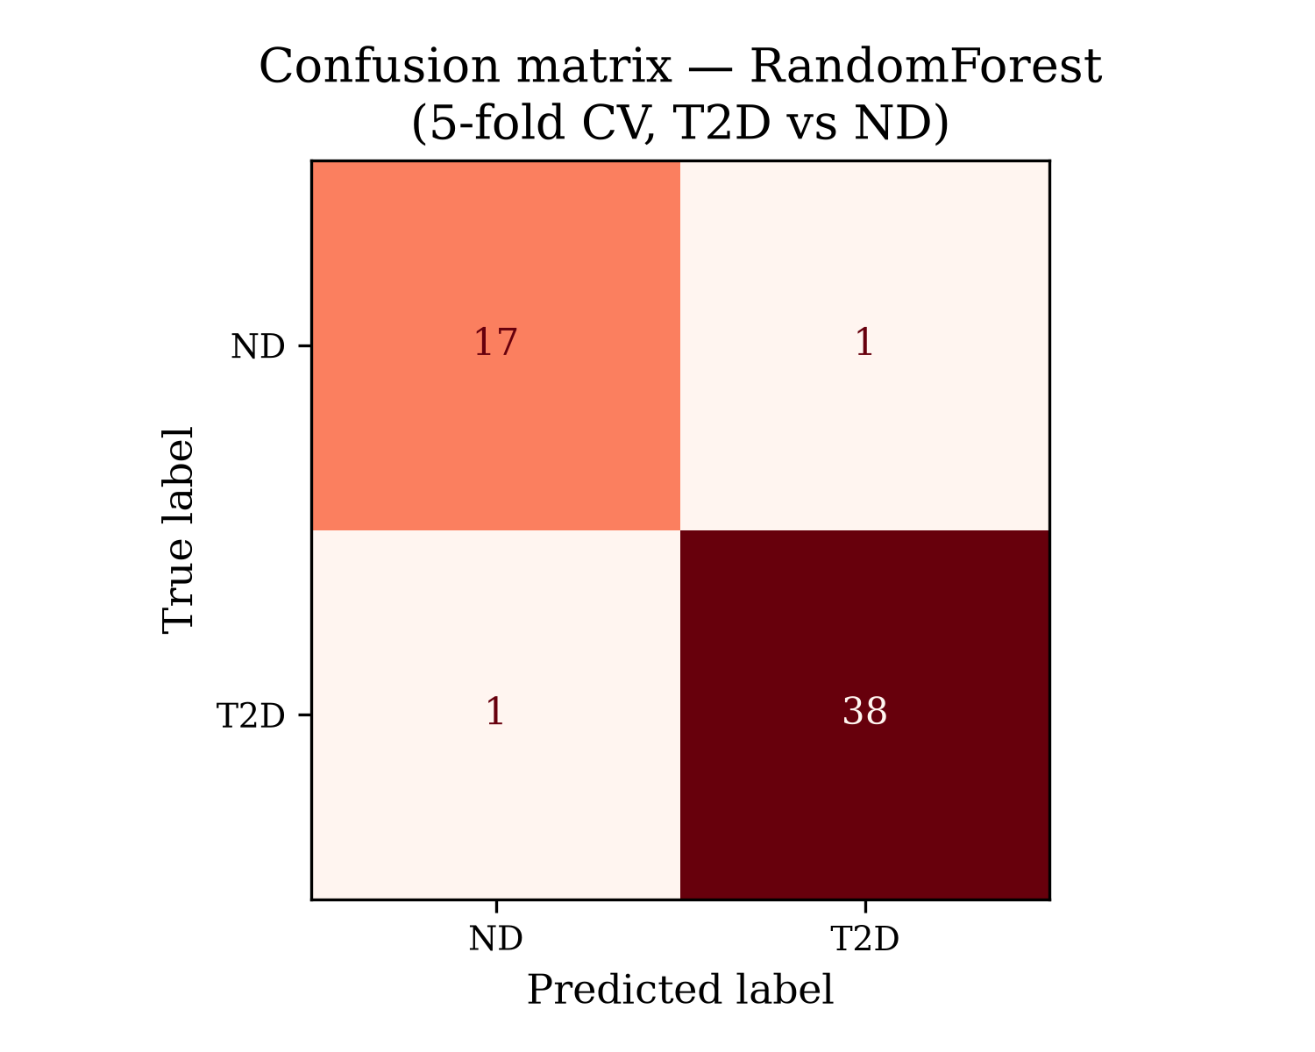
Figure S55. Confusion matrix, Random Forest binary classifier.
Confusion matrix for the Random Forest binary classifier (T2D vs ND) aggregated across cross-validation folds, corresponding to a balanced accuracy of 0.954.
Figure S56. Confusion matrix, Random Forest 3-class classifier.
Confusion matrix for the Random Forest classifier extended to the 3-class problem (ND vs IGT vs T2D), achieving a balanced accuracy of 0.714, reflecting the greater difficulty of distinguishing the intermediate IGT phenotype.
Figure S57. Permutation test of classification significance.
Distribution of AUC scores obtained from 200 permutations of shuffled class labels (null distribution), compared against the observed model AUC (dashed line), confirming that classification performance significantly exceeds chance (p=0.005).
Figure S58. Random Forest feature importance rankings.
Top 10 hub genes ranked by Random Forest mean decrease in Gini importance, including Novel lncRNA, KCNAB2, DKK3, GABRA2, HSD17B13, ACLY, SH3PXD2A, GNG7, and OPRD1, indicating their relative contribution to T2D classification.
Figure S59. SHAP beeswarm plot, XGBoost model.
SHAP (SHapley Additive exPlanations) value distribution for the top features of the XGBoost classifier. Each point represents one sample; horizontal position indicates SHAP value (impact on model output), colour indicates feature expression level (red = high, blue = low).
Figure S60. SHAP waterfall plot for a representative T2D sample.
SHAP waterfall plot decomposing the XGBoost model's prediction for a representative T2D sample into individual per-gene contributions, illustrating how each hub gene's expression level shifts the prediction away from the baseline (expected) value.
Figure S61. Hub gene expression heatmap across all samples.
Z-score-normalised expression heatmap of hub genes from the 8 focus modules across all samples, hierarchically clustered on both axes, with disease status annotated. Visualises the separation of expression patterns between ND, IGT, and T2D groups at the individual hub-gene level.
Figure S62. PCA biplot of hub gene expression.
Principal component analysis biplot of samples using only hub-gene expression features, with gene loading vectors overlaid, illustrating how the hub-gene-restricted feature set retains disease-stage separation observed in the full transcriptome PCA.

