Main Results Figures
The following figures constitute the primary visual evidence presented in the Results section of this dissertation. Each figure is accompanied by a full journal-style legend describing the experimental context, analytical methods, and key findings.

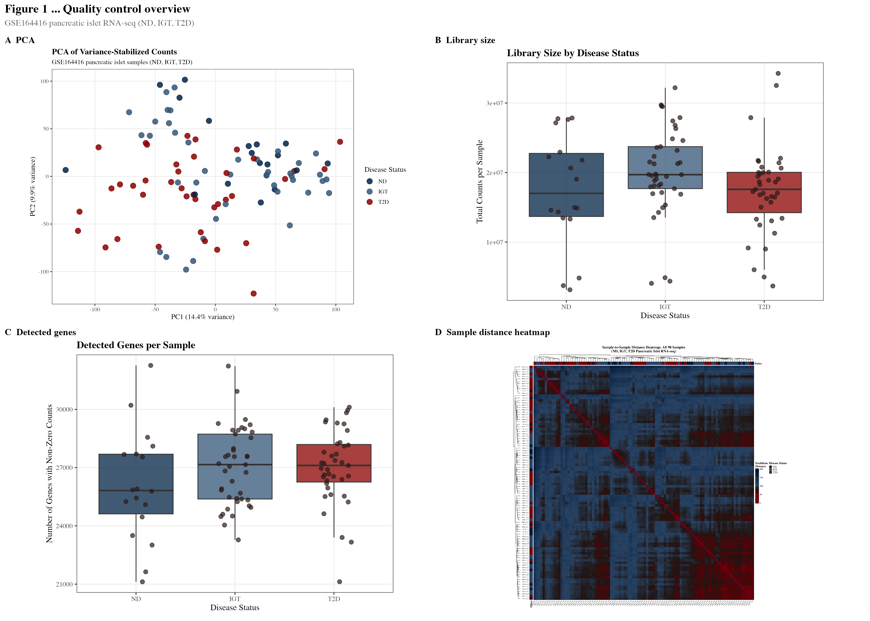
Figure 1. Transcriptome-wide quality control of pancreatic islet RNA-seq data.
(A) Principal component analysis (PCA) of variance-stabilising transformation (VST)-normalised read counts for all 98 pancreatic islet samples, coloured by disease status (non-diabetic [ND], n=18; impaired glucose tolerance [IGT], n=41; type 2 diabetes [T2D], n=39). PC1 and PC2 explain the principal axes of transcriptional variation. (B) Sequencing library size per sample grouped by disease status; bars indicate median. (C) Number of genes detected (count >0) per sample across groups. (D) Euclidean sample-distance heatmap derived from VST-normalised counts. Progressive separation along the disease axis is evident, confirming sample integrity and justifying downstream differential expression analysis. All panels generated from GSE164416 (Wigger et al., 2021, Nature Metabolism).

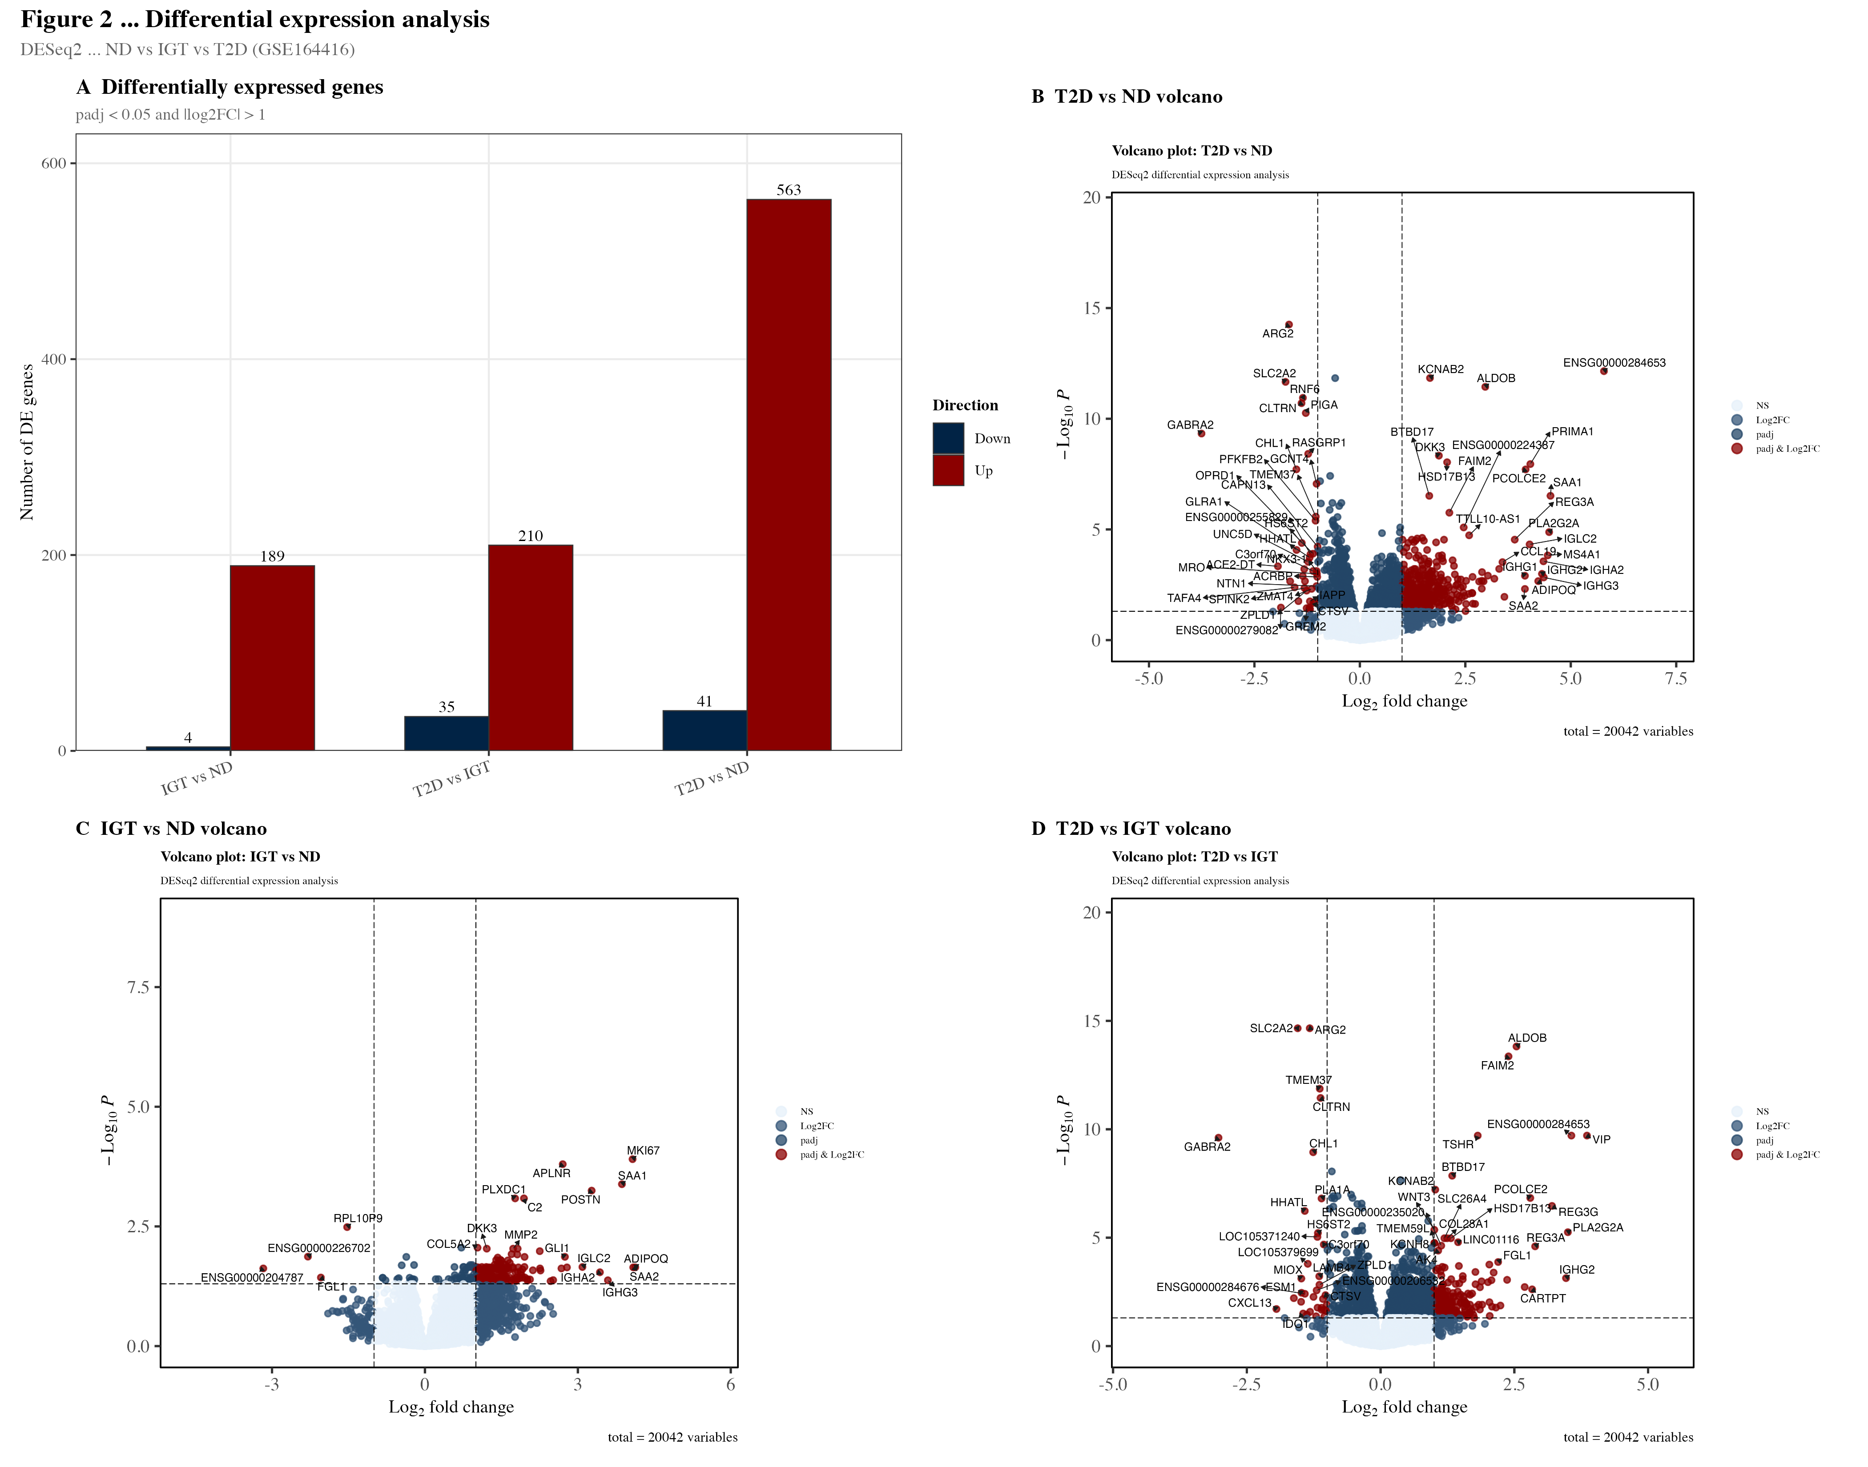
Figure 2. Differential expression landscape across disease progression stages.
Volcano plots and MA plots for each pairwise comparison: T2D vs ND (left), IGT vs ND (centre), and T2D vs IGT (right). Volcano plots display –log10(adjusted p-value) against log2 fold-change; horizontal dashed line indicates FDR < 0.05, vertical dashed lines indicate |log2FC| > 1. Significantly upregulated genes are shown in red, downregulated genes in blue, and non-significant genes in grey. MA plots show log2FC as a function of mean normalised expression (log10 scale) to assess expression-level-dependent bias. Differential expression was assessed using DESeq2 (v1.42) with Benjamini–Hochberg FDR correction. T2D vs ND: 563 upregulated, 41 downregulated (FDR < 0.05, |log2FC| > 1). IGT vs ND: 189 upregulated, 4 downregulated. T2D vs IGT: 210 upregulated, 35 downregulated.

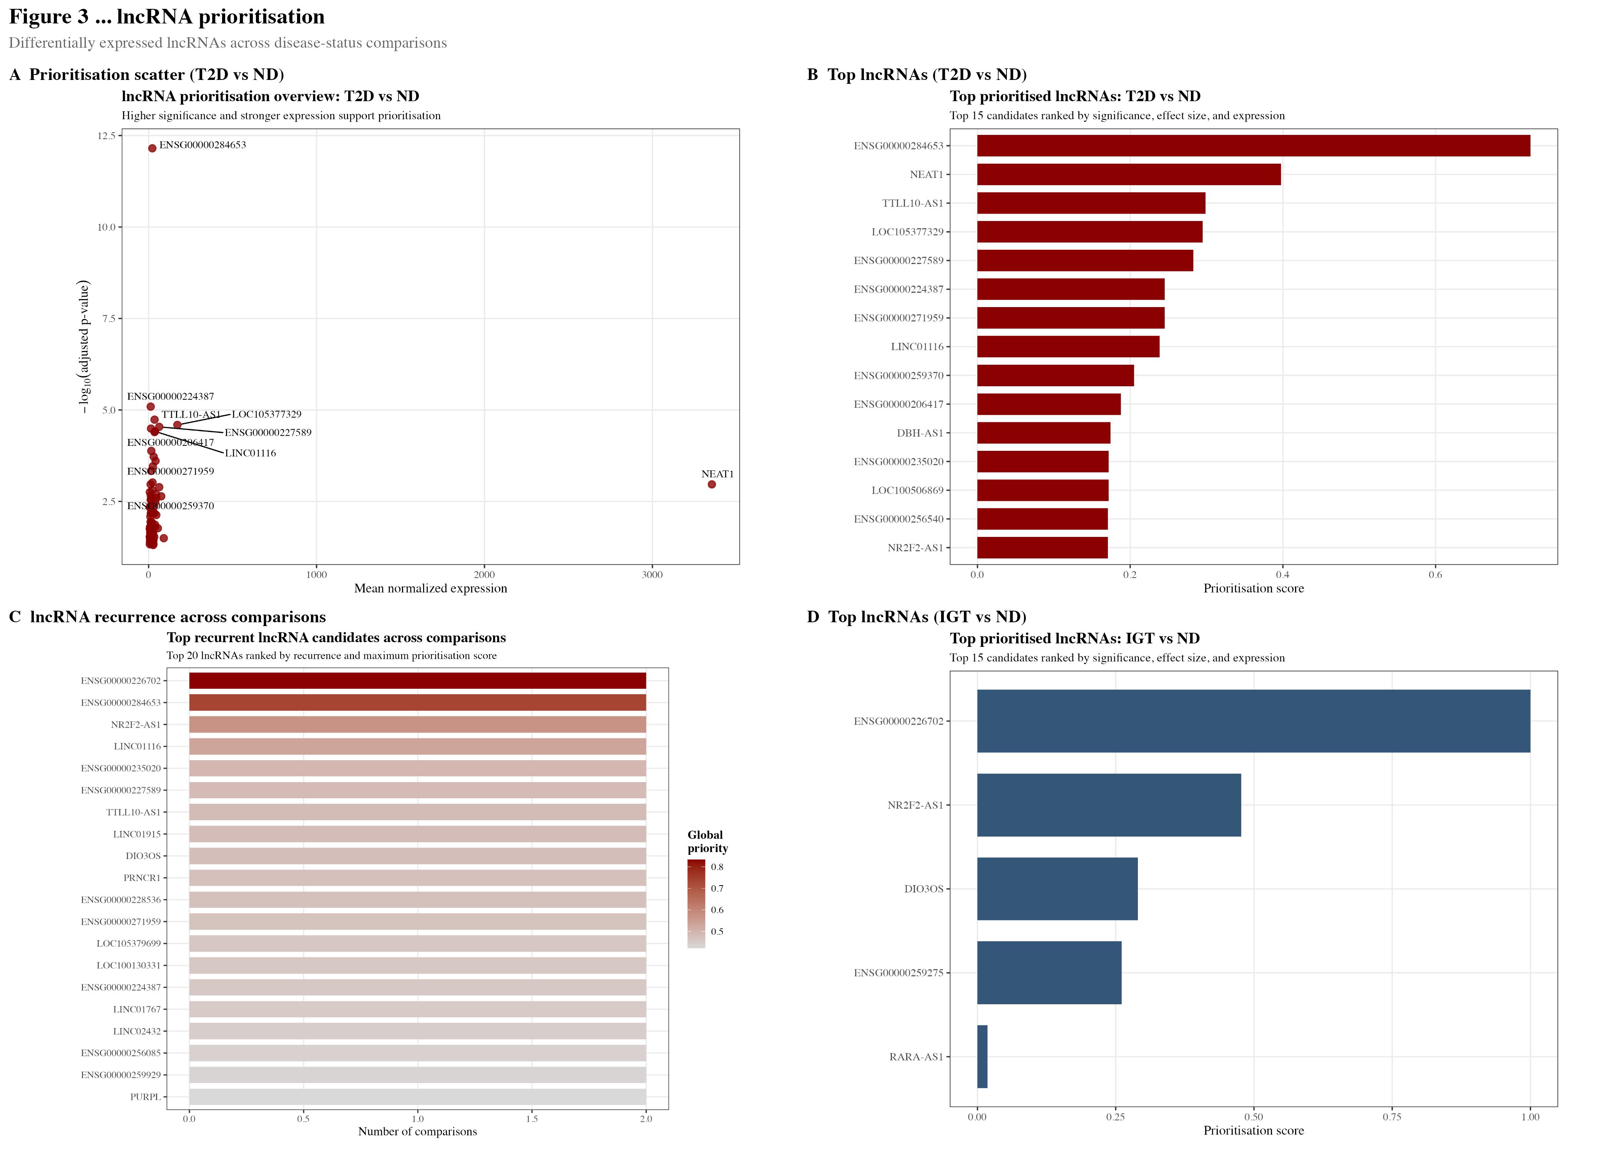
Figure 3. Multi-criteria prioritisation of long non-coding RNAs dysregulated in T2D.
Composite prioritisation of lncRNA candidates identified across differential expression comparisons. (A) Scatter plot of absolute log2 fold-change vs –log10(adjusted p-value) for lncRNAs in the T2D vs ND comparison, coloured by global composite priority score (rescaled fold-change + rescaled significance + rescaled cross-comparison recurrence). (B) Bar chart of lncRNA recurrence across the three comparisons (T2D vs ND, IGT vs ND, T2D vs IGT), indicating multi-stage dysregulation. (C–E) Top 15 prioritised lncRNA candidates per comparison, ranked by composite score. All annotated lncRNAs were identified using GENCODE v43 biotype classification. Analysis restricted to 115 lncRNAs detected across ≥1 comparison.

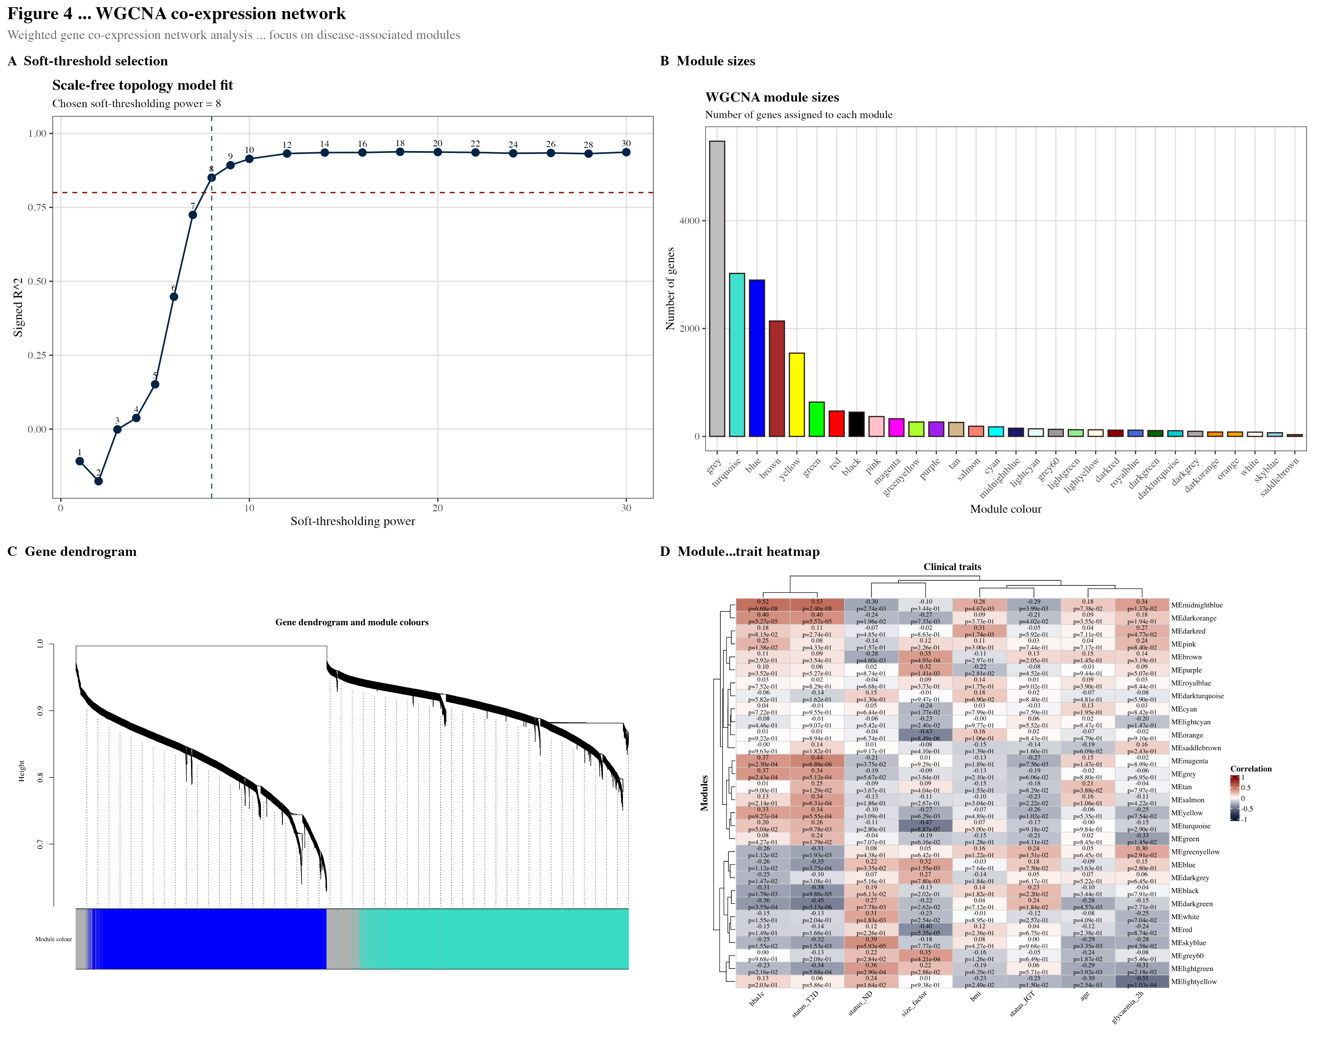
Figure 4. Weighted gene co-expression network construction and module-trait associations.
(A) Scale-free topology fit index (R²) as a function of soft-thresholding power β, used to select β=8 (R²=0.851, indicated by dashed line at 0.80 threshold). (B) Mean network connectivity as a function of β; selected power shown by dashed line. (C) Hierarchical clustering dendrogram of 20,042 genes based on signed bicor topological overlap, with module colour assignments below (30 modules, grey = unassigned). (D) Module-trait correlation heatmap displaying Pearson r between module eigengene expression and continuous clinical variables (HbA1c, fasting glucose, BMI, age) and binary disease status (T2D, IGT, ND). Cell values show r (p-value). Red = positive correlation, blue = negative correlation. Network construction performed using WGCNA (v1.72) with blockwiseModules, mergeCutHeight=0.25.

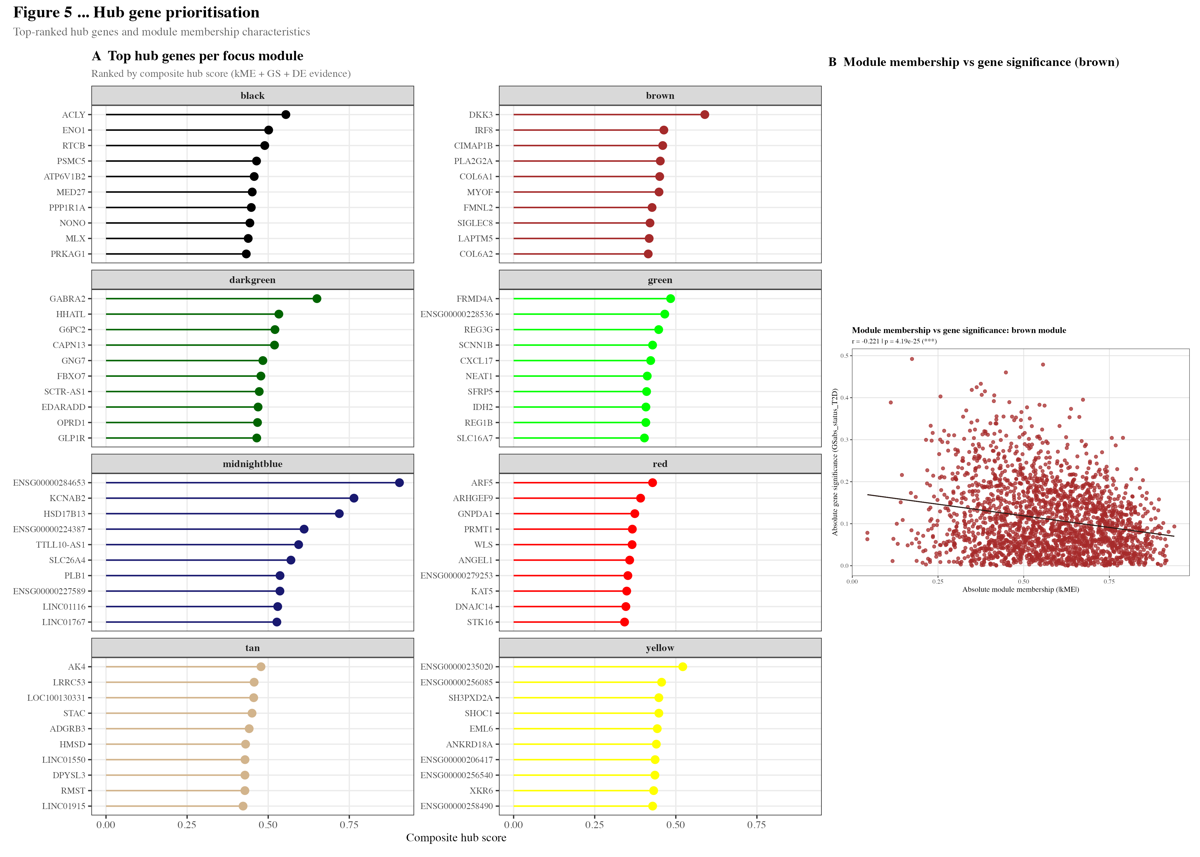
Figure 5. Hub gene identification across disease-associated co-expression modules.
(A) Bar chart of the top 10 hub genes per focus module ranked by composite hub score (module membership [kME] + gene significance [GS] for T2D trait + hub centrality). Focus modules were selected based on significant module-trait correlation (FDR < 0.05) and modules containing prioritised lncRNA candidates: brown, yellow, green, red, black, midnightblue, darkgreen, and tan (8 modules, 5,760 genes). (B) Module membership (kME) vs gene significance (GS) scatter for the brown module, with hub genes labelled. Intramodular connectivity quantified via signed bicorrelation to the module eigengene. Hub genes represent the most biologically informative regulatory nodes within each module.

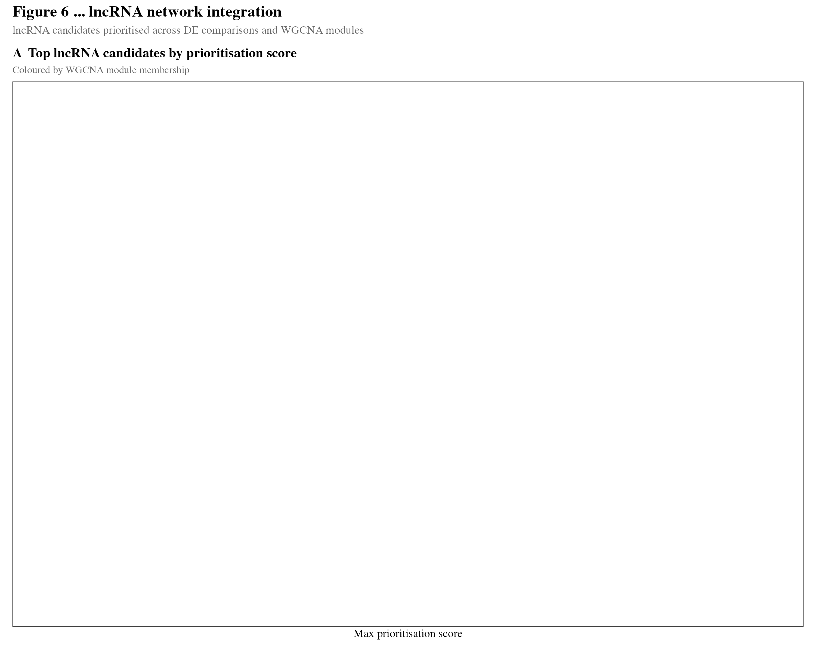
Figure 6. Integration of prioritised lncRNA candidates within the co-expression network.
Network integration of the top 20 prioritised lncRNA candidates with the WGCNA co-expression framework. (A) Module membership of lncRNA candidates across the 8 focus modules, showing distribution of lncRNAs within modules midnightblue, darkgreen, and tan — which were added to the focus set specifically because they harbour high-priority lncRNAs. (B) Comparison of module membership (kME) and gene significance (GS) for lncRNA hub candidates versus protein-coding hub genes within the same modules. lncRNAs with high kME (>0.70) were classified as intramodular hub lncRNAs, indicating co-regulatory roles with protein-coding partners within the T2D-associated network.

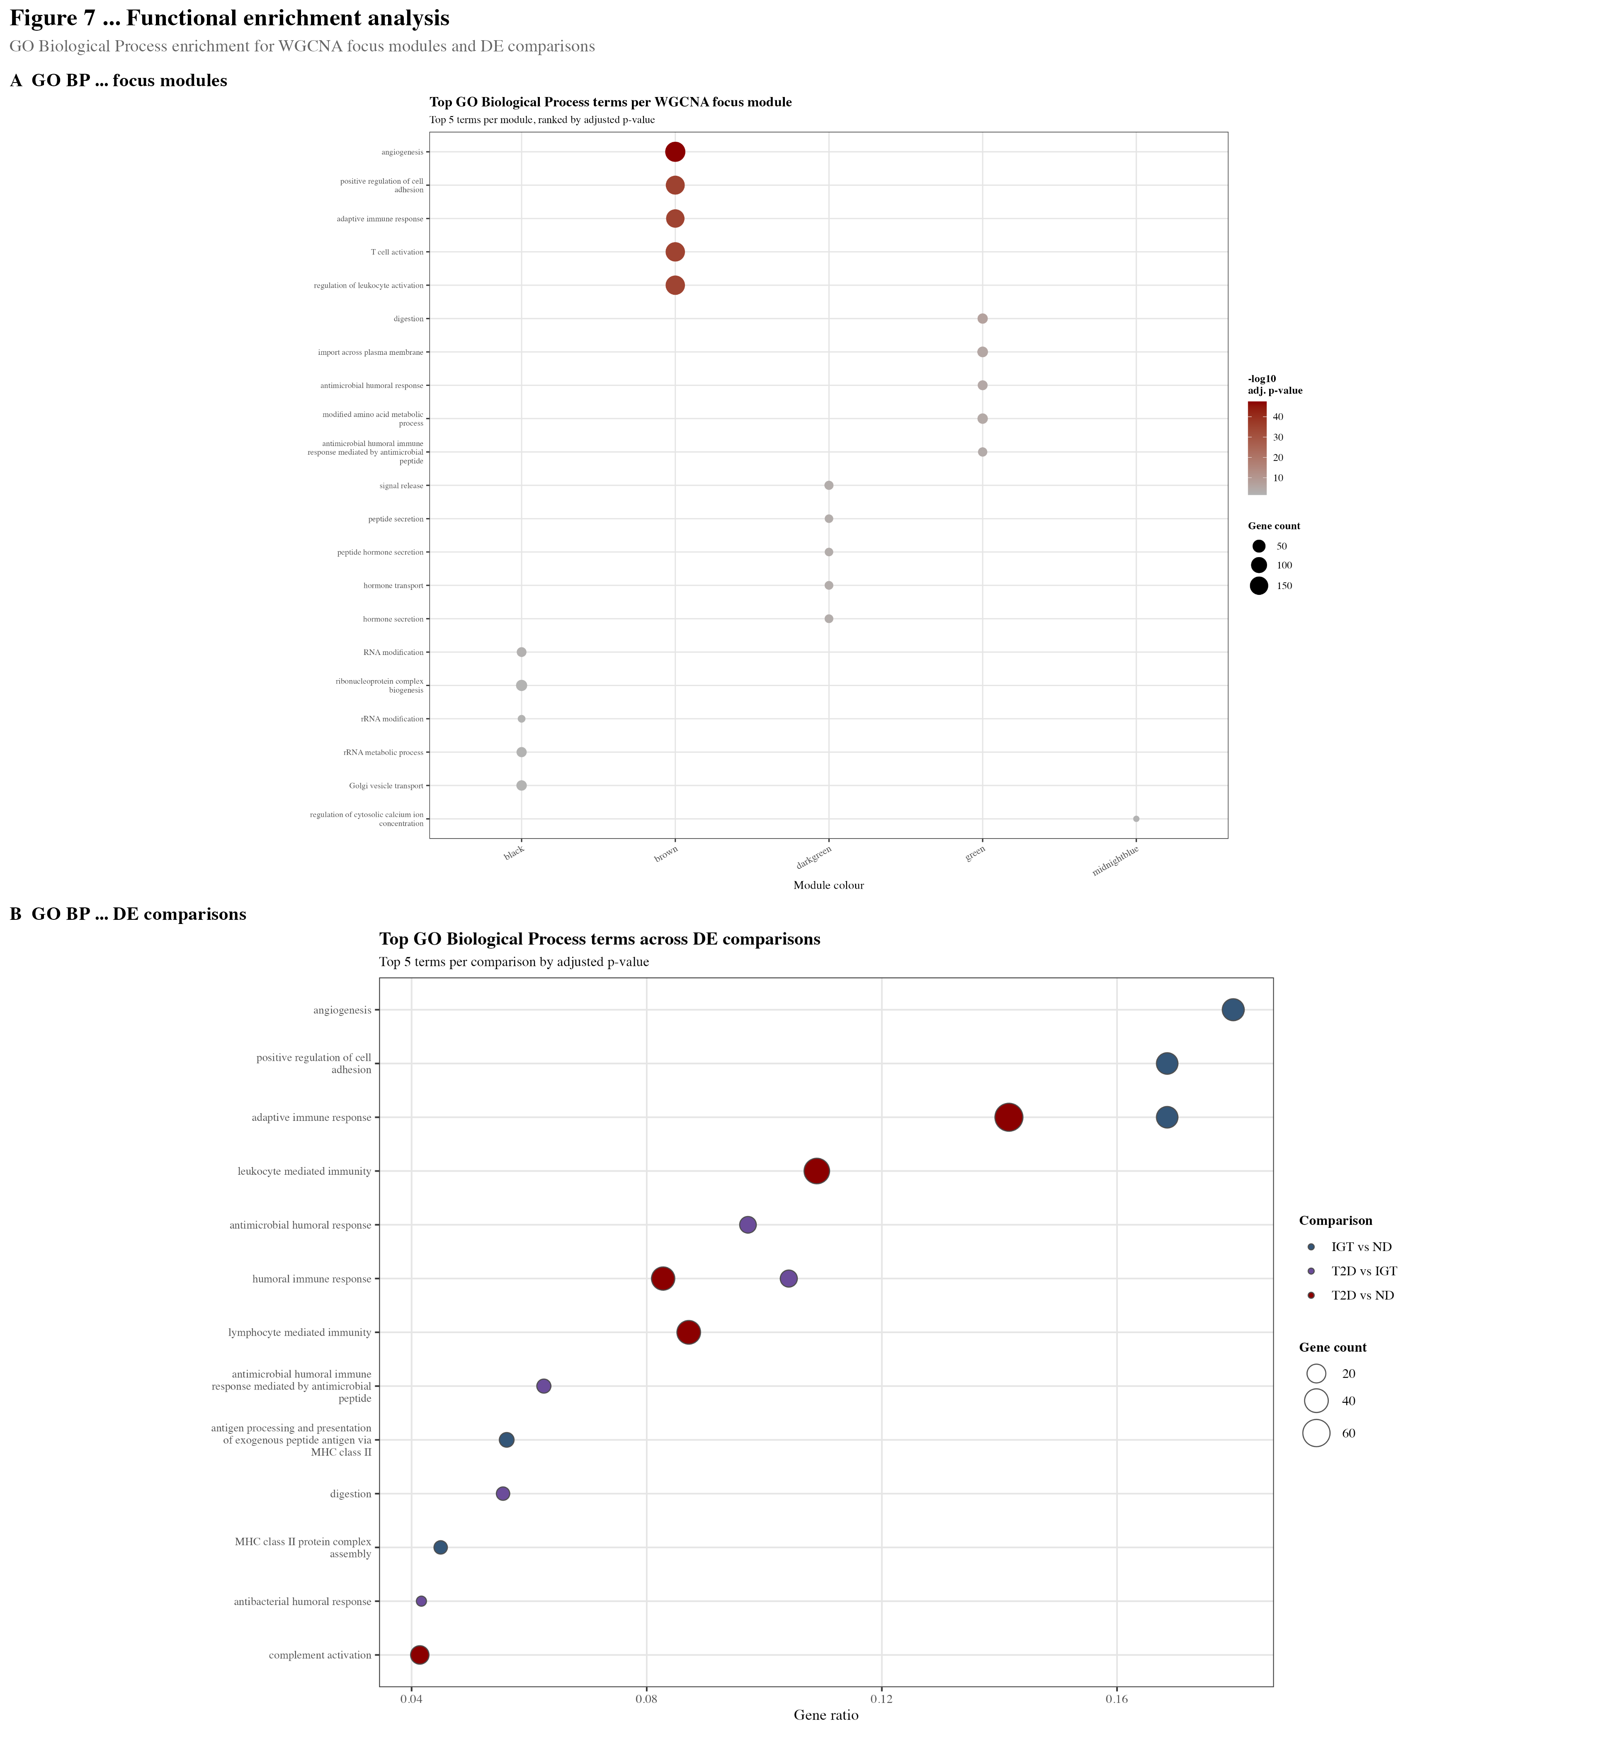
Figure 7. Functional enrichment analysis of disease-associated co-expression modules.
Gene Ontology Biological Process (GO BP) and KEGG pathway enrichment for genes within the 8 focus co-expression modules, performed using clusterProfiler (v4.10) with Benjamini–Hochberg FDR correction (q < 0.05). Background gene set = all 20,042 genes tested in the differential expression analysis. (A) Cross-module GO BP summary dot plot: dot size represents gene ratio (detected/background), colour represents –log10(q-value). Selected significant terms per module are shown. (B) Per-module KEGG pathway enrichment for the brown and black modules, highlighting enrichment for insulin secretion and RNA modification pathways respectively. Enrichment analyses restricted to modules with ≥10 annotated genes per term.

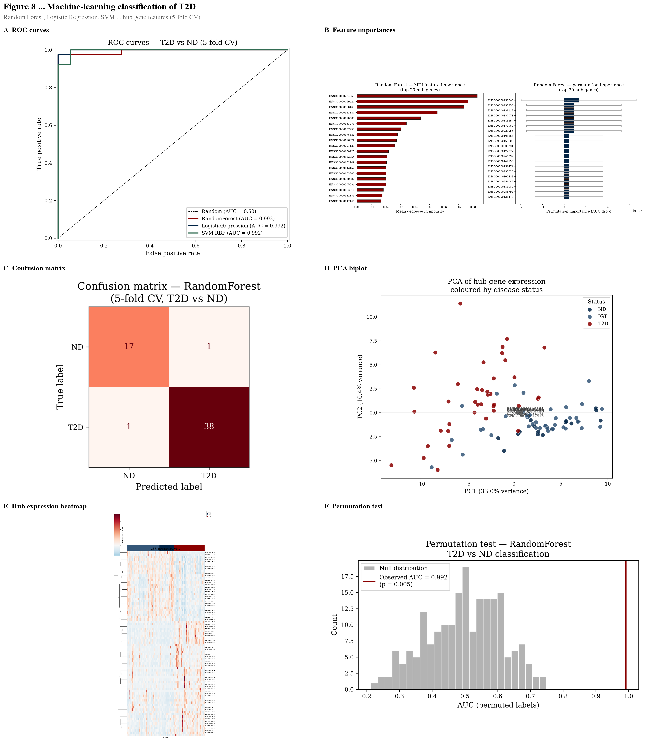
Figure 8. Machine learning classification of T2D using hub gene expression signatures.
(A) Receiver operating characteristic (ROC) curves for binary T2D vs ND classification using three machine learning models: Random Forest (RF; AUC=0.992±0.017), Logistic Regression (LR; AUC=0.992), and Support Vector Machine with radial basis function kernel (SVM-RBF; AUC=0.992), evaluated by 5-fold stratified cross-validation. (B) Permutation test (n=200 permutations) confirming classification significantly exceeds chance (p=0.005). Feature matrix comprised z-score-normalised expression values for hub genes from 8 focus modules. (C) Random Forest feature importance rankings for the top 10 genes. (D) XGBoost SHAP beeswarm plot illustrating directional feature contributions per sample, with red/blue indicating high/low gene expression. All models trained on hub gene features only; XGBoost used for SHAP interpretation (objective='binary:logistic').

