**CHAPTER 1**

**INTRODUCTION**

The rural area is seeing a groundbreaking movement with the coming the GlobalInternet of Things (IoT) innovation, which vows to improve effectiveness, efficiency, and manageability. Among the creative uses of IoT in horticulture is the improvement of the Savvy Cows Framework. This framework use IoT innovations, including water level sensors, gas sensors, GPS trackers, and infrared (IR) sensors, to offer a complete answer for animals the board. By incorporating these advancements, the Shrewd Dairy cattle Framework tends to basic parts of cows cultivating, for example, guaranteeing sufficient hydration, checking natural circumstances, following steers developments, and upgrading generally security. This paper digs into the presentation and issue portrayal of the IoT-based Shrewd Steers Framework, featuring its capability to alter cows the executives rehearses.

# The Brilliant Cows Framework additionally integrates GPS following innovation, giving continuous experiences into steers area and development designs. This element permits ranchers to screen their domesticated animals' whereabouts and recognize any deviations from anticipated conduct, for example, wandering or burglary. By engaging ranchers to go to proactive lengths, the framework upgrades generally speaking security and resource insurance.

# Project Description:

Dairy cattle cultivating faces various difficulties that can fundamentally influence the government assistance of the creatures and the efficiency of the activities. Conventional techniques for overseeing cows frequently include manual checking and responsive measures, which are work serious as well as inclined to mistakes and shortcomings. The central points of contention that need tending to in steers cultivating include:

The IoT-based Shrewd Steers Framework means to address these difficulties by coordinating high level sensors and correspondence innovations. The framework is intended to give ongoing information and alarms, empowering ranchers to settle on informed choices and go to proactive lengths to guarantee the government assistance and efficiency of their animals.

Water Level Sensor: The water level sensor assumes a basic part in guaranteeing that dairy cattle have consistent admittance to water. By checking the water levels in box or tanks, the sensor gives continuous specifics to the ranchers. In the unlikely circumstance that the water level lowers beneath an exact point, the framework sends an alarm, permitting the rancher to recharge the water supply instantly. This proactive methodology forestalls drying out and guarantees the wellbeing and efficiency of the cows.

Gas Sensor: The gas sensor is fundamental for identifying destructive gases that could represent a gamble to the dairy cattle's wellbeing. For example, the presence of alkali or methane in outbuildings or brushing regions can be impeding to the respiratory wellbeing of the creatures. The gas sensor ceaselessly screens the air quality and cautions the rancher considering a rare occurance unsafe gas levels surpass safe cutoff points. This empowers ideal intercession to moderate wellbeing gambles and keep a protected climate for the steers.

GPS Tracker: The GPS tracker gives constant following of steers, offering important bits of knowledge into their area and development designs. This innovation is essential for forestalling wandering and robbery, as it permits ranchers to observee the specific whereabouts of their steers consistently. The framework advises the rancher about any deviations from typical development designs , assuming that they’ve been spotted, empowering quick activity to find and recover the dairy cattle. This improves security and resource insurance, decreasing misfortunes because of burglary or wandering.

Infrared (IR) Sensor: The IR sensor is utilized for distinguishing the presence of cows in unambiguous regions, like nibbling zones or horse shelters. It helps in observing the action levels and development of steers, giving information on their way of behaving and guaranteeing that they’re in the assigned regions. The presence of trespassers or hunters can also be detected using the infrared sensorss, making the rancher aware of possible dangers and empowering opportune intercessions to safeguard the steers.

**CHAPTER 2**

**LITERATURE SURVEY**

Sachin Kumar, Prayag Tiwari and Mikhail Zimbler, this paper addresses a blossoming worldview that works with correspondence between electronic gadgets and sensors through the web, pointed toward improving different features of our reality. Utilizing brilliant gadgets and web network, IoT offers creative answers for a plenty of difficulties experienced across different areas, including business, government, and public/confidential ventures globally. Through working with smooth cooperation and data sharing across gadgets that are arranged, IoT holds the commitment of changing the manner in which we see and address ordinary undertakings and complex issues the same.[1]

Zainab H. Ali, Hesham Arafat Ali, Mahmoud M. Badway, IoT has become firmly as a more prosperous region toexpress this kkind of another innovation. Though distributed computing is definitely not another innovation in this industry, representing the universe of ubiquitous computing has been utilized. In the seventh in the series of ITU Web Reports initially it was sent off in 1997 under the title "Difficulties to the Network".[2]

AbdelRahman H. Hussein, In this papper he recognizes the GlobalInternett of Things (IoT) and the web. The web fills as a result of tremendous correspondence network associating people to data. Conversely, the IoT involves extraordinarily recognizable actual items with handling, detecting, and incitation abilities. These items can interoperate and convey through the web. Hussein's understanding explains the advancing scene of network in the computerized age.[3][11]

M. Dachyar, Teuku Yuri M. Zagloel, L. Ranjaliba Saragih, In the vincinity of 2006 and 2018, the review amassed 8,510 diary papers and 16,775 meeting continuing papers through the Web of Things. The investigation follows the beginnings of IoT conversations to three gathering papers from 2006 by Adelmann et al., Bernard, and Rammig et al. Albeit just a single paper unequivocally incorporates "Web of Things" in its title, the other two notice it in the theoretical. This broad dataset offers bits of knowledge into the development and expansion of IoT talk over the inspected period.[4]

Ahmad Bilal Zia and Ms. Kshamta Chauhan investigate the nuanced scene of private applications inside the Web of Things (IoT), featuring its complicated control and dispersion components. Perceiving the requirement for bits of knowledge and backing for scientists, the creators embrace an outline to depict the examination scene into an organized scientific classification. Zeroing in on late examinations, especially in the domain of savvy homes utilizing IoT innovation, the paper expects to give an exhaustive survey and add to propelling information in this quickly developing domain.[5]

**2.1. Existing system**

A few existing frameworks and innovations presently utilized in animals the executives address various parts of steers cultivating. Mechanized draining frameworks, for example, are intended to drain cows without human intercession. These mechanical frameworks use sensors to identify when a cow is fit to be drained and guide it to a draining station, guaranteeing that the draining system is led productively and cleanly, in this wayy further developing milk yield and quality. In any circumstances, these frameworks center exclusively around draining and don't address other basic parts of steers the board. Wearable wellbeing screens, for example, savvy collars or ear labels, track essential signs and action levels of dairy cattle, giving ongoing wellbeing information like pulse, internal heat level, and development designs. This takes into consideration early identification of medical problems and opportune mediation, diminishing the gamble of sickness spread. By and by, they frequently require manual information incorporation for thorough investigation.

Natural control frameworks in stables use sensors to screen and direct temperature, moistness, and ventilation, guaranteeing ideal everyday environments for cows and forestalling heat pressure and respiratory issues. Robotized changes in light of sensor information work on animal solace and efficiency, yet these frameworks regularly work freely of other homestead the board apparatuses. Accuracy taking care of frameworks use sensors to screen the feed admission of individual cows, guaranteeing every creature gets the fitting supplements in light of their wellbeing status and efficiency. This enhancement of feed productivity decreases squander and work on generally wellbeing and development of the steers however doesn't give bits of knowledge into different parts of dairy cattle the executives. Virtual fencing innovation utilizes GPS and IoT-empowered collars to oversee cows development without actual obstructions, offering an adaptable and proficient method for controlling munching designs and forestall wandering. Regardless of its adequacy in dairy cattle following, it frequently needs coordination with other observing frameworks.

While these current frameworks give significant bits of knowledge and upgrade functional proficiency, they frequently miss the mark on exhaustive mix presented by the IoT-based Brilliant Cows Framework. The Shrewd Cows Framework remarkably consolidates water level sensors, gas sensors, GPS trackers, and IR sensors to give a comprehensive answer for steers the board, tending to hydration, ecological dangers, area following, and generally wellbeing observing in a solitary, coordinated stage. This exhaustive methodology guarantees the government assistance and efficiency of animals while advancing functional productivity and maintainability in steers cultivating.

**2.2. Feasibility study**

# The IoT-based Savvy Cows Framework coordinates trend setting innovations, including water level sensors, gas sensors, GPS trackers, and IR sensors, to actually screen and oversee animals. The specialized parts expected for this framework are promptly accessible and have been demonstrated in different rural and modern applications. The incorporation of these parts into a durable framework is feasible with current innovation and can be upheld by existing remote correspondence conventions like LoRa, Zigbee, or cell networks for information transmission. The framework's design will include a focal center or passage to gather and handle information from the sensors, which can then be gotten to from a distance by ranchers through a portable application or web interface.

# The underlying interest in the IoT-based Savvy Cows Framework incorporates the expense of sensors, specialized gadgets, establishment, and programming improvement. Notwithstanding, the drawn out financial advantages offset the underlying expenses. By guaranteeing ideal hydration, decreasing the gamble of ecological dangers, forestalling cows wandering or burglary, and further developing by and large steers wellbeing, the framework can essentially improve efficiency and diminish functional expenses. Also, the potential for decreased work costs and limited misfortunes because of medical problems or burglary further backings the financial feasibility of the undertaking. Ranchers can accomplish a profit from speculation through better steers efficiency and diminished functional failures.

# Executing the Brilliant Dairy cattle Framework requires preparing ranchers and homestead laborers to actually utilize the new innovation. The framework is intended to be easy to use, with natural points of interaction and robotized alarms to limit the expectation to absorb information. Continuous help and support will be important to guarantee the framework works ideally. Given the developing acknowledgment of innovation in farming, the functional execution is plausible, particularly with appropriate preparation and backing. The framework can be steadily coordinated into existing ranch tasks, permitting ranchers to adjust to the new cycles without critical disturbance.

# 2.3 Tools and Technologies used

# To execute the IoT-based Savvy Steers Framework, a blend of cutting edge sensors and improvement sheets like Hub MCU32, ESP32, and Arduino IDE, alongside programming in C language, shapes the establishment. These parts are painstakingly chosen to address key difficulties in present day domesticated animals the executives. The Hub MCU32 and ESP32 loads up, famous for their strength and availability choices including Wi-Fi and Bluetooth, work with constant information obtaining and correspondence. Modified in C, these sheets guarantee effective asset the board and exact command over sensor associations.

# The framework coordinates fundamental sensors like water level sensors, gas sensors, GPS trackers, and IR sensors. Water level sensors screen hydration levels in box or tanks, pivotal for steers wellbeing. Gas sensors identify destructive substances like methane or smelling salts, prudently making ranchers aware of ecological dangers. GPS trackers give exact area information, supporting crowd the executives and burglary counteraction. IR sensors guarantee cows are securely held inside assigned regions, improving security.

# Using Arduino IDE improves on advancement, offering a recognizable programming climate for fast prototyping and sending. This arrangement not just empowers ongoing checking of dairy cattle wellbeing, development, and ecological circumstances yet additionally upholds proactive navigation. By outfitting these advancements, the IoT-based Savvy Steers Framework upgrades functional proficiency, improves animal government assistance, and supports economical cultivating rehearses in the cutting edge farming scene

# 2.4 The Hardware and Software Requirements

### **HARDWARE REQUIREMENTS**

|  |  |  |  |
| --- | --- | --- | --- |
| **SL.NO** | **COMPONENT NAME** | **SPECIFICATION** | **NO. OF**  **COMPONENT** |
| 01 | ESP 32 | At mega 2560 | 1 |
| 02 | Node MCU | - | 1 |
| 03 | GPS | Neo 6 | 1 |
| 04 | IR Sensor | - | 1 |
| 05 | Gas Sensor | - | 1 |
| 05 | Water Level Sensor | - | 1 |
| 06 | Buzzer | - | 2 |
| 07 | Jumpers | M-F, F-F | 20 |

**Fig.2.5.1**

## **A circuit board with wires and cables Description automatically generatedARDUINO BOARD**

**Fig.2.5.2**

To design and create electronic devices, Arduino is an open-source hardware and programming platform. The Arduino board is made up of sets of straightforward and intelligent I/O (Information/Result) pins that can connect to various circuits, expansion sheets, and breadboards. These sheets describe the sequential correspondence interfaces, Widespread Sequential Transport (USB), and the model that are used for stacking PC programs.

In light of the ATmega328, the Arduino Uno is a microcontroller board. It features a 16 MHz resonator, 20 digital input/yield pins (six of which can be used as PWM results and the remaining six as basic data sources), a USB connection, a power jack, an in circuit framework programming (ICSP) header, and a reset button.

It further provides an IDE (Coordinated Advancement Climate) project, whose code is sent to the real board via the Handling Language. The GPL and LGPL have approved the duties. The GNU (Overall population Permit) is the name of the GPL. The Lesser Overall Population Permit, or GNU, is the name of the approved LGPL. It may be created by anyone and allows the use of Arduino sheets for product delivery.

General Pin Capabilities

•Driven: A computerized pin 13 implicit drive exists. When the pin is high, the drive is on; when it is low, the drive is off.

• VIN: The voltage information sent to the Arduino/Genuino board when it is powered by an external source as opposed to the 5 volts provided by the USB association or another regulated power supply. This pin allows you to supply electricity, or alternatively, it allows you to access voltage provided via the power jack.

•5V: The board's controller provides a directed 5V to this pin. The DC power jack (7 20V), USB connection (5 V), or board VIN pin (7 20V) can all be used to supply power to the board. Using the 3.3V or 5V pins to supply voltage circumvents the controller and may cause damage to the board.

•3.3V: An on-board controller-created 3.3 volt supply. 50 Mama is the most intense current draw.

•GND: Pins on the ground.

•IOREF: The voltage reference that the microcontroller operates on is provided by this pin on the Arduino/Genuino board. A well-designed safety feature can read the IOREF pin voltage and choose the proper power supply, or it can enable voltage interpreters based on the results to operate at either 3.3V or 5V.

• Reset: This button is typically added to add security and prevent the one on the board from being used.

Using pin Mode(), automated Compose(), and advanced Read() functions, every one of the Uno's six basic and 14 advanced pins can be programmed to represent an information or result. It runs on 5 volts. Each pin has an inward draw up resistor of 20 to 50K ohm, which is naturally isolated, and can work in a range of 20 to 20 Mama. It is imperative that no I/O pin be exceeded at 40mA to prevent permanent damage to the microcontroller. Six basic information sources (designated A0 through A5) are available on the Uno. each gives 10 pieces of goal (for example 1024 distinct qualities). Naturally, they measure from ground to 5 volts, however it is feasible to change the upper finish of the reach utilizing the AREF pin and the simple Reference() capability.

Sequential/UART: Pins 0 (RX) and 1 (TX). used to transmit (TX) and receive (RX) TTL sequential data. These pins are connected to the corresponding pins of the USB-to-TTL sequential ATmega8U2 chip.

•Pins 2 and 3 are affected externally. These pins can be made to activate a stop on a low value, a rising or falling edge, or a major value alteration.

•PWM (pulse width modulation): pins 3, 5, 6, 9, 10, and 11. able to provide an 8-bit PWM yield using the basic Compose() function.

•SPI stands for Sequential Fringe Connection point, and its pins are SS, MOSI, MISO, and SCK. By using the SPI library, these pins enable SPI correspondence.

•Pin SDA (A4) and pin SCL (A5) are the TWI (two-wire interface)/I²C pins. Use the Wire library to facilitate TWI correspondence.

•The reference voltage for basic data sources is known as the AREF (simple reference). Simple reference, or AREF, is the voltage used as a reference for basic data sources.

**Particulars of Arduino**

## •An increase in input voltage from 7 to 12 volts is recommended.

## •There is a 6V to 20V information voltage.

## • There are 14 computerized input/yield pins.

## Six basic I/P pins are used, 5v is operating voltage

## • Each info/yield pin has a 40 Mama DC current.

## •50 Mama is the DC current for the 3.3V pin.

## •32 KB is the leak memory.

## **BUZZER**

A mechanical, electromechanical, or piezoelectric sound-detecting device is called a ringer. An electronic circuit that is wavering or another source of sound signals can power a piezo electric ringer. A metal plate and a piezoelectric ceramic plate with terminals on both sides make up a piezoelectric stomach. Cements are used to attach a piezoelectric earthenware plate to a metal plate. The piezoelectric impact causes mechanical mutilation when D.C. voltage is applied between the terminals of a piezoelectric stomach. In the case of a deformed piezoelectric component, the piezoelectric stomach bends in the direction of the heading, and the piezoelectric component contorts in a spiral bearing.The common semiconductor communicating circuit is used to connect a bell. The 0V rails of each power supply must be connected to provide a typical reference if a different power source is used for the ringer.

**Fig.2.5.3**

**Node MCU ESP32**

The NodeMCU ESP32 is a flexible and strong improvement board in view of the ESP32 microcontroller. While it imparts many highlights to the ESP32 CAM module, for example, Wi-Fi and Bluetooth abilities, it doesn't accompany a coordinated camera like the OV2640. Be that as it may, it tends to be utilized for an extensive variety of IoT applications including remote sensor organizations, home mechanization, and IoT projects requiring network and handling capacities. The following is an outline of the NodeMCU

ESP32 particulars:

a. Microcontroller: ESP32-D0WDQ6 V3

b. Processor: Double center Tensilica LX6 chip

c. Built-in Streak: 4MB

d. RAM: Inner 520KB + Outer PSRAM support

e. Antenna: Installed PCB recieving wire

f. WiFi Convention: IEEE 802.11 b/g/n

g. Bluetooth: Bluetooth 4.2 BR/EDR and BLE

h. Wi-Fi Mode: Station/SoftAP/SoftAP+Station

i. Security: WPA/WPA2/WPA2 Endeavor/WPS

j. Peripheral Point of interaction: UART/SPI/I2C/PWM

k. Digital I/O Pins: 36

l. Analog Information Pins: 18 (ADC)

m. UART Baudrate Rate: Default 115200bps

n. Power Supply: 5V by means of miniature USB or Vin pin

o. Transmitting Power:

p. 802.11b: 17 ±2dBm (@11Mbps)

q. 802.11g: 14 ±2dBm (@54Mbps)

r. 802.11n: 13 ±2dBm (@HT20, MCS7)

s. Receiving Responsiveness:

t. CCK, 1Mbps: - 90 dBm

u. CCK, 11Mbps: - 85 dBm

v. 6Mbps (1/2 BPSK): - 88 dBm

w. 54Mbps (3/4 64 QAM): - 70 dBm

x. HT20, MCS7 (65Mbps, 72.2Mbps): - 67 dBm

y. Power Utilization:

z. Active Mode: 160-260mA

aa. Deep Rest: < 10μA

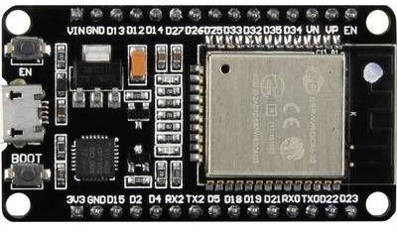bb. Light Rest: < 20mA

**Fig.2.5.4**

**GPS MODULE**

The NEO-6 GPS module is a minimal and solid GPS collector module ordinarily utilized in different route and following applications. The NEO-6 GPS module gives precise situating data low power utilization, making it appropriate for battery-worked and compact applications. It imparts through UART point of interaction and results standard NMEA sentences, permitting simple mix with microcontrollers like Arduino or ESP32 for area based projects. With its quick chance to initially fix and solid execution, the NEO-6 GPS module is generally utilized in IoT gadgets, vehicle global positioning frameworks, drones, and different applications requiring exact situating and route abilities.

Here is an outline of the details of the NEO-6 GPS module:

1. Receiver Sort: u-blox NEO-6M GPS beneficiary

2. Positioning Precision:

3. Horizontal: < 2.5 meters (independent)

4. SBAS (WAAS, EGNOS, MSAS): < 2.0 meters

5. Time to Initially Fix (TTFF):

6. Cold Beginning: < 27 seconds

7. Warm Beginning: < 27 seconds

8. Hot Beginning: < 1 second

9. Sensitivity:

10. Tracking and Route: - 161 dBm

11. Reacquisition: - 160 dBm

12. Cold Beginning: - 147 dBm

13. Update Rate: Up to 5Hz

14. Protocol: NMEA 0183

15. Communication Connection point: UART (TTL)

16. Baud Rate: Default 9600 bps (configurable)

17. Operating Voltage: 3.3V to 5.0V

18. Power Utilization:

19. Acquisition: 45 Mama

20. Tracking: 25 Mama

21. Operating Temperature: - 40°C to +85°C

22. Dimensions: Roughly 25mm x 25mm x 10mm (barring connector)

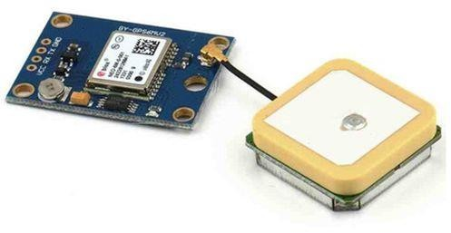

## **Fig.2.5.5**

## **IR SENSOR**

This small Fire sensor infrared beneficiary module start source discovery module is Arduino viable can use to distinguish fire or frequency of the light source inside 760nm~1100nm likewise helpful for Lighter fire recognize at the

distance 80cm.

More noteworthy the fire, farther the test distance. It has the Recognize point of 60 and extremely delicate to fire range.

It delivers the one channel yield signal at the D0 terminal for additional handling like an alert framework or any exchanging framework. The responsiveness is customizable with the assistance of blue potentiometer given on the board.

Highlights :

• Pointer light: a green one for the switch, a red one for power.

• Inherent a potentiometer for responsiveness control.

• Locally available sign result sign, yield viable sign is high, simultaneously the pointer light up, the result sign can straightforwardly interface with microcontroller IO.

• Can identify fire or frequency in 760 ~ 1100 nm nano inside the extent of the light source.

• Recognition point around 60 degrees, the fire range particularly delicate.

• The fire of the most touchy sensors fire, the standard light is likewise a reaction, by and large utilized for alarm purposes.

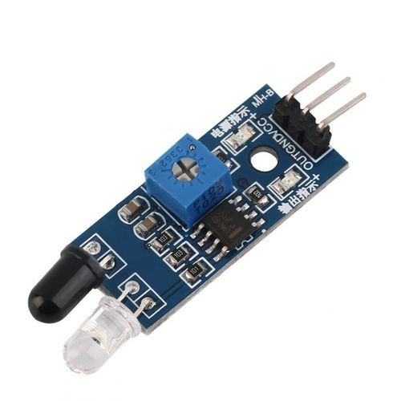

**Fig.2.5.6**

### **Water Level Sensor:**

The water level sensoor is a versatile and reliable component designed to detect the rangeof water in various applications. It provides accurate measurements to ensure efficient water management and monitoring in systems such as tanks, reservoirs, and irrigation systems.

Key Features:

* Precise detection of water levels for effective monitoring and control.
* Compatibility with different types of liquids, including water, chemicals, and fuels.
* Simple installation and integration into existing systems.
* Durable construction for long-term reliability in diverse environments.
* Wide operating temperature range to accommodate various applications.
* Low power consumption for energy-efficient operation.
* Analog or digital output options for seamless integration with monitoring systems.

### **Specifications:**

* Detection Method: Capacitive, resistive, ultrasonic, or optical sensing technology.
* Operating Voltage: Typically ranging from 3.3V to 5V DC.
* Output Signal: Analog voltage, digital signal (e.g., HIGH/LOW), or serial communication (e.g., UART, I2C).
* Detection Range: Varies depending on the sensor type and application, ranging from a few millimetres to several meters.
* Accuracy: High accuracy in measuring water levels, typically within a specified tolerance range.
* Response Time: Fast response time for real-time monitoring and control.
* Operating Temperature: Wide temperature range to ensure reliable performance in different environmental conditions.
* Material: Corrosion-resistant materials such as stainless steel, PVC, or polypropylene for longevity and durability.
* Protection Rating: IP (Ingress Protection) rating indicating resistance to dust and water ingress.
* Mounting Options: Various mounting options available, including threaded, flanged, or adhesive mounting.
* Cable Length: Standard cable length for easy connection to monitoring systems.
* Certifications: Compliance with relevant standards and certifications for quality assurance and safety.

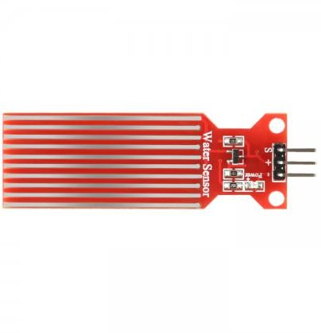

**Fig.2.5.7**

**SOFTWAREREQUIREMENTS**

**ArduinoIDE**

Arduino is a kind of program and equipment organization that offers open source climate for client task and client local area that expects and creates microcontroller based innovations for development computerized gadgets and intelligent items that can detect and deal with the actual world. For programming the microcontrollers, the Arduino proposition gives a product application or IDE in light of the Handling project, which incorporates C, C++ and Java programming. It likewise support for inserted C, C++ and Java programming.

**Working Framework :** Windows 7 or higher

**Programming Language :** C

**Smash :** 4GB or Higher

**Libraries :** ESP 32

**CHAPTER 3**

**SOFTWARE REQUIREMENTS SPECIFICATION**

# Arduino IDE is an incorporated advancement climate intended for programming microcontrollers, especially those from the Arduino stage. It gives an open-source climate to clients to create and model advanced gadgets and intelligent articles that cooperate with the actual world. This Product Prerequisites Detail (SRS) frames the useful and non-practical necessities for Arduino IDE.

# Functional Requirements:

# Arduino IDE gives an easy to use point of interaction to composing, ordering, and transferring code to microcontrollers. Support for Arduino-viable microcontrollers (e.g., Arduino Uno, Hub MCU32, ESP32). Punctuation featuring and code fulfillment for C and C++ programming dialects. Incorporated chronic screen for investigating and checking correspondence among microcontroller and PC. Libraries expand the usefulness of Arduino IDE by giving pre-composed code modules. Capacity to oversee and introduce libraries straightforwardly from the Arduino Library Supervisor. Support for famous libraries like ESP32 for upgraded usefulness and similarity with explicit equipment.

# Non-Functional Requirements

# Arduino IDE should display proficient execution attributes, with negligible reaction times during code arrangement and transferring to microcontrollers. It ought to proficiently use framework assets like central processor and Smash to all the while handle complex ventures and different assignments. Adaptability is basic, empowering the IDE to oblige expanding project size and intricacy without compromising execution. Ease of use highlights incorporate a natural connection point, clear route, and far reaching documentation to help clients from amateur to master levels. Unwavering quality is foremost, guaranteeing stable activity without accidents or information misfortune, working with continuous advancement meetings. Compelling blunder taking care of systems help in identifying and settling coding issues quickly, upgrading engineer efficiency and task respectability. Safety efforts, for example, encoded information transmission and secure stockpiling of undertaking records, safeguard against unapproved access and information breaks. Similarity with a large number of Arduino-viable microcontrollers and working frameworks (Windows, macOS, Linux) guarantees flexibility and openness for engineers. Keeping up with particularity and all around organized code upholds future improvements and updates to the IDE. Customary updates to documentation and local area support gatherings give continuous help and best practices for clients. Asset productivity limits energy utilization and functional expenses, supporting manageable improvement rehearses. Consistence with industry principles and open-source rules guarantees adherence to lawful and moral standards in programming improvement. Openness highlights take care of clients with handicaps, advancing inclusivity in the engineer local area.

# Module Implementation

# The Shrewd Steers Framework incorporates different sensors and availability modules to guarantee the prosperity and security of domesticated animals. Fueled by Arduino and using parts like Peltier modules, GPS, GSM, and sensors, this framework gives ongoing checking and quick reaction capacities. At the center of this framework is the Arduino board, which is fueled by a battery and re-energized by the Peltier module. This arrangement empowers consistent activity even in distant areas. The Arduino speaks with a scope of sensors inserted inside the brilliant steers coats. These sensors incorporate inner and outside sensors intended to screen essential boundaries like temperature, moistness, and water levels. Utilizing Bluetooth network, the sensor information is communicated to a door gadget, like a client's cell phone, for additional handling. From that point, the information is handed-off to focal servers for observing and examination. The utilization of GPS considers exact following of the dairy cattle's area, guaranteeing their wellbeing and security.

# In case of a fire, fire sensors coordinated into the coats can rapidly recognize the presence of blazes, setting off a caution to the focal servers. Additionally, smoke sensors screen air quality, guaranteeing that the climate is ok for the dairy cattle to relax. Important bodily functions of the steers, for example, pulse, are checked utilizing BPM sensors. This data gives experiences into the wellbeing and prosperity of the creatures, considering convenient intercession assuming any irregularities are recognized.

**CHAPTER 4**

**SYSTEM DESIGN**

## **Figure 4.1 system design**

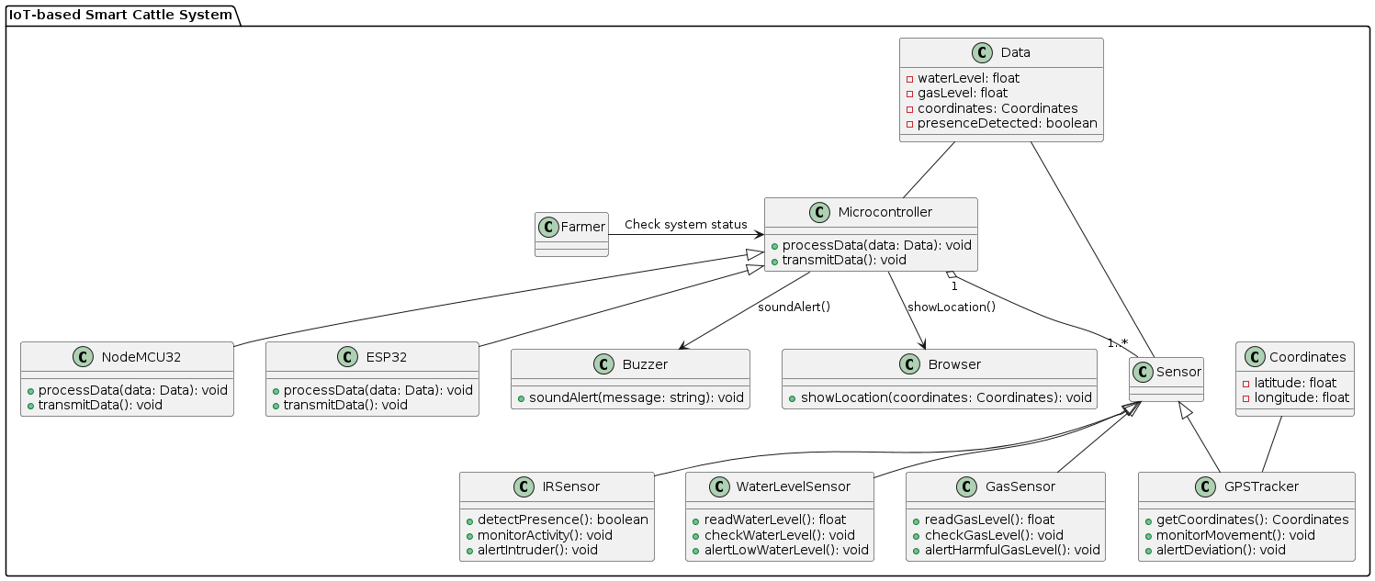

**CHAPTER 5**

**SNAP SHOTS**

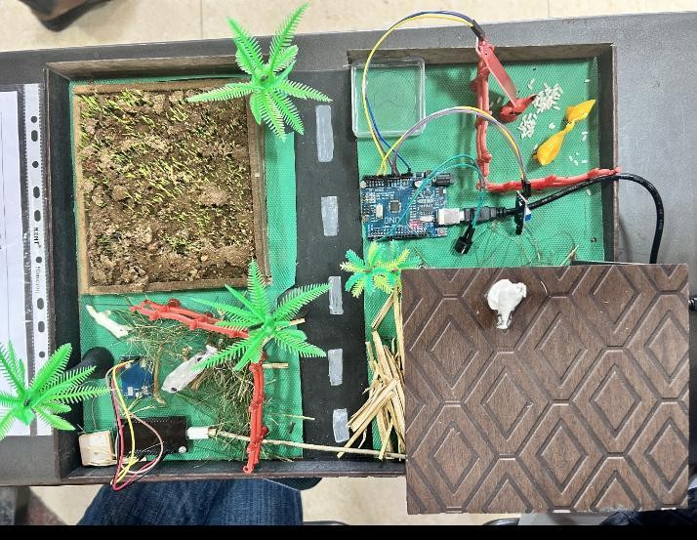

**Fig.5.1 Prototype**

**Fig.5.2 Fire Detection**

**Fig.5.3 GPS Tracker**

**CHAPTER 6**

**TESTING**

Testing is a pivotal stage in the improvement of the IoT-based Savvy Steers Framework. It guarantees that the framework capabilities as planned, dependably accumulates information, and cautions ranchers to basic circumstances. This testing plan frames the techniques and procedures for confirming the framework's presentation, unwavering quality, and heartiness, zeroing in on the sensors (water level, gas, GPS tracker, IR), microcontrollers (NodeMCU32, ESP32), and ready components (signal, program based GPS show).

**1. Testing Goals**

The essential targets of testing the Brilliant Dairy cattle Framework are to:

• Approve the exactness and dependability of sensor information.

• Guarantee the microcontrollers accurately process and communicate information.

• Affirm the usefulness of the ringer and program based GPS show.

• Survey the framework's reaction time and heartiness under different circumstances.

• Recognize and amend any product or equipment issues.

**2. Testing Climate**

The testing climate will copy genuine circumstances as intently as could be expected. The arrangement incorporates:

• A controlled homestead like climate with watering tanks, stables, and brushing regions.

• Reenacted perilous gas conditions to test the gas sensor.

• Geologically unmistakable areas to test GPS following.

• Presence of cows or comparative huge creatures to test the IR sensor.

• An organization arrangement to interface the microcontrollers, sensors, ringer, and program show.

**3. Testing Stages**

**3.1. Unit Testing**

**Water Level Sensor:**

**• Objective:** Guarantee the sensor precisely gauges water levels and triggers cautions when levels are low.

**• System:** Spot the sensor in water holders with differing water levels. Record sensor readings and contrast them and genuine water levels. Actually take a look at the framework's reaction to low water levels by checking bell cautions.

**Gas Sensor:**

**• Objective:** Check the sensor recognizes destructive gases and triggers alarms.

**• Technique:** Open the sensor to controlled convergences of smelling salts and methane. Screen sensor readings and guarantee alarms are set off when gas levels surpass safe limits.

**GPS Tracker:**

**• Objective:** Test the precision of GPS area following.

**• Method:** Move the GPS tracker to different predefined areas. Record the directions given by the tracker and contrast them and the genuine areas. Check the program based GPS show shows exact and continuous area information.

**IR Sensor:**

**• Objective:** Affirm the sensor distinguishes the presence of dairy cattle and triggers alarms for interlopers.

**• Strategy:** Spot the sensor in regions where steers are normal. Screen the sensor's identification exactness and reaction time. Recreate gatecrasher presence to test ready components.

**3.2. Reconciliation Testing**

**Microcontroller Reconciliation:**

**• Objective:** Guarantee the NodeMCU32 and ESP32 accurately process and communicate information from all sensors.

**• Methodology:** Interface every sensor to the microcontroller and recreate information assortment. Check that the microcontroller processes the information precisely and communicates it to the bell and program show. Test various mixes of sensor information to guarantee consistent coordination.

**Ready System Testing:**

**• Objective:** Test the usefulness of the bell and program based GPS show in cautioning the rancher.

**• Methodology:** Reproduce different situations, for example, low water levels, high gas focuses, and startling steers developments. Screen the ringer's reaction and check the GPS show for exact area refreshes. Guarantee the cautions are opportune and clear.

**3.3. Framework Testing**

**By and large Framework Execution:**

**• Objective:** Evaluate the framework's general exhibition in a true climate.

**• Method:** Send the whole framework in a ranch like setting. Screen the framework's presentation over a drawn out period, recording information precision, reaction times, and the recurrence of bogus alarms. Assess the framework's capacity to deal with numerous cautions all the while and its strength under changing ecological circumstances.

**Stress Testing:**

**• Objective:** Test the framework's dependability under outrageous circumstances.

**• Strategy:** Subject the framework to elevated degrees of information traffic, recreate power changes, and open sensors to outrageous ecological circumstances. Screen the framework for steadiness, information uprightness, and ready precision.

**3.4. Client Acknowledgment Testing**

**Rancher Association:**

**• Objective:** Guarantee the framework addresses the end client's issues and is easy to understand.

**• Methodology:** Include ranchers in testing the framework. Assemble input on the simplicity of understanding and answering cautions, the clearness of the program based GPS show, and the general convenience of the framework. Make vital changes in view of client criticism.

**4. Testing Measurements**

To gauge the adequacy of the testing system, the accompanying measurements will be followed:

**• Exactness:** The level of right sensor readings contrasted with genuine estimations.

**• Reaction Time:** The time taken by the framework to deal with information and trigger cautions.

**• Dependability:** The framework's capacity to work without disappointments over a predetermined period.

**• Convenience:** Client criticism on the framework's usability and clearness of alarms.

**• Misleading Alarm Rate:** The recurrence of wrong cautions set off by the framework.

**5. Experiments**

**Experiment 1: Water Level Checking**

**• Objective:** Confirm water level sensor exactness and ready usefulness.

**• Method:** Change water levels and record sensor readings. Trigger low water level circumstances and confirm cautions.

**Experiment 2: Gas Recognition**

**• Objective:** Guarantee gas sensor precisely distinguishes unsafe gases.

**• Method:** Open sensor to controlled gas fixations and check cautions at limit levels.

**Experiment 3: GPS Following**

**• Objective:** Test GPS precision and continuous area refreshes.

**• Technique:** Move GPS tracker to different areas and contrast recorded organizes and genuine areas.

**Experiment 4: IR Sensor Identification**

**• Objective:** Affirm presence location and gatecrasher ready usefulness.

**• Methodology:** Reproduce steers presence and gatecrashers, check sensor precision and ready reactions.

**Experiment 5: Reconciliation and Ready Component**

**• Objective:** Guarantee consistent information handling and alarming.

**• Method:** Incorporate sensors with microcontrollers, recreate information assortment, confirm ringer alarms and program GPS show.

**CHAPTER 7**

**CONCLUSION**

All in all, the reconciliation of savvy advancements, for example, fire and water level checking frameworks, alongside GPS trackers, presents a groundbreaking answer for cows the board. By utilizing these headways, ranchers can improve their functional productivity, guarantee the prosperity of their animals, and moderate potential dangers successfully. The use of fire observing frameworks considers proactive identification and avoidance of fierce blazes, protecting both the steers and the general climate from destruction. At the same time, water level checking guarantees sufficient hydration for the dairy cattle, advancing their wellbeing and efficiency. Moreover, GPS trackers offer constant area following, empowering ranchers to screen their animals' developments and quickly address any deviations or crises.

**CHAPTER 8**

**FUTURE ENHANCEMENT**

Later on, improving the shrewd cows framework with computerized fire concealment systems and crisis reaction capacities could change animals the board rehearses. By coordinating actuators into the fire checking framework, for example, sprinkler frameworks or fire retardant gadgets, the framework could independently answer fire flare-ups, relieving likely harm to both cows and encompassing vegetation. Moreover, integrating prescient examination and AI calculations could empower the framework to expect fire gambles with in view of authentic information and ecological variables, permitting ranchers to go to proactive lengths to limit the danger of fierce blazes. In addition, coordinating the framework with weather conditions checking stations would give continuous updates on weather patterns, working with precautionary activities to lessen fire gambles.

Moreover, empowering remote checking and control would engage ranchers to deal with the framework successfully from anyplace, guaranteeing quick reaction to crises even in their nonattendance. By carrying out these headways, the brilliant dairy cattle framework could essentially upgrade wellbeing, effectiveness, and flexibility in domesticated animals the board, offering significant advantages to ranchers and the more extensive agrarian local area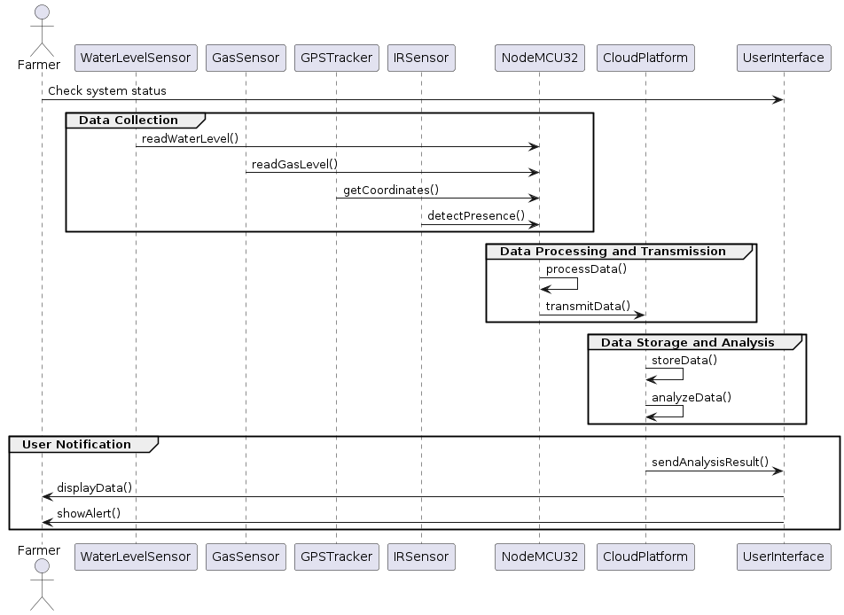

**Fig.7.1 Future Work**

**CHAPTER 9**

**BIBILOGRAPHY**

[1] Sachin Kumar, Prayag Tiwari and Mikhail Zymbler," IoT is a progressive methodology for future innovation improvement.", 09 December 2019,Journal Of Enormous Information.

[2] Zaina H. Ali, Hesham Arafat Ali,"Internet of Things (IoT): Definitions, Difficulties, and Late Exploration Bearings ",October 2015,International Diary of PC Applications.

[3] Anthima Shendge,"Internet of Things (IOT): Exploration Difficulties and Future Applications ", December 2021,ResearchGate Article.

[4] M. Dachyar,Teuku Yuri M. Zagloel, and L. Ranjaliba Saragih,"Knowledge development and improvement: IoT research, 2006-2018 ", 2019 Aug 28,National Community for Biotechnology Information[NCBI].

[5] Ahamed Billal Zia," A Web of Things Exploration Paper Involving OCTAVE Allegro for Security Chance Evaluation in Brilliant Homes ", June 2020,ResearchGate Article.

[6] Khalid El Moutaouakil, Falih Noureddine," A plan of a shrewd ranch framework for cows checking ", November 2023, Indonesian Diary of Electrical Designing and Software engineering.

[7] Valeria V. Krzhizhanovskaya, Gábor Závodszky, Michael H. Dregs, "IoT-Based Cow Wellbeing Observing Framework", 2020 May 5, Public Community for Biotechnology Information[NCBI].

[8] Annu Sharma, Shwetank Arya, Praveena Chaturvedi, Multispectral Picture Combination Framework In light of Wavelet Change for Secure Human Acknowledgment. Global Diary of Cutting edge Science and Innovation. 28, 19 (Dec. 2019), 811 - 820.

[9] R. García, J. Aguilar, Paul Rodríguez," A deliberate writing survey about the utilization of ML[Machine Learning] in accuracy domesticated animals cultivating", PCs and Hardware in,1 December 2020.

[10] Justin Ophir Isaac, "IOT - Domesticated animals Observing AND The board Framework", January 2021,ResearchGate Article.

[11] Annu Sharma, Shwetank Arya, Praveena Chaturvedi, "An Original Picture Pressure Based Technique for Multispectral Finger impression Biometric System,Procedia PC Science,Volume 171,2020,Pages 1698-1707,ISSN0509,https://doi.org/10.1016/j.procs.2020.04.182.

[12] Bhisham Sharma, Deepika Koundal," CattleHealth Monit0ringsystem utilizing WirelessSensor Organization: An Overview according to Development Viewpoint", Walk 2018,IET Remote Sensor Framework.

[13] K. Gupta, R. K. Dwivedi, A. Sharma, M. Farooq and B. R. S, "Execution Assessment of Blockchain Stages," 2023 Global Meeting on IoT, Correspondence and Mechanization Innovation (ICICAT), Gorakhpur, India, 2023, pp. 1-6, doi: 10.1109/ICICAT57735.2023.10263700.

Top of Form

Bottom of Fo