1. **Project Summary**
   1. **Purpose:**

To streamline and simplify the process of storing data about Chocoholics Anonymous (ChocAn) members and providers, and to make it easier for the providers to bill ChocAn for providing services to its members.

* 1. **Scope:**

The ChocAn Data Centre software will be accessible by providers and managers, and will be operating within the confines of the physical location of the Chocoholics Anonymous organization.

* 1. **Objectives:**

To automate the following processes:

* Keeping records of the members of Chocoholics Anonymous and its health care professionals (providers),
* Keeping detailed records of service appointments of members with their providers, containing the date of the appointment, fees, etc.,
* Generating weekly member, provider and summary reports each week and on demand for the manager,

through the ChocAn Data Center software.

* 1. **Deliverables:**

Product:

The product will have the following major functionalities:

* Providing a login module to providers and managers (which uses a keyboard for input, instead of swiping a card, for the acceptance test)
* Validating provider and manager details and providing them access to the services they respectively need.
* Showing member and provider reports and a summarised report once every week.

Documentation:

* Use case diagram
* Description of all use cases
* Functional and non-functional requirements
* Software Project Management Plan
* Entity-Relationship diagram
* State chart
* Class-Responsibility-Collaborator cards
* Data flow analysis
* Class diagram
* Collaboration diagram
* Sequence diagram equivalent to collaboration diagram
* Black box test cases
  1. 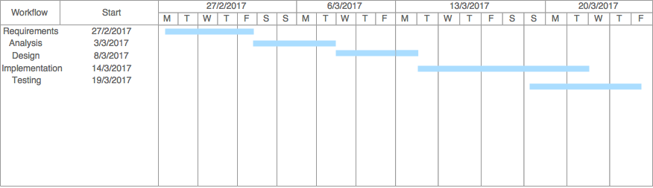**Schedule:**

1. **References:**

Schach, Stephen R. *Object-Oriented and Classical Software Engineering 8th Ed*. 2011. McGraw Hill

1. **Primary roles and responsibilities:**

Requirements, Analysis, Design: Sufiyan Samnani, Furqaan Attarwala

Implementation, Testing: Tanesh Manjrekar, Vishal Chandra

1. **Process Model:**

The waterfall software development model was used in the development of ChocAn Data Centre.