[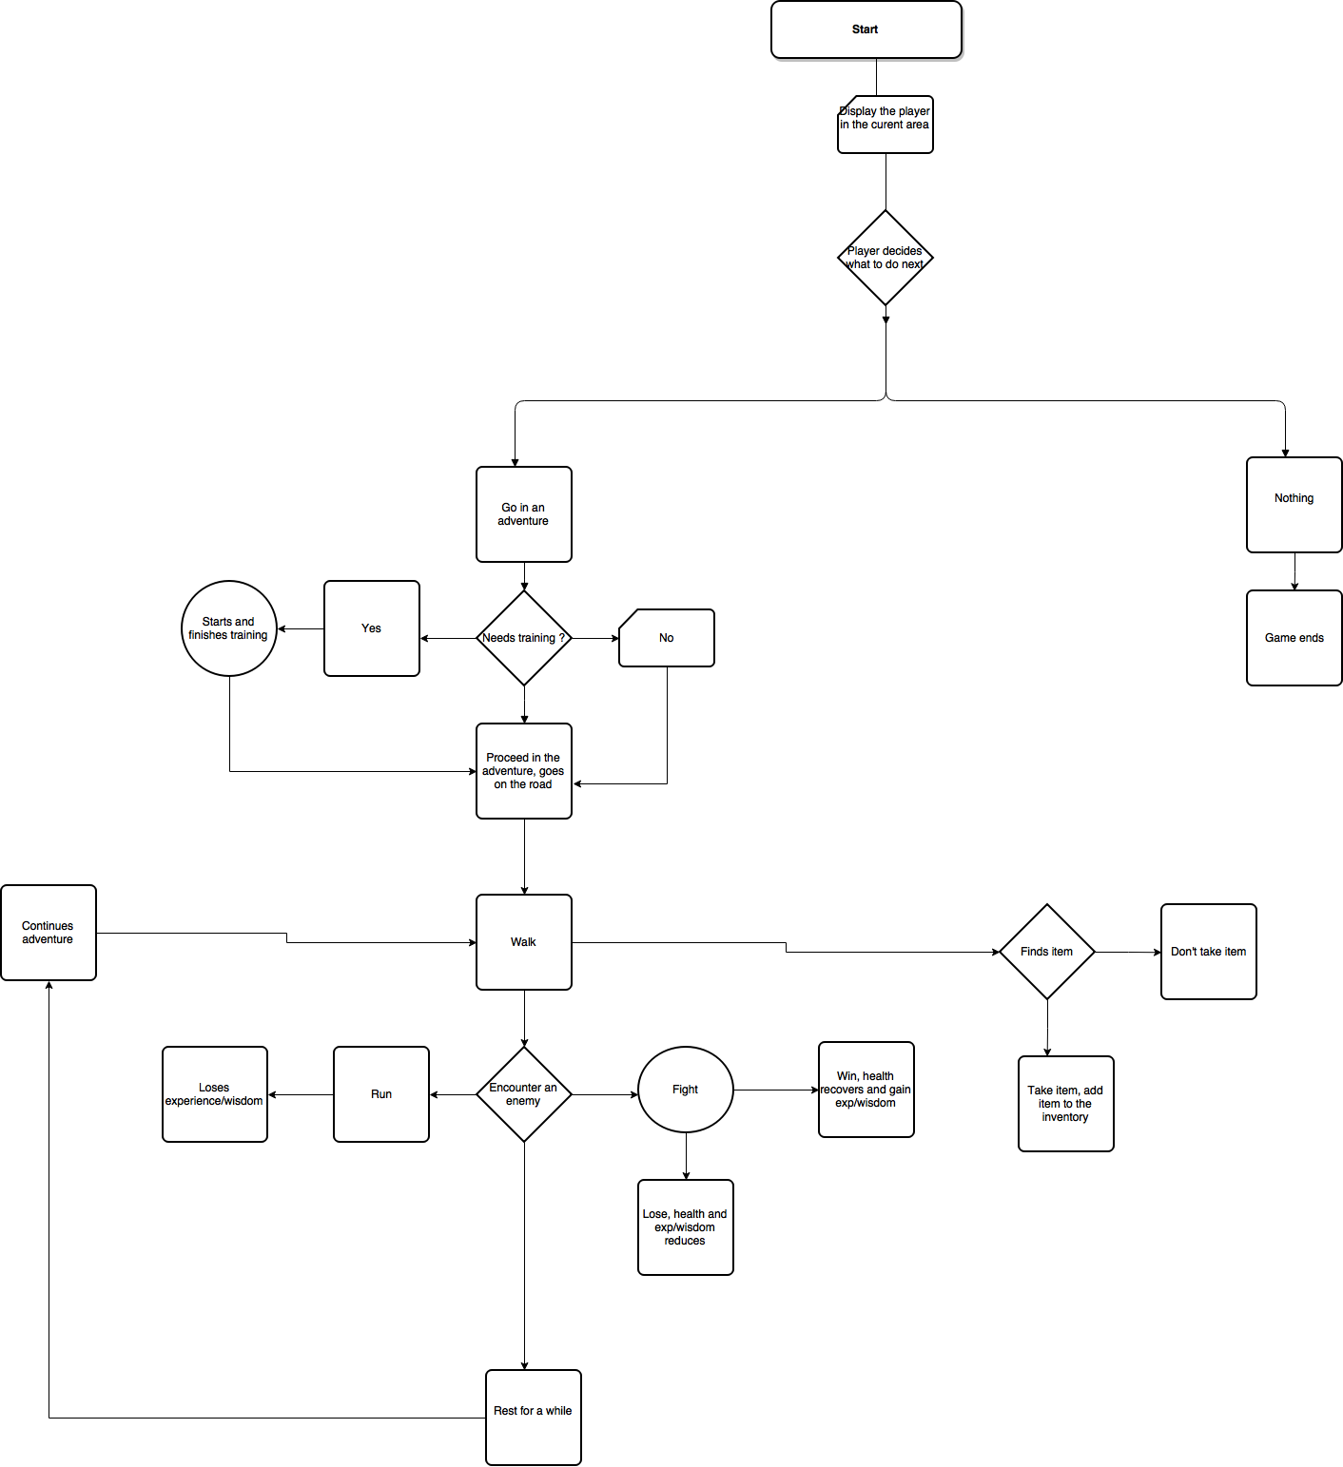](https://www.draw.io/#G0B-KsbJWvqyQEYnpqTnRFVzBkOW8)