[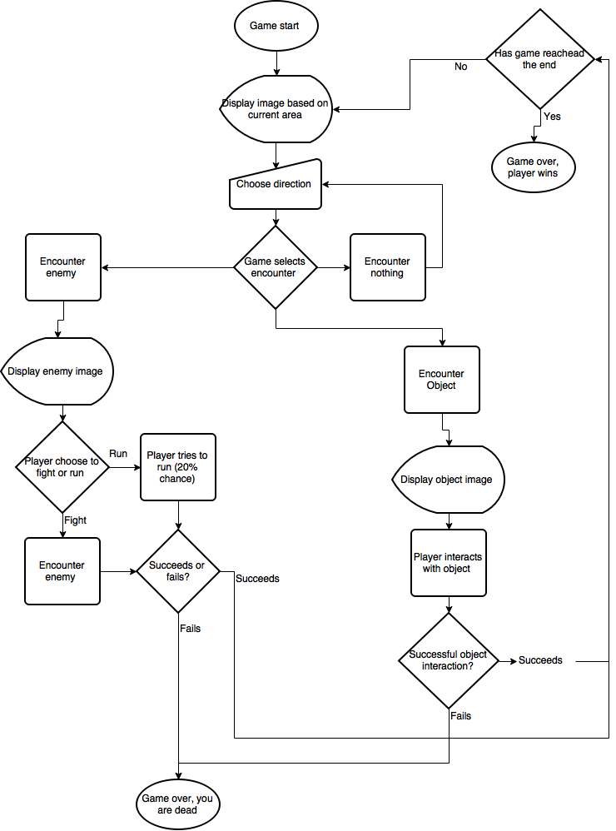](https://www.draw.io/#G0B-8S9iuTI2ztMWV2ZG5kZ0MyUXc)