Darts

# Introduction

Recently Stride acquired a [fictitious] client named Dartsy. Dartsy host professional Dart tournaments. They have engaged Stride to create an electronic scoring system for use in the tournaments they host. Dartsy want Stride to develop an API of the following form:

* score(): Integer – returns the current score
* turn(firstThrow: String, secondThrow: String, thirdThrow: String): String – represents the throws taken in a single turn

# Board Description

Darts is a game in which small weighted objects known as darts are thrown at a round board known as a dartboard (shown at right). The dartboard is composed of 20 numbered segments and the bullseye. Each segment and the bullseye are divided into regions known as beds:

* *Single Ring* scores the amount as shown at the black edge of the board. In this case single 20 is 20.
* *Double Ring* is a ring at the outer edge of the board and is worth double the numeric amount. In this case double 20 is 40.
* *Triple Ring* is a ring that separates the outer and inner Single Rings and is worth triple the amount. In this case triple 18 is 54.
* *Inner Bulls Eye* is the red circle in the center of the board and is worth 50 points.
* *Outer Bulls Eye* is the green circle that surrounds the inner bulls eye, it is worth 25 points.

# Rules

* Players begin the game with a score of 501
* The winner is the first to reach a score of exactly 0, with the following considerations:
  + To bring the score to 0 the final throw must be either a double or land in the inner ring
  + When the score reaches 0 and the final throw is neither a double or in the inner ring, the score resets to what it was at the beginning of the turn
  + When the score reaches 1 or goes below 0 the score resets to what it was at the beginning of the turn
* A player may throw 1, 2 or 3 darts, darts that are not thrown are considered a *pass* and do not score
* A dart that is thrown out of the scoring area is called a *miss* and does not score

# Notes on Scoring

* Dartsy have requested that the strings used as throws within a turn be represented as follows:
  + Single, double and triple scores are represented by S, D and T respectively, followed by the number, e.g. double 14 is represented by “D14”
  + A score within the Outer Ring is represented as “OR” (worth 25 points)
  + A score within the Inner Ring is represented as “IR” (worth 50 points)
  + Misses are represented as “MISS”
  + Passes are represented as “PASS”
* The largest score that can be won from is 170 and is reached with the following throws: T20, T20 and IR
* The lowest non-winning score is 2. This is because the winning throw must be a double or land in the inner ring. The smallest possible double score is D1 for a total of 2. A score of 1 becomes impossible to win from.

# Example Game

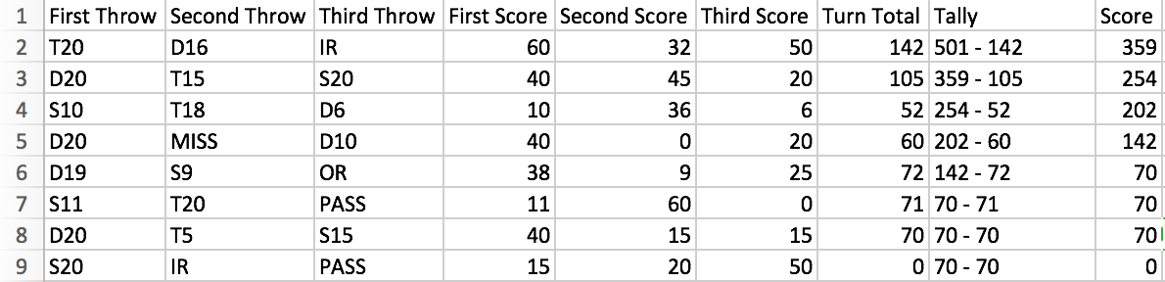

# Notes

* Row 7: 70 - 71 = -1, resets to 70 because the score reached -1
* Row 8: 70 - 70 = 0, resets to 70, the score reached 0 but the last throw was on neither a double or the inner ring.