NAME | CHRISTOPHER LLANDER L. VILLACINO
PROJECT TITLE | ServiFinance: A Multi-Tenant SaaS Service Management System with Embedded Micro-Lending
SUBJECT:  CODE:  TIME: | IT15/L Integrative Programming and Technologies  8466  1:30 – 3:30 PM
TOPIC (Type of Business Process) | #33 Service Management System
Products/Services | SaaS platform for Service-Oriented MSMEs
1st Deliverables
AGILE MODEL: REQUIREMENTS AND PLANNING
Use Case Diagram  (Updated) | 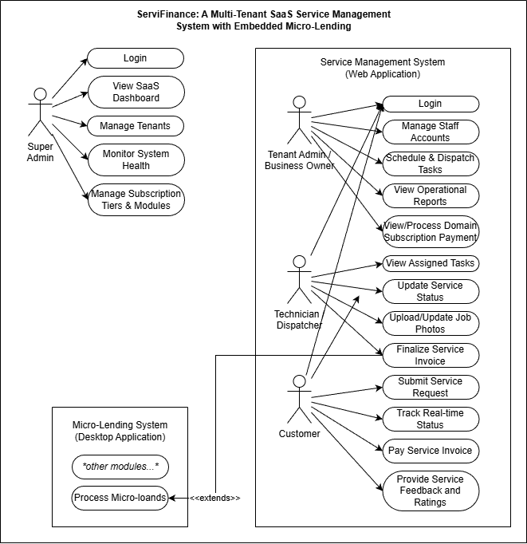
Entity Relational Diagram | 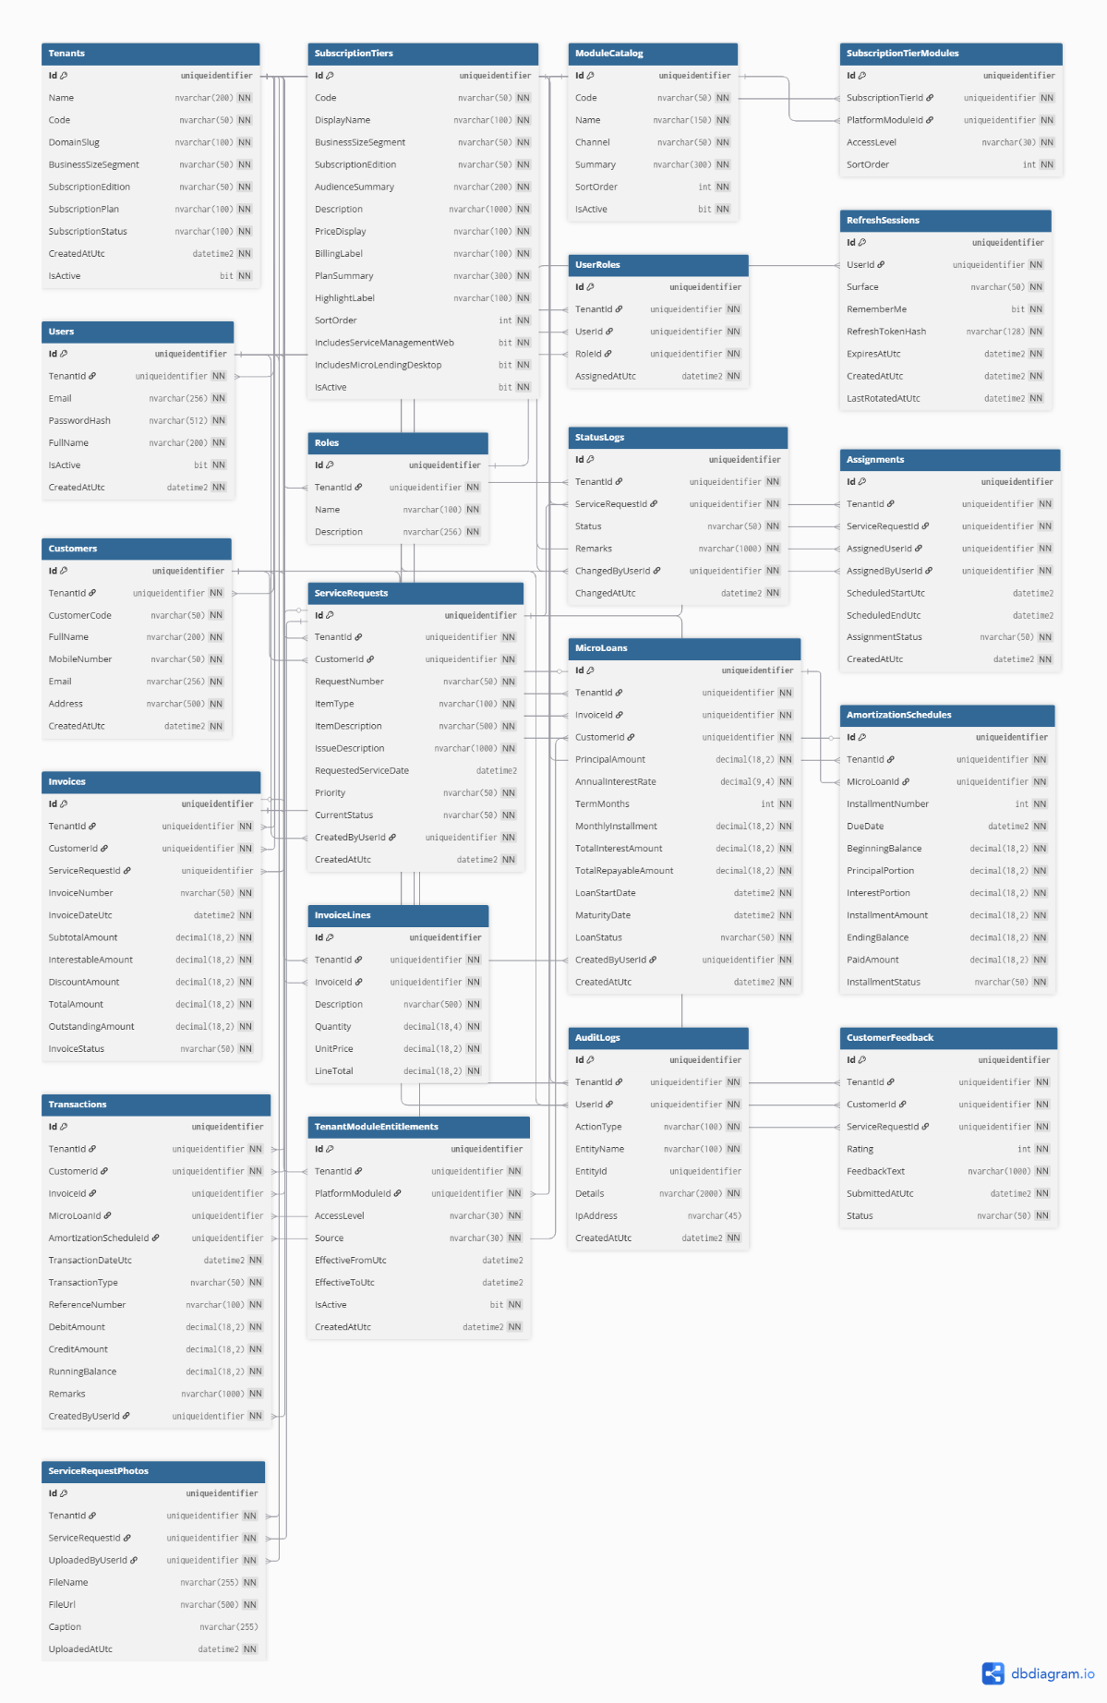
Data Dictionary | ServiFinance: A Multi-Tenant SaaS Service Management System with Embedded Micro-Lending  Level 1 - Super Admin  Tenants table  Field Names Datatype Length Description  Id uniqueidentifier 36 Primary key of the tenant record  Name nvarchar 200 Tenant or business display name  Code nvarchar 50 Unique business code used by the platform  DomainSlug nvarchar 100 Unique route slug used for tenant URLs  BusinessSizeSegment nvarchar 50 MSME size segment such as Micro, Small, or Medium  SubscriptionEdition nvarchar 50 Product edition such as Standard or Premium  SubscriptionPlan nvarchar 100 Commercial plan label for the tenant  SubscriptionStatus nvarchar 100 Current subscription lifecycle state  CreatedAtUtc datetime2 - UTC date and time when the tenant was created  IsActive bit 1 Active or inactive status of the tenant  SubscriptionTiers table  Field Names Datatype Length Description  Id uniqueidentifier 36 Primary key of the subscription tier  Code nvarchar 50 Unique catalog code of the tier  DisplayName nvarchar 100 User-facing name of the tier  BusinessSizeSegment nvarchar 50 MSME segment covered by the tier  SubscriptionEdition nvarchar 50 Edition covered by the tier  AudienceSummary nvarchar 200 Short target audience summary  Description nvarchar 1000 Full description of the tier  PriceDisplay nvarchar 100 Price label shown in the UI  BillingLabel nvarchar 100 Billing period or billing note  PlanSummary nvarchar 300 Short summary of plan inclusions  HighlightLabel nvarchar 100 Badge or marketing highlight label  SortOrder int 10 Display order in the catalog  IncludesServiceManagementWeb bit 1 Indicates if the web service module is included  IncludesMicroLendingDesktop bit 1 Indicates if the desktop lending module is included  IsActive bit 1 Active or inactive catalog state  ModuleCatalog table  Field Names Datatype Length Description  Id uniqueidentifier 36 Primary key of the module catalog row  Code nvarchar 50 Unique module code such as W1 or D1  Name nvarchar 150 Module name shown to operators  Channel nvarchar 50 Delivery channel such as Web or Desktop  Summary nvarchar 300 Short purpose statement of the module  SortOrder int 10 Display order in the module catalog  IsActive bit 1 Active or inactive catalog state  SubscriptionTierModules table  Field Names Datatype Length Description  Id uniqueidentifier 36 Primary key of the tier-module mapping  SubscriptionTierId uniqueidentifier 36 Foreign key to `SubscriptionTiers.Id`  PlatformModuleId uniqueidentifier 36 Foreign key to `ModuleCatalog.Id`  AccessLevel nvarchar 30 Access rule such as Included, Limited, or Not Included  SortOrder int 10 Display order within the tier mapping  Users table  Field Names Datatype Length Description  Id uniqueidentifier 36 Primary key of the user account  TenantId uniqueidentifier 36 Foreign key to `Tenants.Id`; platform superadmins use the reserved platform tenant  Email nvarchar 256 Login email address of the user  PasswordHash nvarchar 512 Hashed password value  FullName nvarchar 200 Full name of the user  IsActive bit 1 Active or inactive status of the account  CreatedAtUtc datetime2 - UTC date and time when the account was created  Roles table  Field Names Datatype Length Description  Id uniqueidentifier 36 Primary key of the role  TenantId uniqueidentifier 36 Foreign key to `Tenants.Id`  Name nvarchar 100 Role name such as SuperAdmin, Administrator, or Staff  Description nvarchar 256 Short description of the role purpose  UserRoles table  Field Names Datatype Length Description  Id uniqueidentifier 36 Primary key of the role assignment  TenantId uniqueidentifier 36 Foreign key to `Tenants.Id`  UserId uniqueidentifier 36 Foreign key to `Users.Id`  RoleId uniqueidentifier 36 Foreign key to `Roles.Id`  AssignedAtUtc datetime2 - UTC date and time when the role was assigned  RefreshSessions table  Field Names Datatype Length Description  Id uniqueidentifier 36 Primary key of the refresh session  UserId uniqueidentifier 36 Foreign key to `Users.Id`  Surface nvarchar 50 Client surface such as web or desktop  RememberMe bit 1 Indicates whether a persistent session was requested  RefreshTokenHash nvarchar 128 Unique hash of the refresh token  ExpiresAtUtc datetime2 - UTC date and time when the refresh session expires  CreatedAtUtc datetime2 - UTC date and time when the session was issued  LastRotatedAtUtc datetime2 - UTC date and time when the refresh token was last rotated  TenantModuleEntitlements table  Field Names Datatype Length Description  Id uniqueidentifier 36 Primary key of the tenant-specific module entitlement  TenantId uniqueidentifier 36 Foreign key to `Tenants.Id`  PlatformModuleId uniqueidentifier 36 Foreign key to `ModuleCatalog.Id`  AccessLevel nvarchar 30 Effective access level for the tenant  Source nvarchar 30 Entitlement source such as tier-default, override, or promo  EffectiveFromUtc datetime2 - Optional start date of the entitlement  EffectiveToUtc datetime2 - Optional end date of the entitlement  IsActive bit 1 Indicates whether the entitlement is currently active  CreatedAtUtc datetime2 - UTC date and time when the entitlement was recorded  AuditLogs table  Field Names Datatype Length Description  Id uniqueidentifier 36 Primary key of the audit log record  TenantId uniqueidentifier 36 Foreign key to `Tenants.Id`  UserId uniqueidentifier 36 Foreign key to `Users.Id` for the actor  ActionType nvarchar 100 Action category such as Login, ProvisionTenant, or UpdateRole  EntityName nvarchar 100 Name of the affected table or business entity  EntityId uniqueidentifier 36 Identifier of the affected record when applicable  Details nvarchar 2000 Full audit details or serialized change summary  IpAddress nvarchar 45 Source IP address if captured  CreatedAtUtc datetime2 - UTC date and time when the action happened  Level 2 - Tenant Administrator / Owner  Tables that are identical to Level 1 – Super Admin:  - Users table  - Roles table  - UserRoles table  Customers table  Field Names Datatype Length Description  Id uniqueidentifier 36 Primary key of the customer  TenantId uniqueidentifier 36 Foreign key to `Tenants.Id`  CustomerCode nvarchar 50 Unique customer code within the tenant  FullName nvarchar 200 Full name of the customer  MobileNumber nvarchar 50 Mobile or contact number  Email nvarchar 256 Customer email address  Address nvarchar 500 Customer address  CreatedAtUtc datetime2 - UTC date and time when the customer was registered  ServiceRequests table  Field Names Datatype Length Description  Id uniqueidentifier 36 Primary key of the service request  TenantId uniqueidentifier 36 Foreign key to `Tenants.Id`  CustomerId uniqueidentifier 36 Foreign key to `Customers.Id`  RequestNumber nvarchar 50 Unique service request number within the tenant  ItemType nvarchar 100 General item type, such as oven or laptop  ItemDescription nvarchar 500 Detailed description of the service item  IssueDescription nvarchar 1000 Customer-reported issue or complaint  RequestedServiceDate datetime2 - Requested service schedule, if provided  Priority nvarchar 50 Priority level of the request  CurrentStatus nvarchar 50 Current workflow status of the request  CreatedByUserId uniqueidentifier 36 Foreign key to `Users.Id` for the creator  CreatedAtUtc datetime2 - UTC date and time when the request was created  StatusLogs table  Field Names Datatype Length Description  Id uniqueidentifier 36 Primary key of the status log  TenantId uniqueidentifier 36 Foreign key to `Tenants.Id`  ServiceRequestId uniqueidentifier 36 Foreign key to `ServiceRequests.Id`  Status nvarchar 50 Status value recorded for the request  Remarks nvarchar 1000 Remarks or explanation of the status change  ChangedByUserId uniqueidentifier 36 Foreign key to `Users.Id` for the operator who changed the status  ChangedAtUtc datetime2 - UTC date and time when the status changed  Assignments table  Field Names Datatype Length Description  Id uniqueidentifier 36 Primary key of the assignment  TenantId uniqueidentifier 36 Foreign key to `Tenants.Id`  ServiceRequestId uniqueidentifier 36 Foreign key to `ServiceRequests.Id`  AssignedUserId uniqueidentifier 36 Foreign key to `Users.Id` for the assigned staff member  AssignedByUserId uniqueidentifier 36 Foreign key to `Users.Id` for the assigning manager  ScheduledStartUtc datetime2 - Planned start date and time  ScheduledEndUtc datetime2 - Planned end date and time  AssignmentStatus nvarchar 50 Current status of the assignment  CreatedAtUtc datetime2 - UTC date and time when the assignment was created  Invoices table  Field Names Datatype Length Description  Id uniqueidentifier 36 Primary key of the invoice  TenantId uniqueidentifier 36 Foreign key to `Tenants.Id`  CustomerId uniqueidentifier 36 Foreign key to `Customers.Id`  ServiceRequestId uniqueidentifier 36 Optional foreign key to `ServiceRequests.Id`  InvoiceNumber nvarchar 50 Unique invoice number within the tenant  InvoiceDateUtc datetime2 - UTC date and time of invoice issuance  SubtotalAmount decimal 18,2 Sum of invoice line amounts before discount and loan handling  InterestableAmount decimal 18,2 Amount eligible for financing or interest  DiscountAmount decimal 18,2 Discount amount applied to the invoice  TotalAmount decimal 18,2 Final total amount due  OutstandingAmount decimal 18,2 Remaining unpaid amount  InvoiceStatus nvarchar 50 Status of the invoice, such as Open or Paid  InvoiceLines table  Field Names Datatype Length Description  Id uniqueidentifier 36 Primary key of the invoice line  TenantId uniqueidentifier 36 Foreign key to `Tenants.Id`  InvoiceId uniqueidentifier 36 Foreign key to `Invoices.Id`  Description nvarchar 500 Description of the billed item or service  Quantity decimal 18,4 Quantity billed on the line  UnitPrice decimal 18,2 Unit price of the line item  LineTotal decimal 18,2 Extended amount of the line item  MicroLoans table (Desktop side)  Field Names Datatype Length Description  Id uniqueidentifier 36 Primary key of the micro-loan  TenantId uniqueidentifier 36 Foreign key to `Tenants.Id`  InvoiceId uniqueidentifier 36 Foreign key to `Invoices.Id`; one invoice can produce at most one loan  CustomerId uniqueidentifier 36 Foreign key to `Customers.Id`  PrincipalAmount decimal 18,2 Loan principal amount  AnnualInterestRate decimal 9,4 Annual interest rate used for computation  TermMonths int 10 Loan term in months  MonthlyInstallment decimal 18,2 Fixed installment amount per month  TotalInterestAmount decimal 18,2 Total interest for the whole loan  TotalRepayableAmount decimal 18,2 Total amount to be repaid  LoanStartDate datetime2 - Start date of the loan  MaturityDate datetime2 - Final due date of the loan  LoanStatus nvarchar 50 Current status of the loan  CreatedByUserId uniqueidentifier 36 Foreign key to `Users.Id` for the creating operator  CreatedAtUtc datetime2 - UTC date and time when the loan was created  AmortizationSchedules table (Desktop side)  Field Names Datatype Length Description  Id uniqueidentifier 36 Primary key of the amortization row  TenantId uniqueidentifier 36 Foreign key to `Tenants.Id`  MicroLoanId uniqueidentifier 36 Foreign key to `MicroLoans.Id`  InstallmentNumber int 10 Sequence number of the installment  DueDate datetime2 - Due date of the installment  BeginningBalance decimal 18,2 Loan balance before the installment  PrincipalPortion decimal 18,2 Principal amount included in the installment  InterestPortion decimal 18,2 Interest amount included in the installment  InstallmentAmount decimal 18,2 Total installment amount due  EndingBalance decimal 18,2 Balance after the installment  PaidAmount decimal 18,2 Amount already paid against the installment  InstallmentStatus nvarchar 50 Status of the installment, such as Unpaid, Partial, or Paid  Transactions table  Field Names Datatype Length Description  Id uniqueidentifier 36 Primary key of the ledger transaction  TenantId uniqueidentifier 36 Foreign key to `Tenants.Id`  CustomerId uniqueidentifier 36 Foreign key to `Customers.Id`  InvoiceId uniqueidentifier 36 Optional foreign key to `Invoices.Id`  MicroLoanId uniqueidentifier 36 Optional foreign key to `MicroLoans.Id`  AmortizationScheduleId uniqueidentifier 36 Optional foreign key to `AmortizationSchedules.Id`  TransactionDateUtc datetime2 - UTC date and time of the ledger event  TransactionType nvarchar 50 Type of ledger event, such as Invoice, Loan, or Payment  ReferenceNumber nvarchar 100 Human-readable transaction reference  DebitAmount decimal 18,2 Debit amount recorded in the ledger  CreditAmount decimal 18,2 Credit amount recorded in the ledger  RunningBalance decimal 18,2 Balance after the transaction posting  Remarks nvarchar 1000 Transaction remarks or explanation  CreatedByUserId uniqueidentifier 36 Foreign key to `Users.Id` for the creating operator  CustomerFeedback table  Field Names Datatype Length Description  Id uniqueidentifier 36 Primary key of the customer feedback record  TenantId uniqueidentifier 36 Foreign key to `Tenants.Id`  CustomerId uniqueidentifier 36 Foreign key to `Customers.Id`  ServiceRequestId uniqueidentifier 36 Foreign key to `ServiceRequests.Id`  Rating int 10 Numeric service rating submitted by the customer  FeedbackText nvarchar 1000 Comment or feedback text  SubmittedAtUtc datetime2 - UTC date and time when feedback was submitted  Status nvarchar 50 Review status of the feedback  ServiceRequestPhotos table  Field Names Datatype Length Description  Id uniqueidentifier 36 Primary key of the service request photo record  TenantId uniqueidentifier 36 Foreign key to `Tenants.Id`  ServiceRequestId uniqueidentifier 36 Foreign key to `ServiceRequests.Id`  UploadedByUserId uniqueidentifier 36 Foreign key to `Users.Id` for the uploader  FileName nvarchar 255 Original or stored file name  FileUrl nvarchar 500 File path or blob URL of the uploaded image  Caption nvarchar 255 Optional caption or note for the image  UploadedAtUtc datetime2 - UTC date and time when the image was uploaded  Level 3 - Service Staff / Technician  Tables that are identical to Level 2 - Tenant Administrator / Owner:  - Customers table  - ServiceRequests table  - StatusLogs table  - Assignments table  - ServiceRequestPhotos table  - CustomerFeedback table  Level 4 - Finance Staff / Loan Officer / Cashier (Desktop side)  Tables that are identical to Level 2 - Tenant Administrator / Owner:  - Customers table  - Transactions table  - AuditLogs table  - Invoices table  - InvoiceLines table  - MicroLoans table  - AmortizationSchedules table  Level 5 - Customer  Tables that are identical to Level 2 - Tenant Administrator / Owner:  - Customers table  - ServiceRequests table  - Invoices table  - CustomerFeedback table
Date Submitted:
Teacher’s Feedback | _________________________________________________________________  _________________________________________________________________  _________________________________________________________________  _________________________________________________________________  _________________________________________________________________  _________________________________________________________________  ________________________________ __________________________  Student’s Signature (after feedbacking) Teacher’s Signature

