**Monthly Price Plot**

**Monthly Return Plot – net return**

**Monthly Return Plot – logreturn**

**Equity Curve**

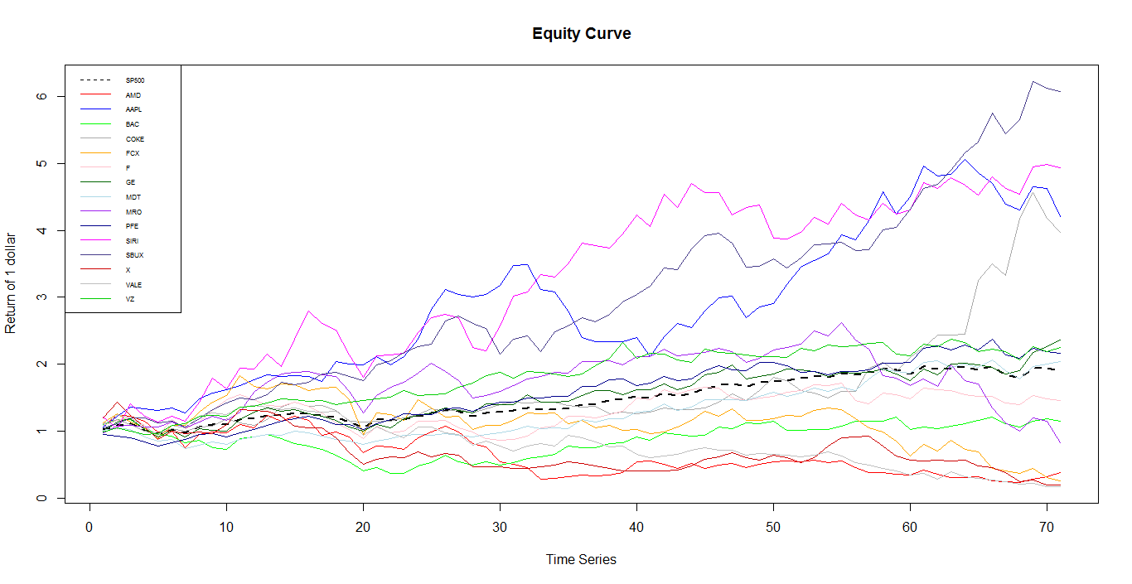

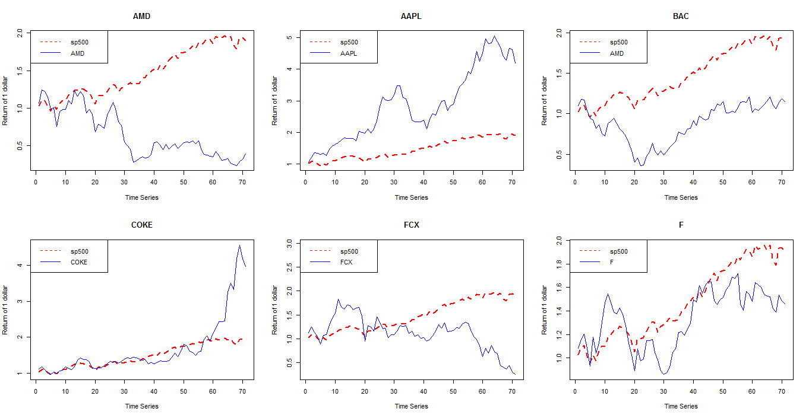

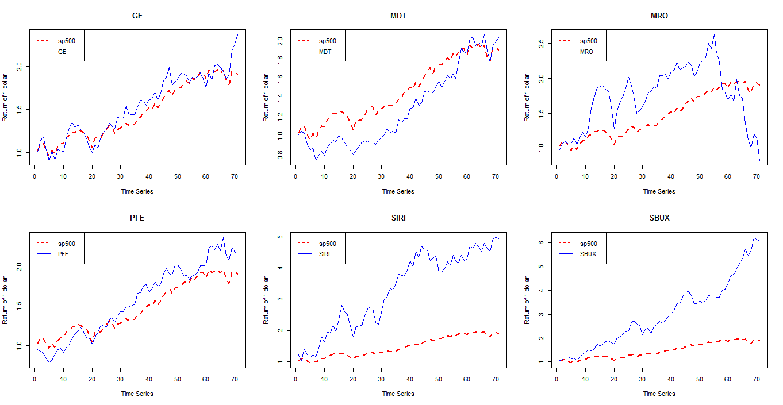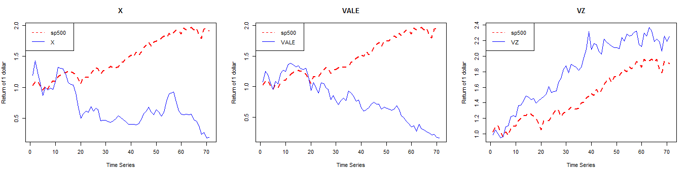

**Histogram**

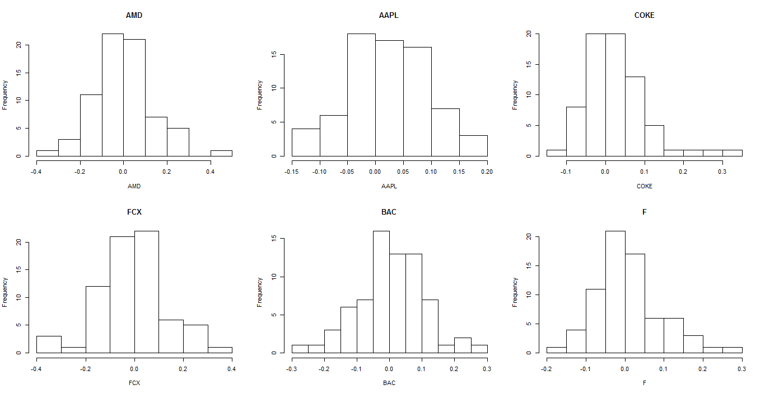

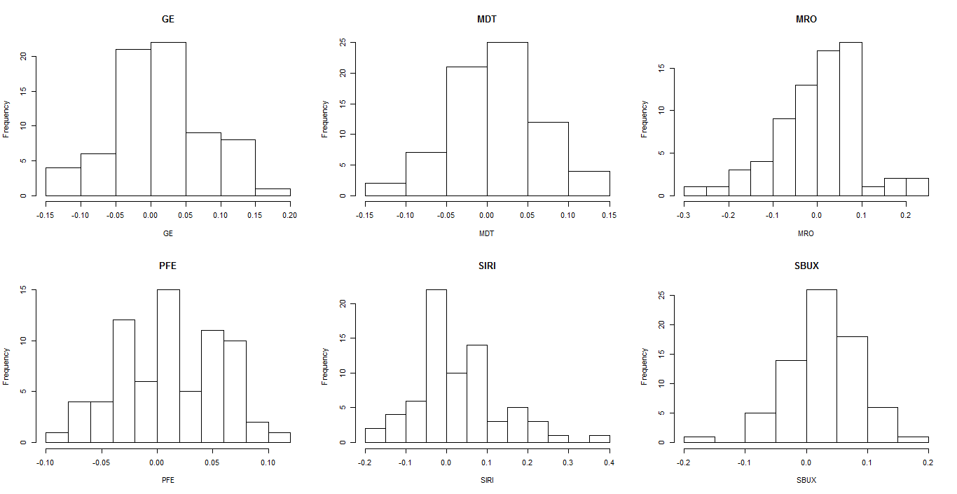

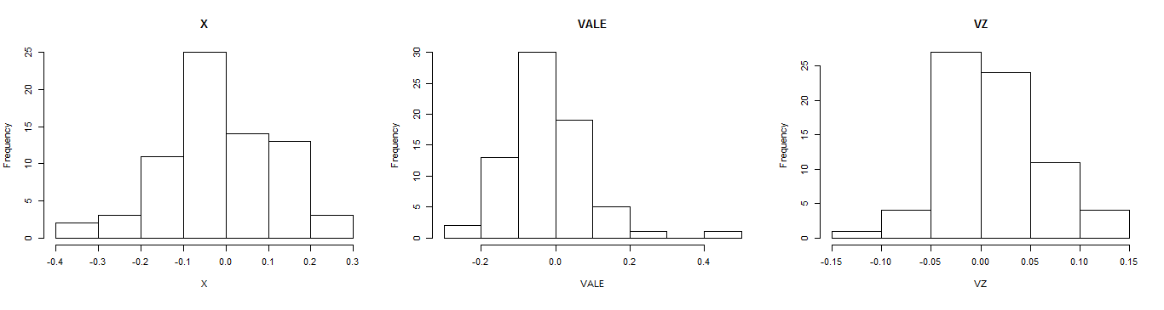

**Boxplot**

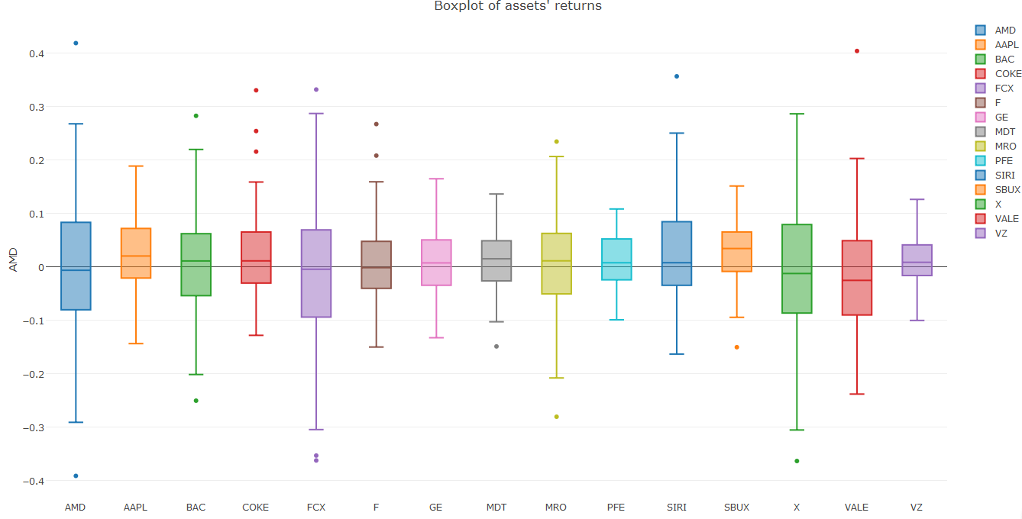

**QQ-Plot**

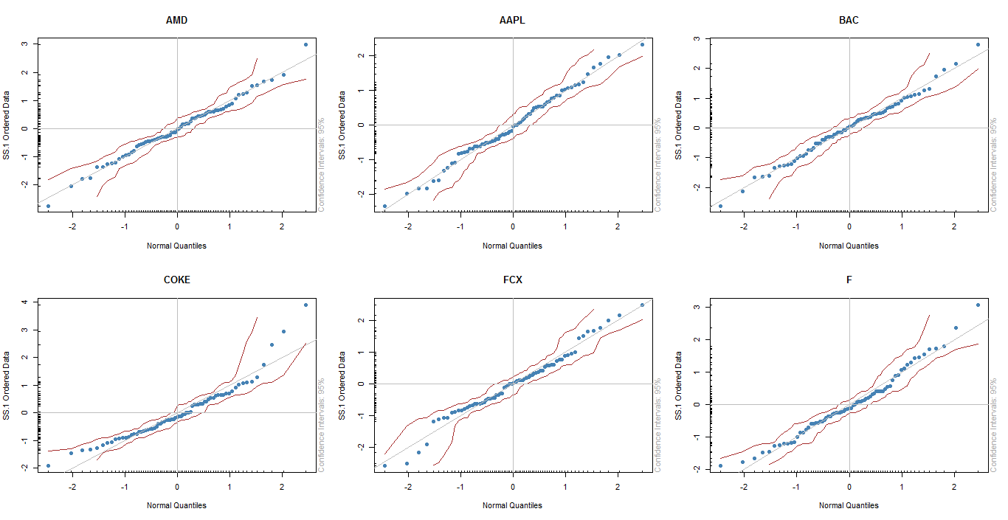

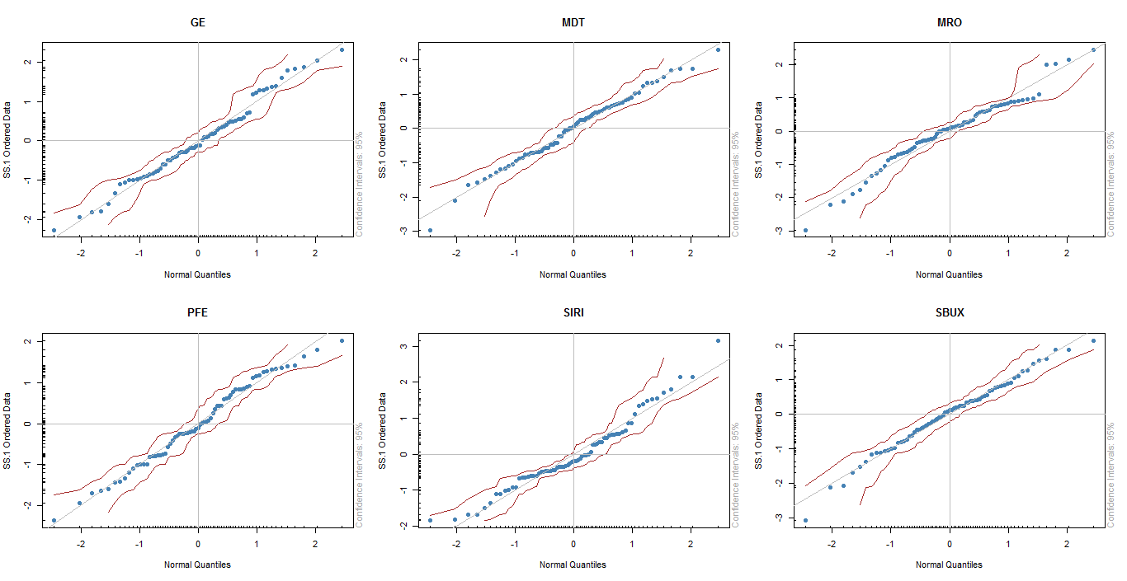

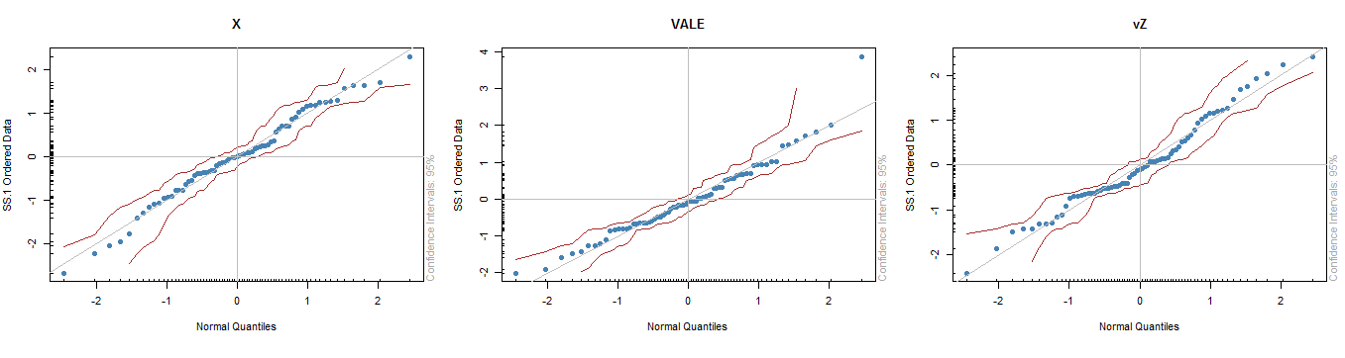

**Stationarity Test**

**Fit Distributions**

**Scatter Plot**

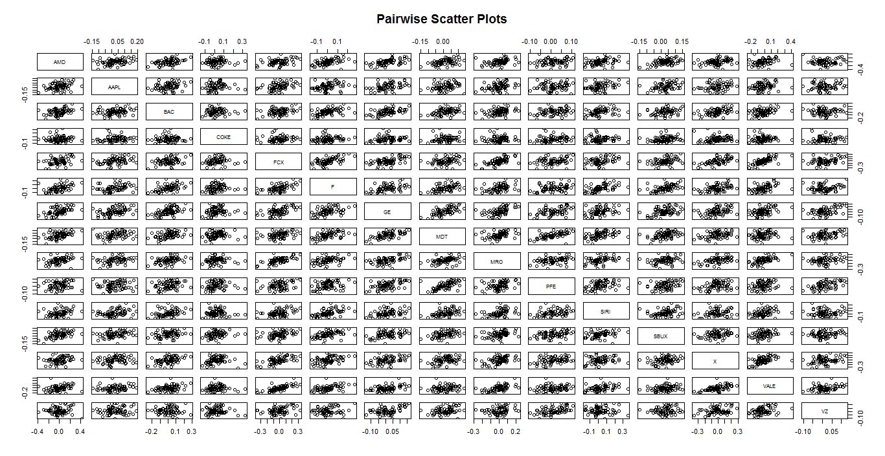

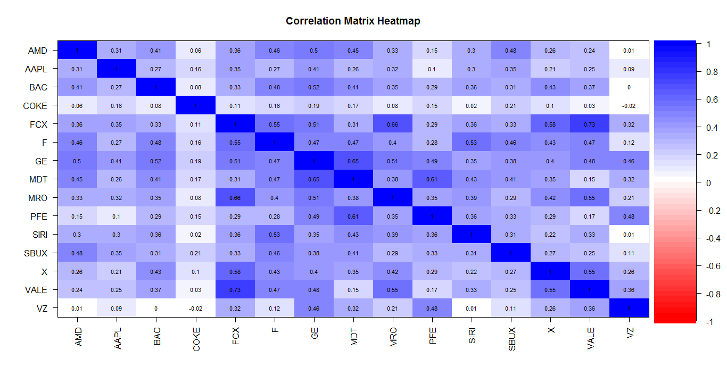

**Beta**

1. **Portfolio Theory**

In portfolio theory part, we are going to construct minimum variance portfolio (MVP), tangent portfolio and compute the efficient frontier under the conditions when the short sales are allowed and when they are not allowed. Under each circumstance, we will compute the portfolio mean, standard deviation, Value at Risk, expected shortfall and Sharpe ratio. Then, we will compare the portfolios with one another with the aim to find the best or most suitable portfolios for potential investors.

For each portfolio, we estimate 5% Value at Risk of the returns over a month, and estimate related expected shortfall on $100,000 investment over a month investment horizon. Because normal distribution doesn’t fit our data well, we use nonparametric method to calculate VaR and expected shortfall here.

1. **Short Sales are allowed**

When short sales are allowed, it is possible for some assets to have negative weights. It means that the investor can sell the asset he or she does not currently owned and subsequently repurchase them. Therefore, some weights in current portfolio can be negative.

1. **Minimum Variance Portfolio (MVP)**

The MVP descriptive statistics and the MVP weights are outlined as below.

In accordance with the definition of MVP, the portfolio has the lowest standard deviation compared with all other 15 single assets. Although MVP doesn’t have the highest mean, it has the highest Sharpe ratio among all 15 single assets. According to the MVP weights, in order to minimize the overall variance (standard deviation), the assets with high standard deviation will be shorted (e.g. FCX, GE and X) or take relatively small amount (e.g. AMD and SIRI) in the portfolio; while the assets with low standard deviation will have relatively more weight (e.g. AAPL, COKE and VZ). The MVP also has the lowest VaR and expected shortfall among all other 15 single assets which means the portfolio diversifies the overall risk.

(Appendix: comparison with assets)

|  |  |  |  |  |  |  |
| --- | --- | --- | --- | --- | --- | --- |
| **Mean** | **Std** | **VaR** | **ES** | **CI of VaR** | **CI of ES** | **Sharpe** |
| 0.203 | 0.107 | 3232 | 4078 | (2476, 4955) | (3191, 5382) | 1.89 |

**Weight and annualized standard deviation of each asset**

|  |  |  |  |  |  |
| --- | --- | --- | --- | --- | --- |
|  | **AMD** | **AAPL** | **BAC** | **COKE** | **FCX** |
| **Weight** | 0.89% | 13.96% | 6.74% | 12.98% | -9.79% |
| **Std** | 0.49 | 0.25 | 0.34 | 0.27 | 0.48 |
|  | **F** | **GE** | **MDT** | **MRO** | **PFE** |
| **Weight** | 4.08% | -21.51% | 9.71% | 5.19% | 15.94% |
| **Std** | 0.29 | 0.23 | 0.19 | 0.33 | 0.16 |
|  | **SIRI** | **SBUX** | **X** | **VALE** | **VZ** |
| **Weight** | 0.85% | 12.97% | -3.14% | 5.02% | 46.12% |
| **Std** | 0.36 | 0.20 | 0.46 | 0.38 | 0.16 |

1. **Tangency Portfolio**

The tangency portfolio descriptive statistics and weights are outlined as below.

In accordance with the definition of tangency portfolio, the Sharpe ratio of tangency portfolio is much higher than all other 15 single assets. According to the tangency portfolio, the asset with low Sharpe ratio will be shorted (e.g. AMD, FCX, X and VALE); while the asset with high Sharpe ratio will take a relatively bigger weight (e.g. AAPL, SBUX and VZ). The tangency portfolio also has the lowest VaR and expected shortfall among all 15 single assets. Compared with MVP, tangency portfolio has lower VaR and expected shortfall as well.

(Appendix: comparison with assets)

|  |  |  |  |  |  |  |
| --- | --- | --- | --- | --- | --- | --- |
| **Mean** | **Std** | **VaR** | **ES** | **CI of VaR** | **CI of ES** | **Sharpe** |
| 0.332 | 0.121 | 2708 | 3162 | (2101, 3835) | (2938, 3858) | 2.73 |

**Weight and Sharpe ratio of each asset**

|  |  |  |  |  |  |
| --- | --- | --- | --- | --- | --- |
|  | **AMD** | **AAPL** | **BAC** | **COKE** | **FCX** |
| **Weight** | -5.33% | 13.56% | 7.39% | 14.22% | -7.53% |
| **Sharpe ratio** | -0.08 | 1.11 | 0.24 | 0.98 | -0.24 |
|  | **F** | **GE** | **MDT** | **MRO** | **PFE** |
| **Weight** | 1.56% | -5.01% | -5.41% | 4.63% | -0.87% |
| **Sharpe ratio** | 0.36 | 0.75 | 0.73 | 0.07 | 0.88 |
|  | **SIRI** | **SBUX** | **X** | **VALE** | **VZ** |
| **Weight** | 10.62% | 32.83% | -3.83% | -10.54% | 53.71% |
| **Sharpe ratio** | 0.92 | 1.64 | -0.37 | -0.60 | 0.92 |

1. **Short sales are not allowed**

When short sales are not allowed, all the weights should be either positive or zero.

1. **Minimum Variance Portfolio (MVP)**

The MVP statistics and MPV weights when there are no short sales are outlined as below.

The standard deviation of MPV is also the smallest among all other 15 single assets, according to MVP definition. The VaR and expected shortfall are also far less than those of the single assets. Because the short sales are not allowed, all weights are non-negative. The current portfolio only contains 8 assets (AAPL, BAC, COKE, MDT, PFE, SIRI, SBUX and VZ), while other assets’ weights are zero.

Because we add a restriction (no short sale) to the portfolio, the standard deviation of current portfolio is higher than that of the MVP with no restriction, while the Sharpe ratio is lower. It means that in some point, the restriction make the portfolio less efficient.

(Appendix: comparison with assets)

|  |  |  |  |  |  |  |
| --- | --- | --- | --- | --- | --- | --- |
| **Mean** | **Std** | **VaR** | **ES** | **CI of VaR** | **CI of ES** | **Sharpe** |
| 0.203 | 0.116 | 3718 | 4582 | (2509, 5302) | (3831, 6051) | 1.74 |

|  |  |  |  |  |  |
| --- | --- | --- | --- | --- | --- |
|  | **AMD** | **AAPL** | **BAC** | **COKE** | **FCX** |
| **Weight** | 0.00% | 10.34% | 2.75% | 12.70% | 0.00% |
| **Std** | 0.49 | 0.25 | 0.34 | 0.27 | 0.48 |
|  | **F** | **GE** | **MDT** | **MRO** | **PFE** |
| **Weight** | 0.00% | 0.00% | 2.09% | 0.00% | 17.87% |
| **Std** | 0.29 | 0.23 | 0.19 | 0.33 | 0.16 |
|  | **SIRI** | **SBUX** | **X** | **VALE** | **VZ** |
| **Weight** | 1.11% | 14.60% | 0.00% | 0.00% | 38.54% |
| **Std** | 0.36 | 0.20 | 0.46 | 0.38 | 0.16 |

1. **Tangency Portfolio**

The tangency portfolio statistics and weights when there are no short sales are outlined as below.

The Sharpe ratio of the portfolio is the highest compared with all other 15 single assets. Because no short sales allowed, the portfolio only contains 5 assets (AAPL, COKE, SIRI, SBUX and VZ) which have relatively high Sharpe ratios. Those assets with low Sharpe ratios are not needed in this portfolio.

Compared with tangency portfolio when the short sales are allowed, the Sharpe ratio of current asset is much lower, while the standard deviation is much higher. This also resonates with our conclusion that the restriction makes the portfolio less effective. The VaR and expected shortfall of the tangency portfolio are far less than those of the single assets.

(Appendix: comparison with assets)

|  |  |  |  |  |  |  |
| --- | --- | --- | --- | --- | --- | --- |
| **Mean** | **Std** | **VaR** | **ES** | **CI of VaR** | **CI of ES** | **Sharpe** |
| 0.261 | 0.129 | 3995 | 4495 | (3828, 5305) | (3324, 5278) | 2.02 |

|  |  |  |  |  |  |
| --- | --- | --- | --- | --- | --- |
|  | **AMD** | **AAPL** | **BAC** | **COKE** | **FCX** |
| **Weight** | 0.00% | 10.24% | 0.00% | 16.07% | 0.00% |
| **Sharpe ratio** | -0.08 | 1.11 | 0.24 | 0.98 | -0.24 |
|  | **F** | **GE** | **MDT** | **MRO** | **PFE** |
| **Weight** | 0.00% | 0.00% | 0.00% | 0.00% | 0.00% |
| **Sharpe ratio** | 0.36 | 0.75 | 0.73 | 0.07 | 0.88 |
|  | **SIRI** | **SBUX** | **X** | **VALE** | **VZ** |
| **Weight** | 7.61% | 36.40% | 0.00% | 0.00% | 29.69% |
| **Sharpe ratio** | 0.92 | 1.64 | -0.37 | -0.60 | 0.92 |

In summary, we can see that the tangency portfolio with short sales has the highest Sharpe ratio and mean, and the lowest VaR and expected shortfall. The MVP with short sales has the lowest standard deviation. For all the portfolios, no short sale means an additional restriction to the portfolio constructions which exert some negative impact to the portfolio structure. The restriction increase the portfolio’s risk and somehow decrease the return. Whether to choose MVP or tangency portfolio or other portfolio structures depends on investors’ risk and return preference.

(Appendix: comparison with assets)

**Annualized**

|  |  |  |  |  |  |
| --- | --- | --- | --- | --- | --- |
|  | **Mean** | **Std** | **VaR** | **ES** | **Sharpe** |
| **MVP (no short sale)** | 0.203 | 0.116 | 3178 | 4582 | 1.74 |
| **Tangent (no short sale)** | 0.261 | 0.129 | 3995 | 4495 | 2.02 |
| **MVP (with short sale)** | 0.203 | 0.107 | 3232 | 4078 | 1.89 |
| **Tangent (with short sale)** | 0.332 | 0.121 | 2708 | 3162 | 2.73 |

1. **Asset Allocation**

Assume we have $100,000 to invest into the 15 assets and our target expected return is 6% per year (which corresponds to an expected return of 0.5% per month). No short sales allowed in this part. We use nonparametric method to calculate VaR and expected shortfall.

1. **No T-Bills and No Short Sales Allowed**

When there are no T-Bills, we will only use the 15 risky assets to construct a portfolio to achieve the target expected return of 6% annually. The portfolio statistics and weights are outlined as below. The portfolio contains 7 assets (AMD, COKE, MDT, PFE, X, VALE and VZ).

The 5% VaR of the portfolio is 6009, which means that there is 5% probability that the portfolio will loss $6009 over a month. The expected shortfall of the portfolio is 7187, which means the expected loss when VaR is exceeded is $7187.

**Annualized!**

|  |  |  |  |  |  |  |
| --- | --- | --- | --- | --- | --- | --- |
| **Mean** | **Std** | **VaR** | **ES** | **CI of VaR** | **CI of ES** | **Sharpe** |
| 0.06 | 0.15 | 6009 | 7187 | (4069, 7320) | (6205, 8610) | 0.39 |

|  |  |  |  |  |  |
| --- | --- | --- | --- | --- | --- |
|  | **AMD** | **AAPL** | **BAC** | **COKE** | **FCX** |
| **Weight** | 4.58% | 0.00% | 0.00% | 5.02% | 0.00% |
| **Mean** | -0.04 | 0.27 | 0.08 | 0.27 | -0.11 |
|  | **F** | **GE** | **MDT** | **MRO** | **PFE** |
| **Weight** | 0.00% | 0.00% | 12.34% | 0.00% | 31.56% |
| **Mean** | 0.10 | 0.17 | 0.14 | 0.02 | 0.14 |
|  | **SIRI** | **SBUX** | **X** | **VALE** | **VZ** |
| **Weight** | 0.00% | 0.00% | 0.41% | 21.96% | 24.13% |
| **Mean** | 0.33 | 0.33 | -0.17 | -0.23 | 0.15 |

1. **With T-Bills and No Short Sales Allowed**

When the T-Bills are allowed in the portfolio, we will use both the 15 risky assets and the risk free asset (T-Bills) to construct a portfolio to achieve the target expected return. We already know that the tangency portfolio is the most efficient one when there are only risky assets. Therefore, when with T-Bills, the efficient portfolio will be the combination of tangency portfolio and risk free asset with proper weights to be assigned to both of them in order to meet the target expected return requirement.

The portfolio statistics and weights are outlined as below. The portfolio only contains 5 risky assets (AAPL, COKE, SIRI, SBUX and VZ) and the risk free asset (T-bill). Because the returns of some assets are negative, some are much greater than 6%; the dominant part of the portfolio is the risk free asset, T-Bill, which accounts for 77.2%.

Compared with the allocation of only risky assets, the standard deviation, VaR and expected short fall of this portfolio are much lower, which means that current portfolio has much better diversification effect and much less risk.

(Appendix: comparison with assets)

|  |  |  |  |  |  |  |
| --- | --- | --- | --- | --- | --- | --- |
| **Mean** | **Std** | **VaR** | **ES** | **CI of VaR** | **CI of ES** | **Sharpe** |
| 0.06 | 0.03 | 906 | 1020 | (868, 1204) | (753, 1197) | 2.02 |

**Annualized!**

|  |  |  |  |  |  |
| --- | --- | --- | --- | --- | --- |
|  | **AMD** | **AAPL** | **BAC** | **COKE** | **FCX** |
| **Weight** | 0.00% | 2.33% | 0.00% | 3.66% | 0.00% |
| **Mean** | -0.04 | 0.27 | 0.08 | 0.27 | -0.11 |
|  | **F** | **GE** | **MDT** | **MRO** | **PFE** |
| **Weight** | 0.00% | 0.00% | 0.00% | 0.00% | 0.00% |
| **Mean** | 0.10 | 0.17 | 0.14 | 0.02 | 0.14 |
|  | **SIRI** | **SBUX** | **X** | **VALE** | **VZ** |
| **Weight** | 1.73% | 8.29% | 0.00% | 0.00% | 6.76% |
| **Mean** | 0.33 | 0.33 | -0.17 | -0.23 | 0.15 |
|  | **Risk Free** |  |  |  |  |
| **Weight** | 77.20% |  |  |  |  |
| **Mean** | 0.0007 |  |  |  |  |

1. **Risk Management**

In order to have a comprehensive grasp of assets’ risk and have a better understanding of different risk measurements, here we use three methods to conduct risk management for the 15 assets. First, we calculate Value at Risk (VaR) and expected shortfall (ES) based on the assumption that the assets follow normal distribution with estimated means and variances. Second, we use nonparametric method to calculate VaR and expected shortfall. Last, we use bootstrap to compute the estimated standard errors and compute 95% confidence interval (CI) for our VaR estimates and expected shortfall estimates.

For each asset, we estimate 5% Value at Risk of the net returns over a month, and estimate related expected shortfall on $100,000 investment over a month investment horizon.

1. **Based on normal distribution**

From the estimation of 5% VaR and Expected shortfall, we find out that the first asset, AMD, has the highest VaR and expected shortfall; while the last asset, VZ, has the lowest VaR and expected shortfall.

**VaR and ES based on Normal**

|  |  |  |  |  |  |
| --- | --- | --- | --- | --- | --- |
|  | **AMD** | **AAPL** | **BAC** | **COKE** | **FCX** |
| **VaR** | 23590 | 9442 | 15531 | 10699 | 23510 |
| **ES** | 29502 | 12421 | 19648 | 13986 | 29246 |
|  | **F** | **GE** | **MDT** | **MRO** | **PFE** |
| **VaR** | 12914 | 9316 | 7790 | 15460 | 6557 |
| **ES** | 16416 | 12045 | 10062 | 19435 | 8527 |
|  | **SIRI** | **SBUX** | **X** | **VALE** | **VZ** |
| **VaR** | 14303 | 6764 | 23012 | 19909 | 6496 |
| **ES** | 18641 | 9177 | 28503 | 24486 | 8465 |

1. **Based on Nonparametric Method**

Using nonparametric method, the 13th asset, X, has the highest VaR, while the 5th asset, FCX, has the highest expected shortfall. The last asset, VZ, has the lowest VaR and expected shortfall.

From the result above, we find out that the asset with the highest VaR does not necessarily have the highest expected shortfall. VaR and expected shortfall depends on the asset’s distribution, and expected shortfall is even more sensitive to the distribution shape. Sometimes, the asset with greater VaR may have a relatively smaller expected shortfall when compared with other assets, and vice versa.

**VaR and ES based on Nonparametric**

|  |  |  |  |  |  |
| --- | --- | --- | --- | --- | --- |
|  | **AMD** | **AAPL** | **BAC** | **COKE** | **FCX** |
| **VaR** | 22342 | 10021 | 15286 | 8057 | 22143 |
| **ES** | 29759 | 11942 | 19090 | 9722 | 32299 |
|  | **F** | **GE** | **MDT** | **MRO** | **PFE** |
| **VaR** | 11524 | 9554 | 7162 | 17236 | 6461 |
| **ES** | 13436 | 11268 | 10116 | 21636 | 7826 |
|  | **SIRI** | **SBUX** | **X** | **VALE** | **VZ** |
| **VaR** | 13702 | 6590 | 25747 | 17746 | 5414 |
| **ES** | 15470 | 10219 | 30519 | 20948 | 7190 |

1. **Based on Bootstrap**

We are also interested in the confidence interval of the VaR and expected shortfall. Because normal distribution does not fit our data very well, we prefer nonparametric VaR and expected shortfall. Due to the small amount of data (each asset only has 71 returns), we use bootstrap to generate more samples of each asset and then calculate the 95% confidence interval based on bootstrap samples.

**VaR**

|  |  |  |  |  |
| --- | --- | --- | --- | --- |
|  | **SE** | **VaR** | **Lower Bound** | **Upper Bound** |
| **AMD** | 3978 | 22342 | 15539 | 28152 |
| **AAPL** | 1751 | 10021 | 8212 | 14541 |
| **BAC** | 2336 | 15286 | 10378 | 19242 |
| **COKE** | 1110 | 8057 | 6866 | 10815 |
| **FCX** | 6823 | 22143 | 8923 | 31101 |
| **F** | 1451 | 11524 | 8981 | 13842 |
| **GE** | 1896 | 9554 | 7863 | 14065 |
| **MDT** | 1398 | 7162 | 4001 | 9388 |
| **MRO** | 3116 | 17236 | 13636 | 24089 |
| **PFE** | 910 | 6461 | 4971 | 8726 |
| **SIRI** | 2426 | 13702 | 11293 | 19807 |
| **SBUX** | 1989 | 6590 | 3695 | 9578 |
| **X** | 4487 | 25747 | 20917 | 35916 |
| **VALE** | 2280 | 17746 | 12785 | 22861 |
| **VZ** | 868 | 5414 | 3296 | 6847 |

**Expected Shortfall**

|  |  |  |  |  |
| --- | --- | --- | --- | --- |
|  | **SE** | **ES** | **Lower Bound** | **Upper Bound** |
| **AMD** | 4988 | 29759 | 20349 | 39235 |
| **AAPL** | 1449 | 11942 | 9475 | 15242 |
| **BAC** | 3093 | 19090 | 13087 | 24566 |
| **COKE** | 1478 | 9722 | 6584 | 12355 |
| **FCX** | 5070 | 32299 | 28316 | 45741 |
| **F** | 1196 | 13436 | 11823 | 16313 |
| **GE** | 1408 | 11268 | 9228 | 14884 |
| **MDT** | 2284 | 10116 | 5300 | 13723 |
| **MRO** | 3299 | 21636 | 15173 | 28269 |
| **PFE** | 1083 | 7826 | 5702 | 9843 |
| **SIRI** | 1336 | 15470 | 14569 | 19638 |
| **SBUX** | 2435 | 10219 | 5360 | 14812 |
| **X** | 3671 | 30519 | 24652 | 39340 |
| **VALE** | 2087 | 20948 | 18042 | 25424 |
| **VZ** | 1392 | 7190 | 4308 | 9276 |

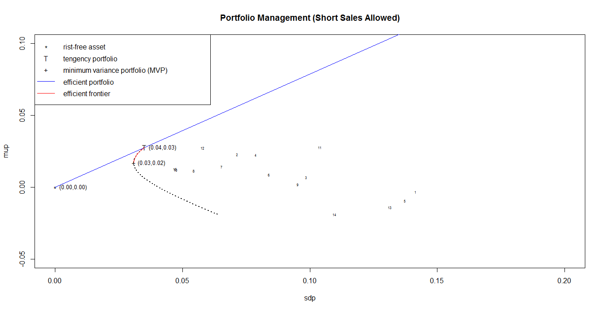

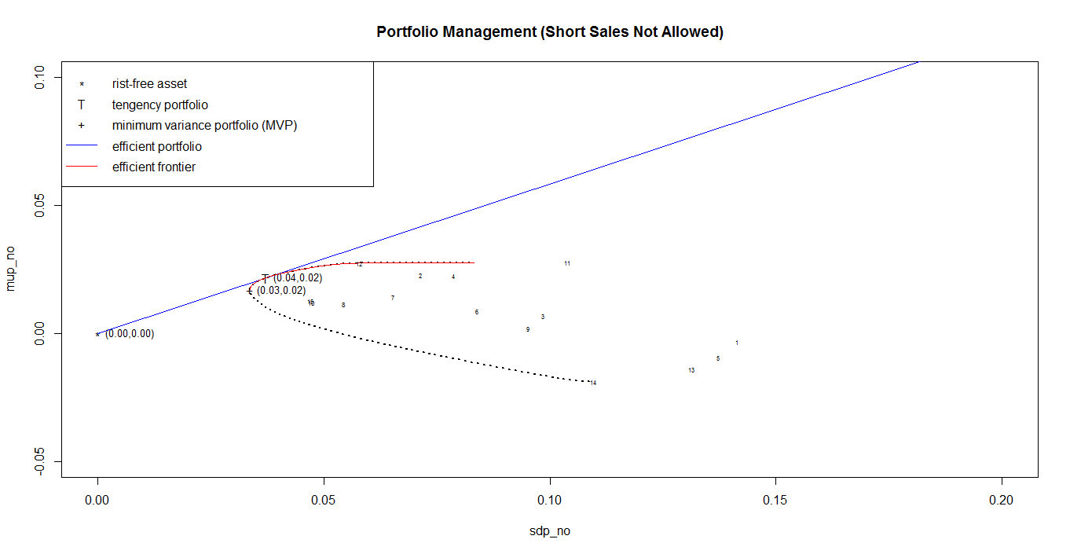

**15 Assets’ mean, standard deviation, value at risk, expected shortfall, Sharpe ratio (Annualized)**

|  |  |  |  |  |  |
| --- | --- | --- | --- | --- | --- |
|  | **Mean** | **Std** | **VaR** | **ES** | **Sharpe** |
| **AMD** | -0.04 | 0.49 | 22342 | 29759 | -0.08 |
| **AAPL** | 0.27 | 0.25 | 10021 | 11942 | 1.11 |
| **BAC** | 0.08 | 0.34 | 15286 | 19090 | 0.24 |
| **COKE** | 0.27 | 0.27 | 8057 | 9722 | 0.98 |
| **FCX** | -0.11 | 0.48 | 22143 | 32299 | -0.24 |
| **F** | 0.10 | 0.29 | 11524 | 13436 | 0.36 |
| **GE** | 0.17 | 0.23 | 9554 | 11268 | 0.75 |
| **MDT** | 0.14 | 0.19 | 7162 | 10116 | 0.73 |
| **MRO** | 0.02 | 0.33 | 17236 | 21636 | 0.07 |
| **PFE** | 0.14 | 0.16 | 6461 | 7826 | 0.88 |
| **SIRI** | 0.33 | 0.36 | 13702 | 15470 | 0.92 |
| **SBUX** | 0.33 | 0.20 | 6590 | 10219 | 1.64 |
| **X** | -0.17 | 0.46 | 25747 | 30519 | -0.37 |
| **VALE** | -0.23 | 0.38 | 17746 | 20948 | -0.60 |
| **VZ** | 0.15 | 0.16 | 5414 | 7190 | 0.92 |

|  |  |  |  |  |  |
| --- | --- | --- | --- | --- | --- |
|  | **Mean** | **Std** | **VaR** | **ES** | **Sharpe** |
| **MVP (no short sale)** | 0.203 | 0.116 | 3178 | 4582 | 1.74 |
| **Tangent (no short sale)** | 0.261 | 0.129 | 3995 | 4495 | 2.02 |
| **MVP (with short sale)** | 0.203 | 0.107 | 3232 | 4078 | 1.89 |
| **Tangent (with short sale)** | 0.332 | 0.121 | 2708 | 3162 | 2.73 |
| **No T-bill with 6% return** | 0.06 | 0.15 | 6009 | 7187 | 0.39 |
| **With T-bill with 6% return** | 0.06 | 0.03 | 906 | 1020 | 2.02 |

**PCA**

