System Integration Testing Report — Online Shopping System
Java and JUnit 5

1. Introduction
Unit testing checks one class on its own. System Integration Testing (SIT) checks that the modules work correctly together and that data flows across them. The online shopping system has six modules (Customer, Product, Order, Payment, Inventory, Notification). Each already passed unit testing, so this report tests their interactions.
Integration flow: Customer → Product → Order → Payment → Inventory → Notification.
Test data: Customer C001 (login john/1234), Product P100 (Laptop, 800.00), quantity 2, stock 10, payment 1,600.00.
Expected result: order created, payment successful, stock 10 → 8, order confirmed, customer notified.

2. Approach
- Unit tests (ModuleUnitTests) test each module alone, using @Test, @BeforeEach, assert statements with messages, and @ParameterizedTest (from the JUnit notes).
- Integration tests (ShoppingSystemIntegrationTest) use real module objects wired into OrderService, with no mocks. That is what makes them integration tests. A fresh set of objects is created in @BeforeEach so tests do not depend on each other or on execution order.
- Each test ID SIT-01 to SIT-10 from the case study has one test method.

3. Test cases and results
Test ID | Integration scenario | Input | Expected result | Actual | Status
SIT-01 | Customer → Order | Valid login and order | Order created | “Order confirmation sent to John” | Pass
SIT-02 | Order → Product | Product ID P100 | Price 800.00 retrieved | 800.00 | Pass
SIT-03 | Order → Inventory | Quantity = 2 | Stock 10 → 8 | 8 | Pass
SIT-04 | Order → Payment | Amount = 1600 | Payment successful | true | Pass
SIT-05 | Payment → Order | Successful payment | Order proceeds to confirmation | Confirmation returned | Pass
SIT-06 | Order → Notification | Successful order | Confirmation sent | “Order confirmation sent to John” | Pass
SIT-07 | Order → Inventory | Quantity = 15 | Order rejected | “Insufficient stock”, stock still 10 | Pass
SIT-08 | Order → Product | Invalid product ID (P999) | Order rejected | “Product not found”, stock still 10 | Pass
SIT-09 | Customer → Order | Invalid login | Order not created | “Login failed”, stock still 10 | Pass
SIT-10 | Payment → Order | Invalid amount (quantity 0 gives total 0.00) | Order fails | “Payment failed”, stock still 10 | Pass
Result: 11 integration tests (SIT-01 to SIT-10 plus one end-to-end test) and 15 unit-test executions, 26 in total, all passing.
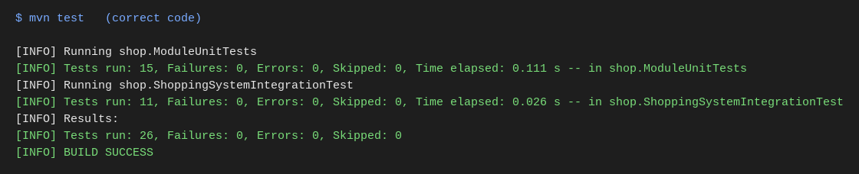
Figure 1: All 26 tests pass on the correct code (BUILD SUCCESS).
Main application output:
Customer logged in successfully.
Order confirmation sent to John
Remaining stock: 8
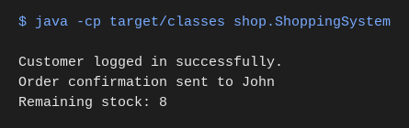
Figure 2: Console output of ShoppingSystem.

4. Deliberate defect demonstration
In OrderService.placeOrder the stock check was changed from
if (!inventoryService.checkStock(quantity)) { return "Insufficient stock"; }
to the faulty
if (inventoryService.checkStock(quantity)) { return "Insufficient stock"; }
For P100, quantity 2, stock 10, the system should confirm the order and leave stock at 8. With the defect it returns “Insufficient stock” and stock stays at 10. 8 of the 11 integration tests failed (SIT-01, 02, 03, 05, 06, 07, 10 and the end-to-end test). SIT-04, 08 and 09 still passed: SIT-08 and SIT-09 stop before the stock check, and SIT-04 only asserts that payment did not fail.
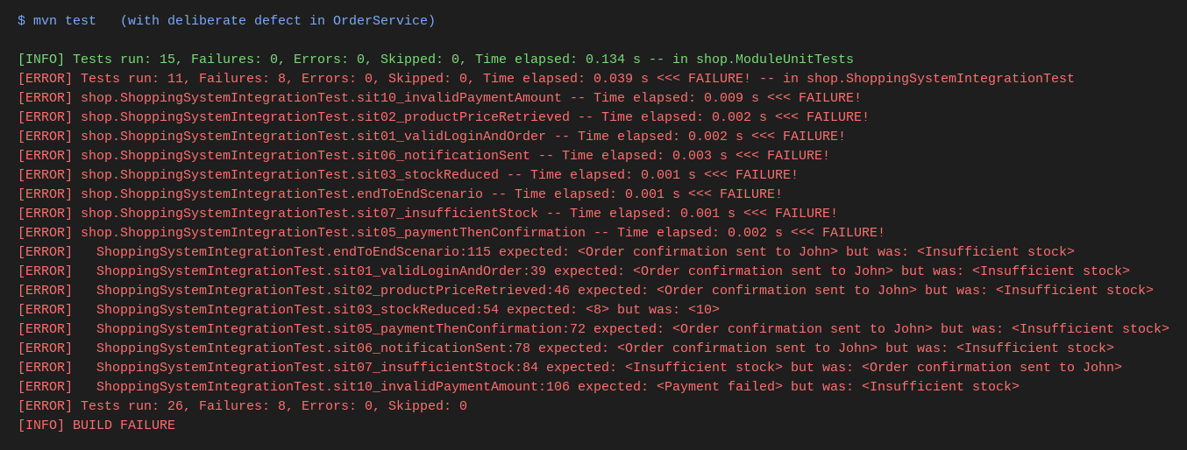
Figure 3: With the deliberate defect, 8 integration tests fail (BUILD FAILURE).
Every module passed its own unit tests, so this defect is in how OrderService uses InventoryService. Only integration testing exposes this kind of fault. The defect was removed afterwards.

5. Conclusion
All ten planned integration scenarios pass on the correct code, and the seeded defect is caught immediately. SIT therefore complements unit testing by validating interfaces and data flow between modules.

Appendix: running the project
mvn test # runs all unit and integration tests (needs internet for JUnit 5)
mvn compile exec:java -Dexec.mainClass=shop.ShoppingSystem
In Eclipse (as in the JUnit notes): right-click the test class → Run As → JUnit Test.

