Kotlin for Android:

A suitable replacement for Android development at Heritage College?

Maxwell Haley
Systems IV
Ronald Patterson
March 13th, 2018

Table of Contents
Executive Summary 3
Introduction 1
1 – What Is Kotlin? 1
2 – Monetary Cost Of Kotlin 2
3 – Tools For Educators 2
4 – Java and Kotlin Syntax Comparison 2
5 – Kotlin Performance 3
6 – Kotlin Documentation Availability 3
7 – Kotlin Staying Power 4
8 – Kotlin and the Job Market 6
Conclusion 8
References 9

Table of Figures
Screenshot 1: Questions tagged with Java as of March 11th, 2018 4
Screenshot 2: Questions tagged with Java and Android as of March 11th, 2018 4
Screenshot 3: Questions tagged with Kotlin as of March 11th, 2018 4
Screenshot 4: Questions tagged with Kotlin and Android as of March 11th, 2018 4
Screenshot 5: Stack Overflow 2017 list of most popular languages, sorted by % of developers that marked the language as liked. 5
Screenshot 6: Most popular programming languages on GitHub, ranked by opened repositories. 6
Screenshot 7: Projected % of developers adopting the Kotlin programming language, as per the Realm Report Q4. 6
Screenshot 8: Indeed search results for Kotlin jobs near Gatineau, QC. 7

Executive Summary
The Computer Science Program at Heritage College currently teaches students to develop applications for the Android mobile platform using the enterprise programming language Java. Java is taught to students starting in their first semester, and the mobile programming course builds on top of that with Android specific programming patterns.
A newer language designed by the popular software development company JetBrains called Kotlin has recently become a first-class programming language for the Android platform. Kotlin boasts reducing the amount of boilerplate needed per applications, as well as avoiding entire classes of errors. All while running in all the same locations that Java can. With both the ease of programming with Kotlin on top of avoiding common Java pitfalls, should the Computer Science Program switch teach Kotlin for Android instead of Java?
There is no cost associated alongside programming with the Kotlin language. It leverages already existing tools—including Android Studio. Android Studio is the industry standard integrated development environment for Android application development. The newest version supports Kotlin by default. Both Kotlin and the recommended integrated development environments are both: Under a free software license, have no monetary cost for individuals, and no monetary cost for teams. JetBrains has a free plug-in for educators that allows for the creation of tutorials withing the Android Studio application. This means educators can teach from within the tools the students will be using.
Kotlin keeps true with it’s promise to remove boilerplate. A comparison of a standard Java class with an equivalent Kotlin class shows how much Kotlin chooses to abstract. A developer only has to define the name of the class, and the attributes contained within. All other boilerplate code such as constructors, getters/setters, and commonly overridden methods—such as the equals method—are implicitly generated for the developer. There are also plug-ins available that abstract several Android specific snippets. For example, it allows directly calling views, and several helper functions for SQLite.
Current published benchmarks by third party show some possible performance costs involved in using Kotlin for Android. In some instances, Kotlin has shown a 300% decrease in compilation performance. However, other benchmarks have shown an increase in compilation time on partial builds. Ultimately, it should be decided by the department if ease-of-code is worth the possibility of worse performance.
Unfortunately, Kotlin simply does not have the market presence that Java has. Documentation—both official and community—is far more abundant for Java. 2017 statistics from both Stack Overflow and GitHub show that Kotlin currently has little to no presence, especially compared to Java which commonly ranks high on most used programming language lists. On top of this, jobs being offered in the Ottawa/Gatineau area asking for Kotlin experience are few. Since Kotlin currently does not increase the skill-set of students in a way that increases their chance of getting a career after their educations, it is not recommended to use Kotlin for Android application development courses.

Introduction
The Heritage College Computer Science Program contains a course on mobile application development. Specifically, applications for the Android mobile platform. The course is currently taught using the popular enterprise programming language Java, which students are taught starting in the course Programming I during their first semester. While Java is still going strong in the Android world, there is a new programming language that is attempting to make waves. Kotlin is a language looking to improve upon Java—making programming for Android a bit more comfortable. Running on the same technologies as Java, Kotlin is looking to become an enterprise language alternative to Java—similar to the programming languages Clojure and Scala. Kotlin boasts being a far more productive language to type than Java—with specific focus in the Android realm—making it easier to program with. It contains several out-of-the-box improvements to the typical Java syntax, and has several improvements for Android specific hardships included in an official plug-in. This begs the question: Should the Computer Science Program start teaching Kotlin for Android as opposed to Java for Android? This research paper will look over an overview of the Kotlin programming language, the cost of setting up a Kotlin development environment, how Kotlin differs syntactically from Java, performance benchmarks comparing Kotlin to Java, documentation availability of Kotlin vs. Java, the staying power of Kotlin, employment opportunities opened to students because of their knowledge of Kotlin, and tools available for educators to teach Kotlin in a classroom.

1 – What Is Kotlin?
Kotlin is a programming language designed, and primarily developed by the software company JetBrains. JetBrains is a well known software development company. They have developed several successful integrated development environments such as the InteliJ IDEA for Java and PyCharm for Python. JetBrains also has a suit of plug-ins for Microsoft’s Visual Studios IDE—including the plug-in ReSharper that is regarded as an essential plug-in for serious .NET developers. Development of Kotlin began due to JetBrains need for a language that: ran via the Java Virtual Machine, fit their feature needs, and performed at a respectable speed. No existing language met that requirement, so work on their own internal programming language began [9]. Kotlin was announced in 2011, and was open-sourced in 2012 under the Apache 2.0 free software license. Kotlin was built specifically to address the short-comings of Java, and runs in all environments that Java traditionally can. Kotlin can run in the Java Virtual Machine, can be transpiled into the JavaScript programming language for use in web applications, can be compiled against the native machine for use without the Java Virtual Machine, and can be used to develop applications for the Android platform [7]. The official Kotlin web page boasts that Kotlin can:
- “...drastically reduce the amount of boilerplate code.”
- “Avoid entire classes of errors, such as null pointer exceptions.”
- “Leverage existing libraries...”
As well, the page states that developers can: “Choose any Java IDE or build from the command line” [7].

2 – Monetary Cost Of Kotlin
Tooling for building Android applications using Kotlin is readily available. As of version 3.0, Android Studio—the official integrated development environment for Android—has native support for the Kotlin programming language. This means developers can develop Android applications using Kotlin without any additional set-up. Android Studio contains an action for converting already existing proper Java code to Kotlin. On top of that, Android Studio will suggest converting Java to Kotlin if you attempt to paste a snippet of Java into a Kotlin file [6]. The popular Java integrated development environment Eclipse can also handle Kotlin, albeit necessary to download an—also free—plug-in. A trend with both the Kotlin programming language and the listed integrated development environments, are that they are free. Both in cost, but also in licensing. Eclipse and Android Studio are both available to all to download for no cost. The source code for Eclipse, and Android Studio are under the Eclipse Public License and Apache 2.0 respectively. Both of these licenses are free software licenses—which is appropriate for a language that is also under a free software license. Neither of these integrated development environments are mandatory to program for Android using Kotlin. Any text editing program can be used to write Kotlin. This, combined with zero monetary investment, makes it extremely accessible to begin programming in Kotlin.

3 – Tools For Educators
JetBrains has released a tool specifically for educators. A free plugin for either Android Studio or IntelliJ IDEA called EduTools can be used to easily create interactive lessons. This tools allows educators to design exorcises for students to be completed within the development environment that students will have to become comfortable with. It allows inserting partially completed code with specific placeholder locations meant to be filled out by students. Educators can develop automated tests to check the answers given by students for correctness. Courses can be exported for use by other educators and can be tied into the IT focused education platform Stepik [5]. While this tool doesn’t negate the need for a lesson plan to be created, it does take some weight of the teachers shoulders as far as how to introduce the language.

4 – Java and Kotlin Syntax Comparison
Developers who are familiar with Java, or any object-oriented programming language, will find getting started typing Kotlin very simple. As with Java, a Kotlin code-base is spread across multiple classes—with each class containing some amount of properties, methods, comments, etc. Data types remain the same as they are in Java—as do Boolean-statements, and loops. Methods have a return type, and none-or-many parameters. All of these core concepts are the same as they are in Java. The largest difference between Kotlin and Java is the actual syntax. Kotlin is extremely terse, requiring significantly fewer lines-of-code than an equivalent Java application. A Java class containing constructors, properties, accessors, mutators, and various default method overrides—equals, toString, hashCode, etc—can easily reach up to hundreds lines-of-code. Since most typical Java classes will require all these to fulfill its purpose, the tedious tasks is often automated away by the development environment. Kotlin removes the verbosity, instead choosing to make assumptions:
data class User (var name: String,
var age: Int,
var password: String)
The above code handles all of the functionality our standard Java class must explicitly contain, including overriding some default methods [8]. There are several other examples of Kotlin code being much more efficient to write, with the explicit declarations of Java replaced with Kotlin’s assumptions. Kotlin also includes several concepts that either do not exist in Java—or have only recently been added—such as: extension methods, the safe call operator, and higher-order functions [10]. Kotlin also shines when it comes to Android development. With the inclusion of the Kotlin Android Extensions, and Anko plug-ins, Kotlin simplifies most hardships a developer would have with Java for Android. Calling views directly without having to find by identifier, helper functions for SQLite, instant toasts/alerts/snackbars, etc [8]. Kotlin’s terse syntax is quicker to parse—as well as more efficient to type—than Java’s verbose syntax. This makes the Kotlin programming language inherently quicker to write and maintain than Java.

5 – Kotlin Performance
Kotlin is inherently more efficient to write, but it’s compile time efficiency has come into question. Does the additional layer of Kotlin cause an increase in compile time compared to Java? A series of blog posts by Android developer Christophe Beyls titled Exploring Kotlin’s Hidden Costs contains the results of several benchmarks ran against Kotlin and Java—specifically inside the Java Virtual Machine. These benchmarks returned the following results: Local functions, null safety operations, indirectly accessing ranges, non-primitive ranges, range iteration with explicit steps, and the use of indices on custom collections did not result in a significant performance loss with Kotlin compared to Java. However, Kotlin’s Varags and Spread Operator doubles performance expense due to a redundant array copy, delegate properties resulted in an approximate 10% performance loss, and making a forEach call against a range resulted in a 300% performance cost [2]. Evan Tatarka—software engineer at the software development agency Willowtree—took these benchmarks and ran them against the Android Runtime. The conclusion was that these costs found on the Java Virtual Machine also exists on the Android Runtime [3]. Aj Alt of Keepsafe Engineering ran build benchmarks to compare Kotlin to Java on the Java Virtual Machine. He found that on a clean build, Java was more optimized than Kotlin between 10% and 15%. However, on partial builds—which are arguably more common—Kotlin was as fast or faster than Java [1]. In the end, it’s a game of trade-offs. Is the decrease in code production thanks to Kotlin’s abstractions worth the possible increase in build times?

6 – Kotlin Documentation Availability
Both Java and Kotlin have full documentation pages readily available. Java has the huge Java Platform Standard Edition API Specifications, while Kotlin has a full reference style documentation page online. The Kotlin documentation is arguably easier to parse through due to it’s size, as well as the fact that it presents high level concepts to the readers upfront. Ideas such as: classes, objects, functions, etc. are given right away—and lower level info such as each class in the standard library is hidden a layer deeper. However, Java’s age lends it an advantage. Any search for issues regarding Java for Android will be met with a solution, due to the fact that Java has had far more years of developers hacking on it. Using the popular Q&A forum Stack Overflow shows that there are 1,386,585 questions tagged with Java [Screenshot 1], and 203,901 questions with both the tags Java and Android [Screenshot 2]. Whereas only 8,450 questions are tagged as Kotlin [Screenshot 3], and only 3,812 tagged with both Kotlin and Android [Screenshot 4]. Of course, Kotlin’s documentation available online will increase over time, assuming it stays relevant.
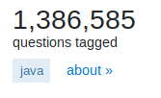Screenshot 1: Questions tagged with Java as of March 11th, 2018
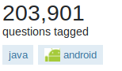Screenshot 2: Questions tagged with Java and Android as of March 11th, 2018
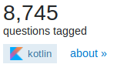Screenshot 3: Questions tagged with Kotlin as of March 11th, 2018
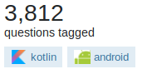Screenshot 4: Questions tagged with Kotlin and Android as of March 11th, 2018

7 – Kotlin Staying Power
Does the Kotlin programming language have staying power? On Stack Overflow’s 2017 Developer Survey, Kotlin does not appear anywhere. It is does not appear on the list of loved language, wanted language, languages by occupation, or even on dreaded languages [12] [Screenshot 5]. The same can be said for GitHub’s Octoverse 2017, where Kotlin does not appear on the list of most used languages [4] [Screenshot 6]. However, data technology company Realm paints a more positive picture of Kotlin. Their Q4 2017 report shows Kotlin’s rate of growth speeding up after being officially brought to Android after Google I/O 2107. It jumps for 7.4% of developers using Kotlin, to 14.7% at the time the report was published. Realm forecasts that Kotlin will overtake Java in percentage of developers by December 2018 [11] [Screenshot 7]. However, Realm’s data-set is pulled from their own community of developers. As Realm’s audience is focused on up-and-coming technologies, the data-set may be skewed to appear as if the adoption rate is greater than it actually is.
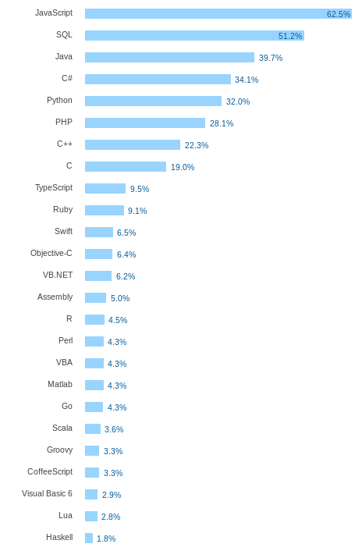Screenshot 5: Stack Overflow 2017 list of most popular languages, sorted by % of developers that marked the language as liked.
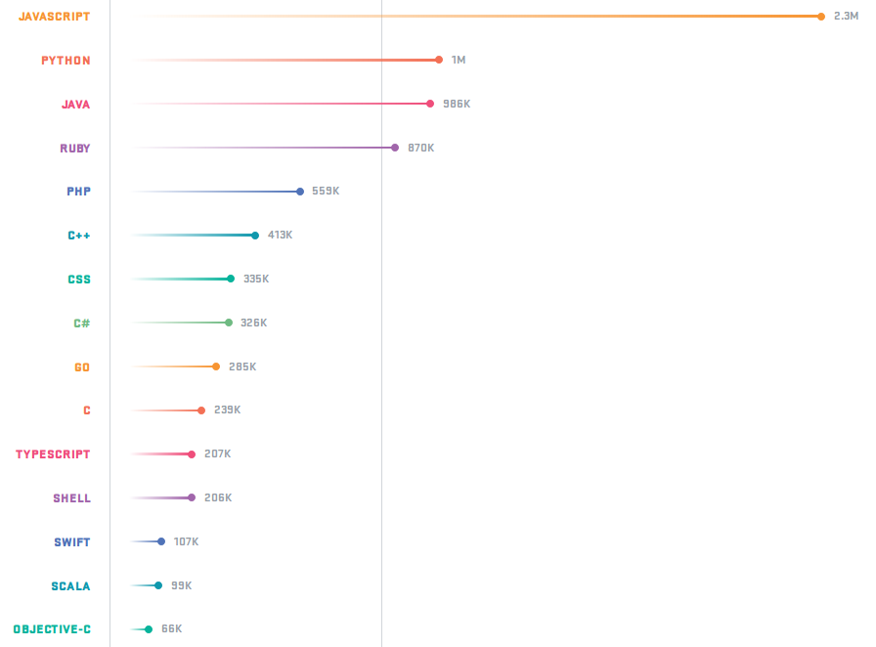Screenshot 6: Most popular programming languages on GitHub, ranked by opened repositories.
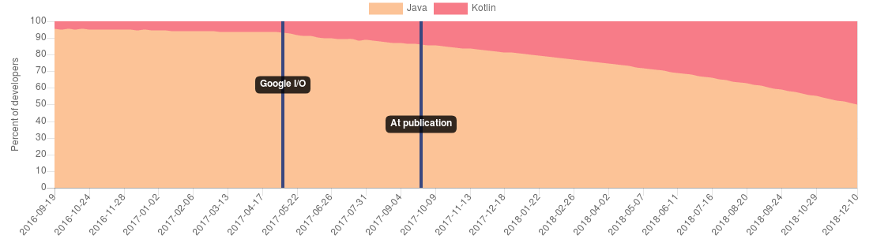Screenshot 7: Projected % of developers adopting the Kotlin programming language, as per the Realm Report Q4.

8 – Kotlin and the Job Market
The Computer Science Program is specifically tailored for students to be able to enter the job force after graduating. Specifically: focusing on public sector jobs and local private industries. In order for Kotlin to be worth teaching, it must increase the chances of students being hired. To determine this, the output of two large job posting aggregation sites—Indeed and the Government of Canada’s Job Bank—has been looked at to determine positions asking for Kotlin as either a main language, or a bonus language. A search on Indeed—performed on the March 11th, 2018—found only three job postings looking for experience with Kotlin [Screenshot 8]. A Job Bank search performed the same day found no job postings for Kotlin around Gatineau, Quebec. This, unfortunately, means Kotlin is currently not a sought after skill. While Kotlin usage may increase with time as the previously mentioned Realm report has foreseen, currently there is no evidence of Kotlin increasing a students chance of becoming employed.
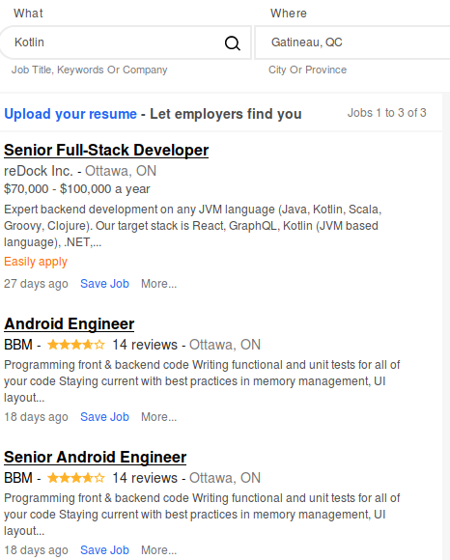Screenshot 8: Indeed search results for Kotlin jobs near Gatineau, QC.

Conclusion
Based on the evidence given above, the Computer Science Program should not switch to Kotlin for Android development. Kotlin contains cleaner syntax, specialized tools for educators, and performance is arguably on par with Java. However, the uncertainty as to the staying power of Kotlin—as well as the lack of employment opportunities—bars Kotlin from becoming an independent language to teach Android. While Kotlin might be nice to teach alongside Java—especially since at this point students have had a lot of exposure to Java—it does not have the influence to warrant ejecting Java for Android as the primary language. Should Kotlin’s popularity rise and we see the adoption of Kotlin from the public sector or local private industries, then Kotlin should be seriously considered as a replacement for Java. Until that point, Java must remain the primary Android platform development language.

References
[1] Alt, A. J. “Kotlin vs Java: Compilation Speed.” Keepsafe Engineering, 8 Sept. 2016, https://medium.com/keepsafe-engineering/kotlin-vs-java-compilation-speed-e6c174b39b5d.
[2] Beyls, Christophe. “Exploring Kotlin’s Hidden Costs — Part 1.” Christophe Beyls, 5 June 2017, https://medium.com/@BladeCoder/exploring-kotlins-hidden-costs-part-1-fbb9935d9b62.
[3] Engineer, Evan TatarkaSoftware. Kotlin’s Hidden Costs - Android Benchmarks. https://willowtreeapps.com/ideas/kotlins-hidden-costs-android-benchmarks. Accessed 3 Feb. 2018.
[4] “GitHub Octoverse 2017.” GitHub Octoverse 2017, https://octoverse.github.com/. Accessed 1 Mar. 2018.
[5] “Kotlin Edu: Learn and Teach Kotlin with Easy and Professional Tools.” JetBrains, https://www.jetbrains.com/education/kotlin-edu/. Accessed 3 Feb. 2018.
[6] “Kotlin for Android - Kotlin Programming Language.” Kotlin, https://kotlinlang.org/docs/reference/android-overview.html. Accessed 3 Feb. 2018.
[7] “Kotlin Programming Language.” Kotlin, https://kotlinlang.org/. Accessed 3 Feb. 2018.
[8] Kotlin VS Java: Basic Syntax Differences. http://yalantis.com/blog/kotlin-vs-java-syntax/. Accessed 3 Feb. 2018.
[9] Krill, Paul. “JetBrains Readies JVM-Based Language.” InfoWorld, 22 July 2011, https://www.infoworld.com/article/2622405/java/jetbrains-readies-jvm-based-language.html.
[10] Lima, Pedro. “Kotlin vs. Java: First Impressions Using Kotlin.” ArcTouch, 3 May 2017, https://arctouch.com/2017/05/kotlin-vs-java/.
[11] Realm Report Q4 2017. https://realm.io/realm-report/. Accessed 10 Feb. 2018.
[12] “Stack Overflow Developer Survey 2017.” Stack Overflow, https://stackoverflow.com/insights/survey/2017/?utm_source=so-owned&utm_medium=social&utm_campaign=dev-survey-2017&utm_content=social-share. Accessed 1 Mar. 2018.

