The dataset we have been given contains data about the number of homicides per year, with a special focus on homicides with firearms. Two populations are included in the dataset: The population of Canada (between 32, and 35 million), and the population of the United States of America (between 295, and 318 million). The data for Canada has been taken by *Statistics Canada*, and the data for the USA is taken from the *Federal Bureau of Investigation*. The data from the FBI was published in 2009, and in 2014. The Statistics Canada and FBI data covers the years of 2005 to 2014. The data was obtained by looking at crime reports filed by law enforcement across the given nation.

Using the following bar charts, we can draw parallels between the dataset and the conclusions came to during the *Science Vs.* podcast. In charts 1, 2, and 3: We see a significant difference not only in base homicide rates, but a drastic difference in homicides cause by firearms. One could draw the conclusion that Canada’s gun control laws, and gun registry program is responsible for this difference. Firearms are split into three classes: non-restricted, restricted, prohibited[1]. To own a non-restricted firearm (E.g. a rifle or shotgun), one must obtain a firearms license that requires taking a course, and paying a fee. To own a restricted firearm (E.g. non-prohibited handguns, and semi-automatic center-fire rifles/shotguns), one must apply for a harsher, and more expensive, license. Lastly, prohibited firearms (E.g. Fully-automatic rifles, snub nosed handguns, .25 and .35 caliber handguns, and sawed-off shotguns/rifles) are not allowed to be owned by a civilian. None of the two licenses allow “concealed carry” as some States allow. All restricted firearms purchased are placed into the firearms registry, which contains a list of all legally purchased restricted firearms, and their owner. Firearms cannot be transported openly. The firearm must be secured in a case, while the ammunition must be secured in it’s own case. Inside a private home, all firearms must be secured inside a “gun safe” behind a combination lock/pad, a key, or both.

Another conclusion made by *Science Vs.* is of culture. The easiest firearm types to get a license to own and operate are the standard rifle, and the standard shotgun. These are common firearms for hunting, which makes sense given Canada’s strong hunting culture. A culture that promotes safe use of firearms against non-human targets. Contrast that to the USA’s concealed carry/castle doctrine[2]/second amendment culture that promotes the use of firearms against human targets. Canada’s firearm culture does not glamorize firearms as a line of defense against theoretical attackers, instead as a tool for hunting and sport.

Another *Science Vs.* conclusion seen in charts 4, and 5 is of correlation. The amount of general homicides does not drastically reduce with the inclusion of gun control laws. In 2012 (2015 for Quebec), Canada passed a bill that meant owners of non-restricted firearms no longer had to be recorded to the firearms registry. As chart 4 shows, there was no spike in firearms related deaths in after this bill had passed. Chart 4 also shows that as the amount of homicides in Canada has lessened, the amount of firearm homicides has stayed relatively the same. In chart 5, we see that despite the drastic reduction in firearm homicides in the USA there is still a far larger rate of general homicides. As well, the rate of firearms deaths in still nowhere near as low as Canada (chart 3).

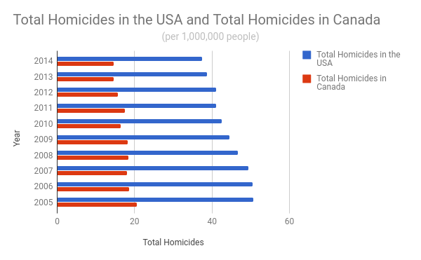  
Chart 1: Total homicides in Canada and the USA.

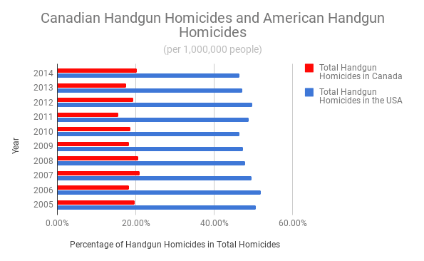  
Chart 2: Comparison of total handgun homicides in Canada and the USA

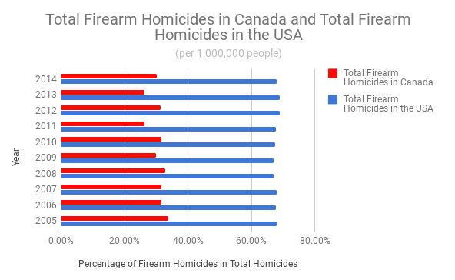  
Chart 3: Comparison of total firearm homicides in Canada and the USA

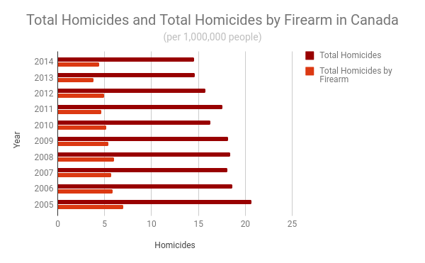  
Chart 4: Comparison of homicides and homicides by firearm in Canada

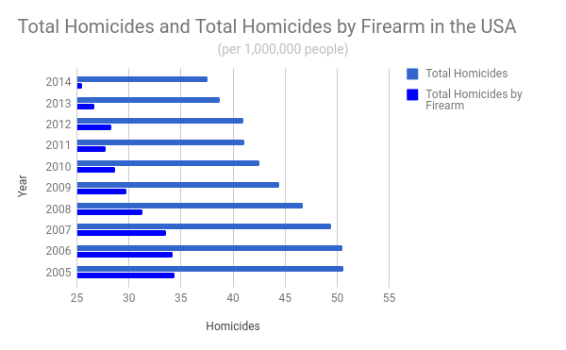  
Chart 5: Comparison of homicides and homicides by firearm in the USA

The following tables show the “5-number” summaries for various datasets. Specifically it shows the smallest value in the set (Min), the value that begins the lowest 25% of the dataset (Q1), the center most value (Median), the value that begins the highest 25% if the data (Q3), and the largest value (Max). In this case, one could use the mean to represent the expected value of the dataset. For example: in table 1 we see that the expected amount of homicides in Canada during the period of 2005 – 20014 was 3.18 million.

These tables help confirm the conclusion in *Science Vs.* that stronger gun control laws result in less firearms related homicides. Looking at tables 2, and 3: One can see that approximately 30% of homicides in Canada were caused by firearms. Compare this to tables 5, and 6 where approximately 67% of homicides in the USA were caused by firearms.

|  |  |  |  |  |
| --- | --- | --- | --- | --- |
| Total Handgun Homicides in Canada during 2005 - 2014 (per 1,000,000 people) | | | | |
| Min | Q1 | Median | Q3 | Max |
| 2.56 | 2.96 | 3.18 | 3.8 | 4.07 |

Table 1: 5-number summary for total handgun homicides in Canada

|  |  |  |  |  |
| --- | --- | --- | --- | --- |
| Total Firearm Homicides in Canada during 2005 - 2014  (per 1,000,000 people) | | | | |
| Min | Q1 | Median | Q3 | Max |
| 3.85 | 4.61 | 5.285 | 5.87 | 6.96 |

Table 2: 5-number summary for total firearm homicides in Canada

|  |  |  |  |  |
| --- | --- | --- | --- | --- |
| Total Homicides in Canada during 2005 - 2014  (per 1,000,000 people) | | | | |
| Min | Q1 | Median | Q3 | Max |
| 14.54 | 15.74 | 17.815 | 18.4 | 20.62 |

Table 3: 5-number summary for total homicides in Canada

|  |  |  |  |  |
| --- | --- | --- | --- | --- |
| Total Handgun Homicides in the USA during 2005 - 2014  (per 1,000,000 people) | | | | |
| Min | Q1 | Median | Q3 | Max |
| 17.44 | 19.77 | 20.705 | 24.53 | 26.24 |

Table 4: 5-number summary for total handgun homicides in the USA

|  |  |  |  |  |
| --- | --- | --- | --- | --- |
| Total Firearm Homicides in the USA during 2005 - 2014  (per 1,000,000 people) | | | | |
| Min | Q1 | Median | Q3 | Max |
| 25.47 | 27.76 | 29.24 | 33.59 | 34.35 |

Table 5: 5-number summary for total firearm homicides in the USA

|  |  |  |  |  |
| --- | --- | --- | --- | --- |
| Total Homicides in the USA during 2005 - 2014  (per 1,000,000 people) | | | | |
| Min | Q1 | Median | Q3 | Max |
| 37.51 | 41.03 | 43.485 | 49.46 | 50.6 |

Table 6: 5-number summary for total homicides in the USA

Looking at plots 1, and 2: One can see more clearly the drastic difference between Canada’s and the USA’s homicide rates. Reviewing the box plots, we can see that the USA’s homicide rates are skewed to the right, while Canada’s firearms homicide rate is symmetrical, and the total homicide rate is skewed to the left. There are no outliers in this dataset, which mean neither country has had a year where homicides drastically increased or decreased.

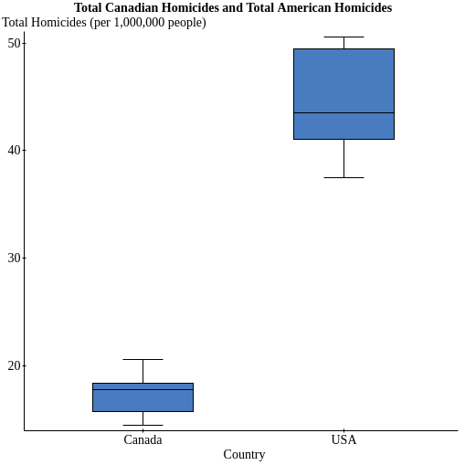  
Plot 1: Box plot comparison of total homicides in Canada and the USA

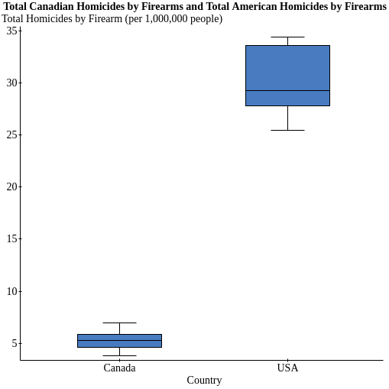  
Plot 2: Box plot comparison of total firearm homicides in Canada and the USA

Plot 1 shows a mildly strong, linear, and positive scatter plot of firearm homicides in relation to total homicides in Canada. The correlation conditions are met for this plot. Neither of the variables are categorical, the plot is “straight enough” (no curves, no change in direction), and the chart has no extreme outliers. Using the formula:

$r=\frac{n\sum{xy}−\left(\sum{x}\right)\left(\sum{y}\right)}{\sqrt{n\left(\sum{x^{2}}\right)−{\left(\sum{x}\right)}^{2}}\sqrt{n\left(\sum{y^{2}}\right)−{\left(\sum{y}\right)}^{2}}}$

The correlation coefficient for this plot is approximately 0.92. This backs up my original statement of the plot being strong, positive, and linear. The coefficient of determination is shown using the formula $R^{2}$, and is approximately 0.84. This means that the regression line shown in plot 2 is a fairly close representation of estimated values.

Plot 3 shows a **very** strong, **very** linear, and **very** positive scatter plot of firearm homicides in relation to total homicides in the USA. The correlation conditions are met for this plot. Neither of the variables are categorical, the plot exceptionally straight enough, and the chart has no outliers. Using the same formula given above: The correlation coefficient for this plot is approximately 0.996. This backs up my original statement of this plot being extremely strong, positive, and linear. The coefficient of determination is shown using the same formula given above, and is approximately 0.992. This meas the regression line shown in plot 4 an almost accurate representation of the actual values. Using the regression line to predict possible values would result in nearly perfect values compared to the real world.

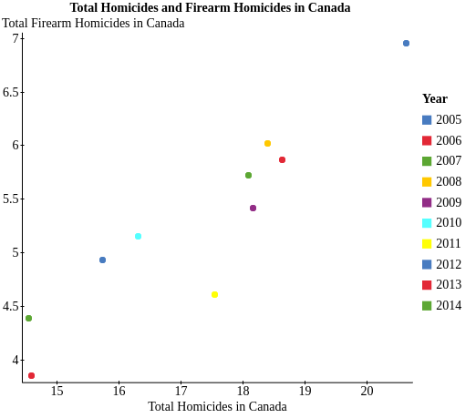  
Plot 3: Scatter plot of total homicides and firearm homicides in Canada (per 1,000,000 people) labeled by year.

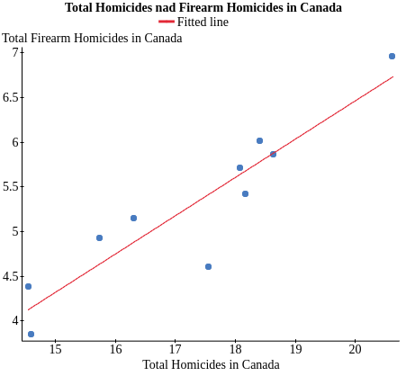  
Plot 4: Scatter plot of total homicides and firearm homicides in Canada (per 1,000,000 people) with regression line.

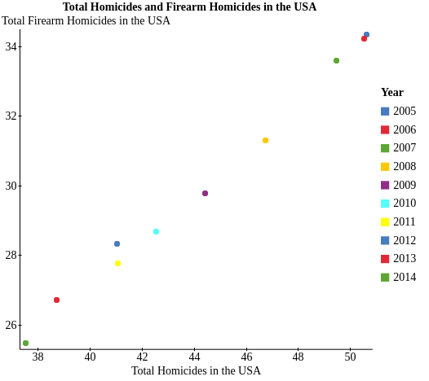  
Plot 5: Scatter plot of total homicides and firearm homicides in the USA (per 1,000,000 people) labeled by year.

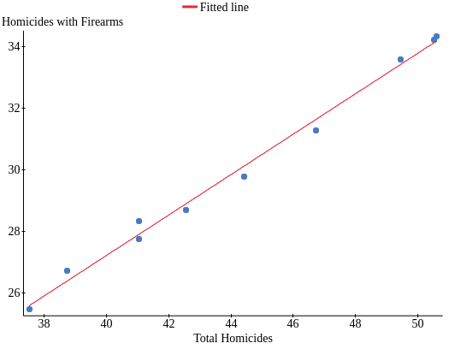  
Plot 6: Scatter plot of total homicides and firearm homicides in the USA (per 1,000,000 people) with regression line.

These four plots confirm what was said in *Science Vs.*, that there is a direct correlation between firearms and homicides. We can expect an increase in firearm homicides if we witness an increase in total homicides, because firearm homicides make up a large majority of the total homicides the USA will experience in a year.

Using the Canadian Firearms Homicide statistic, we can find that the sample mean is 5.292, and a standard error of 0.2858741. This gives us a 95% confidence interval of 4.6453079 to 5.9386921. This means we are 95% sure the true average firearm homicides per year (per 1,000,000 people) in Canada is somewhere inside that interval.

Using the Canadian Firearms Homicide statistic, we can find that the sample mean is 30.024, and a standard error of 1.0127983. This gives us a 95% confidence interval of 27.732891 to 32.315109. This means we are 95% sure the true average firearm homicides per year (per 1,000,000 people) in the United States is somewhere inside that interval.

Both of the figures meet the requirements of a valid confidence interval. We cannot prove that the samples are random, however we can trust that the two organizations responsible for the datasets would not skew the results by using non-independent sample sizes.

We can prove that the datasets are nearly normal. Looking at histogram 1, we see that the Canadian firearm homicide dataset is symmetric, and unimodal. Therefore, we can safely assume histogram 1 is nearly normal.

Histogram 2 is unimodal, but is not perfectly symmetric. However, because it has no outliers (skewing the histogram), we can assume if we applied the *central limit theorem*, we would end up with a nearly normal histogram.

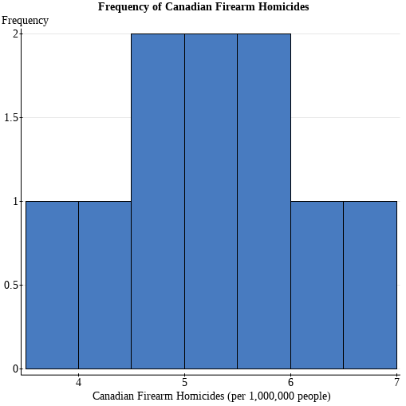  
Histogram 1: Frequency of Firearm Homicides (per 1,000,000 people)

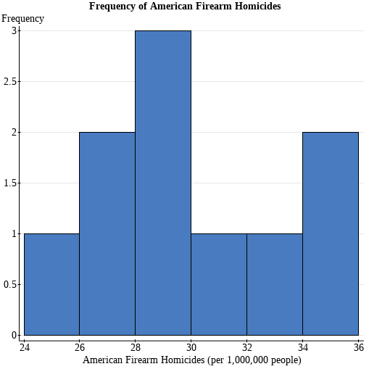  
Histogram 2: Frequency of American Firearm Homicides (per 1,000,000 people)

Using the normalized data, we see that the proportion value for firearm homicide rates in Canada compared to all homicide rates is approximately 30.66%. We find this using:

$\hat{p}=\frac{\sum{firearmhomicidesperyear}}{\sum{totalhomicidesperyear}}$

We also see that the proportion value for firearm homicide rates in the United States compared to all homicide rates is approximately 67.83%. We find this using the same formula above.

Using the United States proportion value as *p̂1,* and the Canadian proportion as *p̂2,* we can start to build our null hypothesis. The null hypothesis I will be using is: $H_{0}:\hat{p_{1}}−\hat{p_{2}}=0$. If the null hypothesis was correct, that would mean the proportions of firearm homicides are the same in the country. Therefore, each country has the same amount of firearm homicides, but the United States has a larger number because of it’s larger population.

Our proposed alternate hypothesis is: $H_{A}:\hat{p_{1}}−\hat{p_{2}}>0$. If our alternate hypothesis was correct, that would mean the proportion of firearm homicides is greater in the United States. Therefore, the United States has greater firearm homicides, even when considering it’s larger population.

To test our hypothesis’, we’ll first construct our *p̂pooled* value, which *is: ${p̂}_{pooled}=\frac{354}{615}≈0.574$.* Next, we find the standard error of *p̂1* - *p̂2*:.

We can then discover the z-value: $z=\frac{0.574}{0.444}=1.29$. Finally, we perform a z-index lookup to determine the p-value: $P\left(X>0\right)=1−0.9015=0.0985$.

At a 5% significance level, we use this evidence to reject H0. This means at 5%, we can reject the idea that Canada has the same firearm homicides as the United States. However, at a 10% significance level, we would just barely fail to reject H0. This means at 10%, we cannot cannot reject the idea that Canada has the same firearm homicides as the United States.

1. http://www.rcmp-grc.gc.ca/cfp-pcaf/faq/index-eng.htm#a3
2. https://en.wikipedia.org/wiki/Castle_doctrine