5.10.2024

完成限制生成的对抗样本扰动在20%以下，做了如下修改

1. d:\\TextAttack\textattack\attack.py 在后面添加了这样一段代码

class MyMaxModificationRateConstraint(Constraint):  
 def __init__(self, max_rate, min_threshold=1):  
 assert isinstance(max_rate, float), "`max_rate` must be a float."  
 assert max_rate >= 0 and max_rate <= 1, "`max_rate` must be between 0 and 1."  
 assert isinstance(min_threshold, int), "`min_threshold` must be an int."  
  
 self.max_rate = max_rate  
 self.min_threshold = min_threshold  
 self.compare_against_original = True # 添加 compare_against_original 属性  
  
 def _check_constraint(self, current_text, transformed_text):  
 threshold = max(  
 math.ceil(current_text.num_words * self.max_rate), self.min_threshold  
 )  
 if len(current_text.attack_attrs["modified_indices"]) >= threshold:  
 return set()  
 else:  
 return set(range(len(current_text.words)))  
  
 def extra_repr_keys(self):  
 return ["max_rate", "min_threshold"]

并将第124行 从self.constraints = []修改为self.constraints = [MyMaxModificationRateConstraint(0.2)]

5.16

关于扰动率计算的修改

1. D:/TextAttack/textattack/metrics/attack_metrics/words_perturbed.py

将原始45-49行注释掉，添加了50-52行

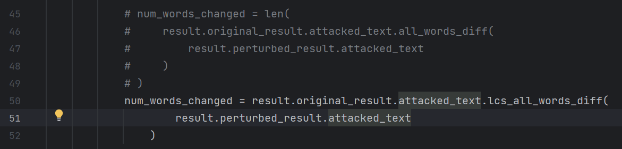

1. D:/TextAttack/textattack/shared/attacked_text.py

添加了如下几行代码

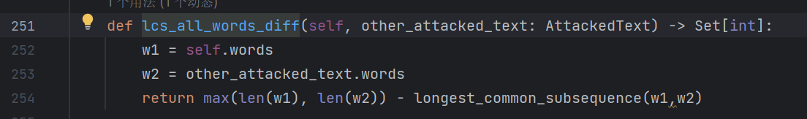

1. 要保留这个D:\TextAttack\testdata\dOpenHowNet.py文件

5.20

为了输出指标use语义相似度和perplexity模型困惑度，作了如下修改

1. D:\TextAttack\textattack\loggers\attack_log_manager.py

添加了271和272行

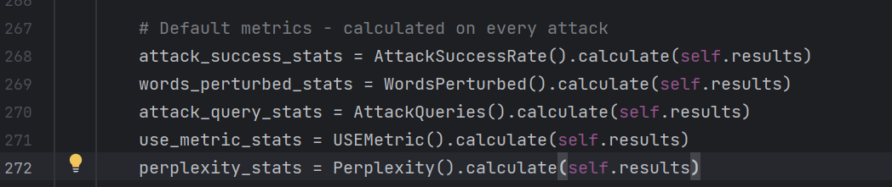

添加了这两段

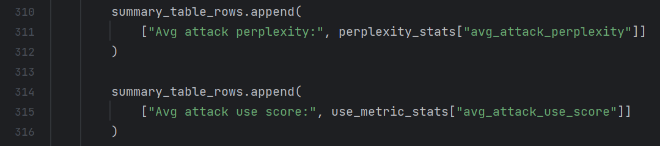

1. 

修改了本地路径

