Zepr - Zombie Engineering Project

User Manual

## 

## Contents

## 

#### Introduction ..………………………………………………………………………………...01

#### Main Menu ..…………………………………………………………………………………02

#### Stage and Character Selection ……………………………………………………………….02

#### Pause Menu ………………………………………………………………………………….03

#### Gameplay ……………………………………………………………………………………04

#### 

#### Full list of characters and power ups ...………………………………………………………05

#### Mini Game …………………………………………………………………………………..08

## Introduction

#### Scenario

After a hard night of partying after the dreaded POPL exam, you wake up to find yourself in the middle of town, your friends nowhere to be found.

As you try and recall how you ended up here, you hear a low rumbling sound coming from the alleyway near you.

A horde of decaying zombies suddenly appears out from the alleyway, their clothes tattered, blood and bone sticking out of their bodies.

Not soon after, the zombies notice you and charge towards you, trampling over each other, their rumbles turning into screams and cries.

But in the spur of the movement, you suddenly realize...

You forgot to hand in your SEPR assessment!

Your goal is to fight through the horde of zombies and get back to your accommodation, to hand in your SEPR assessment before the deadline is over.



## Main Menu

## 

After launching the game, you will be navigated to the main menu.

Click “Start” to begin the game.

Click “Exit” to close the game.

## Stage and Character Selection

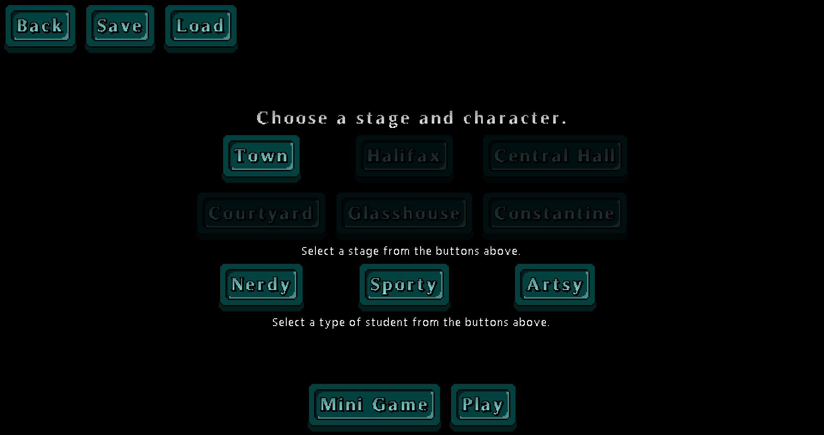

#### Stage

Stage selection allows you see your score (amount of survivors saved) and select which stage you wish to play in. Each stage will offer different obstacles and hence require different strategies to overcome.

#### Character

Character selection allows you to play as your choice of character, where each character will offer unique strengths over the other.

Select one of “Nerdy”,“Sporty” or “Artsy”.

## Pause Menu

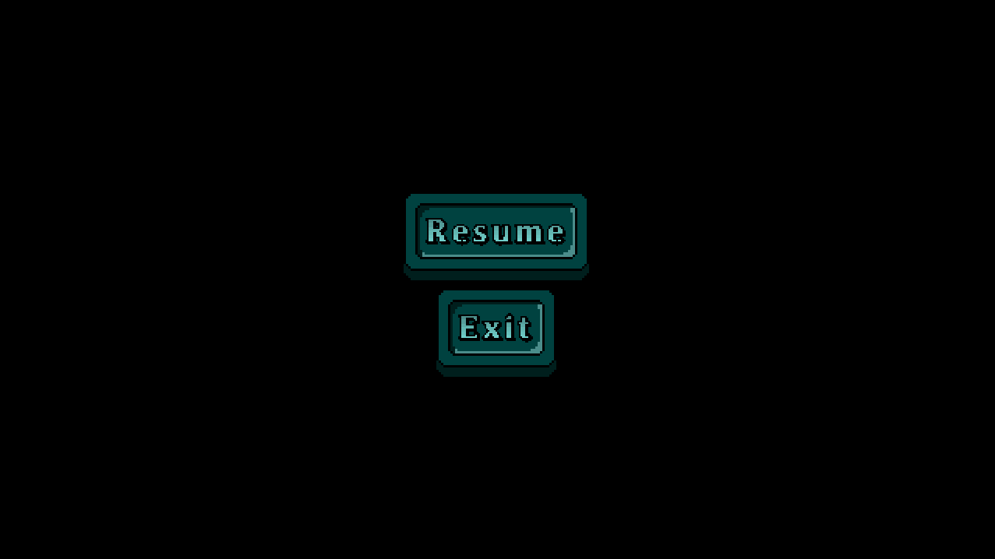

You can pause the game by pressing the “Esc” button.

To return to the game, click the “Resume” button.

To close the game, click the “Exit” button.

## Gameplay

#### Controls

|  |  |
| --- | --- |
| **Key** | **Action** |
| W | Moves the character up the screen |
| A | Moves the character left on the screen |
| S | Moves the character right on the screen |
| D | Moves the character down on the screen |
| E | Trigger player special ability |
| LMB (Left Mouse Button) | The character attacks. |
| Escape | Brings up the Pause Menu |

#### Graphical Interface

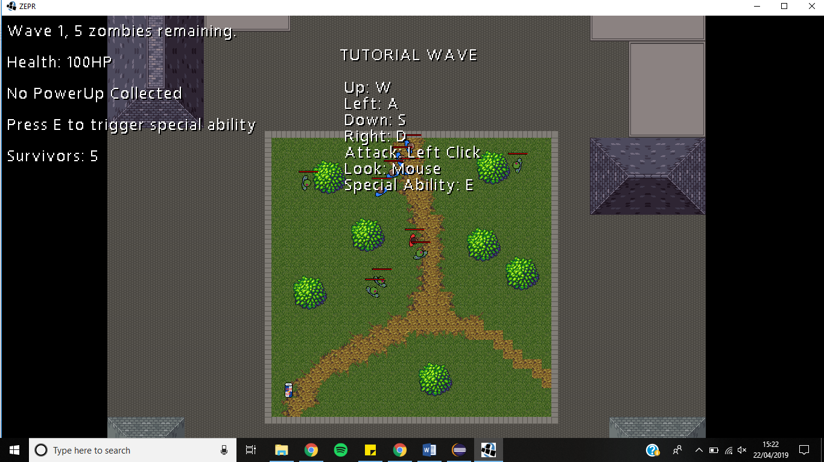

Information on the wave number, the number of zombies remaining in the wave, survivors and the player’s health total are shown on the top left of the screen. The first stage starts with a tutorial wave, explaining all necessary controls for playing the game.

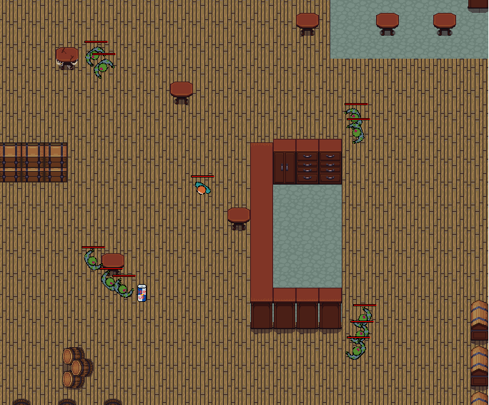

Players must defeat all of the zombies in the wave to progress to the next one and aim to protect as many survivors as possible. After completing several waves, the stage is complete, and the next stage is unlocked.

To complete the game, the player must complete all six stages: *Town*, *Halifax*, *Courtyard*, *Central Hall*, *Glasshouse*, and *Constantine*.

However if the player’s health drops down to 0 they may either become infected (giving the possibility of a second life), or die and restart the stage from the initial wave.

## Full list of Characters, Enemies and Power Ups

#### 

#### Playable Characters:

**Nerdy**



Has higher health. Equipped with a calculator, which is useless as a weapon but better than nothing, giving a low attack damage value.

**Special Ability:** Temporary immunity

**Sporty**



Has greater mobility. Equipped with a baseball bat weapon which gives a minor attack damage value.

**Special Ability:** Temporary speed boost

**Artsy**



Deals more damage. Is equipped with a paint brush which is an effective weapon with powerful ‘creative juices’ which give a high attack damage value.

**Special Ability:** Temporary damage boost

**Infected**



Oh no you’ve become infected and have joined the unrelenting horde of the undead. You will be forced to turn on your fellow colleagues unless you are fortunate enough to stumble across the cure granting you a second chance.

**Special Ability:** None

#### Power Ups:

**Heal**



Heals the player by up to 30 hp.

**Speed up**



For the next 10 seconds, increases the movement speed of the player.

**Immunity**



For the next 5 seconds, makes the player immune to zombie attacks.

**Insta-Kill**



For the next 5 seconds, all zombies are killed with one shot, and damage to bosses is greatly increased.

**Invisibility**



For the next 5 seconds, makes the player invisible to zombies.

**Cure**



Reverts zombies back into their former selves. Gives a second life when player is infected.

#### Zombie Characters:

**Football Society**



Well balanced, not particularly strong but can spawn in high numbers

**Hacking Society**



Deals a high attack damage

**Art Society**



Deals a very high attack damage and moves quickly

**Environmental Society**

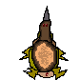

Has a high health value

**Star Trek Society**

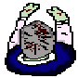

Has a very high health value

Can teleport nearer to the player, and respawn itself

## Mini Game:

The objective of the mini game is to survive as long as possible while zombie after zombie comes out and tries to eat your brains! Each kill adds to your tally. Try to get as many kills as you can before the zombies get to you.

