Zepr - Zombie Engineering Project

User Manual

## 

## Contents

## 

#### Introduction ..………………………………………………………………………………...02

#### Main Menu ..…………………………………………………………………………………03

#### Stage and Character Selection ……………………………………………………………….04

#### Pause Menu ………………………………………………………………………………….05

#### Gameplay …………………………………………………………………………………….06

## 

#### Full list of characters and power ups ...………………………………………………………07

## 

## 

## 

## Introduction

#### Scenario

After a hard night of partying after the dreaded POPL exam, you wake up to find yourself in the middle of town, your friends nowhere to be found.

As you try and recall how you ended up here, you hear a low rumbling sound coming from the alleyway near you.

A horde of decaying zombies suddenly appears out from the alleyway, their clothes tattered, blood and bone sticking out of their bodies.

Not soon after, the zombies notice you and charge towards you, trampling over each other, their rumbles turning into screams and cries.

Your Goal is to survive the zombie horde and defeat the bosses to stop them at their source. Meanwhile you try to keep on top of your University work.



## Main Menu

## 

After launching the game, you will be navigated to the main menu.

Click “Start” to begin the game.

Click “Exit” to close the game.

## 

## 

## 

## 

## Stage and Character Selection

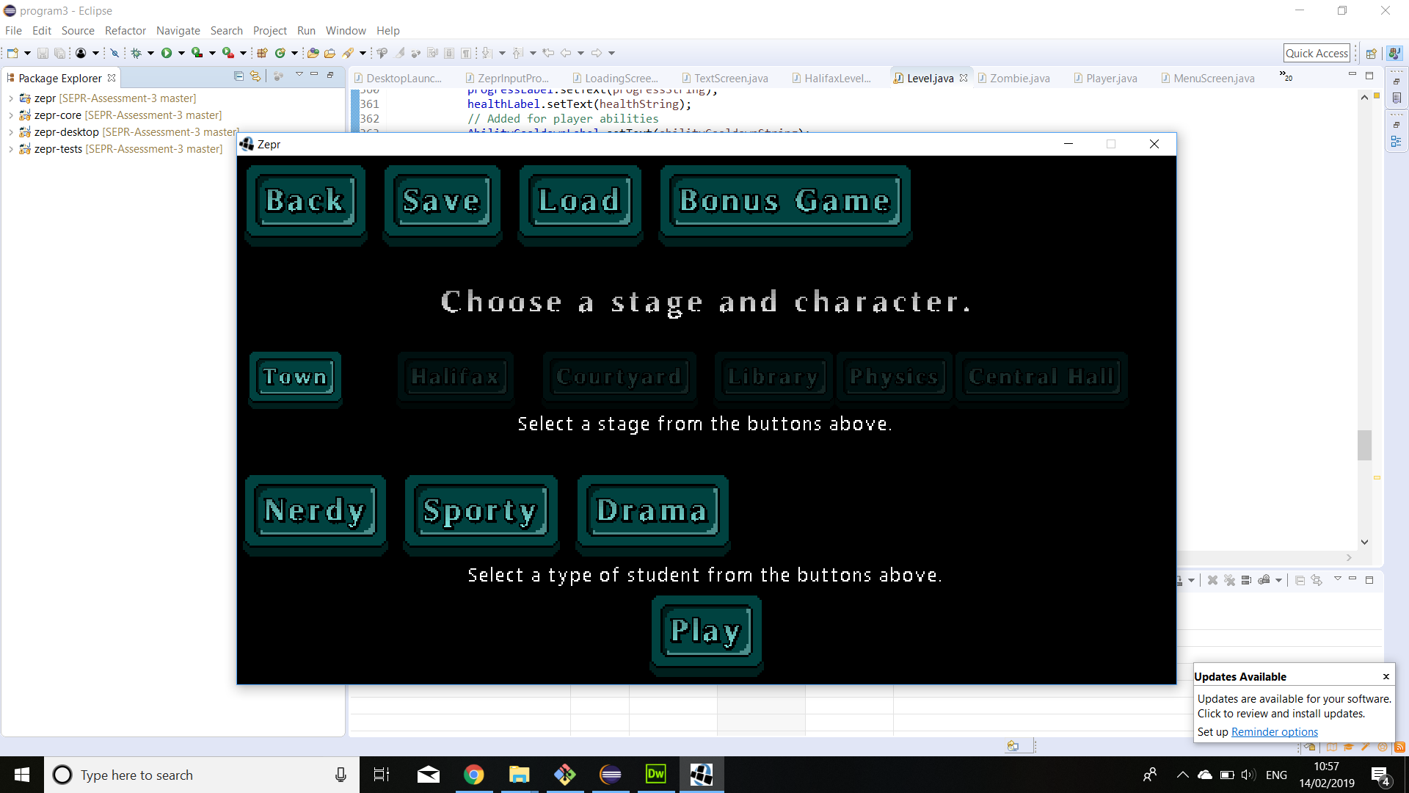

#### Stage

Stage selection allows you to select which stage you wish to play in, where each stage will offer different obstacles and hence require different strategies to overcome.

Select either one of the “Town”, “Halifax”, “Courtyard”, “library”, “Physics” or “Central Hall” buttons. (“Halifax” will be locked until “Town” is completed, and “Courtyard” will be locked until “Town” and “Halifax” is completed and so on.)

Saving at any time on the stage selection screen will save your stage progress. When you start the game again and press load your stage progress will be restored.

There is also a bonus game that can be accessed at any time. This allows the player to shoot down the zombies geese that have infested York.

#### Characters

Character selection allows you to play as a different character, where each character will offer unique strengths over the other.

Select either one of “Nerdy”, “Drama” or “Sporty”.

## Pause Menu

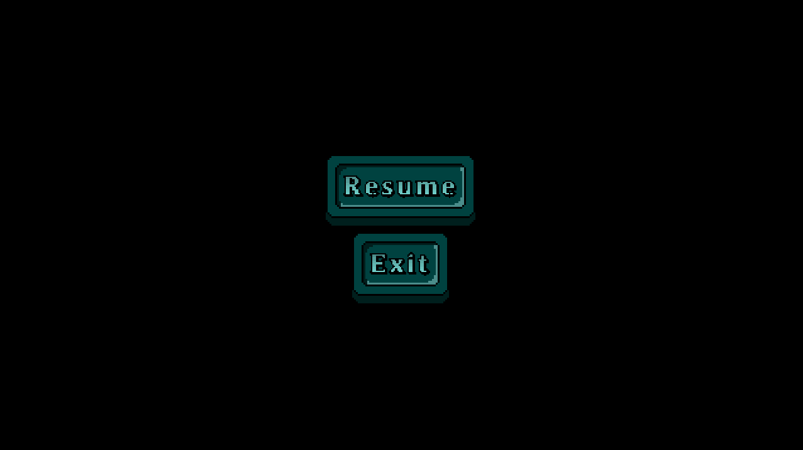

You can pause the game by pressing the “Esc” button.

To return to the game, click the “Resume” button.

To close the game, click the “Exit” button.

## 

## Gameplay

#### Controls

|  |  |
| --- | --- |
| **Key** | **Action** |
| W | Moves the character up the screen |
| A | Moves the character left on the screen |
| S | Moves the character right on the screen |
| D | Moves the character down on the screen |
| E | Uses characters special ability |
| LMB (Left Mouse Button) | The character attacks. |
| Escape | Brings up the Pause Menu |

#### Graphical Interface

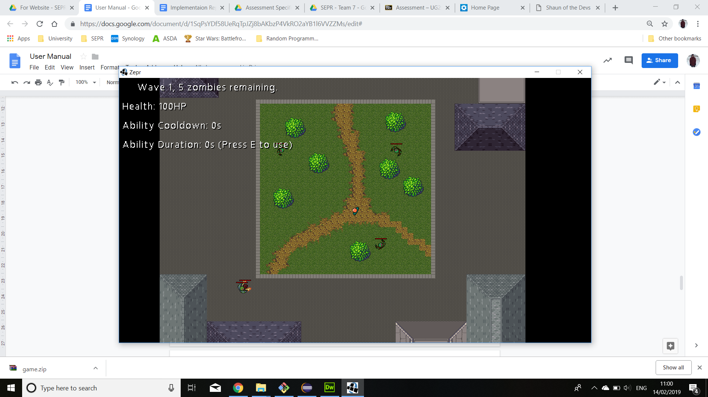

Information on the wave number, the number of zombies remaining in the wave, and the player’s health total is shown on the top left of the screen.

The player’s current ability cooldown time and how long the current ability lasts are also shown in the top left at all times. This allows the player to plan when to use their abilities.

When a power up is available it will be displayed in the top left of the screen. When it has been picked up there will be a timer showing the player how long the power up lasts.

Players must defeat all of the zombies in the wave to progress to the next wave. After completing 3 waves, the stage is complete, and the next stage is unlocked. Apart from on boss stages where the player must fight through an extra fourth wave with a boss.

To complete the game, the player must complete all six stages.

However if the player’s health drops down to 0 during a stage they will have to restart the stage.

#### 

#### 

## Full list of characters and power ups:

#### 

#### Characters:

**Nerdy**



Has higher health.

Ability: power punch

**Sporty**



Has greater mobility.

Ability: sprint

**Drama**



Has greater attack damage.

Ability: fake damage

#### Power Ups:

**Heal**



Heals the player.

**Speed up**



For the next 10 seconds, increases the movement speed of the player.

**Immunity**



For the next 5 seconds, makes the player immune to zombie attacks.

**INSTA KILL**



For 10 seconds, the player can kill any zombies with one hit.

**No ability cooldowns**



For 10 seconds, the character’s ability cooldowns are 0.