第七次实验 KNN
实验要求：


实验原理：
基本原理：
核心分类公式：对测试样本 xx，取 K 个最近邻标签的众数
y^=mode{y(1),…,y(K)}
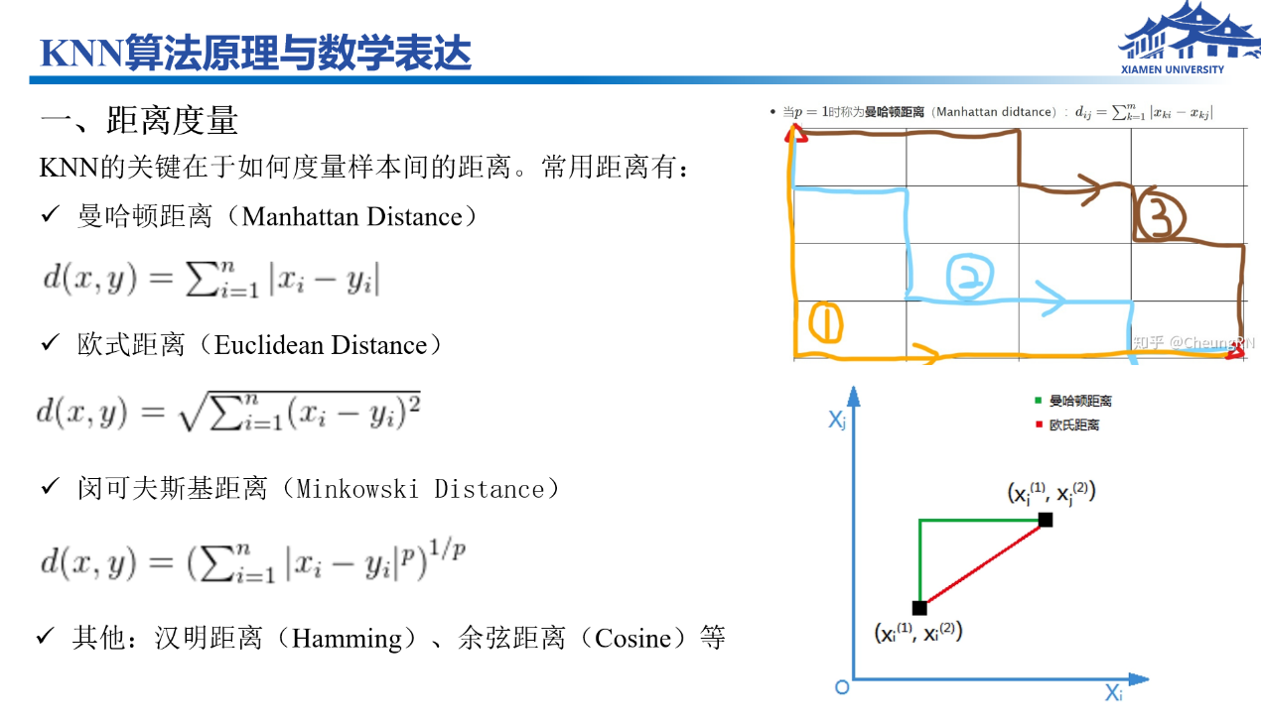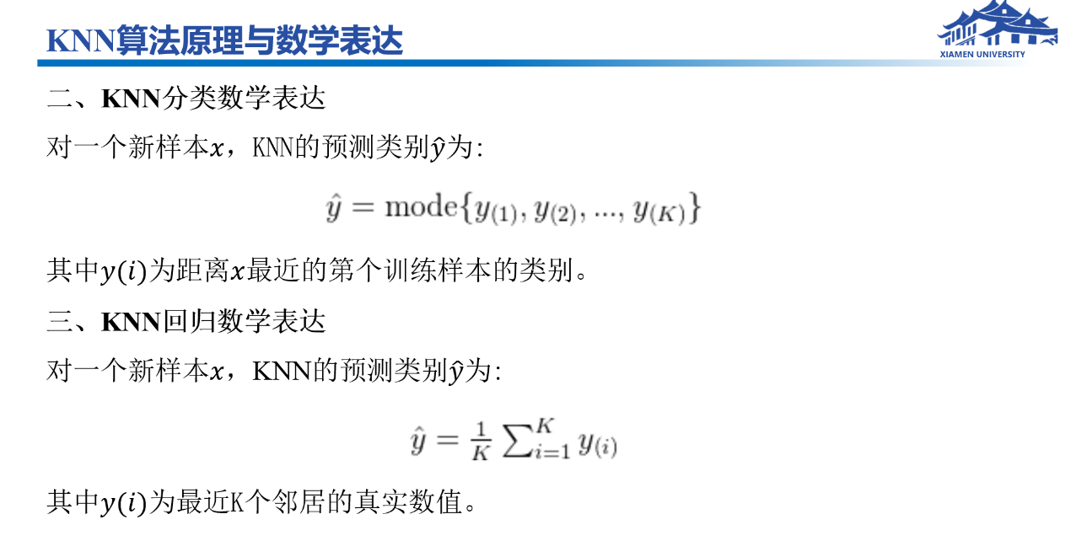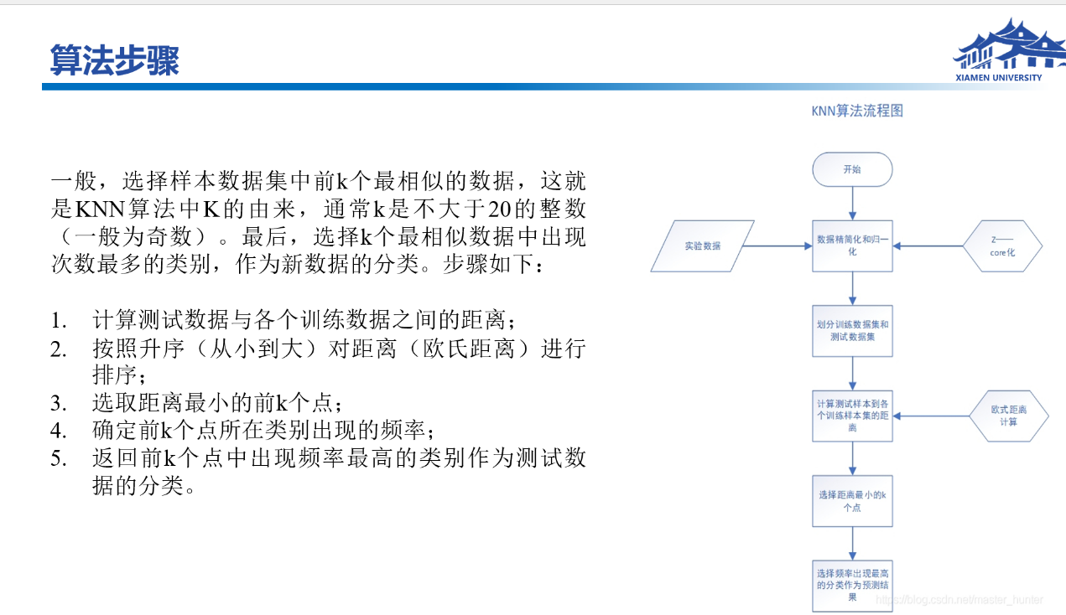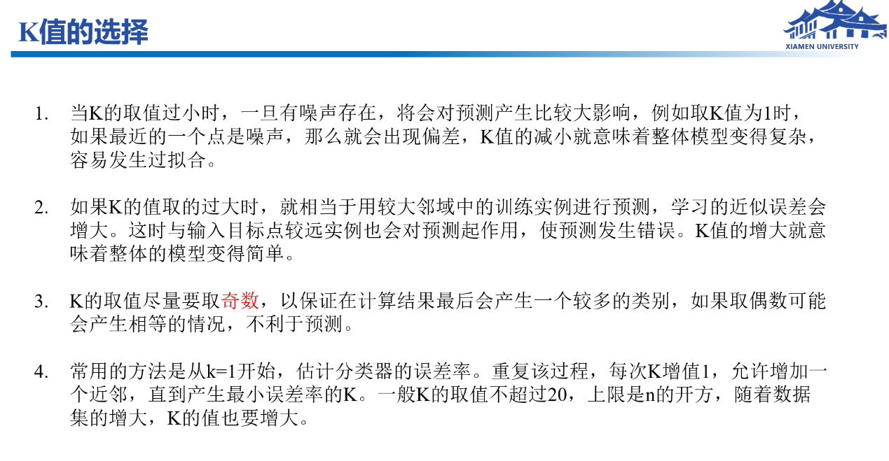

步骤 | 详情
加载 Iris.txt | 150 条样本，4 特征 + 3 类标签
Z-score 标准化 | 流程图中的数据归一化
训练/测试划分 | 7:3 划分，random_state=42
欧式距离 + K 近邻投票 | 算法五步中的距离、排序、选 K、多数表决
K 值选择 | 奇数 K，从 1 到 min(20, √n)，5 折交叉验证取最优
评估输出 | 测试准确率、混淆矩阵、K-准确率曲线图

运行结果：
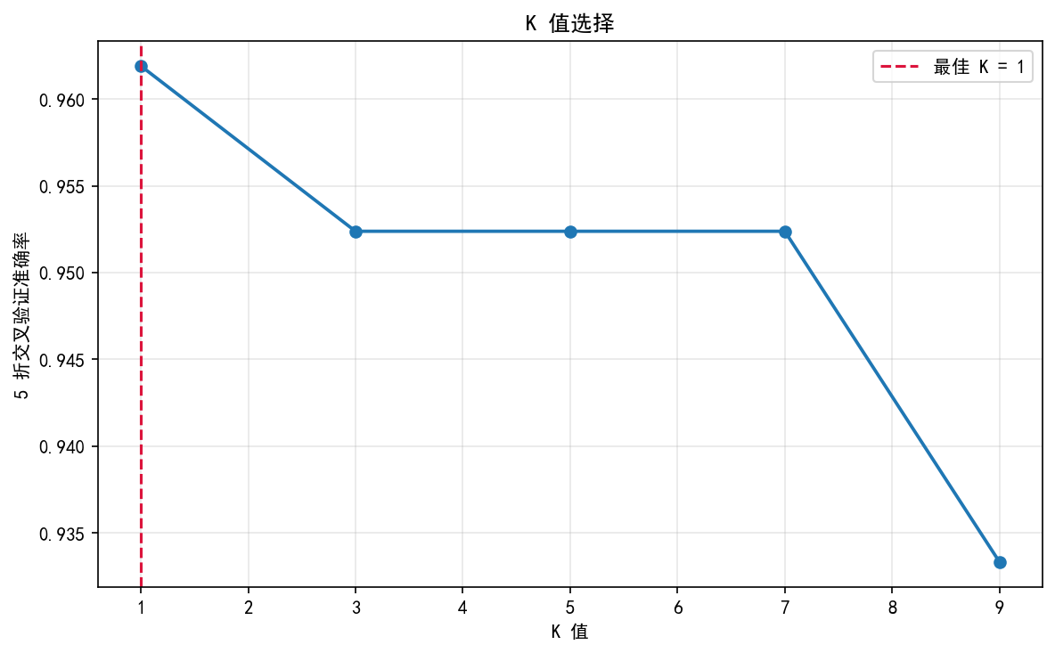
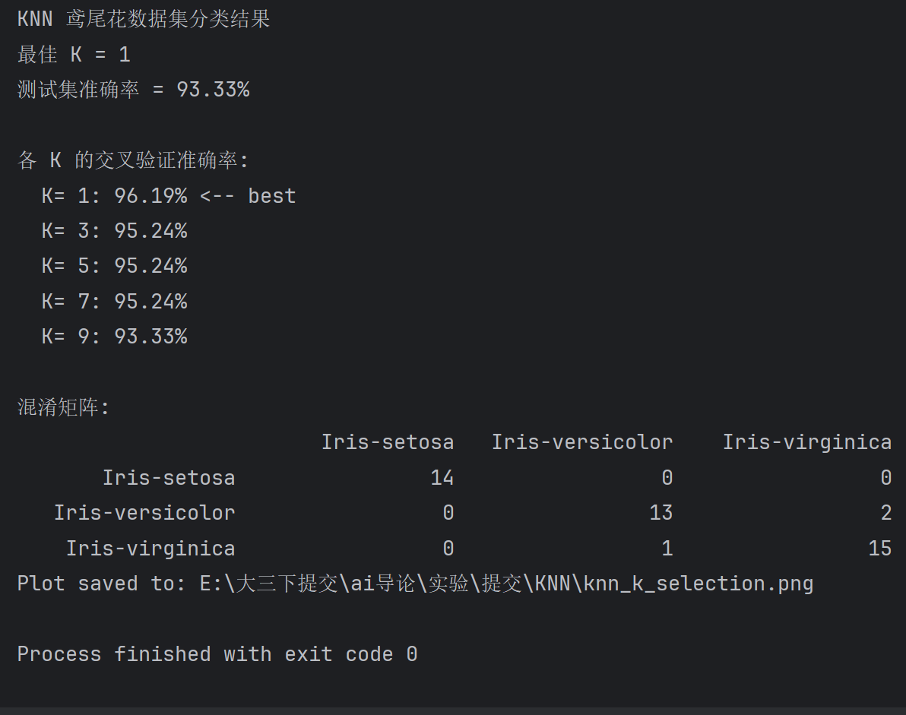
源码：
1. import math
2. import os
3. import sys
4. from collections import Counter
5.
6. import matplotlib.pyplot as plt
7. import numpy as np
8. from matplotlib import rcParams
9.
10. ATTR_NAMES = ["花萼长度", "花萼宽度", "花瓣长度", "花瓣宽度"]
11. SPECIES = ["Iris-setosa", "Iris-versicolor", "Iris-virginica"]
12.
13.
14. def get_base_dir():
15. if getattr(sys, "frozen", False):
16. return os.path.dirname(sys.executable)
17. return os.path.dirname(os.path.abspath(__file__))
18.
19.
20. def load_iris(path):
21. features, labels = [], []
22. with open(path, encoding="utf-8") as f:
23. for line in f:
24. line = line.strip()
25. if not line:
26. continue
27. parts = line.split(",")
28. features.append([float(x) for x in parts[:4]])
29. labels.append(parts[4])
30. X = np.array(features)
31. label_to_id = {name: i for i, name in enumerate(SPECIES)}
32. y = np.array([label_to_id[name] for name in labels])
33. return X, y
34.
35.
36. def train_test_split(X, y, test_size=0.3, random_state=42):
37. rng = np.random.default_rng(random_state)
38. n = len(y)
39. indices = rng.permutation(n)
40. test_count = int(n * test_size)
41. test_idx = indices[:test_count]
42. train_idx = indices[test_count:]
43. return X[train_idx], X[test_idx], y[train_idx], y[test_idx]
44.
45.
46. def z_score_fit(X_train):
47. mean = X_train.mean(axis=0)
48. std = X_train.std(axis=0)
49. std[std == 0] = 1.0
50. return mean, std
51.
52.
53. def z_score_transform(X, mean, std):
54. return (X - mean) / std
55.
56.
57. def euclidean_distance(x, sample):
58. return np.sqrt(np.sum((x - sample) ** 2))
59.
60.
61. class KNN:
62. def __init__(self, k=3):
63. self.k = k
64. self.X_train = None
65. self.y_train = None
66.
67. def fit(self, X, y):
68. self.X_train = np.asarray(X, dtype=float)
69. self.y_train = np.asarray(y)
70. return self
71.
72. def predict(self, X):
73. return np.array([self._predict_one(x) for x in X])
74.
75. def _predict_one(self, x):
76. distances = [euclidean_distance(x, sample) for sample in self.X_train]
77. k_indices = np.argsort(distances)[: self.k]
78. neighbor_labels = self.y_train[k_indices]
79. return Counter(neighbor_labels.tolist()).most_common(1)[0][0]
80.
81.
82. def cross_val_score(model_factory, X, y, folds=5):
83. n = len(y)
84. fold_sizes = [n // folds] * folds
85. for i in range(n % folds):
86. fold_sizes[i] += 1
87.
88. scores = []
89. start = 0
90. for size in fold_sizes:
91. end = start + size
92. val_idx = np.arange(start, end)
93. train_idx = np.concatenate([np.arange(0, start), np.arange(end, n)])
94. start = end
95.
96. model = model_factory()
97. model.fit(X[train_idx], y[train_idx])
98. pred = model.predict(X[val_idx])
99. scores.append(np.mean(pred == y[val_idx]))
100. return float(np.mean(scores))
101.
102.
103. def candidate_k_values(n_train):
104. upper = min(20, int(math.sqrt(n_train)))
105. if upper < 1:
106. upper = 1
107. return [k for k in range(1, upper + 1) if k % 2 == 1]
108.
109.
110. def select_best_k(X_train, y_train):
111. k_values = candidate_k_values(len(y_train))
112. cv_scores = []
113. for k in k_values:
114. score = cross_val_score(lambda k=k: KNN(k=k), X_train, y_train, folds=5)
115. cv_scores.append(score)
116. best_idx = int(np.argmax(cv_scores))
117. return k_values[best_idx], k_values, cv_scores
118.
119.
120. def confusion_matrix(y_true, y_pred, n_classes):
121. matrix = np.zeros((n_classes, n_classes), dtype=int)
122. for true, pred in zip(y_true, y_pred):
123. matrix[pred, true] += 1
124. return matrix
125.
126.
127. def setup_plot_style():
128. rcParams["font.sans-serif"] = ["SimHei", "Microsoft YaHei", "DejaVu Sans"]
129. rcParams["axes.unicode_minus"] = False
130.
131.
132. def plot_k_scores(k_values, cv_scores, best_k, save_path):
133. setup_plot_style()
134. plt.figure(figsize=(8, 5))
135. plt.plot(k_values, cv_scores, marker="o", linewidth=1.8)
136. plt.axvline(best_k, color="crimson", linestyle="--", label=f"最佳 K = {best_k}")
137. plt.xlabel("K 值")
138. plt.ylabel("5 折交叉验证准确率")
139. plt.title("K 值选择")
140. plt.grid(True, alpha=0.3)
141. plt.legend()
142. plt.tight_layout()
143. plt.savefig(save_path, dpi=150, bbox_inches="tight")
144. plt.close()
145.
146.
147. def print_results(best_k, k_values, cv_scores, acc, matrix):
148. print("KNN 鸢尾花数据集分类结果")
149. print(f"最佳 K = {best_k}")
150. print(f"测试集准确率 = {acc * 100:.2f}%")
151.
152. print("\n各 K 的交叉验证准确率:")
153. for k, score in zip(k_values, cv_scores):
154. mark = " <-- best" if k == best_k else ""
155. print(f" K={k:2d}: {score * 100:.2f}%{mark}")
156.
157. print("\n混淆矩阵:")
158. header = " " * 18 + "".join(f"{name:>18}" for name in SPECIES)
159. print(header)
160. for i in range(len(SPECIES)):
161. row = "".join(f"{matrix[i, j]:>18}" for j in range(len(SPECIES)))
162. print(f"{SPECIES[i]:>18}{row}")
163.
164.
165.
166. def main():
167. base_dir = get_base_dir()
168. data_path = os.path.join(base_dir, "Iris.txt")
169. plot_path = os.path.join(base_dir, "knn_k_selection.png")
170.
171. X, y = load_iris(data_path)
172. X_train, X_test, y_train, y_test = train_test_split(X, y, test_size=0.3, random_state=42)
173.
174. mean, std = z_score_fit(X_train)
175. X_train = z_score_transform(X_train, mean, std)
176. X_test = z_score_transform(X_test, mean, std)
177.
178. best_k, k_values, cv_scores = select_best_k(X_train, y_train)
179.
180. model = KNN(k=best_k)
181. model.fit(X_train, y_train)
182. y_pred = model.predict(X_test)
183.
184. acc = np.mean(y_pred == y_test)
185. matrix = confusion_matrix(y_test, y_pred, len(SPECIES))
186.
187. plot_k_scores(k_values, cv_scores, best_k, plot_path)
188. print_results(best_k, k_values, cv_scores, acc, matrix)
189. print(f"Plot saved to: {plot_path}")
190.
191.
192. if __name__ == "__main__":
193. main()
194.

